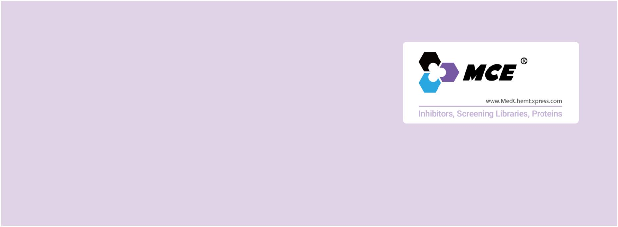Amyloid-β
β-amyloid peptide; Aβ; Abeta
Amyloid-β (Aβ) denotes peptides of 36–43 amino acids that are crucially involved in Alzheimer's disease as the main component of
theamyloid plaques found in the brains of Alzheimer patients. The peptides result from the amyloid precursor protein (APP), which
is being cut by certain enzymes to yield Aβ. Amyloid-β molecules can aggregate to form flexible soluble oligomers which may exist
in several forms. Amyloid-β peptide is due to overproduction of Aβ and/or the failure of clearance mechanisms. Amyloid-β
self-aggregates into oligomers, which can be of various sizes, and forms diffuse and neuritic plaques in the parenchyma and blood
vessels. Amyloid-β oligomers and plaques are potent synaptotoxins, block proteasome function, inhibit mitochondrial activity, alter
intracellular Ca2+levels and stimulate inflammatory processes. Loss of the normal physiological functions of Aβ is also thought to
contribute to neuronal dysfunction.
www.MedChemExpress.com 1
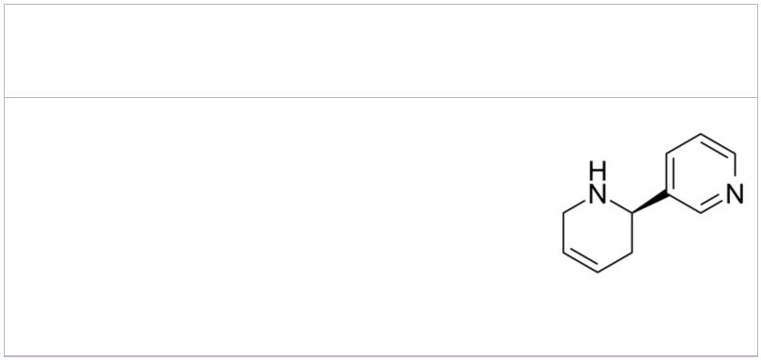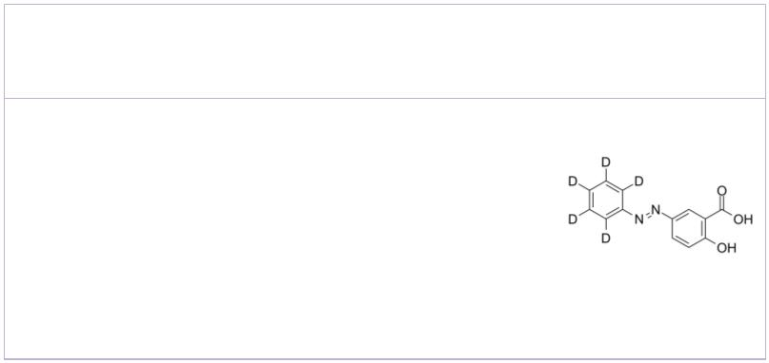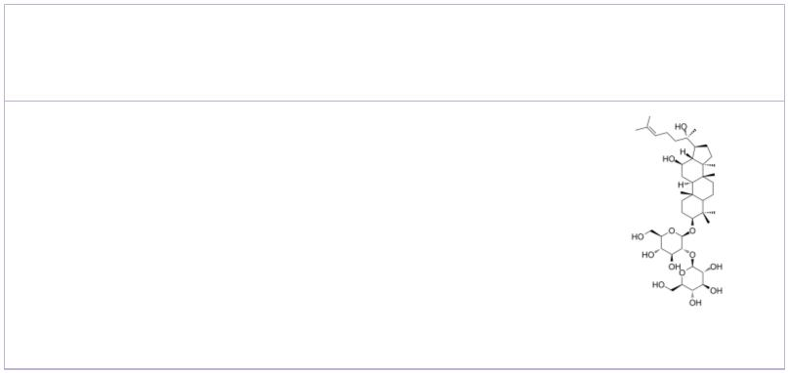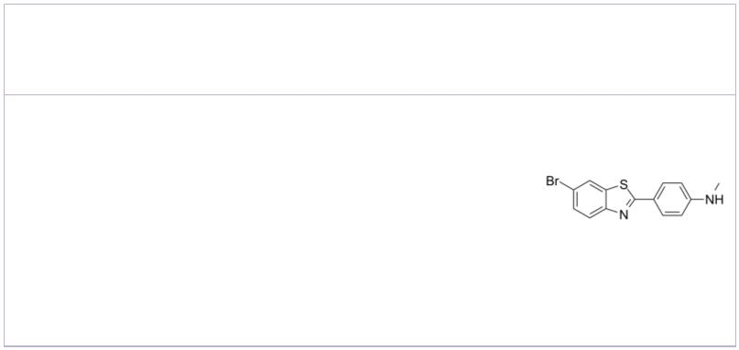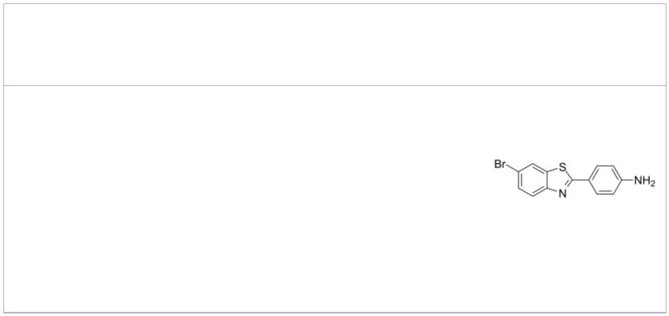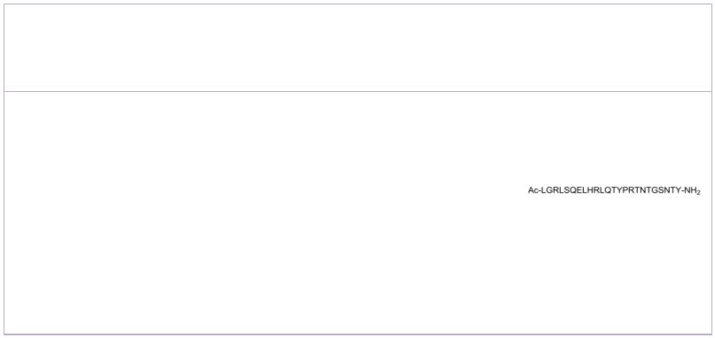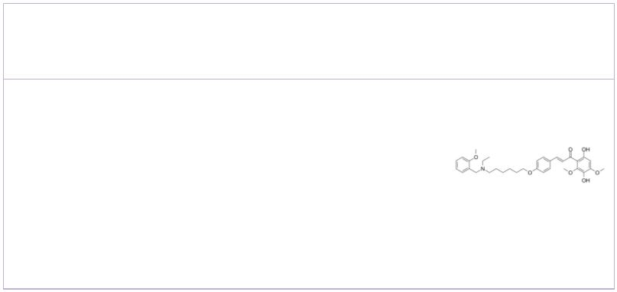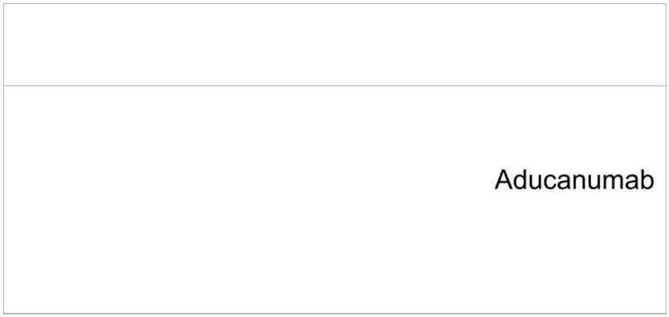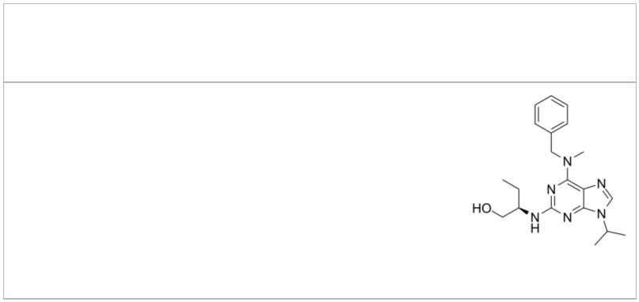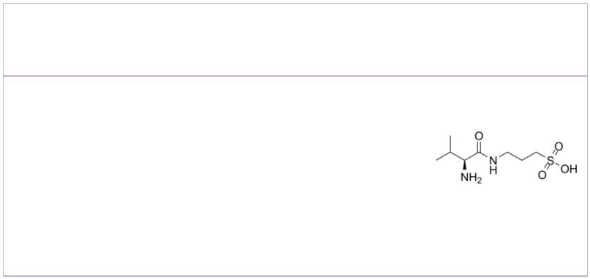Amyloid-β Inhibitors, Agonists, Antagonists, Activators & Chemicals
(R)-(+)-Anatabine 2-Hydroxy-5-(phenyldiazenyl)benzoic acid-d5
Cat. No.: HY-126047B Cat. No.: HY-W013425S
(R)-(+)-Anatabine is an less active R-enantiomer
of Anatabine. Anatabine is a potent α4β2 nAChR
agonist. Anatabine inhibits NF-κB activation
lower amyloid-β (Aβ) production by preventing
the β-cleavage of amyloid precursor protein (APP).
 | Purity: >98%  Clinical Data: No Development Reported  Size: 1 mg, 5 mg |  |  | Purity: >98%  Clinical Data: No Development Reported  Size: 5 mg, 50 mg
 | 20(S)-Ginsenoside Rg3  (20(S)-Propanaxadiol; S-ginsenoside Rg3) Cat. No.: HY-N0603 |  |  | 4-(6-Bromo-2-benzothiazolyl)-N-methylbenzenamine  Cat. No.: HY-111513
 | 20(S)-Ginsenoside Rg3 is the main component of Red  ginseng. Ginsenoside Rg3 inhibits Na+ and  hKv1.4 channel with IC s of 32.2±4.5 and 32.6±2.2  50  μM, respectively. 20(S)-Ginsenoside Rg3 also  inhibits Aβ levels, NF-κB activity, and COX-2  expression. |  |  | 4-(6-Bromo-2-benzothiazolyl)-N-methylbenzenamine  is a potent amyloid imaging agent which binds to  Amyloid-β (1-40) with a K of 1.7 nM.  D
 | Purity: 98.10%  Clinical Data: Launched  Size: 10 mM × 1 mL, 10 mg, 50 mg, 100 mg |  |  | Purity: 98.60%  Clinical Data: No Development Reported  Size: 1 mg, 5 mg
 | 4-(6-Bromo-2-benzothiazolyl)benzenamine AC 253
 |  | Cat. No.: HY-111514 Cat. No.: HY-P2285
 | 4-(6-Bromo-2-benzothiazolyl)benzenamine is a  β-amyloid PET (positron emission tomography)  tracer that can be used in the diagnosis of  neurological diseases, such as Alzheimer's and  Down's syndrome. |  |  | AC 253, an amylin antagonist, inhibits  125I-adrenomedullin binding, with an IC of 25  50  nM.
 | Purity: ≥97.0%  Clinical Data: No Development Reported  Size: 10 mg, 50 mg |  |  | Purity: >98%  Clinical Data: No Development Reported  Size: 1 mg, 5 mg
 | AChE-IN-12 Aducanumab
 |  | Cat. No.: HY-144790 |  | (BIIB037) Cat. No.: HY-P9967
 | AChE-IN-12 is a potent and blood-brain barrier  (BBB) penetrant acetylcholinesterase (AChE) with  IC s of 0.41 μM and 1.88 μM for rat AChE and  50  electric eel AChE. |  |  | Aducanumab (BIIB037), a human monoclonal antibody  selective for aggregated forms of amyloid beta  (Aβ). Aducanumab shows brain penetration, and can  be used for Alzheimer's disease (AD) research.
 | Purity: >98%  Clinical Data: No Development Reported  Size: 1 mg, 5 mg |  |  | Purity: >98%  Clinical Data: Launched  Size: 1 mg, 5 mg
 | Aftin-4 ALZ-801
 |  | Cat. No.: HY-111267 Cat. No.: HY-117259
 | Aftin-4 is an Amyloid-β ( ) inducer.  ₄₂ Aβ₄₂ |  |  | ALZ-801 is a potent and orally available  small-molecule β-amyloid (Aβ) anti-oligomer  and aggregation inhibitor, valine-conjugated  prodrug of Tramiprosate with substantially  improved PK properties and gastrointestinal  tolerability compared with the parent…
 | Purity: 98.03%  Clinical Data: No Development Reported  Size: 10 mM × 1 mL, 2 mg, 5 mg, 10 mg, 25 mg, 50 mg, 100 mg |  |  | Purity: ≥98.0%  Clinical Data: Phase 3  Size: 5 mg, 10 mg, 25 mg, 50 mg, 100 mg
2 Tel: 609-228-6898 Fax: 609-228-5909 Email: sales@MedChemExpress.com
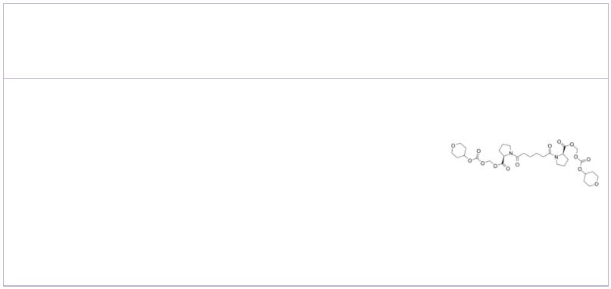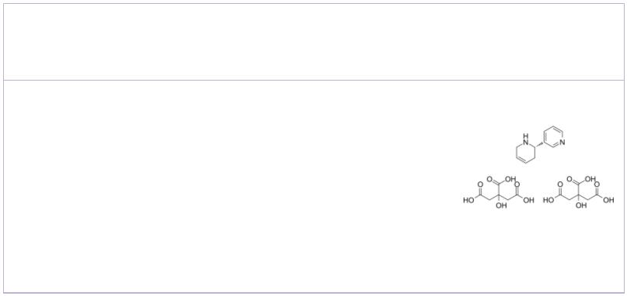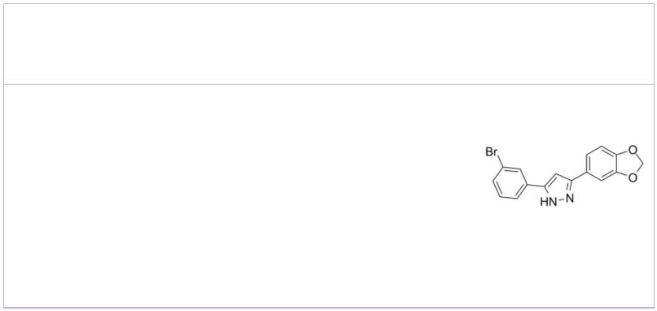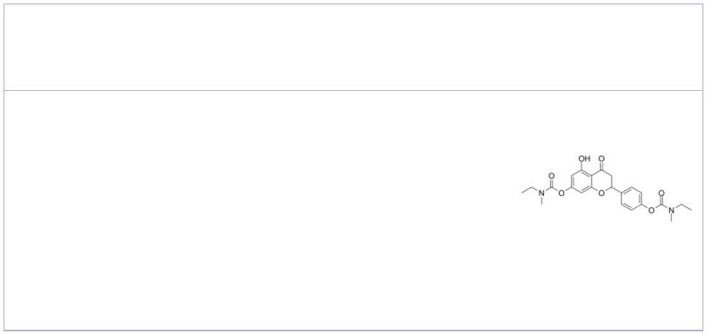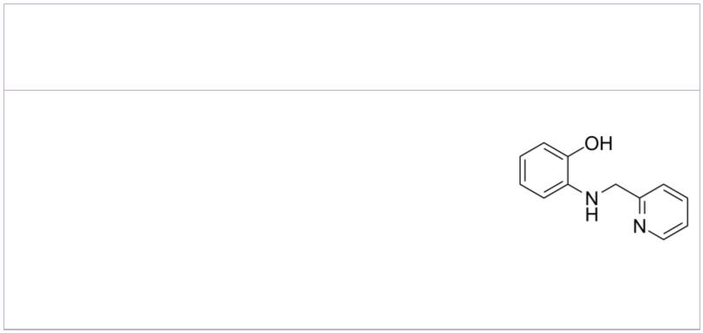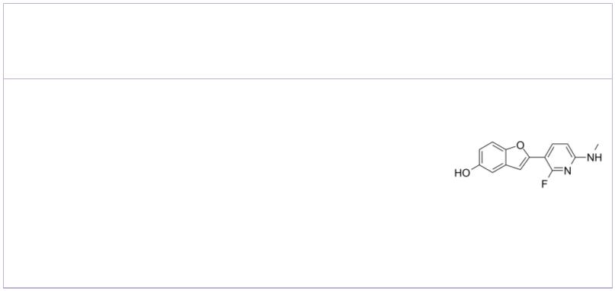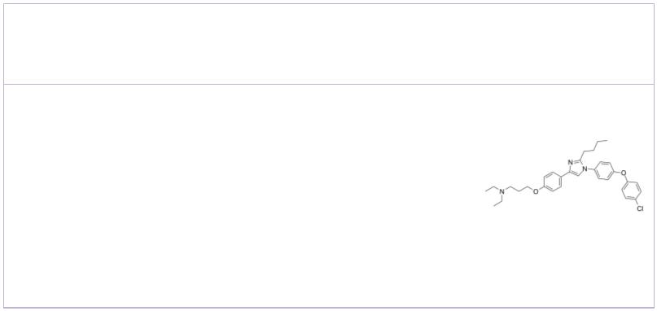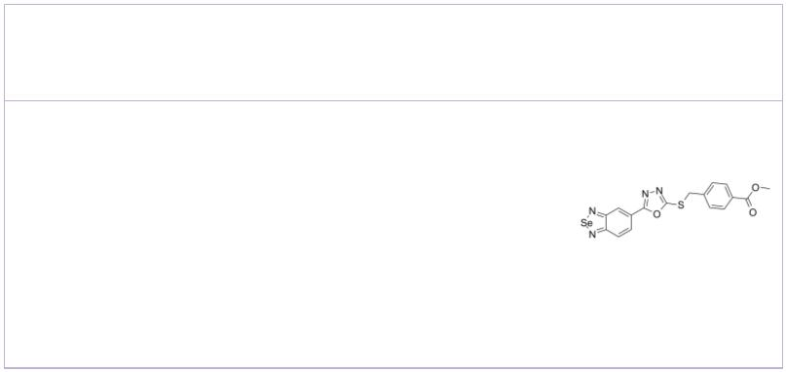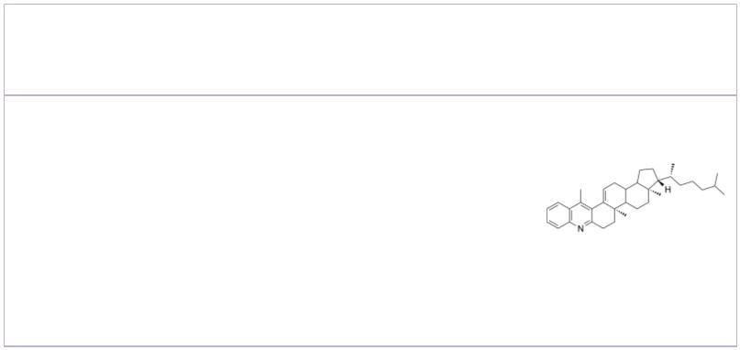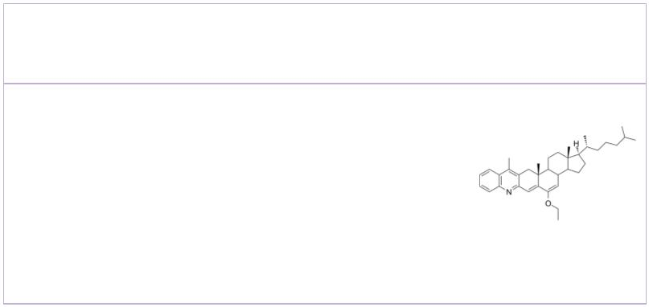amyloid P-IN-1 Anatabine dicitrate
 |  |  | Cat. No.: HY-19771 Cat. No.: HY-19918A
amyloid P-IN-1 is used in the research of diseases  or disorders wherein depletion of serum amyloid P  component (SAP), including amyloidosis,  Alzheimer's disease, type 2 diabetes mellitus and  osteoarthritis. |  |  |  |  | Anatabine dicitrate is a tobacco alkaloid that can  cross the blood-brain barrier. Anatabine dicitrate  is a potent α4β2 nAChR agonist.
Purity: 99.91%  Clinical Data: No Development Reported  Size: 10 mM × 1 mL, 1 mg, 5 mg, 10 mg, 50 mg, 100 mg |  |  |  |  | Purity: 99.24%  Clinical Data: No Development Reported  Size: 10 mM × 1 mL, 5 mg, 10 mg, 50 mg, 100 mg
Anle138b Antioxidant agent-2
 | Cat. No.: HY-101855 Cat. No.: HY-145888
Anle138b, an oligomeric aggregation inhibitor,  blocks the formation of pathological aggregates of  prion protein (PrPSc) and of α-synuclein (α-syn).  Anle138b strongly inhibits oligomer accumulation,  neuronal degeneration, and disease progression in  vivo. |  |  |  |  | Antioxidant agent-2 (comp 3c), an BBB-penetrated  antioxidant agent and a selective metal ions  chelator, presents good neuroprotective effect and  hepatoprotective effect for the study of  Alzheimer’s disease.
Purity: 99.96%  Clinical Data: Phase 1  Size: 10 mM × 1 mL, 5 mg, 10 mg, 25 mg, 50 mg, 100 mg, 200 mg |  |  |  |  | Purity: >98%  Clinical Data: No Development Reported  Size: 1 mg, 5 mg
ARN2966 |  |  | Cat. No.: HY-18292 |  | AZD4694  (NAV4694) Cat. No.: HY-113938
ARN2966 is a potent post-transcriptional modulator  of APP expression; reduces expression of APP with  resultant lower production of Aβ. |  |  |  |  | AZD4694 (NAV4694), a fluorinated β-amyloid (Aβ)  plaque neuroimaging PET radioligand, shows high  affinity for Aβ fibrils (K = 2.3 nM).  d
Purity: 99.57%  Clinical Data: No Development Reported  Size: 10 mM × 1 mL, 5 mg, 10 mg, 50 mg, 100 mg |  |  |  |  | Purity: >98%  Clinical Data: No Development Reported  Size: 1 mg, 5 mg
Azeliragon Aβ Fibrillization modulator 1
(TTP488; PF-04494700) Cat. No.: HY-50682 |  |  |  |  |  |  |  |  |  |  |  |  |  |  |  |  |  | Cat. No.: HY-139740
Azeliragon (TTP488) is an orally bioavailable  inhibitor of the receptor for advanced glycation  end products (RAGE) in development as a potential  treatment to slow disease progression in patients  with mild Alzheimer’s disease (AD). Azeliragon  also can cross the blood-brain barrier (BBB). |  |  |  |  | Aβ Fibrillization modulator 1 stabilizes Aβ  monomers.
Purity: 99.70%  Clinical Data: Phase 3  Size: 10 mM × 1 mL, 5 mg, 10 mg, 50 mg, 100 mg |  |  |  |  | Purity: >98%  Clinical Data: No Development Reported  Size: 1 mg, 5 mg
Aβ-IN-1 Aβ-IN-2
 | Cat. No.: HY-144326 Cat. No.: HY-144327
Aβ-IN-1 is a Aβ1–42 aggregation inhibitor. Aβ-IN-1  inhibits Aβ1-42 self-aggregation in  vitro by delaying the exponential growth  phase or reduces the quantity of fibrils in the  steady state. Aβ-IN-1 can be used for the  research of conformational disorders. |  |  |  |  | Aβ-IN-2 is a Aβ1–42 aggregation inhibitor. Aβ-IN-2  inhibits Aβ1-42 self-aggregation in  vitro by delaying the exponential growth  phase or reduces the quantity of fibrils in the  steady state. Aβ-IN-2 can be used for the  research of conformational disorders.
Purity: >98%  Clinical Data: No Development Reported  Size: 1 mg, 5 mg |  |  |  |  | Purity: >98%  Clinical Data: No Development Reported  Size: 1 mg, 5 mg
www.MedChemExpress.com 3
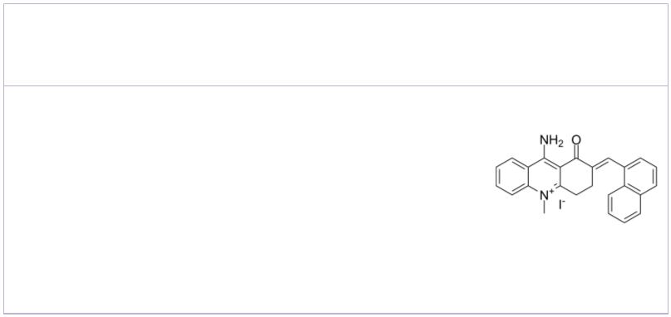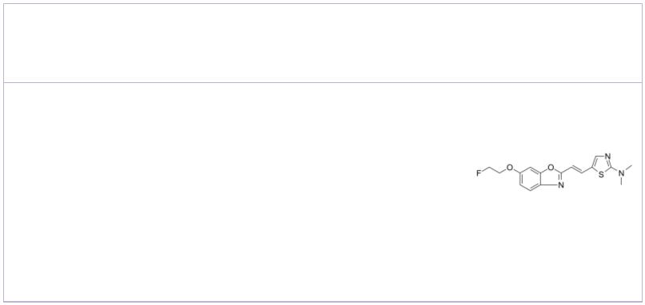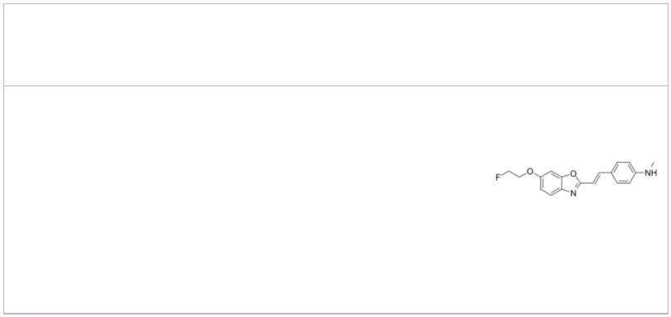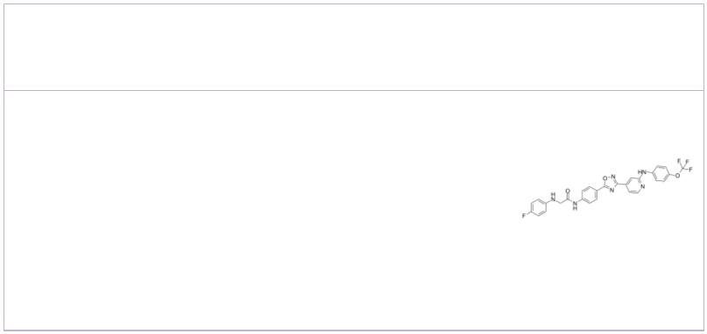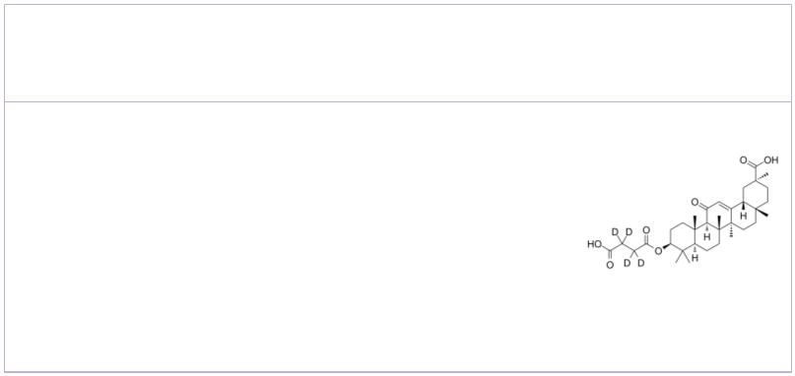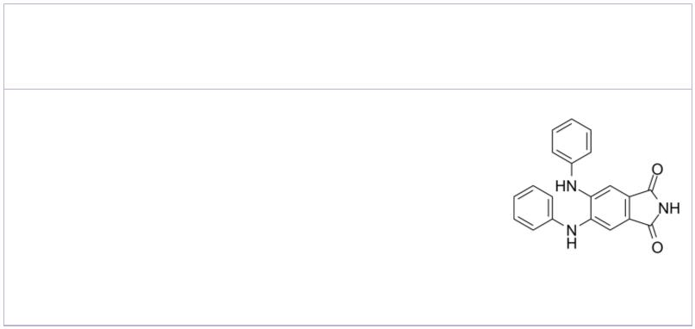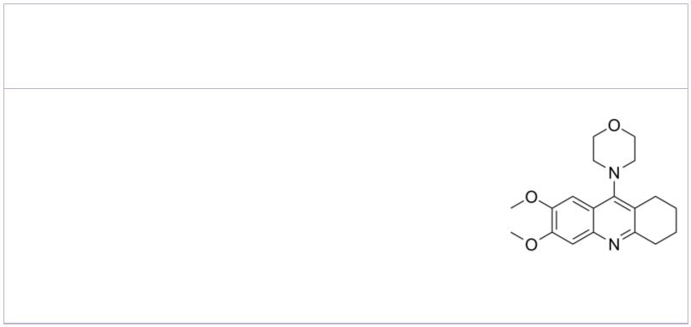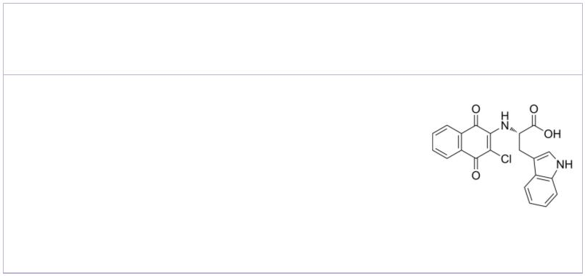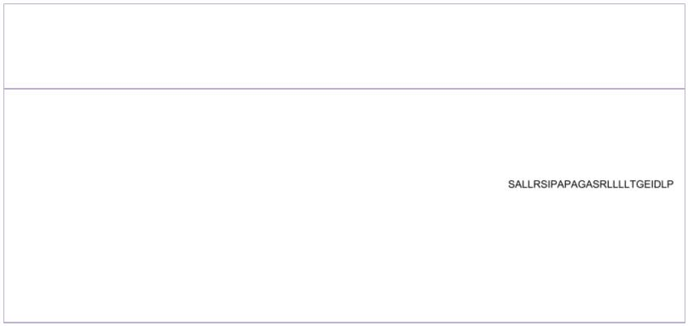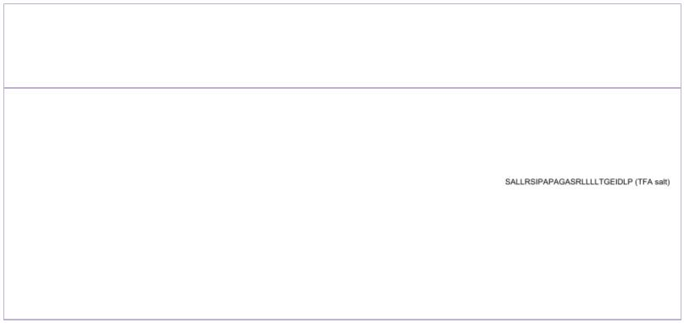 | Aβ/tau aggregation-IN-1 BF 227
 |  |  |  | Cat. No.: HY-141661 Cat. No.: HY-105252A
 | Aβ/tau aggregation-IN-1 is a potent Aβ  1-42  β-sheets formation and tau aggregation  inhibitor. The K values of Aβ/tau  D  aggregation-IN-1 with Aβ and are 160 μM  1-42 tau  and 337 μM, respectively. Aβ/tau aggregation-IN-1  can permeate the blood-brain barrier. |  |  |  |  |  | BF 227 is a candidate for an amyloid imaging probe  for PET, with a K of 4.3 nM for .  i Aβ1-42 fibrils
 | Purity: >98%  Clinical Data: No Development Reported  Size: 10 mM × 1 mL, 5 mg, 10 mg, 25 mg, 50 mg, 100 mg |  |  |  |  |  | Purity: 98.67%  Clinical Data: No Development Reported  Size: 10 mM × 1 mL, 5 mg, 10 mg, 25 mg, 50 mg, 100 mg
 | BF-168 BuChE-IN-2
 |  |  |  | Cat. No.: HY-112830 Cat. No.: HY-143413
 | BF-168, a candidate probe for PET, is found to  specifically recognize both neuritic and diffuse  plaques, with a K of 6.4 nM for .  i Aβ1-42 |  |  |  |  |  | BuChE-IN-2 is an excellent butyrylcholinesterase  (BuChE) inhibitor (IC s of 1.28 μM and 0.67 μM  50  for BuChE and NO). BuChE-IN-2 can inhibit the  aggregation of Aβ, ROS formation and chelate  Cu²⁺, exhibiting proper blood-brain barrier (BBB)  penetration.
 | Purity: 99.39%  Clinical Data: No Development Reported  Size: 5 mg, 10 mg, 25 mg, 50 mg, 100 mg |  |  |  |  |  | Purity: >98%  Clinical Data: No Development Reported  Size: 1 mg, 5 mg
 | Carbenoxolone-d4 |  | Cat. No.: HY-B1588S |  |  |  | CGP52411  (DAPH) Cat. No.: HY-103442
 | Carbenoxolone-d4 is deuterium labeled  Carbenoxolone. Carbenoxolone, a semi-synthetic  derivative of glycyrrhetinic acid, has previously  been used for the management of dyspepsia and  peptic ulcer because of its anti-inflammatory  properties. |  |  |  |  |  | CGP52411 (DAPH) is a high selective, potent,  orally active and ATP-competitive EGFR inhibitor  with an IC of 0.3 μM.  50
 | Purity: >98%  Clinical Data:  Size: 1 mg, 5 mg |  |  |  |  |  | Purity: 99.82%  Clinical Data: No Development Reported  Size: 10 mM × 1 mL, 5 mg
 | ChE/Aβ1-42-IN-1 Cl-NQTrp
 |  |  |  | Cat. No.: HY-144388 Cat. No.: HY-138643
 | ChE/Aβ1-42-IN-1 (compound 28) is a potent ChE and  Aβ₁₋₄₂ IC₅₀  aggregation inhibitor with s of  0.062, 0.767 and 1.227 µM for AChE, BuChE and  Aβ aggregation, respectively. ChE/β1-42-IN-1  1-42  shows excellent BBB penetration. ChE/Aβ1-42-IN-1  is a potent multi-targeted anti-Alzheimer's agent. |  |  |  |  |  | Cl-NQTrp signifcantly disrupts the preformed  fbrillar aggregates of Tau-derived PHF6 (VQIVYK)  peptide and full-length tau protein.
 | Purity: >98%  Clinical Data: No Development Reported  Size: 1 mg, 5 mg |  |  |  |  |  | Purity: >98%  Clinical Data: No Development Reported  Size: 5 mg, 10 mg, 25 mg, 50 mg, 100 mg
 | Colivelin Colivelin TFA
 |  |  |  |  | Cat. No.: HY-P1061 Cat. No.: HY-P1061A
 | Colivelin is a brain penetrant neuroprotective  peptide and a potent activator of STAT3,  suppresses neuronal death by activating  STAT3 in vitro. |  |  |  |  |  | Colivelin TFA is a brain penetrant neuroprotective  peptide and a potent activator of STAT3,  suppresses neuronal death by activating  STAT3 in vitro.
 | Purity: >98%  Clinical Data: No Development Reported  Size: 1 mg, 5 mg |  |  |  |  |  | Purity: 99.22%  Clinical Data: No Development Reported  Size: 500 μg, 1 mg
4 Tel: 609-228-6898 Fax: 609-228-5909 Email: sales@MedChemExpress.com
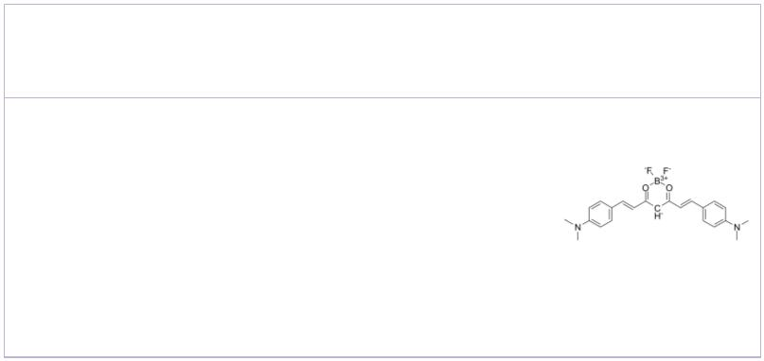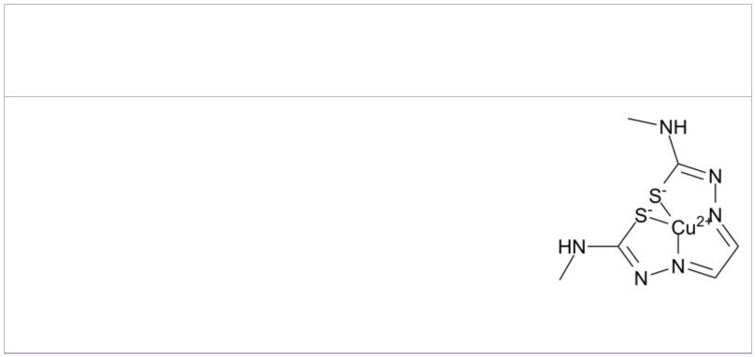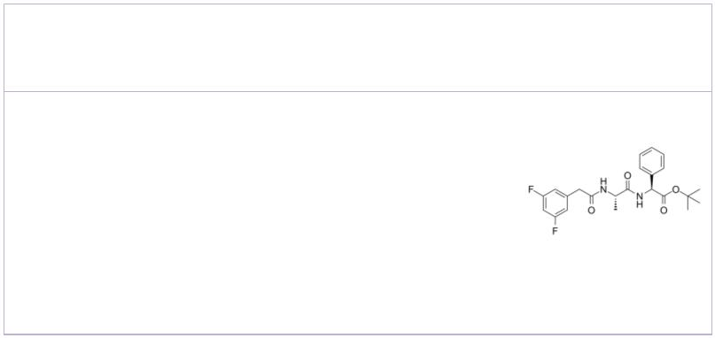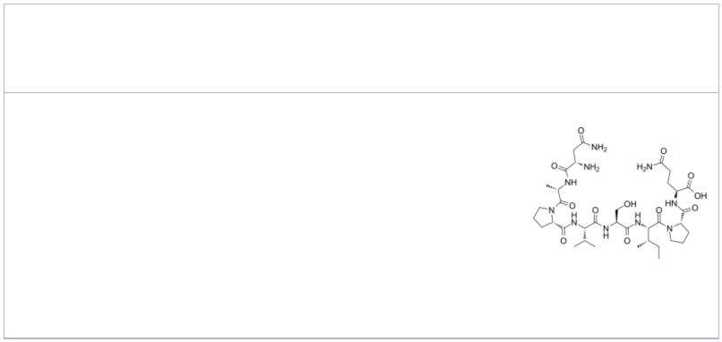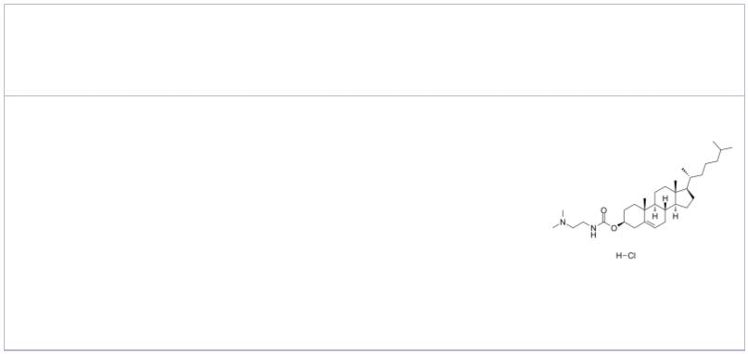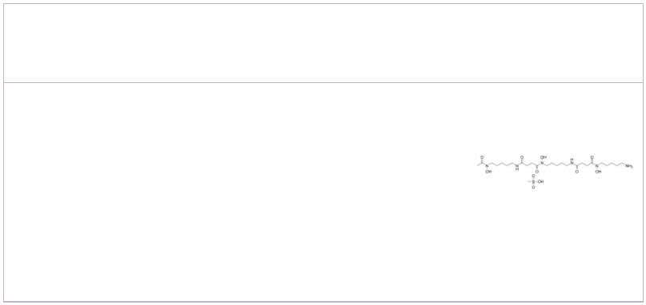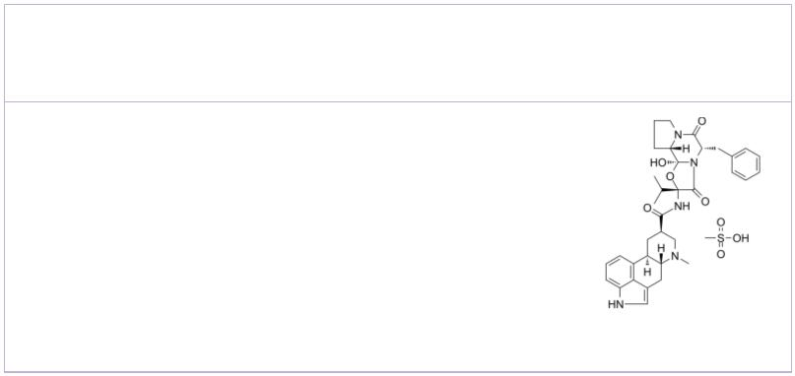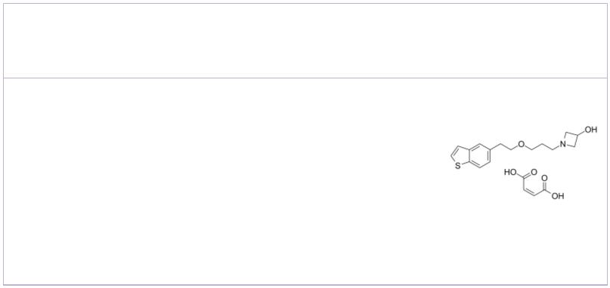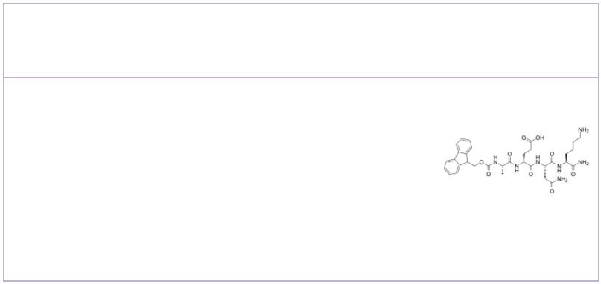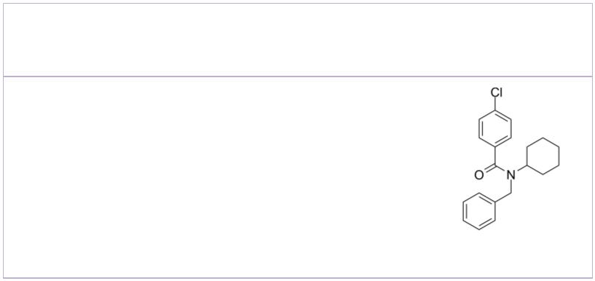CRANAD-2 Cu(II)GTSM
 | Cat. No.: HY-103242 Cat. No.: HY-139324
CRANAD-2 is a near-infrared (NIR) Aβ  plaque-specific fluorescent probe. CRANAD 2  penetrates the blood brain barrier and has a high  affinity for Aβ aggregates with a K of 38 nM.  d |  |  | Cu(II)GTSM, a cell-permeable Cu-complex,  significantly inhibits GSK3β. Cu(II)GTSM inhibits  Amyloid-β oligomers (AβOs) and decreases tau  phosphorylation. Cu(II)GTSM also decreases the  abundance of Amyloid-β trimers. Cu(II)GTSM is a  potential anticancer and antimicrobial agent.
Purity: >98%  Clinical Data: No Development Reported  Size: 1 mg, 5 mg |  |  | Purity: >98%  Clinical Data: No Development Reported  Size: 1 mg, 5 mg
DAPT  (GSI-IX) Cat. No.: HY-13027 |  |  | Davunetide |  |  |  |  |  |  |  |  |  |  | Cat. No.: HY-105066
DAPT (GSI-IX) is a potent and orally active  γ-secretase inhibitor with IC s of 115 nM and  50  200 nM for total amyloid-β (Aβ) and Aβ ,  42  respectively. DAPT inhibits the activation of  Notch 1 signaling and induces cell  differentiation. |  |  | Davunetide is an eight amino acid snippet derived  from activity-dependent neuroprotective protein  (ADNP), a neurotrophic factor that exists in the  mammalian CNS. Davunetide possesses  neuroprotective, neurotrophic and cognitive  protective roperties.
Purity: 99.93%  Clinical Data: No Development Reported  Size: 10 mM × 1 mL, 5 mg, 10 mg, 50 mg |  |  | Purity: 98.85%  Clinical Data: No Development Reported  Size: 1 mg, 5 mg, 10 mg, 25 mg
DC-Chol hydrochloride  (DC-Cholesterol hydrochloride) Cat. No.: HY-137131 |  |  | Deferoxamine mesylate  (Desferrioxamine B mesylate; DFOM) Cat. No.: HY-B0988
DC-Chol hydrochloride could inhibit Aβ40 fibril  formation under appropriate experimental  conditions. DC-Chol hydrochloride strongly  inhibits amyloidogenesis of oxidized hCT in a  dose-dependent manner. |  |  | Deferoxamine mesylate is an iron chelator that  binds free iron in a stable complex, preventing it  from engaging in chemical reactions.
Purity: >98%  Clinical Data: No Development Reported  Size: 100 mg |  |  | Purity: 99.86%  Clinical Data: Launched  Size: 10 mM × 1 mL, 100 mg, 500 mg
Dihydroergocristine mesylate Edonerpic maleate
(DHEC mesylate) Cat. No.: HY-N2319 (T-817 maleate; T-817MA) Cat. No.: HY-17631A
Dihydroergocristine mesylate (DHEC mesylate) is a  inhibitor of γ-secretase (GSI), reduces the  production of the Alzheimer's disease amyloid-β  peptides, binds directly to γ-secretase and  Nicastrin with equilibrium dissociation constants  (K ) of 25.7 nM and 9.8 μM, respectively.  d  Purity: 99.86%  Clinical Data: Launched  Size: 10 mM × 1 mL, 5 mg, 10 mg |  |  | Edonerpic maleate is a novel neurotrophic agent  which can inhibit amyloid-β peptides (Aβ).  Purity: 98.68%  Clinical Data: Phase 2  Size: 10 mM × 1 mL, 1 mg, 5 mg, 10 mg, 50 mg, 100 mg
Fmoc-Ala-Glu-Asn-Lys-NH2 FPS-ZM1
 | Cat. No.: HY-114174 Cat. No.: HY-19370
Fmoc-Ala-Glu-Asn-Lys-NH2 is a selective asparagine  endopeptidase (AEP) inhibitor peptide and  suppresses amyloid precursor protein (APP)  cleavage. AEP, a pH-controlled cysteine  proteinase, is activated during ageing and  mediates APP proteolytic processing. |  |  | FPS-ZM1 is a high-affinity RAGE inhibitor with a  K of 25 nM.  i
Purity: 98.04%  Clinical Data: No Development Reported  Size: 5 mg, 10 mg |  |  | Purity: 99.87%  Clinical Data: No Development Reported  Size: 10 mM × 1 mL, 5 mg, 10 mg, 50 mg, 100 mg, 200 mg
www.MedChemExpress.com 5
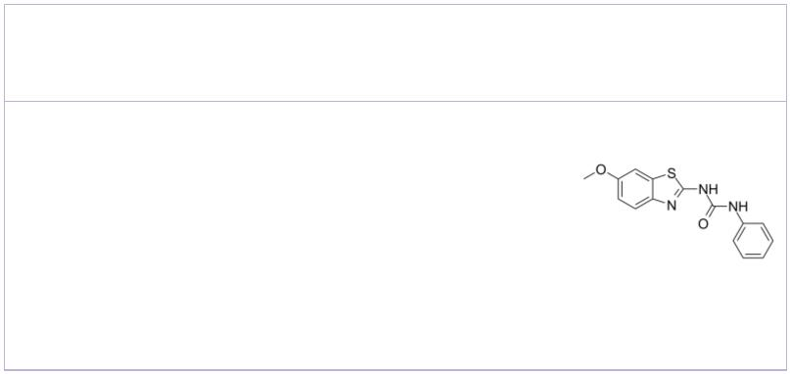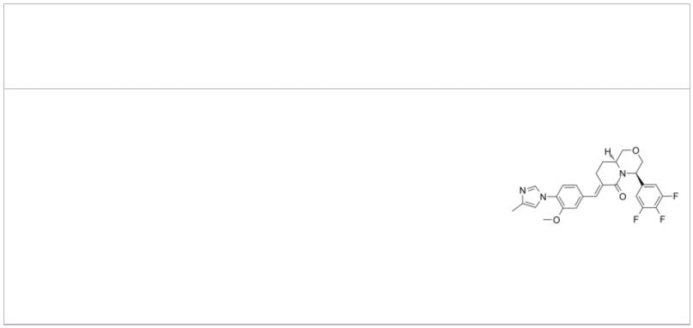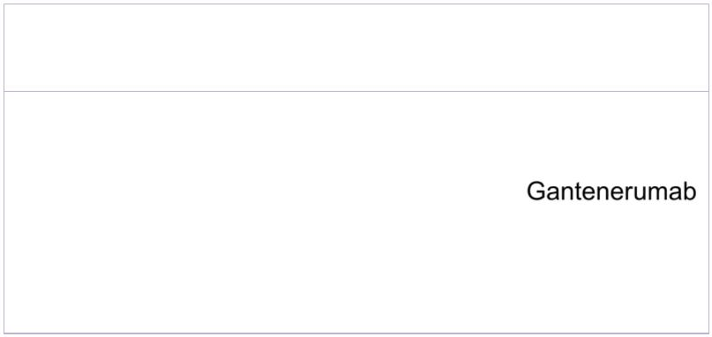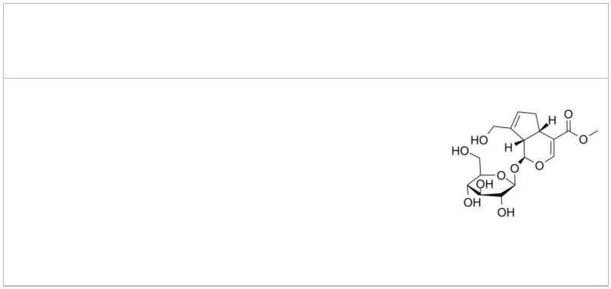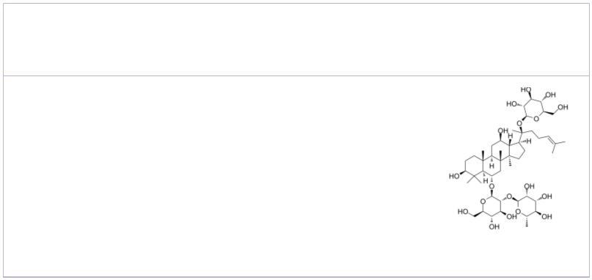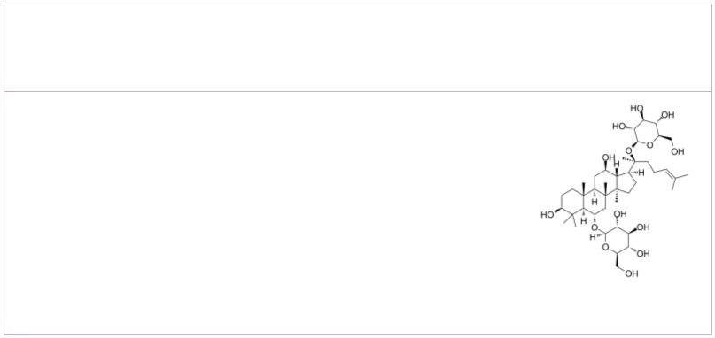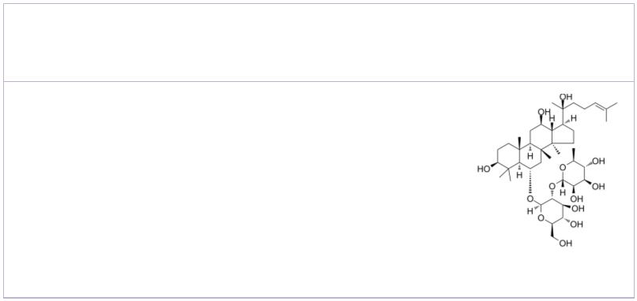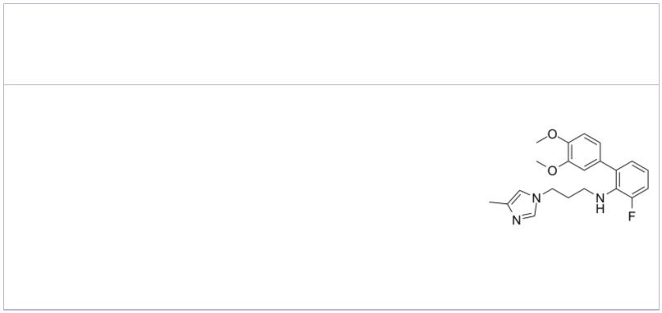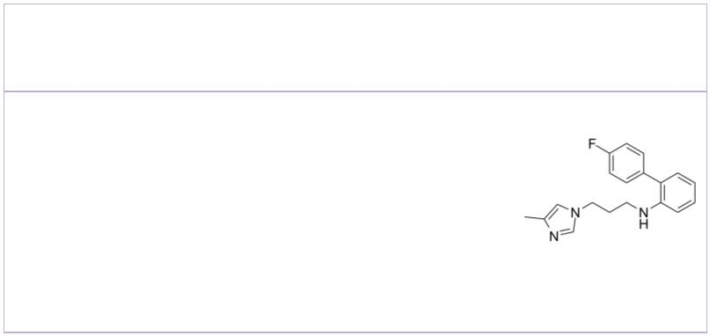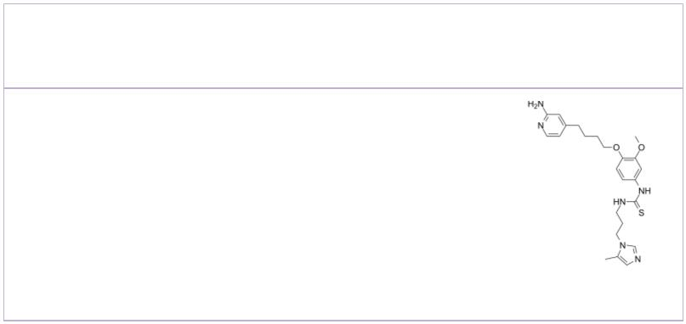 | Frentizole |  |  |  | Cat. No.: HY-15374 |  | gamma-Secretase Modulators  (Amyloid-β production inhibitor; γ-Secretase Modulators) Cat. No.: HY-50900
 | Frentizole, an FDA-approved immunosuppressive  drug, is a novel inhibitor of the Aβ-ABAD  interaction. |  |  |  |  |  | gamma-Secretase Modulators (Amyloid-β production  inhibitor) is a Amyloid-β production inhibitor.  gamma-Secretase Modulators is useful for  Alzheimer's disease. IC50 value: Target:  γ-secretase modulator.
 | Purity: 99.37%  Clinical Data: No Development Reported  Size: 10 mM × 1 mL, 5 mg, 10 mg |  |  |  |  |  | Purity: 99.66%  Clinical Data: No Development Reported  Size: 5 mg, 10 mg
 | Gantenerumab Geniposide
 |  | Cat. No.: HY-P99022 Cat. No.: HY-N0009
 | Gantenerumab is a fully human anti-amyloid-β  (Aβ) IgG1 monoclonal antibody demonstrates  sustained cerebral amyloid-β binding. Gantenerumab  can be used for Alzheimer's disease research. |  |  |  |  |  | Geniposide is an iridoid glucoside extracted from  Gardenia jasminoides Ellis fruits; exhibits a varity  of biological activities such as anti-diabetic,  antioxidative, antiproliferative and  neuroprotective activities.
 | Purity: >98%  Clinical Data: No Development Reported  Size: 1 mg, 5 mg |  |  |  |  |  | Purity: 99.52%  Clinical Data: No Development Reported  Size: 10 mM × 1 mL, 50 mg, 100 mg, 500 mg
 | Ginsenoside Re  (Ginsenoside B2; Panaxoside Re; Sanchinoside Re) Cat. No.: HY-N0044 |  |  |  |  |  | Ginsenoside Rg1  (Panaxoside A; Panaxoside Rg1) Cat. No.: HY-N0045
 | Ginsenoside Re (Ginsenoside B2) is an extract from  Panax notoginseng. Ginsenoside Re decreases the  β-amyloid protein (Aβ). Ginsenoside Re plays a  role in antiinflammation through inhibition of  JNK and NF-κB. |  |  |  |  |  | Ginsenoside Rg1 is one of the major active  components of ginseng. Ginsenoside Rg1 ameliorates  the impaired cognitive function, displays  promising effects by reducing cerebral Aβ levels.  Ginsenoside Rg1 also reduces NF-κB nuclear  translocation.
 | Purity: 98.15%  Clinical Data: Phase 1  Size: 10 mM × 1 mL, 5 mg, 10 mg |  |  |  |  |  | Purity: ≥98.0%  Clinical Data: No Development Reported  Size: 10 mM × 1 mL, 5 mg, 10 mg
 | Ginsenoside Rg2 Glutaminyl Cyclase Inhibitor 1
 | (Chikusetsusaponin I; Panaxoside Rg2; Prosapogenin C2) Cat. No.: HY-N0602 |  |  |  |  |  |  |  |  |  |  |  |  |  |  |  |  |  |  | Cat. No.: HY-112269
 | Ginsenoside Rg2 is one of the major active  components of ginseng. Ginsenoside Rg2 inhibits  VCAM-1 and ICAM-1 expressions stimulated  with lipopolysaccharide (LPS). Ginsenoside Rg2  also reduces Aβ accumulation.  1-42 |  |  |  |  |  | Glutaminyl Cyclase Inhibitor 1 is a glutaminyl  cyclase inhibitor with an IC of 0.5 μM.  50
 | Purity: ≥98.0%  Clinical Data: No Development Reported  Size: 10 mM × 1 mL, 5 mg, 10 mg |  |  |  |  |  | Purity: 99.03%  Clinical Data: No Development Reported  Size: 10 mM × 1 mL, 5 mg, 10 mg, 50 mg, 100 mg
 | Glutaminyl Cyclase Inhibitor 2 Glutaminyl Cyclase Inhibitor 3
 |  |  | Cat. No.: HY-112270 Cat. No.: HY-101282
 | Glutaminyl Cyclase Inhibitor 2 is a glutaminyl  cyclase inhibitor with an IC of 1.23 μM.  50 |  |  |  |  |  | Glutaminyl Cyclase Inhibitor 3 (compound 212 ), a  designed anti-Alzheimer’s compound, is a potent  human Glutaminyl Cyclase (GC) inhibitor, with  an IC of 4.5 nM.  50
 | Purity: >98%  Clinical Data: No Development Reported  Size: 1 mg, 5 mg |  |  |  |  |  | Purity: >98%  Clinical Data: No Development Reported  Size: 1 mg, 5 mg
6 Tel: 609-228-6898 Fax: 609-228-5909 Email: sales@MedChemExpress.com
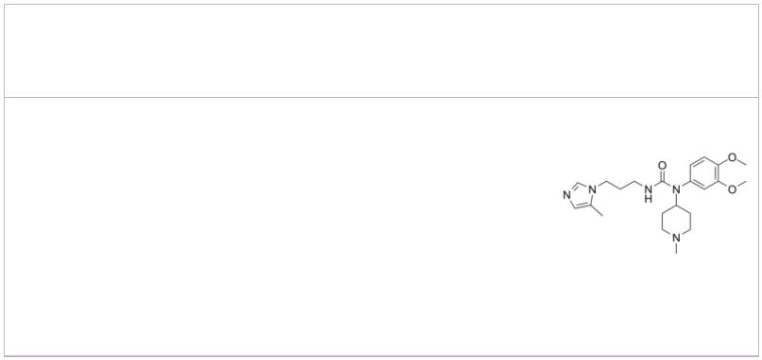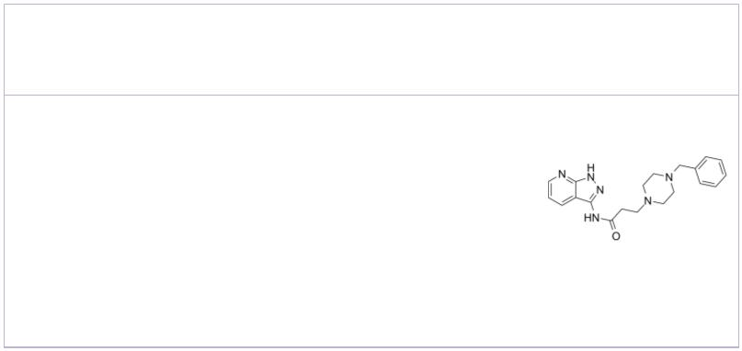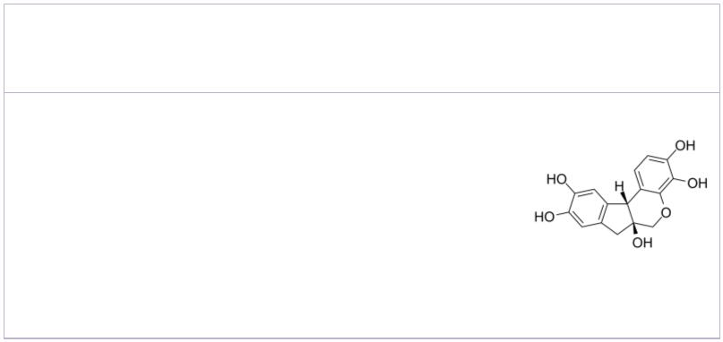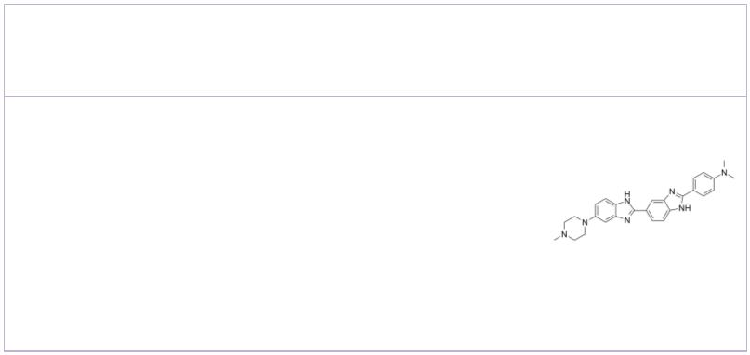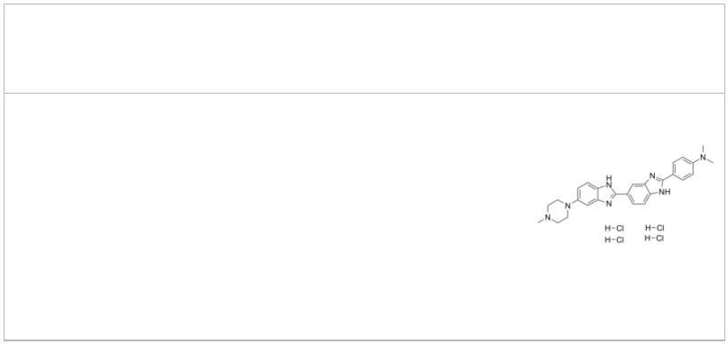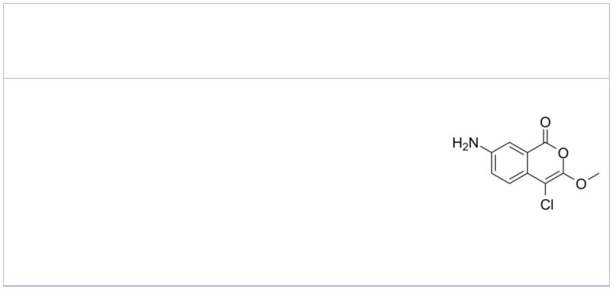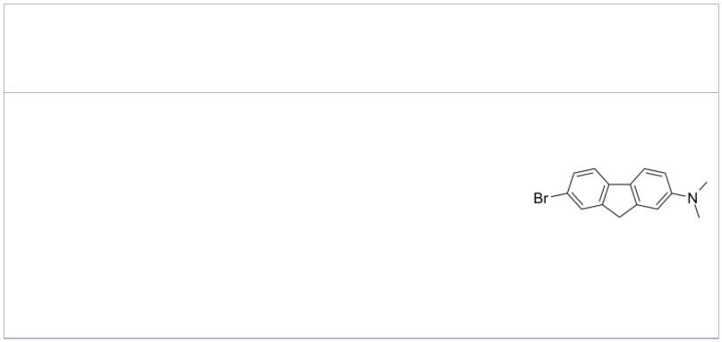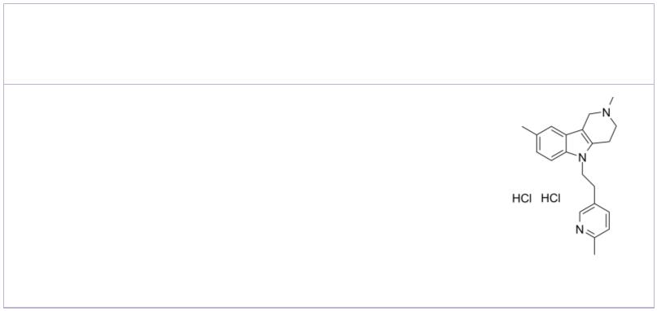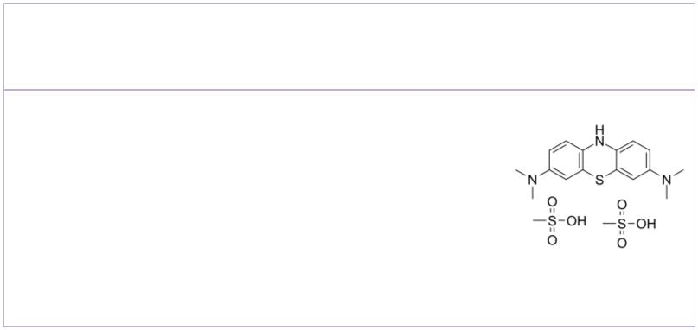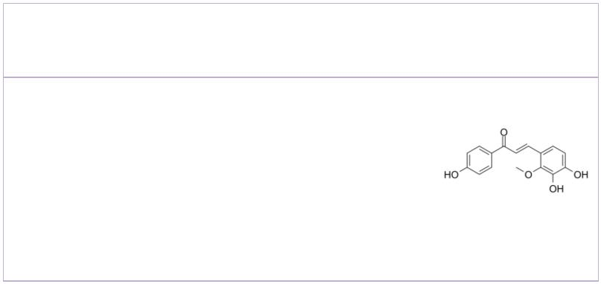Glutaminyl Cyclase Inhibitor 4 hAChE/Aβ1-42-IN-1
 | Cat. No.: HY-126331 Cat. No.: HY-144389
Glutaminyl Cyclase Inhibitor 4 (compound 90) is a  potent, selective glutaminyl cyclase (QC)  inhibitor with an IC of 6.1 nM. Glutaminyl  50  Cyclase Inhibitor 4 is a potent anti-Alzheimer’s  agent. |  |  | hAChE/Aβ1-42-IN-1 (Compound 16) is a potent  inhibitor of hAChE and Aβ1-42 aggregation.  hAChE/Aβ1-42-IN-1 shows acceptable relative safety  upon hepG2 cell line and excellent BBB penetration  with wide safety margin.
Purity: >98%  Clinical Data: No Development Reported  Size: 1 mg, 5 mg |  |  | Purity: >98%  Clinical Data: No Development Reported  Size: 1 mg, 5 mg
Hematoxylin  (Natural Black 1; Haematoxylin) Cat. No.: HY-N0116 |  |  | Hoechst 34580  (HOE 34580) Cat. No.: HY-15560
Hematoxylin (Natural Black 1), a naturally  occurring flavonoid compound derived from the  logwood tree, Haematoxylon campechianum.  Hematoxylin is a nuclear stain in histology and is  also a potent Aβ42 fibrillogenesis inhibitor with  an IC of 1.6 µM.  50  Purity: ≥98.0%  Clinical Data: No Development Reported  Size: 10 mM × 1 mL, 100 mg, 1 g |  |  | Hoechst 34580 is a cell-permeable fluorescent dye  for staining DNA and nuclei.  Purity: 99.84%  Clinical Data: No Development Reported  Size: 10 mM × 1 mL, 5 mg, 10 mg, 50 mg, 100 mg
Hoechst 34580 tetrahydrochloride  (HOE 34580 tetrahydrochloride) Cat. No.: HY-15560B |  |  | JLK-6 |  |  |  |  |  |  |  |  |  |  |  | Cat. No.: HY-103538
Hoechst 34580 tetrahydrochloride is a  cell-permeable fluorescent dye for staining DNA  and nuclei. |  |  | JLK-6 markedly reduce the production of amyloid  β-peptide (Aβ) by amyloid-β Precursor protein  (APP) expressing HEK293 cells by affecting the  γ-secretase cleavage of APP, with no effect on the  cleavage of the Notch receptor.
Purity: 99.58%  Clinical Data: No Development Reported  Size: 5 mg, 10 mg, 50 mg, 100 mg |  |  | Purity: >98%  Clinical Data: No Development Reported  Size: 1 mg, 5 mg
K 01-162 Latrepirdine dihydrochloride
(K162) Cat. No.: HY-14533 (Dimebolin dihydrochloride) Cat. No.: HY-14537
K 01-162 (K162) binds and destabilizes AβO  (β-amyloid), with an EC50 of 80 nM. |  |  | Latrepirdine dihydrochloride is a neuroactive  compound with antagonist activity at  histaminergic, α-adrenergic, and serotonergic  receptors. Latrepirdine stimulates amyloid  precursor protein (APP) catabolism and  amyloid-β (Aβ) secretion.
Purity: 97.57%  Clinical Data: No Development Reported  Size: 5 mg, 10 mg, 25 mg, 50 mg, 100 mg |  |  | Purity: 99.75%  Clinical Data: Launched  Size: 10 mM × 1 mL, 5 mg, 10 mg, 25 mg, 50 mg, 100 mg, 200 mg
Leucomethylene blue mesylate Licochalcone B
(TRx0237 mesylate; Methylene blue leuco base mesylate) Cat. No.: HY-19948 |  |  |  |  |  |  |  |  |  |  |  |  |  |  |  |  | Cat. No.: HY-N0373
Leucomethylene blue (TRx0237) mesylate, an orally  active second-generation tau protein aggregation  inhibitor (K of 0.12 μM), could be used for the  i  study of Alzheimer's Disease. |  |  | Licochalcone B is an extract from the root of  Glycyrrhiza inflate.
Purity: 98.75%  Clinical Data: Phase 3  Size: 10 mM × 1 mL, 5 mg, 10 mg, 50 mg, 100 mg |  |  | Purity: 99.93%  Clinical Data: No Development Reported  Size: 10 mM × 1 mL, 1 mg, 5 mg, 10 mg
www.MedChemExpress.com 7
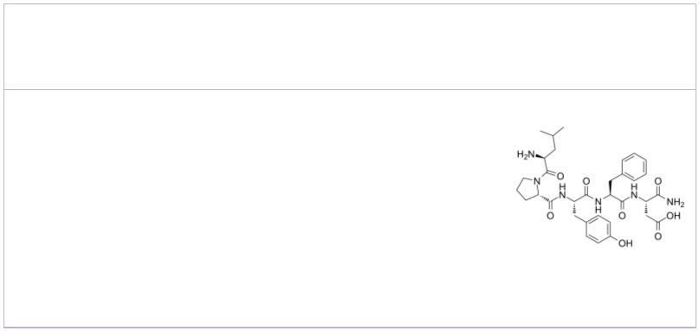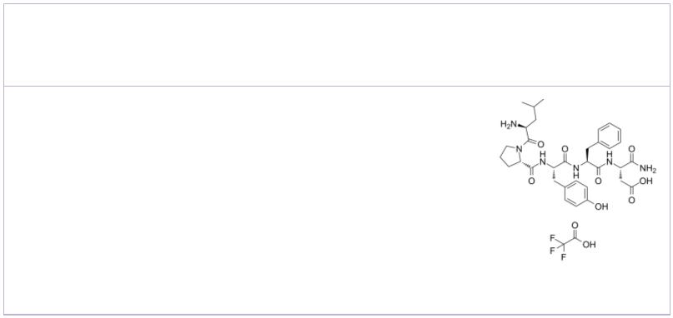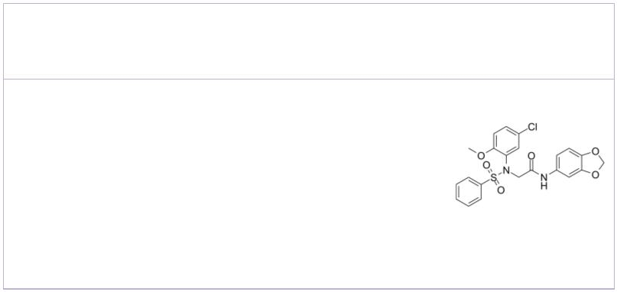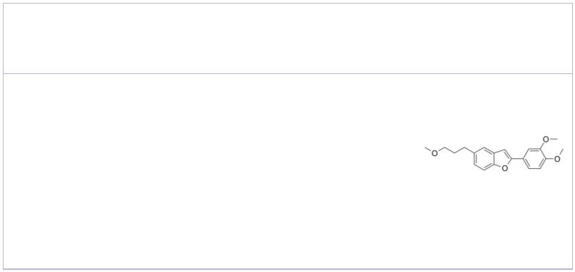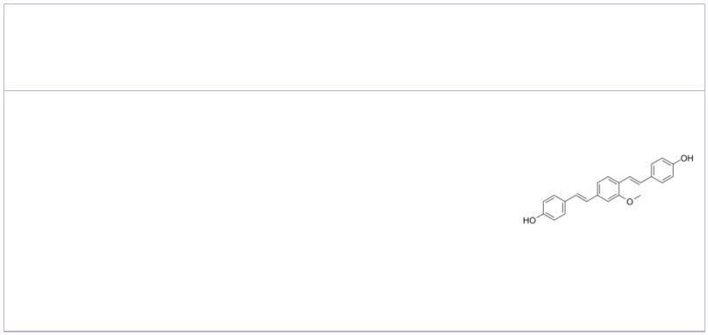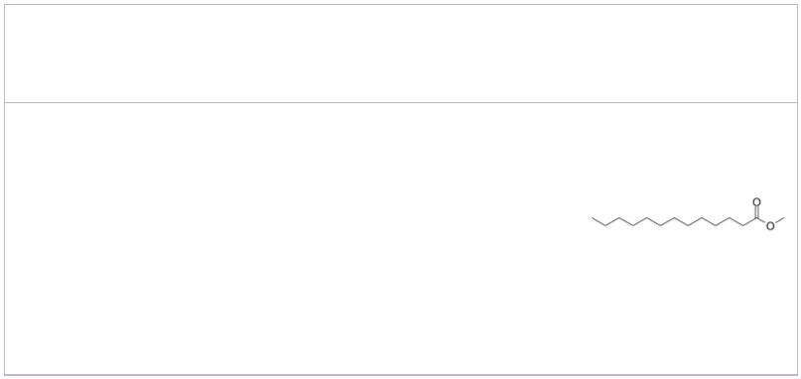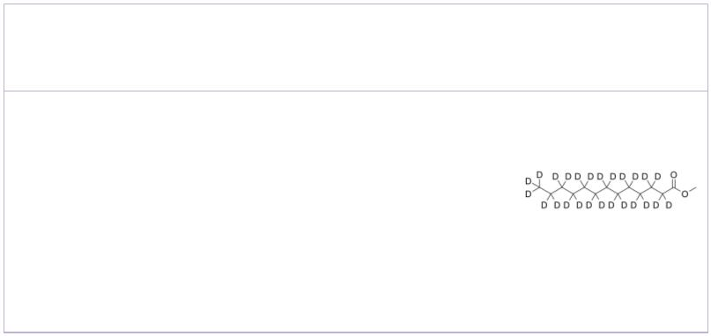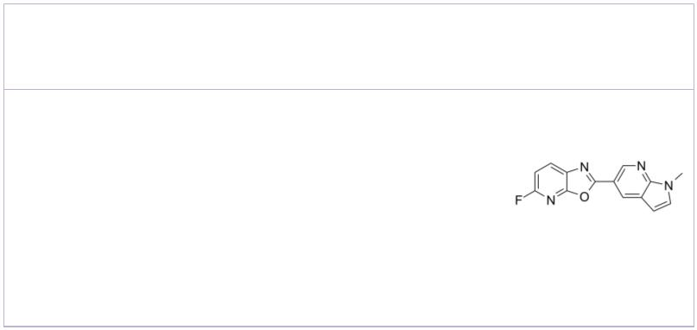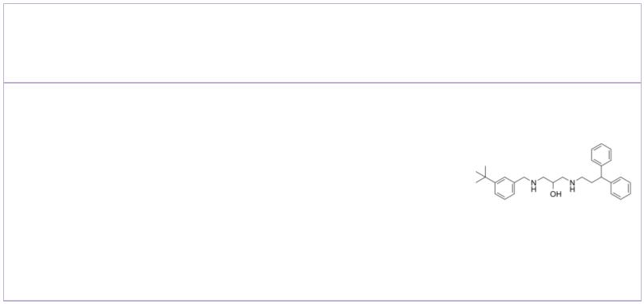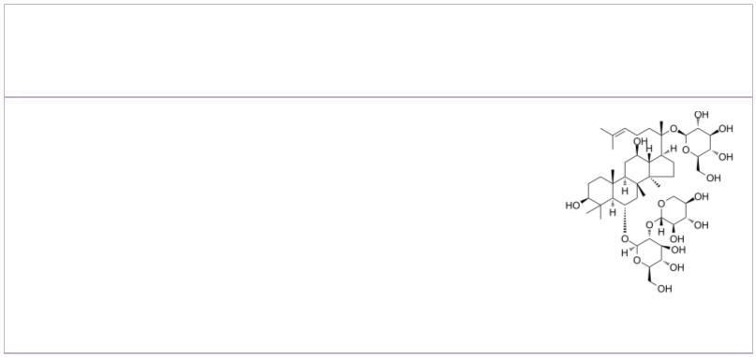 | LPYFD-NH2 LPYFD-NH2 TFA
 |  |  |  |  | Cat. No.: HY-P1060 Cat. No.: HY-P1060A
 | LPYFD-NH2, a pentapeptide, exerts some inhibitory  effect on the aggregation of Aβ(1-42). LPYFD-NH2  can be used for the research of Alzheimer’s  disease. |  |  |  |  |  | LPYFD-NH2 TFA, a pentapeptide, exerts some  inhibitory effect on the aggregation of Aβ(1-42).  LPYFD-NH2 TFA can be used for the research of  Alzheimer’s disease.
 | Purity: >98%  Clinical Data: No Development Reported  Size: 1 mg, 5 mg |  |  |  |  |  | Purity: >98%  Clinical Data: No Development Reported  Size: 1 mg, 5 mg
 | LX2343 |  |  | Cat. No.: HY-111383 |  |  | MDR-1339  (DWK-1339) Cat. No.: HY-14503
 | LX2343 is a BACE1 enzyme inhibitor with an IC  50  value of 11.43±0.36 μM. LX2343 acts as a non-ATP  competitive PI3K inhibitor with an IC of  50  15.99±3.23 μM. LX2343 stimulates autophagy in its  promotion of Aβ clearance. |  |  |  |  |  | MDR-1339 (DWK-1339) is an orally active and  blood-brain-barrier-permeable Aβ-aggregation  inhibitor, used in the research of Alzheimer's  disease.
 | Purity: 99.80%  Clinical Data: No Development Reported  Size: 10 mM × 1 mL, 5 mg, 10 mg, 50 mg, 100 mg |  |  |  |  |  | Purity: 98.03%  Clinical Data: No Development Reported  Size: 10 mM × 1 mL, 5 mg, 10 mg, 25 mg, 50 mg, 100 mg
 | Methoxy-X04 Methyl tridecanoate
 |  |  |  | Cat. No.: HY-103240 Cat. No.: HY-W004287
 | Methoxy-X04 is a fluorescent dye that crosses the  blood-brain barrier and selectively binds to  beta-pleated sheets found in dense core amyloid Aβ  plaques. |  |  |  |  |  | Methyl tridecanoate moderately inhibits β-amyloid  aggregation. Methyl tridecanoate weakly inhibits  acetylcholinesterase (AChE).
 | Purity: >98%  Clinical Data: No Development Reported  Size: 5 mg, 10 mg |  |  |  |  |  | Purity: ≥95.0%  Clinical Data: No Development Reported  Size: 10 mM × 1 mL, 500 mg
 | Methyl tridecanoate-d25 MK-3328
 |  | Cat. No.: HY-W004287S Cat. No.: HY-100275
 | Methyl tridecanoate-d25 is the deuterium labeled  Methyl tridecanoate. Methyl tridecanoate  moderately inhibits β-amyloid aggregation. Methyl  tridecanoate weakly inhibits acetylcholinesterase  (AChE). |  |  |  |  |  | MK-3328 is a β-Amyloid PET ligand, which  exhibits high binding potency with an IC of 10.5  50  nM.
 | Purity: >98%  Clinical Data: No Development Reported  Size: 1 mg, 5 mg |  |  |  |  |  | Purity: >98%  Clinical Data: No Development Reported  Size: 1 mg, 5 mg
 | Multitarget AD inhibitor-1 Notoginsenoside R1
 |  |  |  | Cat. No.: HY-136813 |  |  | (Sanchinoside R1; Sanqi glucoside R1) Cat. No.: HY-N0615
 | Multitarget AD inhibitor-1 is a selective and  reversible butyrylcholinesterase (BuChE) inhibitor  with IC s of 7.22 μM and 1.55 μM for hBuChE and  50  eqBuChE (BuChE from equine serum), respectively. |  |  |  |  |  | Notoginsenoside R1 (Sanchinoside R1), a saponin,  is isolated from P. notoginseng. Notoginsenoside R1  exhibits anti-oxidation, anti-inflammatory,  anti-angiogenic, and anti-apoptosis activities.
 | Purity: >98%  Clinical Data: No Development Reported  Size: 1 mg, 5 mg |  |  |  |  |  | Purity: ≥98.0%  Clinical Data: No Development Reported  Size: 10 mM × 1 mL, 5 mg, 10 mg
8 Tel: 609-228-6898 Fax: 609-228-5909 Email: sales@MedChemExpress.com
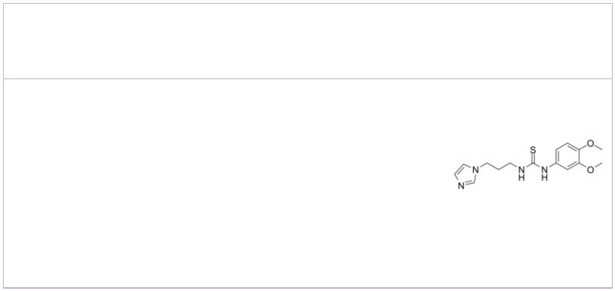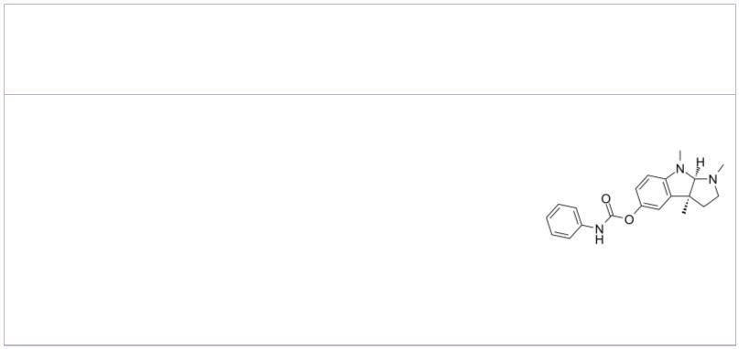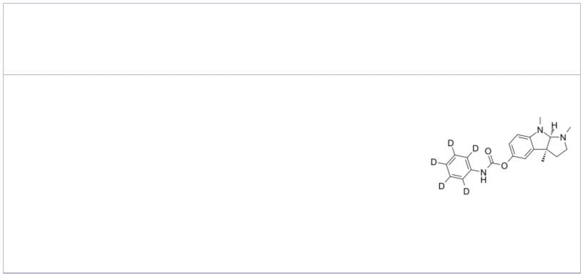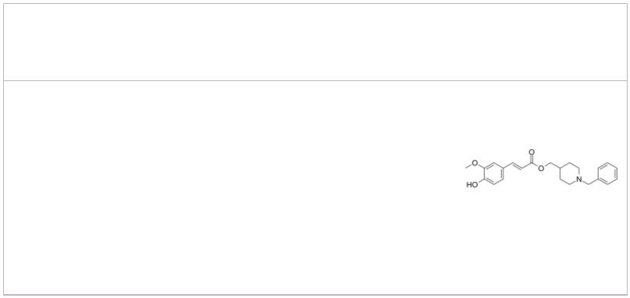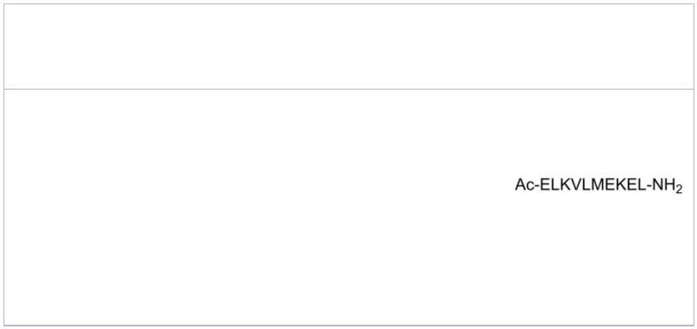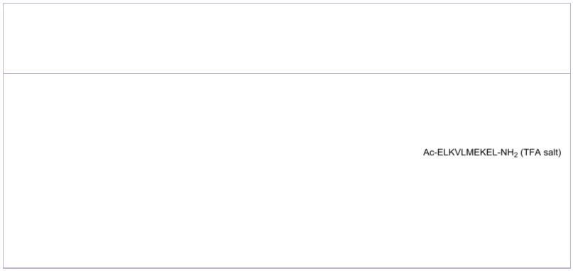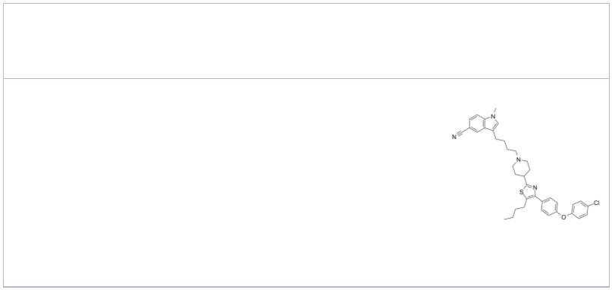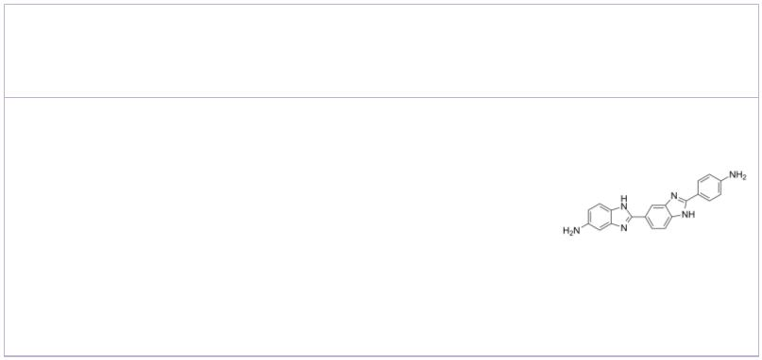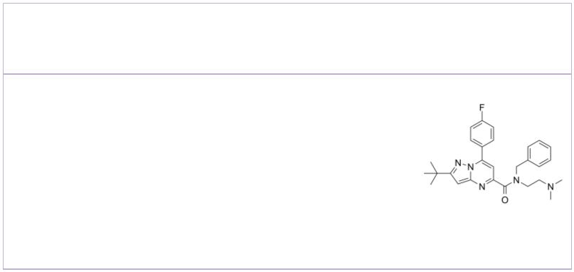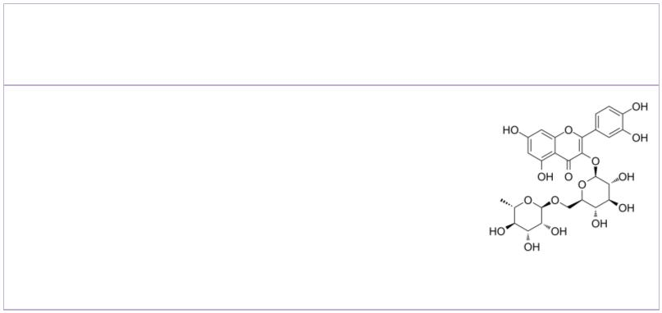PBD-150 |  |  | Cat. No.: HY-119173 |  |  | Phenserine  ((-)-Eseroline phenylcarbamate; (-)-Phenserine) Cat. No.: HY-103374
PBD-150 is a human glutaminyl cyclase (hQC)  Y115E-Y117E variant inhibitor, with a K value of  i  490 nM. |  |  |  |  |  | Phenserine ((-)-Eseroline phenylcarbamate) is a  derivative of Physostigmine and is a potent,  noncompetitive, long-acting and selective AChE  inhibitor. Phenserine reduces β-amyloid  precursor protein (APP) and β-amyloid peptide  (Aβ) formation.
Purity: 98.39%  Clinical Data: No Development Reported  Size: 10 mM × 1 mL, 5 mg, 10 mg, 50 mg |  |  |  |  |  | Purity: ≥98.0%  Clinical Data: No Development Reported  Size: 10 mM × 1 mL, 5 mg, 10 mg
Phenserine-d5 PQM130
 | Cat. No.: HY-103374S Cat. No.: HY-128346
Phenserine-d5 is the deuterium labeled Phenserine.  Phenserine ((-)-Eseroline phenylcarbamate) is a  derivative of Physostigmine and is a potent,  noncompetitive, long-acting and selective AChE  inhibitor. |  |  |  |  |  | PQM130, a Feruloyl-Donepezil Hybrid compound with  brain penatration, is a multitarget drug candidate  against the neurotoxicity induced by Aβ  1-42  oligomer (AβO) and shows anti-inflammatory  activity. PQM130 acts as a neuroprotective  compound for anti-AD drug development.
Purity: >98%  Clinical Data: No Development Reported  Size: 1 mg, 5 mg |  |  |  |  |  | Purity: >98%  Clinical Data: No Development Reported  Size: 1 mg, 5 mg
RAGE antagonist peptide RAGE antagonist peptide TFA
 |  |  |  | Cat. No.: HY-P2268 Cat. No.: HY-P2268A
RAGE antagonist peptide is an advanced glycation  end products (RAGE) antagonist. RAGE antagonist  peptide prevents RAGE from binding with several of  its most important ligands, including HMGB-1,  S100P, and S100A4. |  |  |  |  |  | RAGE antagonist peptide TFA is an advanced  glycation end products (RAGE) antagonist. RAGE  antagonist peptide TFA prevents RAGE from binding  with several of its most important ligands,  including HMGB-1, S100P, and S100A4.
Purity: >98%  Clinical Data: No Development Reported  Size: 1 mg, 5 mg |  |  |  |  |  | Purity: 99.04%  Clinical Data: No Development Reported  Size: 1 mg, 5 mg
RAGE/SERT-IN-1 Ro 90-7501
 |  |  | Cat. No.: HY-146619 Cat. No.: HY-103241
RAGE/SERT-IN-1 is a potent and orally active  advanced glycation end products (RAGE) and  serotonin transporter (SERT) inhibitor with IC s  50  of 8.26 μM and 31.09 nM, respectively. |  |  |  |  |  | Ro 90-7501 is an amyloid β (Aβ ) fibril  42 42  assembly inhibitor that reduces Aβ -induced  42  cytotoxicity (EC of 2 μM). Ro 90-7501 inhibits  50  ATM phosphorylation and DNA repair.
Purity: >98%  Clinical Data: No Development Reported  Size: 1 mg, 5 mg |  |  |  |  |  | Purity: >98%  Clinical Data: No Development Reported  Size: 10 mM × 1 mL, 5 mg, 10 mg, 25 mg, 50 mg, 100 mg
RU-505 Rutin
 |  |  | Cat. No.: HY-117983 |  |  | (Rutoside; Quercetin 3-O-rutinoside) Cat. No.: HY-N0148
RU-505 is an effective β-amyloid (Aβ)-fibrinogen  interaction inhibitor with IC s of 5.00 and 2.72  50  μM in fluorescence polarization (FP) and AlphaLISA  assays, respectively. RU-505 is highly permeable  to the BBB. RU-505 reduces cerebral amyloid  angiopathy (CAA). |  |  |  |  |  | Rutin (Rutoside) is a flavonoid found in many  plants and shows a wide range of biological  activities including anti-inflammatory,  antidiabetic, antioxidant, neuroprotective,  nephroprotective, hepatoprotective and reducing Aβ  oligomer activities.
Purity: >98%  Clinical Data: No Development Reported  Size: 1 mg, 5 mg |  |  |  |  |  | Purity: ≥98.0%  Clinical Data: Launched  Size: 10 mM × 1 mL, 500 mg, 5 g, 10 g
www.MedChemExpress.com 9
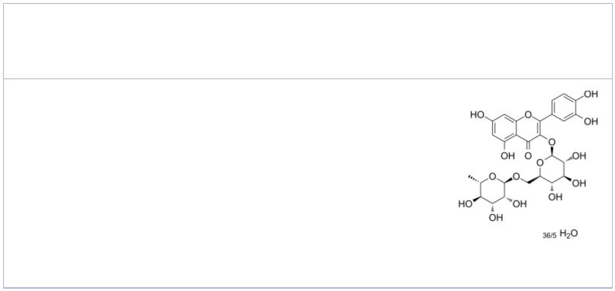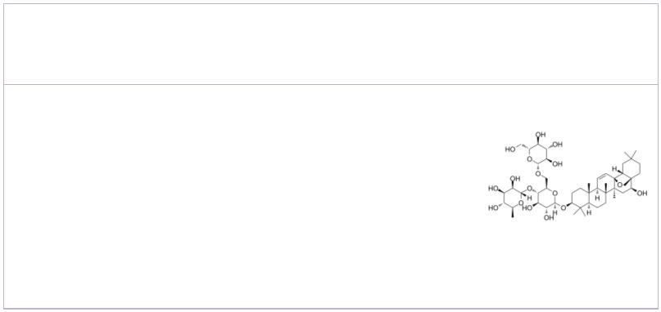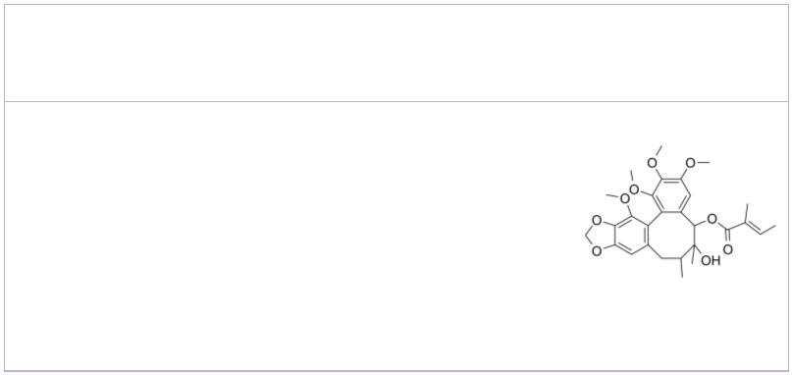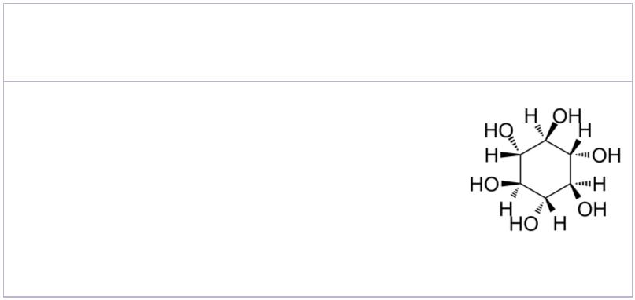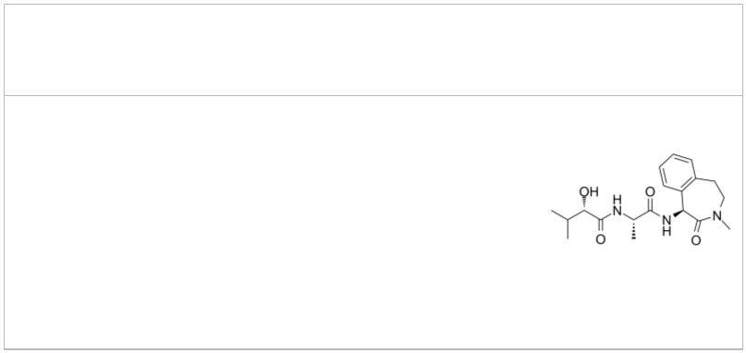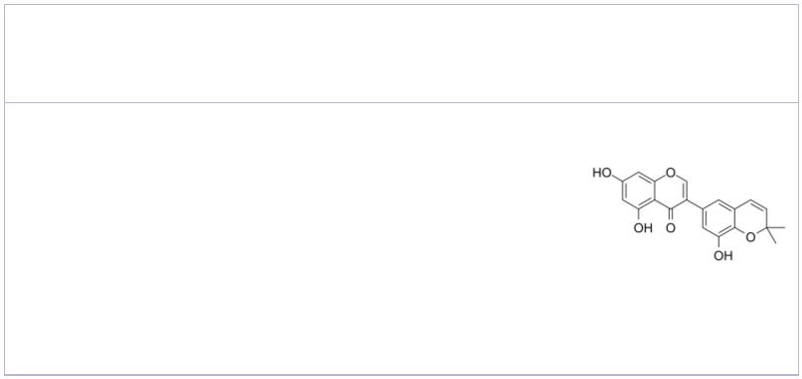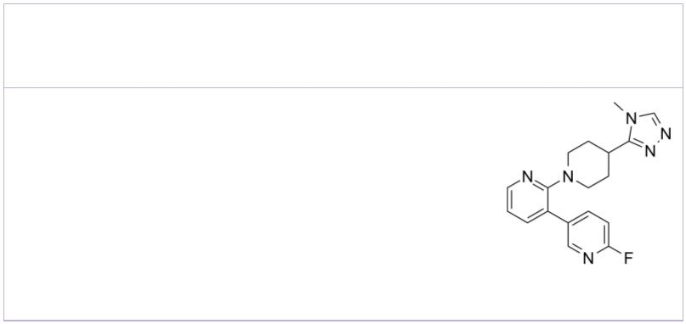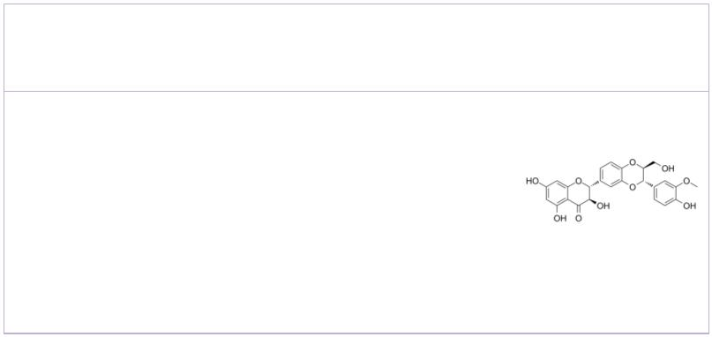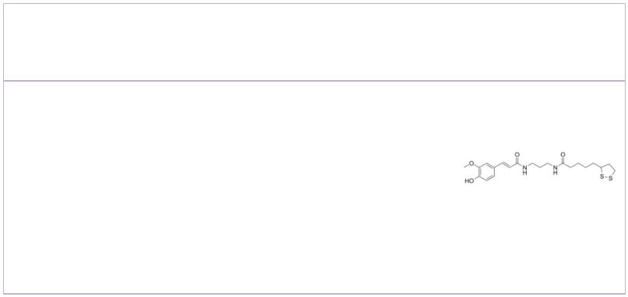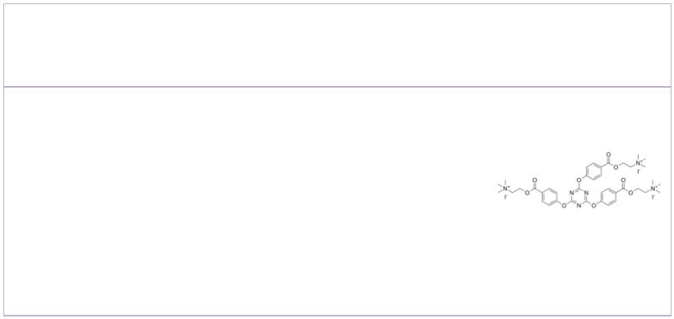 | Rutin hydrate  (Rutoside hydrate; Quercetin 3-O-rutinoside hydrate) Cat. No.: HY-N0148A |  |  | Saikosaponin C |  |  |  |  |  |  |  |  |  |  |  |  | Cat. No.: HY-N0249
 | Rutin (Rutoside) hydrate is a flavonoid found in  many plants and shows a wide range of biological  activities including anti-inflammatory,  antidiabetic, antioxidant, neuroprotective,  nephroprotective, hepatoprotective and reducing Aβ  oligomer activities. |  |  | Saikosaponin C is a bioactive component found in  radix bupleuri, targets amyloid beta and tau in  Alzheimer's disease. Saikosaponin C inhibits the  secretion of both Aβ1-40 and Aβ1-42, and  suppresses abnormal tau phosphorylation, but shows  no effect on BACE1 activity and expression.
 | Purity: ≥98.0%  Clinical Data: Launched  Size: 500 mg |  |  | Purity: 99.65%  Clinical Data: No Development Reported  Size: 5 mg, 10 mg, 20 mg
 | Schisantherin B  (Gomisin-B; Wuweizi ester-B; Schisantherin-B) Cat. No.: HY-N0695 |  |  | Scyllo-Inositol |  |  |  |  |  |  |  |  |  |  | Cat. No.: HY-W010041
 | Schisantherin B (Gomisin-B; Wuweizi ester-B;  Schisantherin-B) is a natural product. |  |  | Scyllo-Inositol, an amyloid inhibitor, potentialy  inhibits α-synuclein aggregation.
 | Purity: 99.90%  Clinical Data: No Development Reported  Size: 1 mg, 5 mg, 10 mg |  |  | Purity: ≥98.0  Clinical Data: Phase 2  Size: 10 mM × 1 mL, 10 mg, 50 mg, 100 mg
 | Semagacestat  (LY450139) Cat. No.: HY-10009 |  |  | Semilicoisoflavone B |  |  |  |  |  |  |  |  |  |  |  |  | Cat. No.: HY-N1280
 | Semagacestat is a γ-secretase inhibitor, inhibits  β-amyloid (Aβ42), Aβ38 and Aβ40 with IC s  50  of 10.9, 12 and 12.1 nM, respectively; also  inhibits Notch signaling with IC of 14.1 nM.  50  Semagacestat can be used for the research of  alzheimer's disease. |  |  | Semilicoisoflavone B, an isoflavone, mainly  derived from Glycyrrhiza uralensis Fisch..  Semilicoisoflavone B reduces amyloid β (Aβ)  secretion by inhibiting β-secretase-1 (BACE1)  expression and activity.
 | Purity: 99.56%  Clinical Data: Phase 3  Size: 10 mM × 1 mL, 5 mg, 10 mg, 50 mg, 100 mg |  |  | Purity: >98%  Clinical Data: No Development Reported  Size: 5 mg, 10 mg, 25 mg
 | SEN177 Silybin B
 |  | Cat. No.: HY-136780 Cat. No.: HY-N7046
 | SEN177 is a potent glutaminyl cyclase (QPCT)  inhibitor with an IC of 0.013μM for  50  glutaminyl-peptide cyclotransferase-like (QPCTL).  SEN177 has a K of 20 nM for human glutaminyl  i  cyclase (hQC). |  |  | Silybin B, a flavonolignan separated from  Silybum marianum, has anti-tumor activity.  Silybin B is the most potent antifibrillogenic and  anti-oligomeric component of silymarin and  proposes it as a promising anti Alzheimer’s  disease drug candidate.
 | Purity: >98%  Clinical Data: No Development Reported  Size: 1 mg, 5 mg |  |  | Purity: ≥99.0%  Clinical Data: No Development Reported  Size: 10 mM × 1 mL, 1 mg, 5 mg
 | SV5 TAE-1
 |  | Cat. No.: HY-147547 Cat. No.: HY-115650
 | SV5 is a potent anti-Alzheimer agent. SV5 can  significantly protect SHSY-5Yꢀcells against  Aβ -induced death. SV5 shows moderate  1-42  antioxidant and good neuroprotective activities.  SV5 shows the high stability in human plasma and  the best pharmacological profile. |  |  | TAE-1 is a potent inhibitor of AChE and BuChE.  TAE-1 also inhibits Aβ fibril formation and  aggregation. TAE-1 can be used for the researches  of Alzheimer's disease.
 | Purity: >98%  Clinical Data: No Development Reported  Size: 1 mg, 5 mg |  |  | Purity: >98%  Clinical Data: No Development Reported  Size: 1 mg, 5 mg
10 Tel: 609-228-6898 Fax: 609-228-5909 Email: sales@MedChemExpress.com
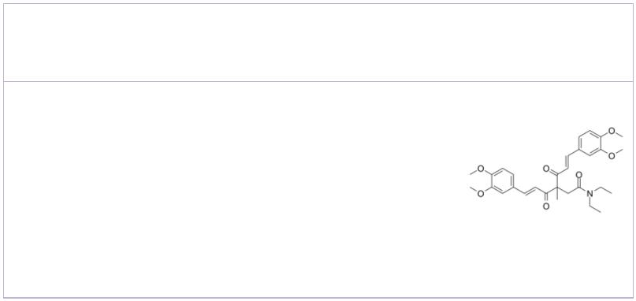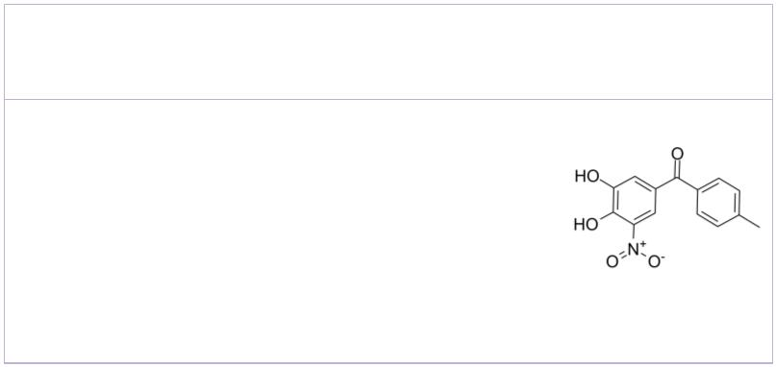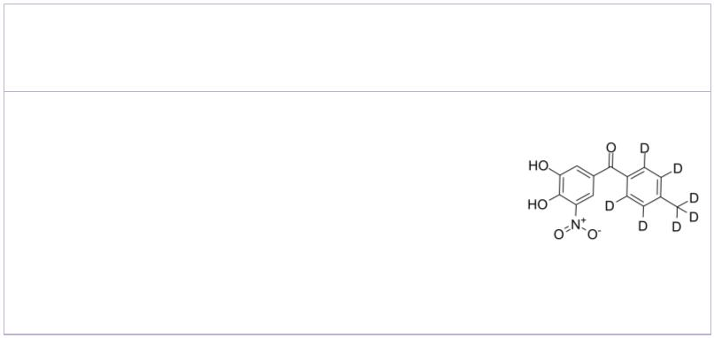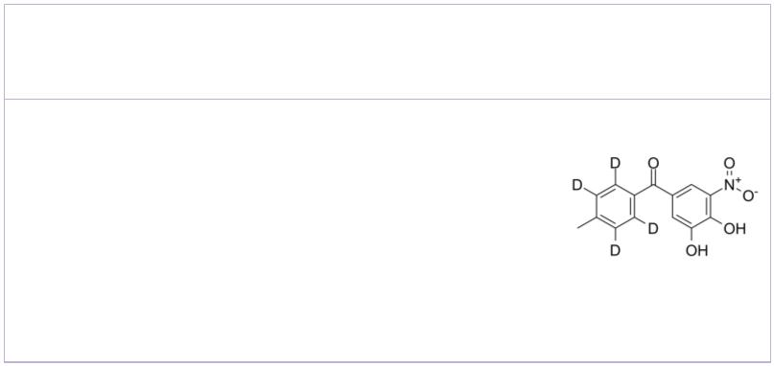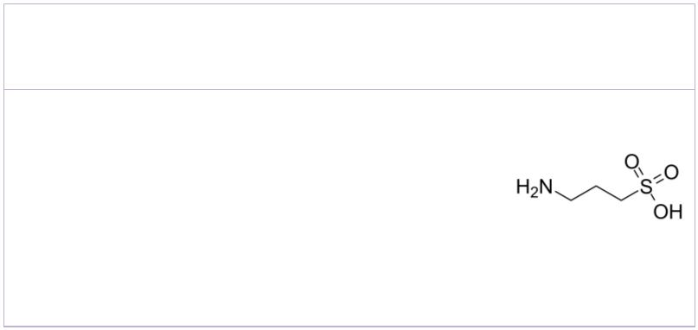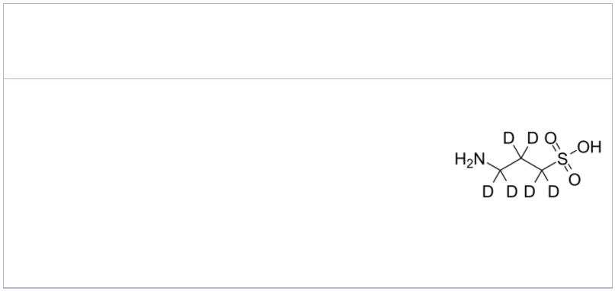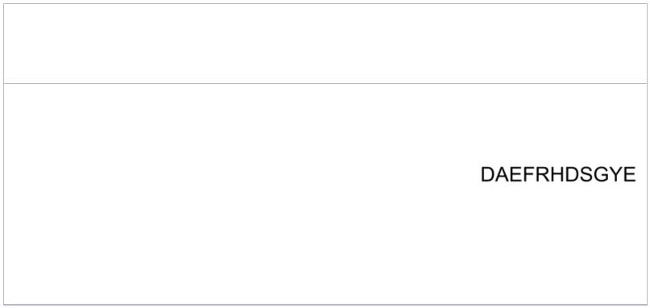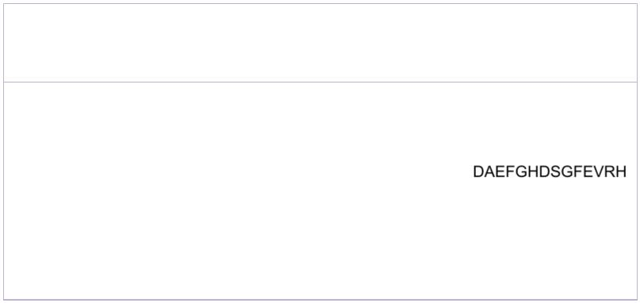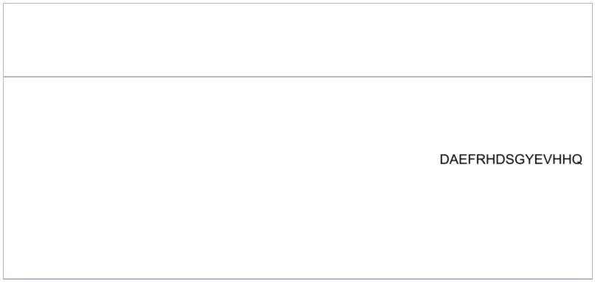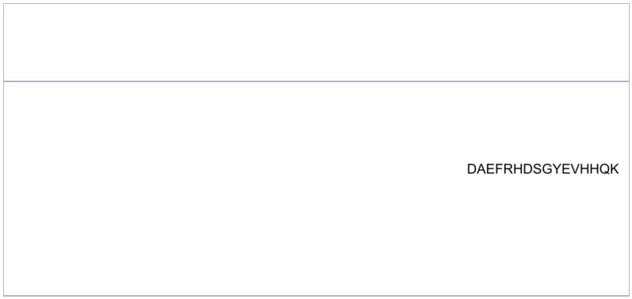TML-6 |  | Cat. No.: HY-137315 |  |  | Tolcapone  (Ro 40-7592) Cat. No.: HY-17406
TML-6, an orally active curcumin derivative,  inhibits the synthesis of the β-amyloid precursor  protein and β-amyloid (Aβ). TML-6 can  upregulate Apo E, suppress NF-κB and mTOR, and  increase the activity of the anti-oxidative Nrf2  gene. |  |  |  |  | Tolcapone (Ro 40-7592) is a selective, orally  active and powerful mixed (peripheral and central)  COMT inhibitor with an IC of 773nM in the  50  liver. Tolcapone is also a potent inhibitor of  α-syn and Aβ42 oligomerization and  fibrillogenesis.
Purity: 98.34%  Clinical Data: No Development Reported  Size: 5 mg, 10 mg |  |  |  |  | Purity: 99.74%  Clinical Data: Launched  Size: 10 mM × 1 mL, 10 mg, 50 mg, 100 mg
Tolcapone D7  (Ro 40-7592 D7) Cat. No.: HY-17406S |  |  |  |  | Tolcapone-d4  (Ro 40-7592-d4) Cat. No.: HY-17406S1
Tolcapone D7 (Ro 40-7592 D7) is a deuterium  labeled Tolcapone. Tolcapone is a selective,  potent and orally active COMT inhibitor. |  |  |  |  | Tolcapone-d4 (Ro 40-7592-d4) is the deuterium  labeled Tolcapone. Tolcapone (Ro 40-7592) is a  selective, orally active and powerful mixed  (peripheral and central) COMT inhibitor with an  IC of 773nM in the liver.  50
Purity: >98%  Clinical Data: No Development Reported  Size: 1 mg, 5 mg |  |  |  |  | Purity: >98%  Clinical Data: No Development Reported  Size: 1 mg, 10 mg
Tramiprosate  (Homotaurine; 3-Amino-1-propanesulfonic acid) Cat. No.: HY-14602 |  |  |  |  | Tramiprosate-d6  (Homotaurine-d6; 3-Amino-1-propanesulfonic acid-d6) Cat. No.: HY-14602S
Tramiprosate (Homotaurine), an orally active and  brain-penetrant natural amino acid found in  various species of red marine algae. Tramiprosate  binds to soluble Aβ and maintains Aβ in a  non-fibrillar form. |  |  |  |  | Tramiprosate-d6 (Homotaurine-d6) is the deuterium  labeled Tramiprosate. Tramiprosate (Homotaurine),  an orally active and brain-penetrant natural amino  acid found in various species of red marine algae.  Tramiprosate binds to soluble Aβ and maintains Aβ  in a non-fibrillar form.
Purity: ≥98.0%  Clinical Data: Phase 3  Size: 10 mM × 1 mL, 500 mg, 1 g, 5 g |  |  |  |  | Purity: >98%  Clinical Data: No Development Reported  Size: 1 mg, 5 mg
β-Amyloid (1-11) β-Amyloid (1-14),mouse,rat
 |  |  | Cat. No.: HY-P1510 Cat. No.: HY-P1524
β-Amyloid (1-11) is a fragment of Amyloid-β  peptide, maybe used in the research of  neurological disease. |  |  |  |  | β-Amyloid (1-14),mouse,rat is a 1 to 14 fragment  of Amyloid-β peptide.
Purity: >98%  Clinical Data: No Development Reported  Size: 1 mg, 5 mg, 10 mg |  |  |  |  | Purity: >98%  Clinical Data: No Development Reported  Size: 1 mg, 5 mg, 10 mg
β-Amyloid (1-15) β-Amyloid (1-16)
(Amyloid β-Protein (1-15)) Cat. No.: HY-P1046 (Amyloid β-Protein (1-16)) Cat. No.: HY-P1466
β-Amyloid (1-15) is a fragment of β-Amyloid  peptide. Beta-amyloid is a peptide that forms  amyloid plaques in the brains of Alzheimer's  disease (AD) patients. |  |  |  |  | β-Amyloid (1-16) is a β-Amyloid protein fragment  involved in metal binding. Beta-amyloid is a  peptide that forms amyloid plaques in the brains  of Alzheimer's disease (AD) patients.
Purity: 96.63%  Clinical Data: No Development Reported  Size: 1 mg, 5 mg, 10 mg |  |  |  |  | Purity: 99.24%  Clinical Data: No Development Reported  Size: 1 mg, 5 mg
www.MedChemExpress.com 11
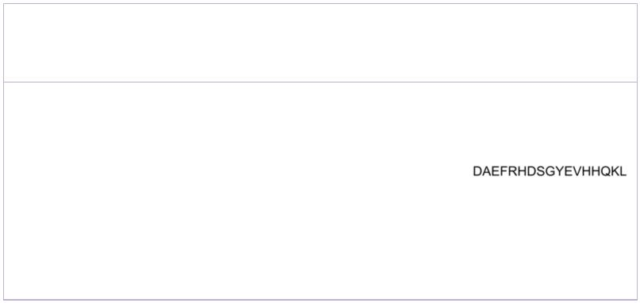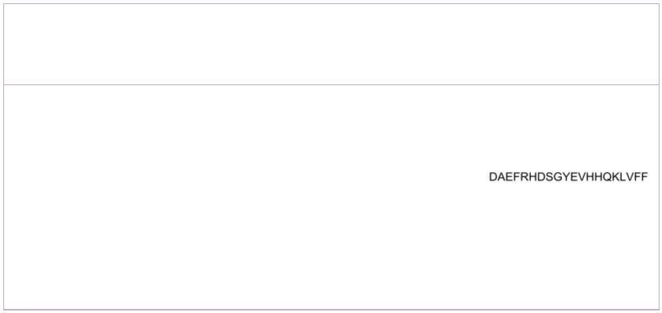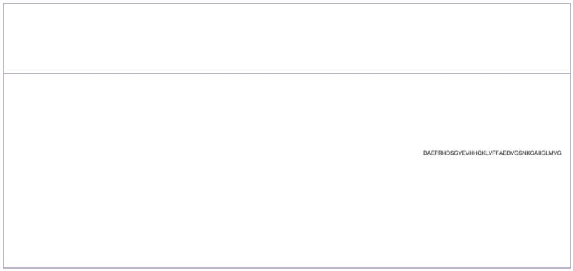 | β-Amyloid (1-17) β-Amyloid (1-20)
 |  |  | Cat. No.: HY-P1772 Cat. No.: HY-P1850
 | β-Amyloid (1-17) is a peptide of β-Amyloid,  stabilizes the fibres and plays a role in Aβ fibre  formation. |  |  |  | β-Amyloid (1-20) consists of amino acids 1 to 20  of beta amyloid protein.
 | Purity: >98%  Clinical Data: No Development Reported  Size: 1 mg, 5 mg |  |  |  | Purity: >98%  Clinical Data: No Development Reported  Size: 1 mg, 5 mg
 | β-Amyloid (1-28)  (Amyloid β-Protein (1-28)) Cat. No.: HY-P1468 |  |  |  | β-Amyloid (1-37) (human) |  |  |  |  |  |  |  |  |  |  | Cat. No.: HY-P2283
 | β-Amyloid (1-28) is a β-Amyloid protein fragment  involved in metal binding. Beta-amyloid is a  peptide that forms amyloid plaques in the brains  of Alzheimer's disease (AD) patients. |  |  |  | β-Amyloid (1-37) (human) correlates moderately  with Mini-Mental State Examination (MMSE) scores  in Alzheimer disease. β-Amyloid (1-37) (human)  possesses an added diagnostic value.
 | Purity: >98%  Clinical Data: No Development Reported  Size: 1 mg, 5 mg |  |  |  | Purity: >98%  Clinical Data: No Development Reported  Size: 1 mg, 5 mg
 | β-Amyloid (1-40) |  | Cat. No.: HY-P0265 |  | β-Amyloid (1-40) (TFA) (Amyloid Beta-Peptide (1-40) (human)  TFA; Amyloid β-Peptide (1-40) (human) TFA) Cat. No.: HY-P0265A
 | β-Amyloid (1-40) is a primary protein in plaques  found in the brains of patients with Alzheimer's  disease. |  |  |  | β-Amyloid (1-40) TFA is a primary protein in  plaques found in the brains of patients with  Alzheimer's disease.
 | Purity: 98.14%  Clinical Data: No Development Reported  Size: 500 μg, 1 mg, 5 mg, 10 mg, 25 mg |  |  |  | Purity: >98%  Clinical Data: No Development Reported  Size: 1 mg, 5 mg
 | β-Amyloid (1-42), (rat/mouse) β-Amyloid (1-42), (rat/mouse) (TFA)
 | (Amyloid β-peptide (1-42) (rat/mouse)) Cat. No.: HY-P1388 (Amyloid β-peptide (1-42) (rat/mouse) TFA) Cat. No.: HY-P1388A
 | β-Amyloid (1-42), (rat/mouse) is a 42-aa peptide,  shows cytotoxic effect on acute hippocampal  slices, and used in the research of Alzheimer's  disease. |  |  |  | β-Amyloid (1-42), (rat/mouse) TFA is a 42-aa  peptide, shows cytotoxic effect on acute  hippocampal slices, and used in the research of  Alzheimer's disease.
 | Purity: 96.46%  Clinical Data: No Development Reported  Size: 500 μg, 1 mg, 5 mg |  |  |  | Purity: 95.52%  Clinical Data: No Development Reported  Size: 500 μg, 1 mg, 5 mg
 | β-Amyloid (1-42), human TFA β-Amyloid (1-43)(human)
 | (Amyloid β-Peptide (1-42) (human) TFA) Cat. No.: HY-P1363 |  |  |  |  |  |  |  |  |  |  |  |  |  |  | Cat. No.: HY-P1378
 | β-Amyloid (1-42), human TFA (Amyloid β-Peptide  (1-42) (human) TFA) is a 42-amino acid peptide  which plays a key role in the pathogenesis of  Alzheimer disease. |  |  |  | β-Amyloid (1-43)(human) is more prone to  aggregation and has higher toxic properties than  the long-known Aβ1-42. β-Amyloid (1-43)(human)  shows a correlation with both sAPPα and sAPPβ.
 | Purity: 98.43%  Clinical Data: No Development Reported  Size: 1 mg, 5 mg |  |  |  | Purity: >98%  Clinical Data: No Development Reported  Size: 1 mg, 5 mg
12 Tel: 609-228-6898 Fax: 609-228-5909 Email: sales@MedChemExpress.com
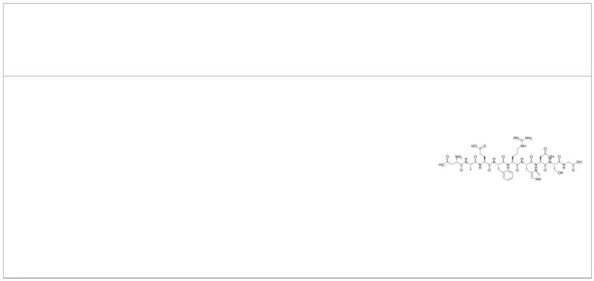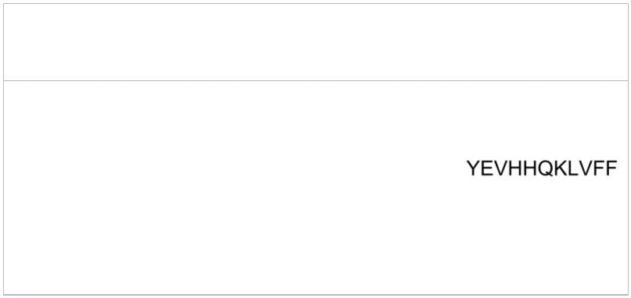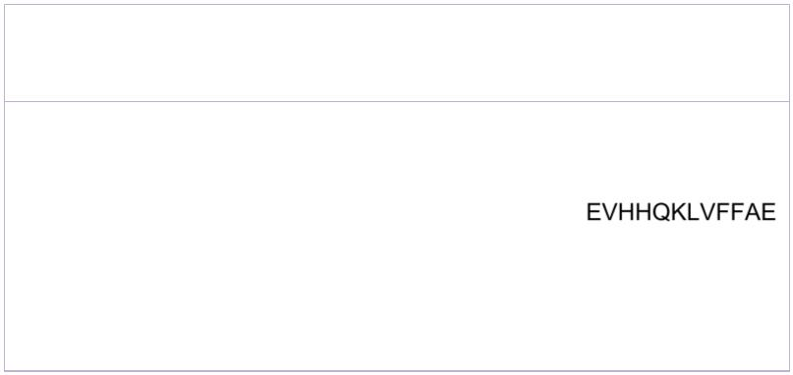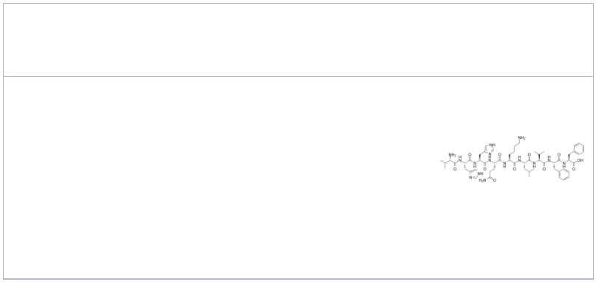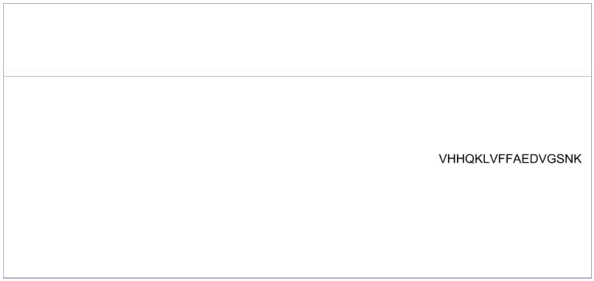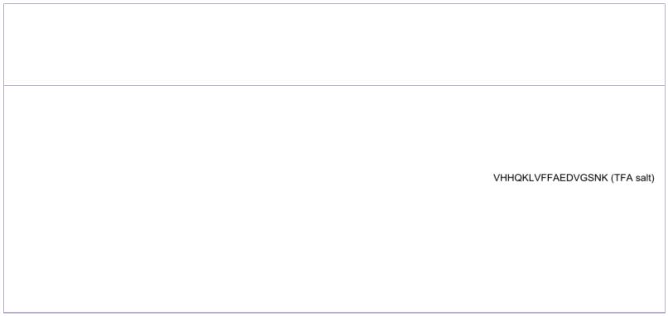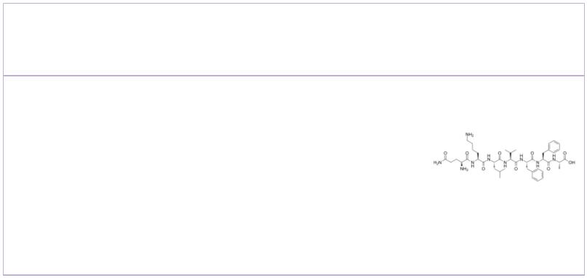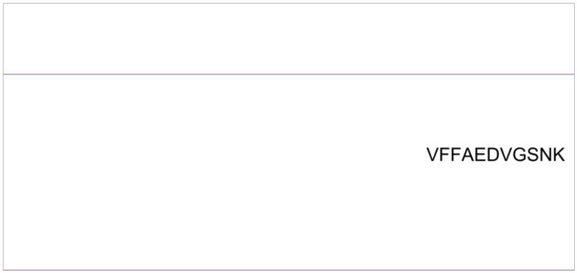β-Amyloid (1-43)(human) TFA β-Amyloid (1-9)
 | Cat. No.: HY-P1378A Cat. No.: HY-P1854
β-Amyloid (1-43)(human) TFA is more prone to  aggregation and has higher toxic properties than  the long-known Aβ1-42. β-Amyloid (1-43)(human) TFA  shows a correlation with both sAPPα and sAPPβ. |  |  |  | β-Amyloid (1-9), an N-terminal fragment of beta  amyloid, consists of amino acid residues 1 to 9.  β-Amyloid (1-9) contains a B cell epitope, but it  does not include T cell epitopes.
Purity: >98%  Clinical Data: No Development Reported  Size: 1 mg, 5 mg |  |  |  | Purity: >98%  Clinical Data: No Development Reported  Size: 1 mg, 5 mg
β-Amyloid (10-20) β-Amyloid (10-35), amide
 |  | Cat. No.: HY-P1053 Cat. No.: HY-P1567
β-Amyloid (10-20) is a fragment of Amyloid-β  peptide and maybe used in the research of  neurological disease. |  |  |  | β-Amyloid (10-35), amide is composed of 26 aa  (10-35 residues of the Aβ peptide) and is the  primary component of the amyloid plaques of  Alzheimer’s disease.
Purity: >98%  Clinical Data: No Development Reported  Size: 1 mg, 5 mg, 10 mg |  |  |  | Purity: >98%  Clinical Data: No Development Reported  Size: 1 mg, 5 mg, 10 mg
β-Amyloid (11-22) β-Amyloid (12-20)
 |  | Cat. No.: HY-P1893 Cat. No.: HY-P1880
β-Amyloid (11-22) is a peptide fragment of  β-Amyloid. |  |  |  | β-Amyloid (12-20) is a peptide fragment of  β-Amyloid.
Purity: >98%  Clinical Data: No Development Reported  Size: 5 mg, 10 mg |  |  |  | Purity: >98%  Clinical Data: No Development Reported  Size: 5 mg, 10 mg
β-Amyloid (12-28) β-Amyloid (12-28) (TFA) (Amyloid β-Protein (12-28) (TFA);
(Amyloid β-Protein (12-28)) Cat. No.: HY-P1051 Amyloid Beta-Peptide (12-28) (human) TFA; …) Cat. No.: HY-P1051A
β-Amyloid (12-28) (Amyloid β-Protein (12-28)) is a  peptide fragment of β-amyloid protein (β1-42).  β1-42, a 42 amino acid protein , is the major  component of senile plaque cores. β-Amyloid  (12-28) shows aggregation properties. |  |  |  | β-Amyloid (12-28) (TFA) (Amyloid β-Protein (12-28)  (TFA)) is a peptide fragment of β-amyloid protein  (β1-42). β1-42, a 42 amino acid protein , is the  major component of senile plaque cores. β-Amyloid  (12-28) (TFA) shows aggregation properties.
Purity: >98%  Clinical Data: No Development Reported  Size: 1 mg, 5 mg, 10 mg |  |  |  | Purity: 99.80%  Clinical Data: No Development Reported  Size: 1 mg, 5 mg
β-Amyloid (15-21) β-Amyloid (18-28)
(Beta-Amyloid (15-21)) Cat. No.: HY-P1521 |  |  |  |  |  |  |  |  |  |  |  |  |  | Cat. No.: HY-P1879
β-amyloid (15-21) is a fragment of Amyloid-β  peptide, maybe used in the research of  neurological disease. |  |  |  | β-Amyloid (18-28) is a peptide fragment of  β-Amyloid.
Purity: >98%  Clinical Data: No Development Reported  Size: 1 mg, 5 mg, 10 mg |  |  |  | Purity: >98%  Clinical Data: No Development Reported  Size: 1 mg, 5 mg
www.MedChemExpress.com 13
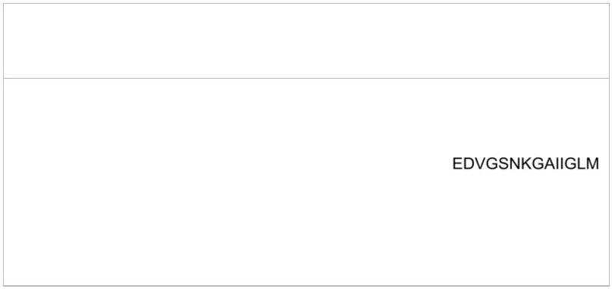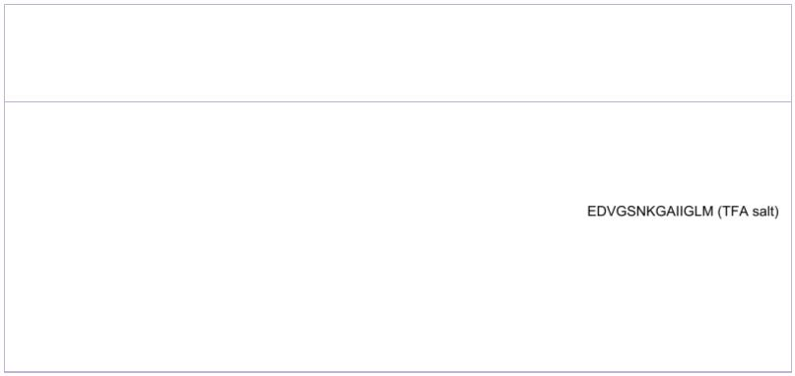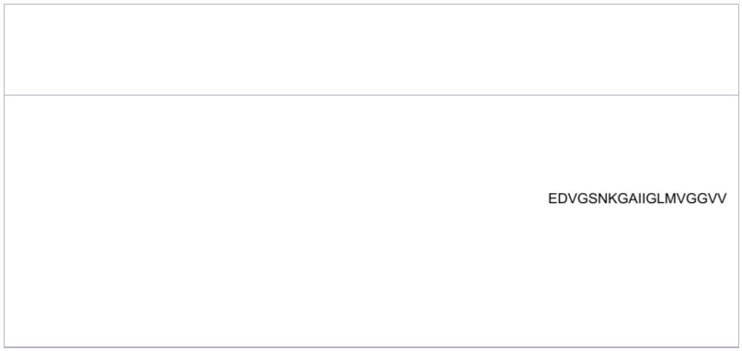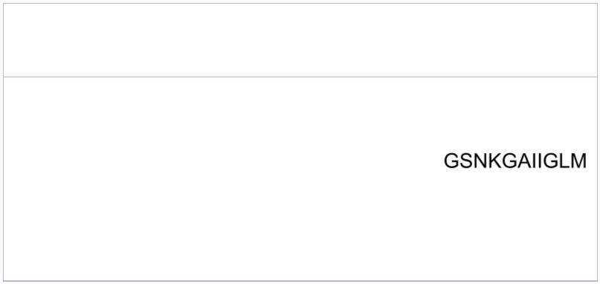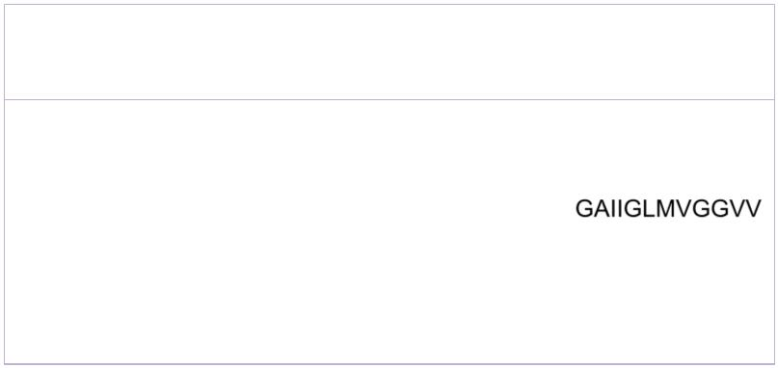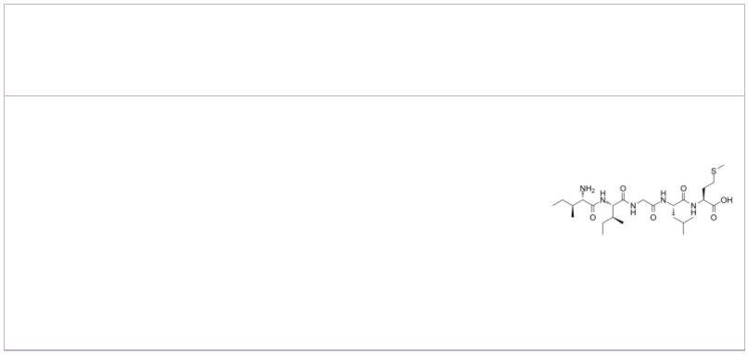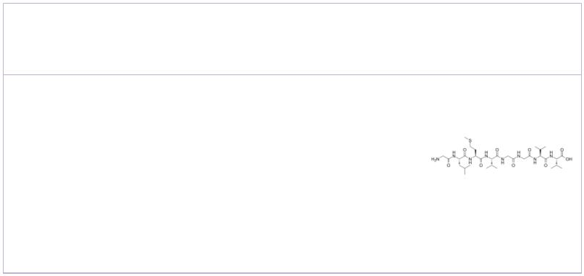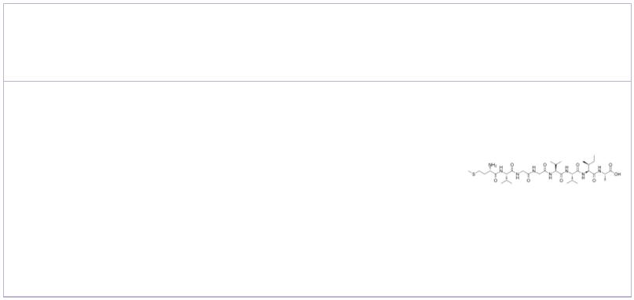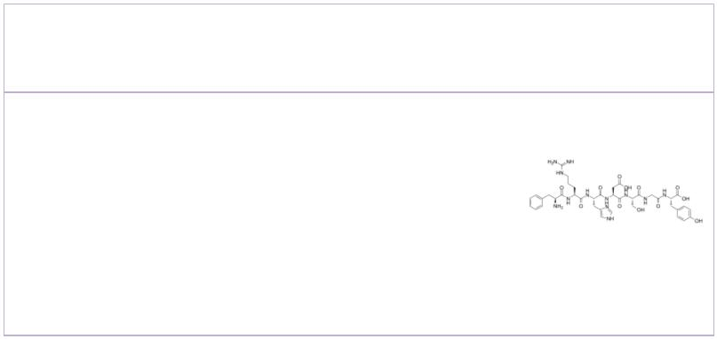 | β-Amyloid (22-35)  (Amyloid β-Protein (22-35)) Cat. No.: HY-P1474 |  |  |  | β-Amyloid (22-35) (TFA)  (Amyloid β-Protein (22-35) (TFA)) Cat. No.: HY-P1474A
 | β-Amyloid 22-35 (Amyloid β-Protein 22-35), the  residues 22-35 fragment ofβ-amyloid protein, has a  cytotoxic effect on cultured neurons from the rat  hippocampus in serum-free medium. |  |  |  | β-Amyloid 22-35 (Amyloid β-Protein 22-35) TFA, the  residues 22-35 fragment ofβ-amyloid protein, has a  cytotoxic effect on cultured neurons from the rat  hippocampus in serum-free medium.
 | Purity: >98%  Clinical Data: No Development Reported  Size: 1 mg, 5 mg, 10 mg |  |  |  | Purity: >98%  Clinical Data: No Development Reported  Size: 1 mg, 5 mg
 | β-Amyloid (22-40) |  | Cat. No.: HY-P1891 |  | β-Amyloid (25-35) (Amyloid beta-peptide (25-35); Aβ25-35;  β-Amyloid peptide (25-35)) Cat. No.: HY-P0128
 | β-Amyloid (22-40) is a peptide fragment of  β-Amyloid. |  |  |  | β-Amyloid (25-35) (Amyloid beta-peptide (25-35))  is the fragment Aβ(25-35) of the Alzheimer's  amyloid β-peptide, has shown neurotoxic activities  in cultured cells.
 | Purity: >98%  Clinical Data: No Development Reported  Size: 1 mg, 5 mg |  |  |  | Purity: 99.74%  Clinical Data: No Development Reported  Size: 1 mg, 5 mg, 10 mg
 | β-Amyloid (29-40)  (Amyloid beta-protein(29-40)) Cat. No.: HY-P1522 |  |  |  | β-Amyloid (31-35) |  |  |  |  |  |  |  |  |  | Cat. No.: HY-P1517
 | β-Amyloid (29-40) is a fragment of Amyloid-β  peptide. |  |  |  | β-Amyloid (31-35) is the shortest sequence of  native Amyloid-β peptide that retains neurotoxic  activity.
 | Purity: >98%  Clinical Data: No Development Reported  Size: 1 mg, 5 mg, 10 mg |  |  |  | Purity: 99.72%  Clinical Data: No Development Reported  Size: 1 mg, 5 mg, 10 mg
 | β-Amyloid (33-40) β-Amyloid (35-42)
 |  |  | Cat. No.: HY-P1895 Cat. No.: HY-P1903
 | β-Amyloid (33-40) is a peptide consisting of amino  acid of 33 to 40 of beta amyloid protein. |  |  |  | β-Amyloid (35-42) is a peptide consisting of amino  acid of 35 to 42 of beta amyloid protein.
 | Purity: >98%  Clinical Data: No Development Reported  Size: 1 mg, 5 mg |  |  |  | Purity: 98.49%  Clinical Data: No Development Reported  Size: 5 mg, 10 mg
 | β-Amyloid (4-10) β-Amyloid (42-1), human
 |  |  | Cat. No.: HY-P1787 |  | (Amyloid β Peptide (42-1)(human)) Cat. No.: HY-P1362
 | β-Amyloid (4-10) is an epitope for the polyclonal  anti-Aβ(1-42) antibody, reduces amyloid deposition  in a transgenic Alzheimer disease mouse model. |  |  |  | β-Amyloid (42-1), human is the inactive form of  Amyloid β Peptide (1-42). β-Amyloid (42-1), human  is a 42-amino acid peptide which plays a key role  in the pathogenesis of Alzheimer disease.
 | Purity: >98%  Clinical Data: No Development Reported  Size: 1 mg, 5 mg |  |  |  | Purity: 96.72%  Clinical Data: No Development Reported  Size: 1 mg
14 Tel: 609-228-6898 Fax: 609-228-5909 Email: sales@MedChemExpress.com

