CRAC Channel
Calcium release-activated channels; Ca2+ release-activated Ca2+ channels
The Ca₂₊ release-activated Ca₂₊ (CRAC) channel is a highly Ca₂₊-selective store-operated channel expressed in T cells, mast cells, and
various other tissues. CRAC channels regulate critical cellular processes such as gene expression, motility, and the secretion of
inflammatory mediators. The identification of Orai1, a key subunit of the CRAC channel pore, and STIM1, the endoplasmic reticulum
(ER) Ca₂₊ sensor, have provided the tools to illuminate the mechanisms of regulation and the pore properties of CRAC channels.
STIM1 proteins span through the membrane of the ER, are competent in sensing luminal Ca ₂₊ concentration, and in turn, are
responsible for relaying the signal of Ca₂₊ store-depletion to pore-forming Orai1 proteins in the plasma membrane. A direct
interaction of STIM1 and Orai1 allows for the re-entry of Ca₂₊ from the extracellular space. CRAC channels are critical for
lymphocyte function and immune responses. A driving force in the quest for CRAC channel drugs has been the
immunocompromised phenotype displayed by humans and mice with null or loss-of-function mutations in STIM1 or Orai1,
suggesting that CRAC channel inhibitors could be useful therapeutics for autoimmune or inflammatory conditions.
www.MedChemExpress.com 1
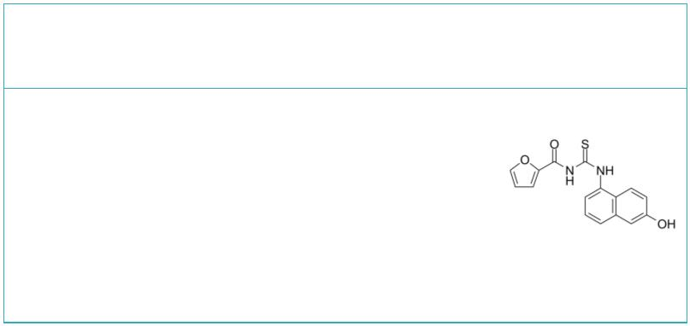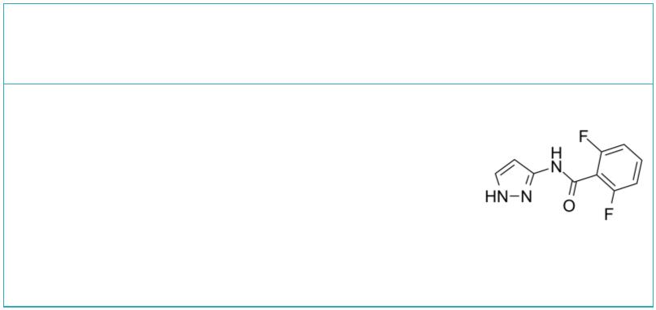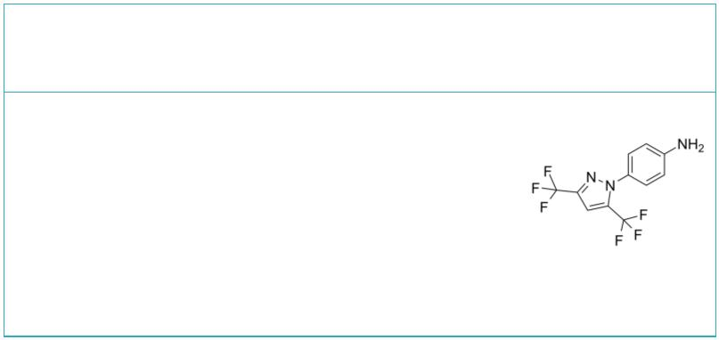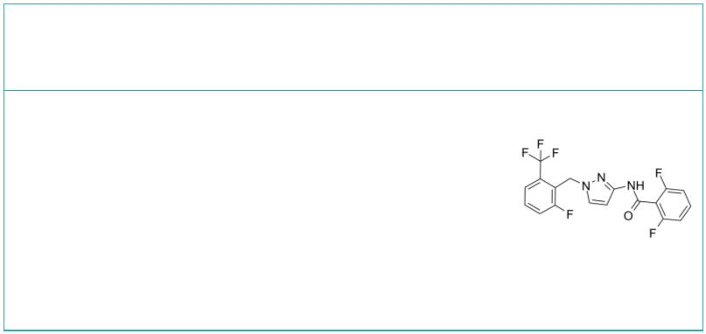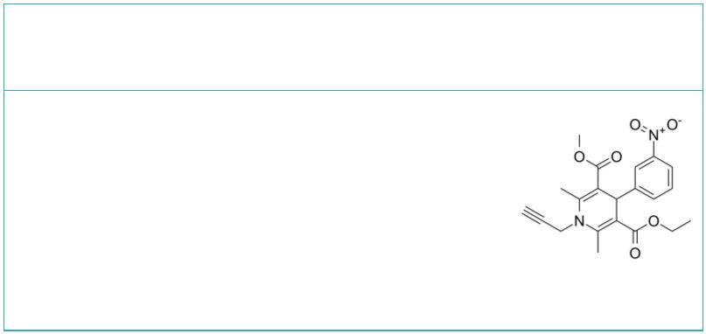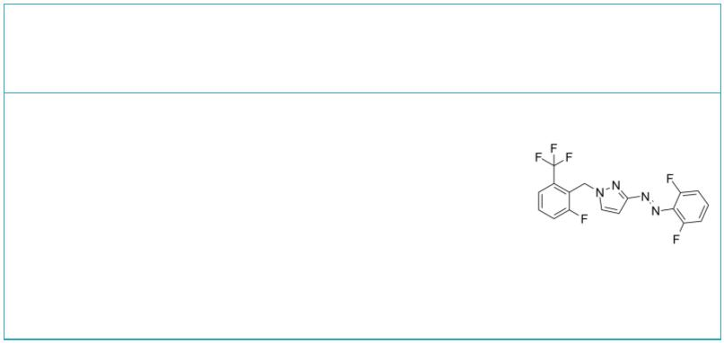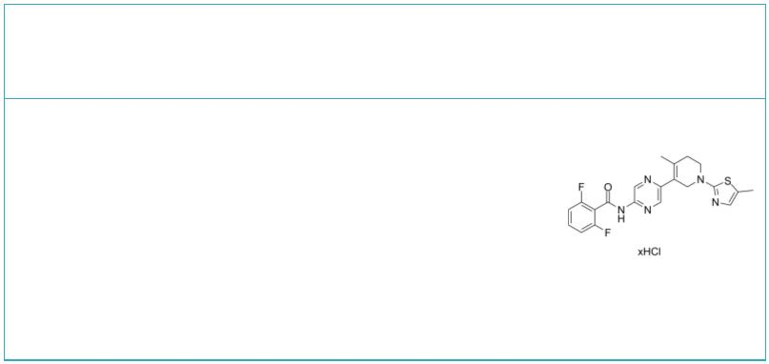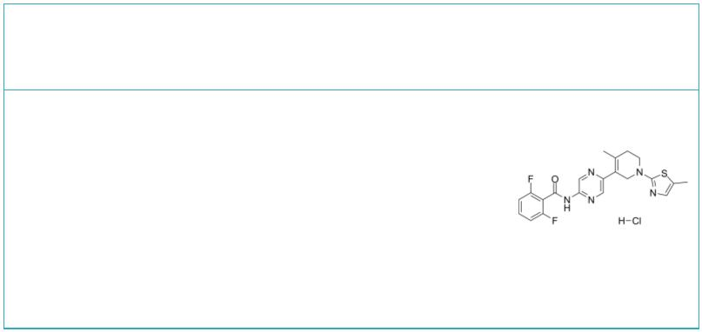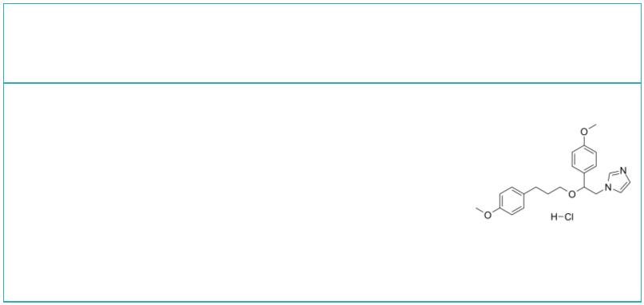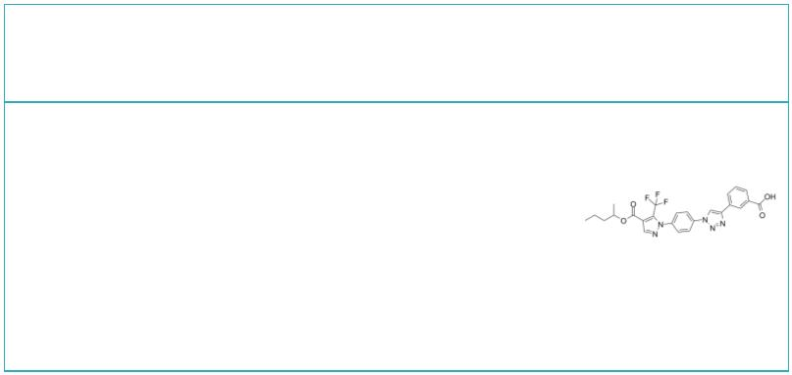CRAC Channel Inhibitors
 | 5J-4 CRAC intermediate 1
 |  |  | Cat. No.: HY-110216 Cat. No.: HY-20587
 | 5J-4 is a potent CRAC inhibitor. 5J-4 decreases  the numbers of infiltrated mononuclear cell into  the CNS, and significantly decreases the  population of infiltrated CD4+ population. |  |  |  |  | CRAC intermediate 1 is a key intermediate in the  chemical synthesis of a series of CRAC channel  inhibitors, detailed information can be found in  Patent WO 2010122089 A1, intermediate 9.
 | Purity: >98%  Clinical Data: No Development Reported  Size: 1 mg, 5 mg |  |  |  |  | Purity: 98.0%  Clinical Data: No Development Reported  Size: 10 mM × 1 mL, 5 mg, 10 mg, 50 mg, 100 mg
 | CRAC intermediate 2 GSK-5498A
 |  |  |  | Cat. No.: HY-20588 Cat. No.: HY-12521
 | CRAC intermediate 2 is a intermediate compound for  CRAC inhibitor synthesis, extracted from patent WO  2013059666A1. |  |  |  |  | GSK-5498A is a selective small molecule blocker of  CARC (IC , 1 μM); inhibits mediator release from  50  mast cells, and pro-inflammatory cytokine release  from T-cells in a variety of species.
 | Purity: 99.96%  Clinical Data: No Development Reported  Size: 10 mM × 1 mL, 5 mg, 10 mg, 25 mg, 50 mg, 100 mg |  |  |  |  | Purity: 98.14%  Clinical Data: No Development Reported  Size: 10 mM × 1 mL, 5 mg, 10 mg
 | MRS1845 piCRAC-1
 |  |  | Cat. No.: HY-103310 Cat. No.: HY-147005
 | MRS1845 is a selective store-operated calcium  (SOC) channel inhibitor with an IC of 1.7 μM.  50  MRS1845 is an ORAI1 inhibitor. |  |  |  |  | piCRAC-1 is a potent, photoinducible Ca²⁺  release-activated Ca²⁺ (CRAC) channel inhibitor.  piCRAC-1 alleviates thrombocytopenia and  hemorrhage.
 | Purity: 99.27%  Clinical Data: No Development Reported  Size: 10 mg, 25 mg, 50 mg, 100 mg |  |  |  |  | Purity: >98%  Clinical Data: No Development Reported  Size: 1 mg, 5 mg
 | RO2959 hydrochloride RO2959 monohydrochloride
 |  | Cat. No.: HY-113618A Cat. No.: HY-113618B
 | RO2959 hydrochloride is a potent and selective  CRAC channel inhibitor with an IC of 402 nM.  50  RO2959 hydrochloride is a potent blocker of store  operated calcium entry (SOCE) mediated by  Orai1/Stim1 channels with an IC of 25 nM.  50 |  |  |  |  | RO2959 monohydrochloride is a potent and selective  CRAC channel inhibitor with an IC of 402 nM.  50  RO2959 monohydrochloride is a potent blocker of  store operated calcium entry (SOCE) mediated by  Orai1/Stim1 channels with an IC of 25 nM.  50
 | Purity: >98%  Clinical Data: No Development Reported  Size: 5 mg |  |  |  |  | Purity: 99.02%  Clinical Data: No Development Reported  Size: 5 mg, 10 mg, 25 mg, 50 mg, 100 mg
 | SKF-96365 hydrochloride SOCE inhibitor 1
 |  |  | Cat. No.: HY-100001 Cat. No.: HY-112913
 | SKF-96365 hydrochloride is a potent TRP channel  blocker and a store-operated Ca²⁺ entry (SOCE)  inhibitor. SKF-96365 hydrochloride significantly  inhibits hERG, hKCNQ1/hKCNE1, hKir2.1 and hKv4.3  current, and significantly prolongs the QTc  interval in isolated guinea pig hearts. |  |  |  |  | SOCE inhibitor 1 is a store-operated calcium  entry (SOCE) inhibitor with an IC of 4.4 μM.  50
 | Purity: 99.51%  Clinical Data: No Development Reported  Size: 10 mM × 1 mL, 5 mg, 10 mg, 50 mg, 100 mg, 200 mg |  |  |  |  | Purity: 99.73%  Clinical Data: No Development Reported  Size: 5 mg, 10 mg, 25 mg, 50 mg, 100 mg
2 Tel: 609-228-6898 Fax: 609-228-5909 Email: sales@MedChemExpress.com
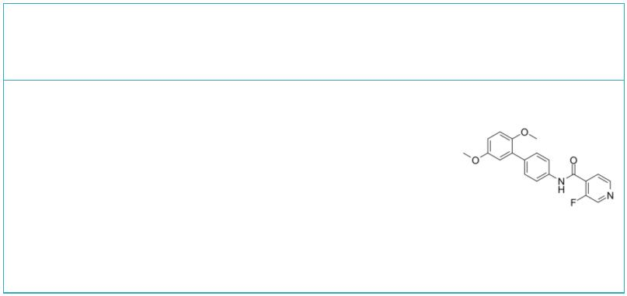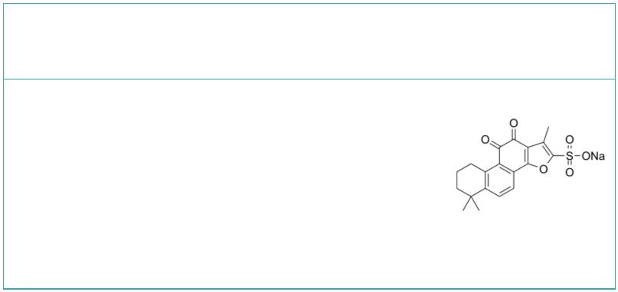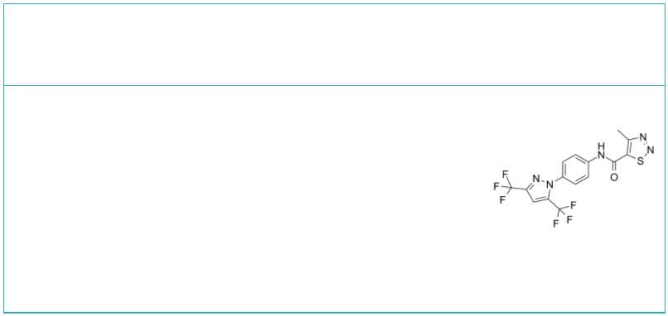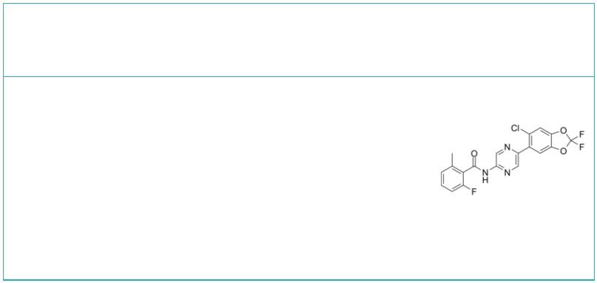Synta66 |  | Cat. No.: HY-111325 |  | Tanshinone IIA sulfonate sodium (Sodium Tanshinone IIA  sulfonate; Tanshinone IIA sodium sulfonate) Cat. No.: HY-N1370
Synta66 is an inhibitor of store-operated calcium  entry channel Orai, which forms the pore of the  CRAC channel, and used for the research of  neurological disease. |  |  |  | Tanshinone IIA sulfonate (sodium) is a derivative  of tanshinone IIA, which acts as an inhibitor of  store-operated Ca²⁺ entry (SOCE), and is used to  treat cardiovascular disorders.
Purity: 99.46%  Clinical Data: No Development Reported  Size: 10 mM × 1 mL, 5 mg, 10 mg, 25 mg |  |  |  | Purity: ≥98.0%  Clinical Data: Launched  Size: 10 mg, 25 mg
YM-58483  (BTP2) Cat. No.: HY-100831 |  |  |  | Zegocractin  (CM-4620) Cat. No.: HY-101942
YM-58483 (BTP2) is the first selective and potent  inhibitor of CRAC channels and subsequent Ca²⁺  signals. YM-584832 is a blocker of store-operated  Ca²⁺ entry (SOCE). |  |  |  | Zegocractin (CM-4620) is a calcium-release  activated calcium-channel (CRAC channel) inhibitor,  with IC₅₀s of 119 nM and 895 nM for Orai1/STIM1  and Orai2/STIM1 channels, respectively.
Purity: 99.78%  Clinical Data: No Development Reported  Size: 10 mM × 1 mL, 2 mg, 5 mg, 10 mg, 25 mg, 50 mg, 100 mg |  |  |  | Purity: 99.96%  Clinical Data: Phase 2  Size: 10 mM × 1 mL, 5 mg, 10 mg, 25 mg
www.MedChemExpress.com 3

