European Stainless Steel Submersible Groundwater Pump Market to Grow at 6.7% CAGR Reaching €663.7 Million by 2031
Porto, Portugal—January 31, 2025

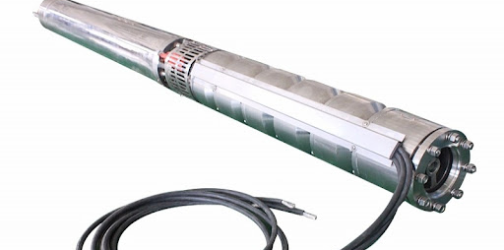

- European Stainless Steel Submersible Groundwater Pump Market Size (€ Million), 2025-2031
According to QY Research, Grundfos has recently strengthened its commitment to sustainability and global water accessibility through a strategic partnership with the Houston Astros. Announced in September 2024, this collaboration aims to support clean water initiatives worldwide, reflecting the company’s long-standing focus on sustainable water management solutions. Grundfos continues to position itself as a leader in the stainless steel submersible groundwater pump market by integrating sustainability efforts with industry innovation. This initiative is part of the company’s broader corporate responsibility strategy, which includes efforts to improve water efficiency and reduce energy consumption in pumping solutions.
QY Research also reports that in October 2024, Wilo SE took significant steps to regionalize its organizational structure in response to evolving geo-economic conditions. The company restructured into three autonomous regional divisions: Wilo Europe, Wilo AMEA (Asia, Middle East, and Africa), and Wilo Americas. This move is designed to enhance operational flexibility and responsiveness to market-specific demands, reinforcing Wilo’s competitive position in the European stainless steel submersible groundwater pump market. By decentralizing decision-making, Wilo aims to improve its ability to adapt to local industry trends and regulatory changes while maintaining its global growth trajectory.
The European market for Stainless Steel Submersible Groundwater Pump was estimated to be worth €424.3 million in 2024 and is forecast to a readjusted size of €663.7 million by 2031 with a CAGR of 6.7% during the forecast period 2025-2031.
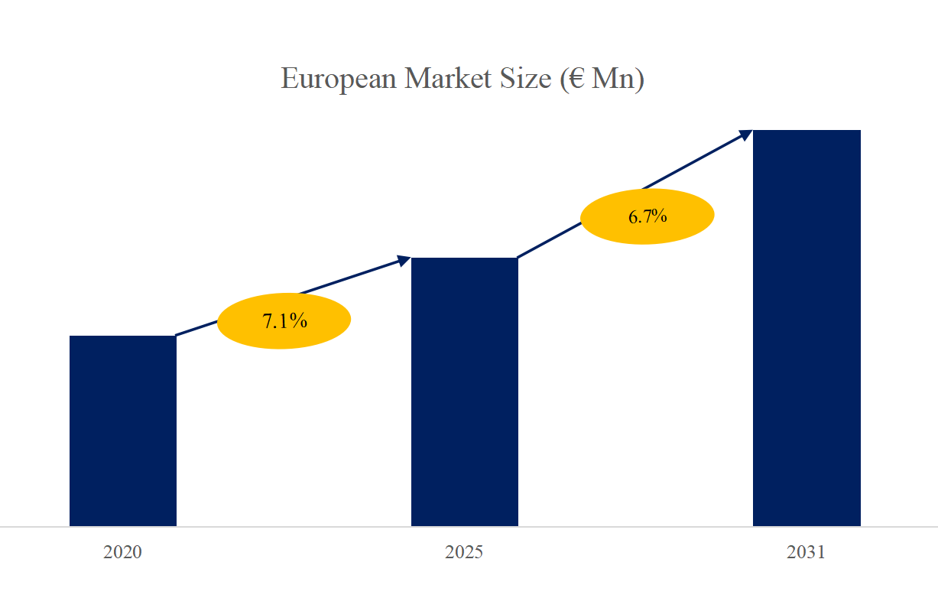
- European Stainless Steel Submersible Groundwater Pump Top 20 Players Ranking and Market Share (Ranking is based on the revenue of 2024, continually updated)
• Grundfos (Denmark)
• Wilo SE (Germany)
• Sulzer AG (Switzerland)
• KSB SE & Co. KGaA (Germany)
• Xylem Inc. (United States)
• Ebara Corporation (Japan)
• Flowserve Corporation (United States)
• Caprari S.p.A. (Italy)
• DAB Pumps S.p.A. (Italy)
• Pedrollo S.p.A. (Italy)
• Lowara (Italy)
• Calpeda S.p.A. (Italy)
• Saer Elettropompe S.p.A. (Italy)
• Zenit Group (Italy)
• HOMA Pumpenfabrik GmbH (Germany)
• Vogelsang GmbH & Co. KG (Germany)
• Tsurumi (Europe) GmbH (Germany)
• ABS Group (Sweden)
• Flygt (Sweden)
• Franklin Electric Europa (Germany)
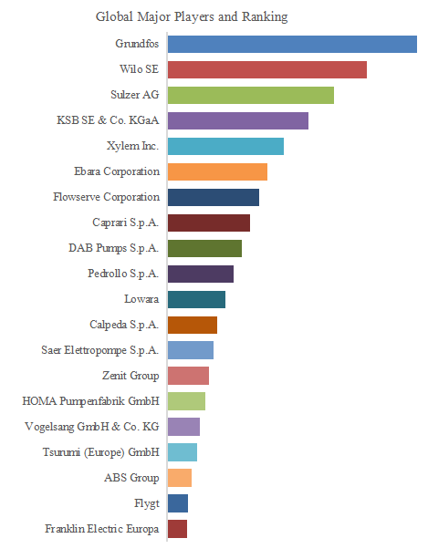

3. Stainless Steel Submersible Groundwater Pump, European Market Size, Split by Region
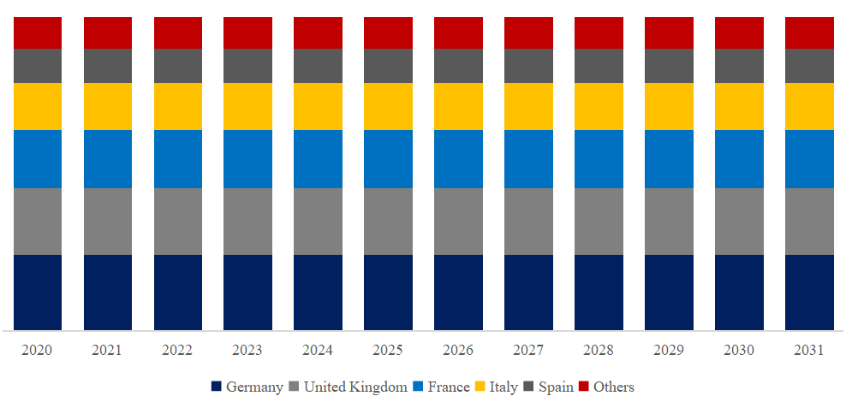
- Stainless Steel Submersible Groundwater Pump, European Market Size, Split by Product Segment
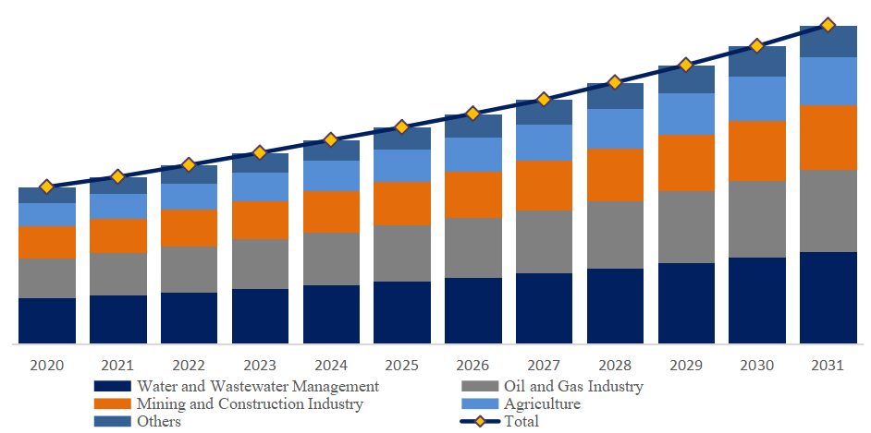

5. Stainless Steel Submersible Groundwater Pump, European Market Size, Split by Application Segment
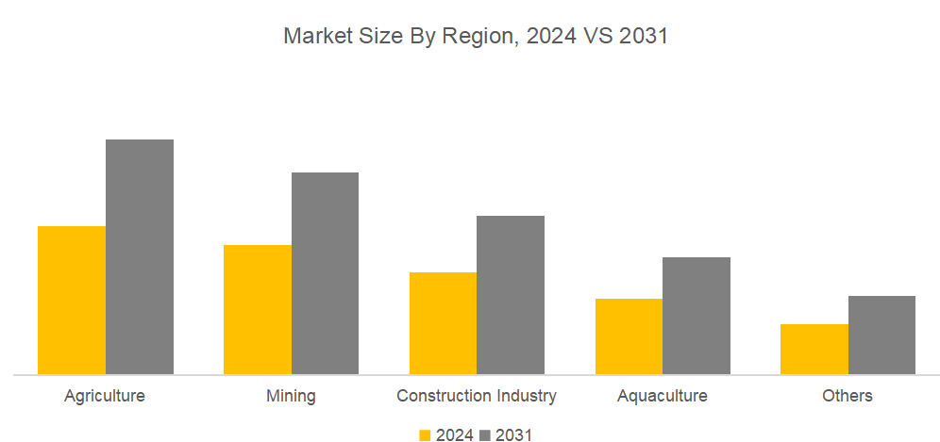

Based on or includes research from QYResearch: Global and European Stainless Steel Submersible Groundwater Pump Market Report 2025-2031

Related Market Reports From QY Research

QY Research Releases Comprehensive Market Reports on the Stainless Steel Submersible Groundwater Pump Market, as shown in the links below. These reports provide an in-depth analysis of the current market landscape, key trends, and future growth opportunities. If you need customized reports for specific European countries or regions, please feel free to contact us.

Stainless Steel Submersible Groundwater Pump - Global Market Share and Ranking, Overall Sales and Demand Forecast 2025-2031
reports/3610339/stainless-steel-submersible-groundwater-pump

Global Stainless Steel Submersible Groundwater Pump Sales Market Report, Competitive Analysis and Regional Opportunities 2025-2031
reports/3610334/stainless-steel-submersible-groundwater-pump

Global Stainless Steel Submersible Groundwater Pump Market Research Report 2025
reports/3610340/stainless-steel-submersible-groundwater-pump

