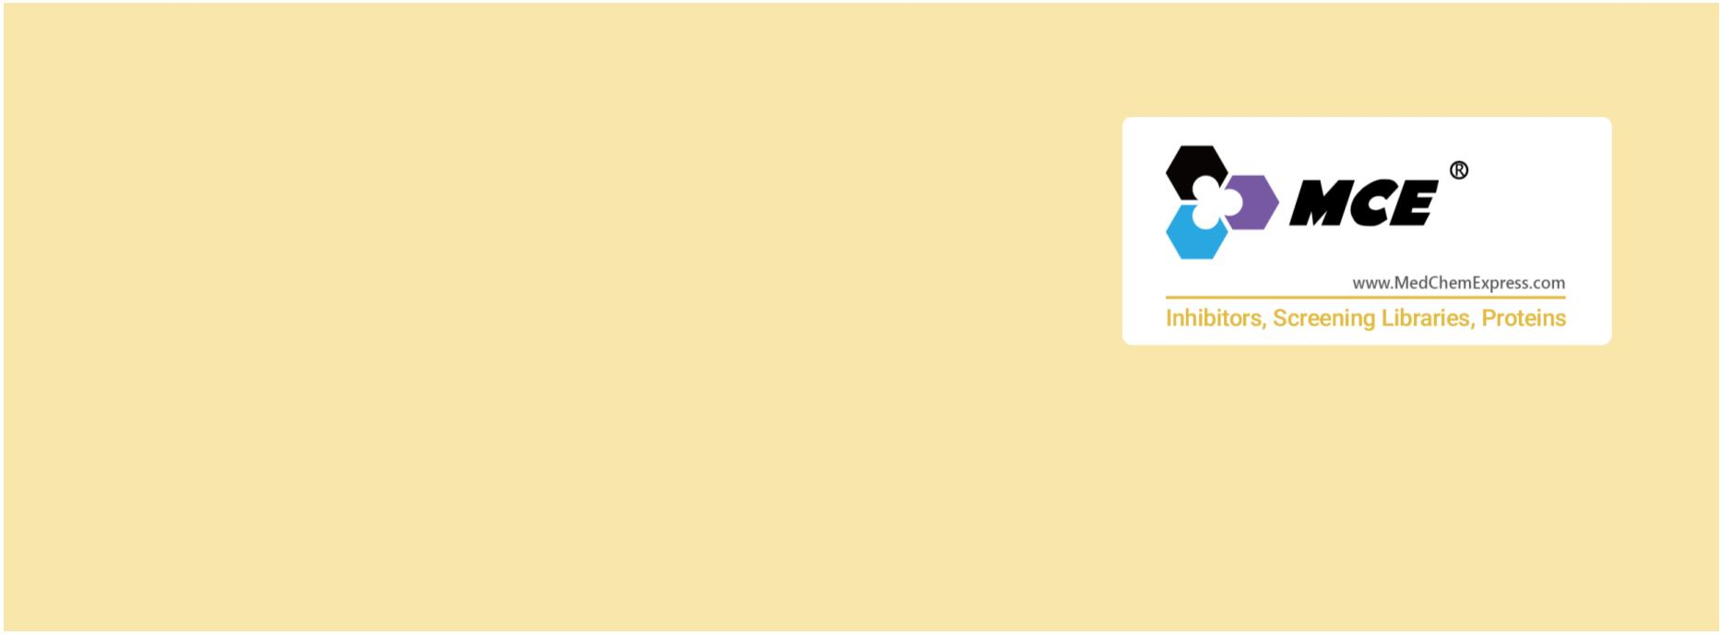IAP
IAP (Inhibitor of apoptosis) proteins, a family of anti-apoptotic proteins, have an important role in evasion of apoptosis, as they can
both block apoptosis-signaling pathways and promote survival. Eight members of this family have been described in humans
(BIRC1/NAIP, BIRC2/cIAP1, BIRC3/cIAP2, BIRC4/XIAP, BIRC5/Survivin, BIRC6/Apollon, BIRC7/ML-IAP and BIRC8/ILP2).
IAP genes encode proteins that directly bind and inhibit caspases, and thus play a critical role in deciding cell fate. The IAPs are in
turn regulated by endogenous proteins (second mitochondrial activator of caspases and Omi) that are released from the
mitochondria during apoptosis. IAP protein family members are frequently overexpressed in cancer and contribute to tumor cell
survival, chemo-resistance, disease progression, and poor prognosis. Targeting critical apoptosis regulators, like IAPs, is an
attractive therapeutic way undertaken for the development of new classes of therapies for cancer.
Although best known for their ability to regulate caspases, IAPs also influence ubiquitin (Ub)-dependent pathways that modulate
innate immune signaling via activation of NF-κB. Several members of the IAP family regulate innate and adaptive immunity through
modulation of signal transduction pathways, cytokine production, and cell survival. The regulation of immunity by the IAPs is
primarily mediated through the ubiquitin ligase function of cIAP1, cIAP2, and XIAP, the targets of which impact NF-κB and MAPK
signalling pathways.
www.MedChemExpress.com 1
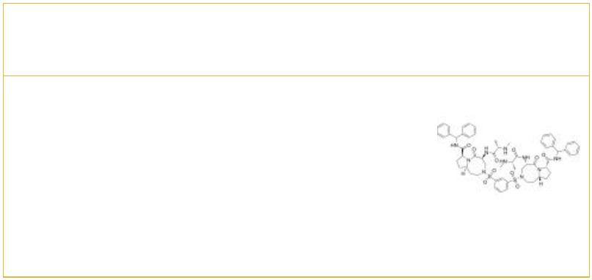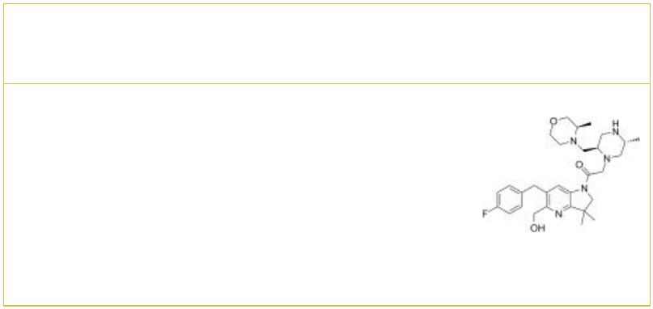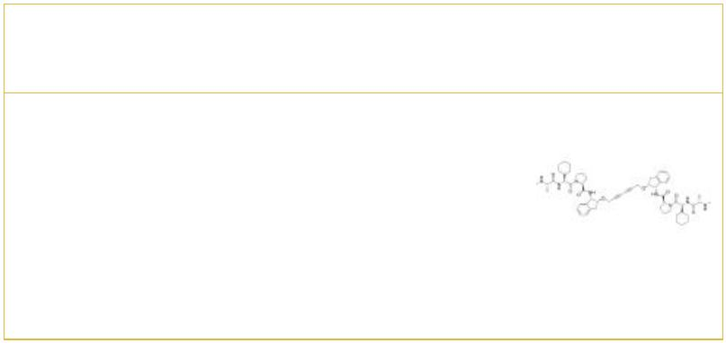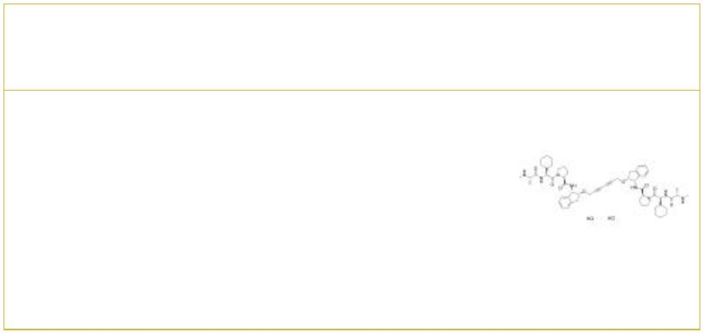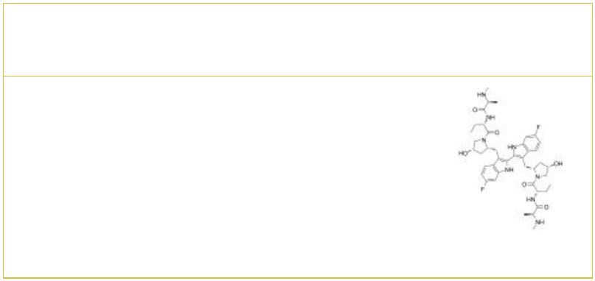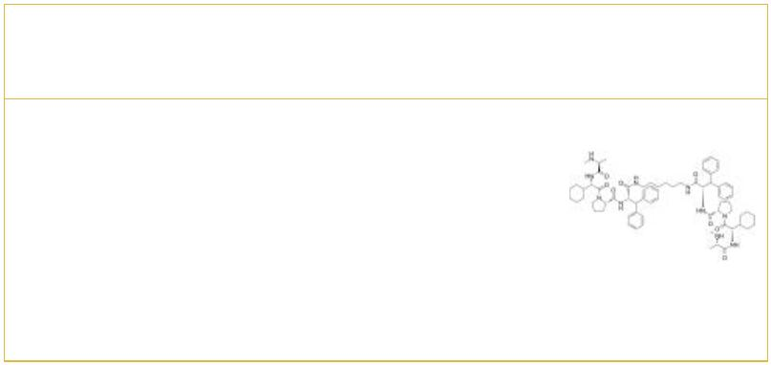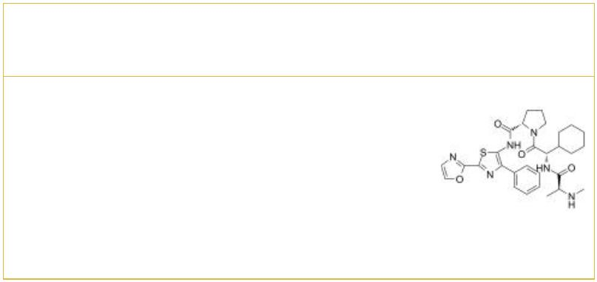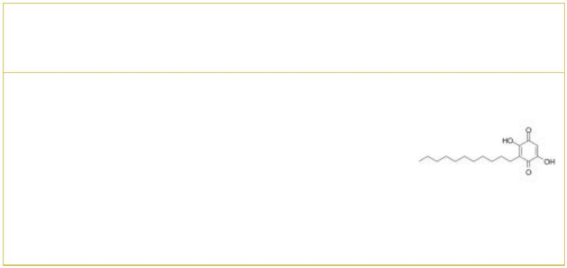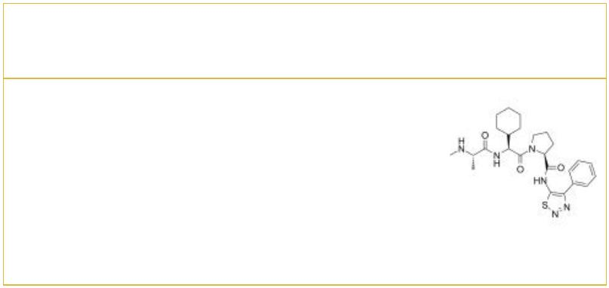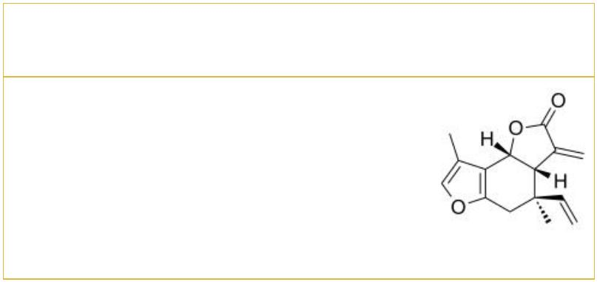IAP Inhibitors & Antagonists
 | APG-1387 ASTX660
 |  | Cat. No.: HY-125593 Cat. No.: HY-109565
 | APG-1387, a bivalent SMAC mimetic and an IAP  antagonist, blocks the activity of IAPs family  proteins (XIAP, cIAP-1, cIAP-2, and ML-IAP).  APG-1387 induces degradation of cIAP-1 and XIAP  proteins, as well as caspase-3 activation and PARP  cleavage, which leads to apoptosis. |  |  |  | ASTX660 is an orally bioavailable dual antagonist  of cellular inhibitor of apoptosis protein (cIAP)  and X-linked inhibitor of apoptosis protein (XIAP).
 | Purity: 99.46%  Clinical Data: Phase 2  Size: 1 mg, 5 mg, 10 mg |  |  |  | Purity: 99.60%  Clinical Data: Phase 2  Size: 10 mM × 1 mL, 5 mg, 10 mg, 25 mg, 50 mg, 100 mg
 | AZD5582 AZD5582 dihydrochloride
 |  |  | Cat. No.: HY-12600 Cat. No.: HY-110346
 | AZD5582 is an antagonist of the inhibitor of  apoptosis proteins (IAPs), which binds to the BIR3  domains cIAP1, cIAP2, and XIAP with IC s of 15,  50  21, and 15 nM, respectively. AZD5582 induces  apoptosis. |  |  |  | AZD5582 dihydrochloride is an antagonist of the  inhibitor of apoptosis proteins (IAPs), which binds  to the BIR3 domains cIAP1, cIAP2, and XIAP with  IC s of 15, 21, and 15 nM, respectively. AZD5582  50  induces apoptosis.
 | Purity: 98.11%  Clinical Data: No Development Reported  Size: 10 mM × 1 mL, 5 mg, 10 mg, 50 mg |  |  |  | Purity: >98%  Clinical Data: No Development Reported  Size: 1 mg, 5 mg
 | Birinapant  (TL32711) Cat. No.: HY-16591 |  |  |  | BV6 |  |  |  |  |  |  |  |  |  |  |  |  |  | Cat. No.: HY-16701
 | Birinapant (TL32711), a bivalent Smac mimetic, is  a potent antagonist for XIAP and cIAP1 with K s of  d  45 nM and less than 1 nM, respectively. |  |  |  | BV6 is an antagonist of cIAP1 and XIAP, members of  the inhibitors of apoptosis (IAP) family.
 | Purity: 99.70%  Clinical Data: Phase 2  Size: 10 mM × 1 mL, 5 mg, 10 mg, 50 mg, 100 mg |  |  |  | Purity: 99.84%  Clinical Data: No Development Reported  Size: 10 mM × 1 mL, 5 mg, 10 mg, 50 mg, 100 mg
 | CUDC-427 Embelin
 | (GDC-0917) Cat. No.: HY-15835 (Embelic acid; Emberine; NSC 91874) Cat. No.: HY-17473
 | CUDC-427 is a potent second-generation  pan-selective IAP antagonist, used for treatment of  various cancers. |  |  |  | Embelin (Embelic acid), a potent, nonpeptidic XIAP  inhibitor (IC =4.1 μM), inhibits cell growth,  50  induces apoptosis, and activates caspase-9 in  prostate cancer cells with high levels of XIAP.
 | Purity: 99.01%  Clinical Data: Phase 1  Size: 10 mM × 1 mL, 5 mg, 10 mg, 50 mg |  |  |  | Purity: 98.75%  Clinical Data: No Development Reported  Size: 10 mM × 1 mL, 10 mg, 50 mg
 | GDC-0152 Isolinderalactone
 |  |  | Cat. No.: HY-13638 Cat. No.: HY-N3001
 | GDC-0152 is a potent IAPs inhibitor, and binds to  the BIR3 domains of XIAP, cIAP1, cIAP2 and the BIR  domain of ML-IAP with K values of 28 nM, 17  i  nM, 43 nM and 14 nM, respectively. |  |  |  | Isolinderalactone suppresses human glioblastoma  growth and angiogenic activity through the  inhibition of VEGFR2 activation in endothelial  cells. Isolinderalactone suppresses the expression  of B-cell lymphoma 2 (Bcl-2), survi.
 | Purity: 99.89%  Clinical Data: Phase 1  Size: 10 mM × 1 mL, 10 mg, 50 mg, 100 mg |  |  |  | Purity: >98%  Clinical Data: No Development Reported  Size: 5 mg, 10 mg, 25 mg
2 Tel: 609-228-6898 Fax: 609-228-5909 Email: sales@MedChemExpress.com
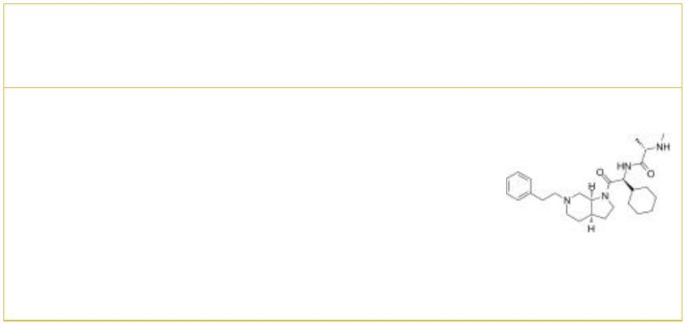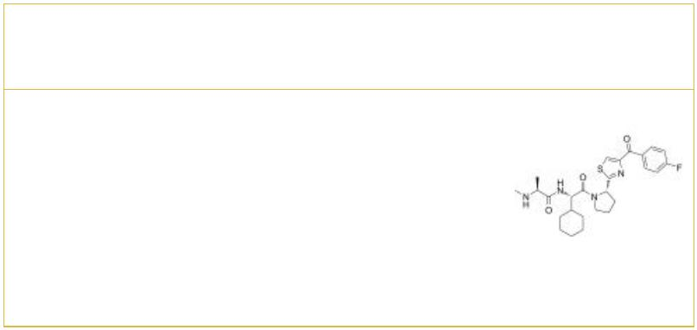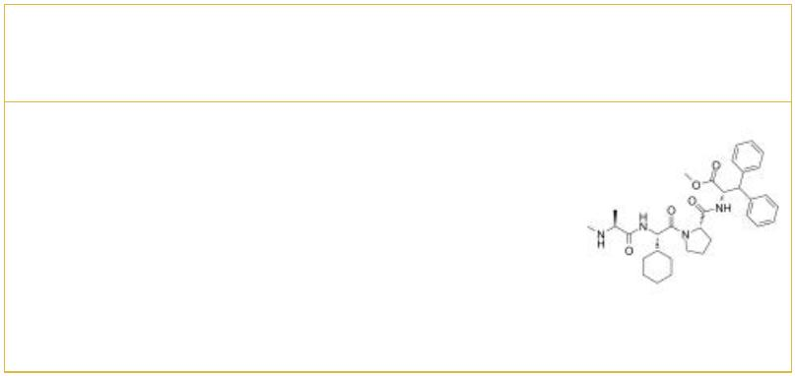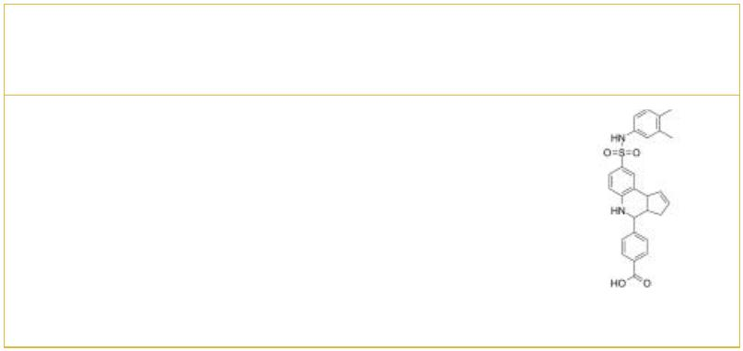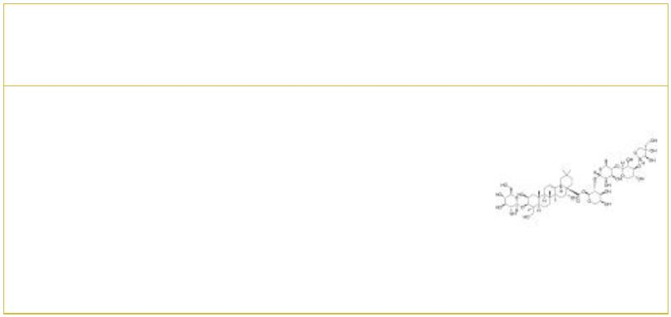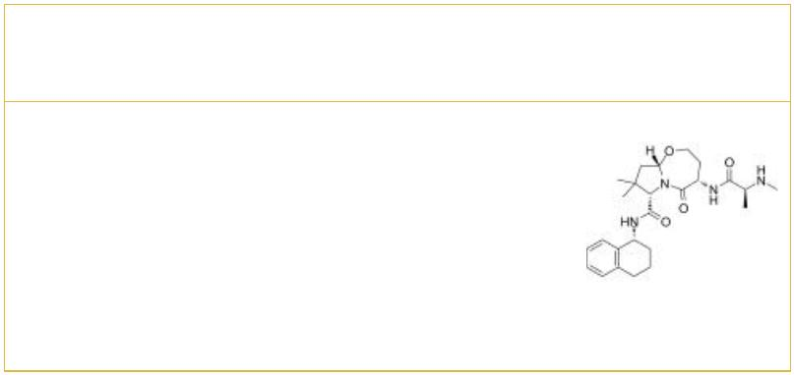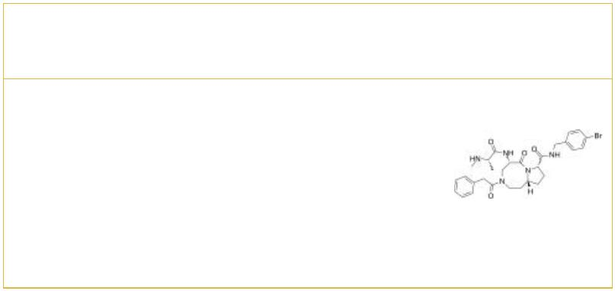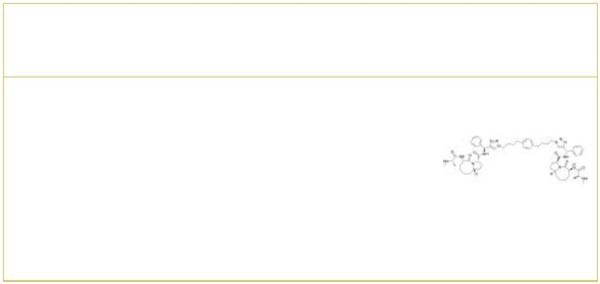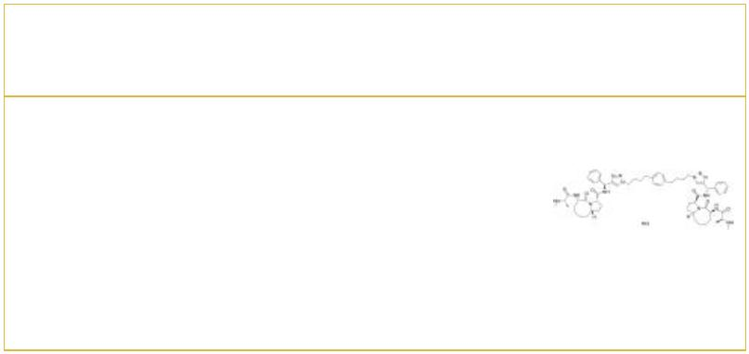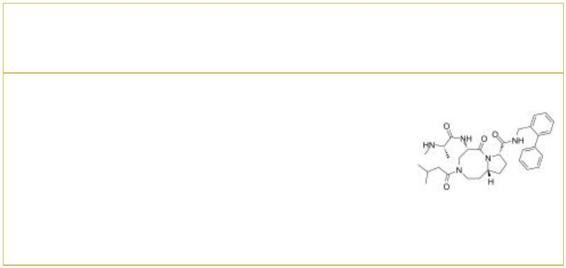LBW242 LCL161
 |  |  |  |  | Cat. No.: HY-15519 Cat. No.: HY-15518
LBW242, a 3-mer and Smac mimetic, is a potent and  orally active proapoptotic IAP inhibitor. LBW242  shows effects on mutant FLT3-expressing cells.  LBW242 has activity against multiple myeloma, and  potentiates TRAIL- and anticancer drug-mediated  cell death of ovarian cancer cells. |  |  |  |  |  |  | LCL161 is a IAP inhibitor which inhibits XIAP in  HEK293 cell and cIAP1 in MDA-MB-231 cell with IC s  50  of 35 and 0.4 nM, respectively.
Purity: >98%  Clinical Data: No Development Reported  Size: 1 mg, 5 mg |  |  |  |  |  |  | Purity: 99.74%  Clinical Data: Phase 2  Size: 10 mM × 1 mL, 5 mg, 10 mg, 50 mg, 100 mg
MV1 MX69
 |  | Cat. No.: HY-113534 Cat. No.: HY-100892
MV1 is an antagonist of IAP (inhibitor of apoptosis  protein), leads to protein knockdown of  HaloTag-fused proteins when combined with HaloTag  ligand. |  |  |  |  |  |  | MX69 is an inhibitor of MDM2/XIAP, used for  cancer treatment.
Purity: 99.54%  Clinical Data: No Development Reported  Size: 10 mM × 1 mL, 5 mg, 10 mg, 50 mg, 100 mg |  |  |  |  |  |  | Purity: 99.99%  Clinical Data: No Development Reported  Size: 10 mM × 1 mL, 1 mg, 5 mg, 10 mg, 50 mg, 100 mg
Polygalacin D |  |  |  | Cat. No.: HY-N6064 |  |  | SBP-0636457  (SBI-0636457; SB1-0636457) Cat. No.: HY-125378
Polygalacin D (PGD) is a bioactive compound  isolated from Platycodon grandiflorum (Jacq.)  with anticancer and anti-proliferative  properties. |  |  |  |  |  |  | SBP-0636457 (SB1-0636457) is a SMAC mimetic, and  as an IAP antagonist. SBP-0636457 binds to the  BIR-domains of the IAP proteins, with a K of 0.27  i  μM. SBP-0636457 can be used for the research of  solid tumors and hematologic cancers.
Purity: 99.30%  Clinical Data: No Development Reported  Size: 1 mg, 5 mg |  |  |  |  |  |  | Purity: 98.42%  Clinical Data: No Development Reported  Size: 5 mg, 10 mg, 25 mg, 50 mg
SM-1295 SM-164
 |  | Cat. No.: HY-124181 Cat. No.: HY-15989
SM-1295 is an inhibitor of apoptosis protein (IAP)  antagonist, with K values of 3077 nM, 3.2 nM  d  and 9.5 nM for XIAP-BIR3, c-IAP1-BIR3 and  c-IAP2-BIR3, respectively. |  |  |  |  |  |  | SM-164 is a cell-permeable Smac mimetic compound.  SM-164 binds to XIAP protein containing both the  BIR2 and BIR3 domains with an IC value of 1.39  50  nM and functions as an extremely potent antagonist  of XIAP.
Purity: 98.71%  Clinical Data: No Development Reported  Size: 5 mg, 10 mg, 25 mg, 50 mg, 100 mg |  |  |  |  |  |  | Purity: 99.65%  Clinical Data: No Development Reported  Size: 5 mg, 10 mg, 50 mg, 100 mg
SM-164 Hydrochloride SM-433
 | Cat. No.: HY-15989A Cat. No.: HY-138059
SM-164 Hydrochloride is a cell-permeable Smac  mimetic compound. SM-164 binds to XIAP protein  containing both the BIR2 and BIR3 domains with an  IC value of 1.39 nM and functions as an  50  extremely potent antagonist of XIAP. |  |  |  |  |  |  | SM-433, a Smac mimetic, function as inhibitor of  inhibitor of apoptosis proteins (IAPs). SM-433  exhibits strong binding affinity XIAP BIR3 protein  with an IC <1 μM (patent WO2008128171A2).  50
Purity: 99.0%  Clinical Data: No Development Reported  Size: 10 mM × 1 mL, 5 mg, 10 mg, 50 mg |  |  |  |  |  |  | Purity: 98.06%  Clinical Data: No Development Reported  Size: 5 mg, 10 mg, 25 mg, 50 mg, 100 mg
www.MedChemExpress.com 3
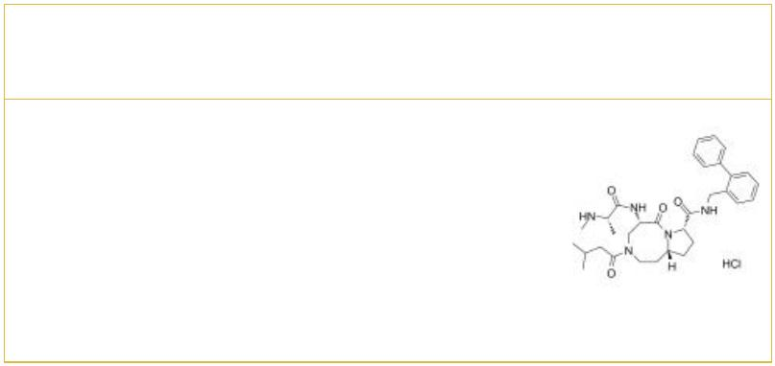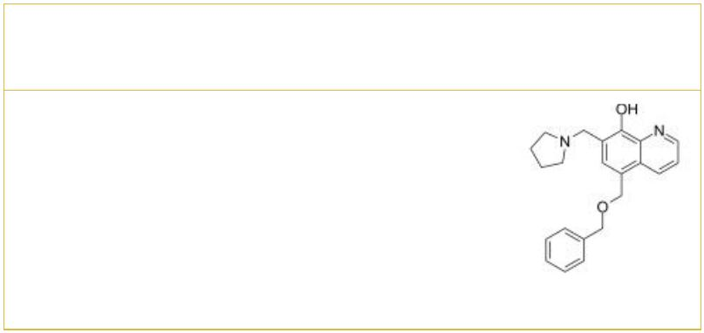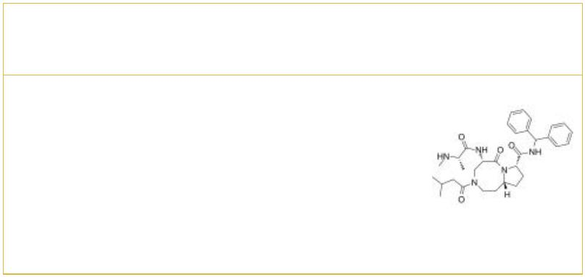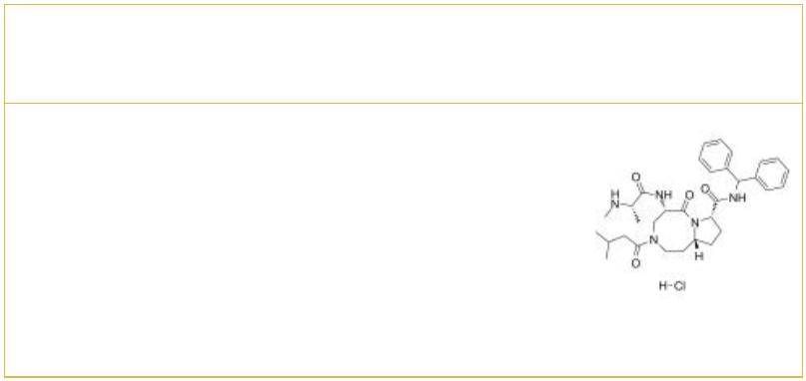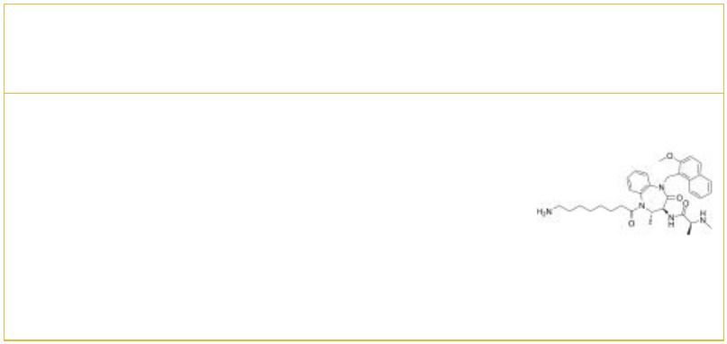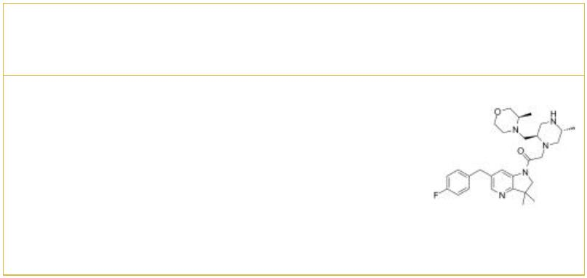 | SM-433 hydrochloride UC-112
 |  | Cat. No.: HY-138059A Cat. No.: HY-12842
 | SM-433 hydrochlorid, a Smac mimetic, function as  inhibitor of inhibitor of apoptosis proteins (IAPs).  SM-433 hydrochlorid exhibits strong binding  affinity XIAP BIR3 protein with an IC <1 μM  50  (patent WO2008128171A2). |  |  |  | UC-112 is a novel potent IAP(Inhibitor of  apoptosis) inhibitor; potently inhibit cell growth  in two human melanoma (A375 and M14) and two human  prostate (PC-3 and DU145) cancer cell  lines(IC50=0.7-3.4 uM).
 | Purity: 98.57%  Clinical Data: No Development Reported  Size: 5 mg, 10 mg, 25 mg, 50 mg, 100 mg |  |  |  | Purity: 99.72%  Clinical Data: No Development Reported  Size: 10 mg
 | Xevinapant  (AT-406; Debio 1143; SM-406) Cat. No.: HY-15454 |  |  |  | Xevinapant hydrochloride (AT-406 hydrochloride; Debio 1143  hydrochloride; SM-406 hydrochloride) Cat. No.: HY-13208
 | Xevinapant (AT-406) is a potent and orally  bioavailable Smac mimetic and an antagonist of  IAPs, and it binds to XIAP, cIAP1, and cIAP2  proteins with K of 66.4, 1.9, and 5.1 nM,  i  respectively. |  |  |  | Xevinapant (AT-406) hydrochloride is a potent and  orally bioavailable Smac mimetic and an antagonist  of the inhibitor of apoptosis proteins (IAPs).  Xevinapant hydrochloride binds to XIAP, cIAP1, and  cIAP2 proteins with Ks of 66.4, 1.9, and 5.1 nM,  i  respectively.
 | Purity: 99.84%  Clinical Data: Phase 3  Size: 10 mM × 1 mL, 10 mg, 50 mg |  |  |  | Purity: 98.80%  Clinical Data: No Development Reported  Size: 10 mg, 50 mg
 | XIAP degrader-1 XIAP/cIAP1 antagonist-1
 |  |  | Cat. No.: HY-115865 Cat. No.: HY-102051
 | XIAP degrader-1, a primary amine tethered small  molecule, promotes the degradation of X-linked  inhibitor of apoptosis protein (XIAP). |  |  |  | XIAP/cIAP1 antagonist-1 is a potent and orally  active XIAP/cIAP1 antagonist with EC s of 5.1 nM  50  and 0.32 nM for XIAP and cIAP1, respectively.  XIAP/cIAP1 antagonist-1 inhibits the tumor growth  in dose-dependent manner in vivo.
 | Purity: 99.31%  Clinical Data: No Development Reported  Size: 5 mg, 10 mg |  |  |  | Purity: >98%  Clinical Data: No Development Reported  Size: 1 mg, 5 mg
4 Tel: 609-228-6898 Fax: 609-228-5909 Email: sales@MedChemExpress.com

