一、选出以下每组单词中与其他不属于同一类的选项。（8分）
()1.
()2.
()3.
()4.
()5.
()6.
()7.
()8.
二、根据图片内容,

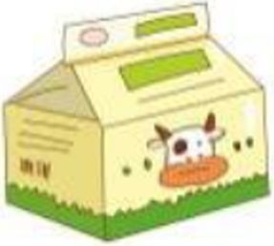


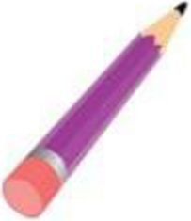
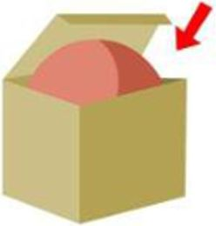
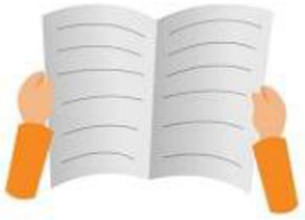
()1.
()2.
()3.
()4.
()5.
()6.
()7.
()8.
二、根据图片内容,
A. desk
A. talk
A. he
A. where
A. on
A. ruler
A. morning
A. window
写出相应的单词。
B. chair
B. class
B. she
B. this
B. not
B. robot
B. evening
B. pencil case
(8分)
C. bird
C. drink
C. it's
C. that
C. in
C. rubber
C. good
C. schoolbag

三、单项选择。（10分，

A. Look

A. Please
- Listen
A. in

A. Look

A. Please
- Listen
A. in
the blackboard, please.
B. Look at
talk in the library.
B. don't
Miss Li.
B. now
C. Open
C. Don't
C. to
)4. This cake is you.
A. forB. toC. at )5. tlnis an English book?
A. it'sB ItC. Is
you like a ball? " B. Whafs
)6.
A. What
C. Would
()7. Don't sit on floor.
A.不填B. theC. a )8. Is that pencil case?
A. youB yourC.I)9.my puppy? IVs in the box.
A. WhatsB. WhereC. Where's )10. Is it in your schoolbag? No,
A. it isB. it isn't
C. he isn't

四、根据情景选择最正确答案，把序号填在括号里。（6分））1.你想知道自己的短裙在哪里，你可以问:
A. Is this my skirt? B. Where is your skirt? C. Where is my skirt?
()2.你想告诉同学这不是你的小汽车，你可以说:
A. This is a car. B. Is that my car?
C. This isn't my car.
()3.同学给你看他新买的夹克衫，你可以说：
A. Here you are. B. It's red.
C. Wow, how beautiful!
()4.你想提醒朋友不要在公交车上跑，你可以说:
A. Don't eat, my puppy. B. Don't sleep, my dear.
C. Don't run, my friend.
)5.风筝飞到了树上，你可以说：
A. Its on the tree. B. It's in the tree.
C. He's in the tree.
()6.当妈妈找不到饭盒，你发现了，可以说：
A・ It's here. B. Its not my lunch box.
C. Thank you.
五、连词成句并翻译成中文(10分)lunch box , where , is , my (?)
中文：
- in , the , don^{J}t, library , talk (.)中文：
- your, that, is , schoolbag (?)中文：
- over there , is , the bird (.)中文：
- on , ifs , the , desk (.) 中文：
六、从II栏中找出与I栏相对应的答语。(6分)
- )1.Please sit down.
- How nice!
- He's behind the door.
- Its in the bag.
- Its a bag.
- Yes, it is.
- Yes, Mr. Green.
- )2.Whafs that?
- )3.This is my doll.
- )4.Where's Bobby?
- )5.Where is the egg?
- )6.Is this your CD?.
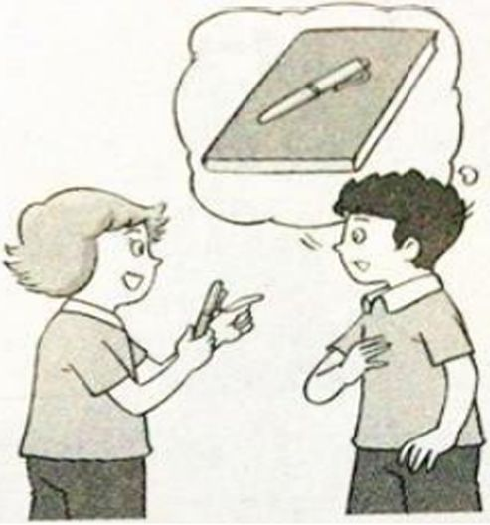
七、根据图片内容，填入所缺单词。(4分)1. A: this your , Liu Tao?
B: No, isnt
A: is it? the book.
B: It's
2. This a rubber.
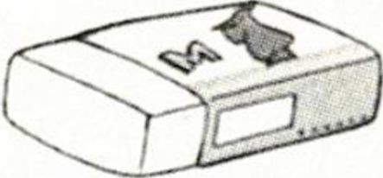
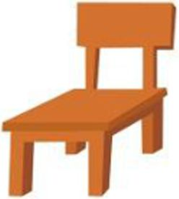
3. This is a. That is a

八、用数字将以下句子重新排列成一段通顺的对话。（8分）
() Now open your books, boys and girls.
()Come in, please.
()I'm sorry, Miss Li.
()Sit down, Liu Tao.
()Sorry, Miss Li. I'm late(迟到).
()All right, Miss Li.
() Don't sleep in class, Gao Shan.
()Thank you, Miss Li.
三下期中试卷听力稿一、听录音，选出你所听到的那个词或词组，听两遍
1. bookbook
- deskdesk
- crayoncrayon
- pencilpencil
- behindbehind
- robotrobot
- stand up7.stand up
8.under the deskunder the desk
- How beautifulHow beautiful
- don't sleepdon't sleep
二、听录音，根据所听顺序用数字给以下句子排序Where is my mother ?
- Where is my mother ?
- Is this your pencil ?
- Is this your pencil ?
- What's that over there ?
- What's that over there ?
- open your English book , Liu Tao .
- open your English book , Liu Tao .
- The robot is behind the tree .
- The robot is behind the tree .
- Sit down , please .
- Sit down , please .
- Look at the parrotLook at the parrot.
8.Don't run in the classroom .
- Don't run in the classroom .
三、听录音，判断以下图片是否与录音内容相符，相符的有J表示，不相符的用X表示，听两遍
- open the door , please .
OK.
- open the door , please .
OK.
- This isn't my pencil .
- This isn't my pencil.
- This ruler is for you .
- This ruler is for you .
- The crayon is under the desk .
- The crayon is under the desk .
- Where⁵s the bird ?
It's on the chair .
- Where's the bird ?
It's on the chair .
- Don't sleep .
- Don't sleep .
- Close the book , please .
- Close the book , please .
- Drink some milk , please .
Thank you .
- Drink some milk , please .
Thank you .
四、听录音，根据所听内容选择合适的答句，听两遍Would you like a hot dog ?
- Would you like a hot dog ?
- Don't talk in class .
- Don't talk in class .
- Where is the bird ?
- Where is the bird ?
- What's that ?
- What's that ?
- Is this a big book ?
- Is this a big book ?
- Where 's Mike ?
- Where's Mike ?
五、听录音，根据所听到的内容，将下面的对话填写完整，听三遍Please open the window . Yes , Miss Li.
- Please open the window . Yes , Miss Li.
- Please open the window . Yes , Miss Li.
- This pie is for you .
Thank you .
- This ^ie is for you . Thank you .
- This gie is for you . Thank you .
- Don't eat in the library . I'm sorry .
- Don't eat in the library . I'm sorry .
- Don,t eat in the library . I'm sorry .
- Where is my ruler ?
IV s otl the desk .
- Where is my ruler ?
It⁵ s on the desk .
- Where is my ruler ?
If s on the desk .
- Is that your bird ? No , it isn't.
- Is that your bird ? No , it isn't.
- Is that your bird,? No , it isn't.

