二O二二年绥化市初中毕业学业考试
英语试蹈
考生注座位号一 1；考斌时闽1加分裨|，9号丁・6号界京：、
2木『府彳的力EHWM” !h --—二二一¹J
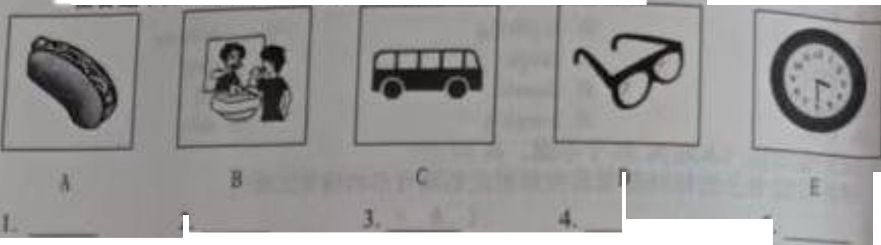
:品荔在善■卡上相对应的■号后的指定区.内
1
1
5,
听力局部（住四个只⁸ AW小M分,6
一,听句子透出苫句干内€相苻的阴片,■个句子谭一漪
・在*M卡上用- ifl■科怀的选项所对应的大写可处濠剧

二,听句子.也If・佳答话.每个句子读两遍请在善■卡上用2S招亳将你的选项所对应的大写字出漆・
B Sorry to hew that B. The same fo you BJ played sports B. No. you dan Y B In ■ month, 珀文谭两遍
6 A !f wts S20l
7. A Thati all nght
S A rm Hutchmf TV
- . A. Yes. we do,A. Lasi vear
三・听娘文.法撵正•警案.
C3^{w}m afrau! n(MVC You*rc nghtJ
Cl read booU3C Sorry, Tm abo new bou
C For two yearsII
请在手比卡上用28倍第将你的透项所对应的大写字母徐黑
IL W^y is Mr Millet in hosp«ui? ^{:s}*'“
A. Rccauic he was hit by a moftxryclc
® &3 g Mwas hun in • but accident.
U Becaux a our hi! him yesterday^{U1w, 40c}M «y ibout Mr. Miller's leg? A. It ts not too venous
B Hitvoylenooi
C ft Mtib two operation!
- ^{HoW} 心如 Md Mr Miller tteym ho刖uT A FerodyaneweeL B For one month绘化不美景信聂911 （芸10 f）
C. For two "I
第:局部9作（共计15分）曲个晨瑟吗文爵”故的期号后的指走区域内
‘卜泡”1方 以“;卜? "/?发出II"恃"的光F绍台自己的改4八件格和 川英由,「瑞知;Wlhkc；的MmyTf”为岫."根据3fl要:点和9件要求. 琳作裳褊⑴你⑨欢Fl已的幅些方曲：
*他■/ F）仇陶欢的峋川是什的
“来,⑺z中不都出现任何U息（姓名.校名削地名等h（2J ?可她朋・威想德附•归用工整$
^{（3）}词数不少上HOM. f文酸开头己给HL他不计入总包数）^{w}huc I like about mysclt
Everyone 阳 spcanl. w am I. Whu( I like about mytelf is about核比市英清认卷 810页（410瓦）

二O二二年绥化市初中毕业学业考试英语试题参考答案及评分说明
听力局部（共四个大题20个小超，不赋分，不计入总分）一、听句子，选出与句子内容相符的图片，每个句子读一遍
I——5 DABCE二、听句子，选择最正确答语，每个句子读两遍
6——10 BACCA三、听短文，选择正确答案，短文读两遍
11——15 BACAC*一 :*四、听短文，完成下面的表格，短文读两遍
- largest17. 7:10/seven ten/ten past seven
- five Z5 19, gate 20. plant笔试局部（共五个大题88个小题,共120分，计入总分） 第一局部 英语知识应用（共计70分）
一、单项选择题（此题共20个小题，每题1分，共20分）1——5 CACBC6——10 BCCBA11——15 BABCC
16——20 BBAAB二、完形填空题（此题共1。个小题，每题1分，共1。分）
21 ——25 CCBCA26——30 BBACB三、综合运用题（此题共30个小题，共40分）
A. （I）完成以下交际用语，词数不限（每题1分，共5分）
- .① Wliat/Which club do you want to join?
② What do you want to do?
- .①（It's） on October Ist/first.
②（It's） on Oct. l（st）.
- .① What's the weather like （today）?
② How*s the weather （today）?
- .① What does he look like?
② What's he like?
经化市英语试题等案品1页（共4页）
.① Certainly not.
② Of course not._{t} .
评分说明：31 — 35小题符合语境的正确答案,即可得分 (11)根据对话内容,用适当的句子将对话补充完整(每题1分,共5分). Good afternoon.
- .① Where did you go (just now)?
- What did you do (just now)?
- Where were you (just now)?
- Where did you go and what did you do?
38.① What do you think ofabout it (the movie)?
- How do you like it (the movie)?
- How do you feel about it (the movie)?
- Whal's your feeling (about iVthe roovie)?
- How is the movie?
- .① Do you have any plans (for it/fbr the speech competition)?
② What plans do you have (for it/for the speech competition)?
- .①(Yes，) I d love/like toJOK.
②(ItThat) sounds good/great!
③ Good^Great idea!/If s/That's a good^grcat idea!
④(It/Tbat) sounds like a good^{z}great idea!
评分说明：36-40小题符合语境的正确答案，即可得分B根据短文内容用所给词的适当形式填空(每空1分,共1。分)
- . flies42. first43. meaningful44.be45 have made46. proud47. beginning48. mistakes
49. Happiness50. betterC,根据所给材料将句子补充完整，每空一词（每空1分,共1。分）

51. provide; with
53. only; also
- look; after/care; for52 teach; how
- own： themselves

D,根据所给材料.提取信息,完成思维导图（每空1分，共1。分）
57. be/keep; quicVsilent
56. science; museum
58. take; photo<photographs/pictures
59. clean, tidy60. call; 2436-7866娱化市美港试题答案第2页（共4页）

第二局部阅读理解（共计35分）
、阅读理解题（此题共27个小题，其中A、B、C各5分，D和E各1。分，共35分）（A） 61——65 BCACB（B） 66——70 CGDAE（C） 7175 FTFTT
评分说明：61-75题，每题1分（D） 76. （1 分）bom
- （1 分）practice/practise
- （2 分）（DEveryone/Every one of us has the ability to leam/study.
②Each/Each one/Each of us has the ability to leam/study.
③We each have the ability to leam/study.
- （ 1 分）His brother bought him a smartphone.
- （3 分）made; a; decision
- （1 分）popular
- （1 分）① Nothing can stop us from achieving our dreams if we put our heart into it.
② Zhang's story shows （that） nothing can stop us from achieving our dreams ifwe put our heart into it.
评分说明：82小题答案符合要求，语句通顺，无语法错误即可得分（E）83. （2 分）（Because） the group wanted to know how much our young people knew about environmental pollution and whether they realized the situation of our environment.
- （2 分）Twoparts./Two./2.
- （2 分）Air pollution.
- （2 分）（They） use the plastic bags./15%/Fifteen percent of the people use the plastic bags.
- （2 分）①（We can see） our young people’s environmental awareness needs to be raised and they are short of the knowledge of the environment.
② It shows （that） our young people's environmental awareness needs to be raised and they are short of the knowledge of the environment.
Thing* to do
【he 0 _
见㈣崛0吧"mon220
of <hc park
flouCT%
KWluidoE^^^二人 Fvwt and ^{r}^^{cw%}P«pen "" Milfer eery day?
IS. Now. how it Mr Mil* & Food and water
.AAagrisr ' _ _.」.：「
四.日均文.完成卞西的.* J⁴
C. Iloppter
ZZZZZZZ^—51的翻旦的型号后的标定―内
Activity
\、：■“ h, Ih_{v} Pel
Activity
笔试局部，宾五牝HI m个小■.旄no分,计入总分）
第一局部英语知M应用（共计70分）
（子其²⁰个小整• ■小MM分.共20分）*卡上用"的笃棒你的您项所对网的大写字母渝黑
I. — Tank you foe %hann^ the cake with _pleasure
A me； mineB tmyC me； my
工fitthcr it a pik< He hat been lo many emmtnet armind the world
A Tony and PEB Temyi and PeicrC Tony、皿1 Pg s
3・一— do you ha、c a iports meeting*
- We have rt once a year
A How longB How wonQ How often
- - I went to the chmty（ 999114） ai a volunteer Ian Saturday
- Good job¹ valuable the cxpcncnce was!
A WhatB HowC Whai・
- Holly pre fen phying the pwio to ihc viohn Listen! She the ptano in her
room.
A pby; is phyingB. paying; pl*yiC playing; H playing
- What about the tong Toffrther for a Shand Fu/urr? Its name U the slogan （口号）of
Beijing 2022 Olympic Wmter Gimo.
A smg
7, There are
B Mnpng pointings on exhibilwn （及电工
C. to sing
works were emted by young
artists.
A. two hundred. Two bundle B two hundred. Hundreds .
C. bundrech of. huraH*<t审美法火及H2I （*10 V）
及—A model plane in
-Look ? The apples
A. in; in9,一Do you like Jq
the tree. Lefs get it down.
•he tnee arc really red
B. oni tn~ Journey to the West
A. and
- C hincsc astronauts
A. are regarded 'L If you have difficulty
A. work
12，- It is convenient
-So it is.
A. for; to buyJean knew nothing about the
A. didn 't； sheumcy to the Hist
C. in; cn
B. or-
m m.C bwas heroes We all look up to them
regard
out the problem.
B. workingus
C. regarded you can ask the teacher for help.
things onlineC. to work
M・一I can't imagine-I think it will be A. how our life was
B. of; to buynews until her aunt told her.
B did; she in 2050.
more and more wonderful.
C. for; buy9 .
C. didn't; JeanB・ what will our life be like C・ wha【our life will be like
- The specials in the restaurant taste weekends.
A. well; goodn ..
- ~ The big stone is heavy.仁 good; well
- Don-t wonyj 而际y：： *—¹ 旬!” 所.
A. such; thatB so th t^{，7} M：2—峰产一■ — 4 "
,用黑黑党产扁忧”一⑼政策黑二
that the students have less homework
A . changes; isB change; is^{9J} can） fb3 the teachers and the university
and sell• Many customers come here on
C, changes; are
many sweet memories.
A. that20. - We should do what we can
¹ "sited two years ago. They bring _{mc}B. which
C. what或甯……产%牖黑”
H・ to preventC. preventing
一形填空题（此题共10个小题,每题1分丑I。分）:在答题卡上用28铅笔将你的选项所对应的大写字母涂黑
3 ；；：常鬻丁 夫fonns in China. q you often see any of them _{in} HL 置曾步叫 us understand and enjoy the traditional Chinese culture. When .

• ooREDMI NOTE


Spring । scissorIn wmicr
"""3 some pen I^{tdllc<j M} 7'然;^{rcd pupcr ln，}° di府rent an works with WaEhsu、Hz： *^{，hc}> ^{bl}<x>m ({« JF) beautifully on the windows
. .: “‘ever. (hey arc not real nowen.
inicrest^u 8m “亚 ^{wrnc} red nowen on the window.
ingers were :^{W shc} - her mothato teach her She tried幽:7WEShebchvedg-Her
, 包 *一小明 and you am make it.” 鹏小 spengE] da” on g up her world*“血11"婀熟地).m rtowers. bioommg like
心s
啊 Jenny.” over and 阳' 咂照砚益，刖hern ihcm.H阿1；sny, 2X .5 M 2l・A.麻

- 卧,pui
A・ orange
I2・ycar.o|dA. knew
A. nothing A . keep» (0
B. ArcB. (urn
B. pinkB.!2-ycars-old
B. askedB・ anything
B. keepsB. should
C, ofC. Do C< take C< red
C. 12-year-okb
mightA. burn
髭膘J煞共³⁰个小题，页40分）
口题卡上把你的答案写在相对应的题号后的指定区域内B. burning
C. madeC something
C. to keep C・ could Ce to bum
(I)完成以下交际用语，词数不限31. A： 9
I warn lo join the swimming club.
When is National Day?
（A ）（每题1分，共5分）
B：
- A：
B：
- A：
B：
- A：
lt^{f}s rainy.
B： Ik is handsome with blue eyes.
35. A ： Would you mind me situng here?
B •・ Sit down, please.
(II)根面面容，甫适当的句子将对话补充完整(每题1分，共5分)Tun： 36. 一.一^:*
Bob： Good aftcmooih Tim. 1 called you just now_{t} but nobody answered.
1^.] _{wen}i to the cinema. And I watched a movie named The Battle at Lake Changjm而>，Cl…M 心 ^{vcry fam0US nmv，k，ays}- ³⁸ 7
Tin : “ mosing.* couldn^l help crying along uifh it l\e learned a lot from i S" ' a speech competmon next week 39. .)it. You know
Lep UlH.
। j_{on}1 have any plans,J ^{SuII}\r ihe way> Vm going to the library. Would you like to go with me?
) sc。*. Let's go.
®0b：40接化市英语试题第4页（410 K）

iT(B )
除据短文内容用所恰词的适当用式填空(触空1分,共10分)
How nnw 4 L(llyM n)c senior high school life is coming. I Mtill rrmwa、4X(one) day like it wwy»tcnlay. Ev«>thing in our school in 43.. "M j
me. I u$cdlo44 sh\. but im teachers always emmiroged me"confident. 1 45.― (nuke) great pfvgrcss in the Insl few years. My tenchcrs ml"
46.(pni^fme^{NtVnK} nrrThe end of junior high school is (he 47. lifelong journey. 1 will learn firvm my 48.
(begin) ot a new life. I knowmuch. 49.
(good) I will be.
,・ l、 •Minima ।(mistake) and never give upj\_{c}
(happy) is always around me. I think the harder I work, the 50.
g<M(C )
根据所给材料将句子补充完整，每空一词(每空1分，共10分)
The government wants to provide cooking lessons for all the children tron)7 |₀ 14 _{ln} England. It will be part of a plan to make them cat more healthily. Diftcrcnt people have different opinions about iL
Emily thinks that every child should be taught how to cook as a life skill. It cun 标 1、 to avoid being too heavy if they cook instead of getting a takeaway.
Cathcnnc says having cooking lessons at school is a good idea. Not only can it teach children to be healthy, but it also shows them how to be safe when cooking at home When(h_{e}y are olden they can take good care of themselves.
Ruby says they shouldn't let the little kids make their own meals because they inav hurt themselves. Kids aged 10 and over should start learning how to cook.
Anna thinks children should learn to cook because they will learn "What's healthy" and they can help their parents in the kitchen.
- The government wants toIn Emily's opinion, we should
all the children from 7 to 14cooking lessons.
childrento cook as a life skill.

53. Having cooking lessons at school not
teaches children to be healthy but
shows them how to be safe when cooking at home.
themselves well when they are older.
54. They can
meals because they may hun
55. According to Ruby, children shouldn't make their(D )
根据所给材料,提取信息，完成思维导图(每空1分，共1。分)A School Trip
Attention, please! I have something important to say. Wc 11 go for a school tnp 〔屋 science museum this Friday. Here are some rules that we have to follow.由
To start with, you must be quiet in the museum. If you speak loudly, the worker^ :; museum will ask you to leave. Next, don't take photos in the museum. Because it s ba ：；4外 paintings. But you can take a pen and a notebook to write down some卜，keep the museum clean and tidy while visiting. By the way, please call 2436-7866 )^{oU} any questions. I hope we will have a good time there. That's all, thank you.
绘化市英语试题第5页（共10面）
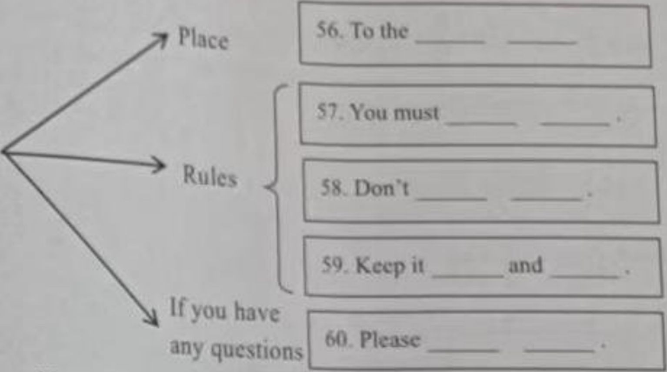
、此臂;婀其中心B. C各5分,D和E各10分，共35分） 请在答题卡上用2B犯笔将你的选项所对应的大舄字母涂黑

Mind map
第二局部阅读理解（共计35分）
jg堡两文内容，丛国小题所给的A、B、C三个选项中,送出一个■佳答案Welcome to Sunshine Farm
Hello, everyone! We are famous for our fresh and delicious tomatoes. Do you want come here? We invite you to visit the farm and enjoy our products. All the customers will have a safe open-air environment You can have a good time here The following instructions may help you.
（S）To pick the tomatoes, you need to nuke a reservation （预约）from 8 a.m. to 5 p.m. the day before the picking day on our website. Il is necessary.
No pets are allowed on the farm.
（2）You can use your baskets or buy ours. A basket only costs two yuan The tomatoesarc 15 yuan tor one kilo.a
（2）If you bnng your children here, they must suy close io you. Running here and there is not allowed We hope【hey can follow the farm rules.
（J） In order to stay safe and healthy, please don t come to the farm if you are ill
C. 7 a.m. on Feb. 24th
6L If you go to the farm on Feb 25th. you can make a reservation at A. 9 a.m. on Feb. 23rd B. 2 p.m on Feb. 24th
C. 7 a.m. on Feb. 24th
- According to the passage, wc can ! takeio the farm.
A a phoneª basketC. a dog
- On the farm, children are allowed io-stay close to their parenis
- run everyw hereC play with their pets
- You should pay 而 2 kilos of tomatoes on Sunshine Farm.
I▲二■B 10 vuanC. 30 yuanA. 15 yuan
- The instructions are most pi""" mm.B a farm ownerC. a waiter
A. a shopper《也市美语认建第6页（共10页）
(B )展据后文内容,从以下&嗔中选出能填入空白处的最正确选嗝 加页中有两项多余
Do you hkc sports¹ What sports do you often play? Walking and ninning arc gcnui excncisc Thc> arc good (br your body. Making plenty of preparations can make you fall ^{,ov，e} with talking and running 66 We have some good suggestions
- Check the weather
You nwd to know b hether it is a nice day. 67.丫训 must be careful mwinter. You rrw> like walking on Miowy days. But the ice under snow may make you fall down .6R
You should make sure your clothes arc comfortable. Sports shoes are good choices. Don I w^{car} leather shoes or slippers (拖 鞋)
- Carry a map or a mobile phone xvith GPS
If)ou x^alk or nin in a new place, you may lose your way. 69. .
Canning a nup or a mobile phone with GPS is a good idea
- Take waler and music players with you
There are ru o cheap things thai can make your walking and running more enjoyable They arc x% atcr and music players. 70.Music can make you feel happy and relaxed.
- > ou need something to help you find the way.
- Make sure lo take enough food with you.
C Do you know how to walk or run in a right way?iD, Wear comfortable clothes and shoes
- Woter is useful when you are thirsty.
- Three things you need lo do before exercising.
- \'ou will nex er have a great time walking or running on cold, hot or rainy days.
(C )根据短文内容判断对错.对的选^{U}V\错的选“F”
Wlicn we (eel hungry , we can take out our phones and order some Ibod easily. When we need lo take a taxi, we can also use our phones(o book one. It*s so easy. But what will happen to the old who don't know how to use a smartphone”
With die development of technology, our lifestyle has been changed a lot. Lois of things can be done tlirough ihc Internet such as shopping, buying tickets and so on. New apps are easy for the young, while they arc difTicult (or the old Now China has come up with several _{wfl}y$(o solve (his problem. Everyone should take actions lo overcome this "digital gap”(数字
Somcliines we only need several minutes to learn somclhing new, but nuiyoc it costs old p_{CO}p|_{e} hours or even a few days. Next time when the old need help, we should be patient with (|_{lcm} and never forget whut ihcy've done for us.
71 \\ c cun lake out our phones and order some food easily when we feel angry.
7，\W know we can use the Internet to shop and buy tickets.
71 To book fl taxi by using the phones ix difficult when the young want io go lo some places.
74 Maybe it takes (he old much time lo 励e new things
Ml of us should play n pan in overcoming this ••digital gap'接比市英泊:Hi H7Mi(410 JI)■

• oo
谓:瞿鳖三成以下各题
In把你的答案写在相对应的题号后的指定区域内
°、由8. WitJi h；；： Zhiqiang was 76. bwith no arms tn a small village in Shandong"c learned kJ^prwktis/, he could do many things with his feet when he grew
^{o|}hers, I ha\_{c} . clothes, cook meals and do farm work He said, “If I want to live like “Mcuhic* 1 h ° 中丫 78. (A)每个人有学习的优力.No matter how many79(R)J will go out of my way to face them.^
Io kag j,¹巫母brother, h凤 bought. He thought it was so useful and decidedg&huc、卜 opened an online store which sold farm products. 80 (C) When his business "题"2 h^{C}" °m*"Al firsL few of them (rusted him because they °w \\hai an online store was. With his effort the products were popular online. And
t. He thought it was w useful and decided with the¹⁰ press its button with his toe tips (脚尖，The Internet connected him
Out of 由。1: ^{C vv}°rld. He had an idea when he knew the local farm products couldn't be sold
¹ "gers came to ask him fbr help. Later, he decided to sell their products on short videos. ^{s a} success and he won himself many follower. He has created a good life for
Hmsclf and the villagers..
bang's story shows that nothing can stop us from achieving our drcams if we put our hen it. W e can also fly even without wmgs because we have a brave and strong heart 76。根据句点及首字母补全单词b<177.根据注音完成单词.
))y ) )
分分分分分 分
，78. •将A处划线句子翻译成英语 加.格B处划线局部组合成完整的句子
- 80,写出C处划线句子的同义句When his business got successful, he
(3 to help other villagers.
（I分）
- 81.请/£文中找出与下面英文释义相符的单词hked by a lo（ of people
n . W hat can we learn from the story?
阅读下面图文，回答所给问题
|谓在答题卡上把你的答案写在相对应的题号后的指定区域内
I. _{a}|j 皿/ environmental pollution is serious now. Our group wanted to know how
、二 mu people knew about this problem and whether they realized the situation of our g" W： “、、n survey of them.
envirwu _{uaS} |_{na}jnly about many diftercni environmental problems in China and the "、；environment. What's more, we also paid attention to the environmental situation "' ;像卓 仪)of “ur young people, In (he project we also designed a questionnaire 心3"；: sunev ihesonng people in China.
问][he questionnaire could be divided into two pons. One was mainly about
I I hc 中心” environmental problems in China, the other was about envitvnmenial轮化市英语认婚（央1。页）
I he rMtilii of oii「qtigUonn.lr」 you know nhouf ihc^c problQES ?
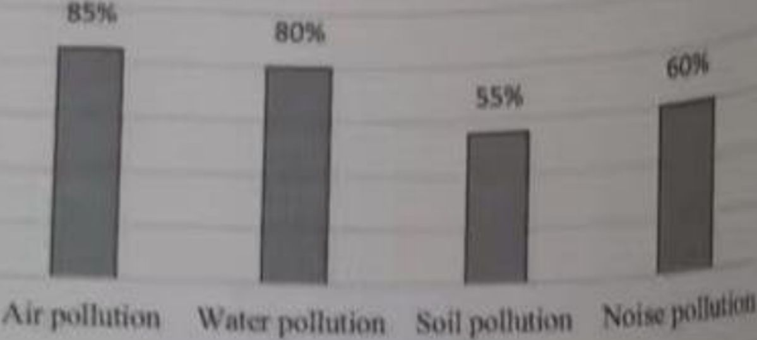
60s
•III%


I Ke the plnslie bags
BO%
100%80%
BO%
Al^avs
5%
Never
SonKtinics
60%40%
20%0%
From the results of the questionnaire, we can see our young people's enviro_{0moi}m। awareness needs to be raised and they arc short of the knowledge of the envimnmmi， wonying.It & re;山、Why did the group do the survey?
- How many parts arc there in the questionnaire?
- Which is known by the most people among the problems?
86，According to the chart what do 15% of the people sometimes do?
87. What docs the data （数据）of the two survey charts show?
媒化市笑语试题第9贝（410贝）

inu-

