山地城市平面交叉口左转待行区建模及应用

主要方案

随着城市交通拥堵加剧,平面交叉口是城市路网的重要节点,需着重强化,左转交通流是影响交叉口运行效率的重要因素,持续优化左转待行区设置是提升效率的主要手段之一。山地城市平面交叉口条件有限,左转待行区设置更需精细化考虑。为了准确、科学地构建山地城市左转待行区样本,
本文利用无人机高空视频采集优势,选取了多个典型山地城市平面交叉口开展左转车辆轨迹行为研究,主要从基于交叉口几何特性的待行区模型构建、基于无人机高空视频的左转微观轨迹资料的待行区模型构建、基于遗传算法的左转待行区交叉口信号配时优化等几方面进行探讨,具体如下:(1)归纳总结了左转待行区设置的方法与条件,并考量了左转车流的运行特性。(2)基于交叉口几何特性的理论待行区样本构建。
本文针对目前左转待行区相关探讨未考虑山地城市车道窄、坡度大、部分交叉口畸形等几何特点的局限,为了明晰在实际应用中待行区“是否设置”、“如何设置”的问题,
本文利用左转排队长度分析探讨了待行区是否设置的边界条件及待行区需要设置时的最短设置长度;基于冲突分析法明确了待行区设置安全间距,构建了左转待行区长度设置区间模型;结合仿真提炼出不同坡度下左转车辆利用冲突点时间变化特征,提出了当道路纵坡坡度超过-5%时对样本的修正方法;探讨了畸形交叉口、中央隔离带及车道属性对待行区设置影响。进一步地，(3)基于车辆实际运行轨迹的待行区模型构建。
本文首先通过无人机高空视频拍摄及数据处理工作,获取了一批具有山地城市特色的交叉口左转车流轨迹数据,利用轨迹特性分析与相关函数拟合考量,确定了单相指数衰减函数为车辆左转轨迹基本函数原型;然后通过交叉口几何特性,确定了起点、讫点、冲突限制点三个约束条件,对左转轨迹函数原型进行了标定,构建了以交叉口几何参数为自变量的车辆左转轨迹的函数样本;基于曲线线形识别法,确定了交叉口车辆左转轨迹由两段缓和曲线组成,根据缓和曲线公式,构建了关于左转待行区长度与半径的分段函数模型。(4)基于遗传算法的左转待行区交叉口信号配时途径研究。
本文针对前面章节构建的左转待行区样本,修正了HCM手册中的通行能力计算公式,并构建了以通行能力最大、平均延误最小、平均停车次数最少为目标,相位绿灯时间、信号周期为寻优参数的多目标求最优解模型,利用遗传算法求得最优解,并结合实际案例开展了验证。
为实现城市精细化管控、大幅提高城市交叉口运行效率和安全水平提供支撑。基于此，最后,结合实例计算出了理论待行区样本和实际待行区样本的待行区长度,建立了VISSIM仿真模型,仿真运行结果显示理论待行区样本计算的待行区长度相较于现状待行区长度,平均每车延误下降了29.5%;实际待行区模型计算的待行区长度相较于理论待行区模型计算的待行区长度,平均每车延误下降了11.2%。

✅ 简介：擅长数据搜集与处理、建模仿真、程序设计、仿真代码、论文写作与指导，毕业论文、期刊论文经验交流。
✅ 具体问题可以联系QQ或者微信：30040983。

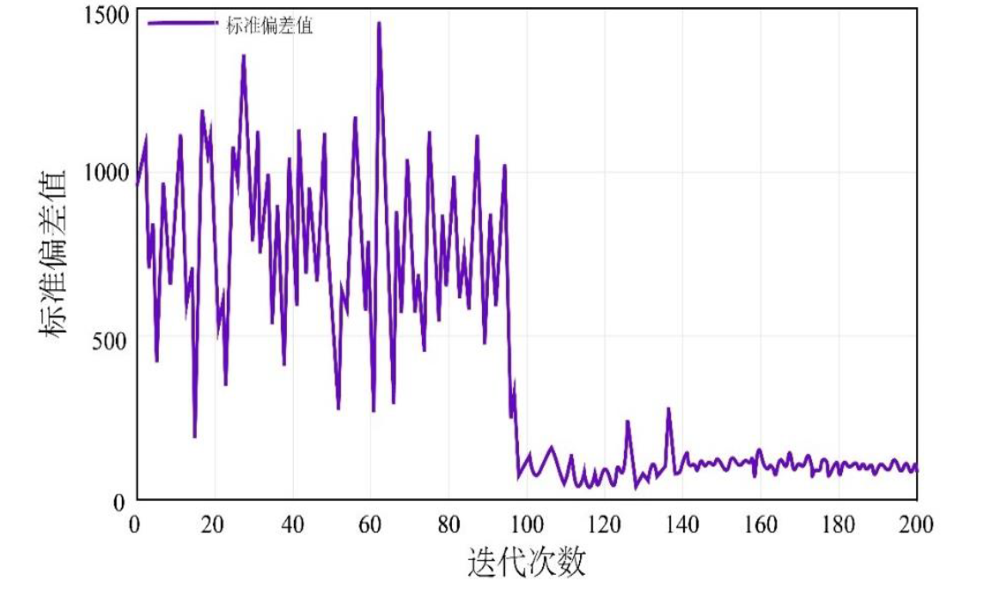
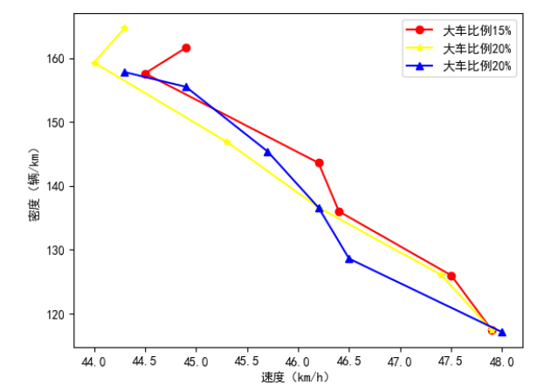
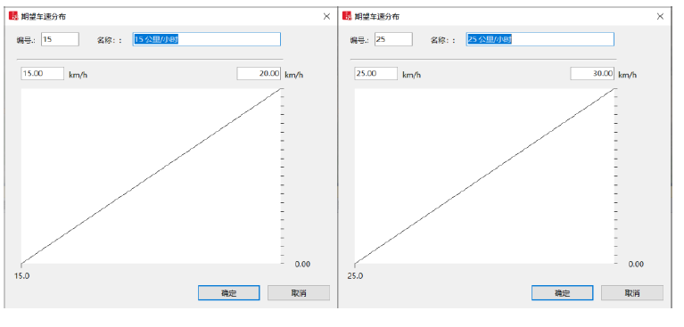
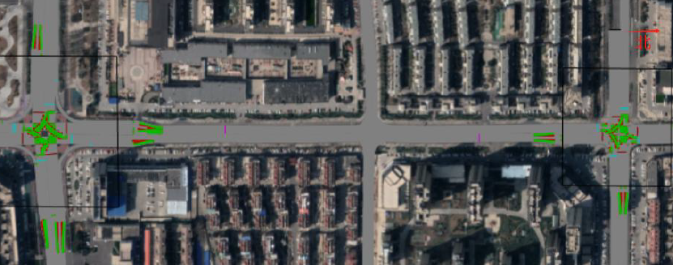

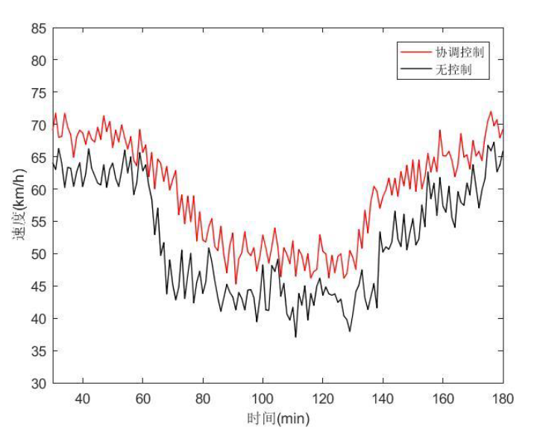

仿真代码

import numpy as np
import heapq
from collections import defaultdict
class RoadNetwork:
def __init__(self):
self.nodes = {}
self.edges = defaultdict(list)
self.traffic_conditions = {}
def add_node(self, node_id, x, y):
self.nodes[node_id] = {'x': x, 'y': y}
def add_edge(self, from_node, to_node, distance, capacity, free_flow_time):
self.edges[from_node].append({
'to': to_node,
'distance': distance,
'capacity': capacity,
'free_flow_time': free_flow_time
})
def update_travel_time(self, from_node, to_node, current_volume):
for edge in self.edges[from_node]:
if edge['to'] == to_node:
t0 = edge['free_flow_time']
capacity = edge['capacity']
alpha = 0.15
beta = 4
if current_volume < capacity:
travel_time = t0 * (1 + alpha * (current_volume / capacity) ** beta)
else:
travel_time = t0 * 10
self.traffic_conditions[(from_node, to_node)] = travel_time
return travel_time
return float('inf')
def dijkstra(self, start, end):
distances = {node: float('inf') for node in self.nodes}
distances[start] = 0
previous = {}
pq = [(0, start)]
visited = set()
while pq:
current_dist, current = heapq.heappop(pq)
if current in visited:
continue
visited.add(current)
if current == end:
break
for edge in self.edges[current]:
neighbor = edge['to']
weight = self.traffic_conditions.get((current, neighbor), edge['free_flow_time'])
distance = current_dist + weight
if distance < distances[neighbor]:
distances[neighbor] = distance
previous[neighbor] = current
heapq.heappush(pq, (distance, neighbor))
path = []
current = end
while current in previous:
path.append(current)
current = previous[current]
path.append(start)
path.reverse()
return path, distances[end]
def astar(self, start, end):
def heuristic(node1, node2):
x1, y1 = self.nodes[node1]['x'], self.nodes[node1]['y']
x2, y2 = self.nodes[node2]['x'], self.nodes[node2]['y']
return np.sqrt((x2 - x1)**2 + (y2 - y1)**2)
open_set = [(0, start)]
came_from = {}
g_score = {node: float('inf') for node in self.nodes}
g_score[start] = 0
f_score = {node: float('inf') for node in self.nodes}
f_score[start] = heuristic(start, end)
while open_set:
current_f, current = heapq.heappop(open_set)
if current == end:
path = []
while current in came_from:
path.append(current)
current = came_from[current]
path.append(start)
path.reverse()
return path, g_score[end]
for edge in self.edges[current]:
neighbor = edge['to']
tentative_g = g_score[current] + self.traffic_conditions.get(
(current, neighbor), edge['free_flow_time'])
if tentative_g < g_score[neighbor]:
came_from[neighbor] = current
g_score[neighbor] = tentative_g
f_score[neighbor] = g_score[neighbor] + heuristic(neighbor, end)
heapq.heappush(open_set, (f_score[neighbor], neighbor))
return [], float('inf')
def k_shortest_paths(network, start, end, k=3):
paths = []
path, cost = network.dijkstra(start, end)
if path:
paths.append((path, cost))
for i in range(k - 1):
if not paths:
break
last_path, _ = paths[-1]
temp_network = RoadNetwork()
temp_network.nodes = network.nodes.copy()
temp_network.edges = defaultdict(list)
for node, edges in network.edges.items():
if node not in last_path[:-1]:
temp_network.edges[node] = edges.copy()
path, cost = temp_network.dijkstra(start, end)
if path and path not in [p for p, c in paths]:
paths.append((path, cost))
return paths
def dynamic_routing(network, start, end, departure_time, time_steps=60):
current_time = departure_time
current_position = start
path = [start]
total_time = 0
for step in range(time_steps):
if current_position == end:
break
for edge in network.edges[current_position]:
volume = np.random.randint(200, 800)
network.update_travel_time(current_position, edge['to'], volume)
remaining_path, cost = network.dijkstra(current_position, end)
if len(remaining_path) > 1:
next_node = remaining_path[1]
travel_time = network.traffic_conditions.get(
(current_position, next_node),
[e['free_flow_time'] for e in network.edges[current_position]
if e['to'] == next_node][0]
)
path.append(next_node)
total_time += travel_time
current_position = next_node
current_time += travel_time
return path, total_time
def multimodal_routing(origin, destination, modes=['car', 'bus', 'metro']):
routes = {}
for mode in modes:
if mode == 'car':
time = np.random.uniform(20, 40)
cost = np.random.uniform(10, 20)
comfort = 8
elif mode == 'bus':
time = np.random.uniform(30, 60)
cost = np.random.uniform(2, 5)
comfort = 6
else:
time = np.random.uniform(15, 30)
cost = np.random.uniform(3, 8)
comfort = 7
routes[mode] = {
'time': time,
'cost': cost,
'comfort': comfort,
'score': 0.4 * (60 - time) + 0.3 * (20 - cost) + 0.3 * comfort
}
best_mode = max(routes, key=lambda m: routes[m]['score'])
return best_mode, routes
def real_time_rerouting(current_path, incident_location, network):
if incident_location not in current_path:
return current_path, False
incident_index = current_path.index(incident_location)
if incident_index == 0:
return current_path, False
reroute_start = current_path[incident_index - 1]
destination = current_path[-1]
for edge in network.edges[reroute_start]:
if edge['to'] == incident_location:
network.traffic_conditions[(reroute_start, incident_location)] = float('inf')
new_segment, cost = network.dijkstra(reroute_start, destination)
if new_segment:
new_path = current_path[:incident_index] + new_segment[1:]
return new_path, True
return current_path, False
def main():
network = RoadNetwork()
for i in range(10):
x = np.random.randint(0, 100)
y = np.random.randint(0, 100)
network.add_node(i, x, y)
for i in range(9):
network.add_edge(i, i+1, 10, 2000, 5)
if i < 8:
network.add_edge(i, i+2, 15, 1500, 8)
for i in range(8):
volume = np.random.randint(500, 1500)
network.update_travel_time(i, i+1, volume)
start_node = 0
end_node = 9
path_dijkstra, time_dijkstra = network.dijkstra(start_node, end_node)
print("Dijkstra Path:", path_dijkstra)
print(f"Travel Time: {time_dijkstra:.2f} minutes")
path_astar, time_astar = network.astar(start_node, end_node)
print("\nA* Path:", path_astar)
print(f"Travel Time: {time_astar:.2f} minutes")
k_paths = k_shortest_paths(network, start_node, end_node, k=3)
print(f"\nTop 3 Shortest Paths:")
for i, (path, cost) in enumerate(k_paths, 1):
print(f"Path {i}: {path}, Cost: {cost:.2f}")
dynamic_path, dynamic_time = dynamic_routing(network, start_node, end_node, 0)
print(f"\nDynamic Routing Path: {dynamic_path}")
print(f"Total Time: {dynamic_time:.2f} minutes")
if __name__ == "__main__":
main()

