VIPOrange

更新更快 出分更稳



真题资料

act.soonvip.com
助橙ACT 小程序

Exam ： VIPOrange - 58

Time ： 2001-1

Version ： DEMO

PART 1 - 英语
Passage I
Take Me Outside to the Ball Game
My sons are fortunate to have grown up in a city where major league baseball is played. When I was a child, it was a five-hour, once-a-summer trek, to the nearest major league ballpark. My sons have to endure only the twenty-minute ride to the stadium that we make five or six times a year. But I think my experience needless to say was richer than theirs. The stadium I remember had a natural grass field and seats piled up high and close to the players so we could hear them mutter. Domed and bowl-shaped, my sons sit in a park where the players meander about on artificial turf that is not natural grass, and where we sat at such a distance that the game appears to be only a rumor. Fans should not have to endure these errors in aesthetics and architecture?

First, the turf should go. There should be nothing artificial about baseball, least of all the grass. The odd green shade of artificial turf is a poor counterfeit of grass green. When my sons and I visit the ballpark we are essential on a picnic. Why gather around a carpet, in which we can do just as well at home, to enjoy our hot dogs, peanuts, and sodas? (10)
Second, the dome should go. While it's true that the dome blocks out rain, it also blocks out the sun and sky. Baseball is a pastoral sport, where players lope across the field, where a strong player can smack a ball seemingly to the sky. Under a dome, the game is hermetically sealed, the players' skins look sickly, and the hit ball is in danger of banging a rafter. Finally, I want my sons to be closer to the game. I don't want us to be forced to the edge, of a bowled stadium, like the remnants of unwanted cereal. I want us to hear the ball slapping the catcher's mitt, and the shortstop yelling "I got it !" when the ball is popped up in the infield. Let us study an outfielders face, without the aid of binoculars. When he's sprinting toward the infield to catch a short fly ball.
Baseball is a game as much about atmosphere as athletics. Architects need to remember stadiums are playgrounds, not office buildings. If architects play fair, they will remember that, and my grandchildren will be thankful when they take their seats in the bleachers.

1.
- NO CHANGE
- child, it was a five-hour, once-a-summer trek
- child, it was a five-hour once-a-summer, trek
- child it was a five-hour once-a-summer trek,

Answer： B

2.
- NO CHANGE
- experience was
- experience, needless to say, was
- experience can be considered to be

Answer： B

3.
- NO CHANGE
- My sons sit, in a park, domed and bowl-shaped
- My sons in a park sit domed and bowl-shaped
- My sons sit in a domed, bowl-shaped park

Answer： D

4.
- NO CHANGE
- that is not real,
- that's not grass
- OMIT the underlined portion.

Answer： D

5.
- NO CHANGE
- would set
- Sit
- were sitting

Answer： C

PART 2 - 数学
- The lowest temperature on a winter morning was -8°F. Later that same day the temperature reached a high of 24° F. By how many degrees Fahrenheit did the temperature increase?
- 3°
- 8°
- 16°
- 24°
- 32°

Answer： E

- Disregarding sales tax, how much will you save when you buy an $11 compact disc that is on sale for 25% off?
- $0.28
- $0.44
- $2.75
- $3.00
- $8.25

Answer： C

- As part of a school project, Akio wants to find the average cost of renting a newly released videotape from video rental stores in his neighborhood. He surveys 4 stores and finds the cost of renting a newly released videotape from the 4 stores to be $3.50, $3.40, $3.50, and $3.00, respectively. Using this data, what is the average cost of renting a newly released videotape from these 4 stores?
- $3.25
- $3.30
- $3.35
- $3.45
- $3.50

Answer： C

4.
In the figure below, AC is parallel to DE with X on AC and B on DE. Also AB ≌ BC, and the measure of ∠XAB is 110° . What is the measure of ∠ACB ?
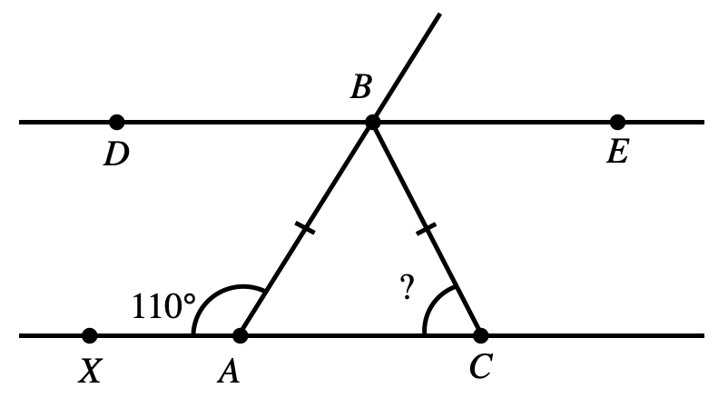
- 35°
- 40°
- 55°
- 70°
- 110°

Answer： D

5.Regular hexagon ABCDEF is inscribed in a circle, as shown below. If the length of radius OD is 15 centimeters, how long is AB, in centimeters?
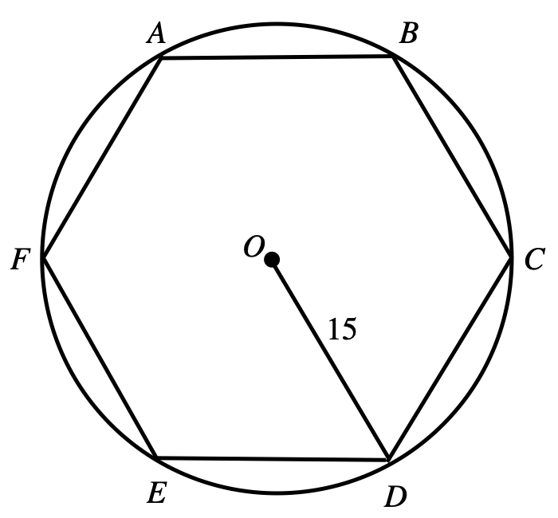

- 15
- 18
- 30
- 5π
- 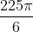

Answer： A

PART 3 - 阅读
Passage I
PROSE FICTION: This passage is adapted from "A New England Nun," a short story by Mary Wilkins Freeman (©1979 by The New American Library, Inc.).

Louisa was slow and still in her movements; it took her a long time to prepare her tea; but when ready it was set forth with as much grace as if she had been a veritable guest to her own self. The little square table stood exactly in the centre of the kitchen, and was covered with a starched linen cloth whose border pattern of flowers glistened. Louisa· had a damask napkin on her tea-tray, where were arranged a cut-glass tumbler full of teaspoons, a silver cream-pitcher, a china sugar-bowl, and one pink china cup and saucer. Louisa used china every day—something which none of her neighbors did. They whispered about it among themselves Their daily tables were laid with common crockery, their sets of best china stayed in the parlor closet, and Louisa Ellis was no richer nor better bred than they. Still she would use the china. She had for her supper a glass dish full of sugared currants, a plate of little cakes, and one of light white biscuits. Also a leaf or two of lettuce, which she cut up daintily. Louisa was very fond of lettuce, which she raised to perfection in her little garden. She ate quite heartily, though in a delicate, pecking way; it seemed almost surprising that any considerable bulk of the food should vanish.

After tea she filled a plate with nicely baked thin corn-cakes, and carried them out into the back-yard.
"Caesar!" she called. "Caesar! Caesar!"

There was a little rush, and the clank of a chain, and a large yellow-and-white dog appeared at the door of his tiny hut, which was half hidden among the tall grasses and flowers. Louisa patted him and gave him the corn-cakes. Then she returned to the house and washed the tea-things, polishing the china carefully....Louisa took off her green gingham apron, disclosing a shorter one of pink and white print. She lighted her lamp, and sat down again with her sewing.

In about half an hour Joe Dagget came. She heard his heavy step on the walk, and rose and took off her pink-and-white apron. Under that was still another—white linen with a little cambric edging on the bottom; that was Louisa's company apron. She never wore it without her calico sewing apron over it unless she had a guest. She had barely folded the pink and white one with methodical haste and laid it in a table-drawer when the door opened and Joe Dagget entered.

He seemed to fill up the whole room. A little yellow canary that had been asleep in his green cage at the south window woke up and fluttered wildly, beating his little yellow wings against the wires. He always did so when Joe Dagget came into the room....

She placed a chair for him, and they sat facing each other, with the table between them. He sat bolt-upright, toeing out his heavy feet squarely, glancing with a good-humored uneasiness around the room. She sat gently erect, folding her slender hands in her white-linen lap.
"Been a pleasant day," remarked Dagget.

"Real pleasant," Louisa assented, softly. "Have you been haying?" she asked, after a little while.

"Yes.... Pretty hot work."...

Presently Dagget began fingering the books on the table. There was a square red autograph album, and a Young Lady's Gift-Book which had belonged to Louisa's mother. He took them up one after the other and opened them; then laid them down again, the album on the Gift-Book.

Louisa kept eyeing them with mild uneasiness. Finally she rose and changed the position of the books, putting the album underneath. That was the way they had been arranged in the first place.
Dagget gave an awkward little laugh. "Now what difference did it make which book was on top?" said he.
Louisa looked at him with a deprecating smile. "I always keep them that way," murmured she.

"You do beat everything," said Dagget, trying to laugh again. His large face was flushed.

He remained about an hour longer, then rose to take leave. Going out, he stumbled over a rug, and trying to recover himself, hit Louisa's work-basket on the table, and knocked it on the floor.

He looked at Louisa, then at the rolling spools; he ducked himself awkwardly toward them, but she stopped him. "Never mind," said she; "I'll pick them up after you're gone."...

Louisa got a dust-pan and brush, and swept Joe Dagget's track carefully.

If he could have known it, it would have increased his perplexity and uneasiness, although it would not have disturbed his loyalty in the least....

They were to be married in a month, after a singular courtship which had lasted for a matter of fifteen years. For fourteen out of the fifteen years the two had not once seen each other, and they had seldom exchanged letters.

- The first paragraph suggests that Louisa's neighbors consider her to be:
- a close friend.
- someone to be emulated.
- a bit odd and stuck up.
- a rich eccentric.

Answer： C
2. It is reasonable to infer from the passage that Joe trips on Louisa's rug because he is:
I. usually reckless and careless.
II. always clumsy and weak.
III. feeling uneasy at the moment.
- I only
- III only
- I and Ⅱ only
- II and Ⅲ only

Answer： B

3.The evidence in the passage most strongly supports an inference that when he is at Louisa's house Joe primarily feels:
- uncomfortable.
- amused.
- happy.
- annoyed.

Answer： C

- It is reasonable to conclude from the sequence of events narrated in the passage that Louisa tells Joe she'll pick up the spools after he leaves because she:
- wants to reassure him that the mess is unimportant to her.
- is trying to get him to pay more attention to her.
- blames herself for leaving the work-basket where it could be knocked over.
- fears that if he does it, he'll only create more disorder.

Answer： D

- The phrase "a veritable guest to her own self" (highlighted portion) most strongly suggests that Louisa:
- pretends that she has visitors.
- wishes she had company.
- treats herself well.
- is self-effacing and ill-at-ease in her own home.

Answer： C

PART 4 - 科学
Passage Ⅰ
Students debate 4 hypotheses regarding the Moon's origin, based on the following observations.
Observations
Observation 1 - Earth and the Moon have the same proportions of various oxygen isotopes (forms of oxygen).
Observation 2 - The same minerals that compose terrestrial lavas are also found in lunar lava specimens.
Observation 3 - The Moon contains little or no water.
Observation 4 - Earth contains a much higher percentage of iron than does the Moon.
Observation 5 - Fossil records show that the length of Earth's day used to be shorter.
Observation 6 - Collisions between Mars and other objects have resulted in the ejection of material from Mars's surface. Some of the ejected material has reached Earth.
Hypothesis 1
All of the material that formed the Moon came from Earth. The rate of Earth's spin on its axis was high enough at one time to eject material from Earth's surface. This material was unable to escape Earth's gravity and went into orbit around Earth, forming the Moon.
Hypothesis 2
The material that composes the Moon came mostly from Earth's surface. A large object from another part of the solar system collided with Earth and threw the surface material into orbit around Earth. Some of the differences in composition between Earth and the Moon might be accounted for by the composition of matter from the large object.
Hypothesis 3
The Moon was never a part of Earth, because Earth's and the Moon's chemical compositions have too few similarities. The Moon and Earth probably formed within the same cloud of gas and dust, when large clumps of gas and dust in the cloud gravitationally attracted additional materials from the cloud. (The collapse of clouds of gas and dust also results in the formation of stars.)
Hypothesis 4
The Moon most likely came from somewhere in the solar system far from Earth. As the Moon approached Earth, it was attracted more strongly by Earth's gravitational field. Although the Moon speeded up as it approached Earth, it was not moving fast enough as it passed Earth to escape Earth's gravity. Consequently, it entered into orbit around Earth.

- According to Hypothesis 2, the origin of most of the matter composing the Moon was most likely which of the following objects?
- A star far from the Sun
- Earth
- Mars
- The Sun

Answer： B

- Supporters of Hypothesis l would most likely agree that at the time the Moon formed, the rotation rate of Earth on its axis was:
- fewer than 1 rotation per year.
- 100 rotations per year.
- 365 rotations per year.
- many more than 365 rotations per year.

Answer： D

- Suppose that supporters of Hypothesis 2 suggested that the Moon contained a significant amount of water when it was first formed. Which of the following statements about the Moon's water content would be most consistent with their suggestion?
- The Moon's water content decreased after the Moon was formed.
- The Moon's water content increased rapidly after the Moon was formed.
- The Moon's water content increased slowly after the Moon was formed.
- The Moon's water content was constant after the Moon was formed.

Answer： A

- Hypothesis 3 includes the assertion that Earth and the Moon probably formed from the same cloud of gas and dust, most likely to explain which of the following pairs of observations?
- Observations 1 and 2
- Observations 2 and 3
- Observations 2 and 4
- Observations 3 and 4

Answer： A

- The 4 hypotheses discuss 4 possible mechanisms for the Moon's formation. The 4 mechanisms all depend the most on which of the following influences?
- Gravity
- Earth's rotation
- The Moon's rotation
- Volcanic action

Answer： A

