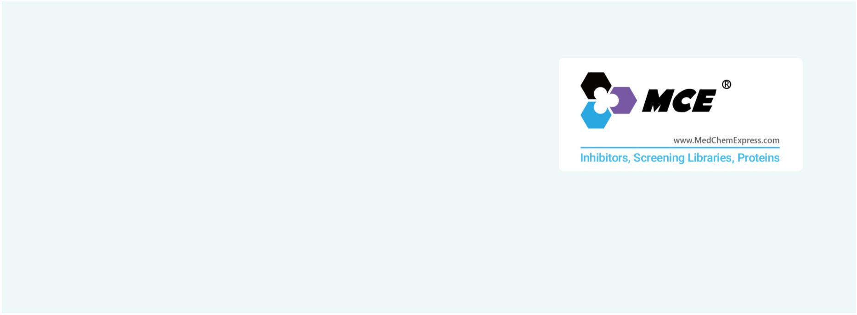RAR/RXR
Retinoic acid receptors; Retinoid X receptors
The nuclear retinoic acid receptors (RARs) are transcriptional transregulators, which control the expression of specific gene subsets
subsequently to ligand binding and to strictly controlled phosphorylation processes. RARs consist of three subtypes, α (NR1B1), β
(NR1B2) and γ (NR1B3), encoded by separate genes. RARs function as ligand-dependent transcriptional regulators, heterodimerized
with retinoid X receptors (RXRs), which also consist of three types, α NR2B1, β (NR2B2) and γ (NR2B3). RARs play critical roles in a
variety of biological processes, including development, reproduction, immunity, organogenesis and homeostasis, as assessed by
vitamin A-deficiency (VAD), pharmacological and genetic studies conducted in the mouse.
Retinoid X receptor (RXR) belongs to a family of ligand-activated transcription factors that regulate many aspects of metazoan life.
A class of nuclear receptors requires RXR as heterodimerization partner for their function.
www.MedChemExpress.com 1
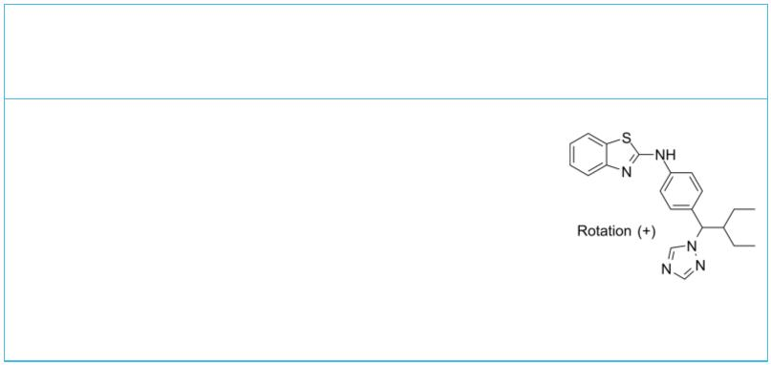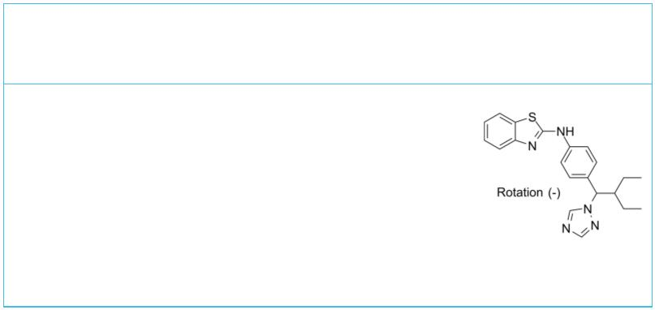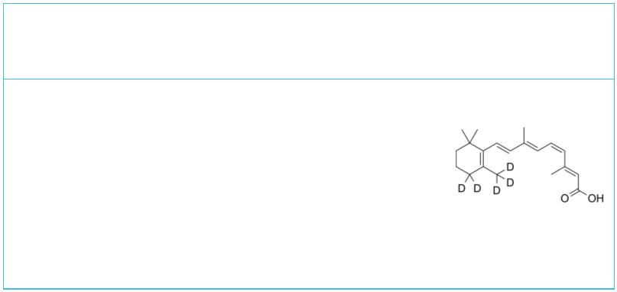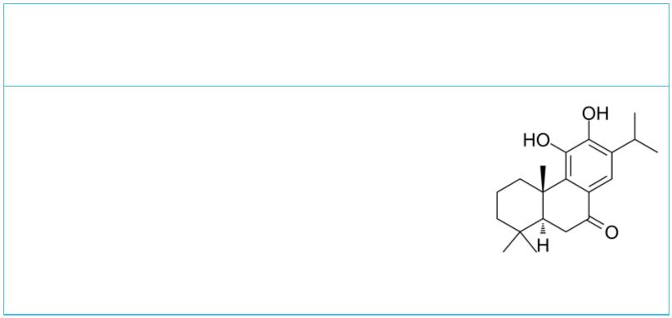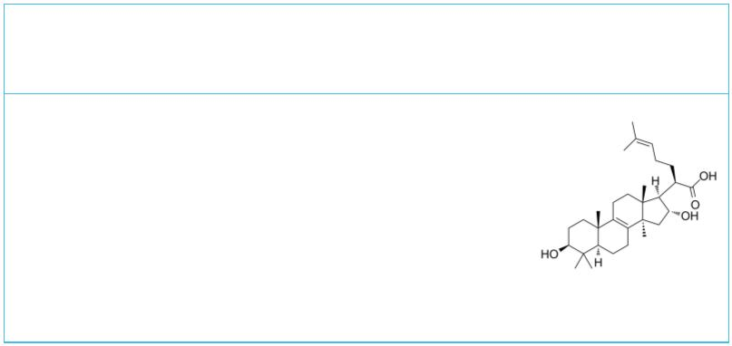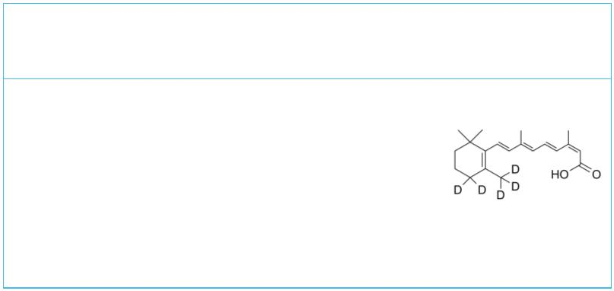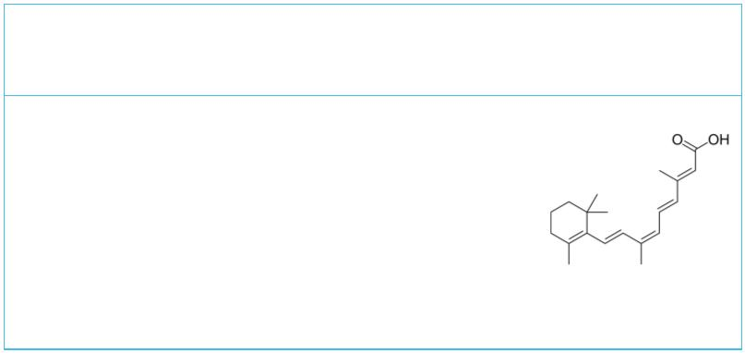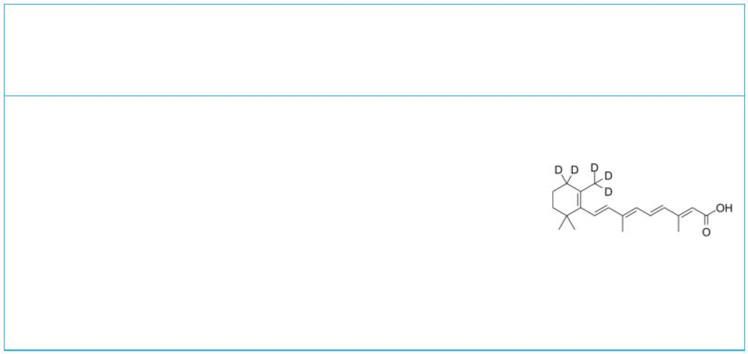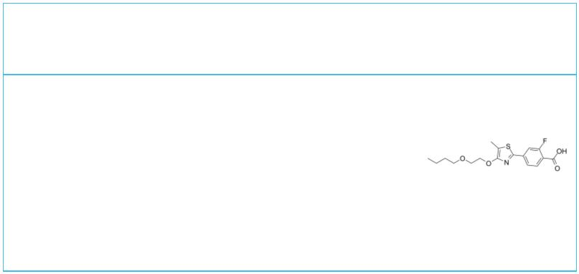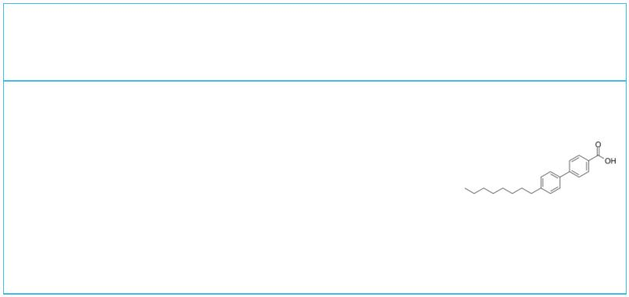RAR/RXR Inhibitors, Agonists, Antagonists, Activators & Modulators
 | (+)-Talarozole (-)-Talarozole
 |  |  | Cat. No.: HY-14802C Cat. No.: HY-14802D
 | (+)-Talarozole is a potent inhibitor of retinoic  acid metabolism extracted from patent WO 1997049704  A1. |  |  |  |  |  | (-)-Talarozole is a potent inhibitor of retinoic  acid metabolism extracted from patent WO 1997049704  A1.
 | Purity: 99.28%  Clinical Data: No Development Reported  Size: 10 mM × 1 mL, 1 mg, 5 mg, 10 mg, 25 mg, 50 mg |  |  |  |  |  | Purity: 98.02%  Clinical Data: No Development Reported  Size: 10 mM × 1 mL, 1 mg, 5 mg, 10 mg, 25 mg, 50 mg
 | 11-cis-Retinoic Acid-d5 11-Hydroxysugiol
 |  | Cat. No.: HY-14649S2 Cat. No.: HY-107218
 | 11-cis-Retinoic Acid-d5 is the deuterium labeled  Retinoic acid. Retinoic acid is a metabolite of  vitamin A that plays important roles in cell  growth, differentiation, and organogenesis. |  |  |  |  |  | 11-Hydroxysugiol regulates the SUMOylation of  intracellular receptors by modulating RARα and  vitamin D₃ receptor (VDR).
 | Purity: >98%  Clinical Data: No Development Reported  Size: 500 μg, 5 mg |  |  |  |  |  | Purity: >98%  Clinical Data: No Development Reported  Size: 1 mg, 5 mg
 | 16α-Hydroxytrametenolic acid 9-cis,13-cis-Retinoic acid-d5
 |  |  |  |  | Cat. No.: HY-N2992 Cat. No.: HY-15127S2
 | 16α-Hydroxytrametenolic acid, a natural  triterpene, is a potential retinoid X receptor  (RXR) selective agonist. |  |  |  |  |  | 9-cis,13-cis-Retinoic acid-d5 is the deuterium  labeled Isotretinoin. Isotretinoin  (13-cis-Retinoic acid) is a medication used for  the treatment of severe acne.
 | Purity: >98%  Clinical Data: No Development Reported  Size: 5 mg, 10 mg, 25 mg |  |  |  |  |  | Purity: >98%  Clinical Data: No Development Reported  Size: 1 mg, 5 mg
 | 9-cis-Retinoic acid 9-cis-Retinoic acid-d5
 | (ALRT1057) Cat. No.: HY-15128 |  |  |  |  |  |  |  |  |  |  |  |  |  |  |  |  |  |  |  | Cat. No.: HY-132334S
 | 9-cis-Retinoic acid (ALRT1057), a vitamin A  derivative, is a potent RAR/RXR agonist.  9-cis-Retinoic acid induces apoptosis, regulates  cell cycle and has anticancer, anti-inflammatory  and neuroprotection activities. |  |  |  |  |  | 9-cis-Retinoic acid-d5 (ALRT1057-d5) is the  deuterium labeled 9-cis-Retinoic acid.  9-cis-Retinoic acid (ALRT1057), a vitamin A  derivative, is a potent RAR/RXR agonist.
 | Purity: 95.15%  Clinical Data: Launched  Size: 5 mg |  |  |  |  |  | Purity: >98%  Clinical Data: No Development Reported  Size: 1 mg, 5 mg, 10 mg
 | AC-261066 AC-55649
 |  |  |  | Cat. No.: HY-108532 Cat. No.: HY-108526
 | AC-261066 is a potent, orally available and  isoform-selective retinoic acid beta2 (RARbeta2)  receptor agonist, with a pEC of 8.0.  50 |  |  |  |  |  | AC-55649 is a potent, highly isoform-selective  agonist of human RARβ2 receptor, with a pEC  of 6.9.  50
 | Purity: >98%  Clinical Data: No Development Reported  Size: 1 mg, 5 mg |  |  |  |  |  | Purity: 99.93%  Clinical Data: No Development Reported  Size: 10 mM × 1 mL, 5 mg, 10 mg, 25 mg
2 Tel: 609-228-6898 Fax: 609-228-5909 Email: sales@MedChemExpress.com
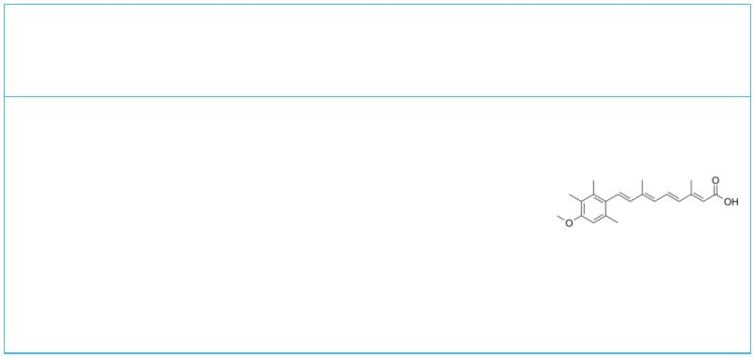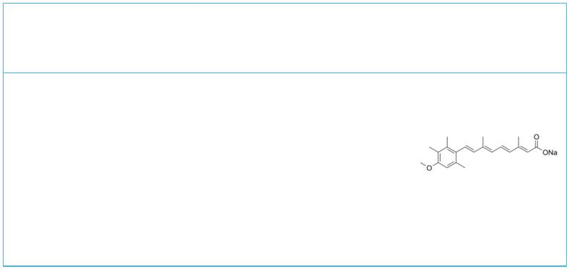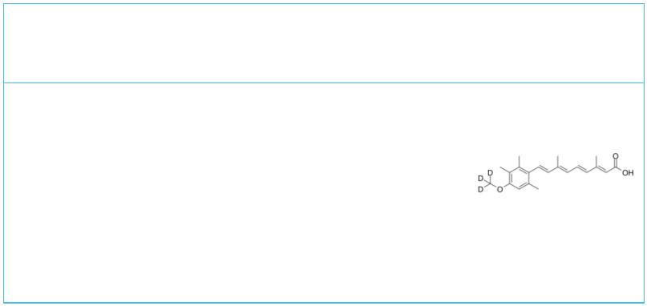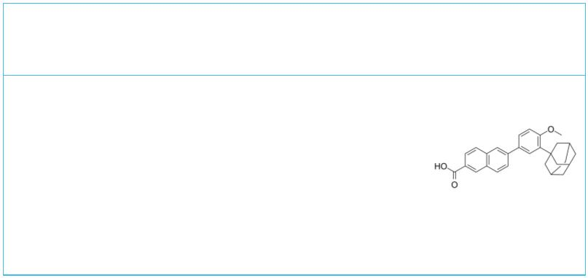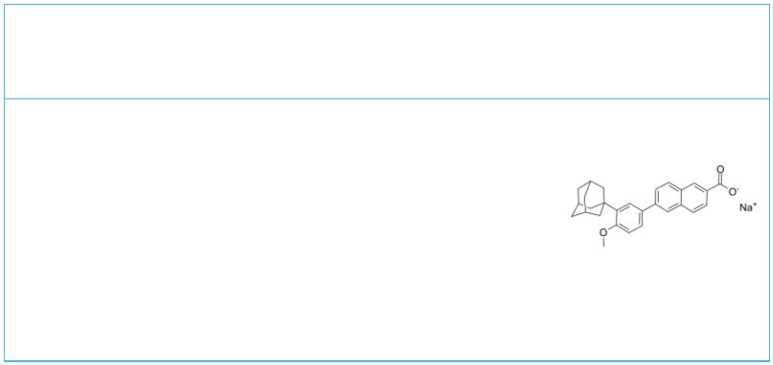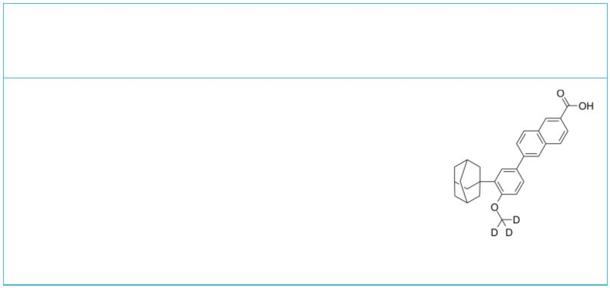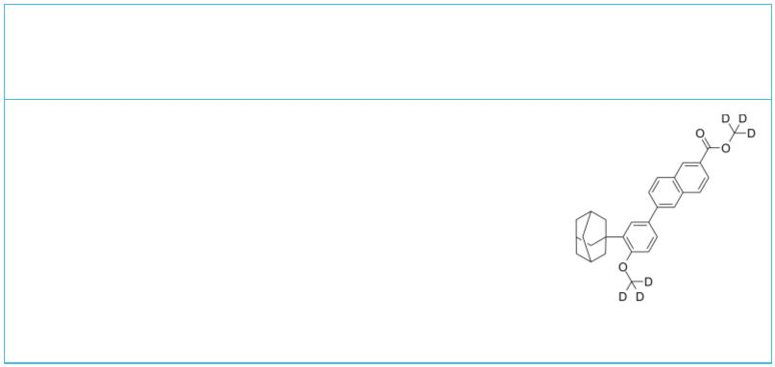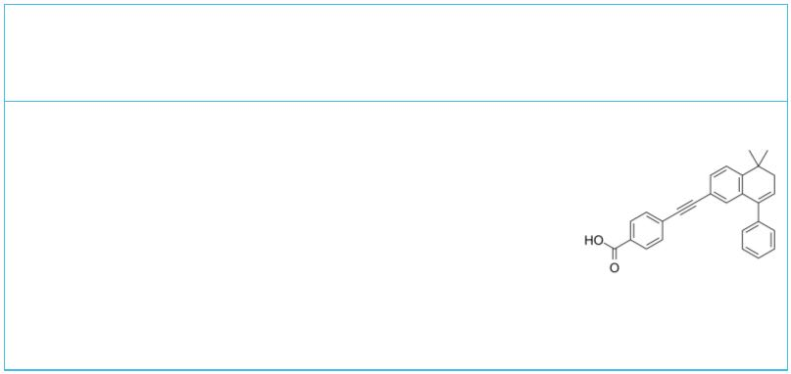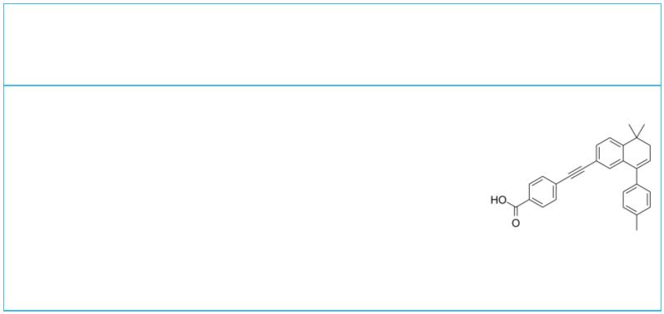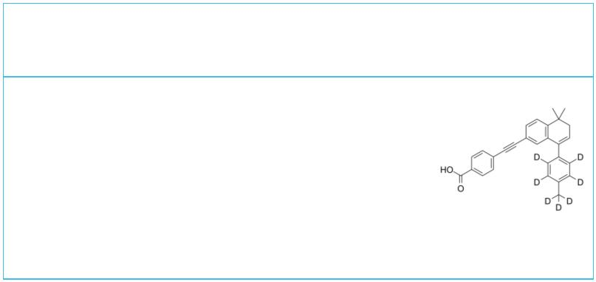Acitretin  (Ro 10-1670) Cat. No.: HY-B0107 |  |  |  | Acitretin sodium  (Ro 10-1670 sodium) Cat. No.: HY-B0107A
Acitretin (Ro 10-1670) is a second-generation,  systemic retinoid that has been used in the  treatment of psoriasis. Acitretin also can be used  for the research of Alzheimer’s disease. |  |  |  | Acitretin (Ro 10-1670) sodium is a  second-generation, systemic retinoid that has been  used in the treatment of psoriasis. Acitretin  sodium also can be used for the research of  Alzheimer’s disease.
Purity: 99.79%  Clinical Data: Launched  Size: 10 mM × 1 mL, 100 mg, 200 mg, 500 mg |  |  |  | Purity: >98%  Clinical Data: Launched  Size: 1 mg, 5 mg
Acitretin-d3  (Ro 10-1670-d3) Cat. No.: HY-B0107S |  |  |  | Adapalene  (CD271) Cat. No.: HY-B0091
Acitretin-d3 (Ro 10-1670-d3) is the deuterium  labeled Acitretin. Acitretin (Ro 10-1670) is a  second-generation, systemic retinoid that has been  used in the treatment of psoriasis. Acitretin also  can be used for the research of Alzheimer’s  disease. |  |  |  | Adapalene (CD271), a third-generation synthetic  retinoid, is widely used for the research of acne.  Adapalene is a potent RAR agonist, with AC s  50  of 2.3 nM, 9.3 nM, and 22 nM for RARβ, RARγ,  RARα, respectively.
Purity: >98%  Clinical Data: No Development Reported  Size: 1 mg, 5 mg |  |  |  | Purity: ≥98.0%  Clinical Data: Launched  Size: 10 mM × 1 mL, 50 mg, 100 mg, 500 mg
Adapalene sodium salt  (CD 271 sodium salt) Cat. No.: HY-B0091A |  |  |  | Adapalene-d3 |  |  |  |  |  |  |  |  |  |  |  | Cat. No.: HY-B0091S
Adapalene (CD271) sodium salt, a third-generation  synthetic retinoid, is widely used for the  research of acne. Adapalene sodium salt is a  potent RAR agonist, with AC s of 2.3 nM, 9.3  50  nM, and 22 nM for RARβ, RARγ, RARα,  respectively. |  |  |  | Adapalene-d3 is the deuterium labeled Adapalene.  Adapalene (CD271), a third-generation synthetic  retinoid, is widely used for the research of acne.  Adapalene is a potent RAR agonist, with AC s  50  of 2.3 nM, 9.3 nM, and 22 nM for RARβ, RARγ,  RARα, respectively.
Purity: >98%  Clinical Data: Launched  Size: 1 mg, 5 mg |  |  |  | Purity: >98%  Clinical Data: No Development Reported  Size: 1 mg, 10 mg
Adapalene-d6 Methyl Ester AGN 192870
 | Cat. No.: HY-B0091S1 Cat. No.: HY-105689
Adapalene-d6 Methyl Ester is the deuterium labeled  Adapalene. Adapalene (CD271), a third-generation  synthetic retinoid, is widely used for the  research of acne. Adapalene is a potent RAR  agonist, with AC s of 2.3 nM, 9.3 nM, and 22 nM  50  for RARβ, RARγ, RARα, respectively. |  |  |  | AGN 192870 is a RAR neutral antagonist with K s  d  of 147, 33, and 42 nM for RARα, RARβ, and RARγ,  respectively. AGN 192870 shows IC s of 87 and 32  50  nM for RARαand RARγ, respectively. AGN 192870  shows RARβ partial agonism.
Purity: >98%  Clinical Data: No Development Reported  Size: 10 mg, 100 mg |  |  |  | Purity: >98%  Clinical Data: No Development Reported  Size: 1 mg, 5 mg
AGN 193109 AGN 193109-d7
 |  | Cat. No.: HY-U00449 Cat. No.: HY-U00449S
AGN 193109 is a retinoid analog, and acts as a  specific and highly effective antagonist of  retinoic acid receptors (RARs), with K s of 2  d  nM, 2 nM, and 3 nM for RARα, RARβ, and RARγ,  respectively. |  |  |  | AGN 193109-d7 is the deuterium labeled AGN 193109.  AGN 193109 is a retinoid analog, and acts as a  specific and highly effective antagonist of  retinoic acid receptors (RARs), with K s of 2  d  nM, 2 nM, and 3 nM for RARα, RARβ, and RARγ,  respectively.
Purity: 99.31%  Clinical Data: No Development Reported  Size: 5 mg, 10 mg, 25 mg |  |  |  | Purity: >98%  Clinical Data: No Development Reported  Size: 1 mg, 10 mg
www.MedChemExpress.com 3
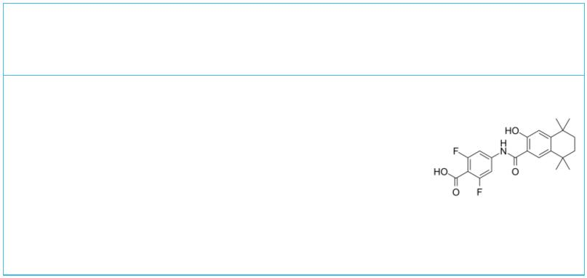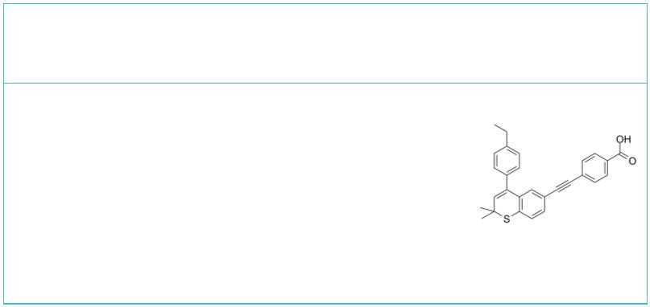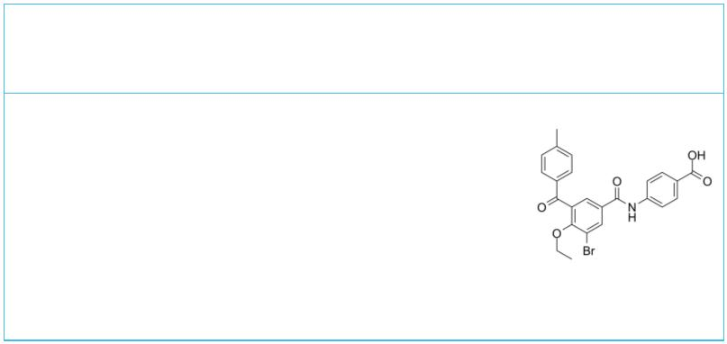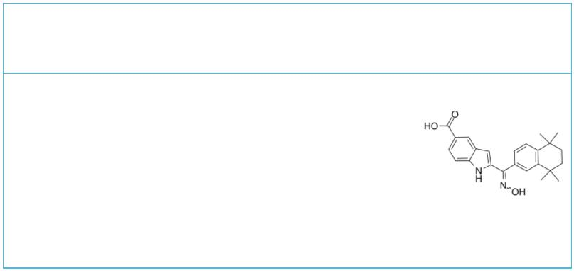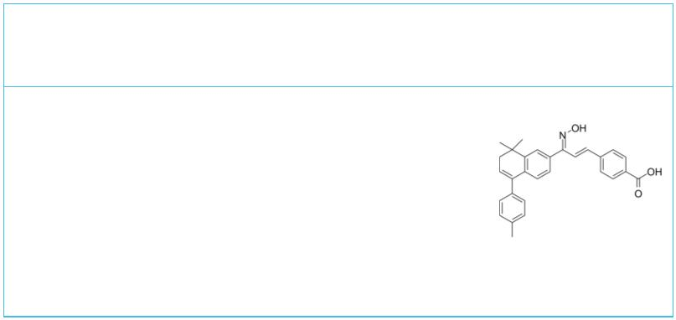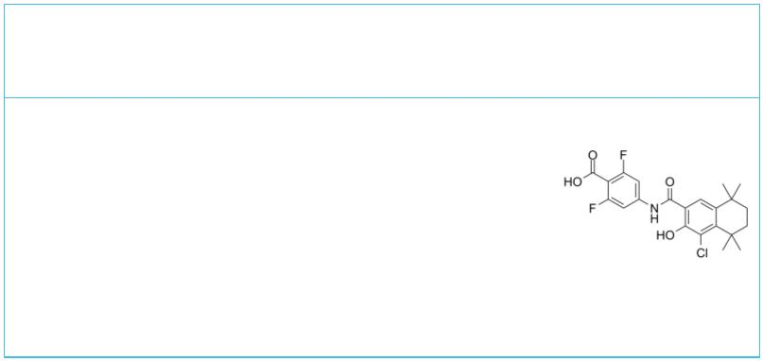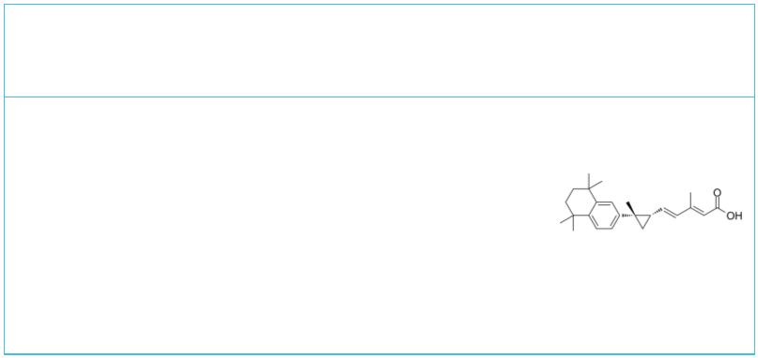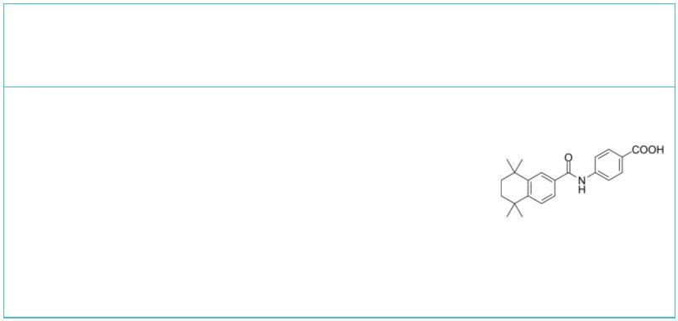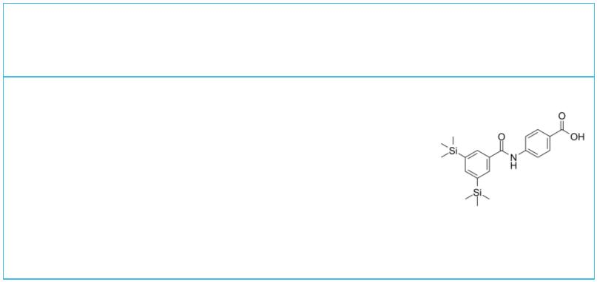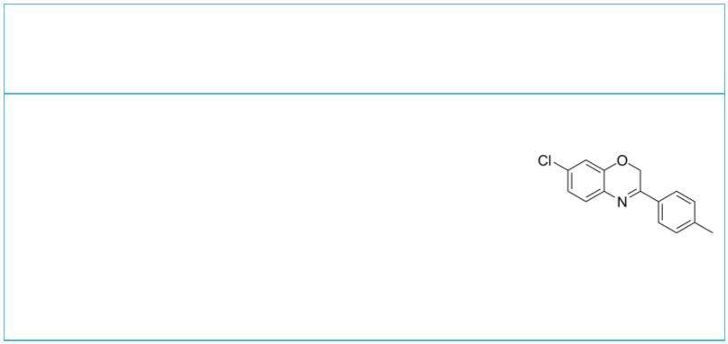 | AGN 194078 |  | Cat. No.: HY-100273 |  |  |  | AGN 194310  (VTP-194310) Cat. No.: HY-16681
 | AGN 194078 is a selective RARα agonist with a  K_{d} and EC₅₀ of 3 and 112 nM, respectively. |  |  |  |  |  | AGN 194310 (VTP-194310) is a high affinity, potent  and selective retinioic acid receptors (RARs)  pan-antagonist with K values of 3 nM, 2 nM, 5 nM  d  for RARα, RARβ, RARγ, respectively.
 | Purity: >98%  Clinical Data: No Development Reported  Size: 1 mg, 5 mg, 10 mg, 25 mg, 50 mg |  |  |  |  |  | Purity: 98.01%  Clinical Data: No Development Reported  Size: 1 mg, 5 mg, 10 mg, 25 mg, 50 mg
 | AGN 196996 AGN 205327
 |  |  |  |  | Cat. No.: HY-16682 Cat. No.: HY-16685
 | AGN 196996 is a potent and selective RARα  antagonist with Ki value of 2 nM; little binding  affinity for RARβ(Ki=1087 nM) and RARγ(Ki=8523  nM). |  |  |  |  |  | AGN 205327 is a potent synthetic RARs agonist with  EC50 of 3766/734/32 nM for RARα/β/γ respectively;  no inhibition on RXR. IC50 value: 3766/734/32 nM  for RARα/β/γ Target: RAR agonist.
 | Purity: 99.37%  Clinical Data: No Development Reported  Size: 1 mg, 5 mg |  |  |  |  |  | Purity: >98%  Clinical Data: No Development Reported  Size: 1 mg, 5 mg
 | AGN 205728 |  |  |  | Cat. No.: HY-16683 |  | AGN-195183  (IRX-5183; VTP-195183; NRX-195183) Cat. No.: HY-16684
 | AGN 205728 is a potent and selective RARγ  antagonist with Ki/IC95 values of 3 nM/ 0.6 nM; no  inhibiton on RARα and RARβ. IC50 value: 3 nM/ 0.6  nM(Ki/IC95) Target: RARγ antagonist More  information can be found in the following patent,  Compound 7a. |  |  |  |  |  | AGN-195183 (IRX-5183) is a potent and selective  agonist of RARα (K =3 nM) with improved binding  d  selectivity relative to AGN 193836. AGN-195183 has  no activity on RARβ/γ.
 | Purity: 96.66%  Clinical Data: No Development Reported  Size: 1 mg, 5 mg |  |  |  |  |  | Purity: 99.76%  Clinical Data: No Development Reported  Size: 10 mM × 1 mL, 5 mg, 10 mg, 25 mg, 50 mg
 | AGN194204 AM580
 | (IRX4204; NRX194204; VTP 194204) Cat. No.: HY-13717 (CD336; NSC608001; Ro 40-6055) Cat. No.: HY-10475
 | AGN194204 (IRX4204) is an orally active and  selective RXR agonist with K values 0.4 nM,  d  3.6 nM and 3.8 nM and EC s of 0.2 nM, 0.8 nM  50  and 0.08 nM for RXRα, RXRβ and RXRγ,  respectively. AGN194204 is inactive against RAR. |  |  |  |  |  | AM580 is a selective RARα agonist with IC and  50  EC of 8 nM and 0.36 nM, respectively.  50
 | Purity: ≥99.0%  Clinical Data: Phase 2  Size: 1 mg, 5 mg |  |  |  |  |  | Purity: 99.61%  Clinical Data: No Development Reported  Size: 10 mM × 1 mL, 5 mg, 10 mg, 50 mg, 100 mg
 | Amsilarotene AR7
 | (TAC-101; Am 555S) Cat. No.: HY-14653 |  |  |  |  |  |  |  |  |  |  |  |  |  |  |  |  |  |  |  | Cat. No.: HY-101106
 | Amsilarotene (TAC-101; Am 555S), an orally active  synthetic retinoid, has selective affinity for  retinoic acid receptor α (RAR-α) binding with K  i  of 2.4, 400 nM for RAR-α and RAR-β. |  |  |  |  |  | AR7 is an atypical RARA/RARα (retinoic acid  receptor, alpha) antagonist. AR7 specifically  activates chaperone-mediated-autophagy (CMA)  activity without affecting macroautophagy.
 | Purity: 99.70%  Clinical Data: No Development Reported  Size: 5 mg, 10 mg, 25 mg, 50 mg, 100 mg |  |  |  |  |  | Purity: 98.85%  Clinical Data: No Development Reported  Size: 10 mM × 1 mL, 5 mg, 10 mg, 25 mg, 50 mg, 100 mg
4 Tel: 609-228-6898 Fax: 609-228-5909 Email: sales@MedChemExpress.com
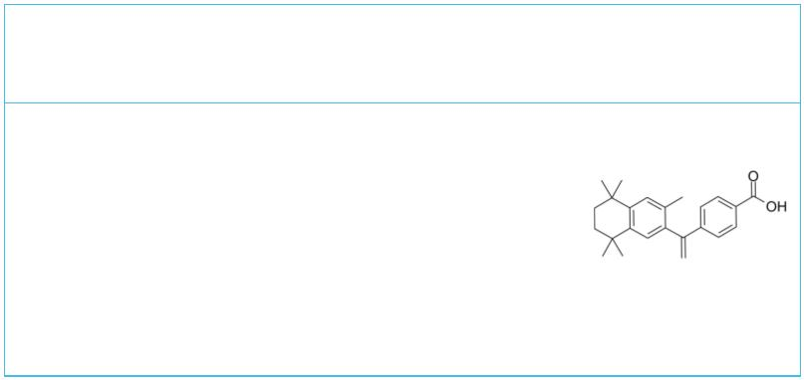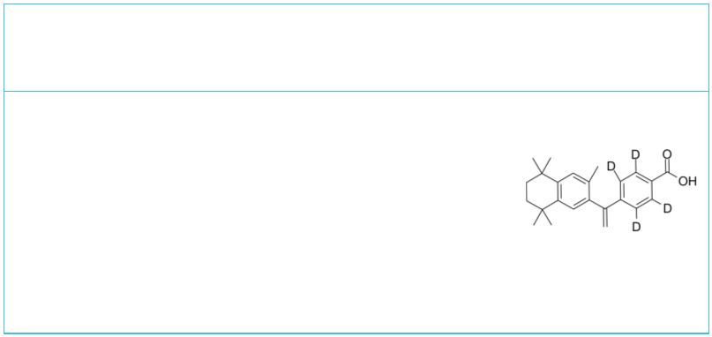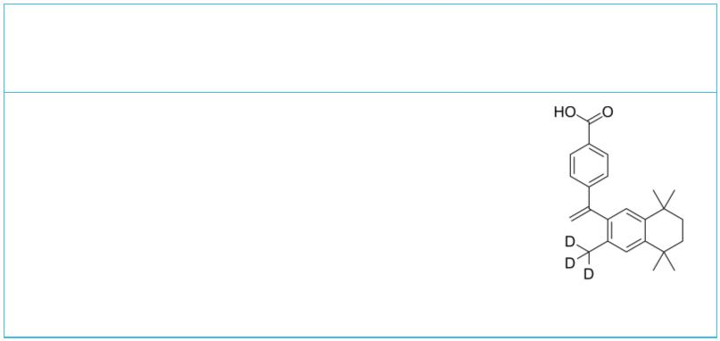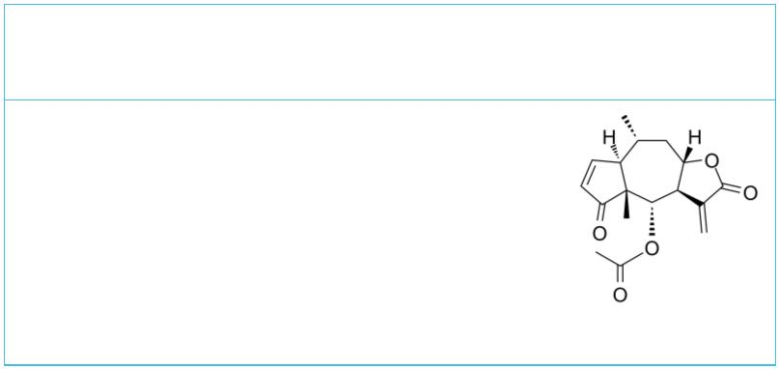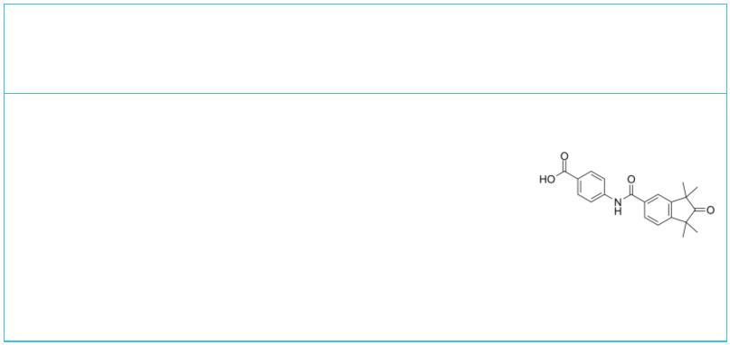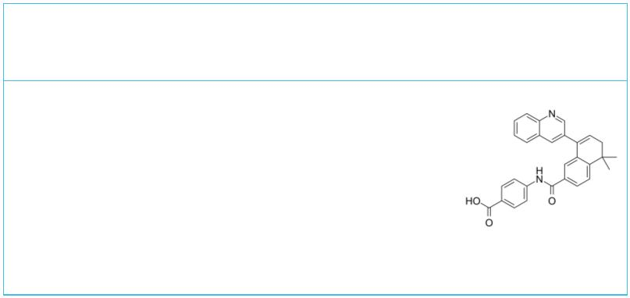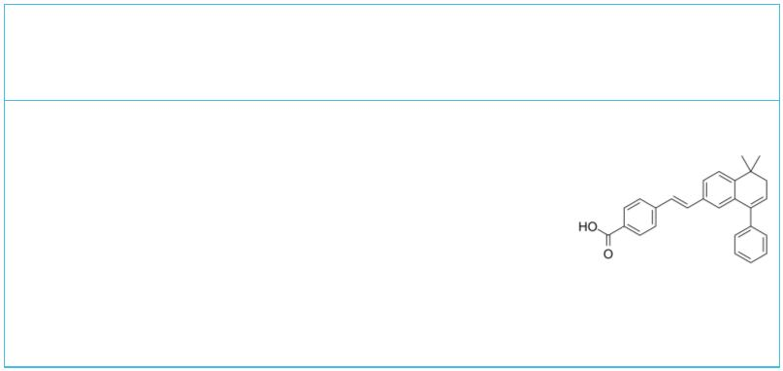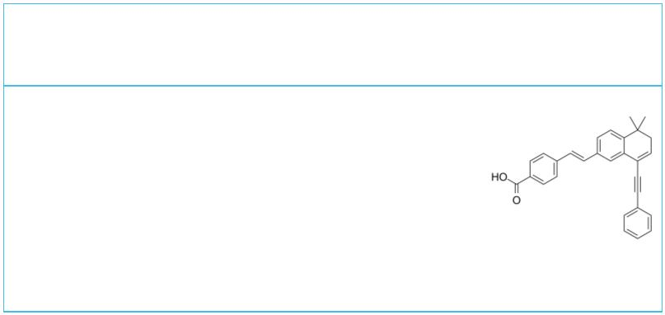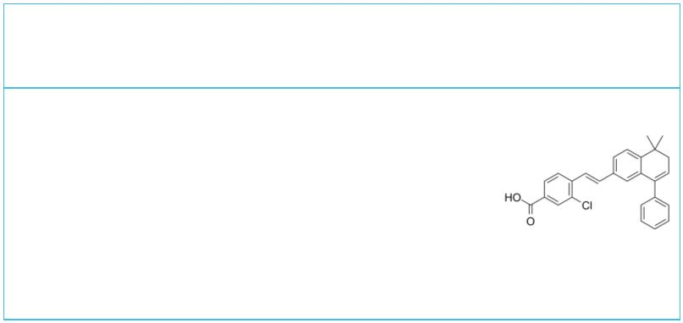ATRA-biotin  (Biotin-ATRA-conjugate) Cat. No.: HY-141793 |  |  | Bexarotene  (LGD1069) Cat. No.: HY-14171
ATRA-biotin (Biotin-ATRA-conjugate) is a  biotin-conjugated ATRA. ATRA-biotin can be used to  track ATRA in cells or a given tissue.  Purity: >98%  Clinical Data: No Development Reported  Size: 1 mg, 5 mg |  |  | Bexarotene (LGD1069) is a high-affinity and  selective retinoid X receptors  (RXR) agonist with EC s of 33, 24, 25  50  nM for RXRα, RXRβ, and RXRγ, respectively.  Bexarotene shows limited affinity for RAR  receptors (EC >10000 nM).  50  Purity: 99.90%  Clinical Data: Launched  Size: 10 mM × 1 mL, 50 mg, 100 mg, 500 mg
Bexarotene D4  (LGD1069 D4) Cat. No.: HY-14171S |  |  | Bexarotene-d3 |  |  |  |  |  |  |  |  |  |  | Cat. No.: HY-14171S1
Bexarotene D4 is a deuterium labeled Bexarotene  (LGD1069). Bexarotene (LGD1069) is a selective  retinoid X receptors (RXR) agonist for the  treatment of cutaneous T-cell lymphoma. |  |  | Bexarotene-d3 (LGD1069-d3) is the deuterium  labeled Bexarotene. Bexarotene (LGD1069) is a  high-affinity and selective retinoid X  receptors (RXR) agonist with EC s of  50  33, 24, 25 nM for RXRα, RXRβ, and RXRγ,  respectively.
Purity: >98%  Clinical Data: No Development Reported  Size: 1 mg, 5 mg |  |  | Purity: >98%  Clinical Data:  Size: 2.5 mg, 1 mg, 5 mg, 10 mg
Bigelovin BMS 753
 | Cat. No.: HY-116506 Cat. No.: HY-107395
Bigelovin, a sesquiterpene lactone isolated from  Inula helianthus-aquatica, is a selective retinoid  X receptor α agonist. Bigelovin suppresses tumor  growth through inducing apoptosis and autophagy  via the inhibition of mTOR pathway regulated by  ROS generation. |  |  | BMS 753 is an isotype-selective retinoic acid  receptor α (RARα) agonist, with a K of 2 nM.  i
Purity: 99.81%  Clinical Data: No Development Reported  Size: 5 mg, 10 mg |  |  | Purity: ≥99.0%  Clinical Data: No Development Reported  Size: 5 mg
BMS-195614 BMS453
(BMS 614) Cat. No.: HY-101259 (BMS-189453) Cat. No.: HY-100608
BMS-195614 (BMS 614) is a neutral RARα-selective  antagonist with a K of 2.5 nM.  i |  |  | BMS453 (BMS-189453), a synthetic retinoid, is a  RARβ agonist and a RARα/RARγ antagonist. BMS453  inhibits breast cell growth predominantly through  the induction of active TGFβ.
Purity: >98%  Clinical Data: No Development Reported  Size: 1 mg, 5 mg |  |  | Purity: 98.89%  Clinical Data: No Development Reported  Size: 5 mg
BMS493 BMS641
 | Cat. No.: HY-108529 |  | (BMS-209641) Cat. No.: HY-119518
BMS493 is an inverse pan-retinoic acid receptor  (RAR) agonist. BMS493 increases nuclear  corepressor interaction with RARs. BMS493 also  could prevent retinoic acid-induced  differentiation. |  |  | BMS641 (BMS-209641) is a selective RARβ agonist.  BMS641 has a higher affinity for RARβ (K , 2.5  d  nM) that is 100 times higher than that for RARα  (K , 225 nM) or RARγ (K , 223 nM).  d d
Purity: 98.46%  Clinical Data: No Development Reported  Size: 5 mg, 10 mg, 25 mg, 50 mg, 100 mg |  |  | Purity: >98%  Clinical Data: No Development Reported  Size: 1 mg, 5 mg
www.MedChemExpress.com 5
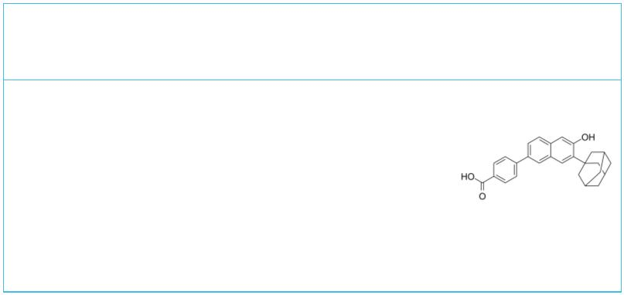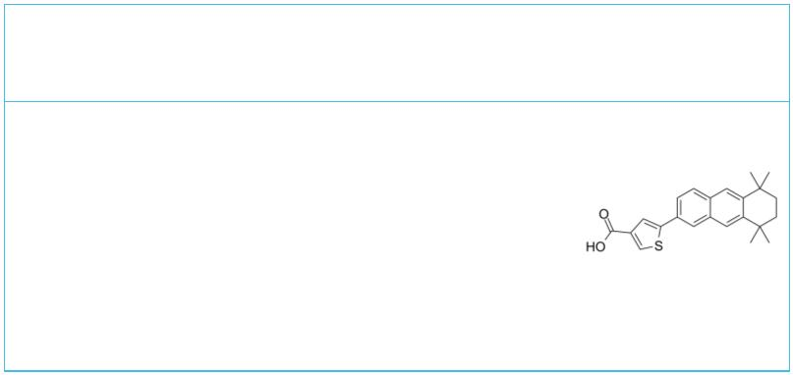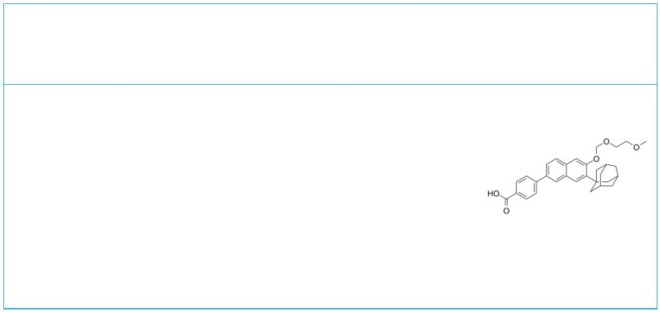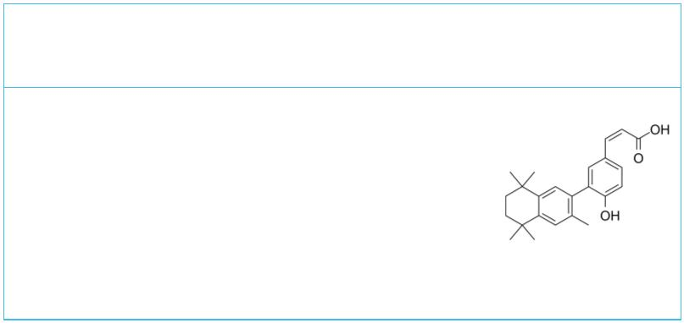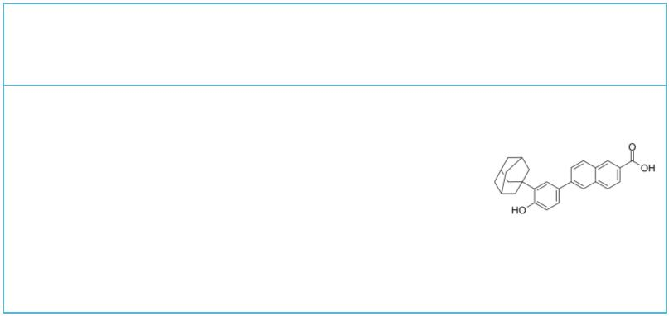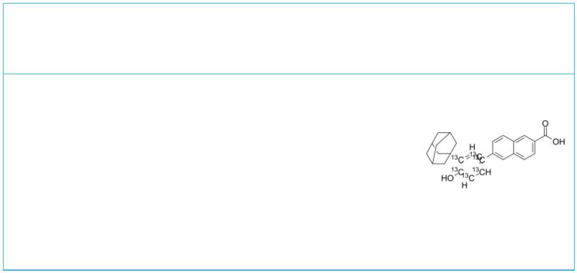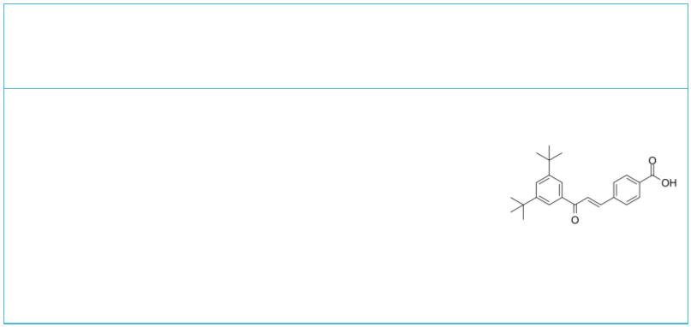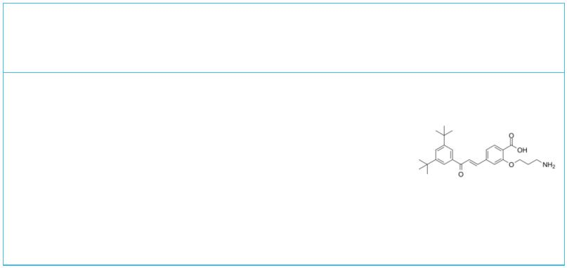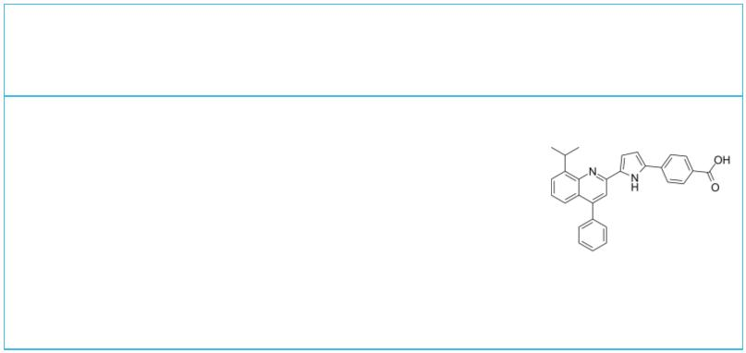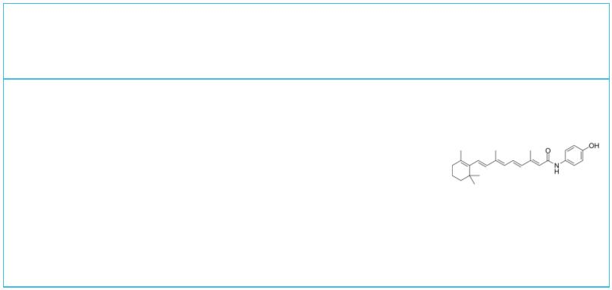 | CD1530 CD2314
 |  | Cat. No.: HY-108527 Cat. No.: HY-108533
 | CD1530 is a selective RARγ agonist with an K  d  of 150 nM. CD1530 has been used in combination  with bexarotene to inhibit oral carcinogenesis  induced by the carcinogen 4-nitroquinoline 1-oxide  in a mouse model of human oral-cavity and  esophageal squamous-cell carcinoma. |  |  | CD2314 is a potent and selective RARβ receptor  agonist with a K of 195 nM in S91 melanoma  d  cells.
 | Purity: >98%  Clinical Data: No Development Reported  Size: 1 mg, 5 mg |  |  | Purity: >98%  Clinical Data: No Development Reported  Size: 1 mg, 5 mg
 | CD2665 CD3254
 |  | Cat. No.: HY-107437 Cat. No.: HY-107399
 | CD2665 is a selective RAR-beta/gamma  antagonist, with K values of 110 nM, 306 nM for  i  RARγ and RARβ, respectively. |  |  | CD3254 a potent and selective retinoid-X-receptor  (RXR) agonist.
 | Purity: ≥99.0%  Clinical Data: No Development Reported  Size: 10 mM × 1 mL, 1 mg, 5 mg |  |  | Purity: 98.13%  Clinical Data: No Development Reported  Size: 10 mM × 1 mL, 5 mg, 10 mg, 25 mg, 50 mg
 | CD437  (AHPN) Cat. No.: HY-100532 |  |  | CD437-13C6  (AHPN-13C6) Cat. No.: HY-100532S
 | CD437 is a selective Retinoic Acid Receptor γ  (RARγ) agonist. |  |  | CD437-13C6 is the 13C- and deuterium labeled.  CD437 is a selective Retinoic Acid Receptor γ  (RARγ) agonist.
 | Purity: ≥98.0%  Clinical Data: No Development Reported  Size: 10 mM × 1 mL, 5 mg, 10 mg, 25 mg, 50 mg, 100 mg |  |  | Purity: >98%  Clinical Data:  Size: 1 mg, 5 mg
 | Ch55 Ch55-O-C3-NH2
 |  | Cat. No.: HY-107397 |  | (RAR ligand 1) Cat. No.: HY-111843
 | Ch55 is a potent synthetic retinoid. Ch55 binds to  RAR-α and RAR-β receptors with high affinity.  Ch55 displays low affinity for cellular retinoic  acid binding protein (CRABP). Ch55 is a potent  inducer of the differentiation of HL60 cells with  an EC of 200 nM.  50  Purity: 99.86%  Clinical Data: No Development Reported  Size: 5 mg, 10 mg, 25 mg |  |  | Ch55-O-C3-NH2 (RAR ligand 1) is a Ch 55-based  ligand, which targets RAR. Ch55-O-C3-NH2 (RAR  ligand 1) binds to cIAP1 ligand Bestatin via a  linker to form SNIPER.  Purity: >98%  Clinical Data: No Development Reported  Size: 1 mg, 5 mg
 | ER 50891 Fenretinide
 |  | Cat. No.: HY-108531 |  | (4-HPR) Cat. No.: HY-15373
 | ER-50891 is a potent antagonist of retinoic acid  receptor α(RARα). ER-50891 significantly  attenuates ATRA's inhibitive effects on BMP  2-induced osteoblastogenesis. |  |  | Fenretinide (4-HPR) is a synthetic retinoid  deriverative, binding to the retinoic acid  receptors (RAR) at concentrations necessary to  induce cell death.
 | Purity: >98%  Clinical Data: No Development Reported  Size: 1 mg, 5 mg |  |  | Purity: 99.08%  Clinical Data: Launched  Size: 10 mM × 1 mL, 10 mg, 50 mg, 100 mg
6 Tel: 609-228-6898 Fax: 609-228-5909 Email: sales@MedChemExpress.com
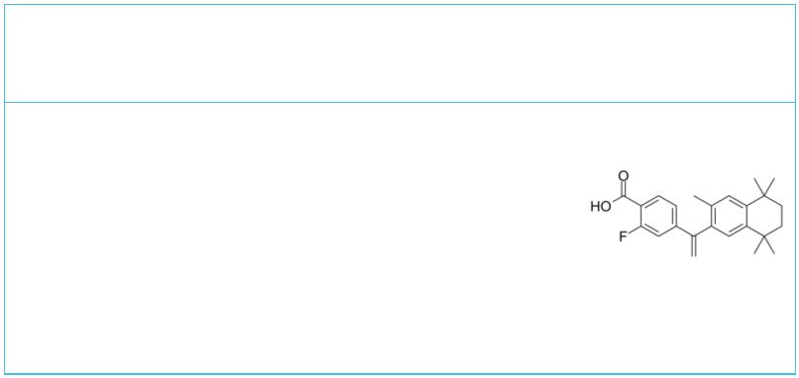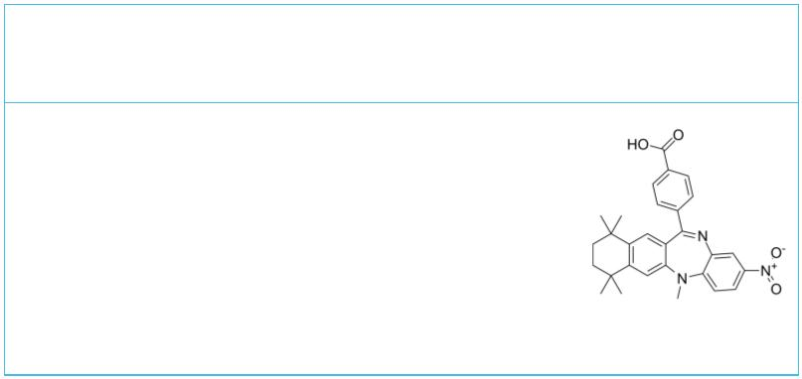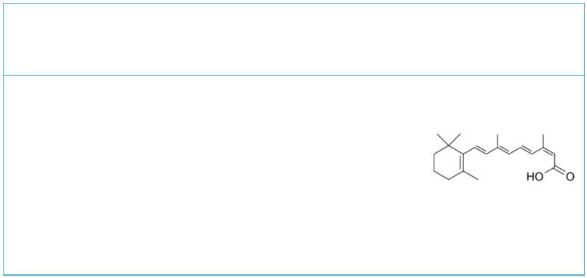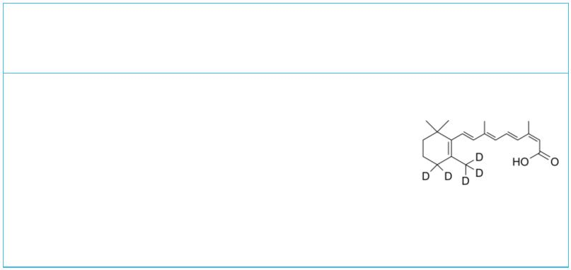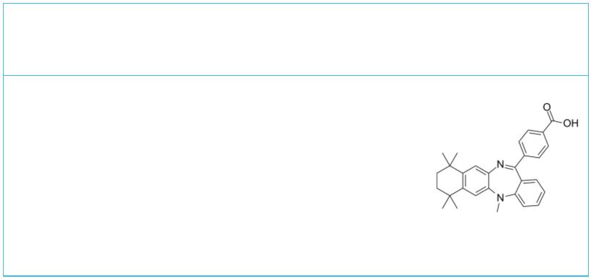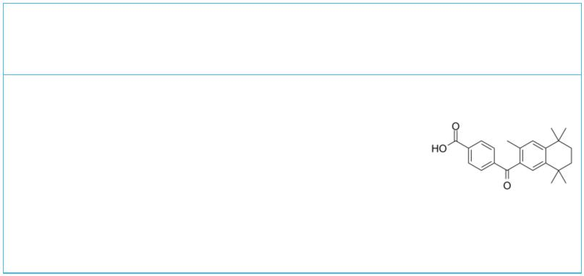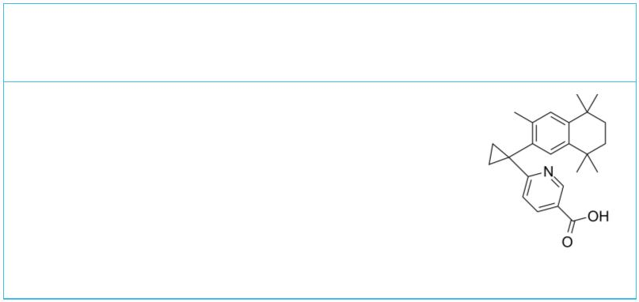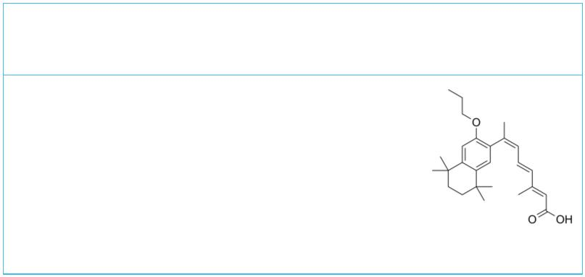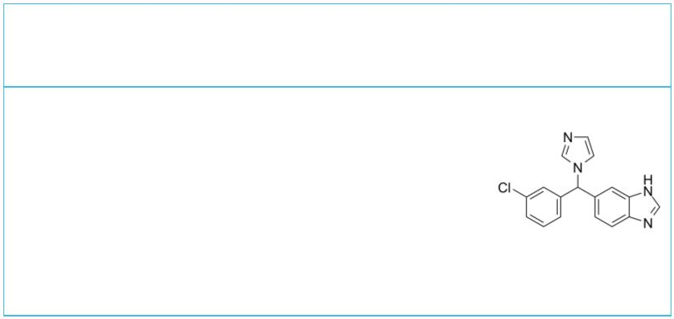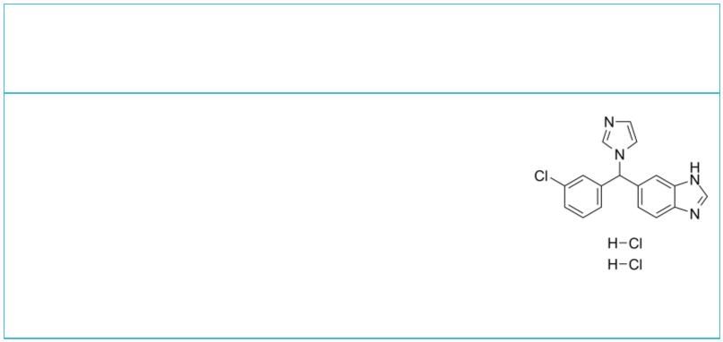Fluorobexarotene HX531
 | Cat. No.: HY-108525 Cat. No.: HY-108521
Fluorobexarotene (compound 20) is a potent  retinoid-X-receptor (RXR) agonist, with a K value  i  of 12 nM and an EC value of 43 nM for RXRα  50  receptor. Fluorobexarotene possesses an apparent  RXR binding affinity that is 75% greater than  Bexarotene. |  |  | HX531 is a potent RXR antagonist with an IC of  50  18 nM. It has been shown to reduce triglyceride  content in white adipose tissue, skeletal muscle,  and the liver of mice on a high fat diet.
Purity: ≥97.0%  Clinical Data: No Development Reported  Size: 10 mM × 1 mL, 5 mg, 10 mg |  |  | Purity: 99.22%  Clinical Data: No Development Reported  Size: 5 mg, 10 mg
Isotretinoin  (13-cis-Retinoic acid) Cat. No.: HY-15127 |  |  | Isotretinoin-d5 |  |  |  |  |  |  |  |  |  |  |  |  |  | Cat. No.: HY-15127S
Isotretinoin(13-cis-Retinoic acid) is a medication  used for the treatment of severe acne. It was  first developed to be used as a chemotherapy  medication for the treatment of brain cancer,  pancreatic cancer and more. |  |  | Isotretinoin-d5 (13-cis-Retinoic acid-d5) is the  deuterium labeled Isotretinoin.  Isotretinoin(13-cis-Retinoic acid) is a medication  used for the research of severe acne.
Purity: 99.88%  Clinical Data: Launched  Size: 100 mg, 500 mg |  |  | Purity: >98%  Clinical Data: No Development Reported  Size: 1 mg
LE135 LG-100064
 | Cat. No.: HY-107436 Cat. No.: HY-104070
LE135 is a potent RAR antagonist that binds  selectively to RARα (K_{i} of 1.4 μM) and RARβ (K_{i}  of 220 nM), and has a higher affinity to RARβ.  LE135 is highly selective over RARγ, RXRα, RXRβ  and RXRγ. |  |  | LG-100064 is a retinoid-X-receptor (RXR) agonist,  with EC s of 330 nM, 200 nM, and 260 nM for  50  RXRα, RXRβ and RXRγ; LG-100064 can be used in the  research of cancer.
Purity: 98.13%  Clinical Data: No Development Reported  Size: 5 mg |  |  | Purity: 99.52%  Clinical Data: No Development Reported  Size: 10 mM × 1 mL, 5 mg, 10 mg
LG100268 LG100754
(LG268) Cat. No.: HY-15340 (UVI 2112) Cat. No.: HY-108523
LG100268 (LG268) is a potent, selective and orally  active retinoid X receptor (RXR) agonist with  EC values of 4 nM, 3 nM, and 4 nM for RXR-α,  50  RXR-β, and RXR-γ, respectively. |  |  | LG100754 (UVI 2112) is a RXR dimers modulater.  LG100754 acts as a RXR:RXR homodimer antagonist,  but functions as a agonist towards RXR:PPARα and  RXR:PPARγ heterodimers. LG100754 is an insulin  sensitizer that functions through RXR.
Purity: 99.22%  Clinical Data: No Development Reported  Size: 10 mM × 1 mL, 5 mg, 10 mg, 25 mg, 50 mg, 100 mg |  |  | Purity: 100.0%  Clinical Data: No Development Reported  Size: 5 mg, 10 mg, 50 mg
Liarozole Liarozole dihydrochloride
(R75251) Cat. No.: HY-106019 (R75251 dihydrochloride) Cat. No.: HY-106019C
Liarozole (R75251; R85246) is an imidazole  derivative and orally active retinoic acid (RA)  metabolism-blocking agent (RAMBA). |  |  | Liarozole (R75251) dihydrochloride is an imidazole  derivative and orally active retinoic acid (RA)  metabolism-blocking agent (RAMBA).
Purity: 98.52%  Clinical Data: Launched  Size: 10 mM × 1 mL, 5 mg, 10 mg, 25 mg, 50 mg, 100 mg |  |  | Purity: 98.66%  Clinical Data: Phase 3  Size: 1 mg
www.MedChemExpress.com 7
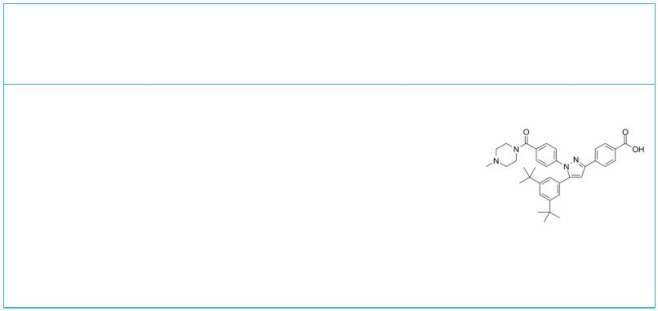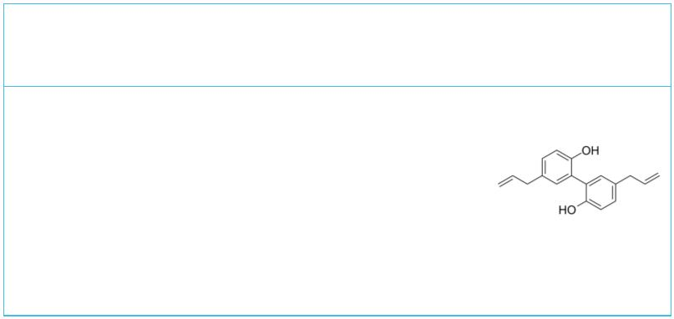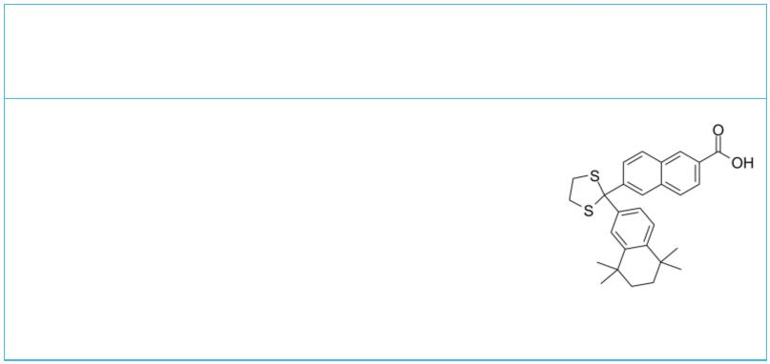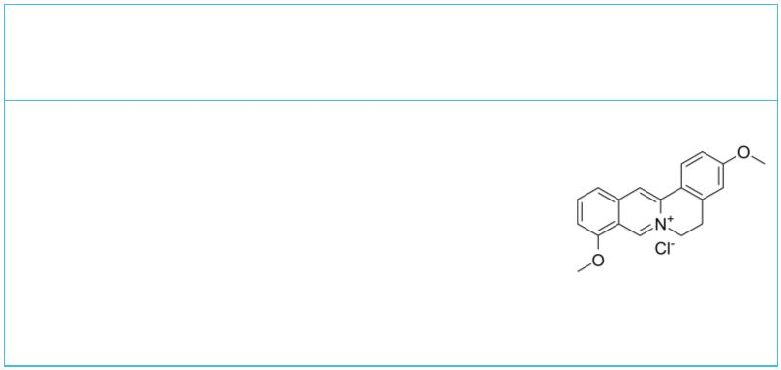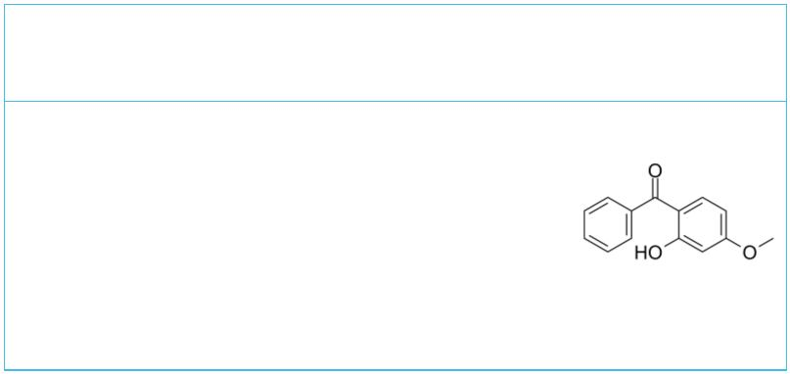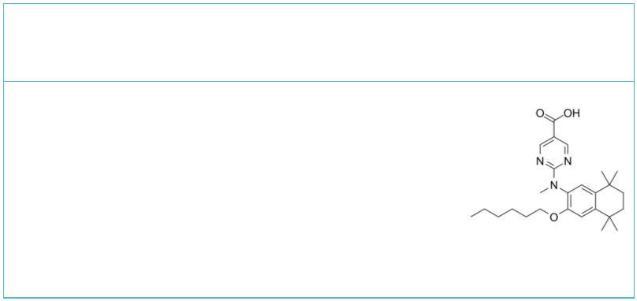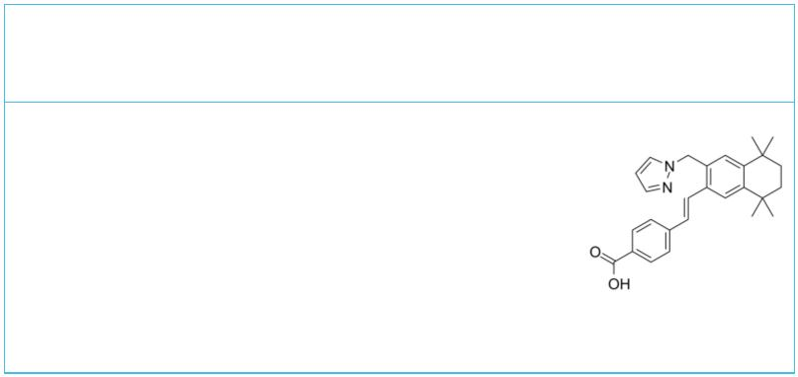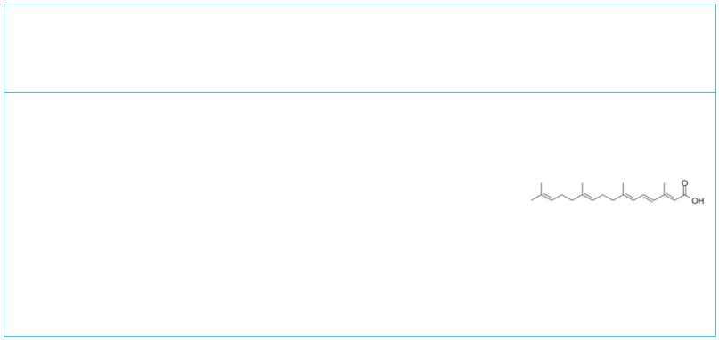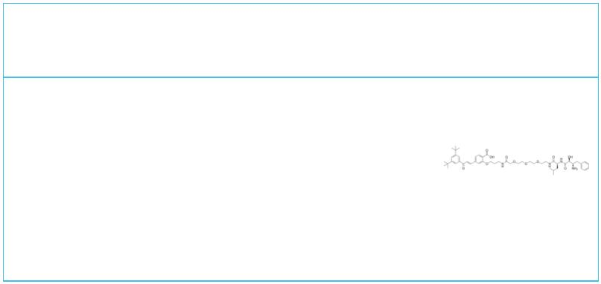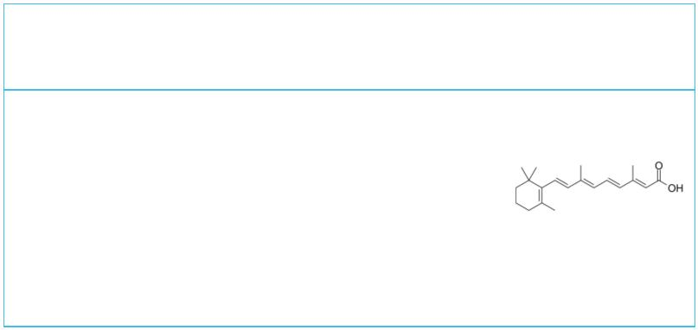 | LY2955303 Magnolol
 |  | Cat. No.: HY-107765 Cat. No.: HY-N0163
 | LY2955303 is a potent and selective retinoic acid  receptor gamma (RARγ) antagonist with a K of  i  1.09 nM. |  |  | Magnolol, a natural lignan isolated from the stem  bark of Magnolia officinalis, is a dual agonist  of both RXRα and PPARγ, with EC values of  50  10.4 µM and 17.7 µM, respectively.
 | Purity: 99.16%  Clinical Data: No Development Reported  Size: 10 mM × 1 mL, 5 mg, 10 mg, 25 mg, 50 mg |  |  | Purity: 99.92%  Clinical Data: Launched  Size: 10 mM × 1 mL, 10 mg, 50 mg, 100 mg
 | MM11253 NBD-125
 |  | Cat. No.: HY-108530 Cat. No.: HY-133739
 | MM11253 is a potent and selective RARγ antagonist  with an IC of 44 nM. MM11253 has lower  50  inhibition of RARα, RARβ and RXRα. MM11253 blocks  the growth inhibitory effects of RARγ-selective  agonists. |  |  | NBD-125 (B-12), a berberine analogue, is an RXRα  activator, with an IC of 31.10 μM in KM12C cell.  50
 | Purity: >98%  Clinical Data: No Development Reported  Size: 1 mg, 5 mg |  |  | Purity: >98%  Clinical Data: No Development Reported  Size: 1 mg, 5 mg
 | Oxybenzone  (Benzophenone 3) Cat. No.: HY-A0067 |  |  | PA452 |  |  |  |  |  |  |  |  |  |  |  |  |  | Cat. No.: HY-108522
 | Oxybenzone (Benzophenone 3) is a commonly used UV  filter in sun tans and skin protectants.  Oxybenzone act as endocrine disrupting chemicals  (EDCs) and can pass through the placental and  blood-brain barriers. |  |  | PA452, retinoic X receptor (RXR) specific  antagonist, inhibits the effect of Retinoic acid  (RA) on Th1/Th2 development.
 | Purity: 99.91%  Clinical Data: Launched  Size: 10 mM × 1 mL, 500 mg, 5 g |  |  | Purity: ≥99.0%  Clinical Data: No Development Reported  Size: 1 mg, 5 mg
 | Palovarotene Peretinoin
 | (R 667; Ro 3300074) Cat. No.: HY-14799 (NIK333) Cat. No.: HY-100008
 | Palovarotene is a nuclear retinoic acid receptor γ  (RAR-γ) agonist. |  |  | Peretinoin is an oral acyclic retinoid with a  vitamin A-like structure that targets retinoid  nuclear receptors such as retinoid X receptor  (RXR) and retinoic acid receptor (RAR).
 | Purity: 99.49%  Clinical Data: Phase 3  Size: 10 mM × 1 mL, 5 mg, 10 mg, 50 mg, 100 mg |  |  | Purity: 99.79%  Clinical Data: Launched  Size: 10 mM × 1 mL, 5 mg, 10 mg, 50 mg, 100 mg
 | PROTAC RAR Degrader-1 Retinoic acid
 |  | Cat. No.: HY-111844 |  | (Vitamin A acid; all-trans-Retinoic acid; ATRA) Cat. No.: HY-14649
 | PROTAC RAR Degrader-1 comprises a IAP ligand  binding group, a linker and a RAR ligand binding  group. PROTAC RAR Degrader-1 is an RAR degrader.  Maximal RAR degradation at 30 μM concentration in  HT1080 cells.  Purity: 95.02%  Clinical Data: No Development Reported  Size: 1 mg |  |  | Retinoic acid is a metabolite of vitamin A that  plays important roles in cell growth,  differentiation, and organogenesis. Retinoic acid  is a natural agonist of RAR nuclear receptors,  with IC s of 14 nM for RARα/β/γ. Retinoic acid  50  bind to PPARβ/δ with K of 17 nM.  d  Purity: 99.74%  Clinical Data: Launched  Size: 10 mM × 1 mL, 100 mg, 500 mg, 1 g, 5 g
8 Tel: 609-228-6898 Fax: 609-228-5909 Email: sales@MedChemExpress.com
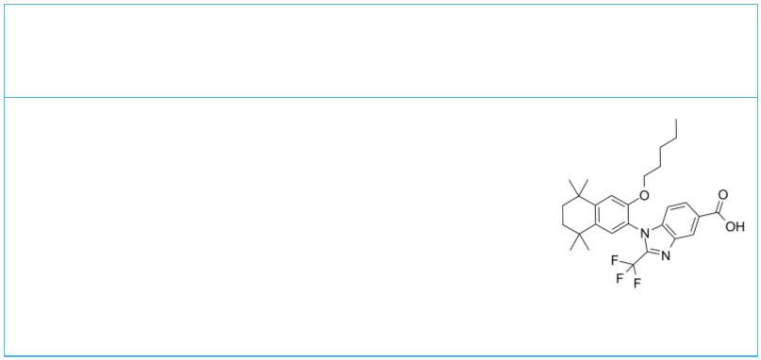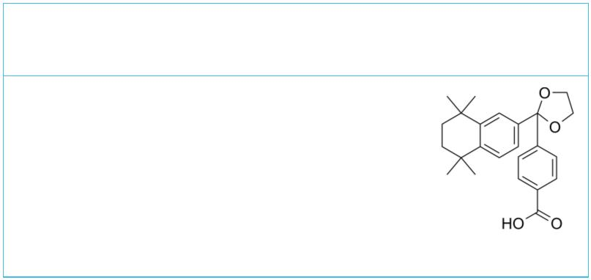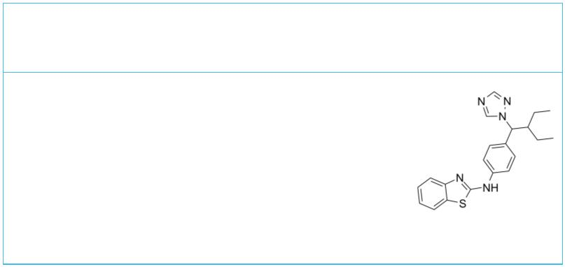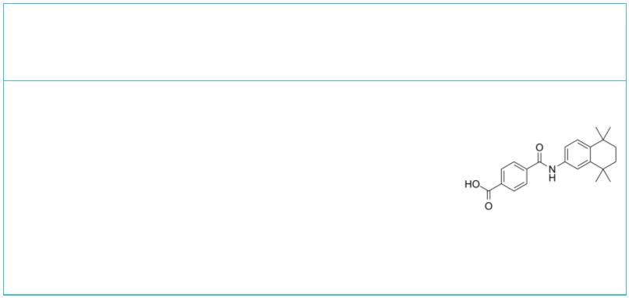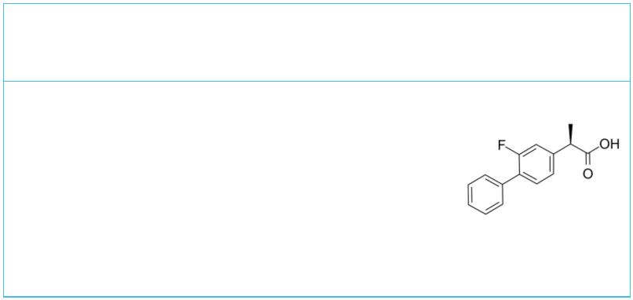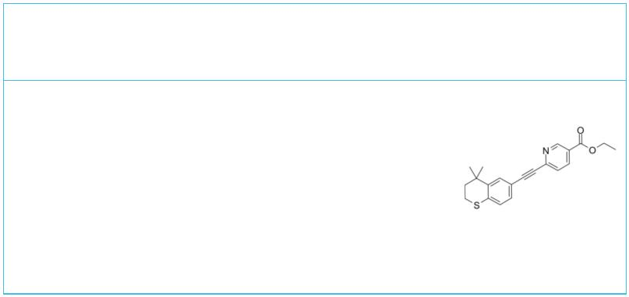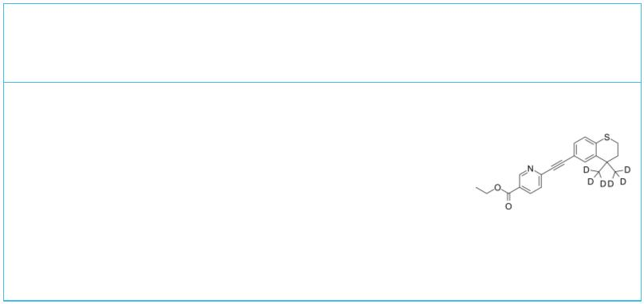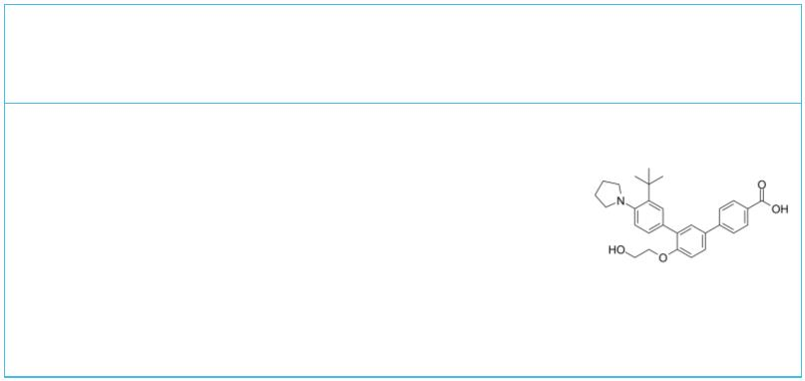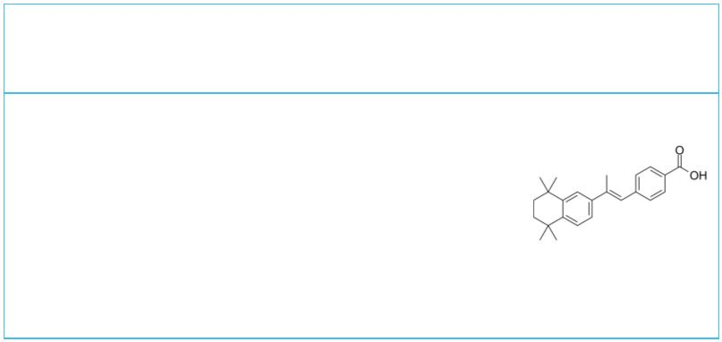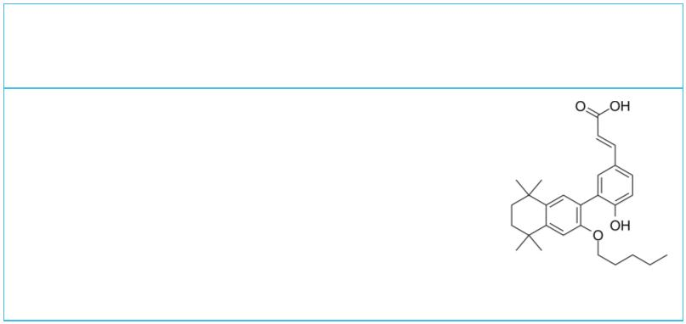RXR antagonist 1 |  | Cat. No.: HY-144377 |  | SR11237  (BMS-649) Cat. No.: HY-107413
RXR antagonist 1 (compound 6a) is a retinoid X  receptor (RXR) modulator. RXR antagonist 1 shows  potent RXR-antagonistic activity, with a pA of  2  8.06. RXR antagonist 1 can be used for type 2  diabetes research. |  |  |  | SR11237 (BMS-649) is a potent retinoid X receptor  (RXR)-selective agonist that is devoid of any RAR  activity. SR11237 can cause RXR/RXR homodimers to  form and transactivate a reporter gene containing  a RXR-response element.
Purity: >98%  Clinical Data: No Development Reported  Size: 1 mg, 5 mg |  |  |  | Purity: 99.91%  Clinical Data: No Development Reported  Size: 5 mg
Talarozole  (R115866) Cat. No.: HY-14531 |  |  |  | Tamibarotene  (Am 80) Cat. No.: HY-14652
Talarozole (R115866) is an oral systemic all-trans  retinoic acid metabolism blocking agent (RAMBA)  which increases intracellular levels of endogenous  all-trans retinoic acid (RA). Talarozole inhibits  both CYP26A1 and CYP26B1 with IC s of 5.4 and  50  0.46 nM, respectively. |  |  |  | Tamibarotene is a retinoic acid receptor α/β  (RARα/β) agonist, showing high selectivity over  RARγ.
Purity: 99.78%  Clinical Data: Phase 2  Size: 10 mM × 1 mL, 2 mg, 5 mg, 10 mg, 50 mg, 100 mg |  |  |  | Purity: 99.94%  Clinical Data: Launched  Size: 10 mM × 1 mL, 10 mg, 50 mg
Tarenflurbil  ((R)-Flurbiprofen; MPC7869) Cat. No.: HY-10291 |  |  |  | Tazarotene  (AGN 190168) Cat. No.: HY-15388
Tarenflurbil ((R)-Flurbiprofen) is the  R-enantiomer of the racemate NSAID Flurbiprofen,  Tarenflurbil ((R)-Flurbiprofen) inhibits the  binding of [³H]9-cis-RA to RXRα LBD with IC of  50  75 μM. Tarenflurbil can be used for Alzheimer's  disease research. |  |  |  | Tazarotene (AGN 190168) is a selective retinoic  acid receptor (RAR) agonist for the treatment of  plaque psoriasis and acne vulgaris.
Purity: 99.96%  Clinical Data: Phase 3  Size: 10 mM × 1 mL, 100 mg |  |  |  | Purity: 99.93%  Clinical Data: Launched  Size: 10 mM × 1 mL, 10 mg, 50 mg, 100 mg
Tazarotene-d8 Trifarotene
 |  | Cat. No.: HY-15388S |  | (CD5789) Cat. No.: HY-100256
Tazarotene-d8 is the deuterium labeled Tazarotene.  Tazarotene (AGN 190168) is a selective retinoic  acid receptor (RAR) agonist for the treatment of  plaque psoriasis and acne vulgaris. |  |  |  | Trifarotene (CD5789) is a potent and selective  RARγ agonist. Trifarotene (CD5789) shows 65-fold  and 16-fold selectivitiy for the RARγ  (EC =7.7 nM) over ( =500 nM) and  50 RARα EC₅₀  RARβ (EC =125 nM), respectively.  50
Purity: >98%  Clinical Data: No Development Reported  Size: 1 mg, 10 mg |  |  |  | Purity: 99.50%  Clinical Data: Launched  Size: 10 mM × 1 mL, 5 mg, 10 mg, 50 mg, 100 mg
TTNPB UVI 3003
(Ro 13-7410; Arotinoid acid; AGN191183) Cat. No.: HY-15682 |  |  |  |  |  |  |  |  |  |  |  |  |  |  |  |  |  | Cat. No.: HY-107500
TTNPB is a highly potent RAR agonist. Competitive  binding assays using human RARs yield IC s of  50  α=5.1 nM, β= 4.5 nM, and γ=9.3 nM,  respectively. |  |  |  | UVI 3003 is a highly selective antagonist of  retinoid X receptor (RXR), and inhibits xenopus  and human RXRα in Cos7 cells, with IC s of 0.22  50  and 0.24 μM, respectively.
Purity: 98.81%  Clinical Data: No Development Reported  Size: 10 mM × 1 mL, 5 mg, 10 mg, 50 mg |  |  |  | Purity: 99.77%  Clinical Data: No Development Reported  Size: 10 mM × 1 mL, 5 mg, 10 mg, 25 mg, 50 mg
www.MedChemExpress.com 9
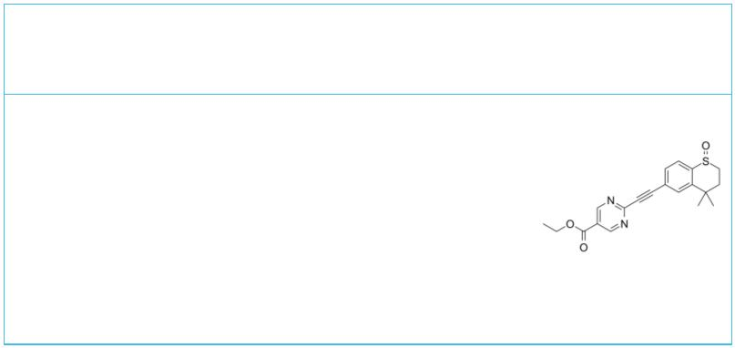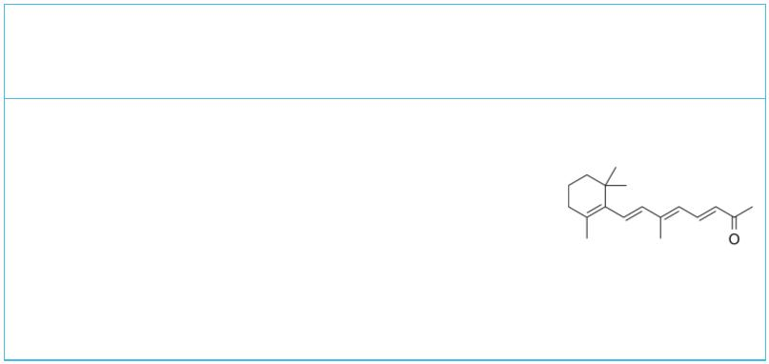 | WYC-209 |  | Cat. No.: HY-124136 |  | β-Apo-13-carotenone  (D'Orenone) Cat. No.: HY-101953
 | WYC-209, a synthetic retinoid, is a retinoic acid  receptor (RAR) agonist. WYC-209 induces apoptosis  primarily via the caspase 3 pathway  (IC =0.19μM for inmalignant murine melanoma  50  TRCs), and has long-term effects with little  toxicity. |  |  |  | β-Apo-13-carotenone (D'Orenone) is a naturally  occurring β-apocarotenoid functioned as an  antagonist of RXRα.
 | Purity: 99.64%  Clinical Data: No Development Reported  Size: 5 mg, 10 mg, 50 mg, 100 mg |  |  |  | Purity: 98.09%  Clinical Data: No Development Reported  Size: 5 mg, 10 mg, 25 mg, 50 mg, 100 mg
10 Tel: 609-228-6898 Fax: 609-228-5909 Email: sales@MedChemExpress.com

