of orie n t al
ate aesthetics
e

2009

传 承 创 新 东 方 建 筑 美 学
Inheriting and Innovating Oriental Architectural Aesthetics

机构简介：

北京德鲁安建筑规划设计院是具有国际视野、值得信赖的专业设计机构， 自2009年成立以来，形成了五大优势业务板块，分别为城市设计、文旅 景区、宗教建筑、禅意园林、装饰设计和剧院建筑设计。其中宝庆寺设 计在2017年荣获中国民族建筑协会颁发最佳建筑设计一等奖，2019年在 国际竞标中，德鲁安获得泰国文化中心竞赛第一名，并完成了以超级剧
院为主体的建筑工程设计，获得了泰国公主诗琳通殿下的接见。
团队拥有广泛的跨学科分析和设计经验，积极回应不断变化的设计需求 和情况。研究领域涵盖产业经济、发展策略、城市规划、城市设计、风 景园林、建筑设计、室内设计、艺术设计、环境保护、交通规划、水生
态处理和建筑节能等多个学科。
德鲁安始终以传承和创造东方建筑美学为使命，随着中国“一带一路”倡
议的提出，德鲁安也拓展到了海外，业务遍布亚洲和美洲，包括中国、
中国香港、泰国、美国和尼泊尔，成为中国为数不多的向海外输出文化
创意和科技服务的企业，向世界展示了中华建筑美学的风貌和文化自信。

“德鲁安”的含义：
“德”:德行天下
“鲁”:鲁班再创
“安”:安得广厦

Institutional Profile:

Beijing Deluan Architectural Planning and Design Institute is a professional
design institution with international vision and trustworthiness. Since its
establishment in 2009, it has formed five dominant business sectors, namely, urban design, cultural and tourist attractions, religious architecture, Zen
garden, decorative design and theatre architectural design. Among them, the design of Baoqing Temple won the first prize of Best Architectural Design
awarded by China National Architecture Association in 2017.In the
international competition in 2019, Deluan won the first prize in the Thai
Cultural Center Competition, and completed the architectural engineering design with the Super Theater as the main body.The team has extensive
interdisciplinary analysis and design experience, and actively responds to
changing design needs and situations. The research fields include industrial economy, development strategy, urban planning, urban design, landscape architecture,architectural design, interior design,art design,environmental protection, transportation planning, water ecological treatment and building energy conservation.It has always been a mission to inherit and create
Oriental architectural aesthetics.With the introduction of China's "one belt and one road"initiative,drew has expanded to overseas, and has been doing business in Asia and the Americas, including China, Hongkong, Thailand, the United States and Nepal.Service enterprises show the world the style and
cultural self-confidence of Chinese architectural aesthetics.The meaning of "Drouan":"Virtue":Virtue under the WorldLu:Re-creation of Lu Ban"An": Ande Guang House

业务范围：

城市设计：
针对目前众多城市面临旧城更新、老城复兴和新区开发过程中，从控制 性详细规划到城市总体建筑风貌控制、经济产业发展和环境资源优化等 方面面临实际困难和痛点，城市设计成为政府高效率行政和城市建设管 理的新的工具，既对原有的法定控规进行细化和延伸，同时对面临快速
城市化和实际实施管理形成了有效的补充。

文旅景区：
德鲁安联合泛华集团的优势资源成立了泛华智慧文旅设计院，致力于国 内外文化旅游景区的规划、设计和运营一站式服务，截止目前，已经为 全国十多家5A级旅游景区提供了规划和设计咨询服务。文旅景区规划是 指为了科学保护和合理开发各项资源、有效经营和科学管理旅游景区， 充分发挥景区资源价值而进行的各项旅游要素的统筹部署和具体安排。 根据规划的内容及深度不同，景区旅游规划分为三个不同的层次，即旅 游景区总体规划、旅游景区控制性详细规划、旅游景区修建性规划。在 这三个规划层次之外，旅游景区还可以根据各景区特点编制景区旅游策
划或概念性规划、旅游项目策划，或针对具体建设项目编制开发规划。

宗教建筑：
受尼泊尔政府委托，2019年德鲁安应邀为佛陀出生地，尼泊尔蓝毗尼圣 园北区规模为2平方公里的土地编制总体规划。十多年来，德鲁安为超 过100座寺庙宫观编制了规划和建筑方案，项目涵盖中国各省区以及泰 国、尼泊尔和美国，建筑风格包括了汉传佛教、藏传佛教和南传佛教各 个历史时期的寺院风格，形成了独具特色的规划和设计体系，既继承传 统寺院布局和施工工法，又创新采用现代科技和材料，并结合当地历史 文化、地域气候和宗教法脉传承，形成了集传统与现代于一体的新型寺
院设计。

Scope of business:

Urban design:
In view of the practical difficulties and pains faced by many cities in the
process of old city renewal, old city renewal and New District development,
from the detailed planning of control to the control of overall urban architectural style, the development of economic industry and the
optimization of environmental resources, urban design has become a new
tool for government's efficient administration and urban construction
management.
Cultural tourist area:
Deluan has set up Pan-China Intelligent Cultural Travel Design Institute with Pan-China Group's superior resources. It is dedicated to the planning, design and operation of cultural tourist attractions at home and abroad. Up to now, it has provided planning and design consulting services for more than 105A tourist attractions in China.According to the content and depth of the
planning, the tourism planning of scenic spots can be divided into three different levels, namely, the overall planning of scenic spots, the detailed planning of controlling scenic spots and the constructive planning of scenic
spots.
Religious architecture:
Entrusted by the Government of Nepal, Deluan was invited to be the
birthplace of Buddha in 2019, and a master plan for the 2 square kilometres of land in the northern part of Lambini Sacred Garden in Nepal was drawn up.
Over the past decade, Deluan has worked out planning and architectural plans for more than 100 temples and temples. The project covers all
provinces and regions of China, Thailand, Nepal and the United States. The
architectural styles include the temple styles of Han Buddhism, Tibetan Buddhism and Southern Buddhism in various historical periods, forming a unique planning and design system.

业务范围：

剧院建筑：
2019年在国际竞标中，德鲁安获得泰国文化中心竞赛第一名，并完成了 以超级剧院为主体的工程设计，并获得泰国王储诗琳通公主殿下的亲切
接见。德鲁安拥有完善的剧院建筑设计团队，从设计理念到设备工程，
包括建筑、结构、造价、设备、声光电和舞台工程众多专业的专家成员，
可以为剧院建筑提供一站式设计和咨询服务。

禅意园林：
中国古典园林有着三千年的悠久历史，禅意园林更是在漫长的发展中形 成了独特的简约的风格，受到亚洲和世界各国人民的喜爱。德鲁安通过 对唐宋时期佛教禅意景观园林的实例和理论的梳理，形成了独特的现代 禅意景观设计方法和体系，为众多不同尺度的寺庙宫观、办公会所以及
私人住宅花园等提供了高品质的禅意园林设计。

装饰设计：
现代室内装饰设计应运用现代科学技术法则和美学规律，尤其是居住建 筑要从适用和经济的原则出发，力求室内空间布局合理，通风采光良好， 利于家具陈设布置等，用较少的人、财、物创造出理想的室内环境，以 提高物质生活水准。同时，还应遵循美学法则，创造出一个富有个性而
且优美的室内环境，充分表现不同功能空间和使用对象的精神内涵。

Scope of business:

Theatre architecture:
In the 2019 international competition, Drouant won the first prize in the
Thailand cultural center competition, and completed the design of the super theatre as the main body, and received the cordial reception of Princess
Royal of Thailand. Drouan has a well-developed theater architectural design team, from design concepts to equipment engineering, including many
professional experts in architecture, structure, cost, equipment, acoustics, optoelectronics and stage engineering. It can provide one-stop design and consulting services for theater architecture.

Zen Garden:
Chinese classical gardens have a long history of 3000 years. Zen gardens have formed a unique and concise style in the long development, which is loved by people in Asia and all over the world. Through sorting out the examples and theories of Buddhist Zen landscape gardens in Tang and Song Dynasties,
Drouan has formed a unique modern Zen landscape design method and
system, which provides high-quality Zen landscape design for many temples, palaces, office clubs and private residential gardens of different scales.
Interior design:
Modern interior decoration design should use modern scientific and
technological principles and aesthetic laws, especially residential buildings
should proceed from the principles of applicability and economy, strive for
reasonable indoor space layout, good ventilation and lighting, conducive to furniture furnishings, etc., create an ideal indoor environment with fewer
people, money and things, in order to improve material livelihood. Living
standard.At the same time, we should also follow the aesthetic principles, create a personalized and beautiful indoor environment, and fully display the spiritual connotation of different functional spaces and users.

管理理念：

项目管理： 针对项目成立项目专案小组，并有项目经理和设计师同时从
事务和技术两方面进行质量控制。
团队管理： 团队管理以发展人的综合素质为出发点，让每一个员工在团
队的监督和促进下全面进步。
得失管理： 在每个项目阶段性成果以及最终结束后，团队和个人都进行
得失总结，总结失误，继承优势，不断进步。
时间管理： 以效率和时间管理为项目服务的理念，所有后勤和人事安排
都围绕项目时间进度管理展开。

社会公益：规划援助行动
德鲁安自2010年起，每年启动年度规划援助行动，向有需要的古寺名刹 免费捐赠规划和设计方案，使得众多古寺名刹和边疆贫困地区得到帮助，
从2010年到2019年期间，规划援助行动的足迹遍布湖北、山东、河北、
广东、江苏、浙江、新疆、福建、海南、尼泊尔和泰国，获得广泛好评。

Management philosophy:

Project management:A project team is set up for the project, and project
managers and designers are engaged in both business and technical aspects of quality control.
Team management: Team management takes the development of people's comprehensive quality as the starting point, so that every employee can make overall progress under the supervision and promotion of the team.
Gain and Loss Management: At the end of each project, the team and
individual summarize the gains and losses, summarize the mistakes, inherit the advantages and make continuous progress.
Time management: With the concept of efficiency and time management as project services, all logistic and personnel arrangements are centered on
project time schedule management.

Social Welfare: Planning Assistance Action
Since 2010,Deluan has launched annual planning and assistance activities, donating free planning and design schemes to famous ancient temples and temples in need, which has helped many famous ancient temples and poor border areas. From 2010 to 2019, the planning and assistance activities have covered Hubei, Shandong, Hebei,Guangdong,Jiangsu and Zhejiang. Jiang, Xinjiang, Fujian, Hainan, Nepal and Thailand have won wide acclaim.

核心人员：

张勋
2005年毕业于华中科技大学，2006年起在美国规划协会担任中国领导人培训班班 主任；2009年6月任北京德鲁安建筑规划设计院院长，由北京德鲁安建筑设计事务 所升为北京德鲁安建筑规划设计院，发展形成了北京、上海、广州和海南4个办公 室，并成立了佛教建筑设计中心。2010年获邀至美国杜兰大学讲学。2011年获邀 请出席在美国波士顿举办的美中未来城市青年论坛，并发表主题演讲；2014年11 月创办北京洛克威尔科技有限公司，专注于服务中国传统文化领域的技术型企业。 2013和2014年或邀至尼泊尔、印度等佛教胜地进行交流学习。2017年获得高级古 建营造师、 BIM 战略规划师等专项技能证书。2019年7月带领团队获得泰国文化中 心国际竞标第一名，作为中标单位负责人收到泰国皇室接见。2019年10月经北京
市高级专业技术资格评审委员会评审，获得建筑学专业高级工程师职称。

北京德鲁安建筑规划设计院
泛华智慧文旅设计院
北京洛克威尔科技有限公司
中国民族建筑研究会宗教建筑专业委员会
中国建筑节能协会
国际建筑装饰室内设计协会

设计院院长
总裁
董事长兼总裁
副主任委员
高级建筑节能工程师
高级室内设计师

规划设计： 主导完成旅景区园区规划，寺庙规划，公共建筑设计和园林景观设计。 其中为中国、尼泊尔、泰国和印度主导完成的寺院规划100多座寺院，包括：“昭王 崛起——现光山相国寺规划方案”,“田园风光——极乐净寺规划方案与建筑设计”, “大鹏展翅——鸡足山迦叶殿规划方案与建筑设计”,“史上最小寺院——伽蓝寺规划 方案与建筑设计”,“弥陀之舟一一香河宝庆寺规划方案与建筑设计”,佛祖诞生地-尼
泊尔蓝毗尼圣园北区2平方公里总体规划，泰国国家文化中心国际竞标中标等等。
软件开发：主导研发智慧寺院APP、 北京智能交通手机APP 系统、学位无纸化办公
系统、无锡灵山慈善基金会：为爱联劝平台开发项目等。

核心人员：

朱林
毕业于清华大学建筑系，获硕士学位。2004年任上海同济规划院主创规划师、
2006年历任美国DEDEJ设计公司设计总监、副总经理等职务。2016年创办北京大圣 风云文化发展有限公司。2017年经北京市高级专业技术资格评审委员会评审，获 得城市规划学专业高级工程师职称。2018年任北京德鲁安建筑规划设计院院长，并
创立泛华智慧文旅设计院任院长。

北京德鲁安建筑规划设计院
泛华智慧文旅设计院
北京大圣风云文化发展有限公司

院长
院长
创始人

规划建筑设计： 十六年间作为项目负责人完成的城市规划、建筑设计、景观设计等 项目数百个，涵盖产业园区、文旅景区、城市综合体、住宅区、商业区、办公楼、
酒店度假村、宗教文化建筑等，建成项目面积超过500万平方米，建成最高建筑
188米。多次国内国际设计招标第一名。信阳农业专科学校规划获国际竞标第一名， 泰国国家文化中心国际国际竞标第一名，受尼泊尔文化部邀请规划设计佛祖诞生地 -尼泊尔蓝毗尼圣园北区，受中国国经中心邀请规划设计北京市丽泽商务区全球智
库集聚区。
著作：参与编著出版《武昌旧城更新改造设计实践》《旧建筑改造设计与实践》等
书籍，著《三城记》书稿，暂未出版。

湖北省钟祥市生态智慧健康城
Zhongxiang Ecological Intelligence Healthy City,Hubei Province

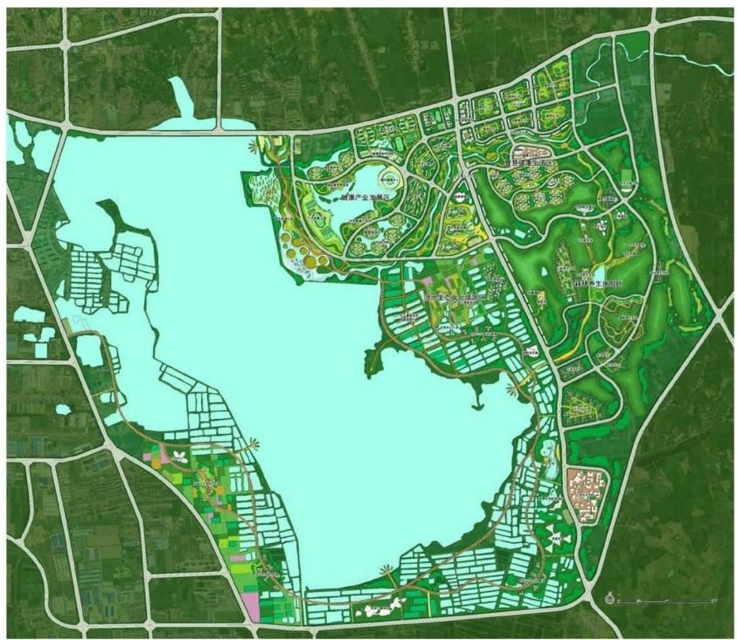

本项目位于湖北省钟祥市，规划区域约3186公顷(47790亩)。项目以 湿地山林生态保护被本体，以大健康产业和生态文旅产业为两大核心产 业，打造立足华中、面向全国的体验式大健康平台，生态文化旅游区，
助力片区经济发展与城市发展双跨越。

湖北省钟祥市生态智慧健康城
Zhongxiang Ecological Intelligence Healthy City,Hubei Province
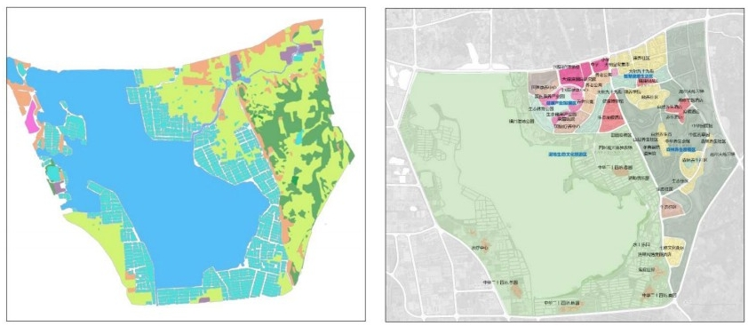
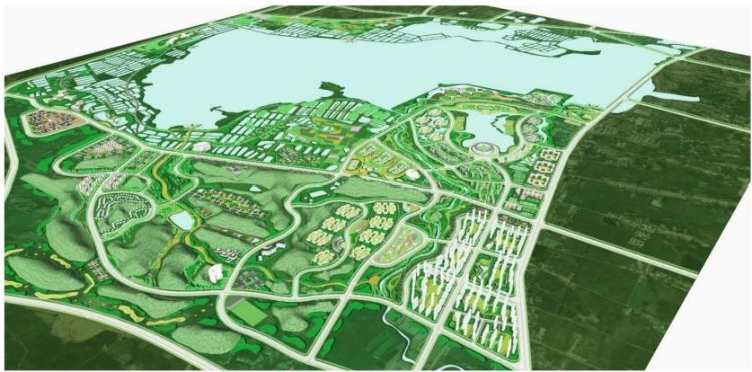

The project is located in Zhongxiang City, Hubei Province, with a planned area
of 3,186 hectares(47,790 mu). The project takes the wetland mountain
forest ecological protection as its main body, the big health industry and the ecological cultural tourism industry as its two core industries,and builds a
large experiential health platform based on central China and facing the
whole country, and an eco-cultural tourism area, which will help the
economic development and urban development of the region to achieve
double leaps.

河北省秦皇岛市北戴河艺术小镇
Beidaihe Art Town,Qinhuangdao City,Hebei Province

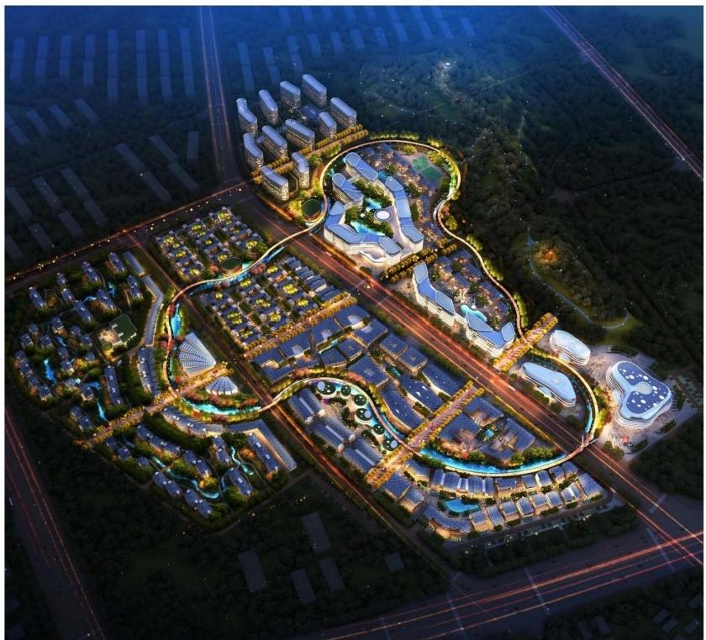

项目是承载秦皇岛市东部特色商业街道、复合文化体验、高端度假酒店 及其它新型业态最佳载体。定位为中国北戴河新会议中心、河北省特色
小镇新典范、秦皇岛文旅产业新地标。

河北省秦皇岛市北戴河艺术小镇
Beidaihe Art Town, Qinhuangdao City,Hebei Province

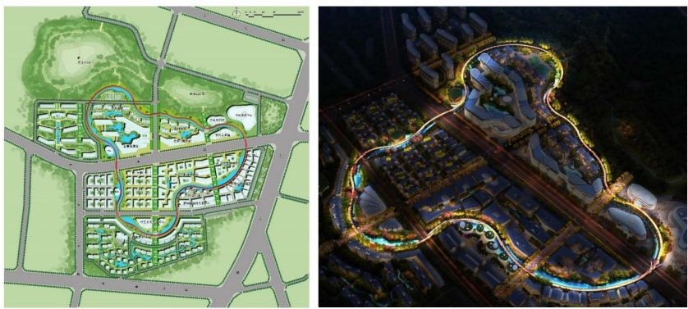
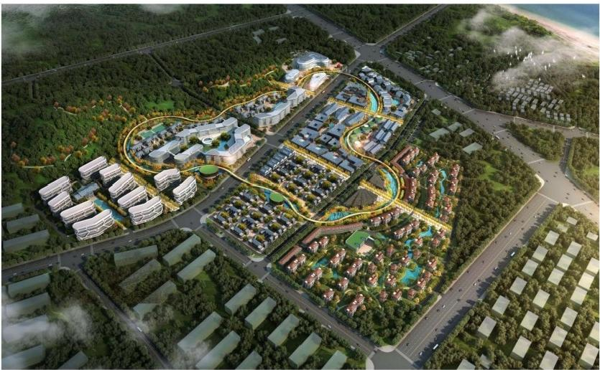

The project is the best carrier for carrying the characteristic commercial
streets, complex cultural experience, high-end resort hotels and other new forms of business in the eastern part of Qinhuangdao City. It is positioned as
the new conference center of Beidaihe, the new model of small towns with
Hebei characteristics, and the new landmark of Qinhuangdao cultural tourism industry.

河南省商丘市金贸中心
Gold Trade Center of Shangqiu City,Henan Province

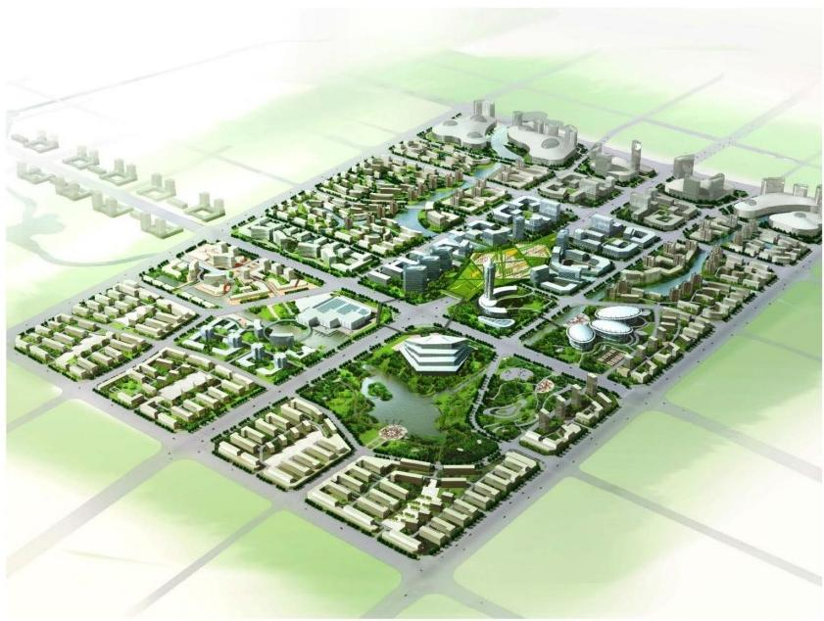

项目依托宋城路东西向规划古城一商贸城特色风貌，集聚旅游文化商业 等大型提升旅游项目规划为古今发展轴线。基地在不同发展阶段形成带 动周围地区发展建设的交通集散中心，中小型商务中心，应天商贸会展
中心。

河南省商丘市金贸中心
Gold Trade Center of Shangqiu City,Henan Province

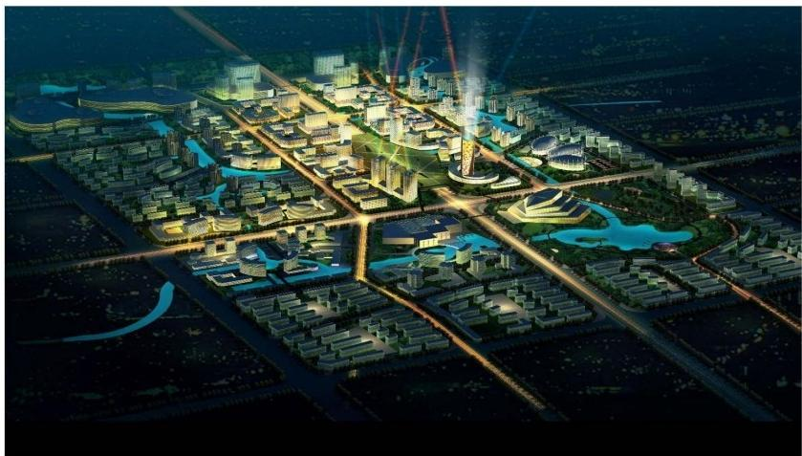
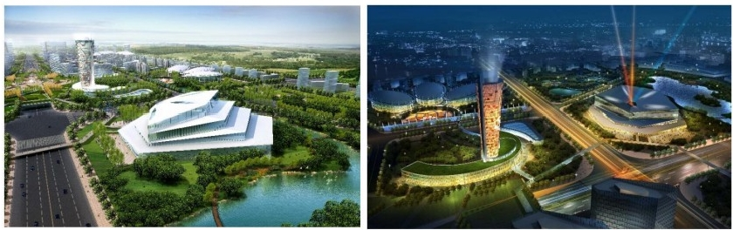

The project relies on the east-west direction of Songcheng Road to plan the characteristic features of the ancient city-commercial city, gathering tourism, culture and Commerce and other large-scale promotion tourism projects to plan for the axis of development of ancient and modern. At different stages of development, the base has formed transportation distribution centers,
small and medium-sized business centers and exhibition centers to promote the development and construction of surrounding areas.

尼泊尔蓝毗尼圣园北区
North Lanbini Sacred Garden,Nepal

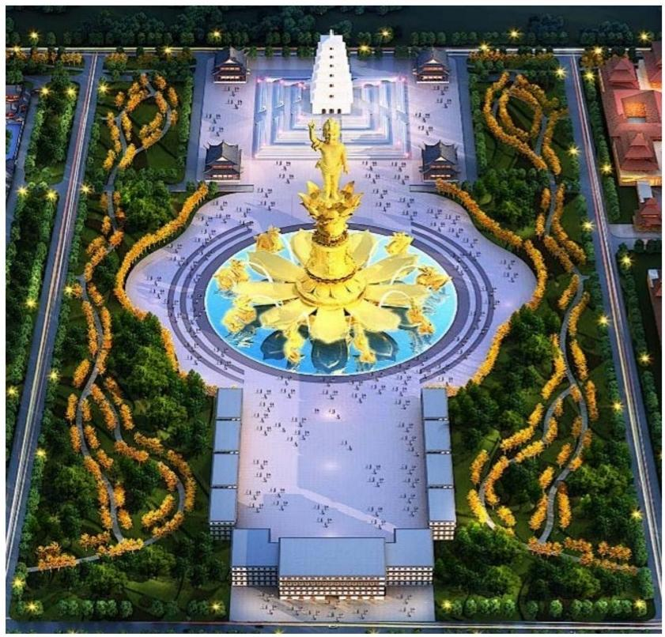

尼泊尔是佛陀的诞辰地，有着历史最为悠久的佛教文化沉淀，在世界佛 教徒心中乃至全球文化领域有着特殊的地位。该项目旨在打造世界佛教
文化旅游圣地，尼泊尔国际佛教中心，中尼和世界文化交流基地。

尼泊尔蓝毗尼圣园北区
North Lanbini Sacred Garden,Nepal
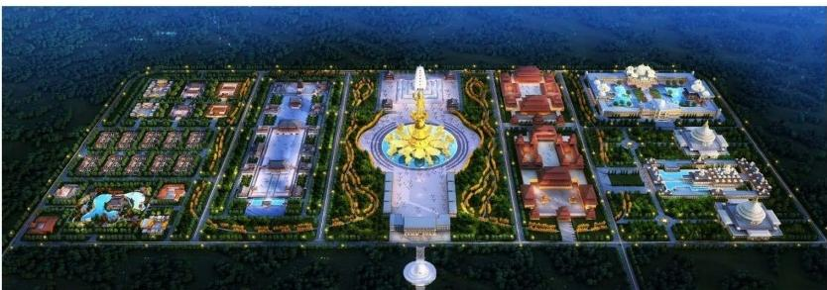
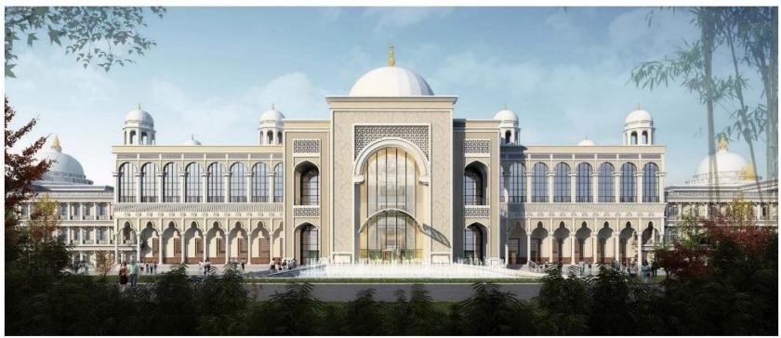
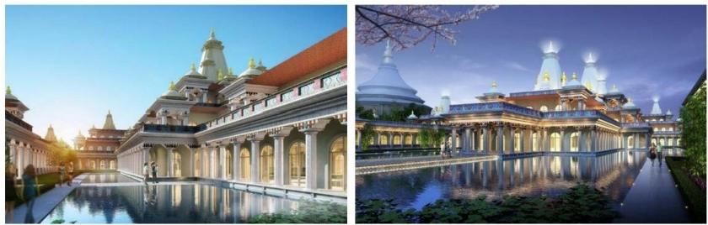

Nepal is the birthplace of the Buddha.It has the longest history of Buddhist culture and has a special place in the hearts of Buddhists in the world and even in the global cultural field.The project aims to create a world Buddhist cultural tourism destination, the Nepal International Buddhist Center, the Sino-Nepalese and World Cultural Exchange Base.

浙江省湖州市西蠡谷文化景区
Xili Valley Cultural Scenic Area,Huzhou City,Zhejiang Province

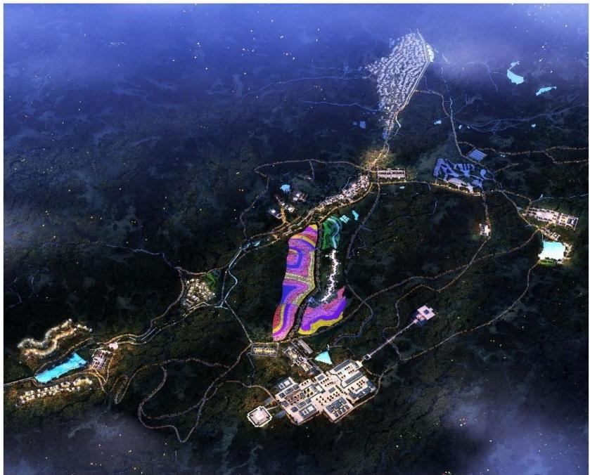

本项目位于浙江湖州德清县上杨村，规划用地面积6000亩，建设用地面 积200亩。本项目充分利用上杨村原有资源及原生态景观环境，建设以 可持续发展为前提，以发展全息旅游为战略，以原生态村落为模式的精
品旅游文化小镇。

浙江省湖州市西蠡谷文化景区
Xili Valley Cultural Scenic Area,Huzhou City,Zhejiang Province

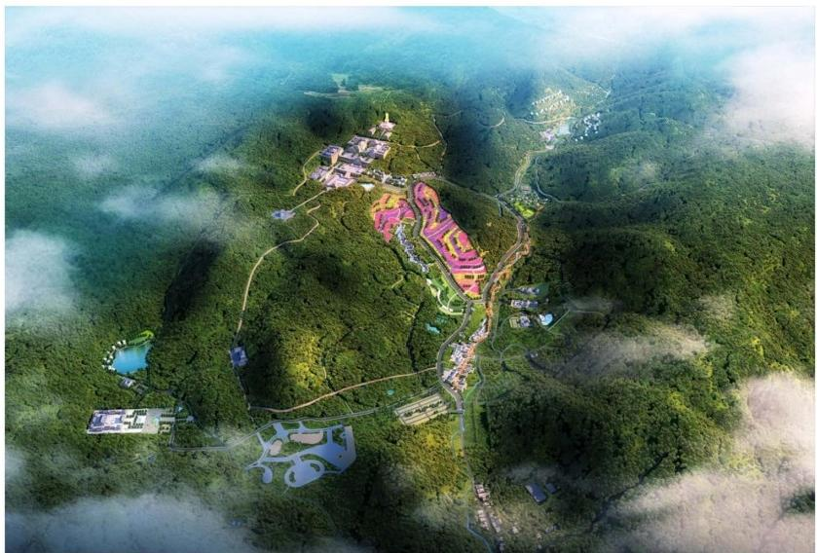
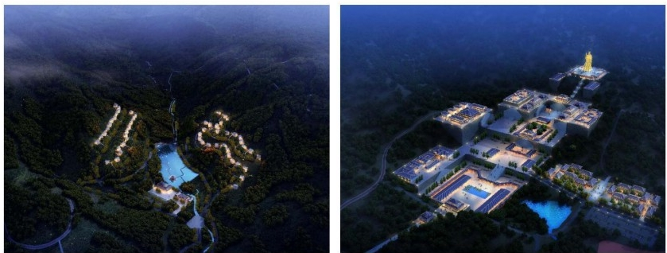

The project is located in Shangyang Village, Deqing County, Huzhou City,
Zhejiang Province. The planned land area is 6,000 mu and the construction land area is 200 mu.The project makes full use of the original resources of Shangyang Village and the original ecological landscape environment, and
builds a boutique tourism culture town with the premise of sustainable
development, the development of holographic tourism as the strategy, and
the original ecological village as the model.

山西省太原市太山景区
Taishan Scenic Area,Taiyuan City,Shanxi Province

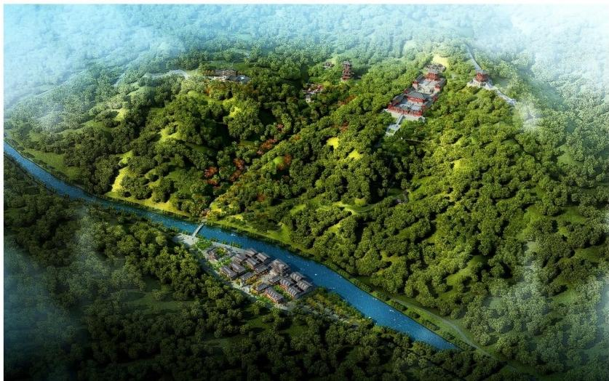

项目位于山西太原太山景区。设计的主要任务是提升景区的结构模式。 深入文化挖掘，加强文物保护。景区空间升级，丰富游客体验。建设智
慧景区，面向未来城市。

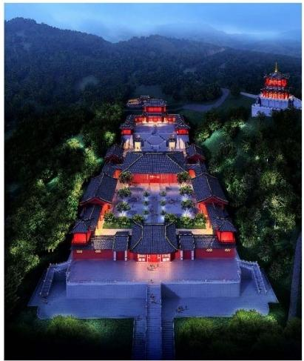
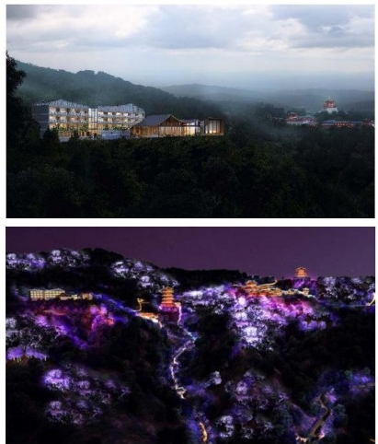

山西省太原市太山景区
Taishan Scenic Area,Taiyuan City,Shanxi Province
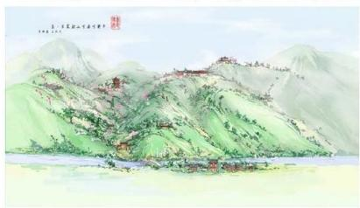
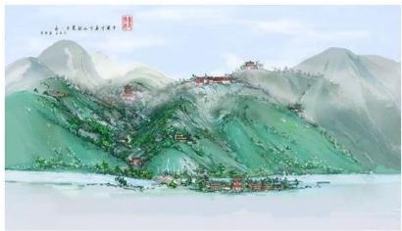
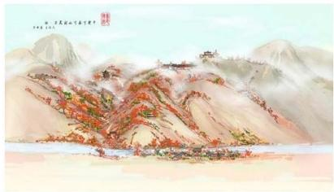

The project is located in Taishan Scenic Area, Taiyuan, Shanxi. The main task of the design is to enhance the structural model of the scenic area.In-depth cultural excavation and strengthening cultural relics protection. The scenic space is upgraded to enrich the visitor experience.Building a smart scenic spot and facing the future city.

山西省原平市龙岩寺生态文化旅游区
Longyan Temple Eco-cultural Tourist Area,Yuanping City,Shanxi Province

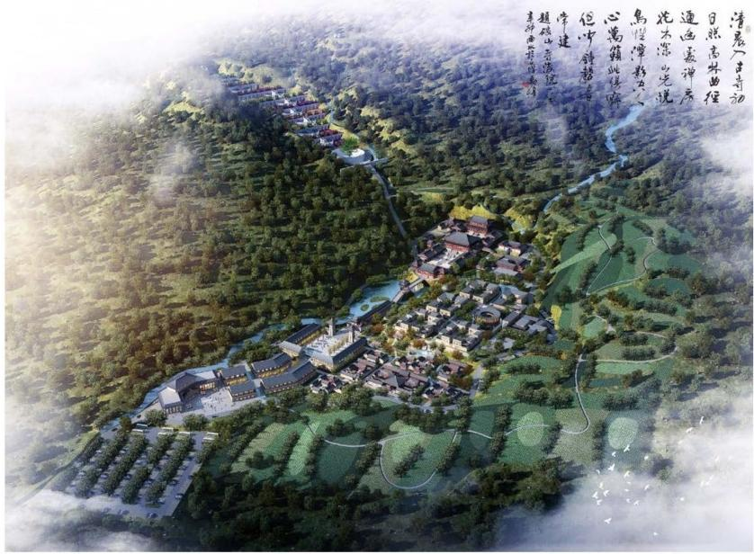

本项目属原平市文物保护单位。据史料记载，龙岩寺始建于宋景佑元年
(1034年),距今已有数千年的历史。2017年，苏龙口生态文化旅游区
综合开发项目获原平市人民政府批准。龙岩寺复建工程纳入总体规划。

山西省原平市龙岩寺生态文化旅游区
Longyan Temple Eco-cultural Tourist Area,Yuanping City,Shanxi Province
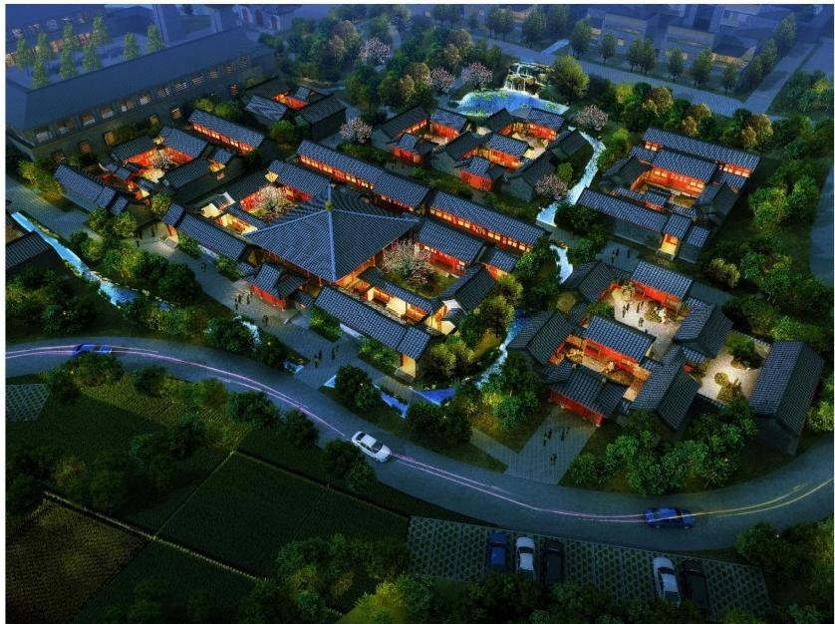
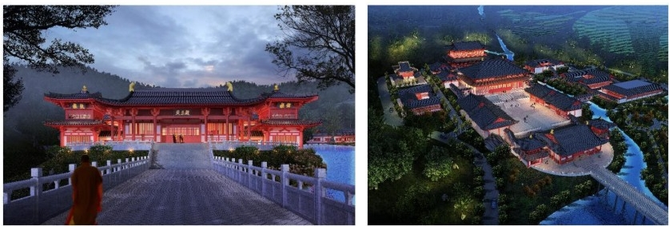

The project belongs to Yuanping Municipal Cultural Relics Protection Unit.
According to historical records, Longyan Temple was built in the first year of Jingyou in the Song Dynasty (1034), which has a history of thousands of years.
In 2017, the comprehensive development project of Sulongkou Eco-cultural Tourism Area was approved by Yuanping Municipal People's Government. Longyan Temple restoration project Naren master plan.

安徽省芜湖市繁昌窑文化产业园
Fanchangyao Cultural Industrial Park,Wuhu City,Anhui Province

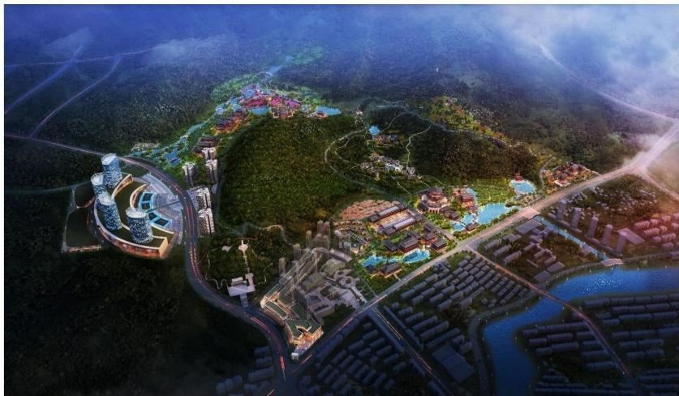

繁昌窑遗址文化产业园项目位于繁昌县南郊和西郊的岗坡，产业园范围 内分布着众多的古瓷窑址。产业园规划总面积约1.98平方公里，设计包
括繁昌窑遗址文化产业园项目策划，总体规划。

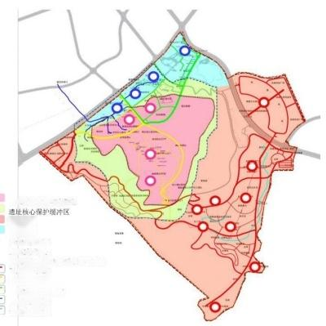

遗址核心保护与展示区
龙湖片区
风湖片区
龙湖重要节点
风湖重要节点
遗址核心保护与展示区重要节点
南唐慢道系统
页富慢道系统
陶瓷之路慢道系统
风湖水上游线
龙额水上游线

安徽省芜湖市繁昌窑文化产业园
Fanchangyao Cultural Industrial Park,Wuhu City,Anhui Province
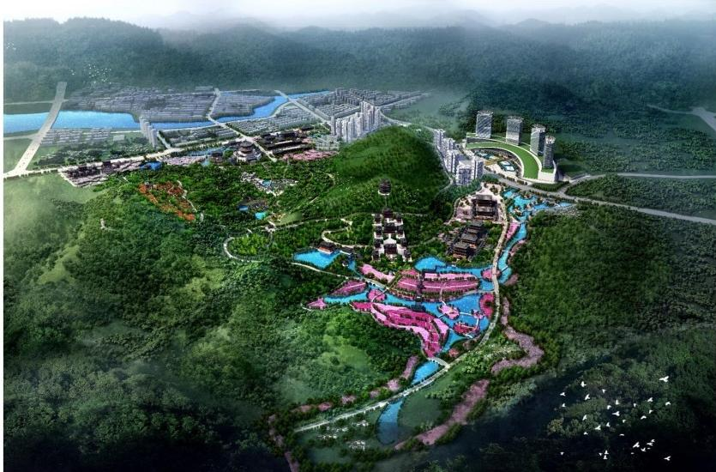
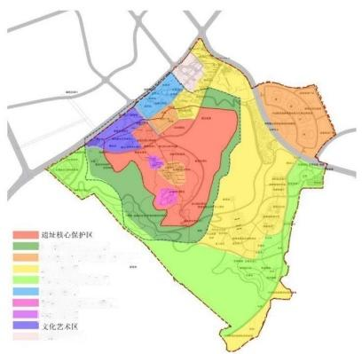

遗址核心风貌缓冲区
富艺文化产业和体闲体验区 …
度假体验区
南唐文化风情展示区
■ 接特服务区
吉白瓷离艺文化展示区
学 术 研 究
政府机构现状
The Fanchang Kiln Heritage Industrial Park Project is located in the southern suburb of Fanchang County and the Gangpo in the western suburbs. There
are many ancient porcelain kiln sites within the industrial park. The total
planned area of the industrial park is about 1.98 square kilometers.The
design includes the planning and overall planning of the Fanchang Kiln
Cultural Industry Park project.

新疆伊犁市大西沟福寿山旅游区
Fushou Mountain Tourist Area,Daxigou,Yili City,Xinjiang Province

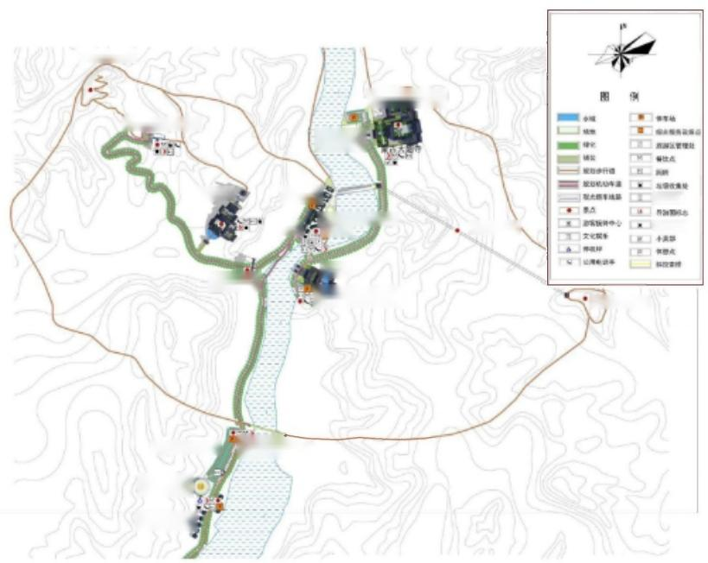
大西沟石窟遗址

成舌思汗西征起念馆
福寿山养生别整酒店
大丽等

福寿山寺 | 青年客  餐服 | 好生樱桃李展示馆  语客中心 | 观光缆车线路 | 医疗设施  放镇、酒店

长春观
福寿胜境牌明
长看直人西行纪念镇

确萨草盐房键厅

直升机停机坪(
哈萨克毡房餐屋
福寿山公共停车场
大西沟石窟遗址

大西沟福寿山景区形成了赛里木湖——果子沟-—大西沟福寿山景区一 一霍尔果斯口岸的一线通旅游线路。大西沟福寿山景区全力打造历史人 文文化旅游和自然风光旅游名片，积极推进旅游名镇名乡建设。明确的
产业导向和跨越式的发展思路为景区的发展提供了坚实的保障。

新疆伊犁市大西沟福寿山旅游区
Fushou Mountain Tourist Area,Daxigou,Yili City,Xinjiang Province

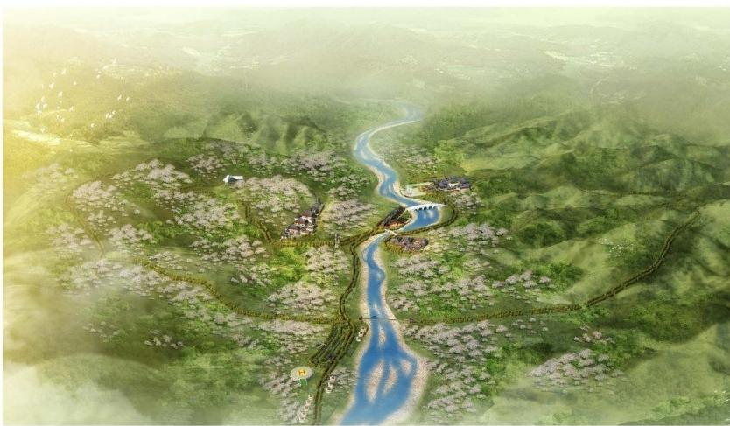
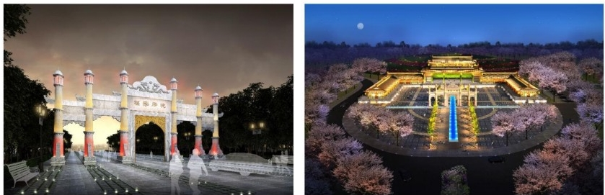

Daxigou Fushou Mountain Scenic Area has formed a first-line tourist route of
Salimu Lake-Guozigou-Daxigou Fushou Mountain Scenic Area-Holguos
Port. Fushoushan Scenic Area in Daxigou has made every effort to create
historical, cultural and natural tourism business cards, and actively promote the construction of famous tourist towns and townships. Clear industrial
orientation and leapfrog development ideas provide a solid guarantee for the development of scenic spots.

广西省百色市观音文化博览园
Guanyin Culture Expo Park in Pingguo County,Guangxi Province

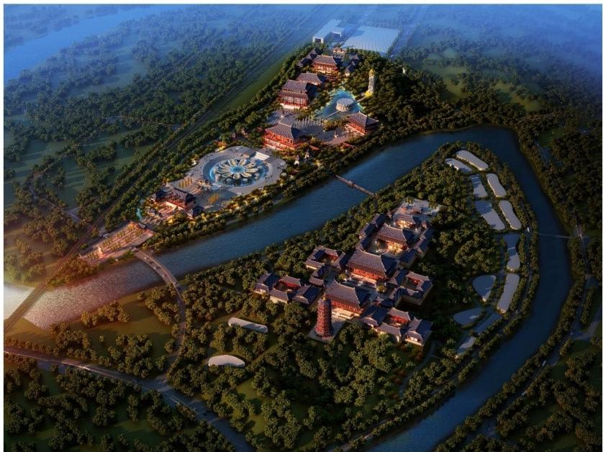

本项目位于广西省平果县，总体规划院用地面积2500亩，主要由东方观
音文化博览园、文化创意产业园与观音寺寺院组成。

广西省百色市观音文化博览园
Guanyin Culture Expo Park in Pingguo County,Guangxi Province

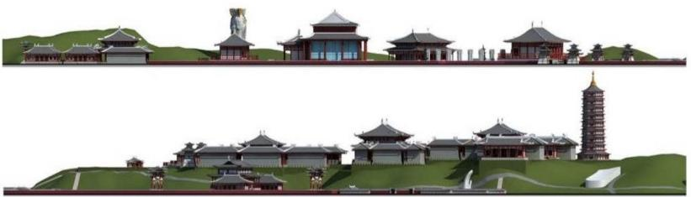

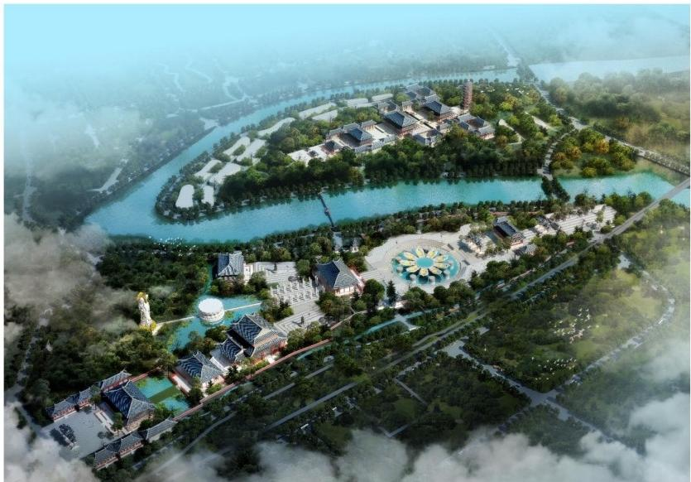

The project is located in Pingguo County,Guangxi Province. The total
planning area is 2,500 mu.It is mainly composed of Dongfang Guanyin
Culture Expo Park,Cultural and Creative Industry Park and Guanyin Temple.

河南省登封市圣竹林寺文化旅游区
Shengzhulin Temple Cultural Tourist Area,Dengfeng City,Henan Province
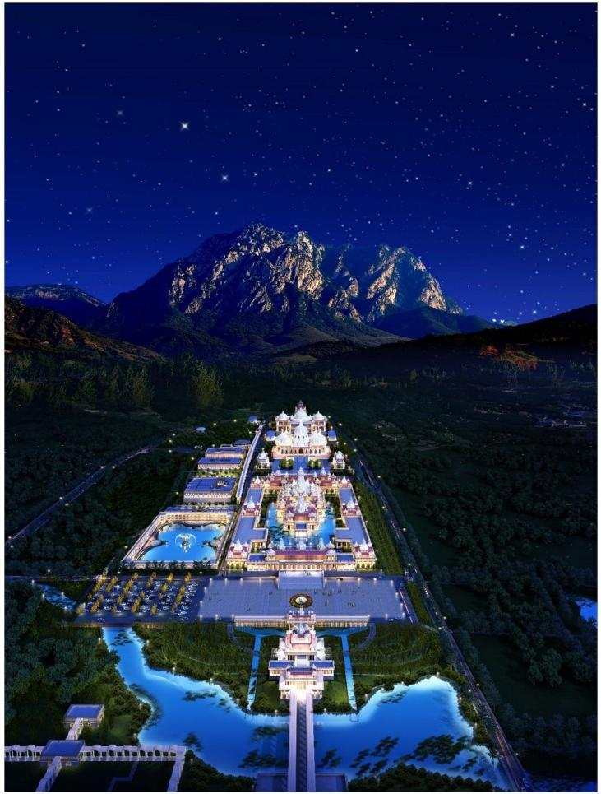
圣竹林寺的风格定位古印度风的现代低碳绿色寺院，规划遵循三个设计
理念：低碳规划，绿色基础设施， LEED绿色建筑理念。

河南省登封市圣竹林寺文化旅游区
Shengzhulin Temple Cultural Tourist Area,Dengfeng City,Henan Province
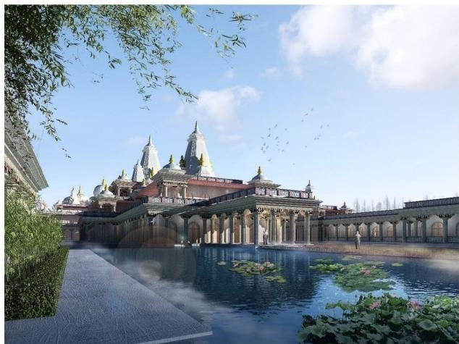
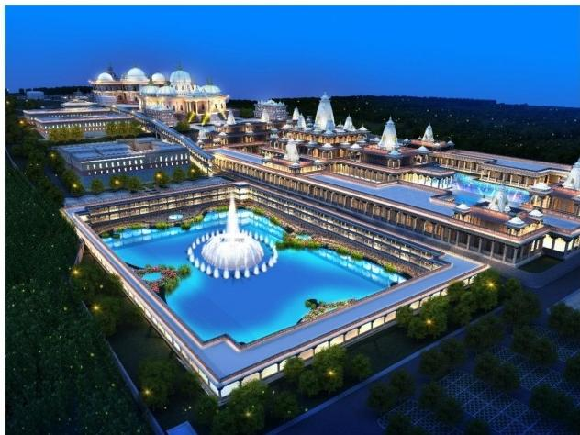
The style of St.Bamboo Forest Temple orientates the modern low-carbon
green temple with ancient Indian style. The planning follows three design
concepts: low-carbon planning, green infrastructure and LEED green building
concepts.

广西壮族自治区天峨县蓝衣壮小镇度假区
The Holiday Resort of TianE County Lanyizhuang Town,Guangxi Province

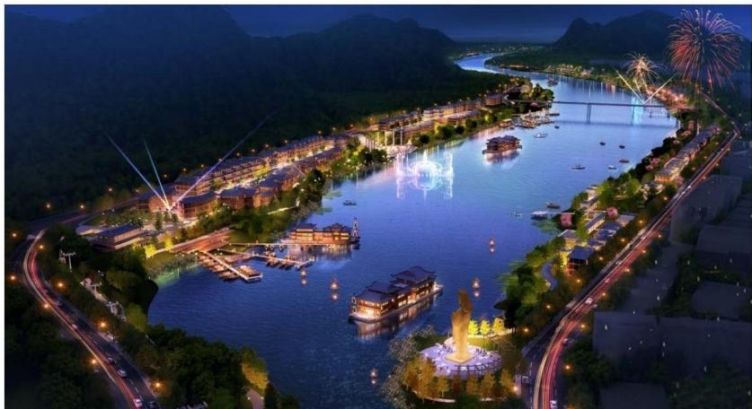

项目按商业水道和水上集市来运营，整个水寨的设计围绕蚂拐传奇来铺 设，所有咖啡厅和餐厅等商业设施暗含蚂拐故事，以船坞经济为爆点， 打造船宿、船妹、水市、船吧、船宴等；以夜经济带动日游览，以天峨
肉带动天峨游。

广西壮族自治区天峨县蓝衣壮小镇度假区
The Holiday Resort of TianE County Lanyizhuang Town,Guangxi Province

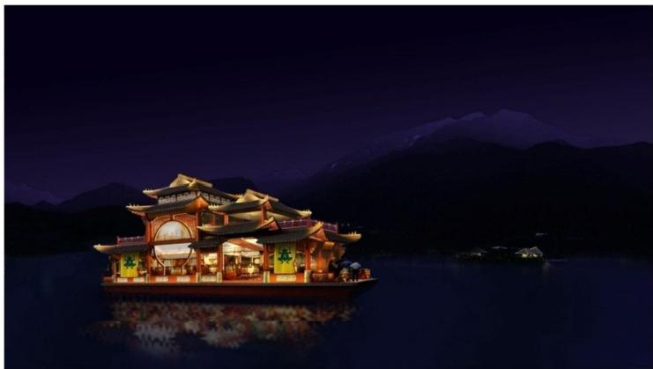
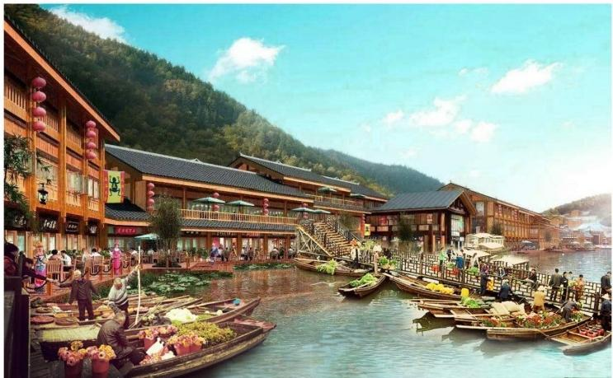

The project is operated according to commercial waterways and water fairs. The design of the whole water village is laid around the legend of the ant
crutch. All commercial facilities, such as coffee shops and restaurants, contain the story of the ant crutch. Taking the dock economy as the exploding point, the project builds boat accommodation, boat sister, water market, boat bar, boat banquet and so on. The night economy drives the day tour, while the
sky meat drives the day tour.

福建省福鼎市棲林寺
Qilin Temple,Fuding City,Fujian Province
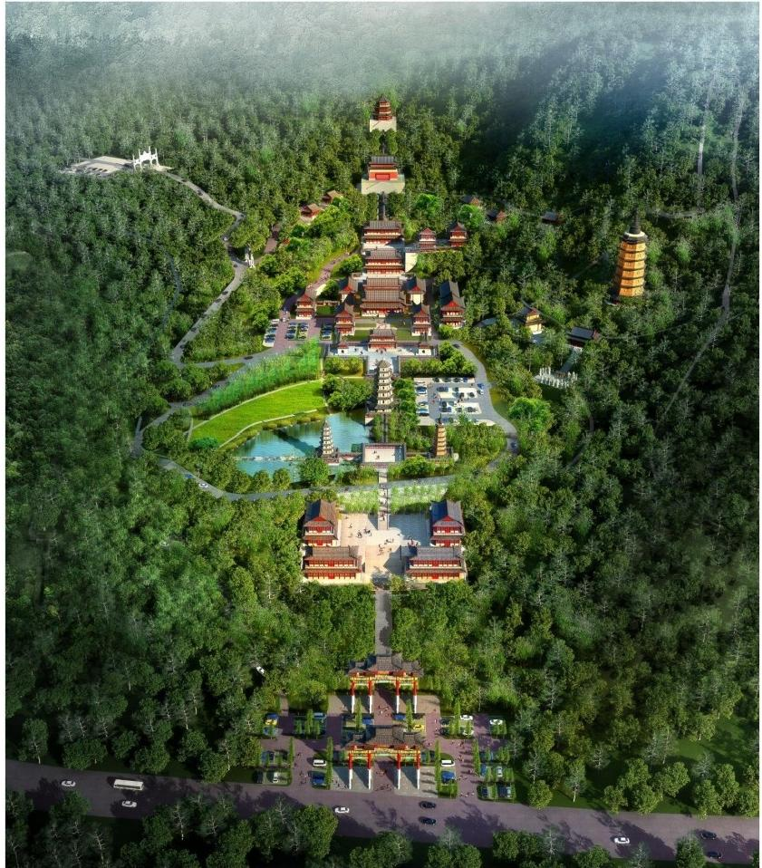

本项目位于福鼎市西郊2.5公里的鳖峰山下，占地面积750万平方米。棲 林寺根据现有地形，建设一个既传承佛教文化又符合现代人需求的综合 性寺院，将棲林寺规划为“一条殿堂主轴、两个不同生活区、三大功能
区及环形交通流线”的总体空间布局。

福建省福鼎市棲林寺
Qilin Temple,Fuding City,Fujian Province

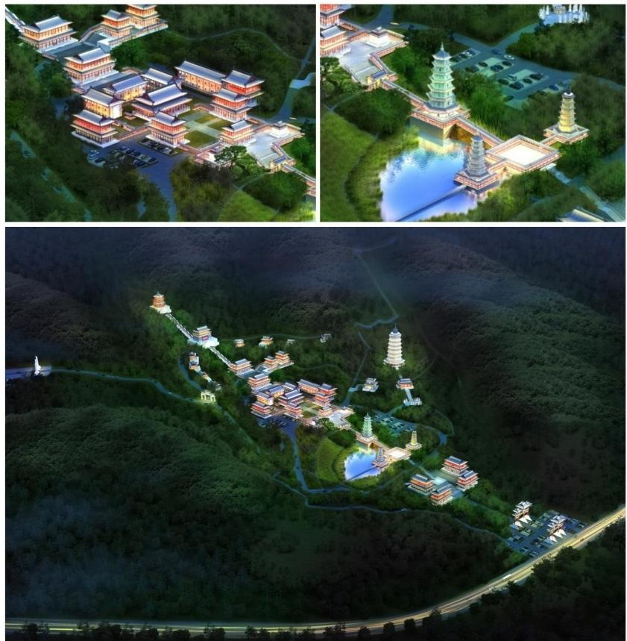

The project is located at the foot of Mount Jifeng, 2.5 kilometers west of Fuding City, covering an area of 7.5 million square meters. Based on the existing topography,Qilin Temple builds a comprehensive temple that
inherits Buddhist culture and meets the needs of modern people.It plans the Qilin Temple as “a main axis of the temple, two different living areas, three functional areas and a circular traffic flow line” .Overall spatial layout

江西省景德镇市方广禅林
Fang Guang Chanlin, Jingdezhen City,Jiangxi Province

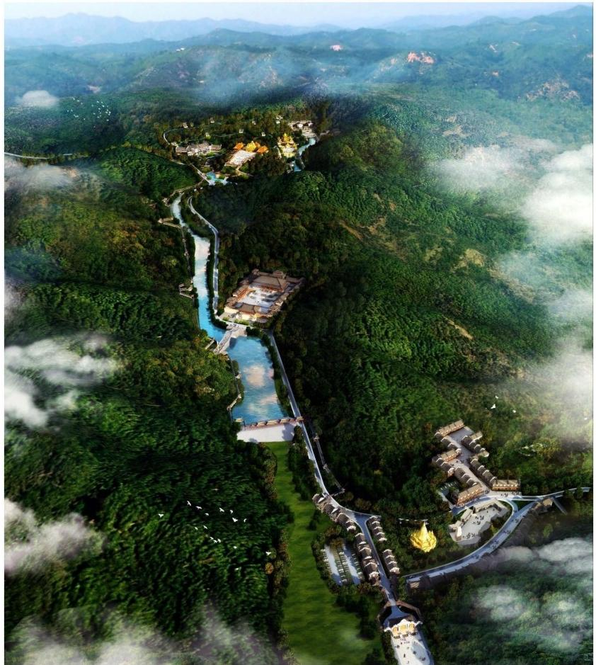

项目位于江西景德镇浮梁县，项目规划占地面积约450亩。寺院规划合 理利用方广禅林周边区域的原有自然条件，避免可能导致的生态破坏， 打造佛瓷圣窑文化公园，保证宗教文化的公益性和参与性，使每个人拥
有自由享受景观空间的权利。

江西省景德镇市方广禅林
Fang Guang Chanlin, Jingdezhen City,Jiangxi Province

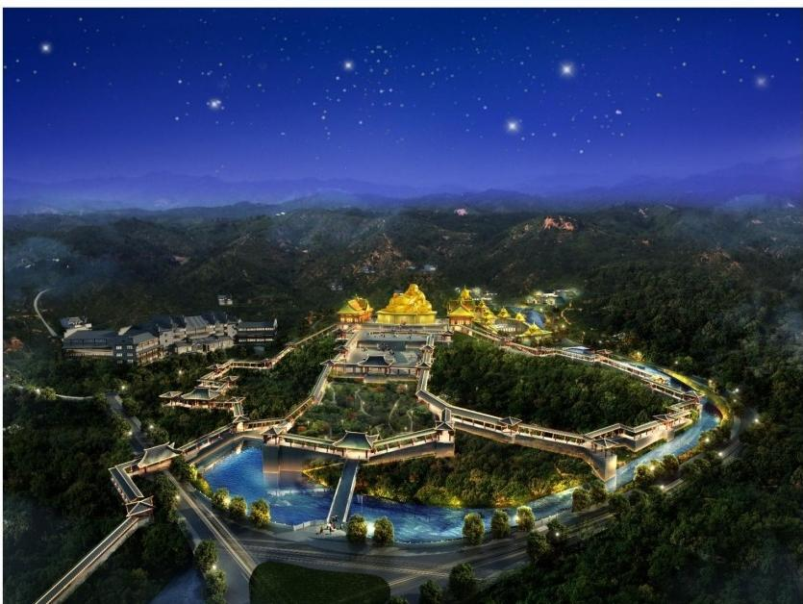
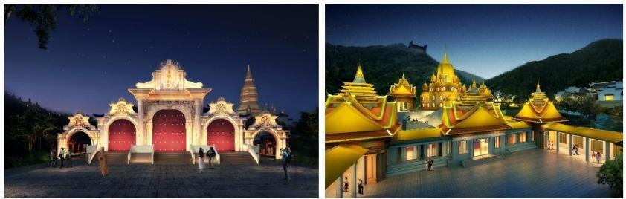

The project is located in Fuliang County,Jingdezhen, Jiangxi Province,
covering an area of about 450 mu.The monastery plans to make rational use of the original natural conditions in the surrounding area of Fangguang Zen Forest, avoid possible ecological damage, build Buddhist Porcelain Sacred Kiln Cultural Park,ensure the public welfare and participation of religious culture, and enable everyone to enjoy the right of landscape space freely.

安徽省池州市九华山茶仙谷
Jiuhua Mountain Tea Valley,Chizhou City,Anhui Province

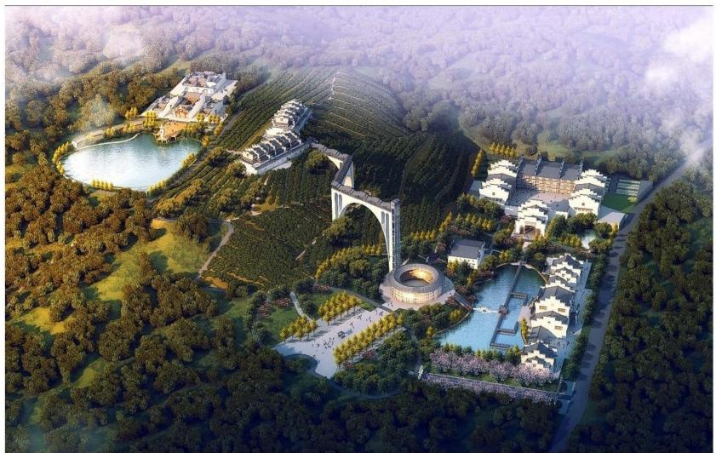

本次设计规划将三分之二的用地面积作为有机茶园。四到六栋徽派老 宅，老宅前后东西庭院，私密空间和独立出入口。特色住宿楼三栋，没
动三十个房间，湖畔周边设计木屋，打造精品民宿和设计禅修酒店。

安徽省池州市九华山茶仙谷
Jiuhua Mountain Tea Valley,Chizhou City,Anhui Province

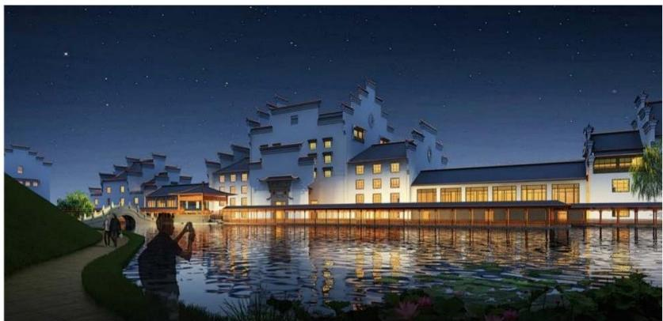
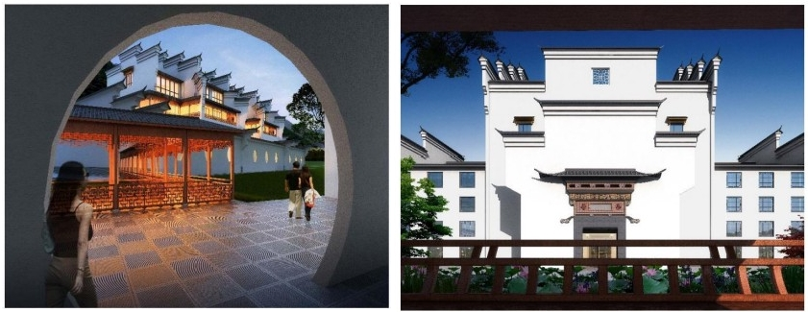

This design plan uses two-thirds of the land area as an organic tea garden. Four to six Huizhou old houses, old and former courtyards, private spaces
and independent entrances and exits. There are three special
accommodation buildings, no room for 30 rooms, wooden houses around
the lake, and boutique hotel and design meditation hotel.

云南省腾冲市2.5文化产业园

2.5 Cultural Industrial Park,Tengchong City,Yunnan Province

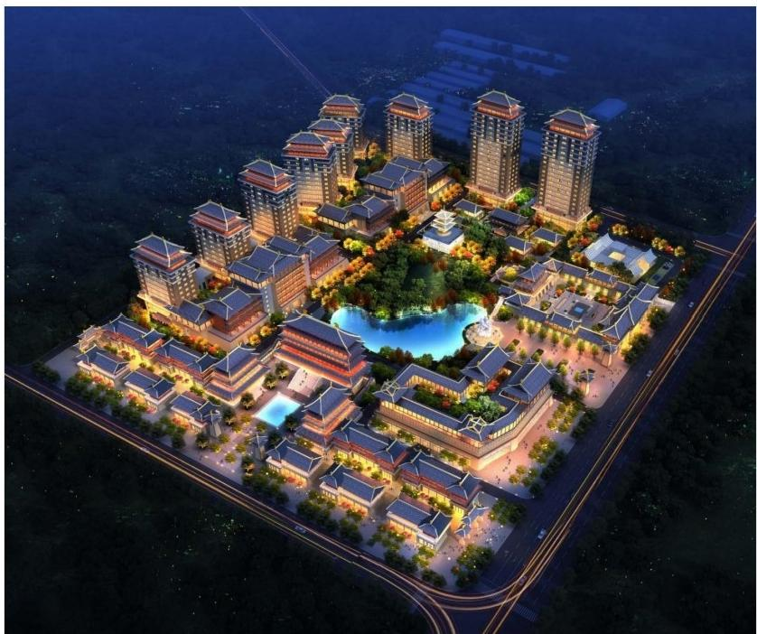

项目依托上位规划定位，打造国康2.5产业园。完善配套的城市商业中 心组团，区域企业和居民的城市客厅。特色商业休闲度假街区，融入全
域旅游。融入唐文化的特色园区。提供旅游度假配套。

云南省腾冲市2.5文化产业园

2.5 Cultural Industrial Park,Tengchong City,Yunnan Province

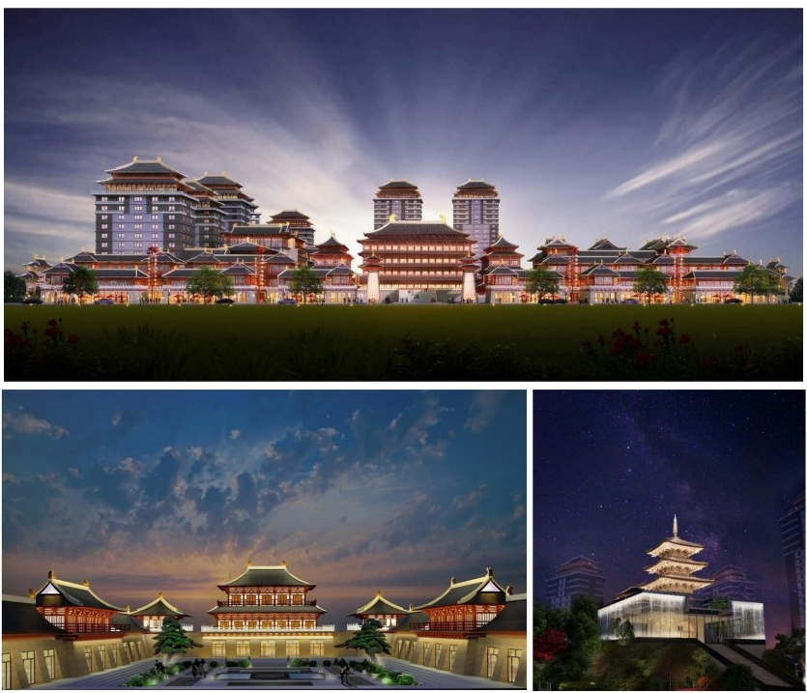

The project relies on superior planning and positioning to build Guokang 2.5 Industrial Park.Perfect supporting urban business center group, regional
enterprises and residents of the city living room. Characteristic commercial leisure and vacation blocks, integrated into the global tourism.Characteristic Park integrated with Tang culture. Provide travel and vacation support.

河北省廊坊市香河宝庆寺
Baoqing Temple of Xianghe River, Langfang City,Hebei Province

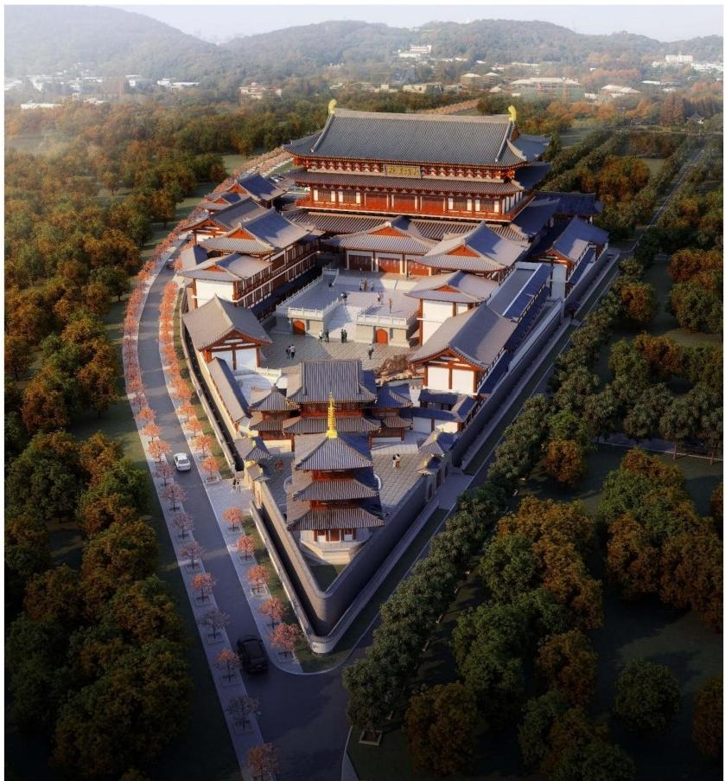

本工程是香河县宝庆寺总体规划与建筑方案设计，规划总用地面积约21 亩，其中寺院规划占地面积15亩、寺院北侧停车场规划面积6亩。工程 位于河北省香河县安平镇王指挥庄村西偏北，运河堤埝南侧，规划地块
南北最大长度为240米，东西最大宽度为105米。

河北省廊坊市香河宝庆寺
Baoqing Temple of Xianghe River,Langfang City,Hebei Province

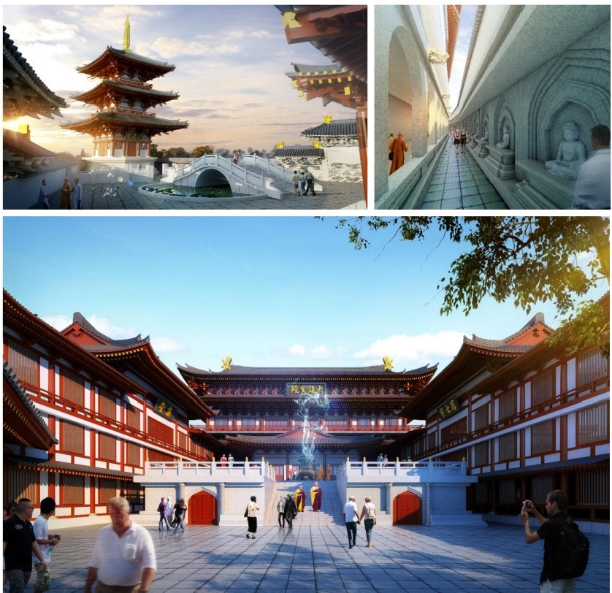

The project is the overall planning and architectural design of Baoqing
Temple in Xianghe County. The total planned land area is about 21 mu.The planned area of the temple is 15 mu, and the planned parking area on the north side of the temple is 6 mu.The project is located in the north of the north of the canal embankment of Anping Town, Xianghe County, Hebei
Province. The maximum length of the planned block is 240 meters, and the
maximum width of the east and west is 105 meters.

广东省惠州市佛宇山寺
Foyushan Temple,Huizhou City,Guangdong Province

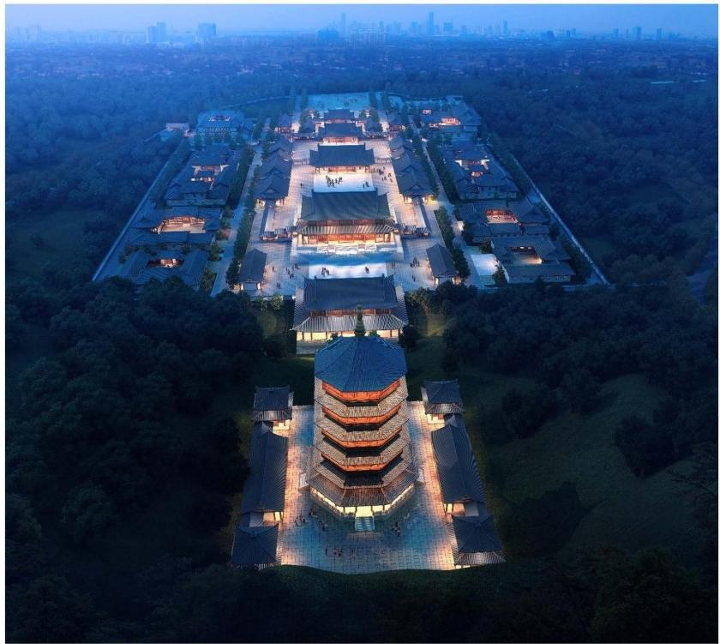

本项目位于广东省中南部东江之滨惠州龙门县，中低山丘陵地貌，依山 傍水。本次设计范围包括总平面设计布局以及道路消防、建筑风格、建
筑结构、园林景观、给水排水、水电暖通、环卫节能等。

广东省惠州市佛宇山寺
Foyushan Temple,Huizhou City,Guangdong Province

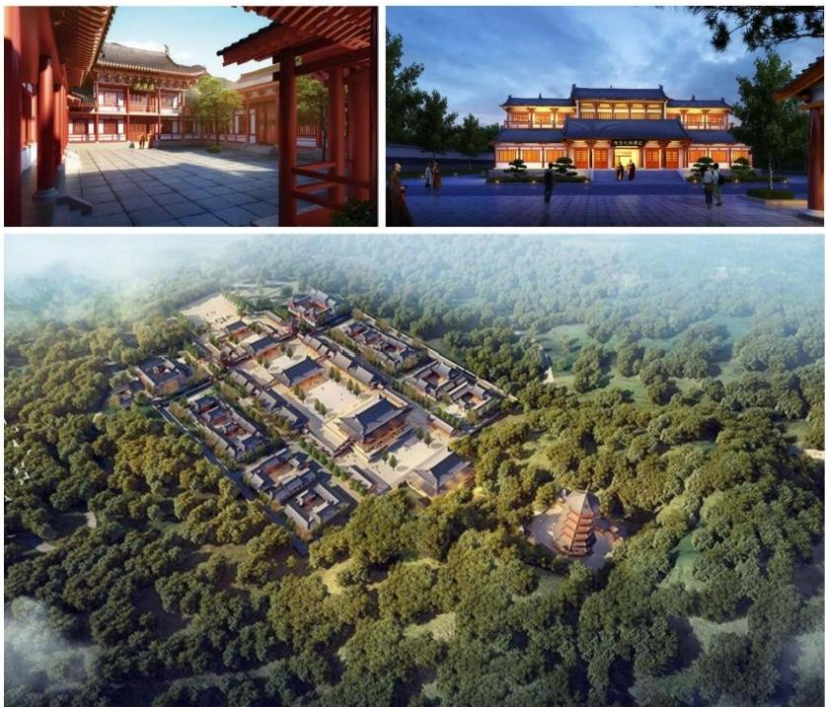

The project is located in Longmen County, Huizhou, on the coast of Dongjiang River in the south-central part of Guangdong Province. It is a hilly landform
with mountains and rivers. The design scope includes the total layout design and road fire protection, architectural style, building structure,garden
landscape, water supply and drainage, water and electricity heating, sanitation and energy conservation, etc.

山西省太原市明秀寺
Mingxiu Temple,Taiyuan City,Shanxi Province

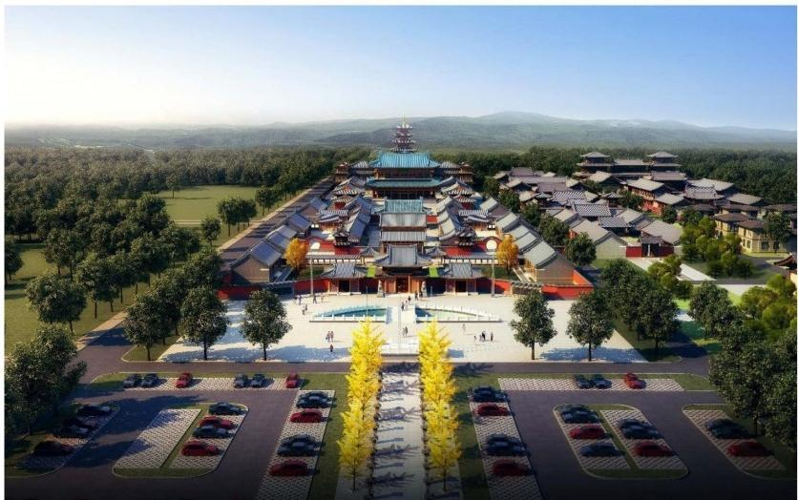

明秀寺位于山西省太原市晋源区晋祠王郭村，因寺院建筑多以绿琉璃瓦 盖顶，俗称“琉璃寺”。寺院位于太原西南郊25公里处，晋祠镇王郭村西
北部，西邻旧晋祠公路，东与大运高速公路接壤，交通十分便利。

山西省太原市明秀寺
Mingxiu Temple,Taiyuan City,Shanxi Province

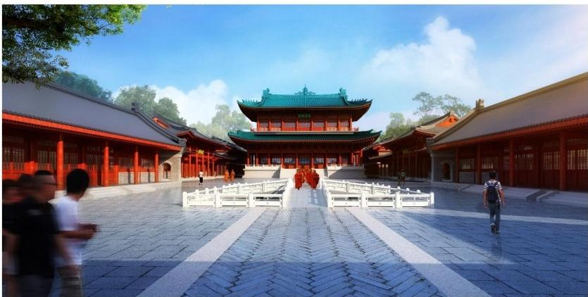
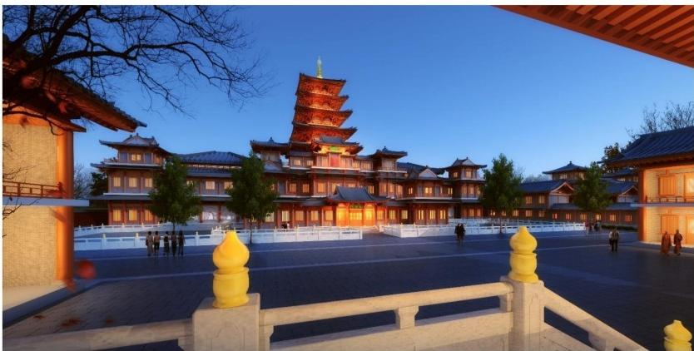

Mingxiu Temple is located in Jingu Village,Jinyu District, Jinyuan District,
Taiyuan City, Shanxi Province. Because the temple buildings are mostly
covered with green glazed tiles, it is commonly known as"Lioli Temple". The
temple is located 25 kilometers southwest of Taiyuan, northwest of Wangguo
Village in Jinci Town, west to the old Jinci Highway, and east to the Dayun Expressway. The traffic is very convenient.

浙江省嘉兴市普光寺
Puguang Temple, Jiaxing City,Zhejiang Province

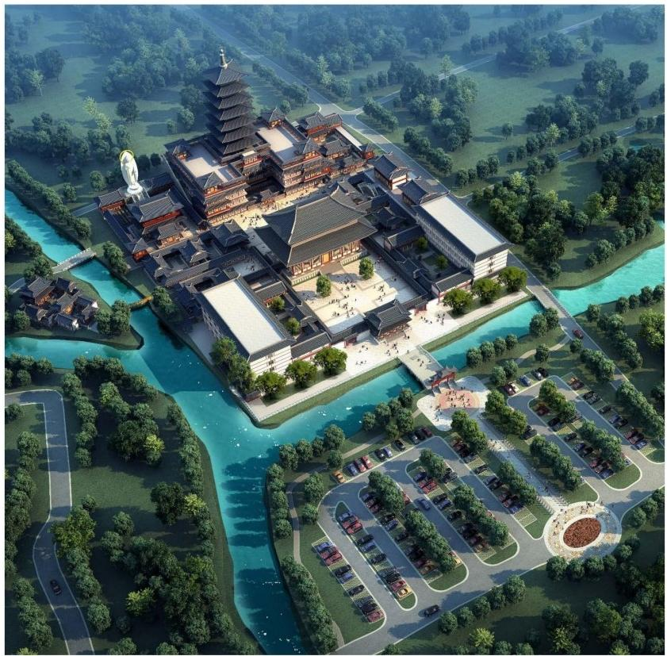

本项目位于浙江省嘉兴市南湖区余新镇普光村。周边交通便利，位于沪 杭高速公路边上。从普光寺向北达市中心有13.5公里的路程，普光寺位
于南湖区的东南部，是嘉兴东南四大名刹之一。

浙江省嘉兴市普光寺
Puguang Temple, Jiaxing City,Zhejiang Province

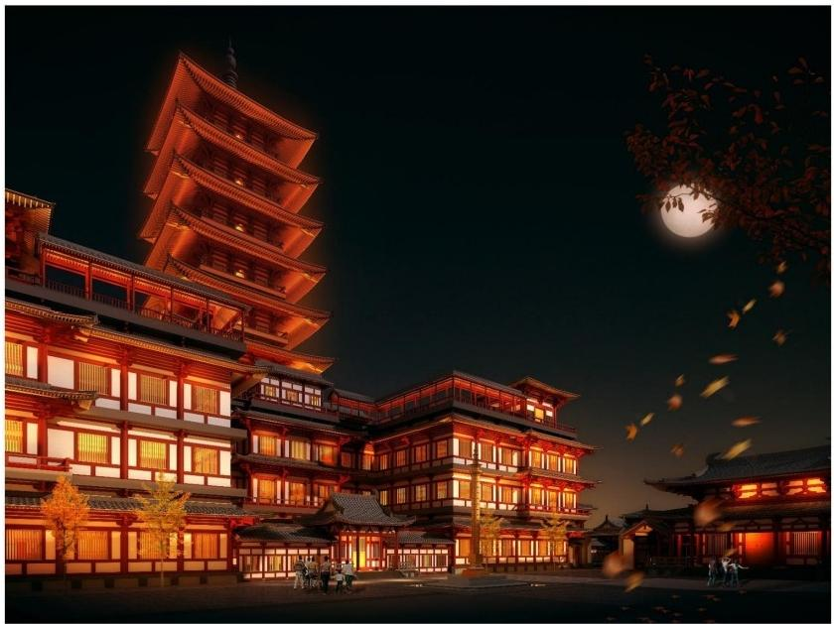

The project is located in Puguang Village, Yuxin Town, Nanhu District, Jiaxing City, Zhejiang Province. Convenient transportation around the hotel, located on the edge of the Shanghai-Hangzhou Expressway. It is 13.5 kilometers away from Puguang Temple to the north of the city center. Puguang Temple is
located in the southeast of Nanhu District and is one of the four famous temples in southeast of Jiaxing.

尼泊尔加德满都摩耶夫人寺
Madame Maya,Kathmandu,Nepal

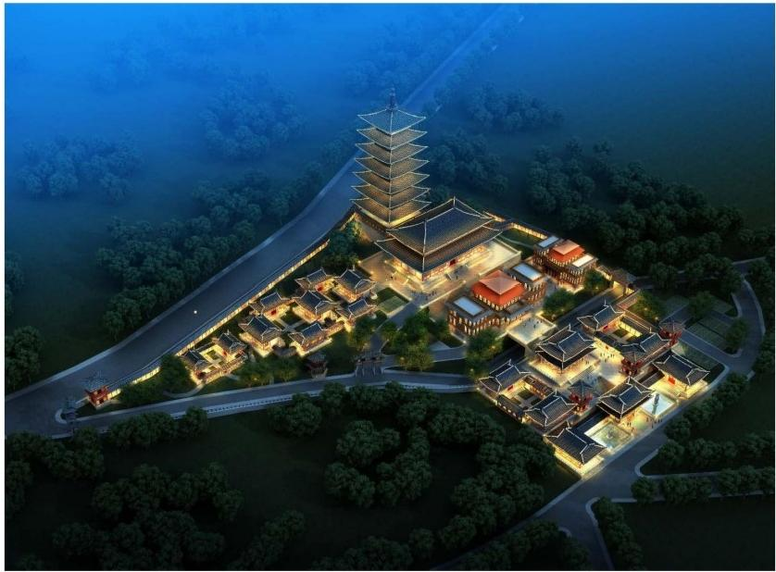

本项目规划目标是创造一个独一无的景点，既传播佛法也发扬尼瓦尔族 文化，创建一个新的世界级的佛教文化旅游目的地，并提供综合性的服
务设施及不同的功能分区。

尼泊尔加德满都摩耶夫人寺
Madame Maya,Kathmandu,Nepal

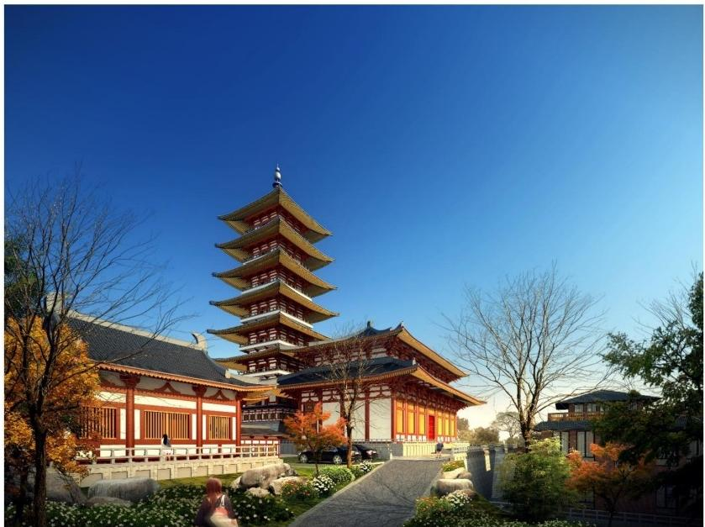

The goal of the project is to create a unique attraction that spreads both Dharma and Nival culture, creates a new world-class Buddhist cultural
tourism destination, and provides comprehensive service facilities and
different functional divisions.

尼泊尔加德满都白玉大乘华严寺
White Jade Mahayana Huayan Temple in Kathmandu,Nepal

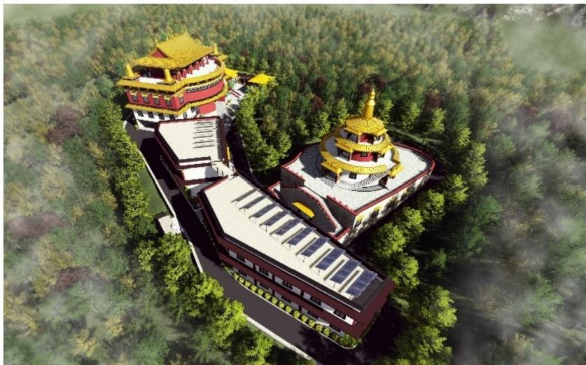

白玉大乘华严寺位于尼泊尔首都加德满都谷地，巴格马提河和比兴马提
河的汇口处。在7米高差的项目用地内设计藏式寺庙建筑。

尼泊尔加德满都白玉大乘华严寺
White Jade Mahayana Huayan Temple in Kathmandu,Nepal

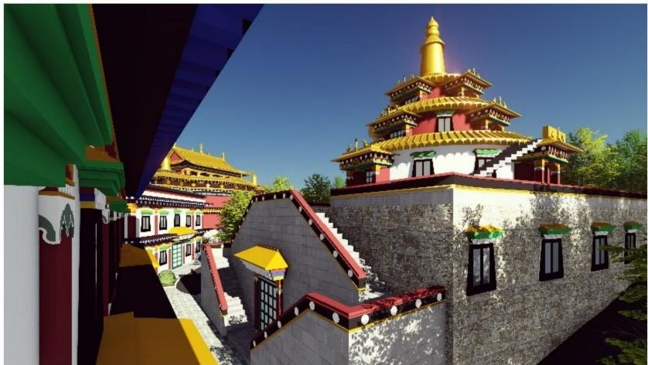
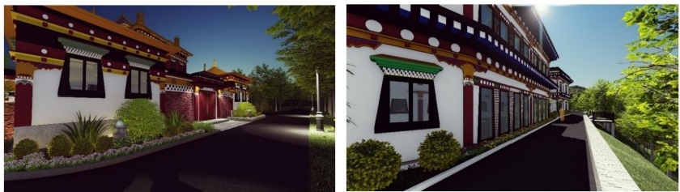

Baiyu Mahayana Huayan Temple is located in the Kathmandu Valley of Nepal, at the confluence of the Bagmati and Bihingmati rivers. The Tibetan temple building is designed in the project area of 7 meters height difference.

湖北省宜昌市古佛寺
Ancient Buddhist Temple in Yichang City,Hubei Province

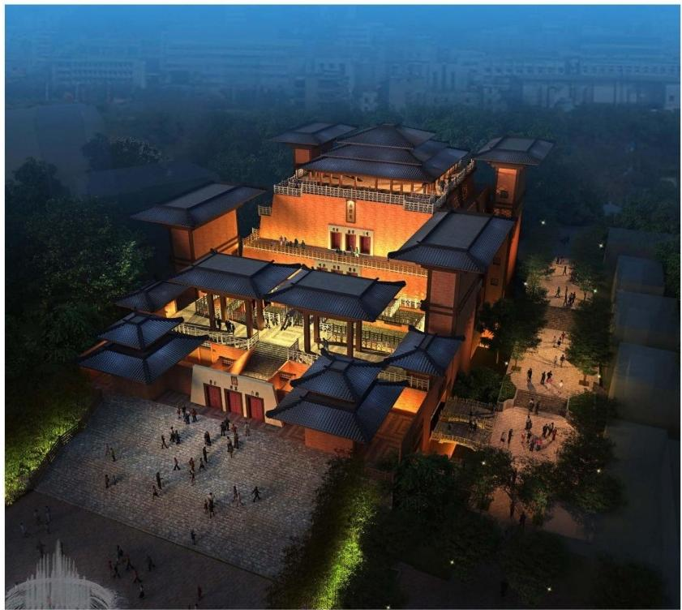

本项目位于湖北省宜昌市中心城区的培心路儿童公园内，规划用地面积 2800平方米，建筑设计面积8032平方米，整个地块朝向为坐东朝西，地
形为东高西低，地形呈长方形。

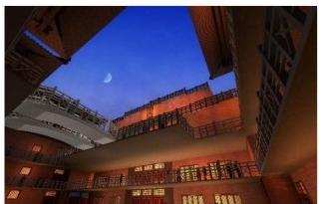
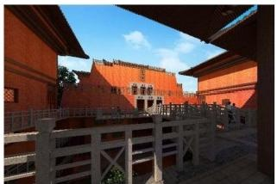

湖北省宜昌市古佛寺
Ancient Buddhist Temple in Yichang City,Hubei Province

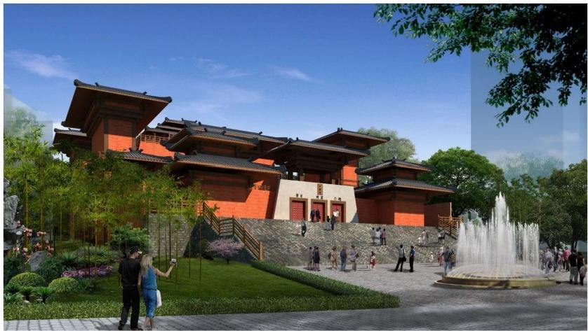
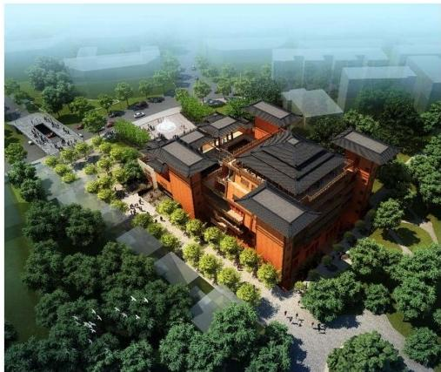

This project is located in the Children's Park of Huaixin Road in Yichang City, Hubei Province. The planned area is 2800 square meters, and the
architectural design area is 8032 square meters. The whole plot faces east
and west, the terrain is high in the East and low in the west, and the terrain is rectangular.

浙江省温州市龙庆寺
Longqing Temple Reconstruction Project in Wenzhou City,Zhejiang Province

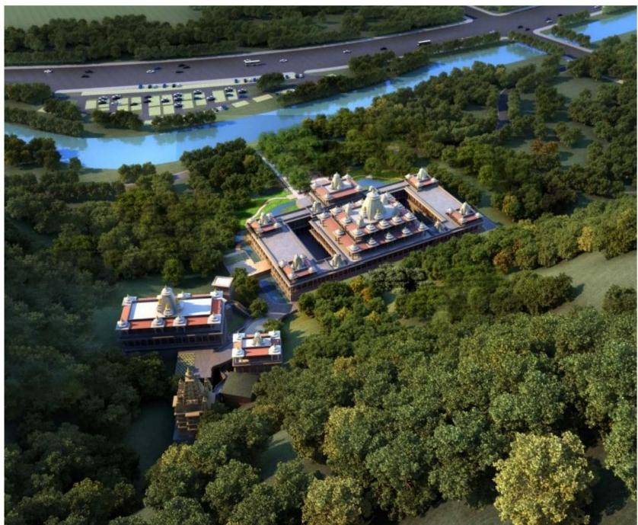

本工程是龙庆寺总体规划，设计地点位于温州市龙湾区中心黄世河以北。
建设用地面积13395平方米，规划地为不规则形状，西南为黄石后河，
东北为黄石山。区域内道路以直线型为主，以曲线型山道为辅，建筑的
直线和景观的曲线互相呼应有机结合。

浙江省温州市龙庆寺
Longqing Temple Reconstruction Project in Wenzhou City,Zhejiang Province

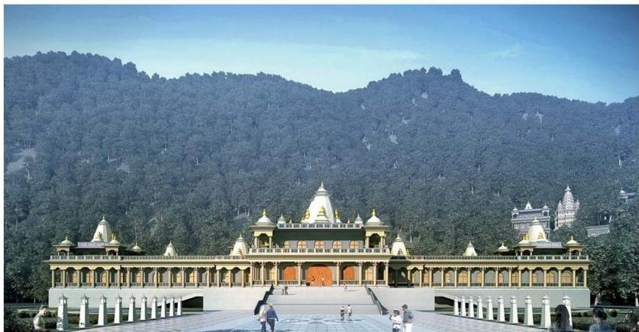
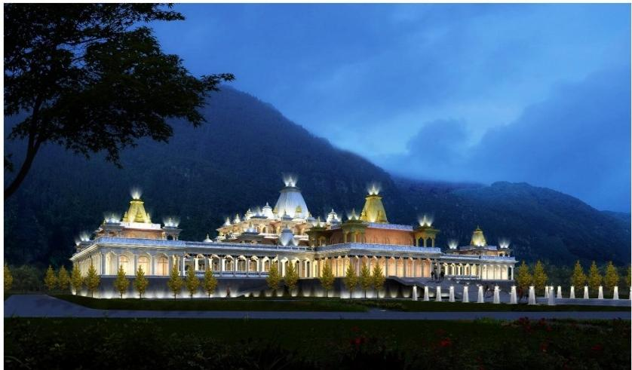
This project is the overall plan of Longqing Temple. The design site is located north of Huangshi River in the center of Longwan District, Wenzhou City. The construction land area is 13,395 square meters, and the planned area is
irregular. The southwest is Huangshi Houhe and the northeast is Huangshi Mountain. The roads in the area are mainly linear, supplemented by curved
mountain roads, and the curves of the buildings and the curves of the landscape echo each other organically.

四川省甘孜州格蒙寺
Gemen Temple in Ganzi Prefecture,Sichuan Province

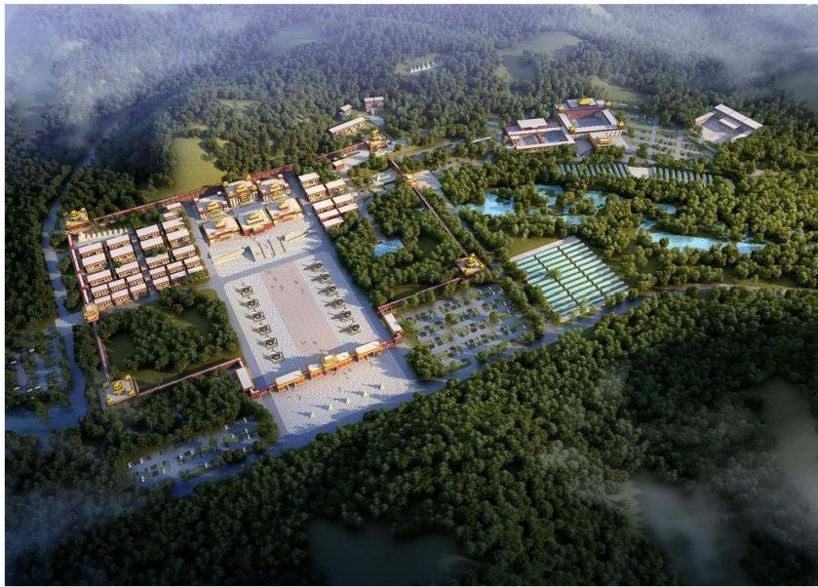

在历史文化上结合传统藏传佛教和宁玛派特色、传统寒地建筑技术和藏 族传统习俗。设计融合绿色建筑技术，建筑声光环境和智慧寺院。功能 分区有经堂、宿舍区、露营区、停车场、设施农业区、酒店医院区、学
校区、湿地公园区和生态涵养区。

四川省甘孜州格蒙寺
Gemen Temple in Ganzi Prefecture,Sichuan Province


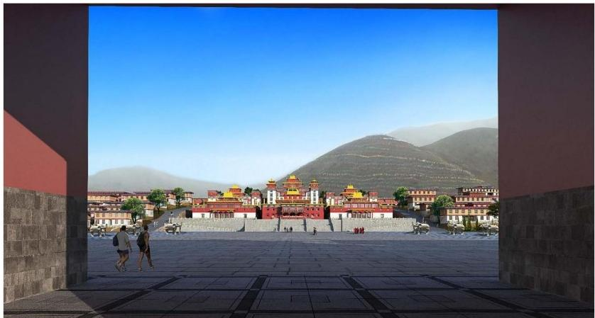

It combines traditional Tibetan Buddhism and Nyingma characteristics,
traditional coldland architecture techniques and Tibetan traditional customs
in history and culture.Designed to blend green building technology, architectural sound and light environments and smart temples. The
functional divisions include Jingtang, dormitory area, camping area, parking lot, facility agriculture area, hotel hospital area, school area, wetland park area and ecological conservation area.

浙江省杭州市萧山先照寺
Xiaoshan Xianzhao Temple,Hangzhou City,Zhejiang Province

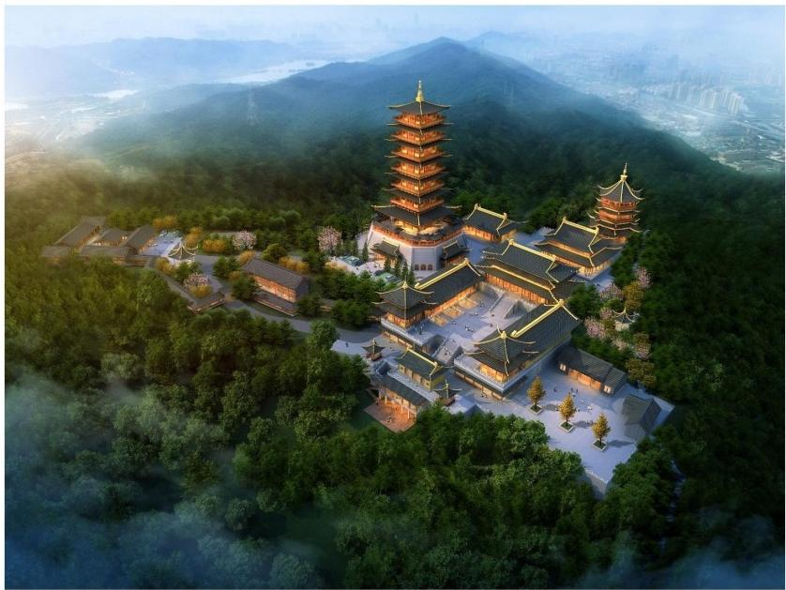

先照寺，位于萧山区蜀山街道石岩山巅，始建于南宋绍兴年间(1131一 1162),每当旭日东升，万道霞光首先照亮古寺的黄墙飞檐，取“旭日
之光先照此寺”之意，故名。“先照晨曦”亦为古湘湖景之一。

浙江省杭州市萧山先照寺
Xiaoshan Xianzhao Temple,Hangzhou City,Zhejiang Province

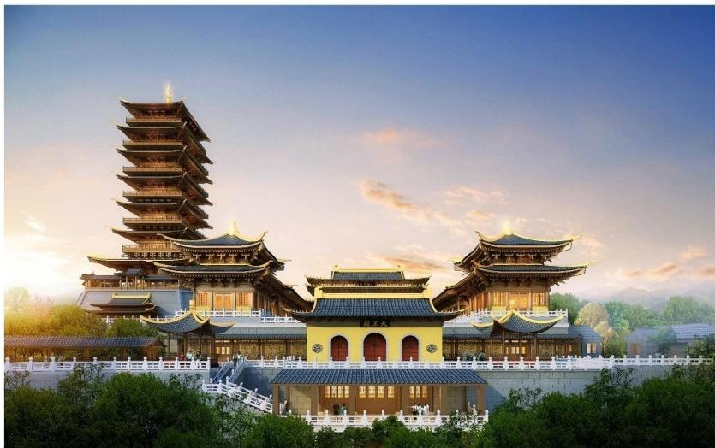
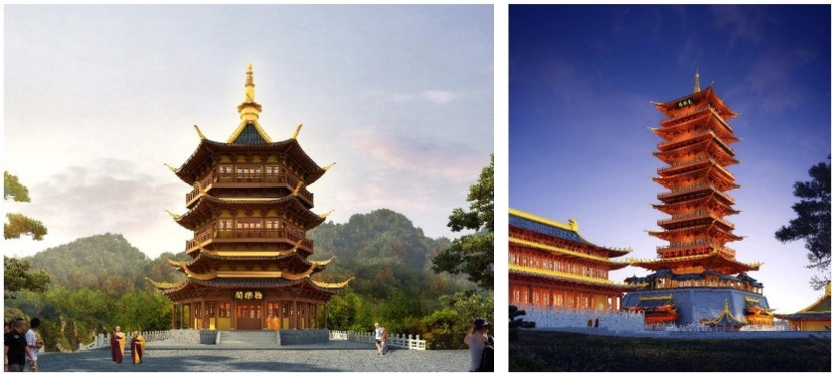

Xianzhao Temple, located on the top of Shiyan Mountain of Shushan Street in Xiaoshan District, was built in Shaoxing of Southern Song Dynasty(1131-
1162). Whenever the rising sun rises eastward, Wandaoxiaguang first
illuminates the eaves of the ancient temple's yellow wall, taking the meaning of "the rising sun shines on the temple first"."Sunrise first" is also one of the ancient Hunan Lake scenery.

重庆市大足云溪寺
Dazu Yunxi Temple,Chongqing City
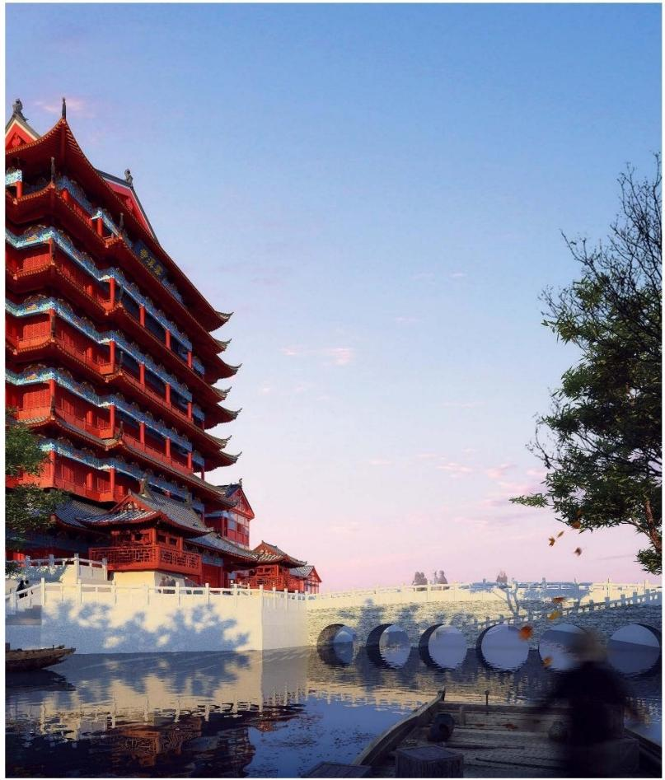
由于寺院所处用地面积狭小，采用阁楼的建筑形式来满足寺院的功能需 求，本方案以明清宫殿式的建筑风格为基础，结合重庆当地民居建筑风
格，以现代寺院多功能需求为原则，设计成古今结合明清阁楼式寺院建
筑 。

重庆市大足云溪寺
Dazu Yunxi Temple,Chongqing City

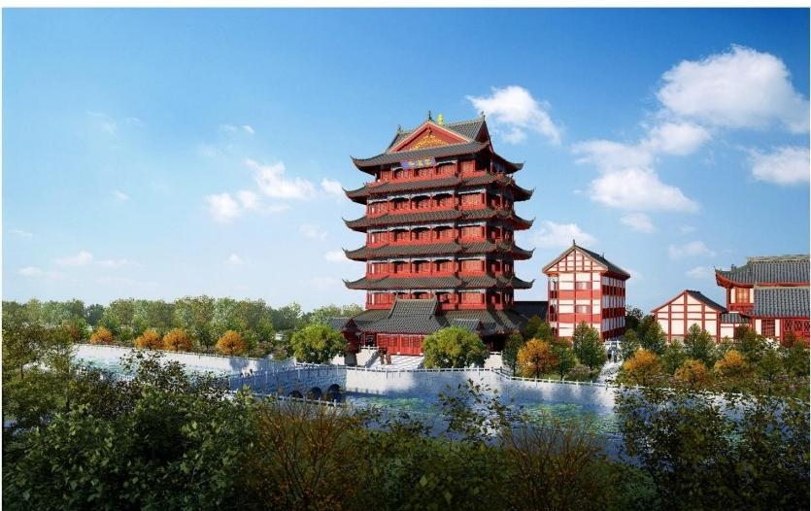
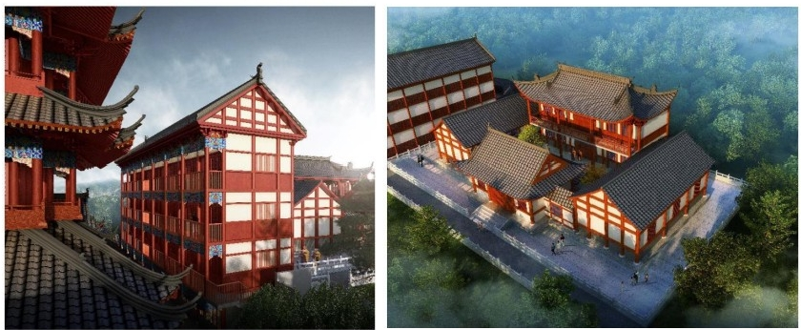

Due to the small area of the temple, the architectural style of the attic is used
to meet the functional needs of the temple. This program is based on the palace-style architectural style of the Ming and Qing Dynasties, combined with the local residential architecture of Chongqing, and designed according to the multi-functional needs of modern temples. Cheng Gujin combines
Ming and Qing loft-style temple buildings.

浙江省杭州市萧山兜率禅寺
Dhyana Temple in Xiaoshan,Hangzhou City,Zhejiang Province

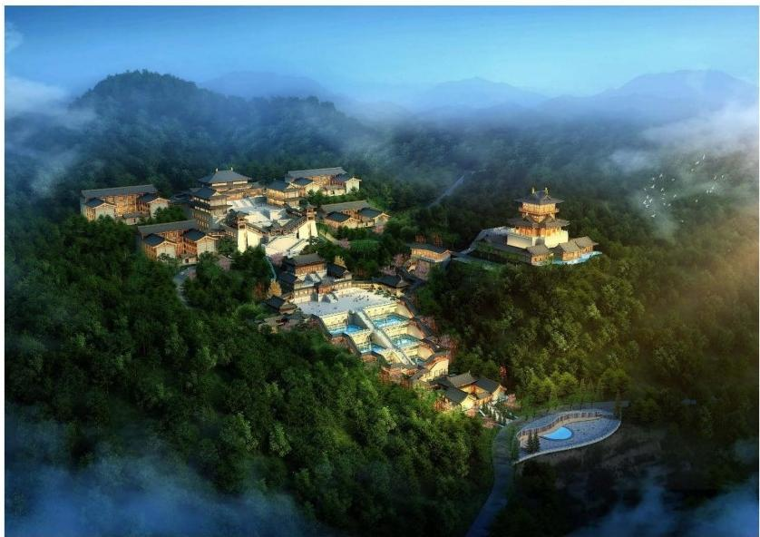

兜率禅寺所处的道林山位于萧山南边，紧邻富阳区，距离西湖风景区 29.9公里，仅一江之隔。整个寺院的格局犹如振翅欲飞的大鹏金翅鸟
,代表佛法修行勇猛精进。

浙江省杭州市萧山兜率禅寺
Dhyana Temple in Xiaoshan,Hangzhou City,Zhejiang Province

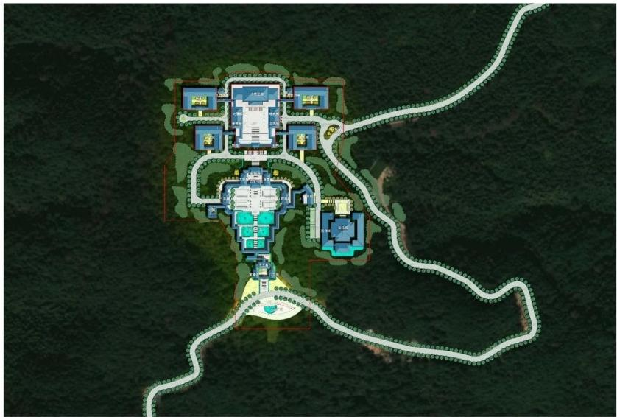
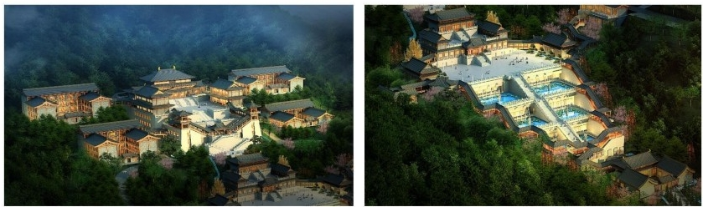

Daolin Mountain, located in the south of Xiaoshan, is adjacent to Fuyang
District, 29.9 kilometers away from the West Lake Scenic Area, only one river
away. The whole monastery is like a flying ROC golden-winged bird
It represents the courageous and progressive practice of Buddhism and

河北省石家庄市生命纪念馆
Life Memorial Hall of Shijiazhuang City,Hebei Province

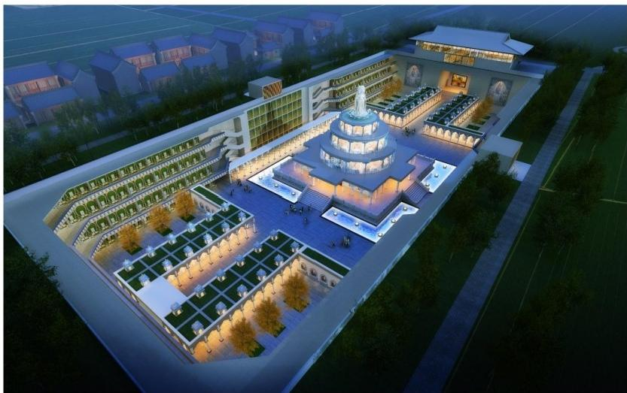

石家庄志公禅寺地宫项目，结合城市生态陵园建设，位于志公禅寺东北 方位，规划占地面积40亩，下沉广场基底面积9000平方米。通过项目的 建设，有效利用废弃坑地建设生态型陵园，弘扬中华孝道文化，融入佛 教文化的生命关怀理念，以佛陀教育为特色，受十方信众拥护，起到了
佛教以教化为本、安定社会的作用。

河北省石家庄市生命纪念馆
Life Memorial Hall of Shijiazhuang City,Hebei Province

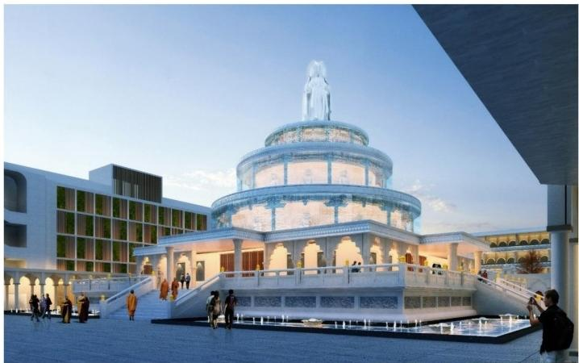
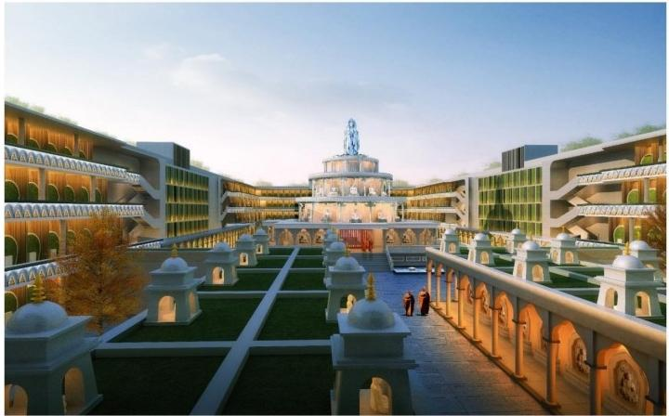

Through the construction of the project, we can effectively use the
abandoned pits to build an ecological cemetery, carry forward the Chinese
filial piety culture, integrate into the concept of life care of Buddhist culture, take Buddha education as the characteristic, and receive the support of the ten believers, which has played the role of Buddhism in stabilizing the society
based on enlightenment.

青海省玉树州嘉洛红宫观景平台
Jialuo Red Palace Scenic Platform,Yushu Prefecture,Qinghai Province

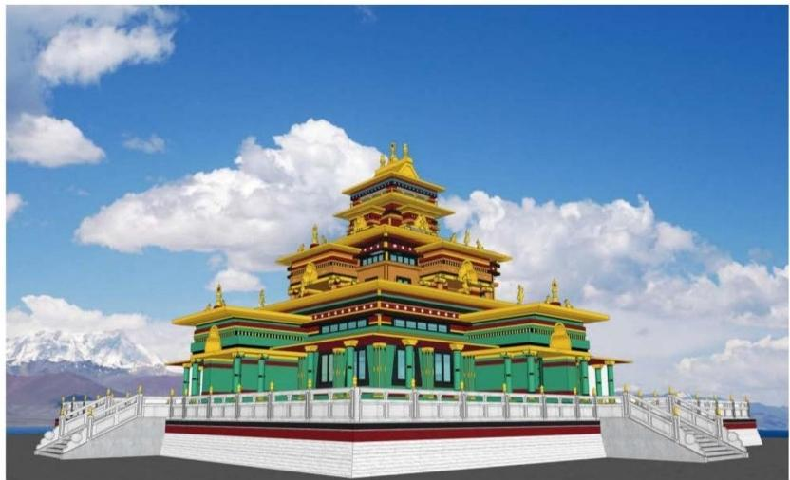

本工程位于青海省玉树州治多县，嘉洛红宫在治多县城背后的嘉吉博洛
草原上，“嘉洛”是珠姆娘家的姓氏，她所住的宫殿又是用红土造就的，
因此称作“嘉洛红宫”。我们的主题是探索遗失的“嘉洛红宫”,再现“文化
遗址嘉洛红宫”的文化内涵。

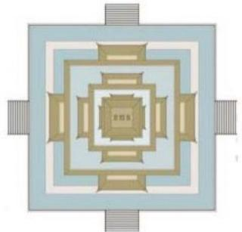

青海省玉树州嘉洛红宫观景平台
Jialuo Red Palace Scenic Platform,Yushu Prefecture,Qinghai Province

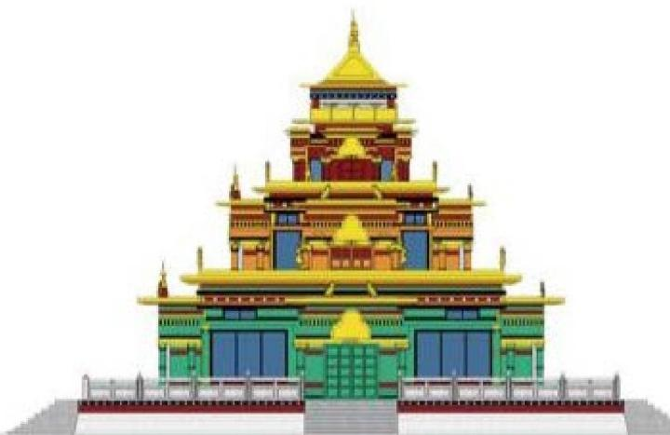

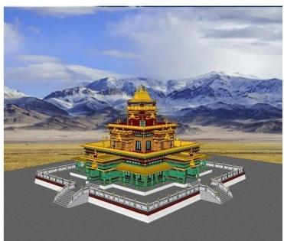

The project is located in Zhiduo County, Yushu Prefecture, Qinghai Province. The Jialuo Red Palace is on the Cargill-Bolo grassland behind Zhiduo County. “Jialo”is the surname of the mother of Zhum,and the palace she lives in is made of red clay.It is called "Jialo Red Palace".Our theme is to explore the
lost "Jialuo Red Palace" and reproduce the cultural connotation of the
"Cultural Site of Jialuo Red Palace".

曼谷市泰国文化中心
Thai Cultural Center,Bangkok ,Thailand

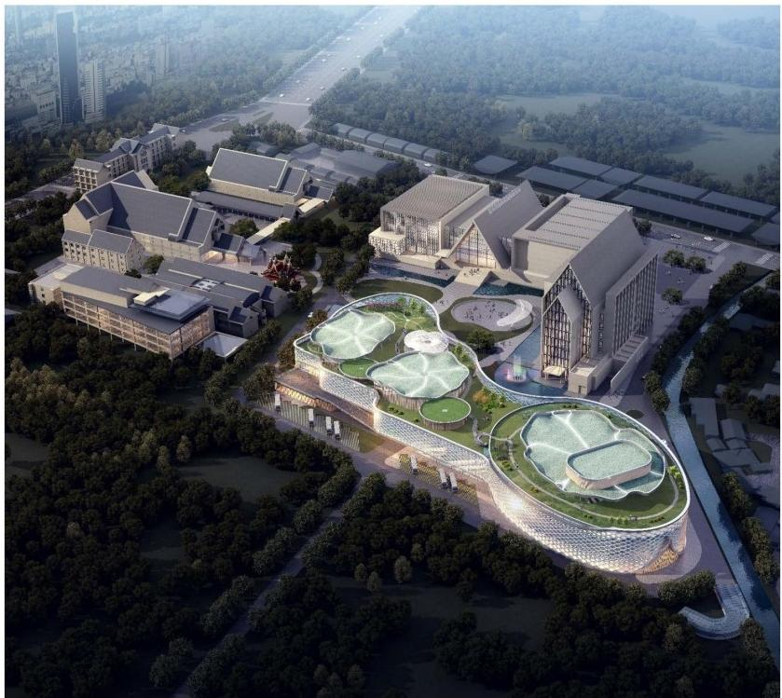

泰国文化中心项目的目标是建设以三个剧场为主的综合楼，同时具有会 议、电子图书馆、餐厅、办公等多种功能。完善泰国文化中心的功能需 求，成为市民的公共文化交流客厅和泰国向世界展示文化的窗口。是集 大剧院以全新的视角来表达灿烂的泰国文化。设计融入泰国的山水文化
和佛教文化，以文化之河作为设计的概念。

曼谷市泰国文化中心
Thai Cultural Center,Bangkok ,Thailand
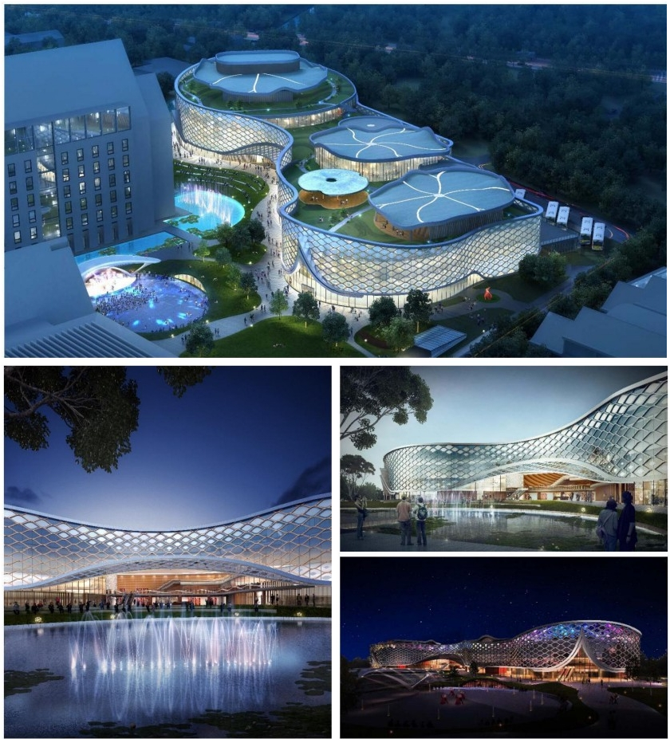

The objective of the Thai Cultural Center project is to build a comprehensive building with three theatres as the main building, with functions of
conference,electronic library, restaurant, office and so on. The design
incorporates Thai landscape culture and Buddhist culture, and takes the river of culture as the concept of design.

黑龙江省哈尔滨市哈尔滨佛学院
Harbin Buddhist College,Harbin City,Heilongjiang Province

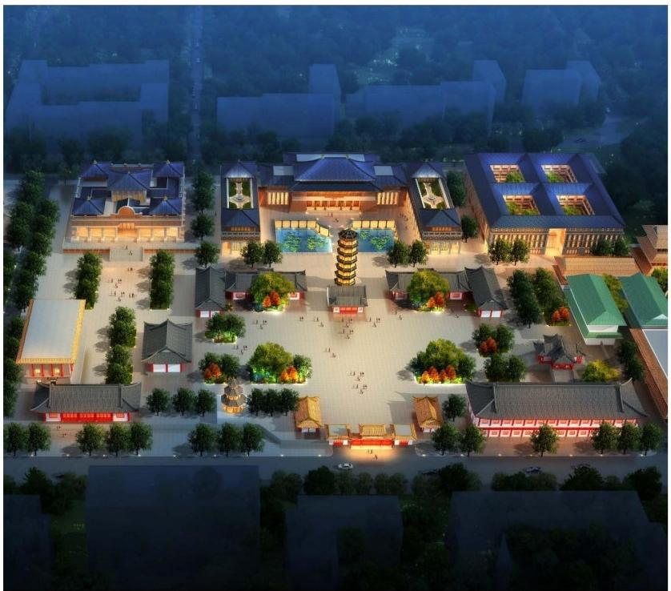

哈尔滨佛学院的新建工程，主要以佛学院的教学区和容纳数千人进行佛 学讲座的弘法楼所组成，设计以福田僧、万法楼为设计概念，把佛教文
化和建筑文化融为一体。

黑龙江省哈尔滨市哈尔滨佛学院
Harbin Buddhist College,Harbin City,Heilongjiang Province

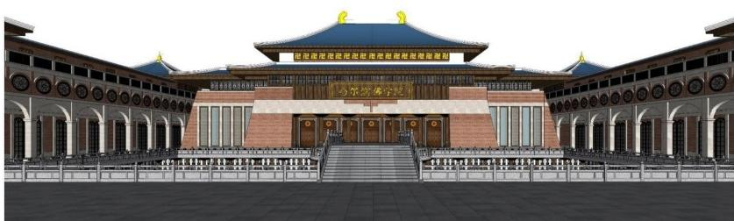
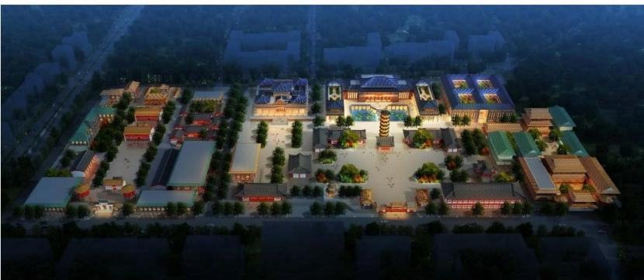

The new project of Harbin Buddhist College is mainly composed of the
teaching area of Buddhist College and the Hongfa Building, which can hold thousands of people to give Buddhist lectures. The design takes Futian Monk and Wanfa Building as design concepts, and integrates Buddhist culture and
architectural culture.

安徽省马鞍山市濮塘桃李
Peach and plum in Putang,Ma'anshan City,Anhui Province

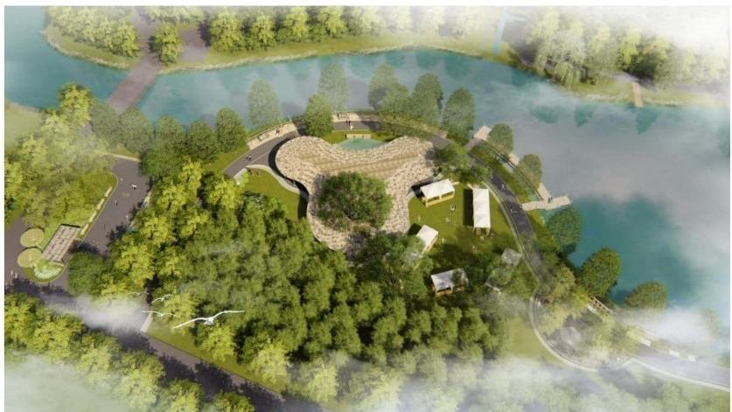
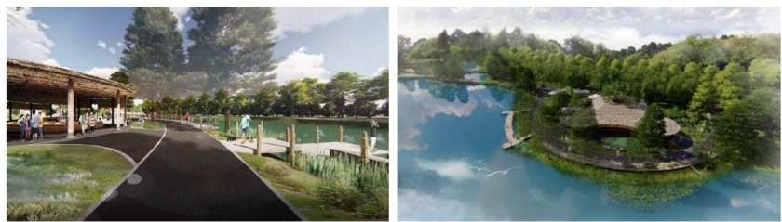

简洁的公园景观和地域人文元素结合，灵动的设计曲线呼应了河流的形
态。
Simple park landscape combined with regional human elements, the flexible design curve echoes the shape of the river.

山西省原平市龙岩寺生态文化旅游区
Longyan Temple Eco-cultural Tourist Area,Yuanping City,Shanxi Province

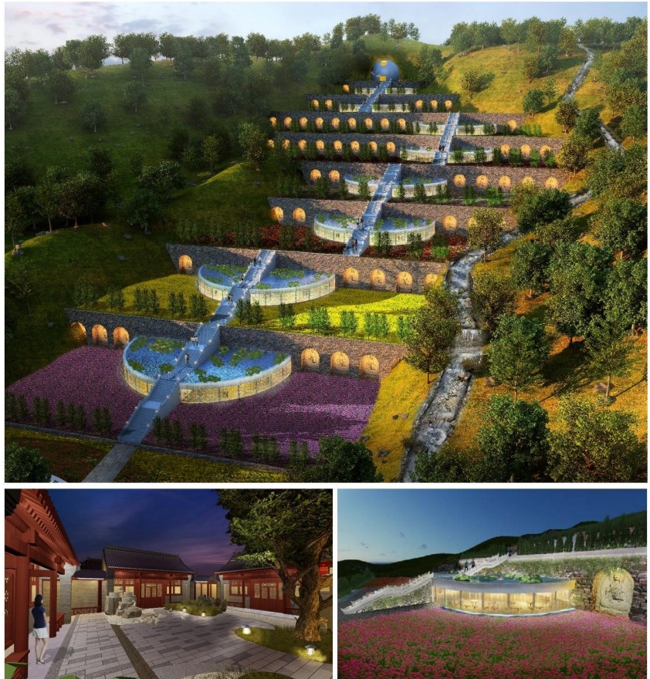

九品莲台花园、禅意国学庭院，是生态文化旅游区的特色景观，分别体
现了公共景观和庭院景观的不同使用功能和特色。
Nine Pin Liantai Garden and Zen Chinese Academy Courtyard are
characteristic landscapes of eco-cultural tourist areas, which respectively reflect the different functions and characteristics of public landscape and courtyard landscape.

江苏省徐州市地藏寺
Tibetan Temple in Xuzhou City, Jiangsu Province

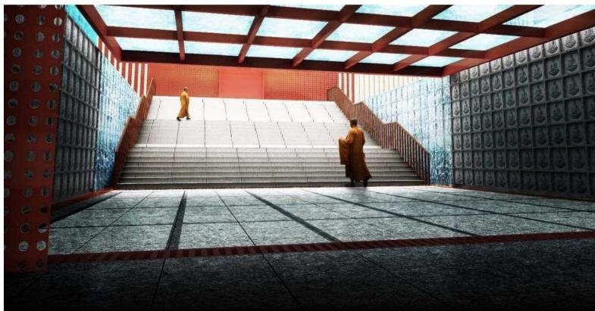
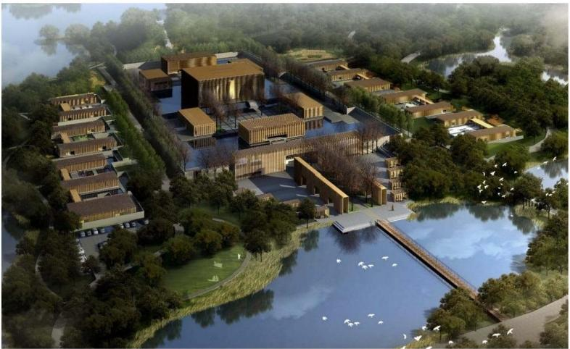

项目是位于公园里的现代风格寺院建筑，禅意的景观风格需要用现代的
设计元素、材料和空间来表达。
The project is a modern style temple building located in the park. The Zen
landscape style needs to be expressed by modern design elements, materials

江西省萍乡市玉皇古宫隐苑
Yinyuan of Yuhuang Palace in Pingxiang City,Jiangxi Province

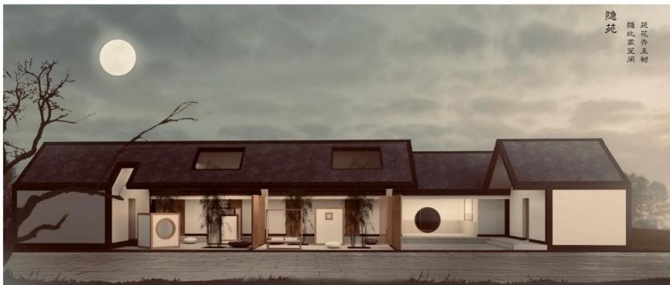
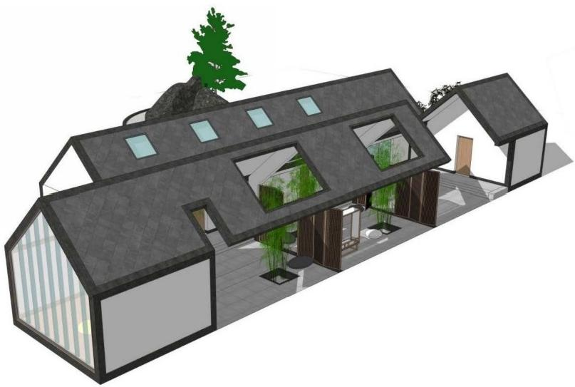

项目是一座位于道观里的居住庭院，简洁的形态融入了东方建筑的元素，
庭院景观以竹子作为主要的景观植物，表达禅意。
The project is a residential courtyard located in Taoist temple.The concise form incorporates elements of Oriental architecture. Bamboo is the main landscape plant in the courtyard landscape to express Zen.

江西省萍乡市玉皇古宫冥想室
Meditation Room of Yuhuang Palace in Pingxiang City,Jiangxi Province

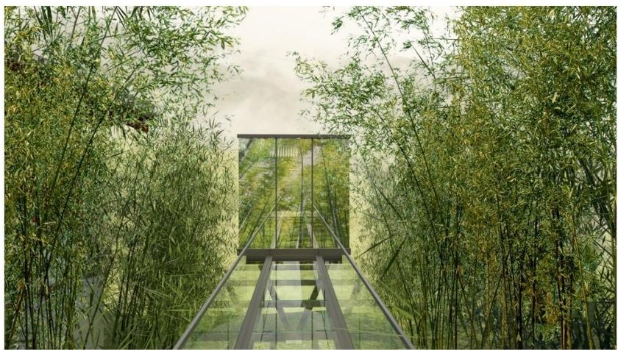
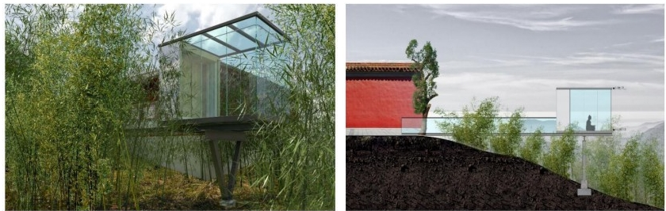

位于竹林里的冥想室，使用玻璃外墙的透明房间，最大化的融于竹林景
观，营造一处遮风挡雨的禅意空间。
The meditation room located in the bamboo forest uses transparent rooms with glass exterior walls to maximize the integration of the bamboo forest landscape and create a Zen space for shelter from wind and rain.

黑龙江省哈尔滨市哈西发展大厦
Harbin Harbin Development Building,Heilongjiang Province

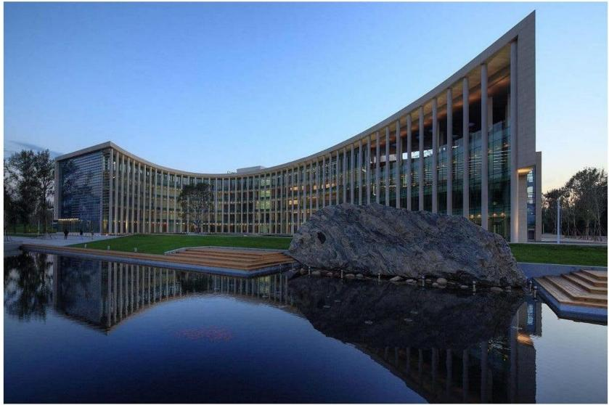
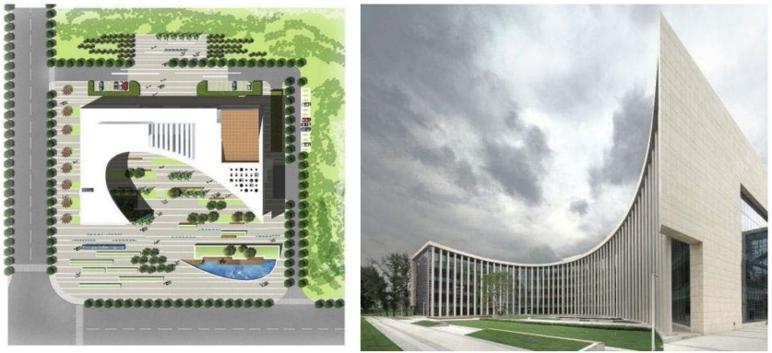
建筑极具特色的弧形外墙，通过景观与其呼应，形成椭圆形的主要入口
景观广场，倒映的水池增强了建筑的美感。
The project is a residential courtyard located in Taoist temple.The concise form incorporates elements of Oriental architecture. Bamboo is the main landscape plant in the courtyard landscape to express Zen.

陕西省西安市西咸太平公园
Xixian Taiping Park,Xi'an City,Shaanxi Province
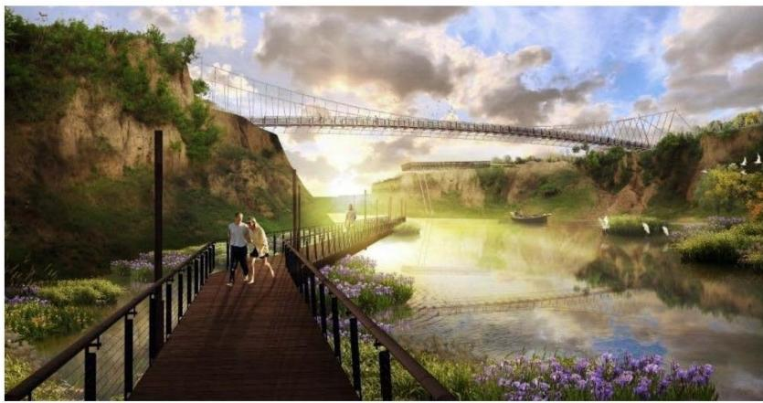
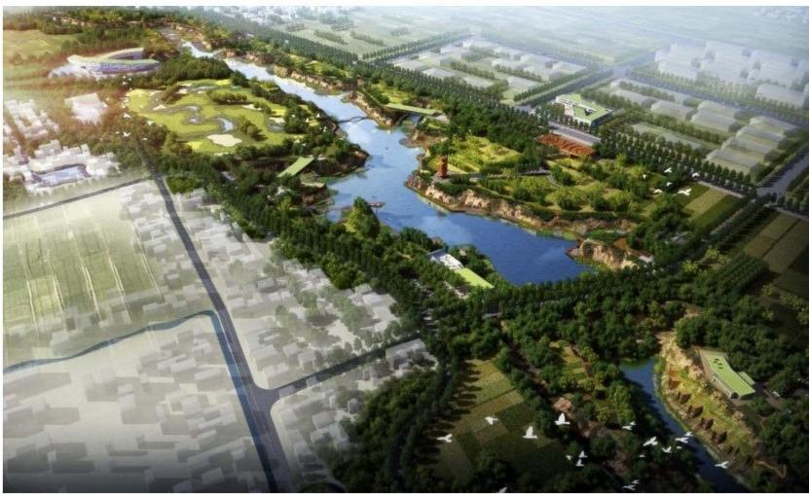
湿地公园景观设计，主要的原则在于最大化的减少人工对于生态景观的
干预，高架的步行栈桥也提供了最佳的观景视野。
The main principle of wetland park landscape design is to minimize artificial intervention in the ecological landscape, and the Elevated pedestrian trestle also provides the best view.

浙江省衢州市鹿鸣公园
Luming Park,Quzhou City,Zhejiang Province

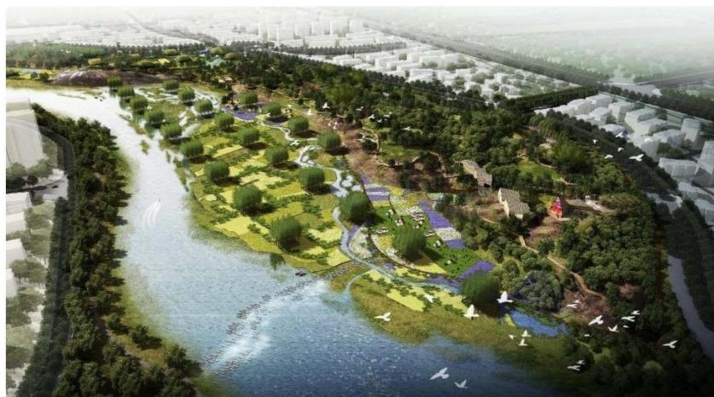
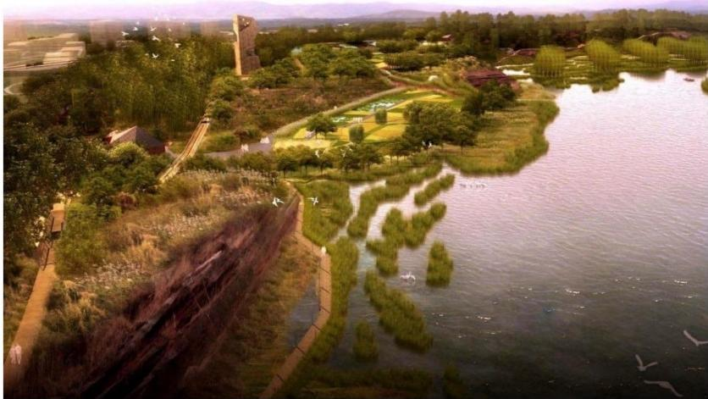

保留的农田和生态的水生植物岛屿，树林和花海，通过景观设计融为有
机的整体。
Reserved farmland and ecological aquatic plant islands,forests and flowers are integrated into an organic whole through landscape design.

北京市房山积山庄佛教文化旅游区
Beijing Fangshan Jishan Villa Buddhist Cultural Tourism Area

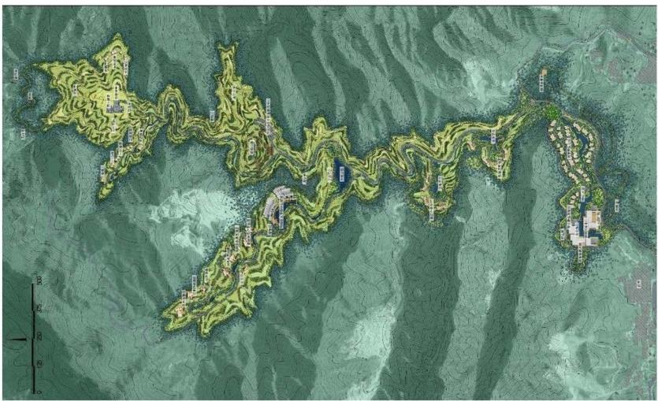
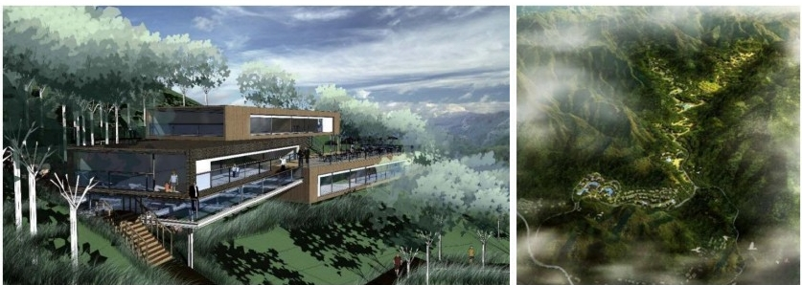

旅游区的建筑和景观结合山地地形和地貌进行设计，形成具有特色的山
谷景观风貌。
The architecture and landscape of the tourist area are designed in
combination with the mountain topography and landform to form a unique landscape of the valley.

天津是中海公园城体育公园
Luming Park,Quzhou City,Zhejiang Province
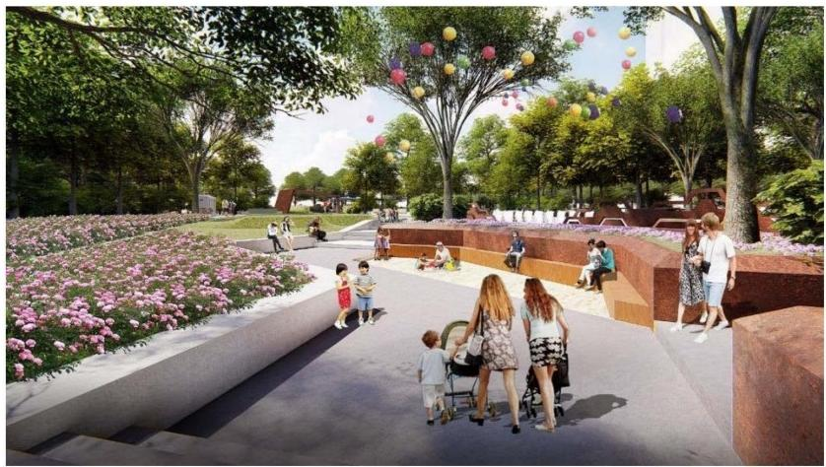
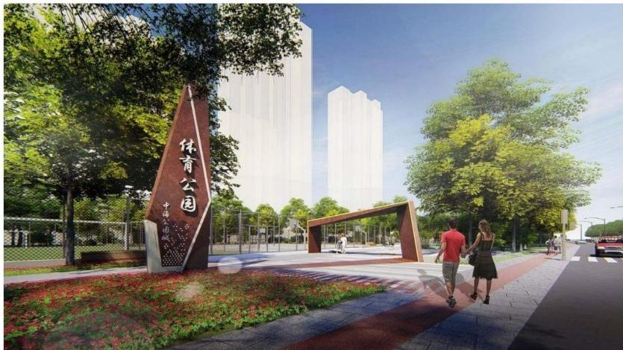

这是一个位于大型社区里的体育公园，具有活力的折线形景观构筑物和
道路铺装贯穿了项目设计，成为鲜明的设计元素。
This is a sports park located in a large community. Vigorous folded landscape structures and road pavement penetrate the project design and become a distinct design element.

北京市科信公司公共空间
Public Space of Beijing Science and Information Corporation
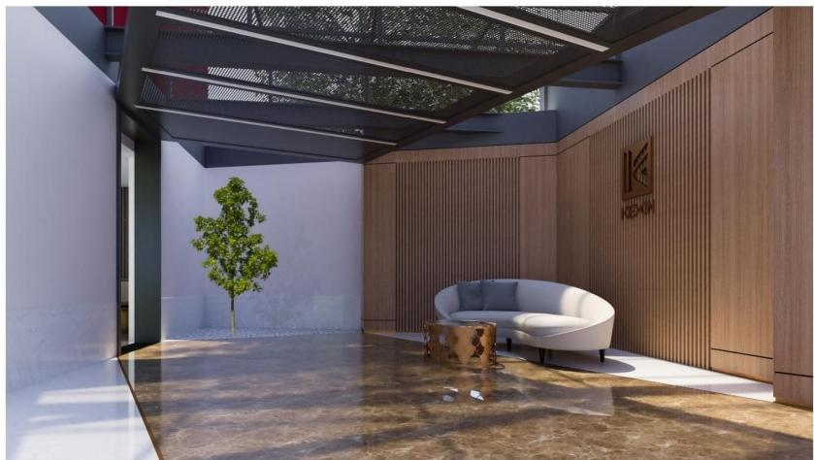
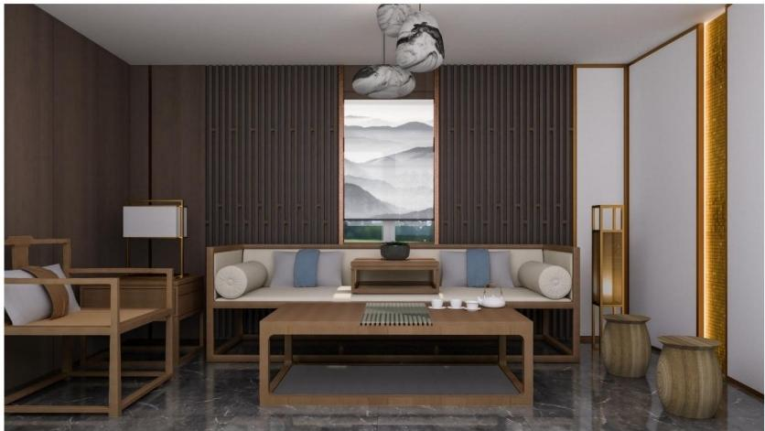

木饰面的主体装饰材料将室内空间与透过玻璃的自然景物相衔接，东方
主义的家具典雅沉稳。
The main decorative material of wood veneer connects the interior space
with natural scenery through glass, and the furniture of Orientalism is elegant

山西省太原市禅茶会所
Zen Tea Club in Taiyuan City,Shanxi Province
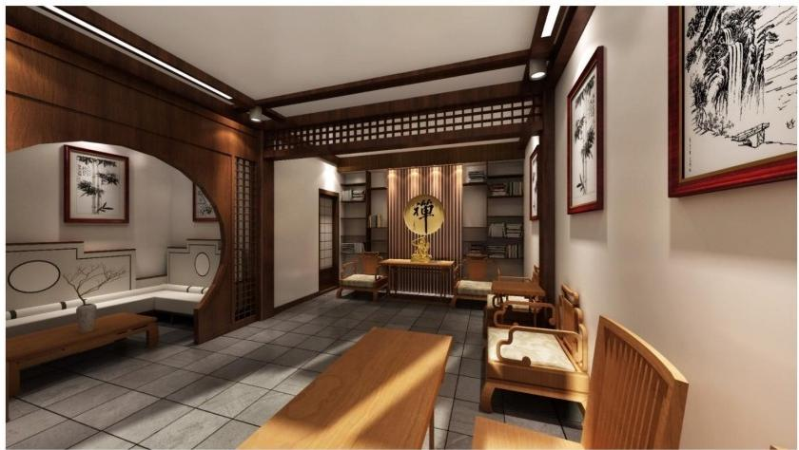
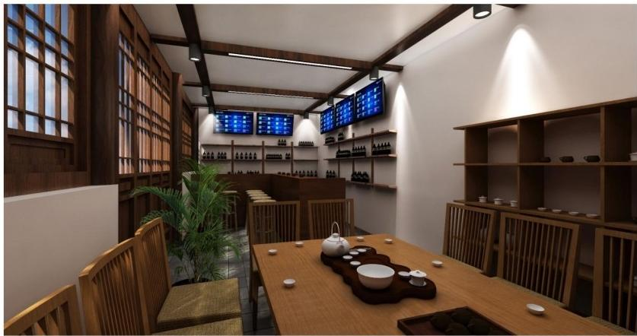

禅茶会所需要通过设计营造一个禅意的室内空间，茶文化在这里进行展
示和交流。
Zen tea party needs to create a Zen interior space through design, where tea culture is displayed and exchanged.

福建省武夷山市别墅
Villas in Wuyishan City,Fujian Province
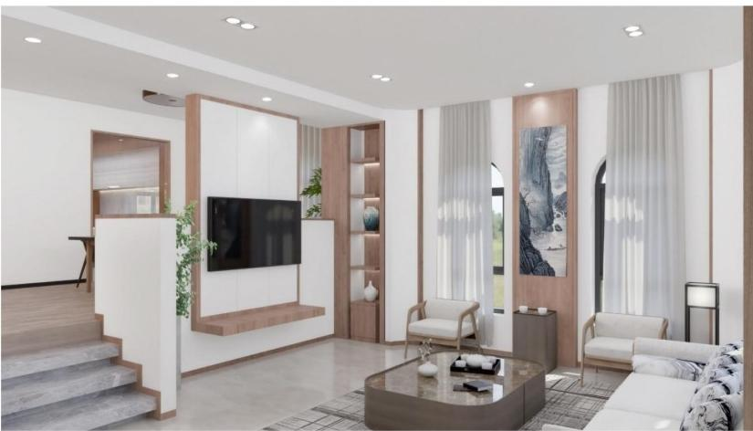
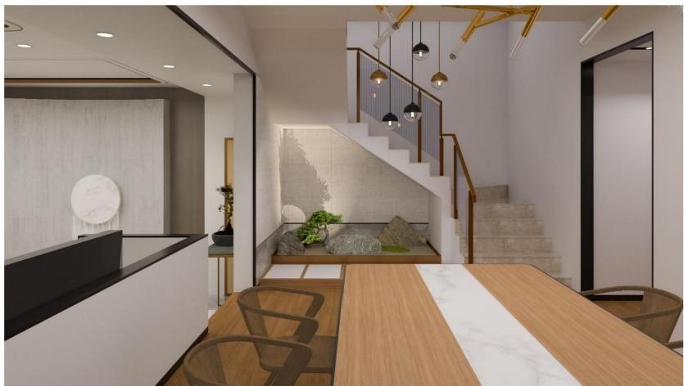

简约的室内设计元素结合新东方主义风格，成为一处优雅的家居空间。 Simple interior design elements combined with the new Orientalism style, become an elegant home space.

湖北省武汉市橙铁健身俱乐部
Orange Iron Fitness Club in Wuhan City,Hubei Province
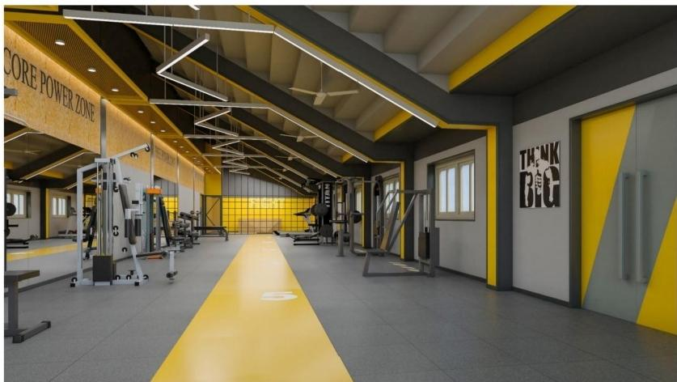
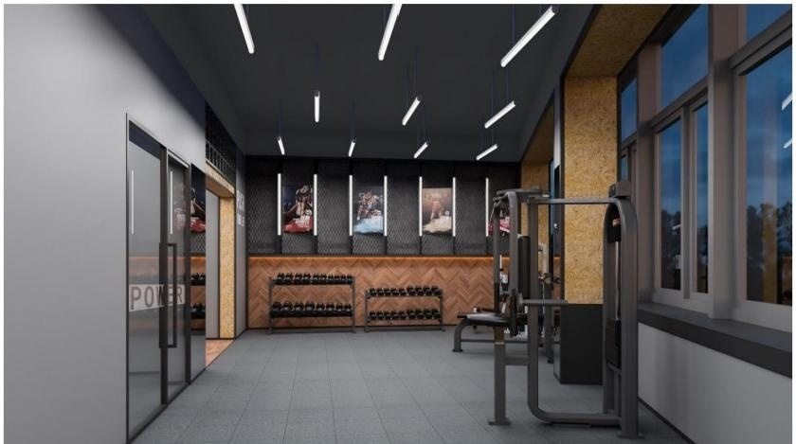
这是一处位于体育场看台的空间改造，新的健身俱乐部功能，融合了建 筑结构的工业设计风格和具有活力的色彩搭配，给场地带来新的气质。 This is a space renovation located in the stadium bleachers, new fitness club functions, integration of the industrial design style of the building structure
and dynamic color matching, to bring a new temperament to the stadium

area.

山西省太原市明秀寺
Mingxiu Temple,Taiyuan City,Shanxi Province

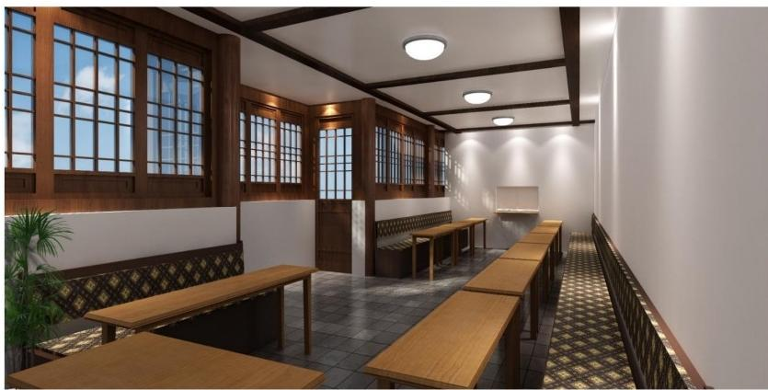
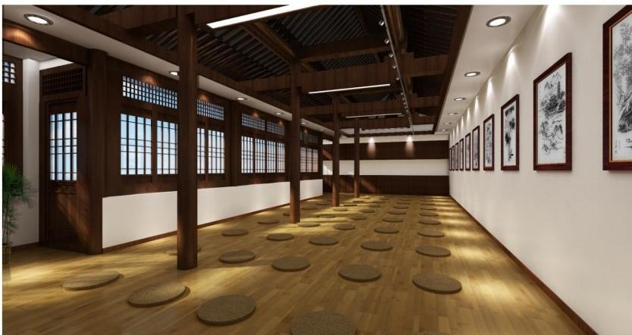

这是一座有千年历史的宋代风格古寺院，典雅宁静的寺院斋堂和禅堂设
计。
This is an ancient temple with a thousand-year-old Song Dynasty style, elegant and tranquil temple hall and Zen hall design.

德鲁安
景区和寺庙设计施工运营服务商
超过100个寺庙和景区落地项目
超过30个4A、5A级景区和商业街落地项目
您最佳的合作伙伴
您最专业的朋友

请扫码关注以上公众号
加微信号(13810104901)为好友
免费咨询

[项目融资]您有好项目，我们就敢投，投资方面对面洽谈。
[找投资人]每月定期举报融资沙龙，与投资人面对面洽谈。
[融资渠道]海量资金库，融资方式多，融资渠道广。
[我们帮你]如果你建设资金有缺口，而土地、建设等手
续齐备，寻求垫资施工和资方，如果你有好工艺、好材
料、好手艺、好服务、好产品、好人缘，找靠谱的甲方，

