2022年浙江省杭州市中考英语试卷第I卷 第一局部 听力（共两节，总分值30）第一节（共5题，每题2 分，总分值10分）听下面5段对话。每段对话后有一个小题，从题中 所给的A、B、C三个选项中选出最正确选项，并标在试卷的相应位置。
听完每段对话后，你都有10秒钟的时间来回答有关小题和阅读下一 小题。每段对话仅读一遍。
- （2 分）Where does the conversation most probably take place?
A.In a bank.
B.In a shop.
C.In a library.
- （2 分）What's the weather like?
A.Cool.
B.Hot.
C.Windy.
- （2 分）Where does the man want to go?
A.To a restaurant.
B.To a post office.
C.To a supermarket.
- （2 分）What does the man think of the trip?
A.Boring.
B.Expensive.
C.WonderfuL
A.A science degree.
B.A pilots license.
C.A healthy body and mind.
D.A weak character.
- What must you do to prepare for a space trip?
A.Experience zero gravity.
B.Wash with running water.
C.Practise long walks.
D.Sleep with your eyes open.
- Why do astronauts have to exercise in space?
A.To make their bones and muscles thinner.
B.To help the heart work well and keep fit.
C.To avoid backache and grow much taller.
D.To stop their skins from getting sunburned.
- What is the text mainly about?
A.What we need to know to become an astronaut.
B.Why young people are interested in space trips.
C.What problems astronauts must solve in space.
D.Why we need to train hard before a space trip.
- (8 分)There are many different ways to solve a problem.One way is to be creative.People often think creative thinking is just for artists and designers, but this is not true.Dr.Edward de Bono, an expert in creative thinking and problem solving, has shown the world that using creativity to solve problems is very useful in business and in our communities, and will continue to be so in the future.
One example of creative thinking is the solution to a parking problem in a town center.In the areas close to stores, people can only park for 20 minutes.There are parking meters where people pay to park in these areas. Ho we ver, the problem is that many people leave their cars there for longer than 20 minutes.Dr.Edward de Bono's solution is to make a rule that all cars parked in these areas must keep their headlights on.Of course, drivers will want to return to their cars before their car batteries （蓄电池）die.
According to Dr.de Bono, people will need to use creative thinking more often in the future.To help people think more creatively, he designed the "Six Thinking Hats^{n} system （系统）.The system helps people think about a problem in different ways in order to find a solution.In the system, there are six imaginary hats of different colors.Each hat symbolizes a different way of thinking.For example, the white hat helps people consider the facts.The black hat is the most logical （有逻辑的）and helps people consider why a possible solution may not work.So, next time you have a problem in your community, think about it creatively, from different perspectives, and see what ideas you have.
- What is the topic of the text?
A.Being a creative artist in the community.
B.Doing business successfully in the future.
C.Asking experts for some useful advice.
D.Using creative thinking to solve problems.
- Why is the example mentioned in Paragraph 2?
A.To express a result.
B.To describe a problem.
C.To support the topic.
D.To list some numbers.
- What does the underlined word "perspectives” in Paragraph 3 mean ?
A.Ways.
B.Places.
C.People.
D.Rules.
- Which of the following is true about the ^{n}Six Thinking Hats^{n} system?
A.Thc system is used to help people think quickly.
B.The white hat helps people think about the facts.
C.The black hat has to do with people's feelings.
D.Six hats of different shapes can be very helpful.
第二节(共5题，每题2分，总分值10分)下面文章中有五处需要添 加小标题。请从以下选项(A、B、C、D、E和F)中选出符合意思 的标题。选项中有一项为哪一项多余选项。
- (10 分)Taking stress out of exams
Pre - exam stress is one of the biggest problems in students¹ lives.lt makes you feel bad and stops you from thinking clearly.So here are some tips to help you lower the stress of exams.

The best way to deal with exam stress is to have a good study plan.Decide which subjects to study every day and how much time to spend on each one.And don't wait until the last minute to study everything.

When we don't understand something, we feel stressed.Its normal.But don't worry about it, do something about it!Ask your teacher for help.You may find it hard to believe but all teachers want their students to do well in exams.

Your body needs exercise for your brain to work better.So don't study all the time.lt can just make you more stressed.Do some sport, go
to the gym or just go for a walk but get up and move!
(4)
It's important for your brain to rest so try to get eight hours* sleep every night.Eat a healthy diet and avoid drinks with caffeine that can stop you from sleeping well.
(5) Finally, if you have followed all this advice and you still feel
stressed, then don't keep it a secret.Talk to someone, your mum or your
dad, a friend or a teacher and tell them how you feel.We all need help
sometimes.
A.Eat and sleep well
B.Make it interesting
C.Don't be afraid to ask
D.Healthy body, healthy brain
E.Be organized and start early
F.Don't keep your stress to yourself第三局部 英语知识运用(共两节，总分值25)第一节：完形填空(共
15题，每题1分，总分值15分）通读下面短文，掌握其大意，然后在各题所给的四个选项（A、B、C和D）中选出一个最正确选项。
- (15 分)Derek Rabelo was born in Brazil in 1992.His father called
him Derek after a famous (1)star, Derek Ho.Derek's father
wanted Derek to become a surfer, too, but there was a (2)
unluckily, Derek was born (3).His father's dream to see his son surf seemed (4) !
When Derek was 17 , his father told him about his
(5) .From that moment, Derek tried his best to become a surfer. (6) went to the beach every day and started taking surfing (7)with a coach.Derek kept trying and (8), he learned to surf!
Derek explains that (9)he can't see, he understands the noises that the waves make and he can (10) them when they are coming.He says every part of a wave makes a different noise, (11) he know which direction to surf in.
In 2012, he flew to Hawaii to surf one of the most challenging and dangerous (12) in the world.Local surfers were very (13) to see the confident young man surf the huge wave with no problem (14) .
A film producer decided to make a film about him.Beyond Sighttells Derek!s inspirational story and teaches us that nothing is impossible if you (15) yourself!
(1) B.surfingA.swimming
C.filmD.pop
C.promise D.plan
(2) A.problem B.rule
(3) A.poor B.weak
(3) A.poor B.weak
C.deaf
D.blind
- A.necessary B .real
- A.story B.advice
- A.They B.We
- A.matches B.lessons
- A.instead B.usually
- A.al though B.unless
处填入适当的内容（1个单词）或括号内单词的正确形式。将答案填
- A.necessary B .real
- A.story B.advice
- A.They B.We
- A.matches B.lessons
- A.instead B.usually
- A.al though B.unless
- A.see
- A.or
B. touch
B.so
- A.waves B.beaches
- A.sorry
B. worried
- A.after all B.at all
C.impossible
C.truth
C.He
C.photos
C.still
C.when
C.hear
C.but
C.islands
C.scared
C.at the time
D.proper
D. dream
D.She
D.exams
D.finally
D.before
D.taste
D.for
D. sports
D.surprised
same D.from time to
time
(15 ) A.deal B.depend on with
C.believe inD.look after
第二节:
（共10题，每题1分,
总分值10分）阅读下面材料，在空白
写在答题纸的相应位置。
- (10 分)Old new medicines
What should you do if you have a headache ? In modern times，
people often take aspirin (阿司匹林).But is aspirin ( 1 )
(actual) a modern medicine ?
More than 4, 000 years ago, ancient Egyptians used dried leaves to treat pain.And in the fourth century B.C., a medicine made from tree bark (树皮)(2) (use) to treat fevers.In the nineteenth century, European scientists discovered that both medicines have the same chemical (化学物质).They used the chemical to make a modern medicine - aspirin.Today, ifs one of the world's (3)( cheap ) and most helpful medicines.
Some of the medicines we have today come ( 4 ) traditional Chinese medicine.In the third century B.C., some people (5) (begin) studying the human body.They tried many different ways to treat the patients and recorded (6) (they) results.For more than 2,000 years, doctors recorded (7) they found in books.These ancient books are still useful today.Tu Youyou, a Chinese medical researcher, found that in(8)past, people used a herb with yellow flowers to treat fevers.After studying it, she developed a medicine that saved millions of people from dying.
For (9) (century), Western medicine paid little attention to traditional Chinese medicine.But today, scientists are studying traditional treatments ( 10) ( develop ) new medicines.
第四局部写作（共两节，总分值25）第一节：单词拼写（共10题, 每题1分，总分值10分）根据以下句子及所给的首字母，在答题纸上 按题号写出各单词的正确、完全形式（每空限填一词）。
- （1 分）Jim will be on summer vacation in June and J .
- （1 分） B is the color of the sky on a sunny day.
- （1 分）I love China and I am p of being Chinese.
- （1 分）Lisa, don^{f}t talk with your m full!Its bad manners.
- （1 分）My deskmate c the school bus this morning, but I missed it and was late for school.
- （1 分）Families often get together and admire the full m on the Mid - Autumn night.
- （1 分） After finishing university? Tom came to China.Three years
- , he was able to speak good Chinese.
- （1 分）Doing chores helps to develop children's independence and teaches them how to look after t .
- （1 分） Although the heavy rain b many things apart, it brought families and neighbors closer together.
- Cl 分）-Will you please help me to carry this box ?
-With p Im more than happy to do it.
第二节：书面表达（共1题，总分值15分）26.（15分）假定你是李平，请阅读以下邮件并回复。词数80左右,
可适当增加细节，以使行文连贯。
Subject： Exchange Visit!
Hi there， Li Ping!
My name's Jack and I'm going to be at your school for the exchange visit next month.Pm really excited about it!
WelL why am I writing right now ? For one thing, I really want to know something about the interesting activities at your school, so could you introduce one of them? Also, I am interested in Chinese culture.So what do you suggest I do after school ?
Take care and hope to hear from you soon.
Jack Dear Jack,Li Ping
- (2 分)How did the man get there?
A.By car.
B.By bus.
C.On foot.
第二节(共10题，每题2分，总分值20分)听下面3段对话或独白。 每段对话或独白后有几个小题，从题中所给的A、B、C三个选项中 选出最正确选项，并标在试卷的相应位置。听每段对话或独白前，你有 时间阅读各小题，每题5秒钟。听完后，各小题将给出5秒钟的作 答时间。每段对话或独白读两遍。
- (6 分)(1) Who does Max want to talk to?
A.Kate.
B.Dave.
C.Alex.
- Where is Alex now?
Ain a store.
B.At home.
C.In a hospital.
- What is Max going to do at 2： 00 p.m.tomorrow?
A.Visit a friend.
B.See a doctor.
C.Make a call.
- (6 分)(1) What's the woman going to do next week?
2022年浙江省杭州市中考英语试卷
参考答案与试题解析
第I卷 第一局部 听力（共两节，总分值30）第一节（共5题，每题2 分，总分值10分）听下面5段对话。每段对话后有一个小题，从题中 所给的A、B、C三个选项中选出最正确选项，并标在试卷的相应位置。 听完每段对话后，你都有10秒钟的时间来回答有关小题和阅读下一 小题。每段对话仅读一遍。
- ・（2 分）Where does the conversation most probably take place?
A.In a bank.
B.In a shop.
C.In a library.
【解答】1・B（2 分）What's the weather like?
A.Cool.
B.Hot.
C.Windy.
【解答】LB（2 分）Where does the man want to go?
A.To a restaurant.
B.To a post office.
C.To a supermarket.
、3. A 【解答】（2 分）What does the man think of the trip?
A.Boring.
B.Expensive.
C.Wonderful.
- （2 分）How did the man get there?
A.By car.
B.By bus.
C.On foot.
第二节（共10题，每题2分，总分值20分）听下面3段对话或独白。
每段对话或独白后有几个小题，从题中所给的A、B、C三个选项中 选出最正确选项，并标在试卷的相应位置。听每段对话或独白前，你有 时间阅读各小题，每题5秒钟。听完后，各小题将给出5秒钟的作 答时间。每段对话或独白读两遍。
- （6 分）（1） Who does Max want to talk to?
A.Kate.
B.Dave.
C.Alex.
- Where is Alex now?
A.In a store.
B.At home.
C.In a hospital.
- What is Max going to do at 2： 00 p.m.tomorrow?
A.Visit a friend.
B.See a doctor.
C.Make a call.
【解答】6.B8. A(6 分)(1) What's the woman going to do next week?
A.Make a speech.
B.Give a lesson.
C.Have a test.
- How does she feel when she speaks in class?
A.Excited.
B.Nervous.
C.Angry.
- What's the man's suggestion?
A.Finish writing a little earlier.
B.Use some beautiful words.
C.Practise on him and his friends.
【解答】^{9，}, A吵? n. c(8 分)(1) How old is the speaker now?
A.10.

C.14.
- Why was he unhappy?
A.Because he was tired of the city life.
B.Because he had to move to a new place.
C.Because he couldn't find his skateboard.
- What does he think of his life now ?
A.Enjoyable.
B.Difficult.
C.Lonely.
- Who is Tony?
A.His new classmate.
B.His younger brother.
C.His old friend.
［解答］12. C13. B14. A15. C第二局部 阅读理解（共两节，总分值40）第一节（共15题，每题2 分，总分值30分）阅读以下短文，从每题所给的四个选项（A、B、C 和D）中选出最正确选项。
- （6 分）A blog by Sascha Marr, aged 14
My hobby is making shoes.Pve always liked designing things! remember drawing clothes and shoes when I was eight, and I made my first skirt aged nine.At eleven, I started making shoes, and I now spend my free time doing that.
I became interested in making shoes when my cousin told me about an online shoe - making course that he was doing.I immediately wanted to do one too.Mum booked （为预约）me on a four - daycourse at the I Can Make Shoes school in London to see if I liked it, and then I did a ten - day course there in the summer holidays.
I loved the courses.On the longer one, I made four pairs of shoes!I couldn^{f}t believe it.The teachers were excellent.Thats what was best about the classes.They made us work really hard but they wanted all their students to have fun, too.
I've made about 15 pairs of shoes now.At the moment I'm making a pair of training shoes using an old pair of jeans, but Fve used all kinds of different things before, from old leather （皮革）handbags to old cotton dresses!
Making shoes has changed my plans for the future.! know now that I want to be a designer, but not a shoe designer.Pve decided I'll do home design.Pve designed lots of shoes and also some clothes, so I'd like to try something new.
- What did Sascha begin to make at the age of 11 ? B
A.Skirts.
B.Shoes.
C.Jeans.
D.Dresses.
- What does the underlined word "They" in Paragraph 3 refer to?
B
A.The courses.
B.The teachers.
C.The classes.
D.The students.
- What does Sascha plan to be in the future? D
A.A shoe designer.
B.A handbag designer.
C.A dress designer.
D.A home designer.
【解答】(1)细节理解题。根据At eleven, I started making shoes, and I now spend my free time doing that.(十——点， 我开始做鞋， 现 在我把空闲时间花在做这件事上。)可知，Sascha在11岁时开始 制作鞋。应选B。
(2)代词指代题。根据 The teachers were excellent.Thats what was best about the classes.They made us work really hard but they wanted all their students to have fun, too.(老师们非常好。这就是课堂上最 好的地方。他们让我们非常努力地学习，但他们也希望他们所有的 学生都玩得开心。)可知they指的是老师。应选Bo
（3）细节理解题。I know now that I want to be a designer, but not a shoe designer.Fve decided TH do home design.（我现在矢口道我想 成为一名设计师，但不是鞋类设计师。我决定做家居设计。）可知, 萨沙未来打算做家居设计师。应选D。
- （8 分）What did people do to communicate in ancient times? Here are some very interesting answers to this question.
Alphorns （阿尔卑斯长号角）were once used to communicate in the mountains in Switzerland.They are very long and they are very heavy, too.So, alphorns are hard work to blow.Then why use them? Well, they make a loud sound which travels much further than the human voice.Herdsmen （牧民）used them to call cows in the distance for milking.At sunset, alphorns were also used to send a message down to villagers that all was well.These days, they're mostly used as musical instruments.
The people of La Gomera, an island in Europe, have their own special way of sending messages from mountain to mountain.They use a whistled （口 哨的）language called el silbo, which comes from their language Spanish.Whistling can be heard within five kilometers, which means it can be used across much greater distances than shouting.El silbo can be used for all kinds of messages, including greetings and announcements.El silbo is used a lot less than it used to be, but primary
school students in La Gomera have to learn it.
Did you know it's also possible to send messages without making a noise? This is called visual communication, and it includes the use of flags and even smoke.Long ago, soldiers along the Great Wall China used smoke as a warning.If they noticed the enemy from their signal (信号)tower, they lit a smoky fire.When soldiers in other towers saw the smoke signal, they lit fires too.In this way, messages about the enemy's arrival could travel as far as 800 km in just a few hours.
- What are alphorns mostly used for today ? DA.Communicating in the mountains.
B.Calling cows for milking.
C.Sending messages down to villagers.
D.Playing a kind of music.
- Why do the people of La Gomera use el silbo to communicate? cA.Because it can send messages to animals.
B.Because it is different from their language.
C.Because it can be heard at a great distance.
D.Because it is a subject for young students.
- How did soldiers along the Great Wall get warning messages between towers ? DA.By listening.
B.By whistling.
C.By shouting.
D.By watching.
- Which of the following best shows the structure of the text? (P=Paragraph) A
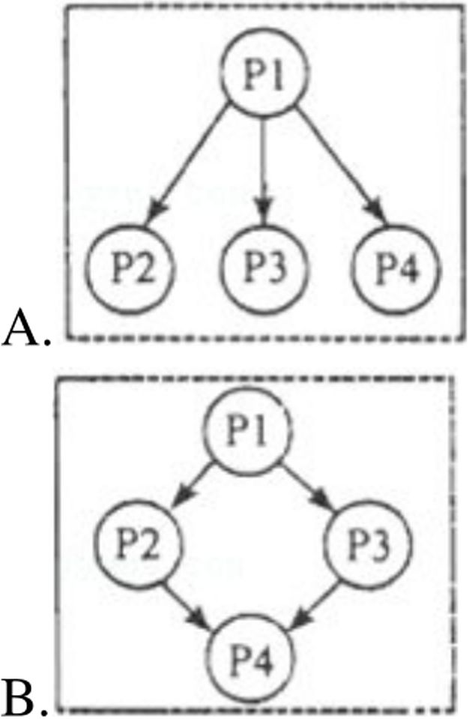
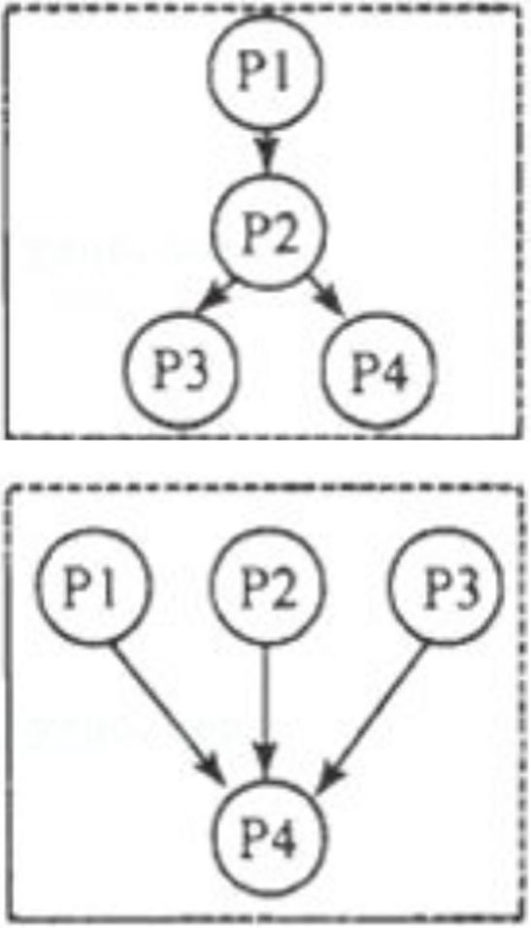
【解答】（1）细节理解题。根据第二段These days, they're mostly used as musical instruments.（如今，它们大多被用作乐器。）可知今天阿尔卑斯长号角的主要用途是播放一种音乐。应选D。
(2)细节理解题。根据第三段 Whistling can be heard within five kilometers, which means it can be used across much greater distances than shouting. （口哨声可以在五公里内听到，这意味着它可以在比 叫喊声更远的距离内使用。）可知因为它可以在很远的地方听到。
应选C。
（3）细节理解题。根据第四段 Long ago, soldiers along the Great Wall China used smoke as a warning.（很久以前，中国长城沿线的士兵用 烟雾作为警告。）可知他们通过观看获得警告信息。应选D。
（4）段落结构题。根据第一段 What did people do to communicate in ancient times? Here are some very interesting answers to this question.
（古代人们做了什么来交流？下面是这个问题的一些非常有趣的 答案。）2-4段介绍了有趣的事情。可知本文是总分结构。应选A。
- （8 分）Can anyone be an astronaut?
Of course not.You don't have to have a science degree but most astronauts do.Most of them are pilots too.Life in a spaceship is hard so you must have a healthy body and mind.You need to be easy - going, patient, and helpful to spend so much time in a small space with other people.

What's the training like?
People have to train for a year to learn how to stay healthy and safe.They practise space walking and living in zero gravity （重 力）.They train in difficult conditions to learn how to solve problems and to work in a team.Everyday tasks like eating, washing and sleeping can be difficult on a spaceship.There is no running water so you have
A.Make a speech.
B.Give a lesson.
C.Have a test.
- How does she feel when she speaks in class?
A.Excited.
B.Nervous.
C.Angry.
- Whats the man^{f}s suggestion?
A.Finish writing a little earlier.
B.Use some beautiful words.
C.Practise on him and his friends.
8. (8 分)(1) How old is the speaker now?
A. 10.
B.12.
C.14.
- Why was he unhappy?
A.Because he was tired of the city life.
B.Because he had to move to a new place.
C.Because he couldn't find his skateboard.
- What does he think of his life now ?
A.Enjoyable.
B.Difficult. to wash with wet tissues； it's hard to enjoy the dry food that astronauts have to eat.And to sleep you must cover your eyes because the sun rises every 90 minutes on the International Space Station.You also have to tie yourself to something so you don't fly away!

What health problems do astronauts have ?
Life in zero gravity causes changes to our bodies.Bones and muscles （肌肉）become thin and weak so you must do a lot of exercise in space to stay fit and to help the heart move blood around your body.Astronauts often get backache because you grow in space - up to 8 centimeters!Its also common to have headaches and to feel sick, especially at the beginning.You must have vitamins to take the place of fresh fruit and vegetables.But you don't have to put on sun cream because space suits protect your skin （皮月夫）.

Are you still interested ?
So now you know.If you want to go to space, study hard, learn to fly and take care of your body and mind.
- What is a must for an astronaut? C A.A science degree.
B.A pilots license.
C.A healthy body and mind.
D.A weak character.
- What must you do to prepare for a space trip? A A.Experience zero gravity.
B.Wash with running water.
C.Practise long walks.
D.Sleep with your eyes open.
- Why do astronauts have to exercise in space? BA.To make their bones and muscles thinner.
B.To help the heart work well and keep fit.
C.To avoid backache and grow much taller.
D.To stop their skins from getting sunburned.
- What is the text mainly about? AA.What we need to know to become an astronaut.
B.Why young people are interested in space trips.
C.What problems astronauts must solve in space.
D.Why we need to train hard before a space trip.
【解答】(1)细节理解题。根据第一段Life in a spaceship is hard so you must have a healthy body and mind.(宇宙飞船里的生活很艰难, 所以你必须有一个健康的身心。)可知，宇航员必须有健康的身心。 应选C。
(2)细节理解题。根据第二段 They practise space walking and living in zero gravity.They train in difficult conditions to learn how to solve problems and to work in a team.(他们练习太空行走和零重力生活。
他们在困难的条件下训练，学习如何解决问题和团队合作。）可知, 太空旅行需要做好体验零重力的准备。应选A。
（3）细节理解题。根据第三段 Bones and muscles become thin and weak so you must do a lot of exercise in space to stay fit and to help the heart move blood around your body.（骨骼和肌肉变得又薄又弱， 因此你必须在太空中进行大量运动以保持健康并帮助心脏将血液 输送到你的身体周围。）可知，宇航员在太空中需要锻炼从而帮助 心脏正常工作并保持健康。应选B。
（4）主旨大意题。根据文中Can anyone be an astronaut?（任何人 都可以成为宇航员吗? ） What's the training like?（训练是怎样 的？）What health problems do astronauts have?（宇航员有哪些健 康问题？）结合全文内容，可知，本文主要讲述了要成为一名宇航 员，我们需要知道什么。应选A。
12. （8 分）There are many different ways to solve a problem.One way is to be creative.People often think creative thinking is just for artists and designers, but this is not true.Dr.Edward de Bono, an expert in creative thinking and problem solving, has shown the world that using creativity to solve problems is very useful in business and in our communities, and will continue to be so in the future.
One example of creative thinking is the solution to a parking problem in a town center.In the areas close to stores, people can only park for 20 minutes.There are parking meters where people pay to park in these areas.However, the problem is that many people leave their cars there for longer than 20 minutes.Dr.Edward de Bono's solution is to make a rule that all cars parked in these areas must keep their headlights on.Of course, drivers will want to return to their cars before their car batteries （蓄 电池）die.
According to Dr.de Bono, people will need to use creative thinking more often in the future.To help people think more creatively, he designed the ^{n}Six Thinking Hats^{n} system （系统）.The system helps people think about a problem in different ways in order to find a solution.In the system, there are six imaginary hats of different colors.Each hat symbolizes a different way of thinking.For example, the white hat helps people consider the facts.The black hat is the most logical （有逻辑的）and helps people consider why a possible solution may not work.So, next time you have a problem in your community, think about it creatively, from different perspectives, and see what ideas you have.
- What is the topic of the text ? D A.Being a creative artist in the community. B.Doing business successfully in the future. C.Asking experts for some useful advice. D.Using creative thinking to solve problems.
- Why is the example mentioned in Paragraph 2? CA.To express a result.
B.To describe a problem.
C.To support the topic.
D.To list some numbers.
- What does the underlined word "perspectives” in Paragraph 3 mean ?AA.Ways.
B.Places.
C.People.
D.Rules.
- Which of the following is true about the “Six Thinking Hats” system? BA.The system is used to help people think quickly.
B.The white hat helps people think about the facts.
C.The black hat has to do with people's feelings.
D.Six hats of different shapes can be very helpful.
【解答】(1)主旨大意题。根据第一段There are many different ways to solve a problem.One way is to be creative.People often think creative thinking is just for artists and designers, but this is not true.Dr.Edward de Bono, an expert in creative thinking and problem solving, has shown the world that using creativity to solve problems is very useful in business and in our communities, and will continue to be so in the future.（解决问题有很多不同的方法。一种方法是创造性。 人们通常认为创造性思维只适用于艺术家和设计师，但事实并非如 此。创造性思维和解决问题的专家Edward de Bono博士，已经向 世界展示了用创造力解决问题在商业和我们的社区中非常有用，并 且在未来将继续如此。）可知，本文的主题是用创造性思维解决问 题。应选D。
（2）推理判断题。根据第二段 One example of creative thinking is the solution to a parking problem in a town center.（仓4造性思维的一个 例子是解决市中心的停车问题。）可知，第二段中讲述的创造性思 维的一个例子是解决市中心的停车问题，用来支持文章主题，即用 创造性思维解决问题。应选C。
（3）词义猜想题。根据最后——段So, next time you have a problem in your community , think about it creatively , from different perspectives, and see what ideas you have.（所以， 下次你在你的社 区遇到问题时，创造性地思考它，从不同的perspectives,看看你 有什么想法。）可知，perspectives是"角度,方面”的意思,与ways 意思相近。应选A。
（4）正误判断题。根据最后一段 For example, the white hat helps people consider the facts.（例如，白帽子帮助人们思考事实。）可知, 白帽子帮助人们思考事实。表述正确。应选B。
第二节（共5题，每题2分，总分值10分）下面文章中有五处需要添
加小标题。请从以下选项(A、B、C、D、E和F)中选出符合意思 的标题。选项中有一项为哪一项多余选项。
- (10 分)Taking stress out of exams
Pre - exam stress is one of the biggest problems in students¹ lives.lt makes you feel bad and stops you from thinking clearly.So here are some tips to help you lower the stress of exams.
- E
The best way to deal with exam stress is to have a good study plan.Decide which subjects to study every day and how much time to spend on each one.And don't wait until the last minute to study everything.
- C
When we don't understand something, we feel stressed.Its normal.But don't worry about it, do something about it!Ask your teacher for help.You may find it hard to believe but all teachers want their students to do well in exams.
- D
Your body needs exercise for your brain to work better.So don!t study all the time.lt can just make you more stressed.Do some sport, go to the gym or just go for a walk but get up and move!
- A
Its important for your brain to rest so try to get eight hours* sleep every night.Eat a healthy diet and avoid drinks with caffeine that can stop you from sleeping well.
- F
Finally, if you have followed all this advice and you still feel stressed, then don't keep it a secret.Talk to someone, your mum or your dad, a friend or a teacher and tell them how you feel.We all need help sometimes.
A.Eat and sleep well
B.Make it interesting
C.Don't be afraid to ask
D.Healthy body, healthy brain
E.Be organized and start early
F.Dont keep your stress to yourself
【解答】(1)主旨大意题。根据 The best way to deal with exam stress is to have a good study plan.Decide which subjects to study every day and how much time to spend on each one.And don't wait until the last minute to study everything.(应对考试压力的最好方法是制定一个好 的学习计划。决定每天学习哪些科目，以及每个科目上花多少时间。 不要等到最后一刻才去研究一切。)可知本段说的是组织起来，早 点开始。应选E。
(2)主旨大意题。根据 When we don't understand something, we feel stressed.Its normal.But don't worry about it, do something about it!Ask your teacher for help.You may find it hard to believe but all teachers want their students to do well in exams.（当我们不理解某事时，我们 会感到压力。这很正常。但别担忧，做点什么吧！向你的老师寻求 帮助。你可能很难相信，但所有的老师都希望他们的学生在考试中 取得好成绩。）可知本段说的是不要害怕问。应选C。
（3）主旨大意题。 根据 Your body needs exercise for your brain to work better.So don't study all the time.lt can just make you more stressed.Do some sport, go to the gym or just go for a walk but get up and move!（你的身体需要锻炼，大脑才能更好地工作。所以不要 一直学习。这只会让你压力更大。做些运动，去健身房，或者只是 散散步，但要站起来行动！）可知本段说的是健康的身体，健康的 大脑。应选D。
（4）主旨大意题。根据 Its important for your brain to rest so try to get eight hours¹ sleep every night.Eat a healthy diet and avoid drinks with caffeine that can stop you from sleeping well.（休息对你的大脑很重 要，所以尽量每晚睡八个小时。健康饮食，防止含咖啡因的饮料， 因为咖啡因会阻碍你的睡眠。）可知本段说的是吃好睡好。应选A。
（5）主旨大意题。根据 Finally, if you have followed all this advice and you still feel stressed, then don't keep it a secret.Talk to someone, your mum or your dad, a friend or a teacher and tell them how you feel.We all need help sometimes.（最后，如果你遵循了所有这些建议，但仍然感到压力，那么就不要保守秘密。与某人交谈，你的妈 妈或爸爸,朋友或老师，告诉他们你的感受。有时我们都需要帮助。) 可知本段说的是不要把压力留给自己。应选F。
第三局部英语知识运用(共两节，总分值25)第一节：完形填空(共 15题，每题1分，总分值15分)通读下面短文，掌握其大意，然后在 各题所给的四个选项(A、B、C和D)中选出一个最正确选项。
- (15 分)Derek Rabelo was born in Brazil in 1992.His father called him Derek after a famous (1) B star, Derek Ho.Derek's father wanted Derek to become a surfer, too, but there was a (2) A ： unluckily, Derek was born (3) D .His father's dream to see his son surf seemed (4) C !
When Derek was 17, his father told him about his (5) D_.From that moment, Derek tried his best to become a surfer. (6) C went to the beach every day and started taking surfing (7) B with a coach.Derek kept trying and (8) D , he learned to surf!
Derek explains that (9) A he can't see, he understands the noises that the waves make and he can (10) C them when they are coming.He says every part of a wave makes a different noise, (11)B he know which direction to surf in.
In 2012, he flew to Hawaii to surf one of the most challenging and dangerous (12) A in the world.Local surfers were very (13) _D
to see the confident young man surf the huge wave with no problem
C.Lonely.
（4） Who is Tony?
A.His new classmate.
- .His younger brother.
C.His old friend.
第二局部 阅读理解（共两节，总分值40）第一节（共15题，每题2 分,总分值30分）阅读以下短文，从每题所给的四个选项（A、B、C 和D）中选出最正确选项。
- . （6 分）A blog by Sascha Marr, aged 14
My hobby is making shoes.Pve always liked designing things.1 remember drawing clothes and shoes when I was eight, and I made my first skirt aged nine.At eleven, I started making shoes, and I now spend my free time doing that.
I became interested in making shoes when my cousin told me about an online shoe - making course that he was doing! immediately wanted to do one too.Mum booked （为预约）me on a four - day
course at the I Can Make Shoes school in London to see if I liked it, and then I did a ten - day course there in the summer holidays.
I loved the courses.On the longer one, I made four pairs of shoes!I couldn't believe it.The teachers were excellent.Thats what was best
about the classes.They made us work really hard but they wanted all
(14) BA film producer decided to make a film about him.Beyond Sight
tells Derek's inspirational story and teaches us that nothing isimpossible if you (15) C yourself!
(1) B.surfingA.swimming
- A.problem B.ruleA.poorB.weak
- A.necessary B.realA.storyB.advice
- A.TheyB.WeA.matches B.lessons
- A.instead B.usuallyA.al though B.unless
- A.seeA.or
B. touchB.so
(12) A.waves B.beaches(13) A.sorry
B. worried(14) A.after all B.at all
C.filmC.promise
C.deafC.impossible
C.truthC.He
C.photosC.still
C.whenC.hear
C.butC.islands
C.scaredC.at the time
D.popD.plan
D.blindD.proper
D. dreamD.She
D.examsD.finally
D.beforeD. taste
D.forD. sports
D.surprisedsame D.from time to
time

(15 ) A.deal B.depend onC.believe in D.look afterwith
【解答】(1)名词辨析。A.swimming游泳；B.surfing冲浪；C.film 电影；D.pop 流行音乐。tSJS Derek's father wanted Derek to become a surfer, too (Derek的父亲也希望Derek成为一名冲浪者)可知 是一名冲浪明星。应选B。
(2)名词辨析。A.problem 问题；B.rule 规那么；C.promise 承诺； D.plan计划。根据unluckily可知是一个问题，应选A。
(3)形容词辨析。A.poor贫穷的；B.weak虚弱的；C.deaf聋的； D.blind瞎的。根据he can't see可知是瞎的。应选D。
(4)形容词辨析。A.necessary 必要的；B.real 真正的；C.impossible 不可能的；D.proper合适的。不幸的是，德里克生来就失明。他父 亲看到儿子冲浪的梦想似乎是不可能的。应选C。
(5)名词辨析。A.story 故事；B. ad vice 建议；C. truth 真相；D. dream 梦想。根据 From that moment, Derek tried his best to become a surfer.
(从那一刻起，Derek就努力成为一名冲浪者。)可知这是他的梦 想。应选D。
(6)代词辨析。A.They他们；B.We我们；C.He他；D.She她。 用he指代Derek _{o}应选C。
(7)名词辨析。A.matches 比赛；B.lessons 课；C.photos 照片； D.exams考试。他每天都去海滩，开始跟着教练上冲浪课。应选B。
(8)副词辨析。A.instead 相反；B.usually 通常；C.still 仍然；D.finally最后。Derek不断尝试，终于，他学会了冲浪！应选D。
(9)连词辨析。A.although虽然；B.unless除非；C.when当…时 候；D.before在…之前。Derek解释说，虽然他看不见，但他能理 解海浪发出的声音，当它们来临时他能听到它们。应选A。
(10)动词辨析。A.see 看；B.touch 触摸；C.hear 听到；D.taste 品 尝。Derek解释说，虽然他看不见，但他能理解海浪发出的声音， 当它们来临时他能听到它们。应选C。
(11)连词辨析。A.or或者；B.so所以；C.but但是；D.for由于。 他说海浪的每一局部都会发出不同的声音，所以他知道要冲浪的方 向。应选B。
(12)名词辨析。A.waves 浪；B.beaches 海滩；C.islands 岛屿； D.sports运动。2012年，他飞往夏威夷冲浪世界上最具挑战性和 危险的海浪之一。应选A。
(13)形容词辨析。A.sorry抱歉的；B.worried担忧的；C.scared害 怕的；D.surprised吃惊的。当地冲浪者很惊讶地看到这位自信的年 轻人毫无问题地冲浪巨浪。应选D。
(14)介词短语辨析。A.after all毕竟;B.at all究竟，根本；C.at the same time同时；D.from time to time不时，当地冲浪者很惊讶地看 到这位自信的年轻人毫无问题地冲浪巨浪。应选B。
(15)动词短语辨析。A.deal with 处理;B.depend on 依靠；C.believe in 相信；D.look after 照看。Beyond Sight 讲述了 Derek 的励志故 事，并告诉我们，如果你相信自己，没有什么是不可能的！应选C。 第二节：(共10题，每题1分，总分值10分)阅读下面材料，在空白 处填入适当的内容(1个单词)或括号内单词的正确形式。将答案填 写在答题纸的相应位置。
- (10 分)Old new medicines
What should you do if you have a headache ? In modern times, people often take aspirin (阿司匹林).But is aspirin (1) actually (actual) a modern medicine ?
More than 4, 000 years ago, ancient Egyptians used dried leaves to treat pain.And in the fourth century B.C., a medicine made from tree bark (树皮)(2) was used(use) to treat fevers.In the nineteenthcentury, European scientists discovered that both medicines have the same chemical (化学物质).They used the chemical to make a modern medicine - aspirin.Today, it's one of the world's ( 3 ) cheapest (cheap) and most helpful medicines.
Some of the medicines we have today come (4) from traditional Chinese medicine.In the third century B.C., some people (5) began (begin) studying the human body.They tried many different ways to treat the patients and recorded (6) their(they)
results.For more than 2, 000 years, doctors recorded (7) what
they found in books.These ancient books are still useful today.Tu
Youyou, a Chinese medical researcher, found that in (8) the past. people used a herb with yellow flowers to treat fevers.After studying it, she developed a medicine that saved millions of people from dying.
For (9) centuries (century), Western medicine paid little attention to traditional Chinese medicine.But today, scientists are studying traditional treatments (10) to develop (develop) new medicines.
【解答】(1)考查副词。句意：但是阿司匹林真的是一种现代药物 吗?用副词作状语。故答案为actually。
(2)考查被动语态。句意：在公元前4世纪，一种由树皮制成的 药物被用来治疗发烧。根据in the fourth century B.C.判断时态为一 般过去时，被动语态，单数名词后谓语动词为was done的形式。 故答案为was usedo
(3)考查形容词最高级。句意：今天，它是世界上最廉价和最有 帮助的药物之一。one of后跟形容词最高级。故答案为cheapest。
(4)考查介词。句意：我们今天的一些药物来自传统的中医。come from为短语。故答案为from。
(5)考查动词过去式。句意：在公元前三世纪，一些人开始研究 人体。一般过去时中谓语动词用过去式。故答案为began。
(6)考查形容词性物主代词。句意：他们尝试了许多不同的方法 来治疗这些病人，并记录了他们的结果。名词前用形容词性物主代 词。故答案为their。
(7)考查连接代词。句意：2000多年来，医生们在书中记录了他
们的发现。what"什么”符合题意。故答案为what。
（8）考查定冠词。句意：中国医学研究者屠呦呦发现，在过去， 人们用一种开黄花的草药来治疗发烧。in the past为短语。故答案 为 the。
（9）考查名词。句意：几个世纪以来，西医对中医的关注甚少。
用可数名词复数表示数量。故答案为centuries。
（10）考查动词不定式。句意：但是今天，科学家们正在研究传统 疗法来开发新的药物。用动词不定式表示目的。故答案为to develop。
第四局部写作（共两节，总分值25）第一节：单词拼写（共10题， 每题1分，总分值10分）根据以下句子及所给的首字母，在答题纸上 按题号写出各单词的正确、完全形式（每空限填一词）。
- （ 1 分）Jim will be on summer vacation in June and J uly .
【解答】根据”吉姆将在六月和……度暑假。”及首字母提示可知， 应该是“七月”，填名词July。
故答案为：July。
- （1 分）B lue is the color of the sky on a sunny day.
【解答】根据”……是晴天天空的颜色。”及首字母提示可知，应该 是“蓝色”，填不可数名词Blue。
故答案为：Blueo（1 分）I love China and I am p roud of being Chinese.
【解答】根据I love China"我爱中国"，及首字母提示可知，be proud
Of...”为……感到骄傲”固定短语。
故答案为：proud o（1 分）Lisa, don't talk with your m outh full!It's bad manners.
【解答】根据dont talk”不要说话”，可知，应该是“嘴”里塞满东西 的时候，这里指丽莎的嘴，填单数名词mouth。
故答案为：moutho（1 分）My deskmate c aught the school bus this morning, but I missed it and was late for school.
【解答】根据”我的同桌今天早上……了校车，但我错过了它，上学 迟到了。”及首字母提示可知，应该是“赶上"。由过去式missed可 知，一般过去时态，谓语动词用catch的过去式caught。
故答案为：caughto（1 分）Families often get together and admire the full m oon on the Mid - Autumn night.
【解答】根据on the Mid - Autumn night“中秋之夜"，及首字母提示 可知，应该欣赏“月亮”，填专有名词moon。
故答案为：moon_{o}（1 分）After finishing university, Tom came to China.Three years 1 ater , he was able to speak good Chinese.
【解答】根据“大学毕业后，汤姆来到了中国。三年……，他能说一 口流利的中文。”及首字母提示可知，应该是“以后"，填副词later。 故答案为：later。
- （1 分）Doing chores helps to develop children's independence and
teaches them how to look after t hemselves
【解答】根据“做家务有助于培养孩子的独立性，教会他们如何照
顾……%及首字母提示可知，应该是，他们自己“，填反身代词
themselves。
故答案为：themselves。
- （1 分） Although the heavy rain b roke many things apart, it brought families and neighbors closer together.
【解答】根据“虽然大雨……许多东西二及首字母提示可知，应该 是"损坏"。由过去式brought可知，一般过去时态，谓语动词用break 的过去式broke_{o}
故答案为：broke（1 分）-Will you please help me to carry this box ?
-With p leasure .Pm more than happy to do it.
【解答】根据“请你帮我搬这个箱子好吗？"，及首字母提示可知,
With pleasure"我很乐意”，日常交接用语。
故答案为：pleasure□ 第二节：书面表达（共1题，总分值15分）（15分）假定你是李平，请阅读以下邮件并回复。词数80左右,
可适当增加细节，以使行文连贯。
Subject： Exchange Visit!
Hi there, Li Ping!
My name's Jack and I'm going to be at your school for the exchange visit next month.Fm really excited about it!
Well, why am I writing right now? For one thing, I really want to know something about the interesting activities at your school, so could you introduce one of them? Also, I am interested in Chinese culture.So what do you suggest I do after school ?
Take care and hope to hear from you soon.
Jack Dear Jack,Li Ping
【解答】Dear Jack,I'm pleased to know that you're coming for the exchange visit.
We have many interesting school activities.Among them, the singing competition is the most popular.lt offers a great chance to show our talents and helps us to learn something new.As for Chinese culture, I suggest you visit the Hangzhou National Tea Museum.【高分句型——] You can learn about the history of Chinese tea there.
Hope this helps.And tell me if there is anything else you need to know.
【高分句型二】Li Ping
their students to have fun, too.
I've made about 15 pairs of shoes now.At the moment I'm making a pair of training shoes using an old pair of jeans, but I've used all kinds of different things before, from old leather (皮革)handbags to old cotton dresses!
Making shoes has changed my plans for the future.! know now that I want to be a designer, but not a shoe designer.Pve decided I'll do home design.Pve designed lots of shoes and also some clothes, so I'd like to try something new.
- What did Sascha begin to make at the age of 11 ? A.Skirts.
B.Shoes.
C.Jeans.
D.Dresses.
- What does the underlined word "They" in Paragraph 3 refer to?
A.The courses.
B.The teachers.
C.The classes.
D.The students.
- What does Sascha plan to be in the future? A.A shoe designer.
B.A handbag designer.
C.A dress designer.
D.A home designer.
- （8 分）What did people do to communicate in ancient times? Here are some very interesting answers to this question.
Alphorns （阿尔卑斯长号角）were once used to communicate in the mountains in Switzerland.They are very long and they are very heavy, too.So, alphorns are hard work to blow.Then why use them? Well, they make a loud sound which travels much further than the human voice.Herdsmen （牧民）used them to call cows in the distance for milking.At sunset, alphorns were also used to send a message down to villagers that all was well.These days, they're mostly used as musical instruments.
The people of La Gomera, an island in Europe, have their own special way of sending messages from mountain to mountain.They use a whistled （口 哨的）language called el silbo, which comes from their language Spanish.Whistling can be heard within five kilometers, which means it can be used across much greater distances than shouting.El silbo can be used for all kinds of messages, including greetings and announcements.El silbo is used a lot less than it used to be, but primary school students in La Gomera have to learn it.
Did you know it's also possible to send messages without making
a noise? This is called visual communication, and it includes the use of flags and even smoke.Long ago, soldiers along the Great Wall China used smoke as a warning.If they noticed the enemy from their signal (信号)tower, they lit a smoky fire.When soldiers in other towers saw the smoke signal, they lit fires too.In this way, messages about the enemy's arrival could travel as far as 800 km in just a few hours.
- What are alphorns mostly used for today ? A.Communicating in the mountains.
B.Calling cows for milking.
C.Sending messages down to villagers.
D.Playing a kind of music.
- Why do the people of La Gomera use el silbo to communicate?
A.Because it can send messages to animals.
B.Because it is different from their language.
C.Because it can be heard at a great distance.
D.Because it is a subject for young students.
- How did soldiers along the Great Wall get warning messages between towers ?
A.By listening.
B.By whistling.
C.By shouting.
D.By watching.
- Which of the following best shows the structure of the text? (P
=Paragraph) 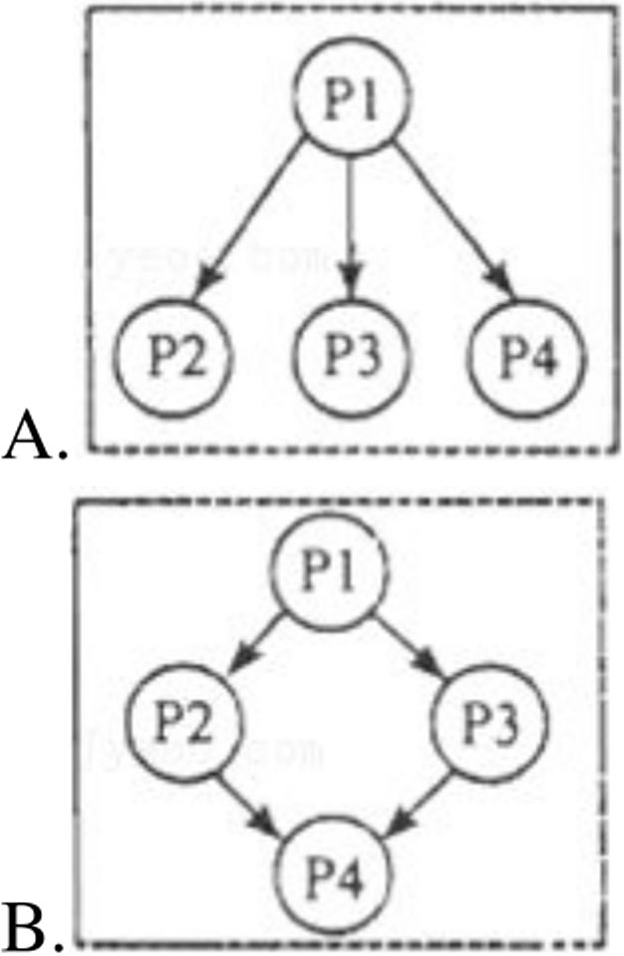
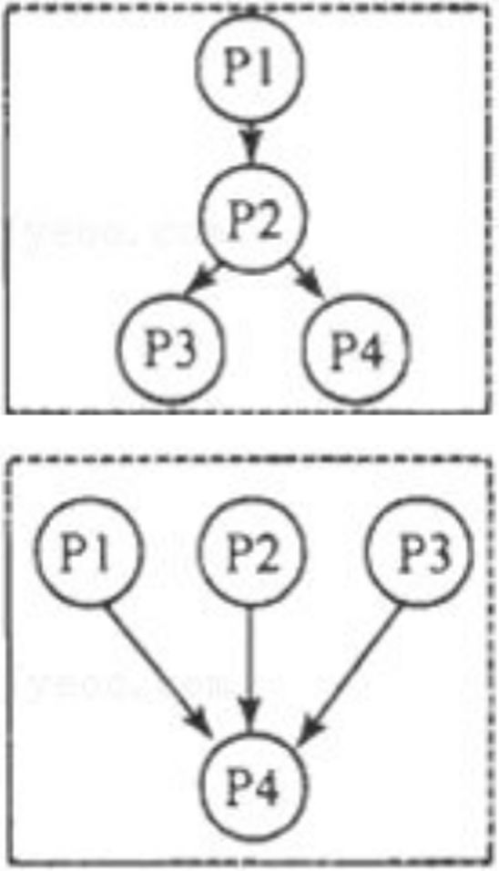
- (8 分)Can anyone be an astronaut?
Of course not.You don!t have to have a science degree but most astronauts do.Most of them are pilots too.Life in a spaceship is hard so you must have a healthy body and mind.You need to be easy - going, patient, and helpful to spend so much time in a small space with other people.

What^{f}s the training like?
People have to train for a year to learn how to stay healthy and safe.They practise space walking and living in zero gravity （重 力）.They train in difficult conditions to learn how to solve problems and to work in a team.Everyday tasks like eating, washing and sleeping can be difficult on a spaceship.There is no running water so you have to wash with wet tissues； its hard to enjoy the dry food that astronauts have to eat.And to sleep you must cover your eyes because the sun rises every 90 minutes on the International Space Station.You also have to tie yourself to something so you don't fly away!

What health problems do astronauts have?
Life in zero gravity causes changes to our bodies.Bones and muscles （肌肉）become thin and weak so you must do a lot of exercise in space to stay fit and to help the heart move blood around your body.Astronauts often get backache because you grow in space - up to 8 centimeters!Its also common to have headaches and to feel sick, especially at the beginning.You must have vitamins to take the place of fresh fruit and vegetables.But you don't have to put on sun cream because space suits protect your skin （皮肤）.

Are you still interested ?
So now you know.If you want to go to space, study hard, learn to fly and take care of your body and mind.
（1） What is a must for an astronaut?

