COMT
Catechol-O-methyltransferase
Catechol O-methyltransferase (COMT) is the enzyme responsible for the O-methylation of endogenous neurotransmitters and of
xenobiotic substances and hormones incorporating catecholic structures. COMT is present in mammals as soluble (S-COMT) and
membrane-bound (MB-COMT) forms. S-COMT is the predominant form of COMT in the peripheral organs and MB-COMT is more
abundant in the Central Nervous System.
Physiological substrates of COMT include L-dopa, catecholamines (dopamine, norepinephrine, and epinephrine), their hydroxylated
metabolites, catecholestrogens, ascorbic acid, and dihydroxyindolic intermediates of melanin. Specifically, COMT plays a critical role
in the inactivation and metabolism of dopamine and other catechol compounds. The enzyme reduces a catechol molecule in order
to prevent genomic damage through DNA adduct formation or via oxygen radicals produced from the redox cycling of catechols.
COMT is a druggable biological target for the treatment of various central and peripheral nervous system disorders, including
Parkinson's disease, depression, schizophrenia, and other dopamine deficiency-related diseases.
www.MedChemExpress.com 1
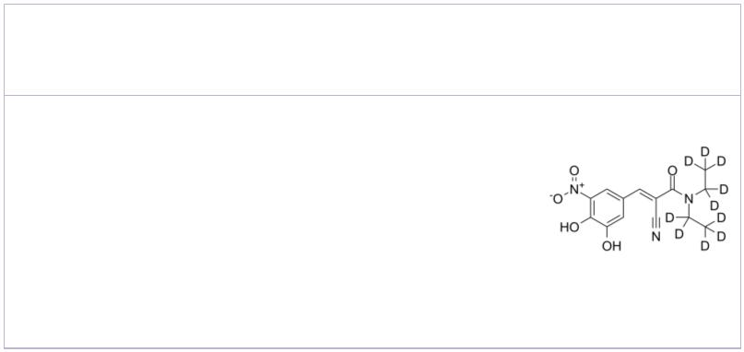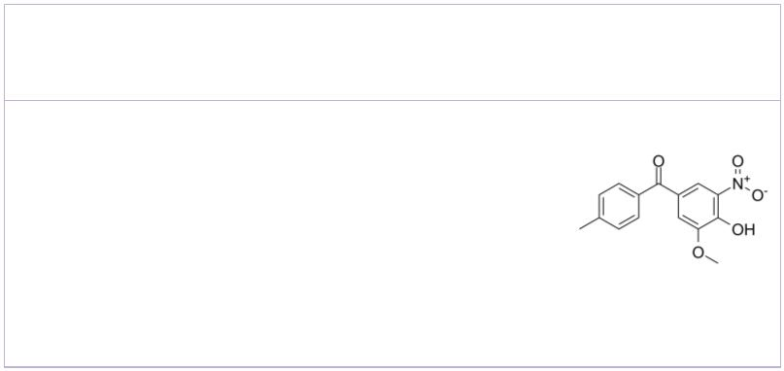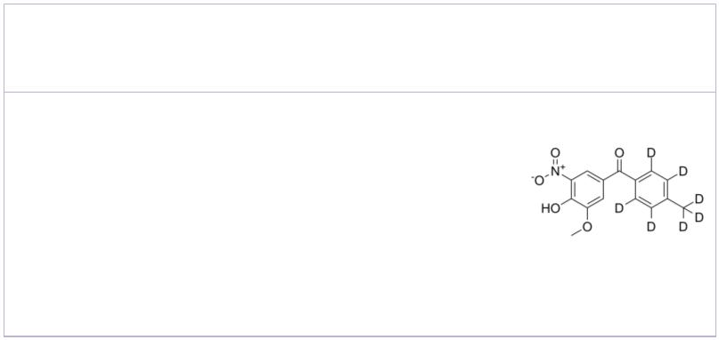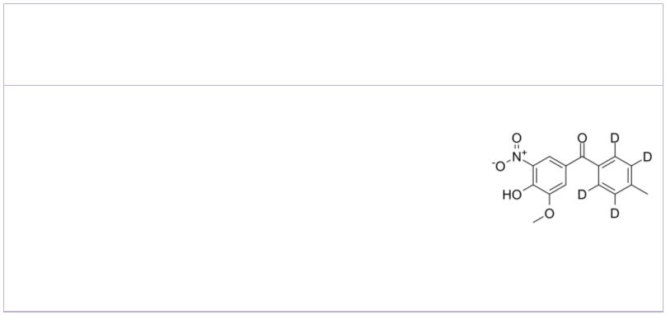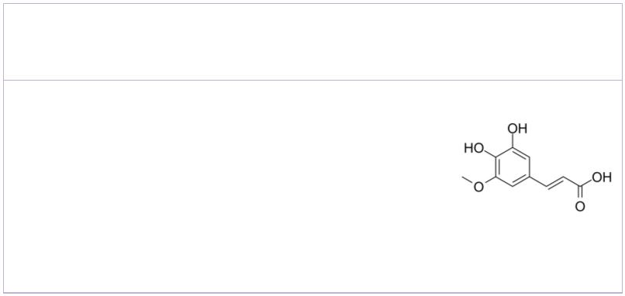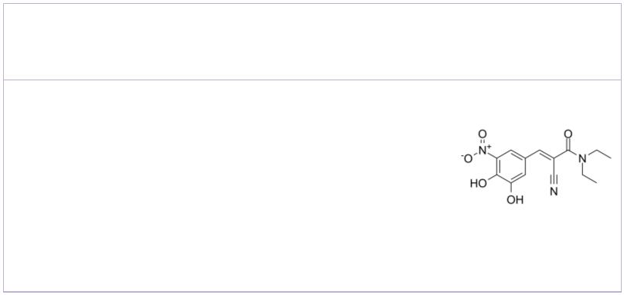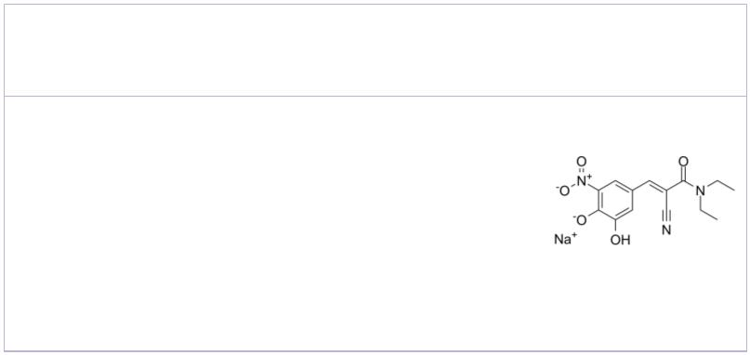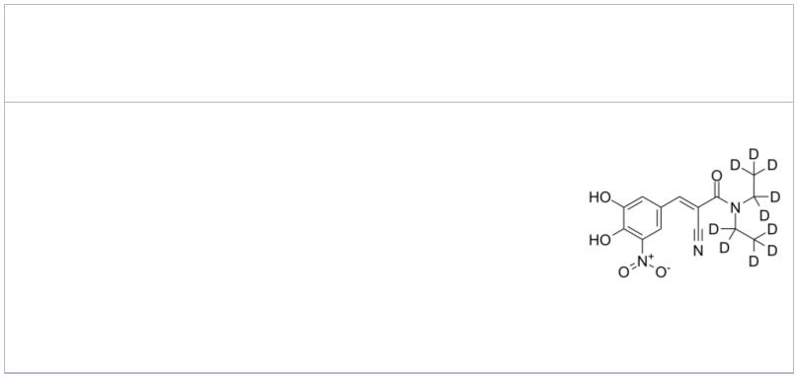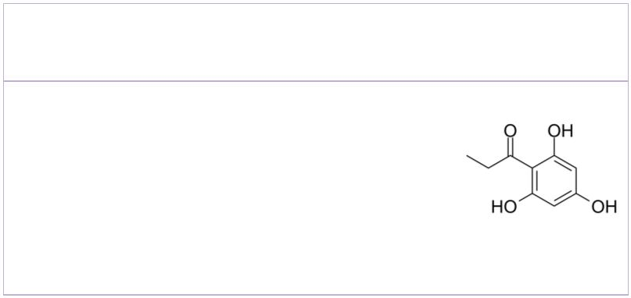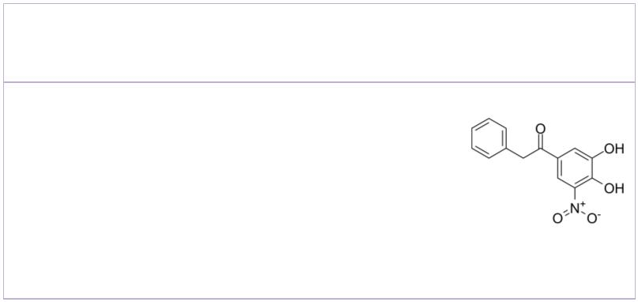COMT Inhibitors
 | (E)-Entacapone-d10 |  | Cat. No.: HY-14280S2 |  |  |  | 3-O-Methyltolcapone  (Ro 40-7591) Cat. No.: HY-100642
 | Entacapone-d10 is the deuterium labeled  Entacapone. Entacapone is a potent, reversible,  peripherally acting and orally active  catechol-O-methyltransferase (COMT)  inhibitor. |  |  |  |  |  | 3-O-Methyltolcapone (Ro 40-7591) is a metabolite  of Tolcapone. Tolcapone is an orally active,  reversible, selective and potent COMT  inhibitor. Tolcapone crosses the blood-brain  barrier, and can be used for treatment of  Parkinson's disease.
 | Purity: >98%  Clinical Data: No Development Reported  Size: 1 mg, 5 mg |  |  |  |  |  | Purity: >98%  Clinical Data: No Development Reported  Size: 1 mg, 5 mg
 | 3-O-Methyltolcapone D7  (Ro 40-7591 D7) Cat. No.: HY-100642S |  |  |  |  |  | 3-O-Methyltolcapone-d4  (Ro 40-7591-d4) Cat. No.: HY-100642S1
 | 3-O-Methyltolcapone D7 (Ro 40-7591 D7) is a  deuterium labeled 3-O-Methyltolcapone.  3-O-Methyltolcapone is a metabolite of Tolcapone.  Tolcapone is an orally active, reversible,  selective and potent COMT inhibitor. |  |  |  |  |  | 3-O-Methyltolcapone-d4 (Ro 40-7591-d4) is the  deuterium labeled 3-O-Methyltolcapone.  3-O-Methyltolcapone (Ro 40-7591) is a metabolite  of Tolcapone. Tolcapone is an orally active,  reversible, selective and potent COMT  inhibitor.
 | Purity: >98%  Clinical Data: No Development Reported  Size: 1 mg, 5 mg |  |  |  |  |  | Purity: >98%  Clinical Data: No Development Reported  Size: 1 mg, 5 mg
 | 5-Hydroxyferulic acid Entacapone
 |  |  |  |  | Cat. No.: HY-133068 Cat. No.: HY-14280
 | 5-Hydroxyferulic acid is a hydroxycinnamic acid  and is a metabolite of the phenylpropanoid  pathway. 5-Hydroxyferulic acid is a precursor in  the biosynthesis of sinapic acid and is also a  COMT non-esterifed substrate. |  |  |  |  |  | Entacapone is a potent, reversible, peripherally  acting and orally active  catechol-O-methyltransferase (COMT)  inhibitor. Entacapone inhibits COMT from rat  brain, erythrocytes and liver with IC values of  50  10 nM, 20 nM, and 160 nM, respectively.
 | Purity: 99.80%  Clinical Data: No Development Reported  Size: 5 mg, 10 mg |  |  |  |  |  | Purity: 99.97%  Clinical Data: Launched  Size: 10 mM × 1 mL, 10 mg, 50 mg, 100 mg
 | Entacapone sodium salt Entacapone-d10
 |  |  |  | Cat. No.: HY-14280A Cat. No.: HY-14280S
 | Entacapone sodium salt is a potent, reversible,  peripherally acting and orally active  catechol-O-methyltransferase (COMT)  inhibitor. |  |  |  |  |  | Entacapone-d10 is the deuterium labeled  Entacapone. Entacapone is a potent, reversible,  peripherally acting and orally active  catechol-O-methyltransferase (COMT)  inhibitor.
 | Purity: >98%  Clinical Data: Launched  Size: 1 mg, 5 mg |  |  |  |  |  | Purity: >98%  Clinical Data: No Development Reported  Size: 1 mg, 5 mg
 | Flopropione Nebicapone
 |  |  |  |  | Cat. No.: HY-100562 |  | (BIA 3-202) Cat. No.: HY-106405
 | Flopropione is a 5-HT receptor antagonist and  also a catechol-o-methyltransferase (COMT)  inhibitor. Flopropione also as an antispasmodic  agent. |  |  |  |  |  | Nebicapone (BIA 3-202), a reversible  catechol-O-methyltransferase (COMT)  inhibitor, is mainly metabolized by  glucuronidation.
 | Purity: 98.93%  Clinical Data: Launched  Size: 10 mM × 1 mL, 100 mg |  |  |  |  |  | Purity: >98%  Clinical Data: Phase 2  Size: 1 mg, 5 mg
2 Tel: 609-228-6898 Fax: 609-228-5909 Email: sales@MedChemExpress.com
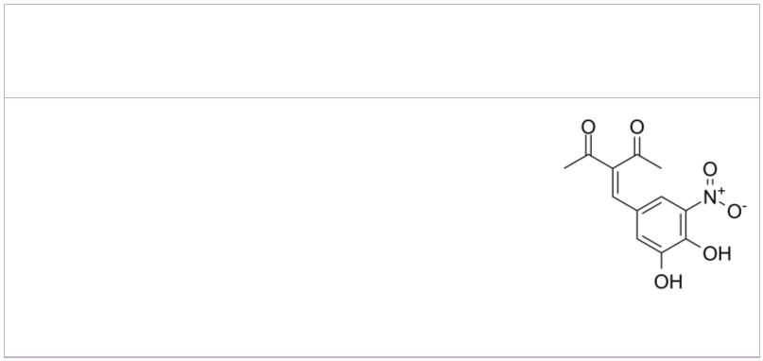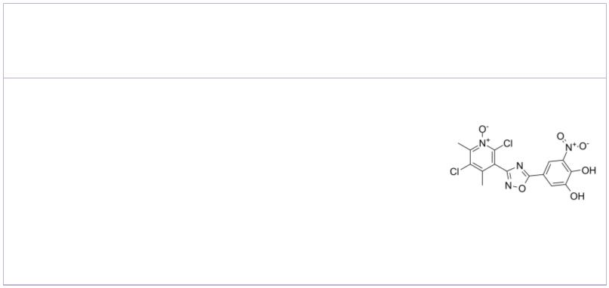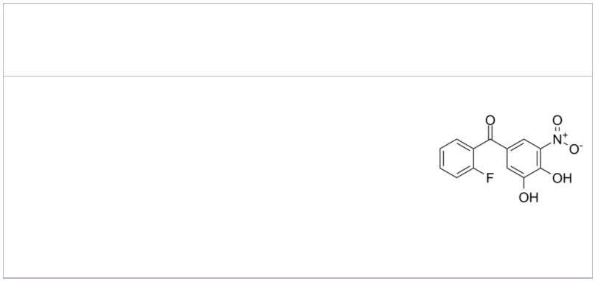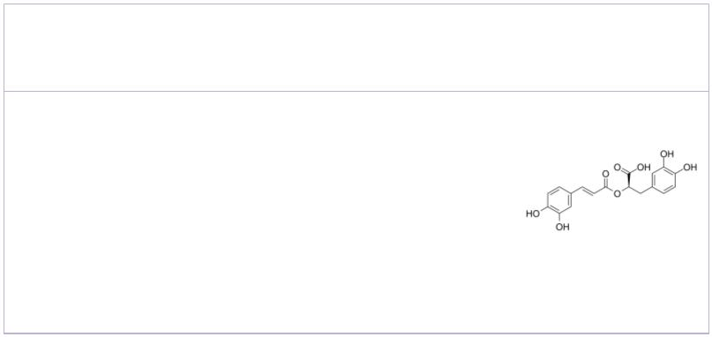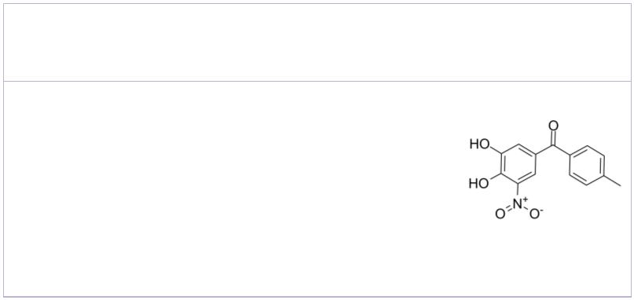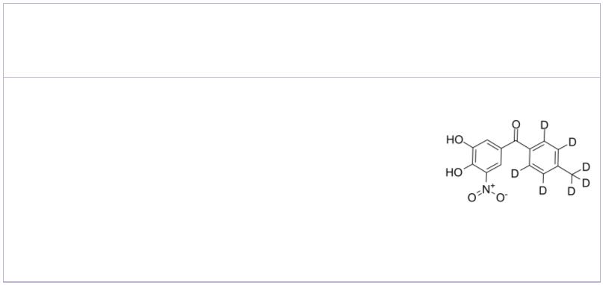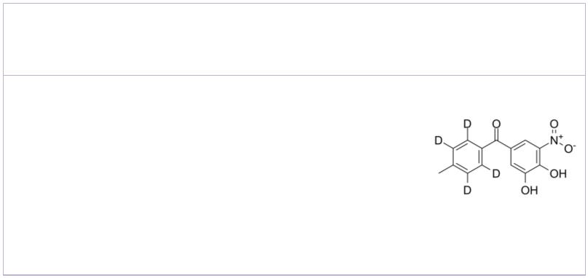Nitecapone  (OR-462) Cat. No.: HY-106842 |  |  |  | Opicapone  (BIA 9-1067) Cat. No.: HY-14896
Nitecapone (OR-462) is an orally active and  short-acting catechol-O-methyltransferase  (COMT) inhibitor with gastroprotective and  antioxidant properties. Nitecapone (OR-462)  scavenges reactive oxygen and nitric radicals and  prevents lipid peroxidation.  Purity: 99.32%  Clinical Data: No Development Reported  Size: 5 mg, 10 mg |  |  |  | Opicapone (BIA 9-1067) is a potent  third-generation catechol-O-methyltransferase  (COMT) inhibitor for the research of  Parkinson's disease and motor fluctuations.  Opicapone decreases the ATP content of the cells  with an IC of 98 μM.  50  Purity: 99.64%  Clinical Data: Launched  Size: 10 mM × 1 mL, 5 mg, 10 mg, 25 mg, 50 mg, 100 mg
Ro 41-0960 |  | Cat. No.: HY-125339 |  | Rosmarinic acid  (Labiatenic acid) Cat. No.: HY-N0529
Ro 41-0960 is a selective  catechol-O-methyltransferase(COMT) inhibitor. |  |  |  | Rosmarinic acid is a widespread phenolic ester  compound in the plants. Rosmarinic acid inhibits  MAO-A, MAO-B and COMT enzymes with IC s  50  of 50.1, 184.6 and 26.7 μM, respectively.
Purity: >98%  Clinical Data: No Development Reported  Size: 1 mg, 5 mg |  |  |  | Purity: 99.70%  Clinical Data: Phase 4  Size: 10 mM × 1 mL, 50 mg, 100 mg
Tolcapone  (Ro 40-7592) Cat. No.: HY-17406 |  |  |  | Tolcapone D7  (Ro 40-7592 D7) Cat. No.: HY-17406S
Tolcapone (Ro 40-7592) is a selective, orally  active and powerful mixed (peripheral and central)  COMT inhibitor with an IC of 773nM in the  50  liver. Tolcapone is also a potent inhibitor of  α-syn and Aβ42 oligomerization and  fibrillogenesis. |  |  |  | Tolcapone D7 (Ro 40-7592 D7) is a deuterium  labeled Tolcapone. Tolcapone is a selective,  potent and orally active COMT inhibitor.
Purity: 99.74%  Clinical Data: Launched  Size: 10 mM × 1 mL, 10 mg, 50 mg, 100 mg |  |  |  | Purity: >98%  Clinical Data: No Development Reported  Size: 1 mg, 5 mg
Tolcapone-d4
(Ro 40-7592-d4) Cat. No.: HY-17406S1
Tolcapone-d4 (Ro 40-7592-d4) is the deuterium
labeled Tolcapone. Tolcapone (Ro 40-7592) is a
selective, orally active and powerful mixed
(peripheral and central) COMT inhibitor with an IC of 773nM in the liver.
50
Purity: >98%
Clinical Data: No Development Reported
Size: 1 mg, 10 mg
www.MedChemExpress.com 3

