IGF-1R
Insulin-like growth factor-1 receptor
IGF-1R (Insulin-like growth factor 1 receptor), a receptor tyrosine kinase, is activated upon binding to the ligands IGF-1 or IGF-2
leading to cell growth, survival and migration of both normal and cancerous cells.
IGF-1R can initiate the activation of the PI3K/AKT/mTOR signaling and Ras/Raf/MEK/MAPK pathways resulting in the activation of
multiple transcription factors such as ELK-1, CREB and AP-1 to modulate cell proliferation, survival, differentiation, motility, invasion
and angiogenesis. IGF-1R overexpression or increased IGF-1R kinase activity is associated with a broad range of human cancers and
therefore the IGF-1R is widely considered as a very promising target for cancer treatment.
www.MedChemExpress.com 1
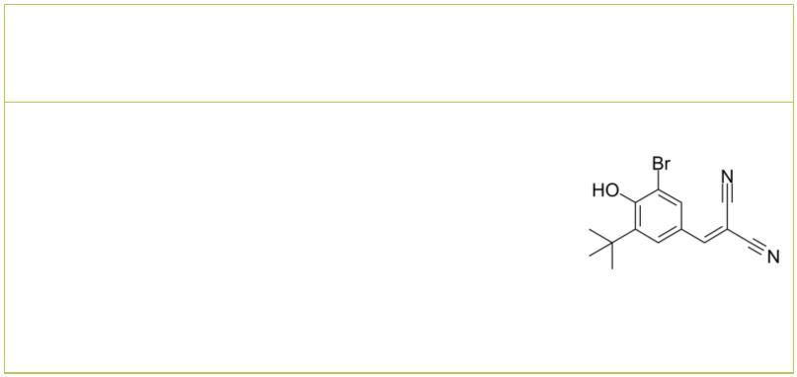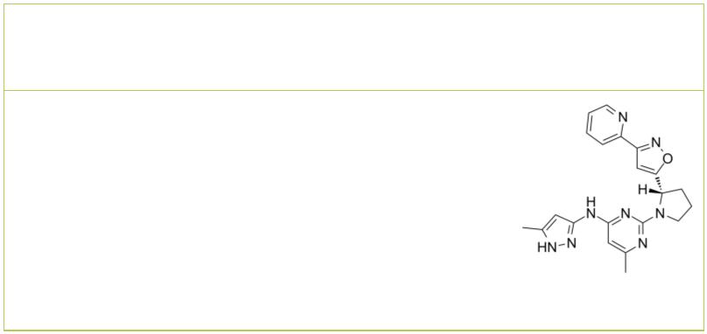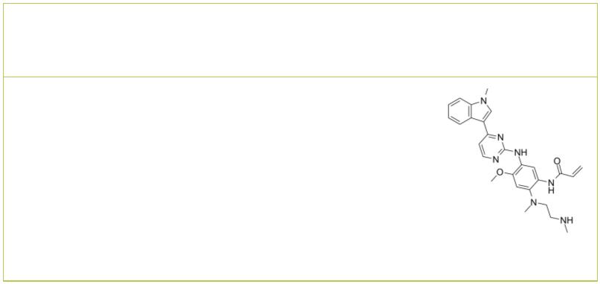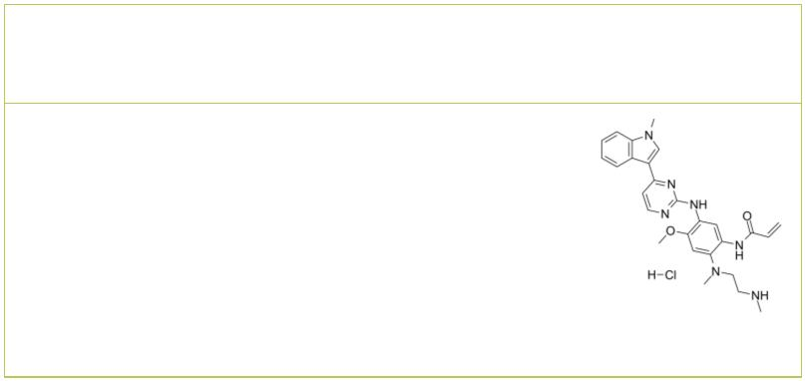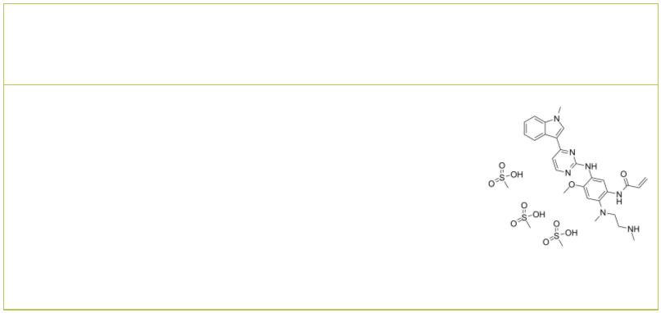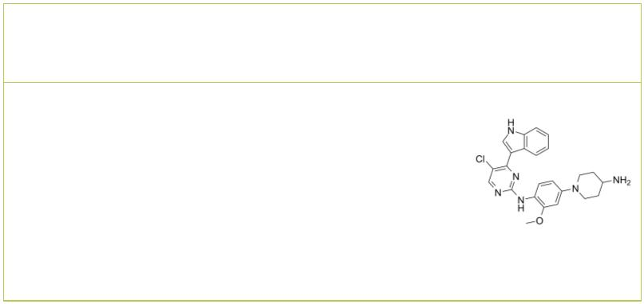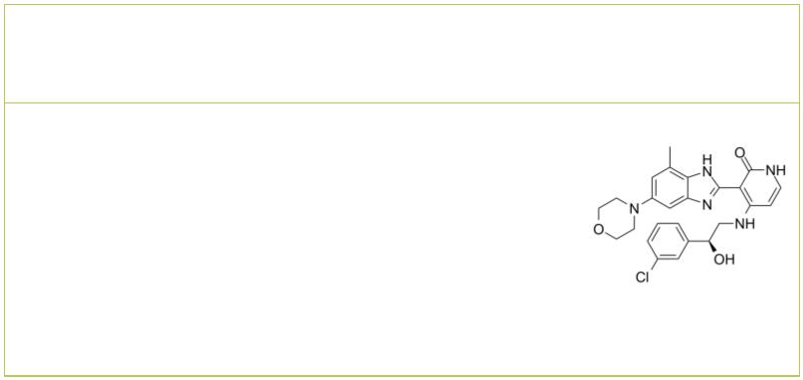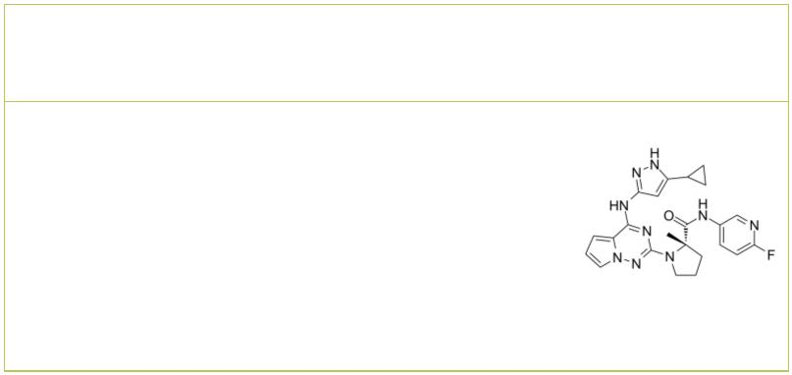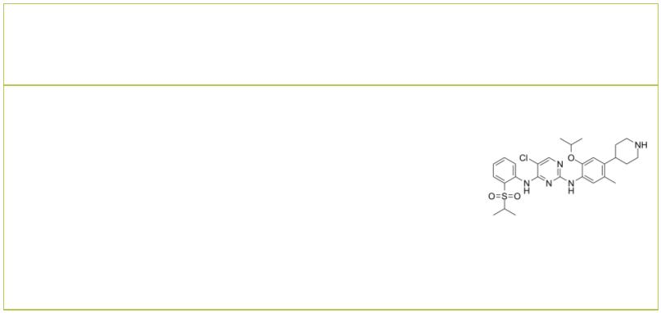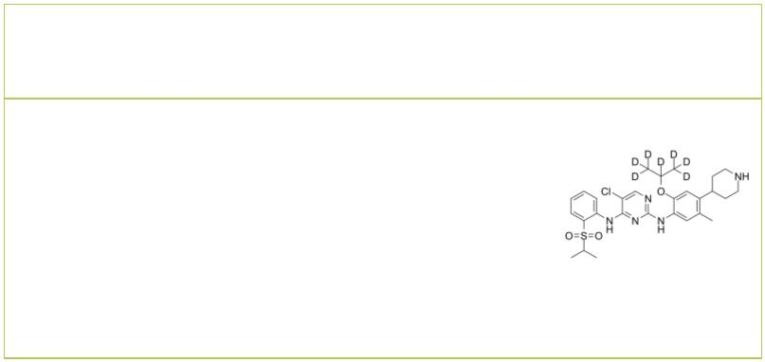IGF-1R Inhibitors & Agonists
 | AG1024  (Tyrphostin AG 1024) Cat. No.: HY-10253 |  |  |  | AZ12253801 |  |  |  |  |  |  |  |  |  |  |  |  | Cat. No.: HY-125102
 | AG1024 (Tyrphostin AG 1024) is a reversible,  competitive and selective IGF-1R inhibitor with an  IC₅₀ of 7 μM. AG1024 inhibits phosphorylation of IR  (IC =57 μM). AG1024 induces and has  50 apoptosis  anti-cancer activity.  Purity: 98.86%  Clinical Data: No Development Reported  Size: 10 mM × 1 mL, 5 mg, 10 mg, 50 mg, 100 mg |  |  |  | AZ12253801 is an ATP-competitive IGF-1R tyrosine  kinase inhibitor that shows 10-fold selectivity  over the insulin receptor. AZ12253801 inhibits  IGF-1R–driven proliferation in 3T3 mouse  fibroblasts (transfected with human IGF-1R) with  an IC of 17 nmol/L.  50  Purity: >98%  Clinical Data: No Development Reported  Size: 1 mg, 5 mg
 | AZ7550 AZ7550 hydrochloride
 |  | Cat. No.: HY-B0794 Cat. No.: HY-B0794A
 | AZ7550 is an active metabolite of AZD9291 and  inhibits the activity of IGF1R with an IC of 1.6  50  μM. |  |  |  | AZ7550 hydrochloride is an active metabolite of  AZD9291 and inhibits the activity of IGF1R with an  IC of 1.6 μM.  50
 | Purity: >98%  Clinical Data: No Development Reported  Size: 1 mg, 5 mg |  |  |  | Purity: 98.66%  Clinical Data: Phase 1  Size: 5 mg, 10 mg
 | AZ7550 Mesylate  (AZ7550 trimesylate salt) Cat. No.: HY-B0794B |  |  |  | AZD-3463  (ALK/IGF1R inhibitor) Cat. No.: HY-15609
 | AZ7550 Mesylate is an active metabolite of AZD9291  and inhibits the activity of IGF1R with an IC of  50  1.6 μM. |  |  |  | AZD-3463 (ALK/IGF1R inhibitor) is an orally active  ALK/IGF1R inhibitor, with a K of 0.75 nM for ALK.  i  AZD3463 induces apoptosis and autophagy in  neuroblastoma cells.
 | Purity: 99.34%  Clinical Data: Phase 1  Size: 10 mM × 1 mL, 5 mg, 10 mg |  |  |  | Purity: 99.96%  Clinical Data: No Development Reported  Size: 10 mM × 1 mL, 5 mg, 10 mg, 50 mg, 100 mg
 | BMS-536924 BMS-754807
 |  |  | Cat. No.: HY-10262 Cat. No.: HY-10200
 | BMS-536924 is an orally active, competitive and  selective insulin-like growth factor receptor  (IGF-1R) kinase and insulin receptor (IR) inhibitor  with IC s of 100 nM and 73 nM, respectively.  50  BMS-536924 has anti-cancer activity. |  |  |  | BMS-754807 is a potent and reversible IGF-1R/IR  inhibitor (IC =1.8 and 1.7 nM, respectively;  50  K=<2 nM for both). BMS-754807 also shows  i  potent activities against Met, RON, TrkA, TrkB,  AurA, and AurB with IC values of 6, 44, 7, 4, 9,  50  and 25 nM, respectively.
 | Purity: 99.74%  Clinical Data: No Development Reported  Size: 10 mM × 1 mL, 5 mg, 10 mg, 50 mg, 100 mg |  |  |  | Purity: 99.76%  Clinical Data: Phase 2  Size: 10 mM × 1 mL, 5 mg, 10 mg, 25 mg, 50 mg, 100 mg
 | Ceritinib Ceritinib D7
 | (LDK378) Cat. No.: HY-15656 (LDK378 D7) Cat. No.: HY-15656S
 | Ceritinib (LDK378) is a selective, orally  bioavailable, and ATP-competitive ALK tyrosine  kinase inhibitor with an IC of 200 pM. Ceritinib  50  (LDK378) also inhibits IGF-1R, InsR, and STK22D  with IC values of 8, 7, and 23 nM, respectively.  50  Ceritinib (LDK378) shows great antitumor potency. |  |  |  | Ceritinib D7 (LDK378 D7) is a deuterium labeled  Ceritinib. Ceritinib is a selective, orally  bioavailable and ATP-competitive ALK tyrosine  kinase inhibitor.
 | Purity: 99.97%  Clinical Data: Launched  Size: 10 mM × 1 mL, 5 mg, 10 mg, 50 mg, 100 mg, 200 mg |  |  |  | Purity: >98%  Clinical Data: No Development Reported  Size: 1 mg, 5 mg
2 Tel: 609-228-6898 Fax: 609-228-5909 Email: sales@MedChemExpress.com
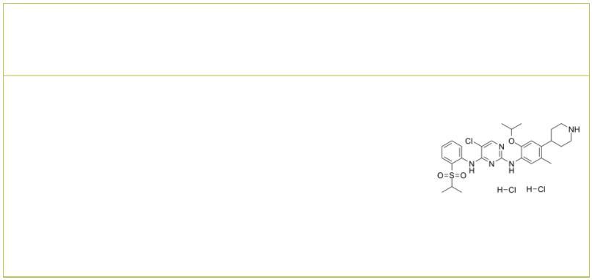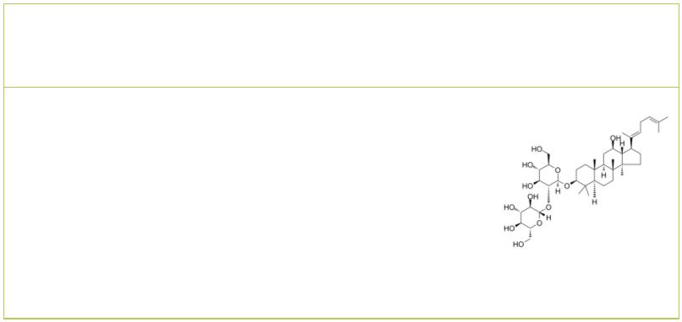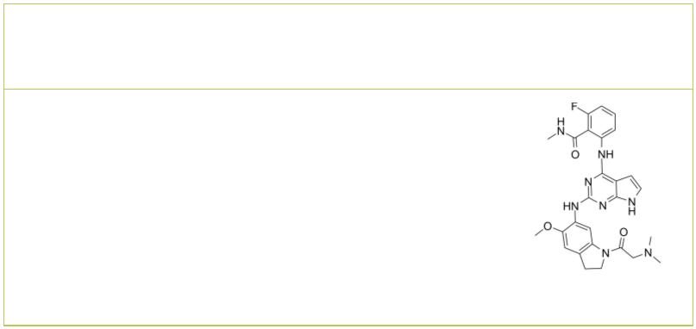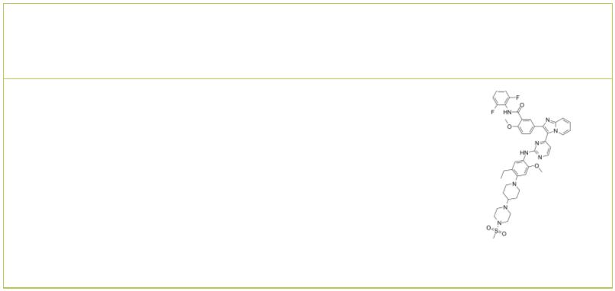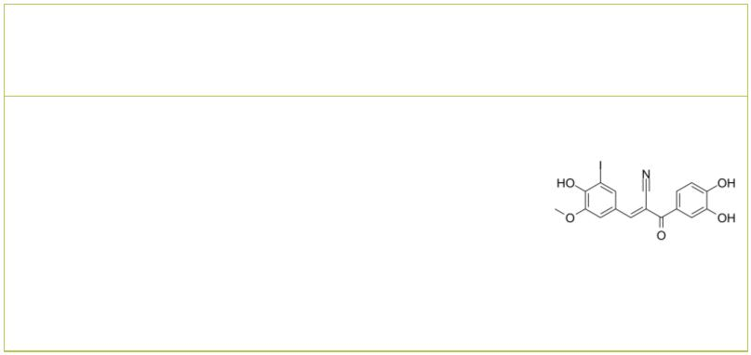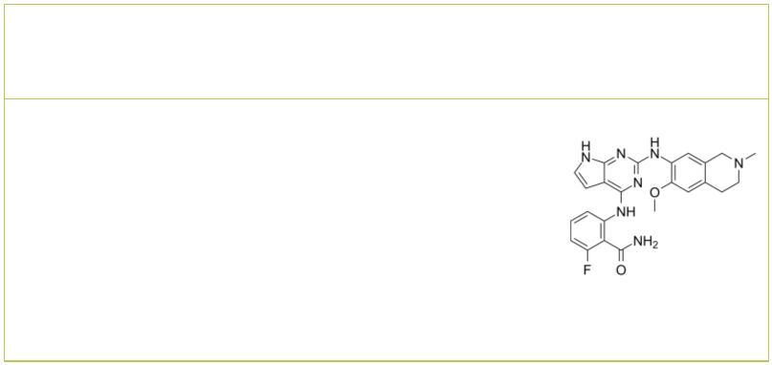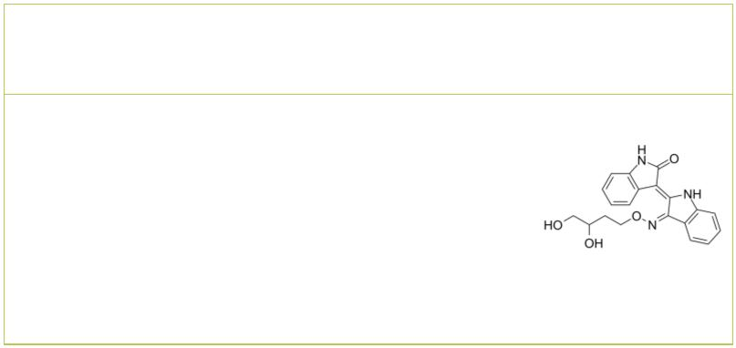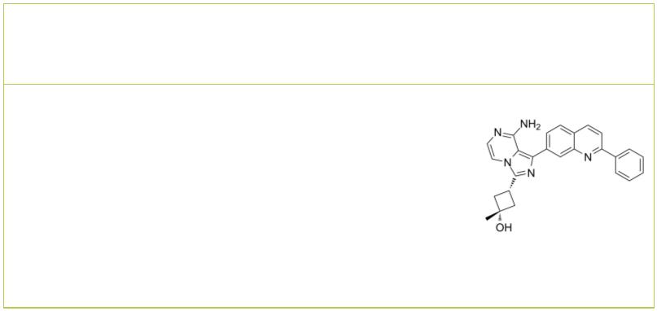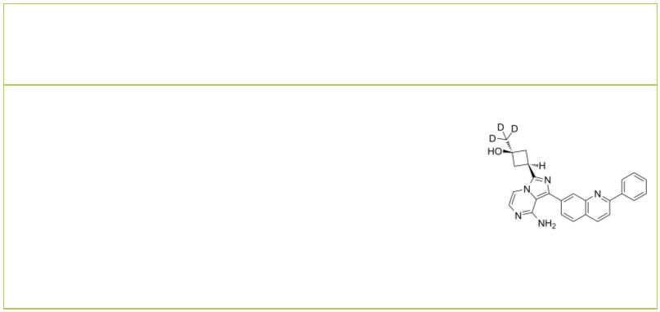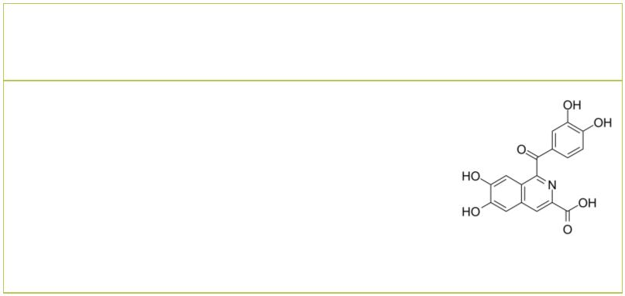Ceritinib dihydrochloride  (LDK378 dihydrochloride) Cat. No.: HY-15656A |  |  | Ginsenoside Rg5 |  |  |  |  |  |  |  |  |  |  |  |  |  |  |  | Cat. No.: HY-N0908
Ceritinib dihydrochloride (LDK378 dihydrochloride)  is a selective, orally bioavailable and  ATP-competitive ALK tyrosine kinase inhibitor  with an IC of 200 pM.  50 |  |  | Ginsenoside Rg5 is the main component of Red  ginseng. Ginsenoside blocks binding of IGF-1 to its  receptor with an IC of ~90 nM. Ginsenoside Rg5  50  also inhibits the mRNA expression of COX-2 via  suppression of the DNA binding activities of  NF-κB p65.
Purity: 99.83%  Clinical Data: Launched  Size: 10 mM × 1 mL, 5 mg, 10 mg, 50 mg, 100 mg |  |  | Purity: 99.86%  Clinical Data: No Development Reported  Size: 10 mM × 1 mL, 5 mg, 10 mg
GSK1838705A GSK1904529A
 | Cat. No.: HY-13020 Cat. No.: HY-10524
GSK1838705A is a potent and reversible IGF-IR and  the insulin receptor inhibitor with IC s of 2.0  50  and 1.6 nM, respectively. It also inhibits ALK  with an IC of 0.5 nM.  50 |  |  | GSK1904529A is a potent, selective, orally active,  and ATP-competitive inhibitor of insulin-like  growth factor-1 receptor (IGF-1R) and insulin  receptor (IR), with IC s of 27 and 25 nM,  50  respectively.
Purity: 99.28%  Clinical Data: No Development Reported  Size: 10 mM × 1 mL, 5 mg, 10 mg, 50 mg, 100 mg |  |  | Purity: 99.22%  Clinical Data: No Development Reported  Size: 10 mM × 1 mL, 10 mg, 50 mg, 100 mg
I-OMe-Tyrphostin AG 538  (I-OMe-AG 538) Cat. No.: HY-135680 |  |  | IGF-1R inhibitor-2 |  |  |  |  |  |  |  |  |  |  |  |  |  | Cat. No.: HY-145110
I-OMe-Tyrphostin AG 538 (I-OMe-AG 538) is a  specific inhibitor of IGF-1R (insulin-like growth  factor-1 receptor tyrosine kinase). |  |  | IGF-1R inhibitor-2 (example 121) is an  insulin-like growth factor-1 receptor (IGF-1R)  inhibitor. Downregulation of IGF-1R can reverse  the transformed phenotype of tumor cells and  potentially render them susceptible to apoptosis.
Purity: 99.34%  Clinical Data: No Development Reported  Size: 5 mg, 10 mg, 25 mg, 50 mg, 100 mg |  |  | Purity: >98%  Clinical Data: No Development Reported  Size: 1 mg, 5 mg
Indirubin Derivative E804 Linsitinib
 | Cat. No.: HY-18785 |  | (OSI-906) Cat. No.: HY-10191
Indirubin Derivative E804 is a potent inhibitor of  Insulin-like Growth Factor 1 Receptor (IGF1R), with  an IC of 0.65 μM for IGF1R.  50 |  |  | Linsitinib (OSI-906) is a potent, selective and  orally bioavailable dual inhibitor of the IGF-1  receptor and insulin receptor (IR) with IC s of 35  50  and 75 nM, respectively.
Purity: 99.79%  Clinical Data: No Development Reported  Size: 1 mg, 5 mg, 10 mg, 25 mg, 50 mg, 100 mg |  |  | Purity: 99.88%  Clinical Data: Phase 3  Size: 10 mM × 1 mL, 5 mg, 10 mg, 50 mg, 100 mg
Linsitinib-d3 NBI-31772
(OSI-906-d3) Cat. No.: HY-10191S |  |  |  |  |  |  |  |  |  |  |  |  |  |  |  |  | Cat. No.: HY-110135
Linsitinib-d3 (OSI-906-d3) is the deuterium  labeled Linsitinib. Linsitinib (OSI-906) is a  potent, selective and orally bioavailable dual  inhibitor of the IGF-1 receptor and insulin  receptor (IR) with IC s of 35 and 75 nM,  50  respectively. |  |  | NBI-31772 is the potent and nonselective inhibitor  of IGFBP with a K value of 47 nM. NBI-31772 has  i  the potential for the research of IGF-responsive  diseases.
Purity: >98%  Clinical Data: No Development Reported  Size: 1 mg, 5 mg |  |  | Purity: >98%  Clinical Data: No Development Reported  Size: 1 mg, 5 mg
www.MedChemExpress.com 3
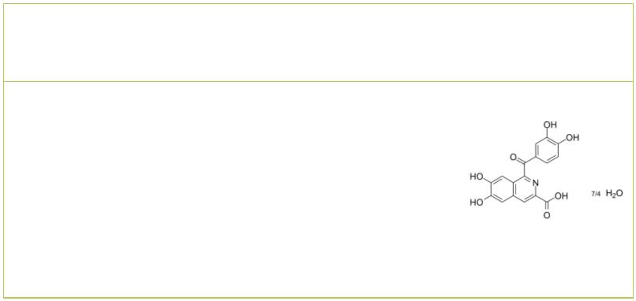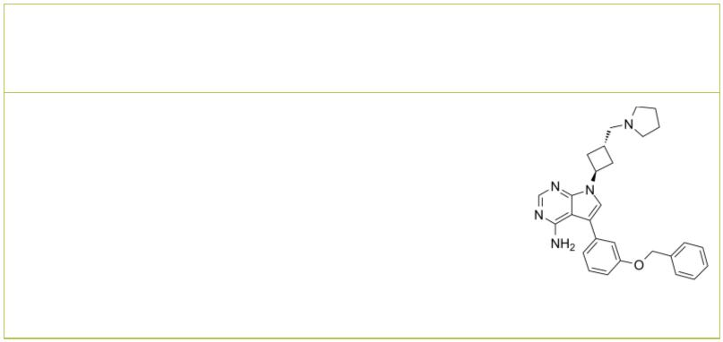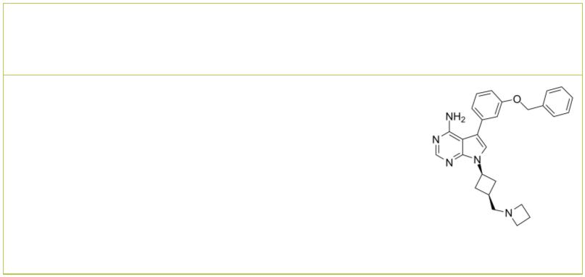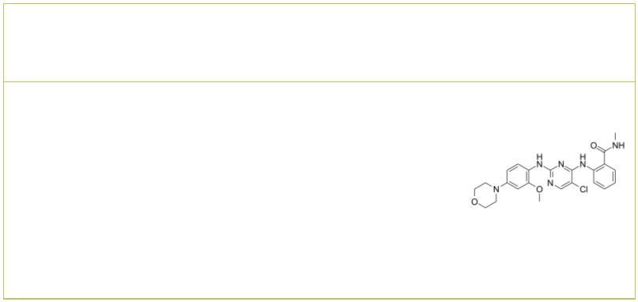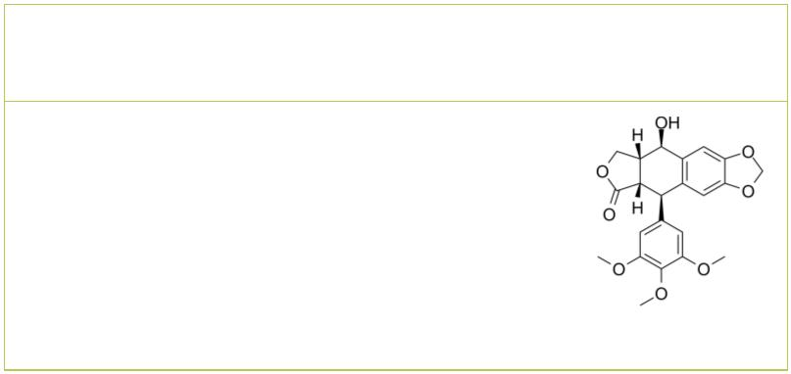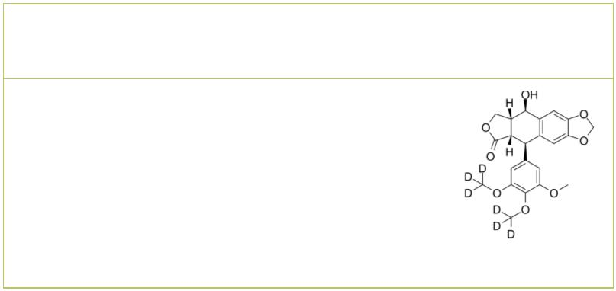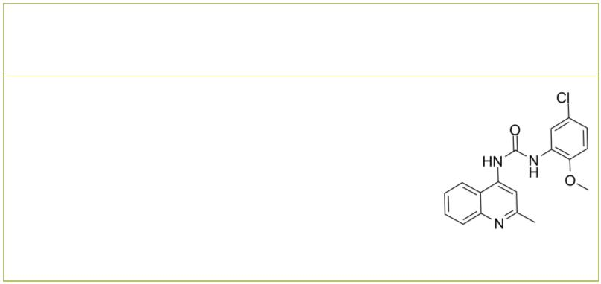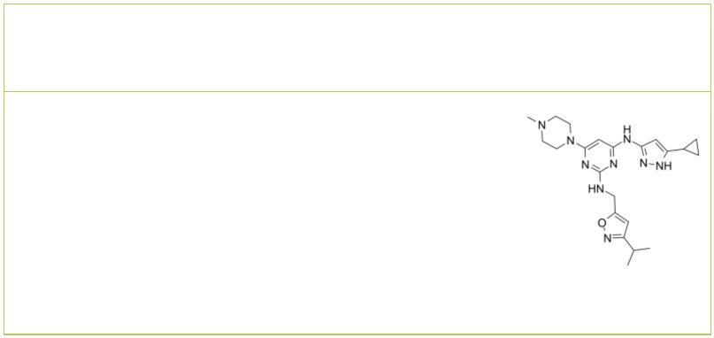 | NBI-31772 hydrate |  | Cat. No.: HY-110135A |  |  | NVP-ADW742  (ADW742; GSK 552602A; ADW) Cat. No.: HY-10252
 | NBI-31772 hydrate is a potent inhibitor of  interaction between insulin-like growth factor (IGF)  and IGF-binding proteins (IGFBPs). |  |  |  |  | NVP-ADW742 (ADW742) is an orally active, selective  IGF-1R tyrosine kinase inhibitor with an IC of  50  0.17 μM. NVP-ADW742 inhibits insulin receptor (InsR)  with an IC of 2.8 μM. NVP-ADW742 induces  50  pleiotropic antiproliferative/proapoptotic biologic  sequelae in tumor cells.
 | Purity: ≥98.0%  Clinical Data: No Development Reported  Size: 5 mg |  |  |  |  | Purity: 99.30%  Clinical Data: No Development Reported  Size: 10 mM × 1 mL, 5 mg, 10 mg, 50 mg, 100 mg
 | NVP-AEW541  (AEW541) Cat. No.: HY-50866 |  |  |  |  | NVP-TAE 226  (TAE226) Cat. No.: HY-13203
 | NVP-AEW541 (AEW541) is a potent inhibitor of IGF-1R  with IC₅₀ of 0.15 μM, also inhibits InsR, with IC₅₀  of 0.14 μM. |  |  |  |  | NVP-TAE 226 (TAE226) is a potent and  ATP-competitive dual FAK and IGF-1R inhibitor with  IC s of 5.5 nM and 140 nM, respectively. NVP-TAE  50  226 (TAE226) also effectively inhibits Pyk2 and  insulin receptor (InsR) with IC s of 3.5 nM and 44  50  nM, respectively.
 | Purity: 98.90%  Clinical Data: No Development Reported  Size: 10 mM × 1 mL, 2 mg, 5 mg, 10 mg, 50 mg, 100 mg |  |  |  |  | Purity: 99.92%  Clinical Data: No Development Reported  Size: 10 mM × 1 mL, 5 mg, 10 mg, 50 mg, 100 mg
 | Picropodophyllin  (AXL1717; Picropodophyllin; PPP) Cat. No.: HY-15494 |  |  |  |  | Picropodophyllotoxin-d6 |  |  |  |  |  |  |  | Cat. No.: HY-15494S1
 | Picropodophyllin (AXL1717) is a selective  insulin-like growth factor-1 receptor (IGF-1R)  inhibitor with an IC of 1 nM.  50 |  |  |  |  | Picropodophyllotoxin-d6 is deuterium labeled  Picropodophyllin. Picropodophyllin (AXL1717) is a  selective insulin-like growth factor-1 receptor  (IGF-1R) inhibitor with an IC50 of 1 nM.
 | Purity: 99.90%  Clinical Data: Phase 3  Size: 10 mM × 1 mL, 5 mg, 10 mg, 50 mg, 100 mg |  |  |  |  | Purity: >98%  Clinical Data: No Development Reported  Size: 1 mg, 5 mg
 | PQ401 XL228
 |  |  |  | Cat. No.: HY-13686 Cat. No.: HY-15749
 | PQ401 is a potent inhibitor of IGF-IR signaling.  PQ401 inhibits IGF-I-stimulated IGF-IR  autophosphorylation with an IC of 12.0 μM in a  50  series of studies in MCF-7 cells. PQ401 is  effective at inhibiting IGF-I-stimulated growth of  MCF-7 cells (IC , 6 μM).  50  Purity: 99.88%  Clinical Data: No Development Reported  Size: 10 mM × 1 mL, 10 mg, 50 mg |  |  |  |  | XL228 is a multi-targeted tyrosine kinase  inhibitor with IC s of 5, 3.1, 1.6, 6.1, 2 nM for  50  Bcr-Abl, Aurora A, IGF-1R, Src and Lyn,  respectively.  Purity: 99.58%  Clinical Data: No Development Reported  Size: 10 mM × 1 mL, 5 mg, 10 mg, 50 mg, 100 mg
4 Tel: 609-228-6898 Fax: 609-228-5909 Email: sales@MedChemExpress.com

