JAK
Janus kinase
Janus kinase (JAK) is a family of intracellular, nonreceptor tyrosine kinases that transduce cytokine-mediated signals via the
JAK-STAT pathway. Since members of the type I and type II cytokine receptor families possess no catalytic kinase activity, they rely
on the JAK family of tyrosine kinases to phosphorylate and activate downstream proteins involved in their signal transduction
pathways. The receptors exist as paired polypeptides, thus exhibiting two intracellular signal-transducing domains. JAKs associate
with a proline-rich region in each intracellular domain, which is adjacent to the cell membrane and called a box1/box2 region. After
the receptor associates with its respective cytokine/ligand, it goes through a conformational change, bringing the two JAKs close
enough to phosphorylate each other. The JAK autophosphorylation induces a conformational change within itself, enabling it to
transduce the intracellular signal by further phosphorylating and activating transcription factors called STATs. The activated STATs
dissociate from the receptor and form dimers before translocating to the cell nucleus, where they regulate transcription of selected
genes.
www.MedChemExpress.com 1
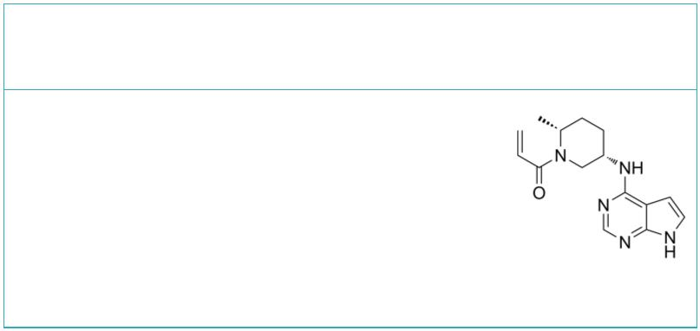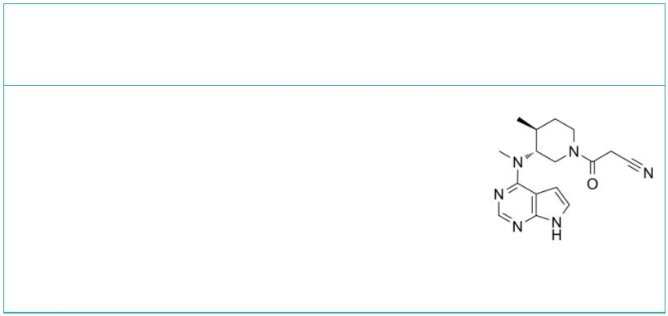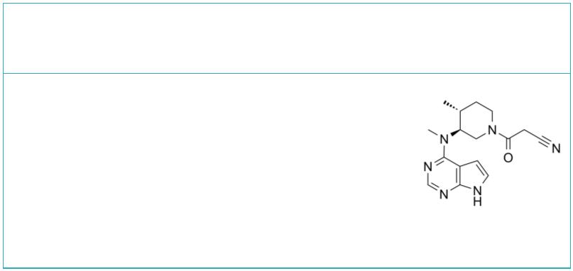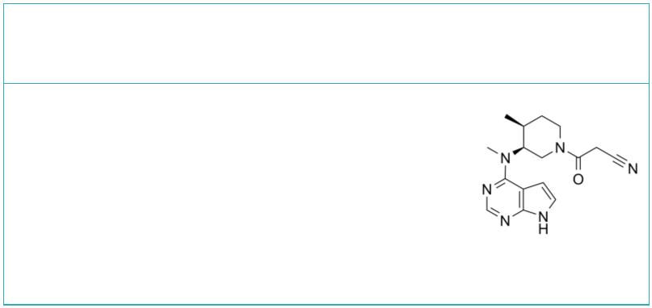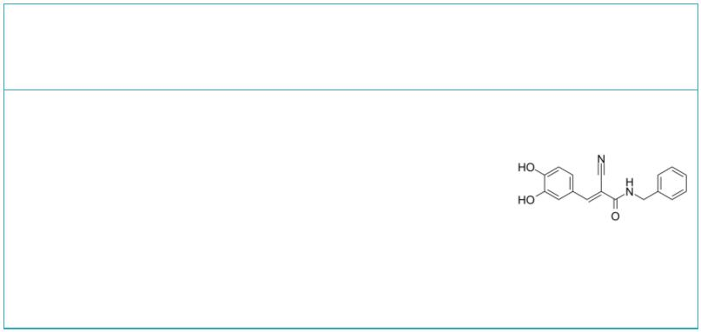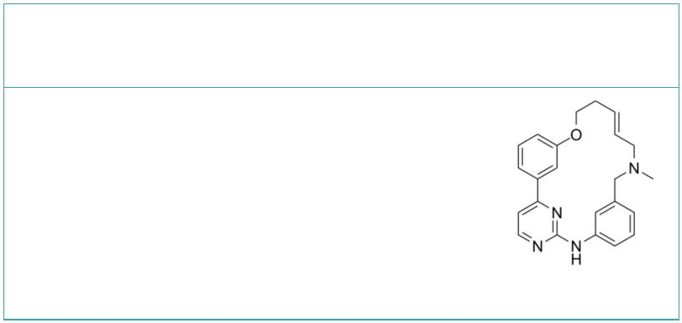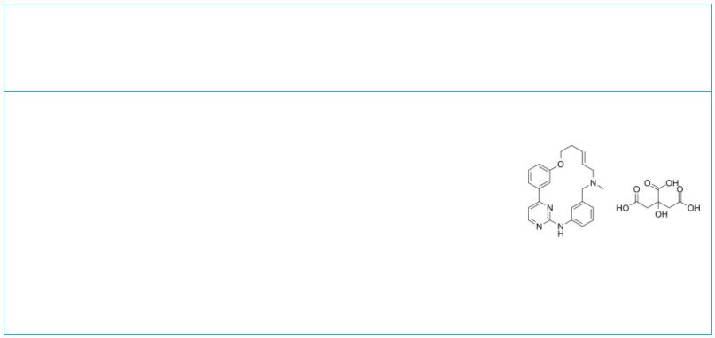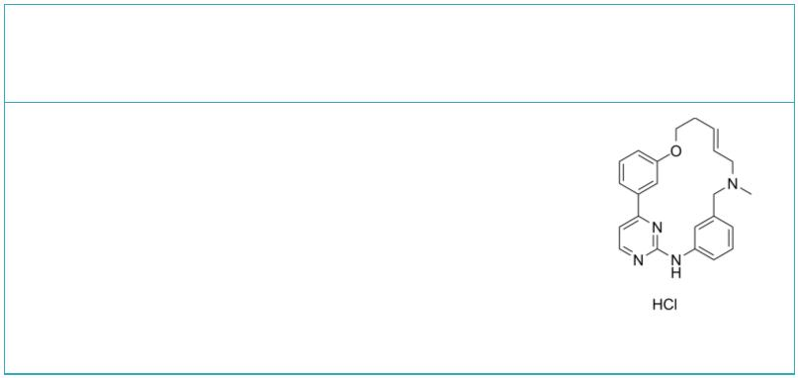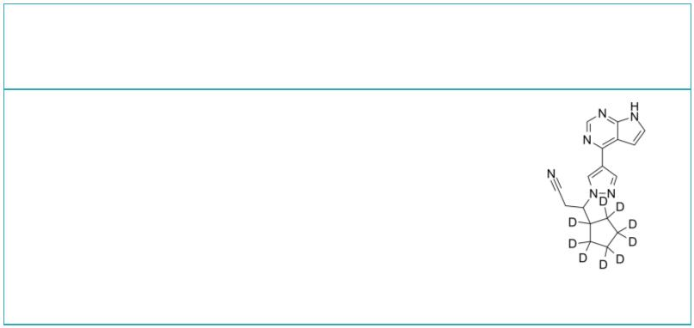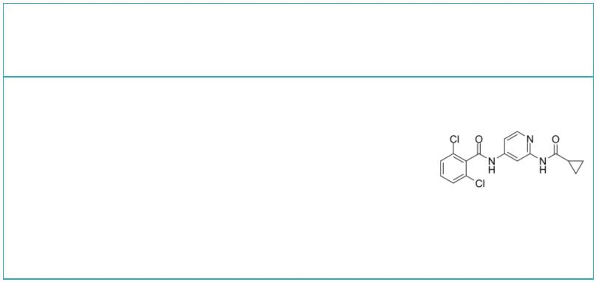JAK Inhibitors, Activators & Agonists
 | (2R,5S)-Ritlecitinib  ((2R,5S)-PF-06651600) Cat. No.: HY-100754B |  |  | (3R,4S)-Tofacitinib |  |  |  |  |  |  |  |  |  |  |  |  |  | Cat. No.: HY-40354D
 | (2R,5S)-Ritlecitinib ((2R,5S)-PF-06651600) is a  potent and selective JAK3 inhibitor (IC =144.8  50  nM) extracted from patent US20150158864A1, example  68. |  |  | (3R,4S)-Tofacitinib is an less active enantiomer  of Tofacitinib. Tofacitinib inhibits JAK3 with  IC of 1 nM.  50
 | Purity: 98.83%  Clinical Data: No Development Reported  Size: 5 mg |  |  | Purity: >98%  Clinical Data: Launched  Size: 1 mg, 5 mg
 | (3S,4R)-Tofacitinib (3S,4S)-Tofacitinib
 |  | Cat. No.: HY-40354B Cat. No.: HY-40354C
 | (3S,4R)-Tofacitinib is an less active enantiomer  of Tofacitinib. Tofacitinib inhibits JAK3 with  IC of 1 nM.  50 |  |  | (3S,4S)-Tofacitinib is the less active  S-enantiomer of Tofacitinib. Tofacitinib inhibits  JAK3 with IC of 1 nM.  50
 | Purity: >98%  Clinical Data: Launched  Size: 1 mg, 5 mg |  |  | Purity: 99.24%  Clinical Data: No Development Reported  Size: 1 mg
 | (E/Z)-AG490  ((E/Z)-Tyrphostin AG490; (E/Z)-Tyrphostin B42) Cat. No.: HY-107459 |  |  | (E/Z)-Zotiraciclib  ((E/Z)-TG02; (E/Z)-SB1317) Cat. No.: HY-15166
 | (E/Z)-AG490 ((E/Z)-Tyrphostin AG490) is a racemic  compound of (E)-AG490 and (Z)-AG490 isomers.  (E)-AG490 (HY-12000) is a tyrosine kinase inhibitor  that inhibits EGFR, Stat-3 and JAK2/3. |  |  | (E/Z)-Zotiraciclib ((E/Z)-TG02) is a potent  inhibitor of CDK2, JAK2, and FLT3.  (E/Z)-Zotiraciclib ((E/Z)-TG02) can be used for  the research of cancer.
 | Purity: ≥96.0%  Clinical Data: No Development Reported  Size: 1 mg, 5 mg |  |  | Purity: 99.96%  Clinical Data: Phase 2  Size: 10 mM × 1 mL, 5 mg, 10 mg, 50 mg, 100 mg
 | (E/Z)-Zotiraciclib citrate (E/Z)-Zotiraciclib hydrochloride
 | ((E/Z)-TG02 citrate; (E/Z)-SB1317 citrate) Cat. No.: HY-15166B ((E/Z)-TG02 hydrochloride; (E/Z)-SB1317 hydrochloride) Cat. No.: HY-15166A
 | (E/Z)-Zotiraciclib citrate is a potent CDK2,  JAK2, and FLT3 inhibitor. |  |  | (E/Z)-Zotiraciclib ((E/Z)-TG02) hydrochloride is a  potent CDK2, JAK2, and FLT3 inhibitor.
 | Purity: >98%  Clinical Data: No Development Reported  Size: 1 mg, 5 mg |  |  | Purity: 99.45%  Clinical Data: No Development Reported  Size: 5 mg, 10 mg, 50 mg, 100 mg
 | (Rac)-Ruxolitinib-d9 2,6-Dichloro-N-(2-(cyclopropanecarboxamido)pyridin-4-yl)benz
 | ((Rac)-INCB18424-d9) Cat. No.: HY-W062703S |  |  | amide Cat. No.: HY-120469
 | (Rac)-Ruxolitinib D9 ((Rac)-INCB18424 D9) is the  deuterium labeled (Rac)-Ruxolitinib.  (Rac)-Ruxolitinib is a JAK2 inhibitor. |  |  | GDC-046 is a potent, selective, and orally  bioavailable TYK2 inhibitor with Ks of 4.8, 0.7,  i  0.7, and 0.4 nM for TYK2, JAK1, JAK2, and JAK3,  respectively.
 | Purity: >98%  Clinical Data: No Development Reported  Size: 1 mg, 5 mg |  |  | Purity: 98.78%  Clinical Data: No Development Reported  Size: 10 mM × 1 mL, 5 mg, 10 mg, 25 mg
2 Tel: 609-228-6898 Fax: 609-228-5909 Email: sales@MedChemExpress.com
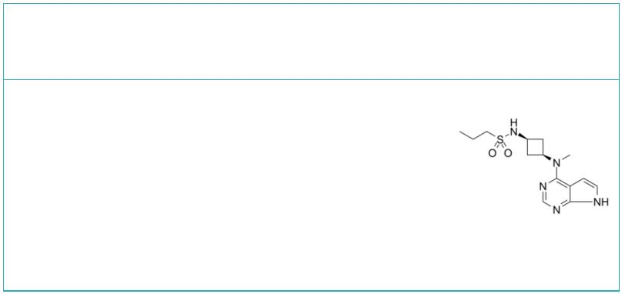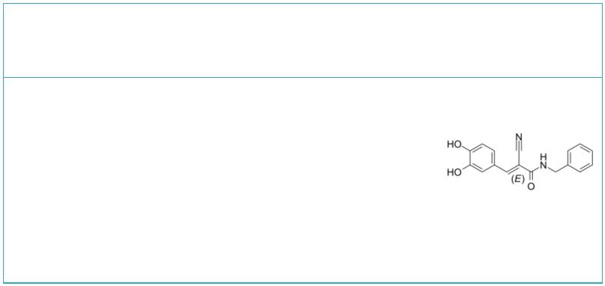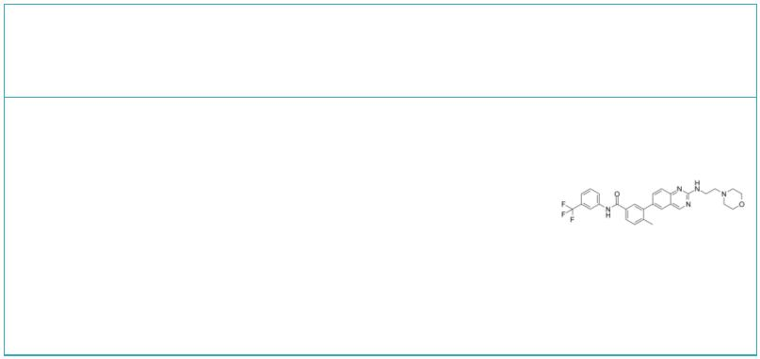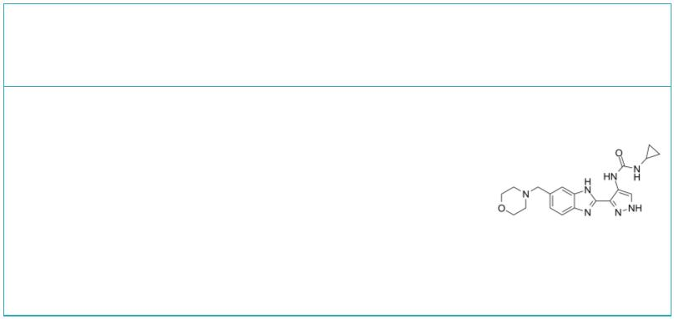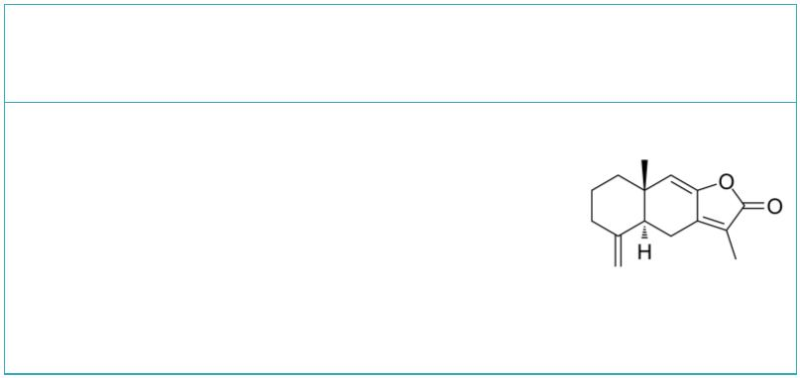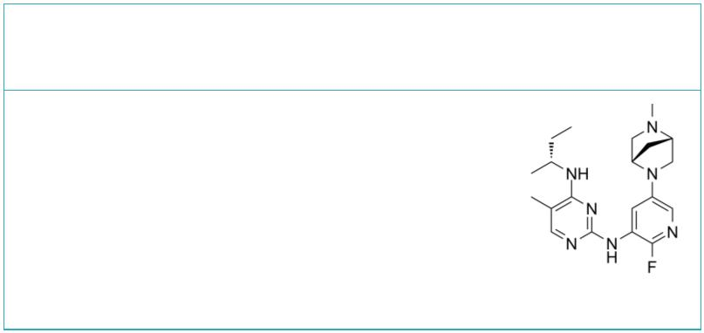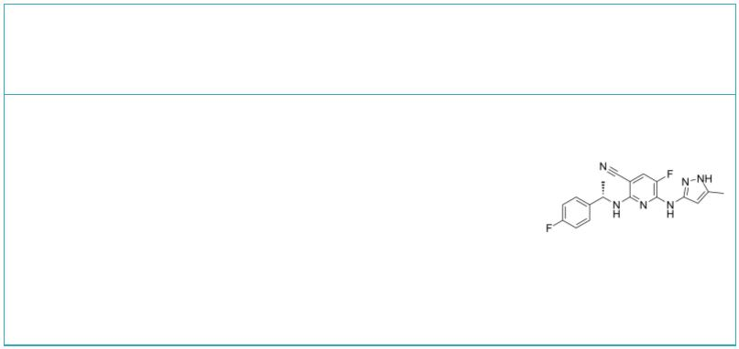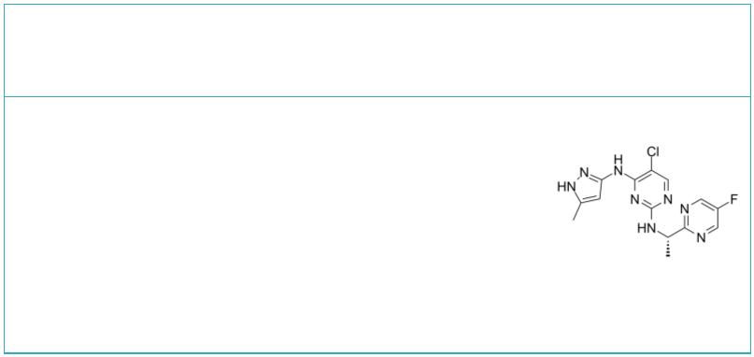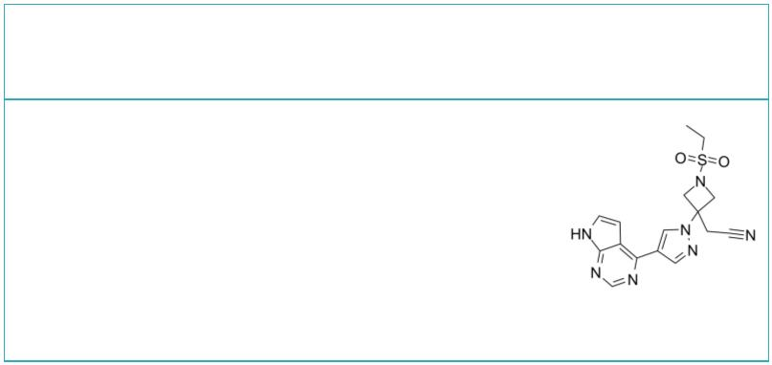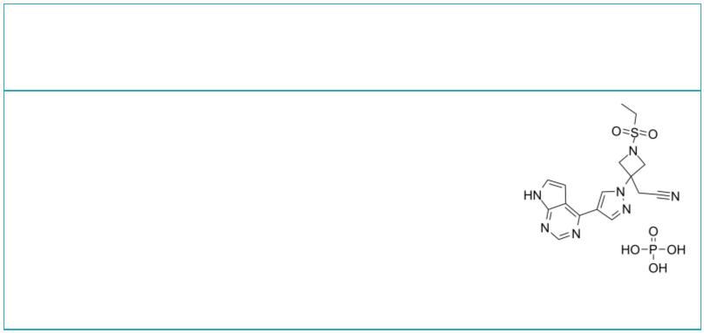Abrocitinib  (PF-04965842) Cat. No.: HY-107429 |  |  |  | AG490  (Tyrphostin AG490; Tyrphostin B42) Cat. No.: HY-12000
Abrocitinib (PF-04965842) is a potent, orally  active and selective JAK1 inhibitor, with IC s  50  of 29 and 803 nM for JAK1 and JAK2, respectively. |  |  |  | AG490 (Tyrphostin AG490) is a tyrosine kinase  inhibitor that inhibits EGFR, Stat-3 and  JAK2/3.
Purity: 99.26%  Clinical Data: Launched  Size: 10 mM × 1 mL, 5 mg, 10 mg, 25 mg, 50 mg, 100 mg |  |  |  | Purity: 99.92%  Clinical Data: No Development Reported  Size: 10 mM × 1 mL, 10 mg, 50 mg, 100 mg, 200 mg
AMG-47a AT9283
 |  | Cat. No.: HY-18303 Cat. No.: HY-50514
AMG-47a is a potent and orally active  lymphocyte-specific protein tyrosine kinase  (Lck) inhibitor, with an IC of 0.2 nM. AMG-47a  50  also inhibits VEGF2, p38α, Jak3 and MLR and  IL-2 with IC s of 1 nM, 3 nM, 72 nM, 30 nM and 21  50  nM, respectively. |  |  |  | AT9283 is a multi-targeted kinase inhibitor with  potent activity against Aurora A/B, JAK2/3, Abl  (T315I) and Flt3 (IC s ranging from 1 to 30 nM).  50  AT9283 inhibits growth and survival of multiple  solid tumors in vitro and in vivo.
Purity: 98.72%  Clinical Data: No Development Reported  Size: 10 mM × 1 mL, 5 mg, 10 mg, 25 mg, 50 mg |  |  |  | Purity: 99.70%  Clinical Data: Phase 2  Size: 10 mM × 1 mL, 2 mg, 5 mg, 10 mg, 50 mg, 100 mg
Atractylenolide I AZ-3
 | Cat. No.: HY-N0201 Cat. No.: HY-112442
Atractylenolide I is a sesquiterpene derived from  the rhizome of Atractylodes macrocephala,  possesses diverse bioactivities, such as  neuroprotective, anti-allergic, anti-inflammatory  and anticancer properties. |  |  |  | AZ-3 is a potent and selective JAK1 inhibitor  with an IC of 34 nM.  50
Purity: 99.83%  Clinical Data: No Development Reported  Size: 10 mM × 1 mL, 5 mg, 10 mg, 50 mg |  |  |  | Purity: >98%  Clinical Data: No Development Reported  Size: 1 mg, 5 mg
AZ960 AZD-1480
 |  | Cat. No.: HY-10411 Cat. No.: HY-10193
AZ960 is a potent and specific inhibitor of the  JAK2 kinase with a K of 0.45 nM.  i |  |  |  | AZD-1480 is an ATP-competitive inhibitor of JAK1  and JAK2 with IC s of 1.3 nM and  50  <0.4nM, respectively.
Purity: 97.15%  Clinical Data: No Development Reported  Size: 10 mM × 1 mL, 1 mg, 5 mg, 10 mg, 50 mg, 100 mg |  |  |  | Purity: 99.37%  Clinical Data: Phase 1  Size: 10 mM × 1 mL, 5 mg, 10 mg, 50 mg, 100 mg, 200 mg
Baricitinib Baricitinib phosphate
(LY3009104; INCB028050) Cat. No.: HY-15315 (LY3009104 phosphate; INCB028050 phosphate) Cat. No.: HY-15315A
Baricitinib (LY3009104; INCB028050) is a selective  and orally bioavailable JAK1 and JAK2 inhibitor  with IC s of 5.9 nM and 5.7 nM, respectively.  50 |  |  |  | Baricitinib phosphate (LY3009104 phosphate;  INCB028050 phosphate) is a selective orally  bioavailable JAK1/JAK2 inhibitor with IC of  50  5.9 nM and 5.7 nM, respectively.
Purity: 99.97%  Clinical Data: Launched  Size: 10 mM × 1 mL, 5 mg, 10 mg, 50 mg, 100 mg |  |  |  | Purity: 99.91%  Clinical Data: Launched  Size: 10 mM × 1 mL, 5 mg, 10 mg, 50 mg, 100 mg
www.MedChemExpress.com 3
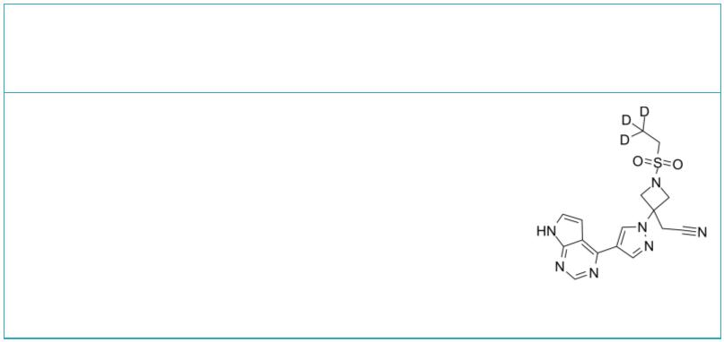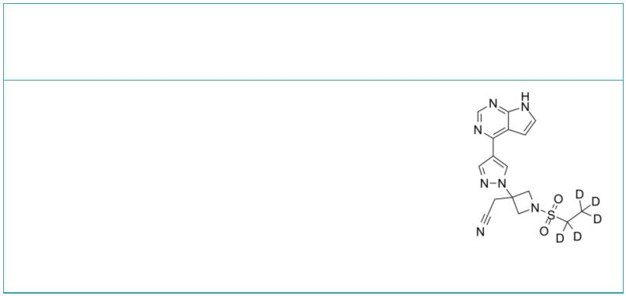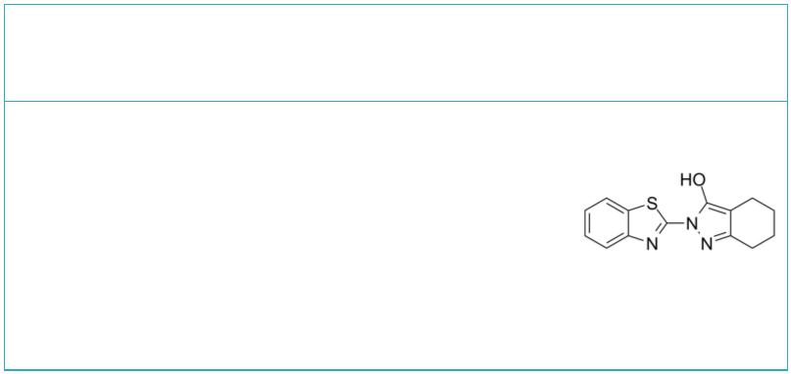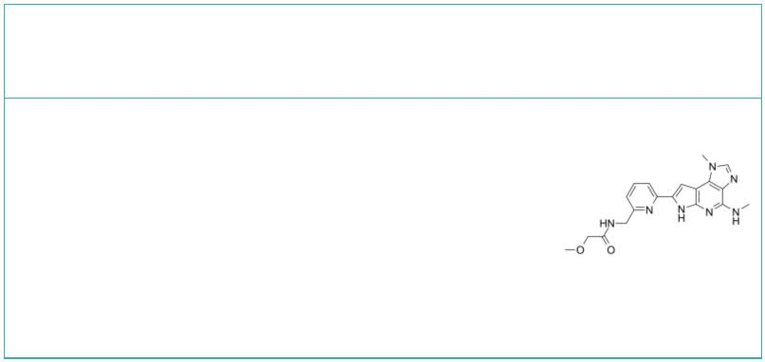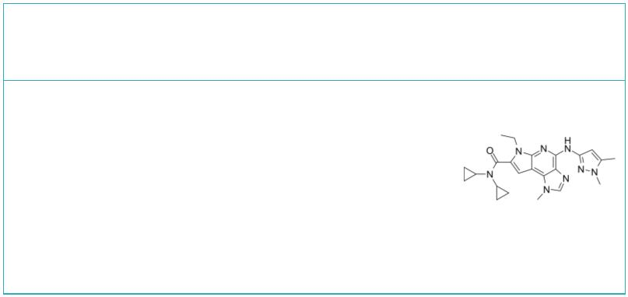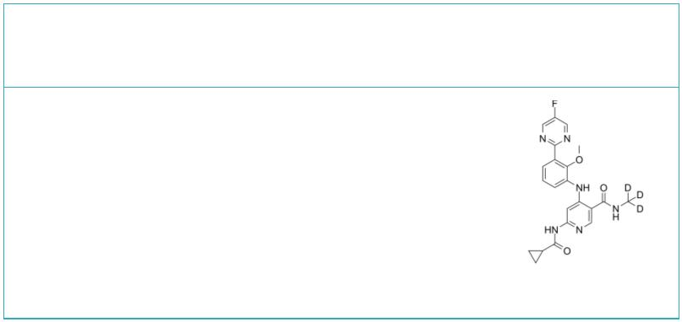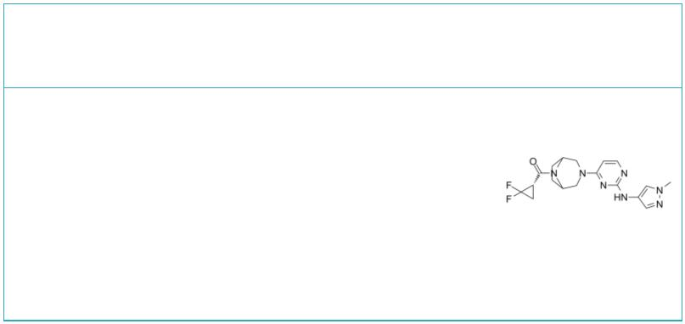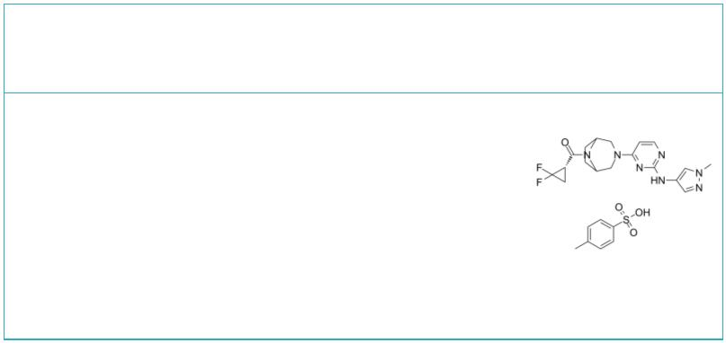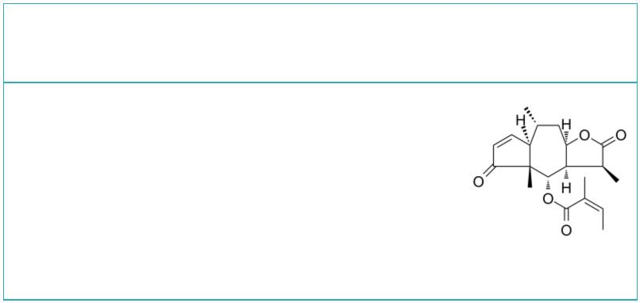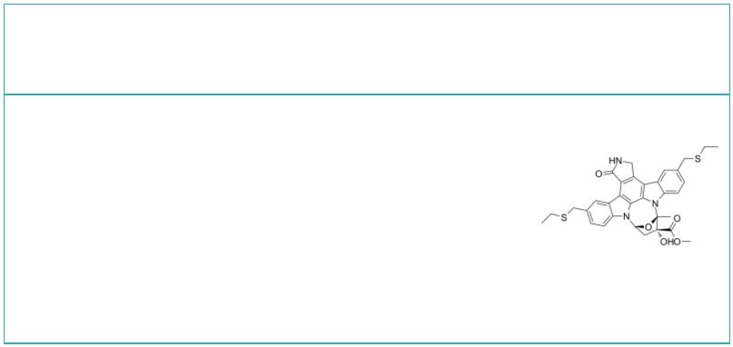 | Baricitinib-d3  (LY3009104-d3; INCB028050-d3) Cat. No.: HY-15315S1 |  |  |  |  | Baricitinib-d5  (LY3009104-d5; INCB028050-d5) Cat. No.: HY-15315S
 | Baricitinib-d3 (LY3009104-d3) is the deuterium  labeled Baricitinib. Baricitinib (LY3009104;  INCB028050) is a selective and orally bioavailable  JAK1 and JAK2 inhibitor with IC s of 5.9 nM and  50  5.7 nM, respectively. |  |  |  |  | Baricitinib-d5 (LY3009104-d5) is the deuterium  labeled Baricitinib. Baricitinib (LY3009104;  INCB028050) is a selective and orally bioavailable  JAK1 and JAK2 inhibitor with IC s of 5.9 nM and  50  5.7 nM, respectively.
 | Purity: >98%  Clinical Data: No Development Reported  Size: 1 mg, 5 mg |  |  |  |  | Purity: >98%  Clinical Data: No Development Reported  Size: 1 mg, 5 mg
 | BD750 BMS-066
 |  | Cat. No.: HY-131140 Cat. No.: HY-18710
 | BD750, an effective immunosuppressant and a  JAK3/STAT5 inhibitor, inhibits IL-2-induced  JAK3/STAT5-dependent T cell proliferation, with  IC values of 1.5 μM and 1.1 μM in mouse and human  50  T cells, respectively. |  |  |  |  | BMS-066 is an IKKβ/Tyk2 pseudokinase inhibitor,  with IC s of 9 nM and 72 nM, respectively.  50
 | Purity: 99.79%  Clinical Data: No Development Reported  Size: 10 mM × 1 mL, 5 mg, 10 mg, 25 mg, 50 mg, 100 mg |  |  |  |  | Purity: >98%  Clinical Data: No Development Reported  Size: 1 mg, 5 mg
 | BMS-911543 BMS-986202
 |  |  |  | Cat. No.: HY-15270 Cat. No.: HY-131968
 | BMS-911543 is a selective JAK2 inhibitor, with  IC s of 1.1 nM, less selective at JAK1, JAK3 and  50  TYK2 (IC , 75, 360, 66 nM, respectively).  50 |  |  |  |  | BMS-986202 is a potent, selective and orally  active Tyk2 inhibitor that binds to Tyk2 JH2  with an IC of 0.19 nM and a of 0.02 nM.  50 K_{i}  BMS-986202 is remarkably selective over other  kinases including Jak family members.
 | Purity: 98.05%  Clinical Data: Phase 2  Size: 10 mM × 1 mL, 2 mg, 5 mg, 10 mg, 50 mg, 100 mg |  |  |  |  | Purity: 99.46%  Clinical Data: Phase 1  Size: 5 mg, 10 mg, 25 mg, 50 mg, 100 mg
 | Brepocitinib Brepocitinib P-Tosylate
 | (PF-06700841) Cat. No.: HY-112708 (PF-06700841 P-Tosylate) Cat. No.: HY-112708A
 | Brepocitinib (PF-06700841) is a potent dual  Janus kinase 1 (JAK1) and TYK2 inhibitor with  IC s of 17 nM and 23 nM, respectively.  50  Brepocitinib also inhibits JAK2 and JAK3 with  IC s of 77 nM and 6.49 μM, respectively.  50 |  |  |  |  | Brepocitinib (PF-06700841) P-Tosylate is a potent  dual Janus kinase 1 (JAK1) and TYK2 inhibitor  with IC s of 17 nM and 23 nM, respectively.  50  Brepocitinib P-Tosylate also inhibits JAK2 and  JAK3 with IC s of 77 nM and 6.49 μM,  50  respectively.
 | Purity: >98%  Clinical Data: Phase 2  Size: 1 mg, 5 mg |  |  |  |  | Purity: 99.69%  Clinical Data: Phase 2  Size: 10 mM × 1 mL, 5 mg, 10 mg, 50 mg, 100 mg
 | Brevilin A CEP-1347
 |  |  | Cat. No.: HY-N2959 |  |  | (KT7515) Cat. No.: HY-10412
 | Brevilin A is a sesquiterpene lactone isolated  from Centipeda minima with anti-tumor activity.  Brevilin A is a selective inhibitor of JAK-STAT  signal pathway by attenuating the JAKs activity  and blocking STAT3 signaling (IC =ꢀ10.6 µM) in  50  Cancer Cells. |  |  |  |  | CEP-1347 is an inhibitor of the JNK/SAPK pathway  with neuroprotective effects.
 | Purity: 99.77%  Clinical Data: No Development Reported  Size: 5 mg, 10 mg |  |  |  |  | Purity: >98%  Clinical Data: No Development Reported  Size: 1 mg
4 Tel: 609-228-6898 Fax: 609-228-5909 Email: sales@MedChemExpress.com
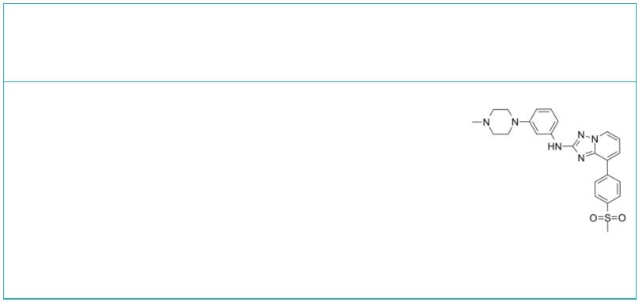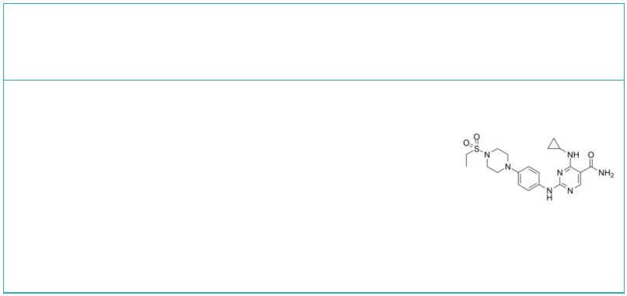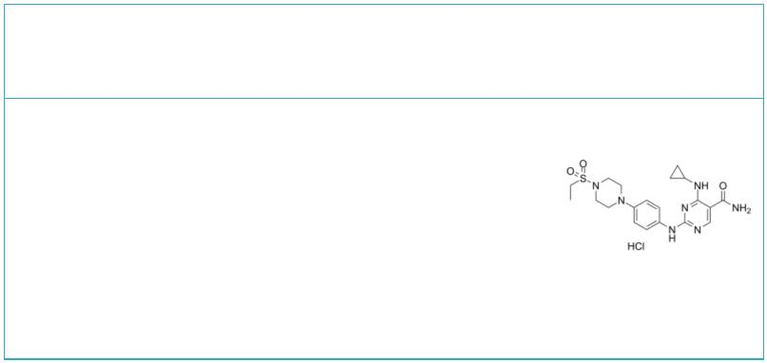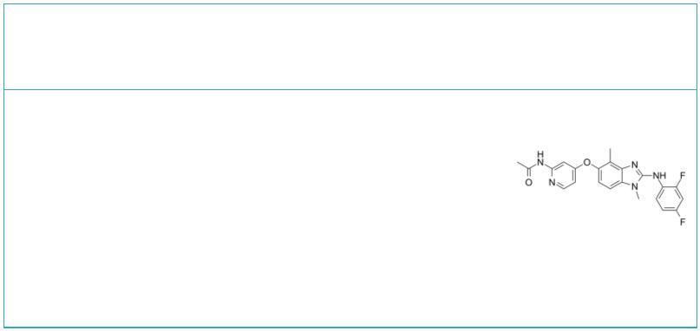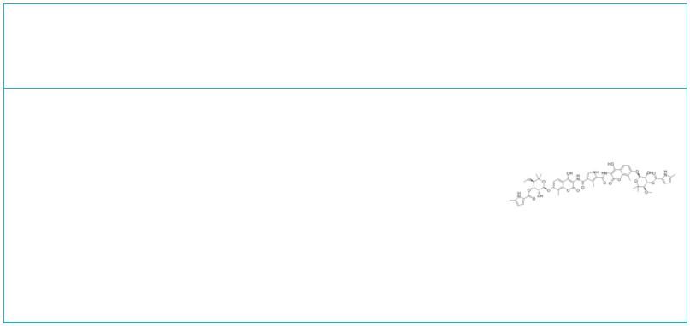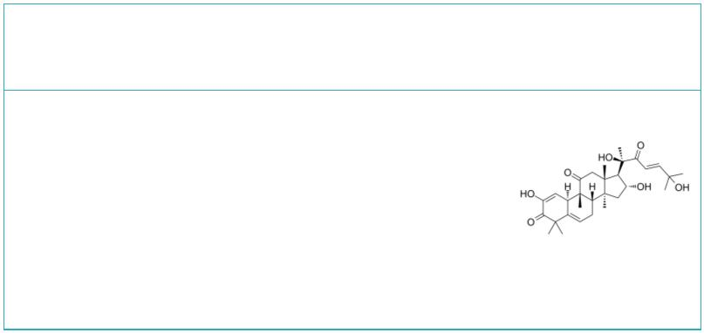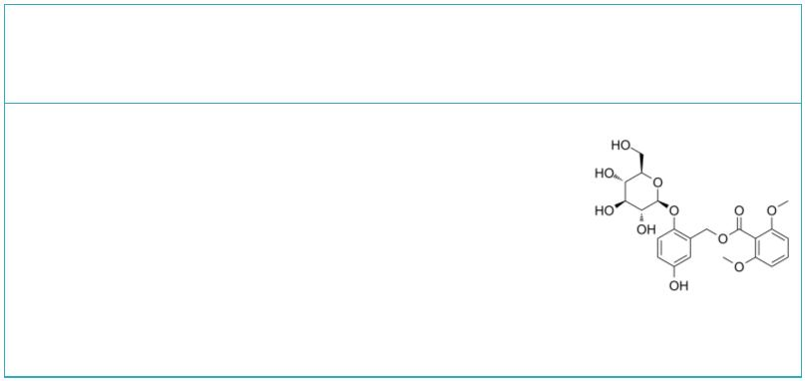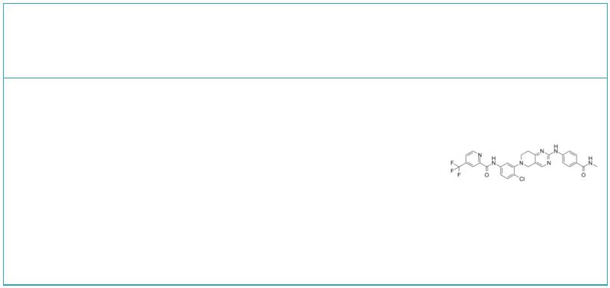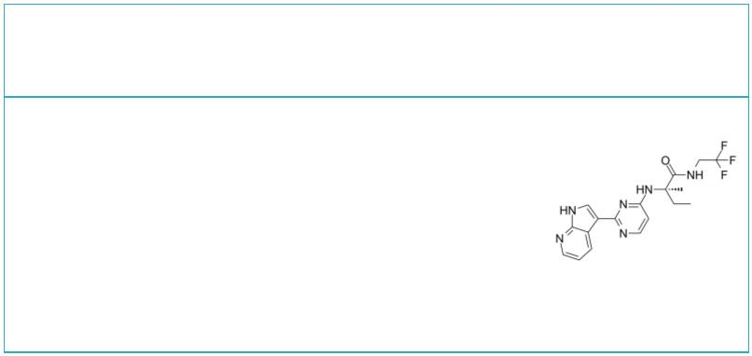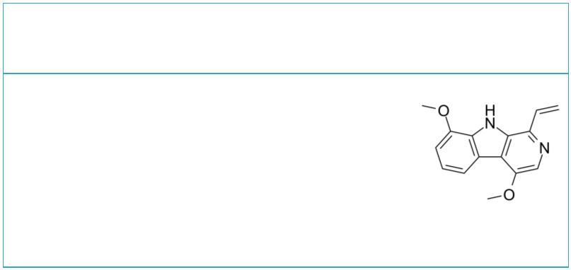CEP-33779 |  |  |  | Cat. No.: HY-15343 |  | Cerdulatinib  (PRT062070; PRT2070) Cat. No.: HY-15999
CEP-33779 is a novel, selective, and orally  bioavailable inhibitor of JAK2 with an IC of  50  1.8±0.6 nM. |  |  |  |  |  | Cerdulatinib (PRT062070) is a selective Tyk2  inhibitor with an IC of 0.5 nM. Cerdulatinib  50  (PRT062070) also is a dual JAK and SYK inhibitor  with IC s of 12, 6, 8 and 32 for JAK1, 2, 3 and  50  SYK, respectively.
Purity: 99.36%  Clinical Data: No Development Reported  Size: 10 mM × 1 mL, 5 mg, 10 mg, 50 mg, 100 mg |  |  |  |  |  | Purity: 99.0%  Clinical Data: Phase 3  Size: 10 mM × 1 mL, 5 mg, 10 mg, 50 mg, 100 mg, 200 mg
Cerdulatinib hydrochloride  (PRT062070 hydrochloride; PRT2070 hydrochloride) Cat. No.: HY-15999A |  |  |  |  |  | CHZ868 |  |  |  |  |  |  |  |  |  |  | Cat. No.: HY-18960
Cerdulatinib hydrochloride (PRT062070) is a  selective, oral active and reversible  ATP-competitive inhibitor of dual SYK and JAK,  with IC s of 32 nM, 0.5 nM, 12 nM, 6 nM and 8 nM  50  for SYK and Tyk2, JAK1, 2, 3, respectively. |  |  |  |  |  | CHZ868 is a type II JAK2 inhibitor with an IC  50  of 0.17 μM in EPOR JAK2 WT Ba/F3 cell.
Purity: 99.54%  Clinical Data: No Development Reported  Size: 10 mM × 1 mL, 5 mg, 10 mg, 50 mg, 100 mg |  |  |  |  |  | Purity: 99.22%  Clinical Data: No Development Reported  Size: 10 mM × 1 mL, 5 mg, 10 mg, 25 mg, 50 mg, 100 mg
Coumermycin A1 |  | Cat. No.: HY-N7452 |  |  |  | Cucurbitacin I  (Elatericin B; JSI-124; NSC-521777) Cat. No.: HY-N1405
Coumermycin A1 is a JAK2 signal activator.  Coumermycin A1 inhibits DNA Gyrase which thereby  inhibits cell division in bacteria. |  |  |  |  |  | Cucurbitacin I is a natural selective inhibitor of  JAK2/STAT3, with potent anti-cancer activity.
Purity: ≥98.0%  Clinical Data: No Development Reported  Size: 5 mg |  |  |  |  |  | Purity: ≥98.0%  Clinical Data: No Development Reported  Size: 10 mM × 1 mL, 1 mg, 5 mg, 10 mg
Curculigoside Debio 0617B
 |  | Cat. No.: HY-N0705 Cat. No.: HY-108417
Curculigoside is the main saponin in C. orchioide,  exerts significant antioxidant, anti-osteoporosis,  antidepressant and neuroprotection effects.  Curculigoside possesses significant anti-arthritic  effects in vivo and in vitro via regulation of the  JAK/STAT/NF-κB signaling pathway. |  |  |  |  |  | Debio 0617B, a multi-kinase inhibitor, reduces  maintenance and self-renewal of primary human AML  CD34+ stem/progenitor cells.
Purity: 99.73%  Clinical Data: No Development Reported  Size: 10 mM × 1 mL, 1 mg, 5 mg, 10 mg |  |  |  |  |  | Purity: >98%  Clinical Data: No Development Reported  Size: 1 mg, 5 mg
Decernotinib Dehydrocrenatidine
(VX-509; VRT-831509) Cat. No.: HY-12469 (Kumujian G; O-Methylpicrasidine I) Cat. No.: HY-N3710
Decernotinib is a potent, orally active JAK3  inhibitor, with Ks of 2.5, 11, 13 and 11 nM for  i  JAK3, JAK1, JAK2, and TYK2, respectively. |  |  |  |  |  | Dehydrocrenatidine, a natural alkaloid, is a  specific JAK inhibitor. Dehydrocrenatidine  inhibits voltage-gated sodium channels and  ameliorates mechanic allodia in a rat model of  neuropathic pain.<br/>.
Purity: 99.67%  Clinical Data: Phase 3  Size: 10 mM × 1 mL, 2 mg, 5 mg, 10 mg, 25 mg, 50 mg |  |  |  |  |  | Purity: >98%  Clinical Data: No Development Reported  Size: 5 mg, 10 mg, 25 mg
www.MedChemExpress.com 5
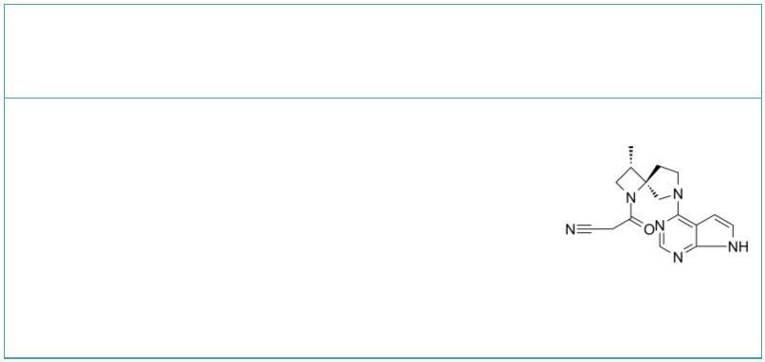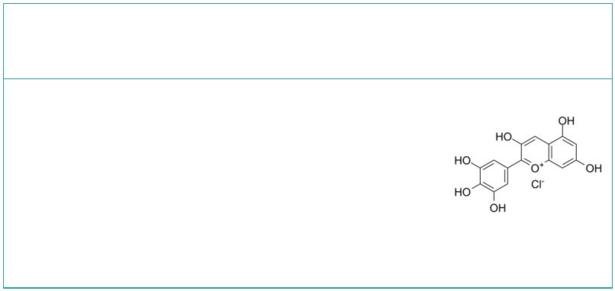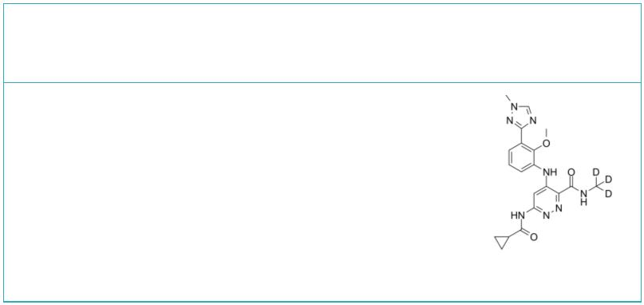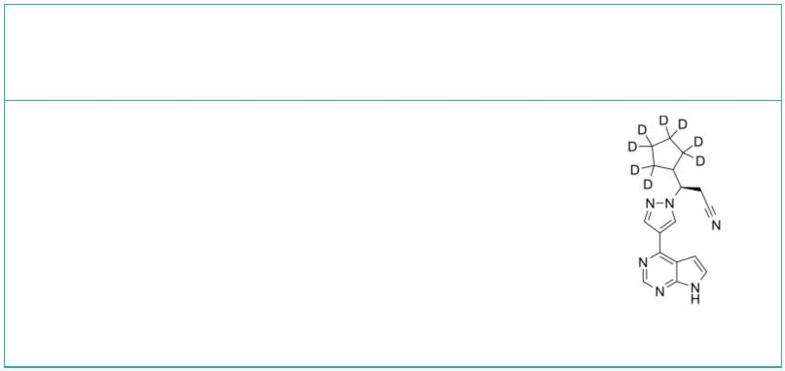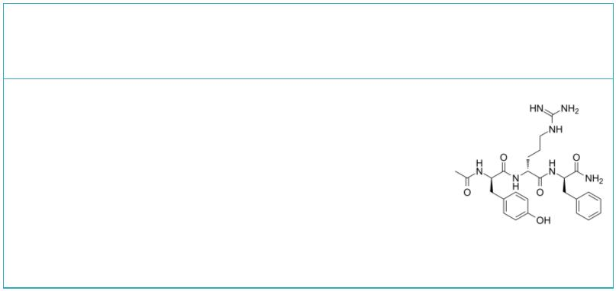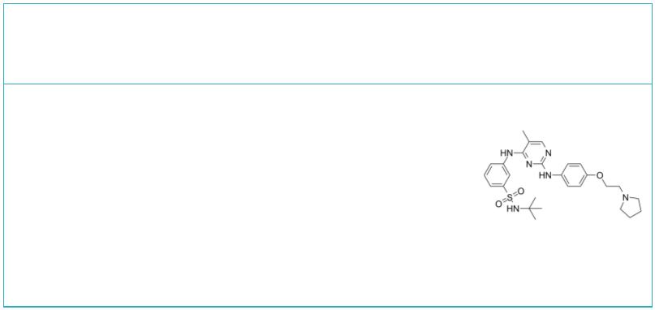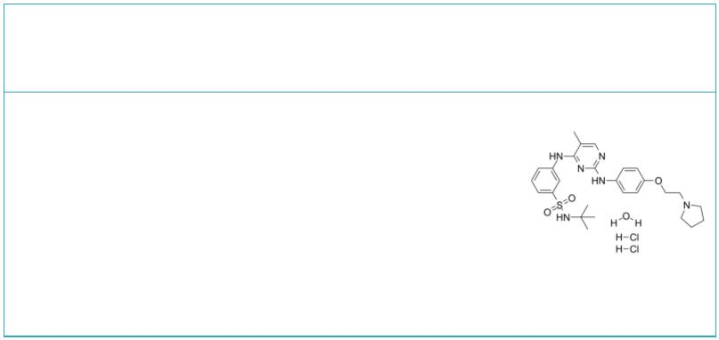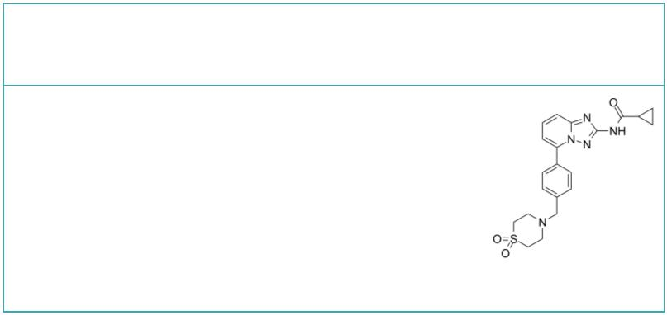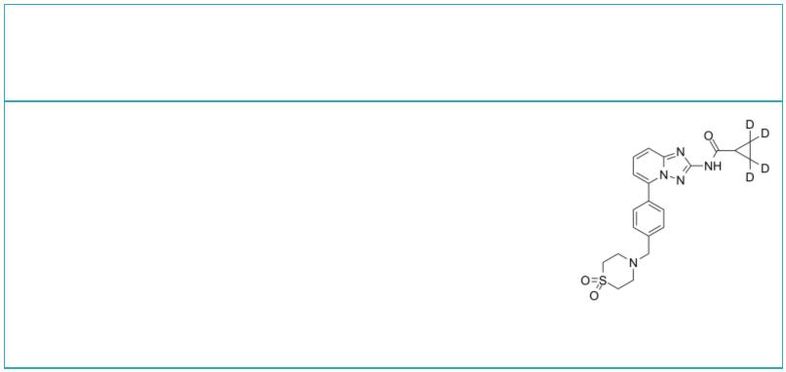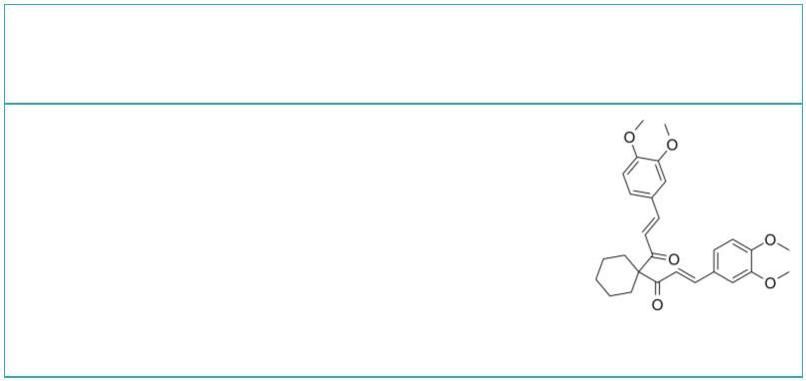 | Delgocitinib  (JTE-052) Cat. No.: HY-109053 |  |  |  | Delphinidin chloride |  |  |  |  |  |  |  |  |  |  |  | Cat. No.: HY-N2409
 | Delgocitinib (JTE-052) is a specific JAK  inhibitor with IC s of 2.8, 2.6, 13 and 58 nM for  50  JAK1, JAK2, JAK3 and Tyk2, respectively. |  |  |  | Delphinidin chloride, an anthocyanidin, is  isolated from berries and red wine. Delphinidin  chloride shows endothelium-dependent  vasorelaxation. Delphinidin chloride also can  modulate JAK/STAT3 and MAPKinase signaling to  induce apoptosis in HCT116 cells.
 | Purity: 99.76%  Clinical Data: Launched  Size: 10 mM × 1 mL, 1 mg, 5 mg, 10 mg, 25 mg, 50 mg, 100 mg |  |  |  | Purity: ≥98.0%  Clinical Data: No Development Reported  Size: 5 mg, 10 mg
 | Deucravacitinib  (BMS-986165) Cat. No.: HY-117287 |  |  |  | Deuruxolitinib  (CTP-543; Ruxolitinib D8; Deuterated Ruxolitinib) Cat. No.: HY-50856S
 | Deucravacitinib (BMS-986165) is a highly  selective, orally bioavailable allosteric TYK2  inhibitor for the treatment of autoimmune  diseases, which selectively binds to TYK2  pseudokinase (JH2) domain (IC =1.0 nM) and blocks  50  receptor-mediated Tyk2 activation by… |  |  |  | Deuruxolitinib (CTP-543), a deuterated  Ruxolitinib, modulates the activity of JAK1/JAK2.  Deuruxolitinib can be used for the research hair  loss disorders (from patent WO2017192905A1,  compound I).
 | Purity: 99.79%  Clinical Data: Phase 3  Size: 10 mM × 1 mL, 5 mg, 10 mg, 25 mg, 50 mg, 100 mg, 200 mg |  |  |  | Purity: >98%  Clinical Data: No Development Reported  Size: 1 mg, 5 mg
 | DTP3 |  | Cat. No.: HY-100538 |  | Fedratinib  (TG-101348; SAR 302503) Cat. No.: HY-10409
 | DTP3 TFA is a potent and selective GADD45β/MKK7  inhibitor. DTP3 TFA targets an essential,  cancer-selective cell-survival module downstream  of the NF-κB pathway. |  |  |  | Fedratinib (TG-101348) is a potent, selective,  ATP-competitive and orally active JAK2 inhibitor  with IC₅₀s of 3 nM for both JAK2 and JAK2V617F  kinase. Fedratinib shows 35- and 334-fold  selectivity over JAK1 and JAK3, respectively.
 | Purity: 99.43%  Clinical Data: No Development Reported  Size: 5 mg, 10 mg, 25 mg, 50 mg, 100 mg |  |  |  | Purity: 99.87%  Clinical Data: Launched  Size: 10 mM × 1 mL, 5 mg, 10 mg, 100 mg, 200 mg, 500 mg, 1 g
 | Fedratinib hydrochloride hydrate (TG-101348 hydrochloride Filgotinib
 | hydrate; SAR 302503 hydrochloride hydrate) Cat. No.: HY-10409A (GLPG0634) Cat. No.: HY-18300
 | Fedratinib hydrochloride hydrate (TG-101348  hydrochloride hydrate) is a potent, selective,  ATP-competitive and orally active JAK2 inhibitor  with IC₅₀s of 3 nM for both JAK2 and JAK2V617F  kinase. |  |  |  | Filgotinib (GLPG0634) is a selective and orally  active JAK1 inhibitor with IC of 10 nM, 28 nM,  50  810 nM, and 116 nM for JAK1, JAK2, JAK3, and TYK2,  respectively.
 | Purity: 99.86%  Clinical Data: Launched  Size: 10 mM × 1 mL, 5 mg, 10 mg, 100 mg, 200 mg, 500 mg, 1 g |  |  |  | Purity: 99.37%  Clinical Data: Launched  Size: 10 mM × 1 mL, 5 mg, 10 mg, 25 mg, 50 mg, 100 mg
 | Filgotinib-d4 FLLL32
 | (GLPG0634-d4) Cat. No.: HY-18300S |  |  |  |  |  |  |  |  |  |  |  |  |  | Cat. No.: HY-100544
 | Filgotinib-d4 (GLPG0634-d4) is the deuterium  labeled Filgotinib. Filgotinib (GLPG0634) is a  selective JAK1 inhibitor with IC of 10 nM, 28  50  nM, 810 nM, and 116 nM for JAK1, JAK2, JAK3, and  TYK2, respectively. |  |  |  | FLLL32, a synthetic analog of curcumina, is a  JAK2/STAT3 dual inhibitor with anti-tumor  activity. FLLL32 can inhibit the induction of  STAT3 phosphorylation by IFNα and IL-6 in breast  cancer cells.
 | Purity: >98%  Clinical Data: No Development Reported  Size: 1 mg |  |  |  | Purity: 99.78%  Clinical Data: No Development Reported  Size: 10 mM × 1 mL, 5 mg, 10 mg, 25 mg, 50 mg, 100 mg
6 Tel: 609-228-6898 Fax: 609-228-5909 Email: sales@MedChemExpress.com
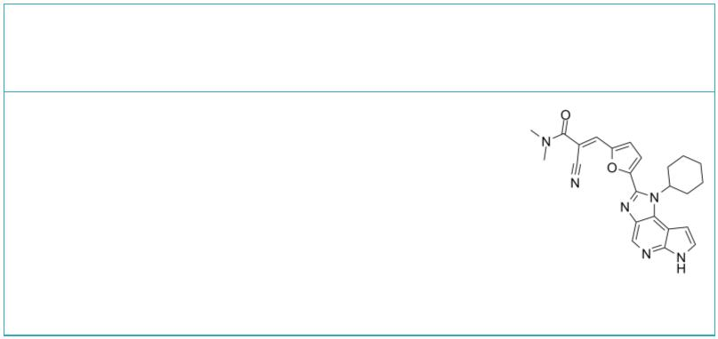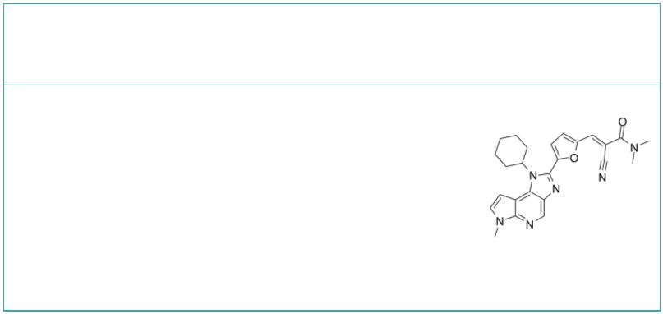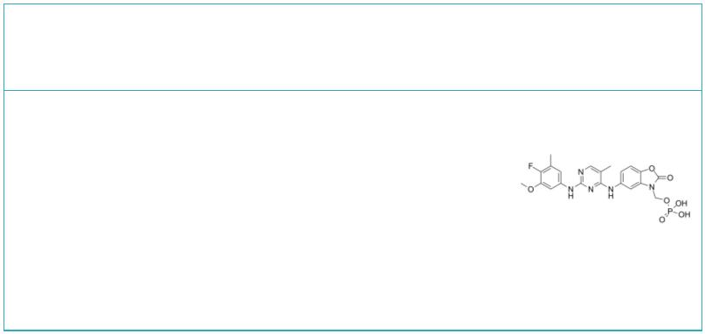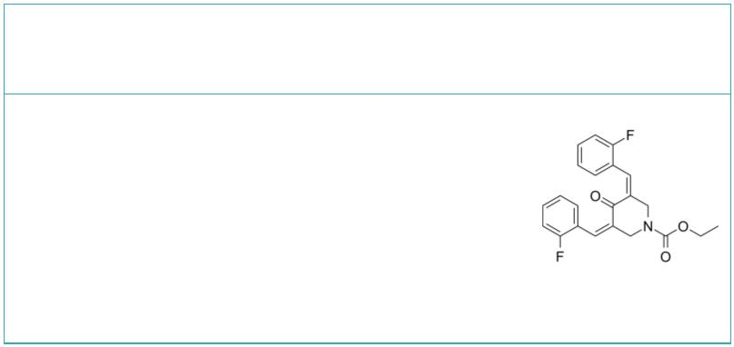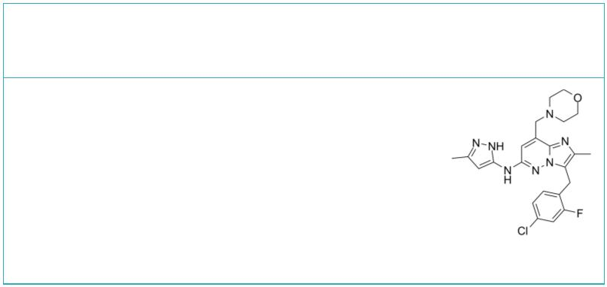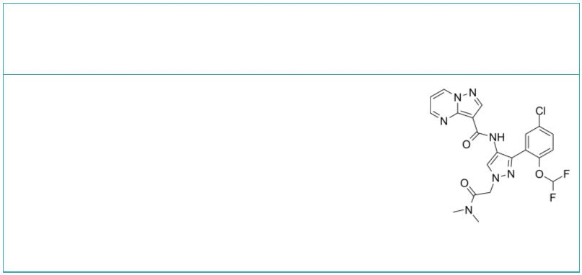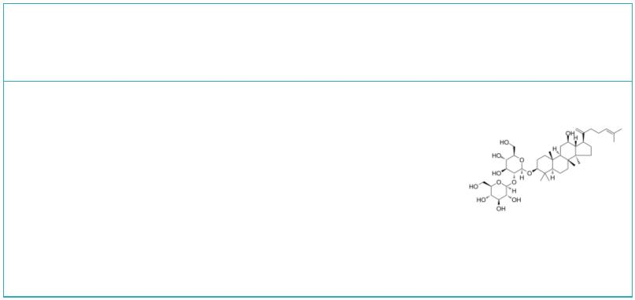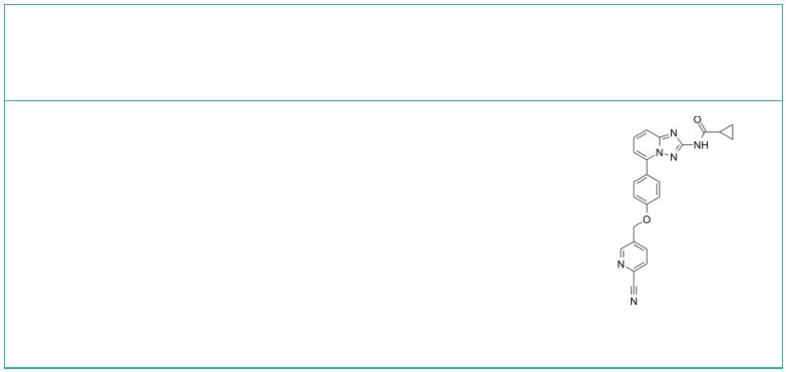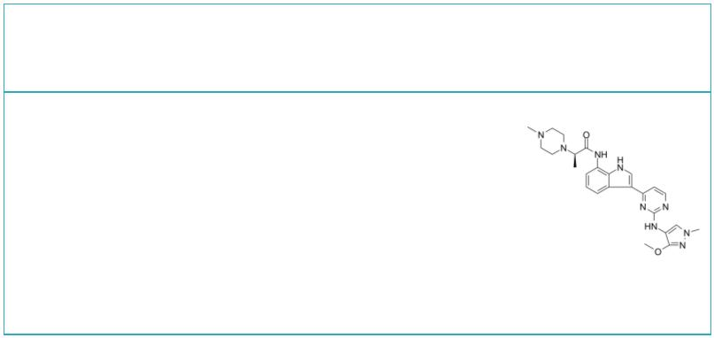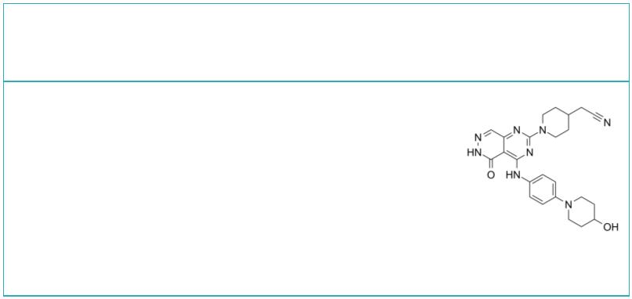FM-381 FM-479
 | Cat. No.: HY-102046 Cat. No.: HY-131014
FM-381 is a potent covalent reversible inhibitor  of JAK3 targeting the unique Cys909. FM-381 has  an IC of 127 pM for JAK3, with 410, 2700 and  50  3600-fold selectivity over JAK1, JAK2 and TYK2,  respectively. |  |  |  | FM-479 is the negative control of FM-381 (HY-102046)  and has no activity on JAK3 or other kinases.  FM-381 is a potent covalent reversible inhibitor  of JAK3 targeting the unique Cys909.
Purity: 98.25%  Clinical Data: No Development Reported  Size: 10 mM × 1 mL, 2 mg, 5 mg, 10 mg, 25 mg, 50 mg, 100 mg |  |  |  | Purity: >98%  Clinical Data: No Development Reported  Size: 1 mg, 5 mg
Fosifidancitinib G5-7
 | Cat. No.: HY-109175 Cat. No.: HY-115452
Fosifidancitinib is a potent and selective  inhibitor of JAK kinases 1/3. Fociatinib is used  in studies of allergies, asthma and autoimmune  diseases. |  |  |  | G5-7, an orally active and allosteric JAK2  inhibitor, selectively inhibits JAK2 mediated  phosphorylation and activation of EGFR (Tyr¹⁰⁶⁸)  and STAT3 by binding to JAK2. G5-7 induces cell  cycle arrest, apoptosis and possesses  antiangiogenic effect.
Purity: >98%  Clinical Data: No Development Reported  Size: 1 mg, 5 mg |  |  |  | Purity: 99.84%  Clinical Data: No Development Reported  Size: 5 mg, 10 mg, 25 mg
Gandotinib  (LY2784544) Cat. No.: HY-13034 |  |  |  | GDC-4379 |  |  |  |  |  |  |  |  |  |  |  |  |  | Cat. No.: HY-139837
Gandotinib (LY2784544) is a potent JAK2 inhibitor  with IC of 3 nM. Gandotinib (LY2784544) also  50  inhibits FLT3, FLT4, FGFR2, TYK2, and TRKB with  IC of 4, 25, 32, 44, and 95 nM.  50 |  |  |  | GDC-4379 is a JAK1 inhibitor that can be used for  the research of asthma.
Purity: 99.82%  Clinical Data: Phase 2  Size: 10 mM × 1 mL, 5 mg, 10 mg, 50 mg, 100 mg |  |  |  | Purity: >98%  Clinical Data: No Development Reported  Size: 1 mg, 5 mg
Ginsenoside Rk1 GLPG0634 analog
 |  | Cat. No.: HY-N2515 Cat. No.: HY-13961
Ginsenoside Rk1 is a unique component created by  processing the ginseng plant (mainly Sung Ginseng,  SG) at high temperatures. Ginsenoside Rk1 has  anti-inflammatory effect, suppresses the  activation of Jak2/Stat3 signaling pathway and  NF-κB. |  |  |  | GLPG0634 (analog) (compound176)is a pan JAK  inhibitor with IC50s of 50-200 nM for  JAK1/JAK2/JAK3; more information can be found in  the reference patents.
Purity: 99.90%  Clinical Data: No Development Reported  Size: 5 mg, 10 mg, 20 mg |  |  |  | Purity: 98.58%  Clinical Data: No Development Reported  Size: 10 mM × 1 mL, 5 mg, 10 mg, 50 mg
Golidocitinib Gusacitinib
(AZD4205) Cat. No.: HY-107361 (ASN-002) Cat. No.: HY-103018
Golidocitinib (AZD4205) is a selective JAK1  inhibitor, with an IC of 73 nM, weakly inhibits  50  JAK2 (IC >14.7 μM), and shows little  50  inhibition on JAK3 (IC >30 μM).  50 |  |  |  | Gusacitinib (ASN-002) is an orally active and  potent dual inhibitor of spleen tyrosine kinase  (SYK) and janus kinase (JAK) with IC values of  50  5-46 nM. Gusacitinib has anti-cancer activity in  both solid and hematological tumor types.
Purity: 99.75%  Clinical Data: Phase 2  Size: 10 mM × 1 mL, 5 mg, 10 mg, 50 mg, 100 mg |  |  |  | Purity: 99.41%  Clinical Data: Phase 2  Size: 10 mM × 1 mL, 25 mg, 50 mg, 100 mg
www.MedChemExpress.com 7
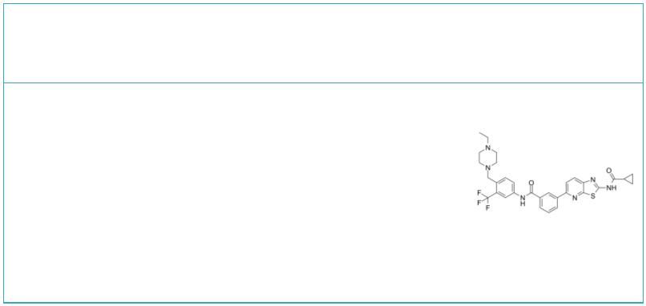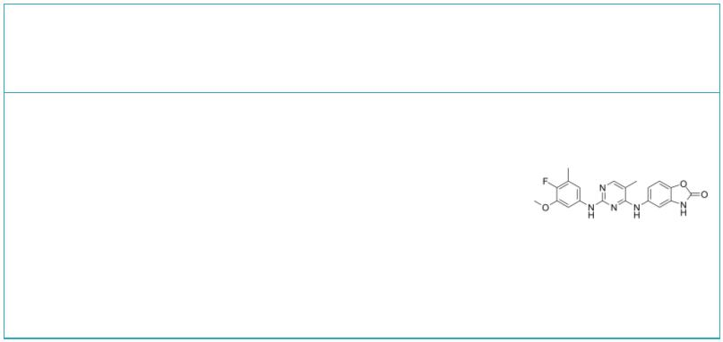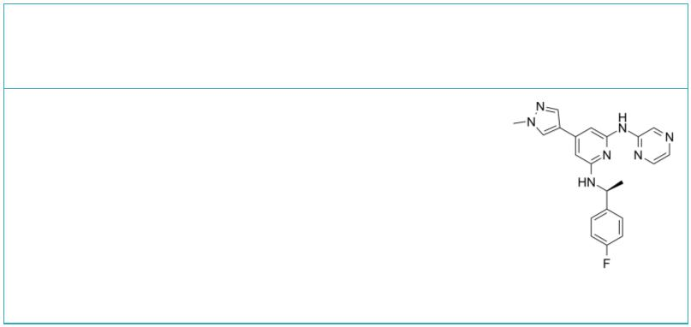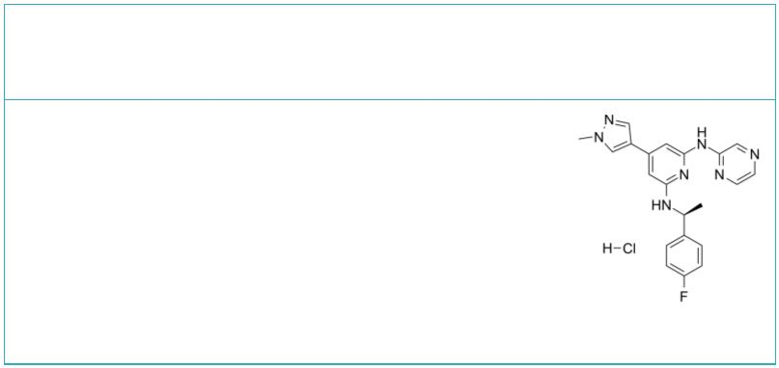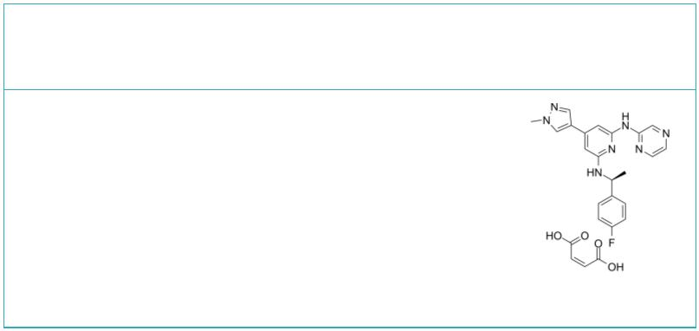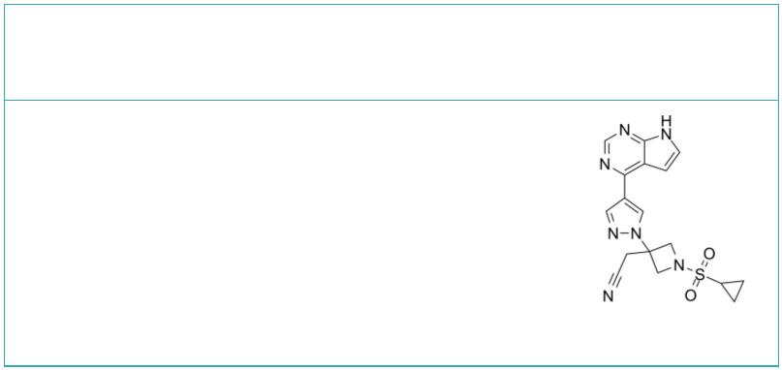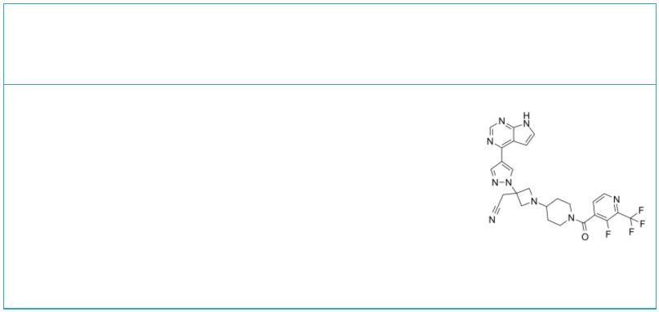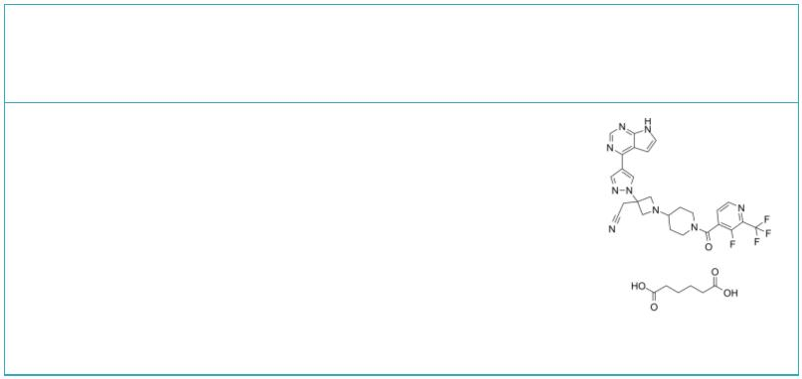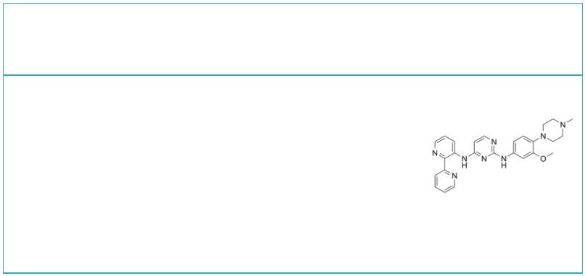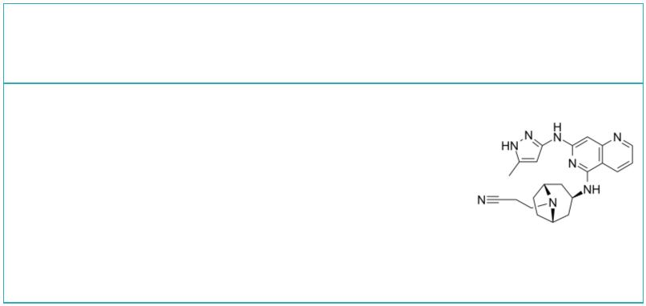 | HG-7-85-01 |  | Cat. No.: HY-15814 |  | Ifidancitinib  (ATI-50002; ATI-502) Cat. No.: HY-109178
 | HG-7-85-01 is a type II ATP competitive inhibitor  of wild-type and gatekeeper mutations forms of  Bcr-Abl, PDGFRα, Kit, and Src kinases. |  |  |  | Ifidancitinib (ATI-50002) is a potent and  selective inhibitor of JAK kinases 1/3.  Ifidancitinib can be used in studies of allergies,  asthma and autoimmune diseases.
 | Purity: >98%  Clinical Data: No Development Reported  Size: 1 mg, 5 mg |  |  |  | Purity: 98.05%  Clinical Data: No Development Reported  Size: 5 mg, 10 mg, 25 mg, 50 mg, 100 mg
 | Ilginatinib  (NS-018) Cat. No.: HY-19631A |  |  |  | Ilginatinib hydrochloride  (NS-018 hydrochloride) Cat. No.: HY-19631B
 | Ilginatinib (NS-018) is a highly active and orally  bioavailable JAK2 inhibitor, with an IC of 0.72  50  nM, 46-, 54-, and 31-fold selectivity for JAK2  over JAK1 (IC , 33 nM), JAK3 ( , 39 nM), and  50 IC₅₀  Tyk2 (IC , 22 nM).  50 |  |  |  | Ilginatinib hydrochloride (NS-018 hydrochloride)  is a highly active and orally bioavailable JAK2  inhibitor, with an IC of 0.72 nM, 46-, 54-, and  50  31-fold selectivity for JAK2 over JAK1 (IC , 33  50  nM), JAK3 (IC₅₀, 39 nM), and Tyk2 (IC₅₀, 22 nM).
 | Purity: 99.15%  Clinical Data: Phase 2  Size: 10 mM × 1 mL, 5 mg, 10 mg, 25 mg, 50 mg, 100 mg |  |  |  | Purity: ≥98.0%  Clinical Data: Phase 2  Size: 10 mM × 1 mL, 5 mg, 10 mg, 25 mg, 50 mg, 100 mg
 | Ilginatinib maleate  (NS-018 maleate) Cat. No.: HY-19631 |  |  |  | Ilunocitinib |  |  |  |  |  |  |  |  |  |  |  | Cat. No.: HY-132819
 | Ilginatinib maleate (NS-018 maleate) is a highly  active and orally bioavailable JAK2 inhibitor,  with an IC of 0.72 nM, 46-, 54-, and 31-fold  50  selectivity for JAK2 over JAK1 (IC , 33 nM), JAK3  50  (IC₅₀, 39 nM), and Tyk2 (IC₅₀, 22 nM). |  |  |  | Ilunocitinib (compound 27) is a JAK inhibitor  (extracted from patent WO2009114512A1).
 | Purity: 97.04%  Clinical Data: Phase 2  Size: 10 mM × 1 mL, 5 mg, 10 mg, 25 mg, 50 mg, 100 mg |  |  |  | Purity: 98.01%  Clinical Data: No Development Reported  Size: 5 mg, 10 mg, 25 mg, 50 mg, 100 mg
 | Itacitinib Itacitinib adipate
 | (INCB039110) Cat. No.: HY-16997 |  |  |  |  |  |  |  |  |  |  |  |  |  |  | Cat. No.: HY-16997A
 | Itacitinib (INCB039110) is an orally active and  selective inhibitor of JAK1 with an IC of 2 nM  50  for human JAK1. Itacitinib shows >20-fold  selectivity for JAK1 over JAK2 and >100-fold  over JAK3 and TYK2; Itacitinib is used in the  research of myelofibrosis. |  |  |  | Itacitinib adipate is an orally bioavailable and  selective JAK1 inhibitor which has been tested  for efficacy and safety in a phase II trial in  myelofibrosis.
 | Purity: 99.97%  Clinical Data: Phase 3  Size: 10 mM × 1 mL, 5 mg, 10 mg, 50 mg, 100 mg, 200 mg |  |  |  | Purity: 99.37%  Clinical Data: No Development Reported  Size: 10 mM × 1 mL, 1 mg, 5 mg, 10 mg, 50 mg, 100 mg
 | Itacnosertib Izencitinib
 | (TP-0184) Cat. No.: HY-109179 (TD-1473; JNJ-8398) Cat. No.: HY-109148
 | Itacnosertib (TP-0184) is both inhibitor to JAK2,  ACVR1 (ALK2) and ALK5 as described in  WO2014151871. |  |  |  | Izencitinib (TD-1473) is an orally active,  non-selective and gut-restricted JAK inhibitor.  Izencitinib (TD-1473) can be used in the study for  ulcerative colitis.
 | Purity: 99.77%  Clinical Data: No Development Reported  Size: 10 mM × 1 mL, 5 mg, 10 mg, 25 mg, 50 mg, 100 mg |  |  |  | Purity: ≥98.0%  Clinical Data: No Development Reported  Size: 5 mg, 10 mg, 25 mg, 50 mg, 100 mg
8 Tel: 609-228-6898 Fax: 609-228-5909 Email: sales@MedChemExpress.com
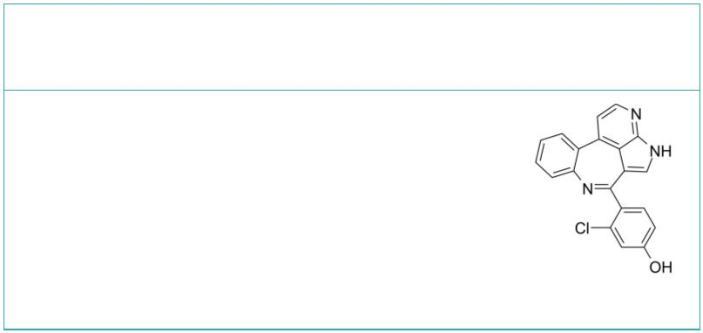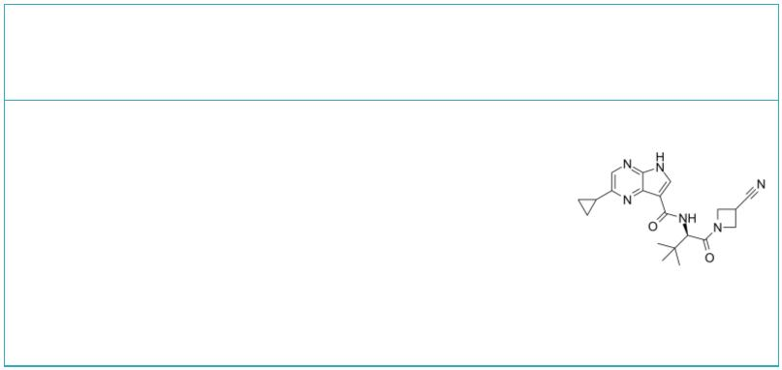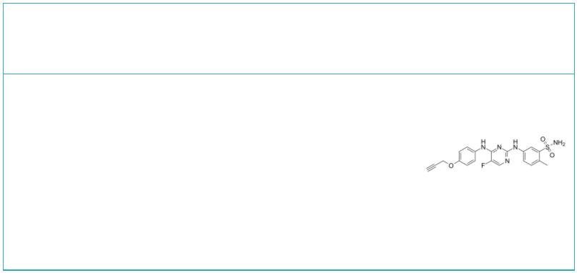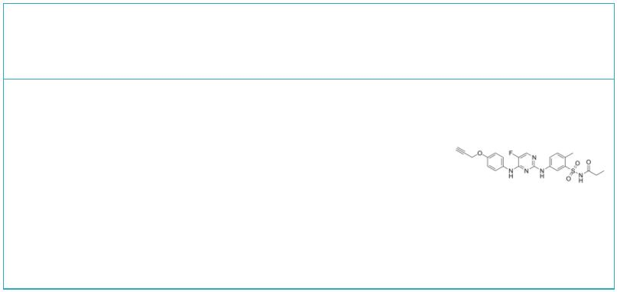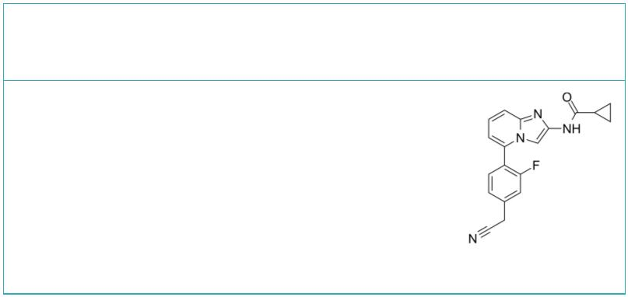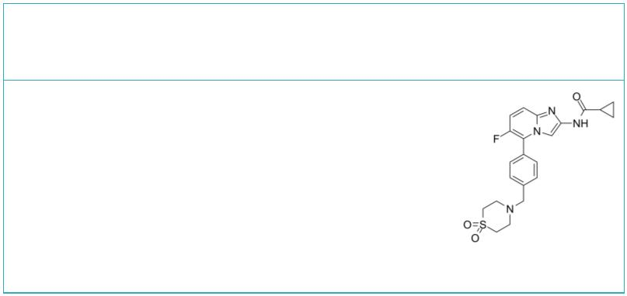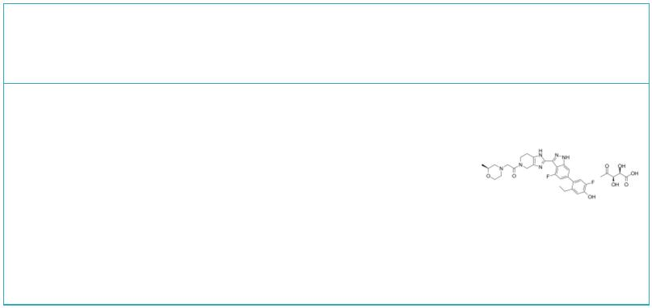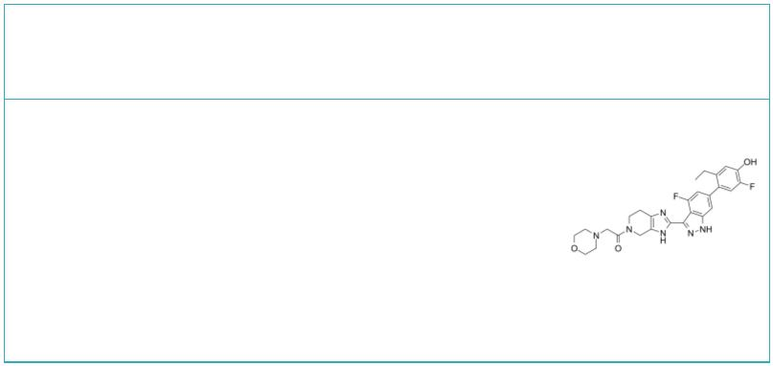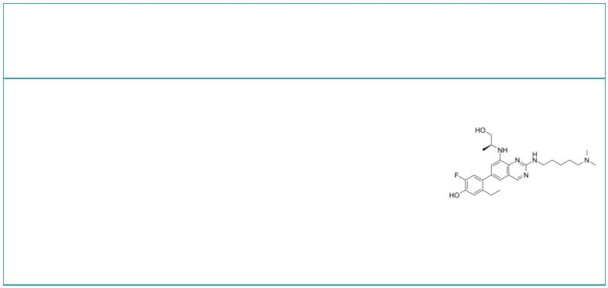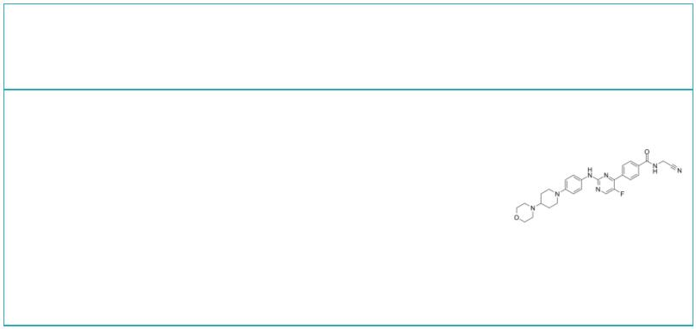JAK-2/3-IN-1 JAK-IN-1
 |  |  | Cat. No.: HY-10652 Cat. No.: HY-13827
JAK-2/3-IN-1 is a potent JAK-2 and JAK-3  inhibitor extracted from patent US8163732B2,  compound 46, has Ks of <250 nM for both  i  isoforms. |  |  |  |  | JAK-IN-1 is a JAK1/2/3 inhibitor with IC s of  50  0.26, 0.8 and 3.2 nM, respectively. JAK-IN-1 shows  improved selectivity for JAK3 over JAK1.
Purity: >98%  Clinical Data: No Development Reported  Size: 1 mg, 5 mg |  |  |  |  | Purity: >98%  Clinical Data: No Development Reported  Size: 1 mg, 5 mg
JAK-IN-10 JAK-IN-11
 | Cat. No.: HY-U00277 Cat. No.: HY-U00318
JAK-IN-10 is a JAK inhibitor. JAK-IN-10 can be  used for the research of dry eye disorders. |  |  |  |  | JAK-IN-11 is a potent and selective JAK inhibitor  extracted from patent WO2012122452A1, Compound II,  has the potential for the skin disorders (such as  cutaneous lupus) treatment.
Purity: >98%  Clinical Data: No Development Reported  Size: 1 mg, 5 mg |  |  |  |  | Purity: >98%  Clinical Data: No Development Reported  Size: 1 mg, 5 mg
JAK-IN-14 JAK-IN-15
 |  | Cat. No.: HY-139807 Cat. No.: HY-46262
JAK-IN-14 is a potent and selective JAK1  inhibitor, with an IC of <5 μM. JAK-IN-14 is  50  >8-fold more selective for JAK1 than JAK2 and  JAK3 (Patent WO2016119700A1, compound 16). |  |  |  |  | JAK-IN-15 is a JAK inhibitor. WO2016119700A1  (Compound 15).
Purity: 98.72%  Clinical Data: No Development Reported  Size: 5 mg, 10 mg, 25 mg, 50 mg |  |  |  |  | Purity: >98%  Clinical Data: No Development Reported  Size: 1 mg, 5 mg
JAK-IN-17 JAK-IN-18
 |  | Cat. No.: HY-144057 Cat. No.: HY-144058
JAK-IN-17 is a potent inhibitor of JAK. JAK-IN-17  is useful for the research of multiple diseases,  particularly ocular, skin, and respiratory  diseases (extracted from patent WO2021185305A1,  compound 9-1). |  |  |  |  | JAK-IN-18 is a potent inhibitor of JAK. JAK-IN-18  is useful for the research of multiple diseases,  particularly ocular, skin, and respiratory  diseases (extracted from patent WO2018204238A1,  compound 1).
Purity: >98%  Clinical Data: No Development Reported  Size: 1 mg, 5 mg |  |  |  |  | Purity: >98%  Clinical Data: No Development Reported  Size: 1 mg, 5 mg
JAK-IN-19 JAK-IN-20
 |  | Cat. No.: HY-144075 Cat. No.: HY-143444
JAK-IN-19 is a potent JAK inhibitor (PBMC IFNγ  pIC =7.2 and HLF Eotaxin =7.7). JAK-IN-19  50 pIC₅₀  has good retentive properties in the lung via  mitigating being metabolized by Aldehyde Oxidase  (AO), with diminished VEGFR2 selectivity (VEGFR2  pIC =7.0, Aurora B =5.8).  Purity: >98%  50 pIC₅₀  Clinical Data: No Development Reported  Size: 1 mg, 5 mg |  |  |  |  | JAK-IN-20 is a potent, pan and orally active JAK  inhibitor with an IC s of 7 nM, 5 nM, 14 nM for  50  JAK1, JAK2, JAK3, respectively. JAK-IN-20 shows  excellent pharmacokinetics and displays  anti-inflammatory efficacy in vivo.  Purity: >98%  Clinical Data: No Development Reported  Size: 1 mg, 5 mg
www.MedChemExpress.com 9
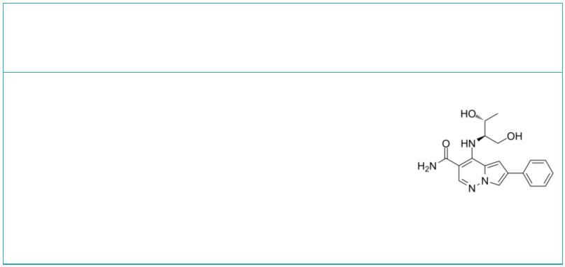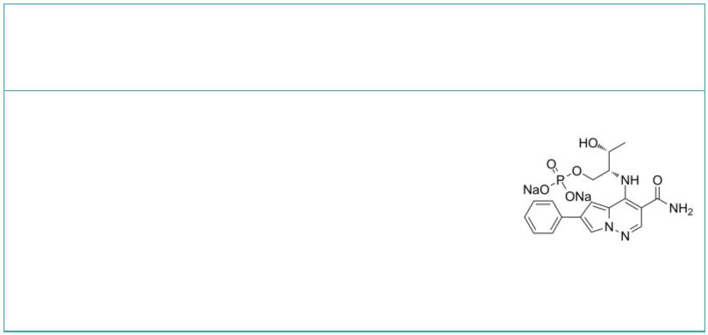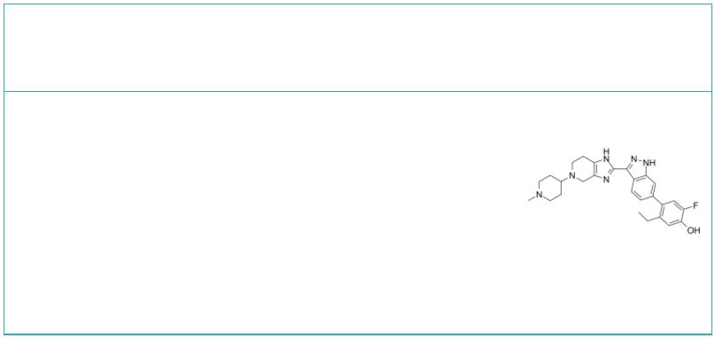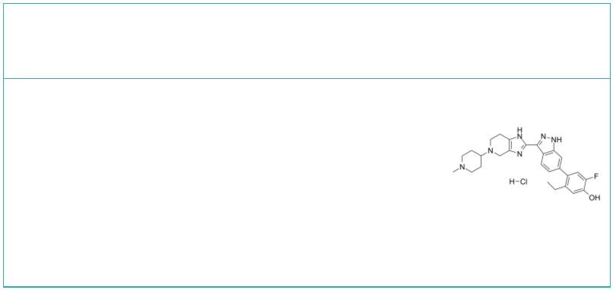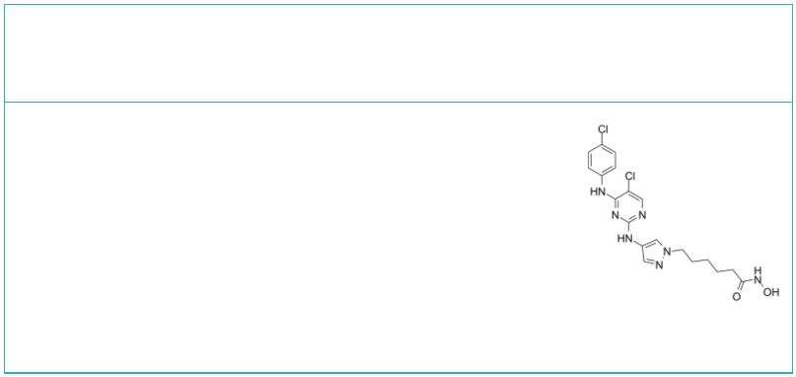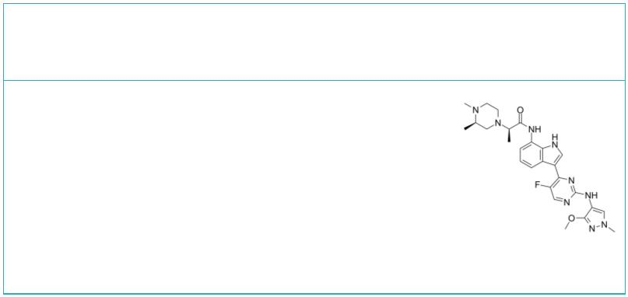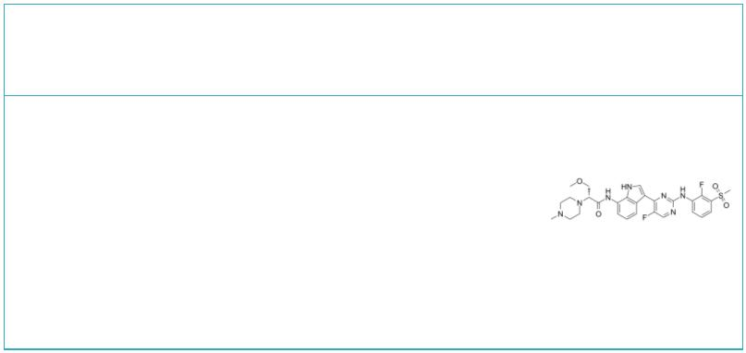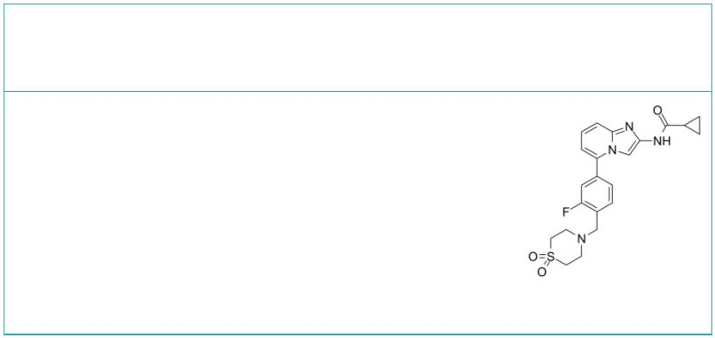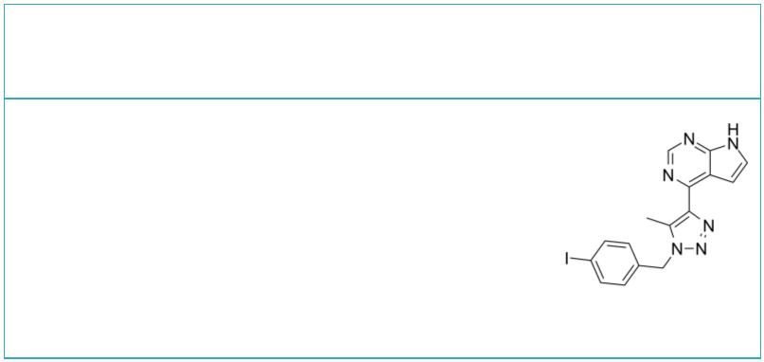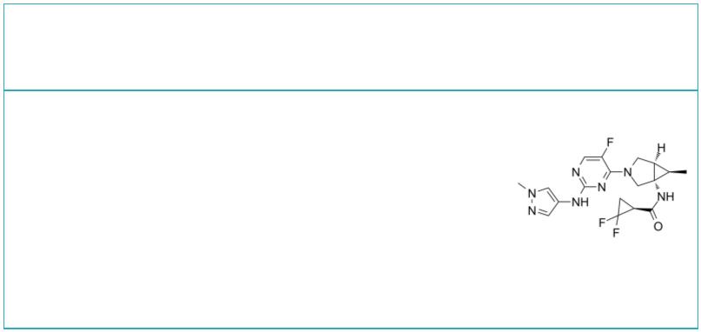 | JAK-IN-3 JAK-IN-4
 |  | Cat. No.: HY-111750 Cat. No.: HY-111749
 | JAK-IN-3 (compound 22) is a potent JAK inhibitor,  with IC values of 3 nM, 5 nM, 34 nM and 70 nM  50  for JAK3, JAK1, TYK2 and JAK2, respectively. |  |  | JAK-IN-4 is a prodrug of a JAK inhibitor,  effective in murine collagen induced arthritis  model.
 | Purity: >98%  Clinical Data: No Development Reported  Size: 5 mg, 10 mg, 25 mg, 50 mg, 100 mg |  |  | Purity: >98%  Clinical Data: No Development Reported  Size: 1 mg, 5 mg
 | JAK-IN-5 JAK-IN-5 hydrochloride
 |  | Cat. No.: HY-111471 Cat. No.: HY-111471A
 | JAK-IN-5 is an inhibitor of JAK extracted from  patent US20170121327A1, compound example 283. |  |  | JAK-IN-5 hydrochloride is an inhibitor of JAK  extracted from patent US20170121327A1, compound  example 283.
 | Purity: >98%  Clinical Data: No Development Reported  Size: 5 mg, 10 mg, 25 mg, 50 mg, 100 mg |  |  | Purity: 99.54%  Clinical Data: No Development Reported  Size: 5 mg, 10 mg, 25 mg, 50 mg, 100 mg
 | JAK/HDAC-IN-1 JAK1-IN-4
 |  | Cat. No.: HY-126141 Cat. No.: HY-116505
 | JAK/HDAC-IN-1 is a potent JAK2/HDAC dual  inhibitor, exhibits antiproliferative and  proapoptotic activities in several hematological  cell lines. JAK/HDAC-IN-1 shows IC s of 4 and 2  50  nM for JAK2 and HDAC, respectively. |  |  | JAK1-IN-4 is a potent and selective JAK1  inhibitor, with IC s of 85 nM, 12.8 μM and >30  50  μM for JAK1, JAK2, and JAK3, respectively.  JAK1-IN-4 inhibits STAT3 phosphorylation in NCI-H  1975 cells (IC , 227 nM).  50
 | Purity: 98.04%  Clinical Data: No Development Reported  Size: 10 mM × 1 mL, 5 mg, 10 mg, 50 mg, 100 mg |  |  | Purity: >98%  Clinical Data: No Development Reported  Size: 1 mg, 5 mg
 | JAK1-IN-7 JAK1-IN-8
 |  | Cat. No.: HY-126294 Cat. No.: HY-139423
 | JAK1-IN-7 is a Janus-associated kinase 1 (JAK1)  inhibitor extracted from patent WO2018134213A1,  Example 63, has an anti-inflammatory effect. |  |  | JAK1-IN-8, a potent JAK1 inhibitor (IC <500  50  nM), compound 28, extracted from patent  WO2016119700A1.
 | Purity: >98%  Clinical Data: No Development Reported  Size: 1 mg, 5 mg |  |  | Purity: ≥95.0%  Clinical Data: No Development Reported  Size: 5 mg, 10 mg, 25 mg, 50 mg, 100 mg
 | JAK1-IN-9 JAK1/TYK2-IN-1
 |  | Cat. No.: HY-144440 Cat. No.: HY-145336
 | JAK1-IN-9 (compound 23a) is a potent and selective  JAK1 inhibitor with an IC of 72 nM. JAK1-IN-9  50  shows selective against other JAKs by 12 times or  more. |  |  | JAK1/TYK2-IN-1 is a dual inhibitor of TYK2 and  JAK1 (IC = 29 and 41 nM respectively).  50
 | Purity: >98%  Clinical Data: No Development Reported  Size: 1 mg, 5 mg |  |  | Purity: >98%  Clinical Data: No Development Reported  Size: 1 mg, 5 mg
10 Tel: 609-228-6898 Fax: 609-228-5909 Email: sales@MedChemExpress.com
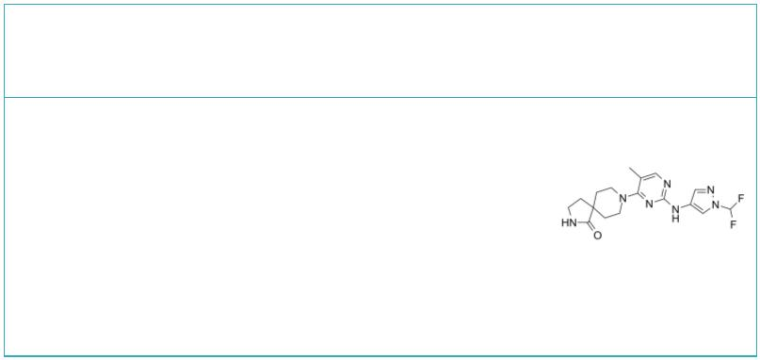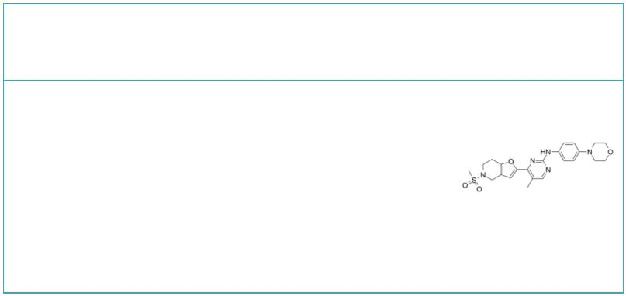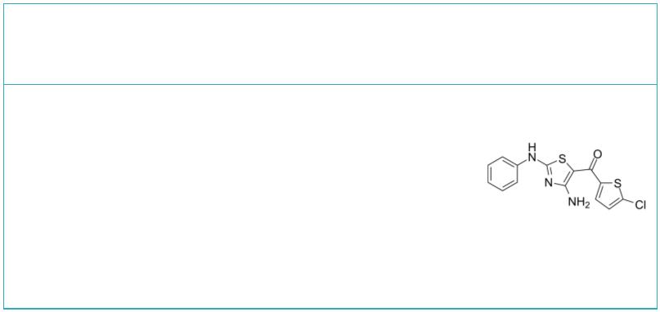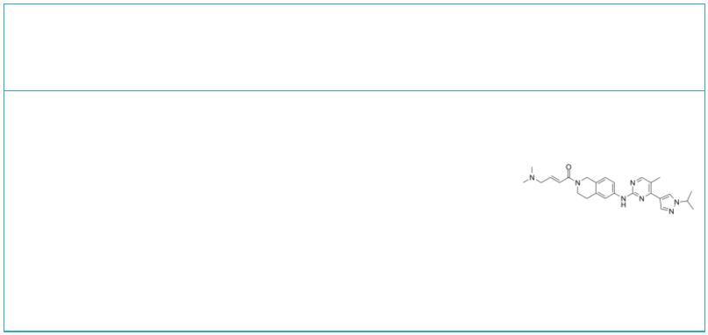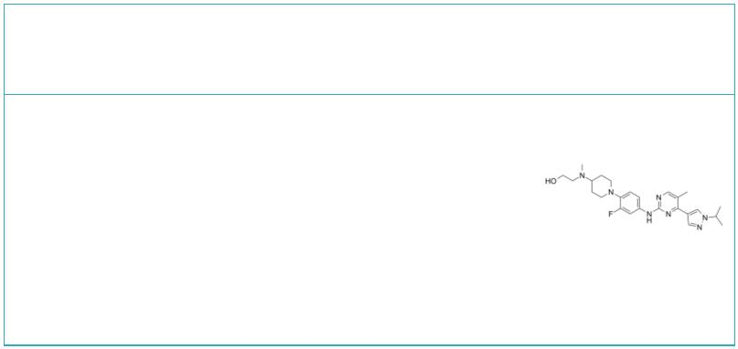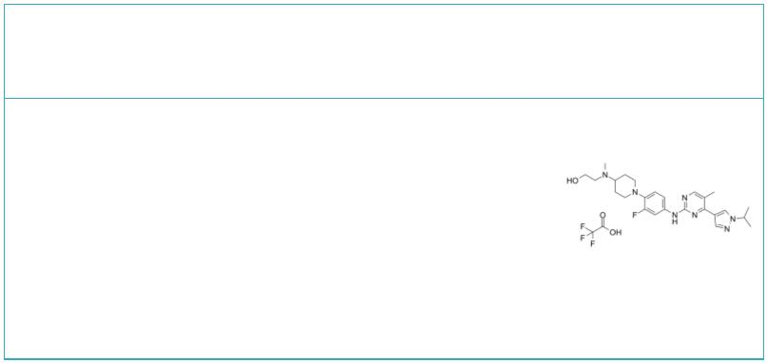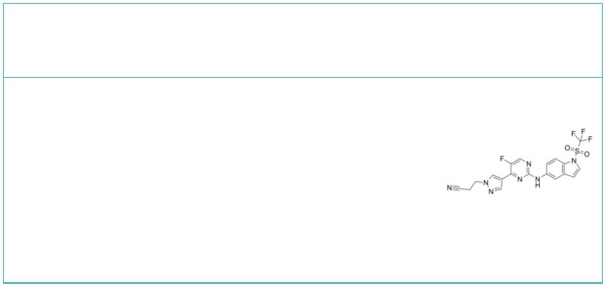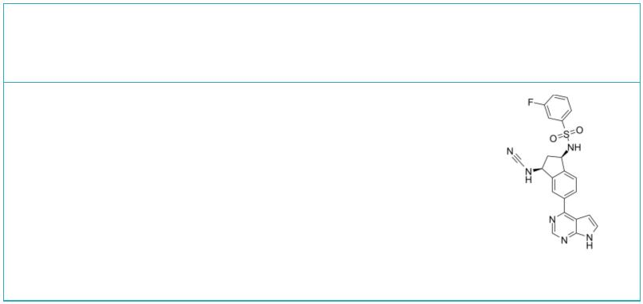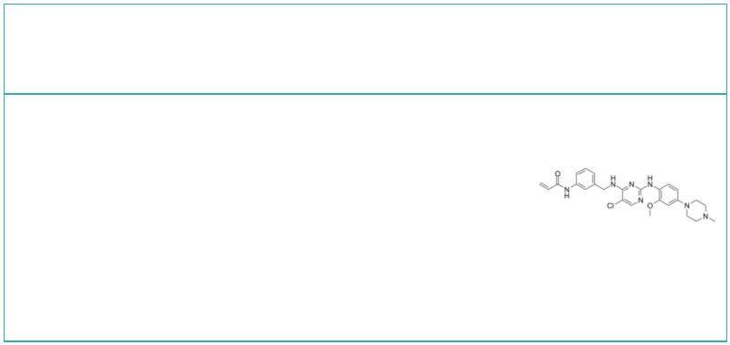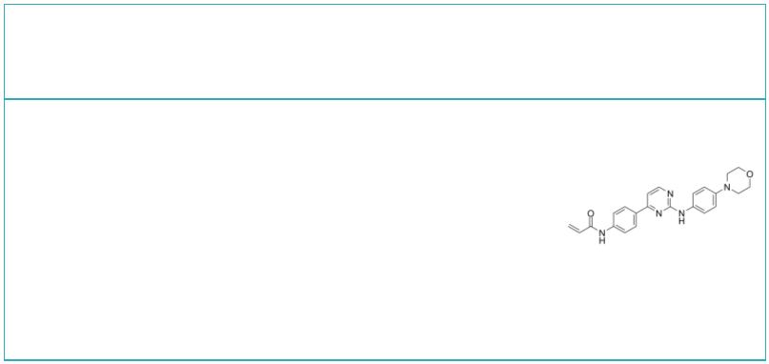JAK1/TYK2-IN-3 JAK2-IN-4
 | Cat. No.: HY-143885 Cat. No.: HY-100759
JAK1/TYK2-IN-3 is a potent, selective and orally  active dual TYK2/JAK1 inhibitor with IC values  50  of 6 and 37 nM, respectively. JAK1/TYK2-IN-3 also  shows selectively relative to JAK2 (IC =140 nM)  50  and JAK3 (IC =362 nM).  50 |  |  |  | JAK2-IN-4 (compound 16h) is a selective JAK2/JAK3  inhibitor, with IC values of 0.7 nM and 23.2 nM  50  for JAK2 and JAK3, respectively.
Purity: >98%  Clinical Data: No Development Reported  Size: 1 mg, 5 mg |  |  |  | Purity: >98%  Clinical Data: No Development Reported  Size: 1 mg, 5 mg
JAK2-IN-6 JAK2-IN-7
 | Cat. No.: HY-137756 Cat. No.: HY-131906
JAK2-IN-6, a multiple-substituted aminothiazole  derivative, is a potent and selective JAK2  inhibitor with an IC of 22.86 μg/mL. JAK2-IN-6  50  shows no activity against JAK1 and JAK3. JAK2-IN-6  has anti-proliferative effect against cancer  cells. |  |  |  | JAK2-IN-7 is a selective JAK2 inhibitor with  IC s of 3, 11.7, and 41 nM for JAK2, SET-2, and  50  Ba/F3^{V617F} cells, respectively. JAK2-IN-7  possesses >14-fold selectivity over JAK1, JAK3,  FLT3.
Purity: >98%  Clinical Data: No Development Reported  Size: 1 mg, 5 mg |  |  |  | Purity: 99.42%  Clinical Data: No Development Reported  Size: 10 mM × 1 mL, 5 mg, 10 mg, 25 mg, 50 mg, 100 mg
JAK2/FLT3-IN-1 JAK2/FLT3-IN-1 TFA
 | Cat. No.: HY-130247 Cat. No.: HY-130247A
JAK2/FLT3-IN-1 is a potent and orally active dual  JAK2/FLT3 inhibitor with IC values of 0.7 nM, 4  50  nM, 26 nM and 39 nM for JAK2, FLT3, JAK1 and JAK3,  respectively. JAK2/FLT3-IN-1 has anti-cancer  activity. |  |  |  | JAK2/FLT3-IN-1 (TFA) is a potent and orally active  dual JAK2/FLT3 inhibitor with IC values of 0.7  50  nM, 4 nM, 26 nM and 39 nM for JAK2, FLT3, JAK1 and  JAK3, respectively. JAK2/FLT3-IN-1 (TFA) has  anti-cancer activity.
Purity: >98%  Clinical Data: No Development Reported  Size: 1 mg, 5 mg |  |  |  | Purity: 98.94%  Clinical Data: No Development Reported  Size: 5 mg, 10 mg
JAK2/TYK2-IN-1 JAK3 covalent inhibitor-1
 | Cat. No.: HY-143884 Cat. No.: HY-119935
JAK2/TYK2-IN-2 is a potent and selective TYK2  inhibitor with IC values of 9 and 157 nM for  50  TYK2 and JAK2, respectively. JAK2/TYK2-IN-2 has  anti-inflammatory activity. |  |  |  | JAK3 covalent inhibitor-1 is a potent and  selective janus kinase 3 (JAK3) covalent  inhibitor with an IC of 11 nM and shows 246-fold  50  selectivity vs other JAKs.
Purity: >98%  Clinical Data: No Development Reported  Size: 1 mg, 5 mg |  |  |  | Purity: >98%  Clinical Data: No Development Reported  Size: 1 mg, 5 mg
JAK3-IN-1 JAK3-IN-11
 |  | Cat. No.: HY-19544 Cat. No.: HY-146727
JAK3-IN-1 is a potent, selective and orally active  JAK3 inhibitor with an IC of 4.8 nM. JAK3-IN-1  50  shows over 180-fold more selective for JAK3 than  JAK1 (IC of 896 nM) and JAK2 (IC of 1050 nM).  50 50 |  |  |  | JAK3-IN-11 (Compound 12), a potent, noncytotoxic,  irreversible, orally active JAK3 inhibitor with  IC value of 1.7 nM, has excellent selectivity  50  (>588-fold compared to other JAK isoforms),  covalently bind to the ATP-binding pocket in JAK3.
Purity: 99.98%  Clinical Data: No Development Reported  Size: 5 mg, 10 mg, 50 mg, 100 mg |  |  |  | Purity: >98%  Clinical Data: No Development Reported  Size: 1 mg, 5 mg
www.MedChemExpress.com 11
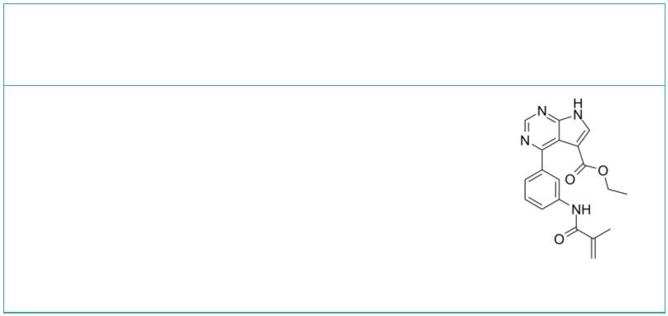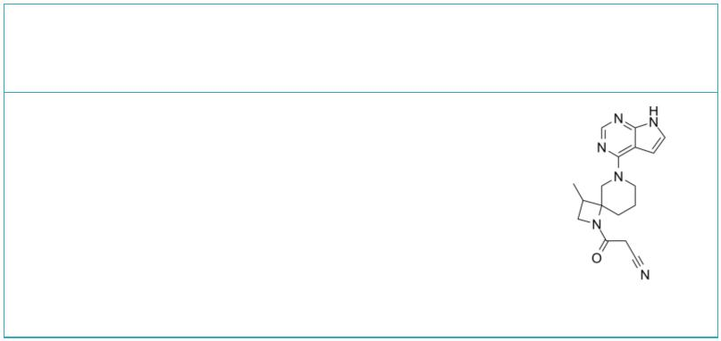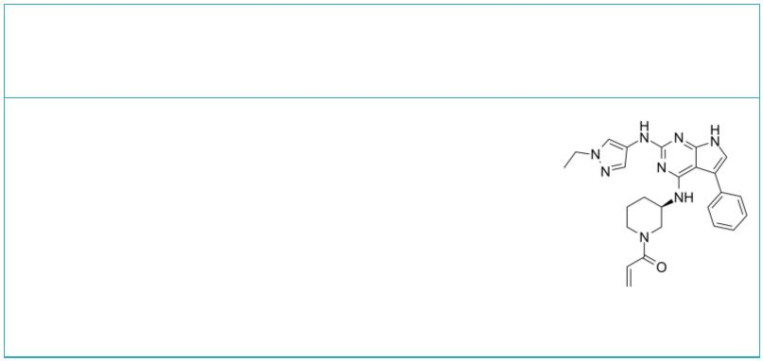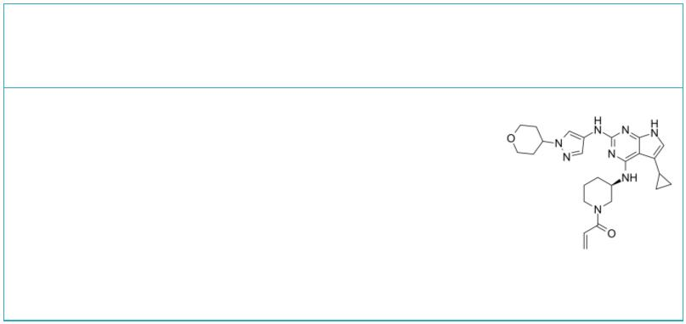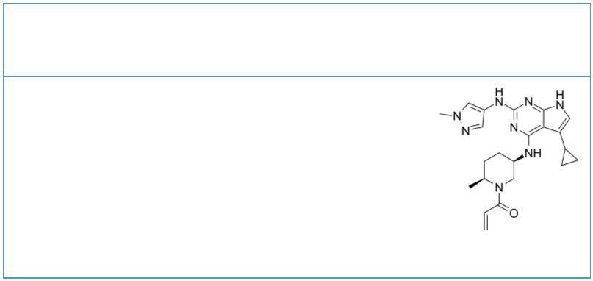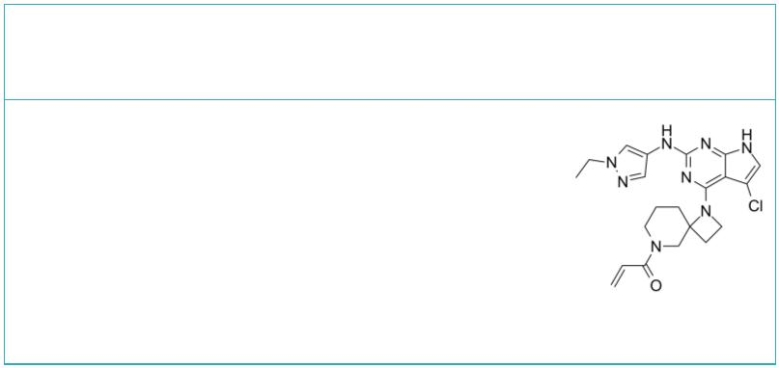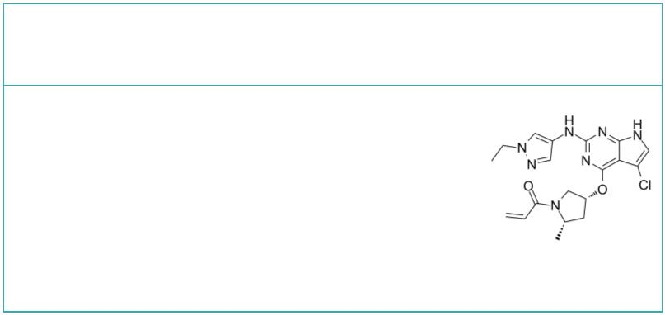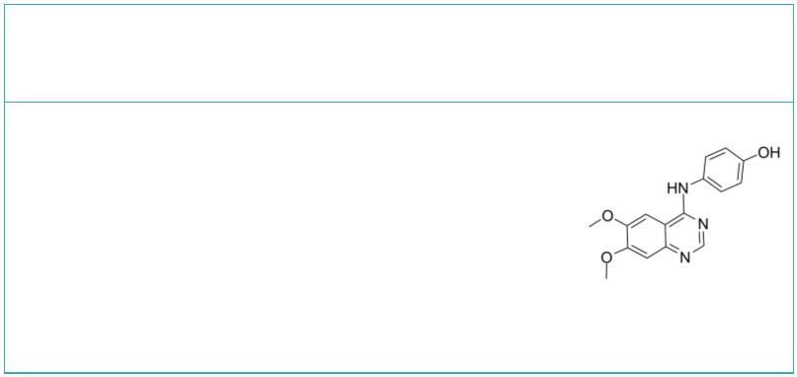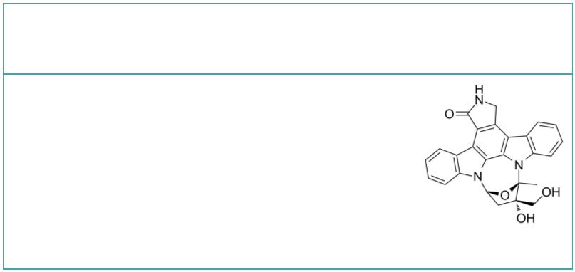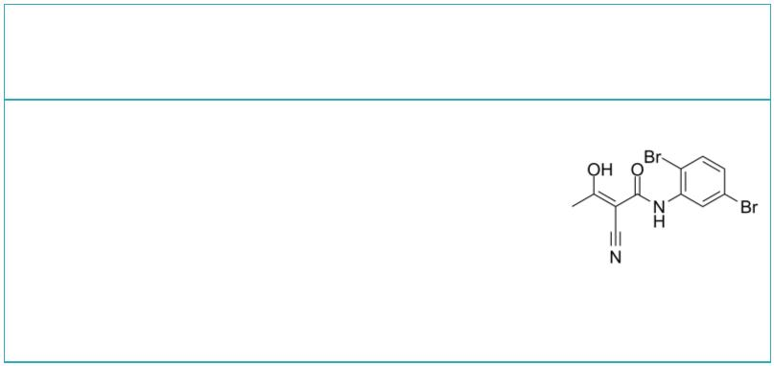 | JAK3-IN-6 JAK3-IN-7
 |  | Cat. No.: HY-101976 Cat. No.: HY-U00390
 | JAK3-IN-6 is a potent, selective irreversible  Janus Associated Kinase 3 (JAK3) inhibitor, with  an IC of 0.15 nM.  50 |  |  | JAK3-IN-7 is a potent and selective JAK3  inhibitor extracted from patent WO2011013785A1,  has an IC of <0.01 μM.  50
 | Purity: 98.07%  Clinical Data: No Development Reported  Size: 10 mM × 1 mL, 5 mg, 10 mg, 50 mg |  |  | Purity: >98%  Clinical Data: No Development Reported  Size: 1 mg, 5 mg
 | JAK3/BTK-IN-1 JAK3/BTK-IN-2
 |  | Cat. No.: HY-143716 Cat. No.: HY-143717
 | JAK3/BTK-IN-1 is a potent inhibitor of JAK3/BTK.  BTK and JAK3 are two important targets for  autoimmune diseases. Simultaneous inhibition of  the BTK/JAK3 signalling pathway exhibits  synergistic effects. |  |  | JAK3/BTK-IN-2 is a potent inhibitor of JAK3/BTK.  BTK and JAK3 are two important targets for  autoimmune diseases. Simultaneous inhibition of  the BTK/JAK3 signalling pathway exhibits  synergistic effects.
 | Purity: >98%  Clinical Data: No Development Reported  Size: 1 mg, 5 mg |  |  | Purity: >98%  Clinical Data: No Development Reported  Size: 1 mg, 5 mg
 | JAK3/BTK-IN-3 JAK3/BTK-IN-4
 |  | Cat. No.: HY-143718 Cat. No.: HY-143719
 | JAK3/BTK-IN-3 is a potent inhibitor of JAK3/BTK.  BTK and JAK3 are two important targets for  autoimmune diseases. Simultaneous inhibition of  the BTK/JAK3 signalling pathway exhibits  synergistic effects. |  |  | JAK3/BTK-IN-4 is a potent inhibitor of JAK3/BTK.  BTK and JAK3 are two important targets for  autoimmune diseases. Simultaneous inhibition of  the BTK/JAK3 signalling pathway exhibits  synergistic effects.
 | Purity: >98%  Clinical Data: No Development Reported  Size: 1 mg, 5 mg |  |  | Purity: >98%  Clinical Data: No Development Reported  Size: 1 mg, 5 mg
 | JAK3/BTK-IN-5 JANEX-1
 |  | Cat. No.: HY-143720 |  | (WHI-P131; Jak3 inhibitor I) Cat. No.: HY-15508
 | JAK3/BTK-IN-5 is a potent inhibitor of JAK3/BTK.  BTK and JAK3 are two important targets for  autoimmune diseases. Simultaneous inhibition of  the BTK/JAK3 signalling pathway exhibits  synergistic effects. |  |  | JANEX-1 (WHI-P131) is a potent and specific JAK3  inhibitor (estimated K=2.3 μM). JANEX-1  i  (WHI-P131) shows potent JAK3-inhibitory activity  (IC of 78 μM), does not inhibit JAK1 and JAK2.  50
 | Purity: >98%  Clinical Data: No Development Reported  Size: 1 mg, 5 mg |  |  | Purity: 99.60%  Clinical Data: No Development Reported  Size: 10 mM × 1 mL, 5 mg, 10 mg, 50 mg
 | Lestaurtinib LFM-A13
 | (CEP-701; KT-5555) Cat. No.: HY-50867 |  |  |  |  |  |  |  |  |  |  |  |  |  |  | Cat. No.: HY-18009
 | Lestaurtinib (CEP-701;KT-5555) is an  ATP-competitive multi-kinase inhibitor with potent  activity against the Trk family of receptor  tyrosine kinases. Lestaurtinib inhibits JAK2,  FLT3 and TrkA with IC s of 0.9, 3 and less than  50  25 nM, respectively. |  |  | LFM-A13 is a potent BTK, JAK2, PLK inhibitor,  inhibits recombinant BTK, Plx1 and PLK3 with IC s  50  of 2.5 μM, 10 μM and 61 μM; LFM-A13 shows no  effects on JAK1 and JAK3, Src family kinase HCK,  EGFR and IRK.
 | Purity: 99.92%  Clinical Data: Phase 3  Size: 5 mg |  |  | Purity: 99.97%  Clinical Data: No Development Reported  Size: 10 mM × 1 mL, 5 mg, 10 mg, 50 mg
12 Tel: 609-228-6898 Fax: 609-228-5909 Email: sales@MedChemExpress.com
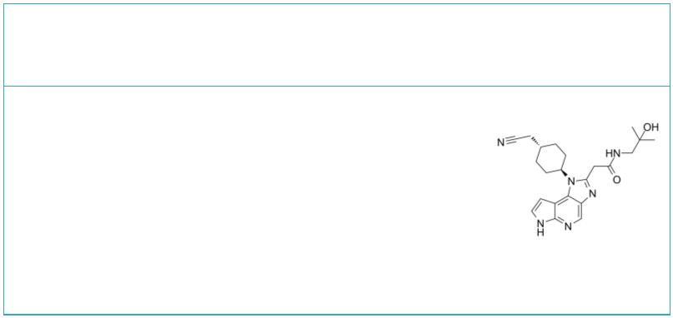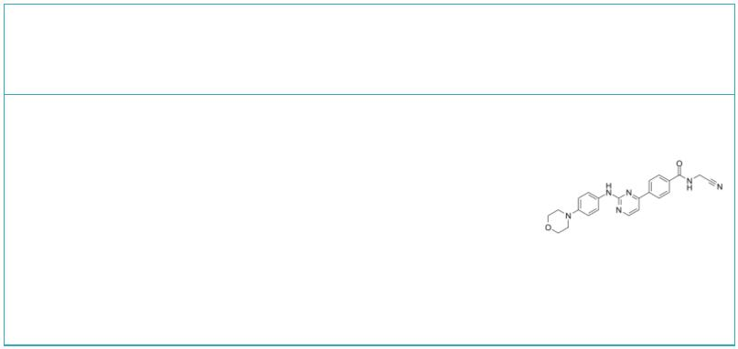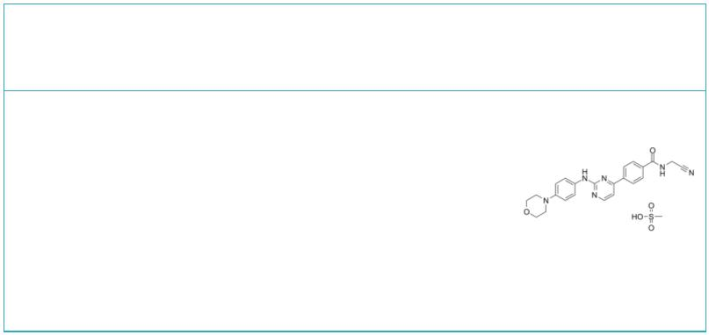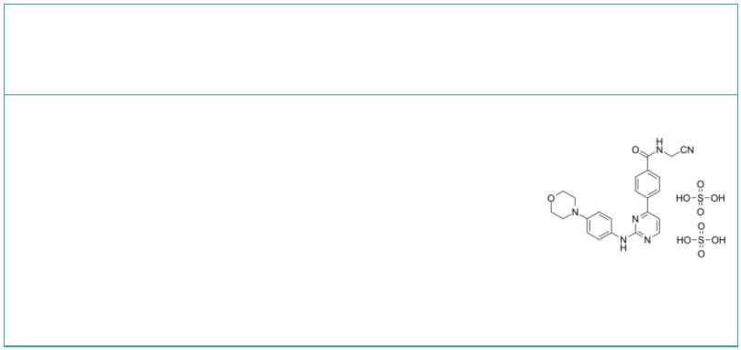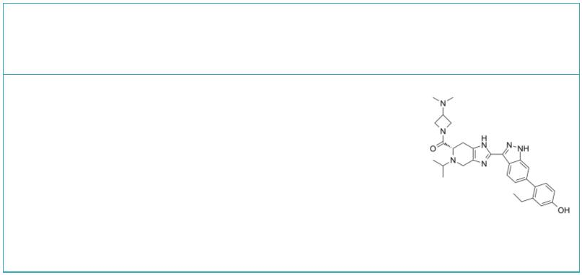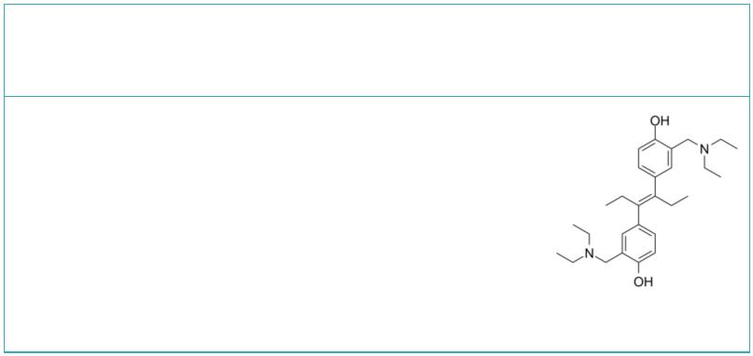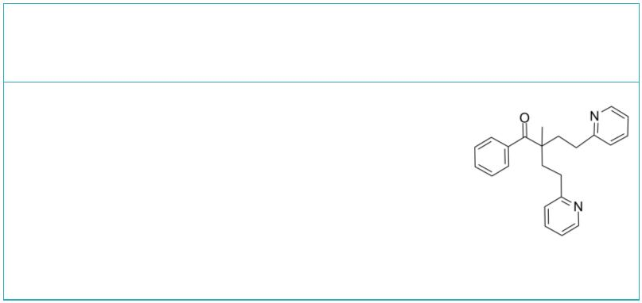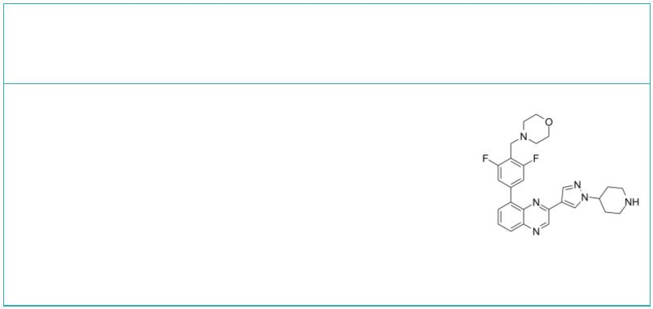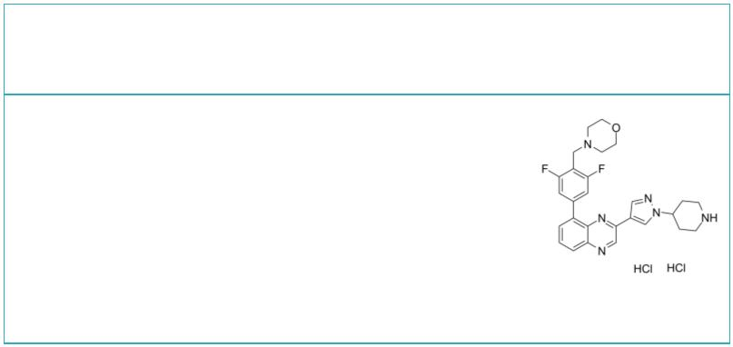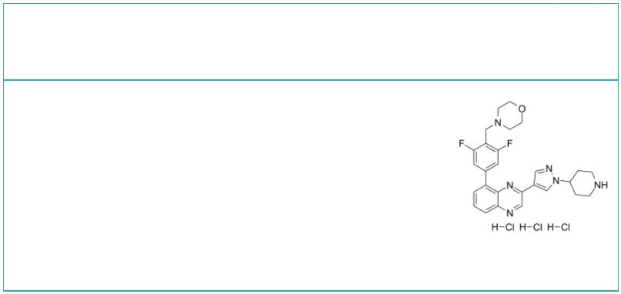Lorpucitinib  (JNJ-64251330) Cat. No.: HY-109182 |  |  | Momelotinib  (CYT387) Cat. No.: HY-10961
Lorpucitinib is a Gut-Restricted JAK Inhibitor  for the research of Inflammatory Bowel Disease. |  |  | Momelotinib (CYT387) is an ATP-competitive  inhibitor of JAK1/JAK2 with IC a of 11 nM and 18  50  nM,respectively. CYT387 shows much less activity  against JAK3.
Purity: 99.97%  Clinical Data: No Development Reported  Size: 5 mg, 10 mg, 25 mg, 50 mg |  |  | Purity: 98.93%  Clinical Data: Phase 3  Size: 10 mM × 1 mL, 5 mg, 10 mg, 50 mg, 100 mg, 200 mg
Momelotinib Mesylate  (CYT387 Mesylate) Cat. No.: HY-10963 |  |  | Momelotinib sulfate  (CYT387 sulfate salt) Cat. No.: HY-10962
Momelotinib Mesylate (CYT387 Mesylate) is an  ATP-competitive inhibitor of JAK1/JAK2 with IC  of 11 nM/18 nM, appr 10-fold selectivity versus  JAK3.  50 |  |  | Momelotinib sulfate (CYT387 sulfate salt) is an  ATP-competitive inhibitor of JAK1/JAK2 with IC  of 11 nM/18 nM, 10-fold selectivity versus JAK3  50  (IC =155 nM).  50
Purity: >98%  Clinical Data: Phase 3  Size: 1 mg, 5 mg |  |  | Purity: 98.04%  Clinical Data: Phase 3  Size: 10 mM × 1 mL, 5 mg, 10 mg, 50 mg, 100 mg
Nezulcitinib  (TD-0903) Cat. No.: HY-132849 |  |  | NSC 33994 |  |  |  |  |  |  |  |  |  |  | Cat. No.: HY-18293
Nezulcitinib (TD-0903) is an inhaled and  lung-selective pan-Janus kinase (JAK) inhibitor.  Nezulcitinib can be used for the research of  COVID-19 associated acute lung injury and impaired  oxygenation. |  |  | NSC 33994 (G6) is a selective JAK2 inhibitor,  with an IC of 60 nM.  50
Purity: >98%  Clinical Data: No Development Reported  Size: 1 mg, 5 mg |  |  | Purity: >98%  Clinical Data: No Development Reported  Size: 1 mg, 5 mg
NSC 42834 NVP-BSK805
(JAK2 Inhibitor V; Z3) Cat. No.: HY-15480 |  |  |  |  |  |  |  |  |  |  |  |  |  | Cat. No.: HY-14722
NSC 42834 (JAK2 Inhibitor V), a novel specific  inhibitor of Jak2, inhibits Jak2-V617F and  Jak2-WT autophosphorylation in a dose-dependent  manner but was not cytotoxic to cells at  concentrations that inhibited kinase activity. |  |  | NVP-BSK805 is an ATP-competitive JAK2 inhibitor,  with IC s of 0.48 nM, 31.63 nM, 18.68 nM, and  50  10.76 nM for JAK2 JH1 (JAK homology 1), JAK1 JH1,  JAK3 JH1, and TYK2 JH1, respectively.
Purity: 96.79%  Clinical Data: No Development Reported  Size: 10 mM × 1 mL, 5 mg, 10 mg, 50 mg, 100 mg |  |  | Purity: >98%  Clinical Data: No Development Reported  Size: 1 mg, 5 mg
NVP-BSK805 dihydrochloride NVP-BSK805 trihydrochloride
 | Cat. No.: HY-14722A Cat. No.: HY-14722C
NVP-BSK805 dihydrochloride is an ATP-competitive  JAK2 inhibitor, with IC s of 0.48 nM, 31.63 nM,  50  18.68 nM, and 10.76 nM for JAK2 JH1 (JAK homology  1), JAK1 JH1, JAK3 JH1, and TYK2 JH1,  respectively. |  |  | NVP-BSK805 trihydrochloride trihydrochloride is an  ATP-competitive JAK2 inhibitor, with IC s of  50  0.48 nM, 31.63 nM, 18.68 nM, and 10.76 nM for JAK2  JH1 (JAK homology 1), JAK1 JH1, JAK3 JH1, and TYK2  JH1, respectively.
Purity: 99.36%  Clinical Data: No Development Reported  Size: 10 mM × 1 mL, 5 mg, 10 mg, 50 mg, 100 mg |  |  | Purity: >98%  Clinical Data: No Development Reported  Size: 1 mg, 5 mg
www.MedChemExpress.com 13
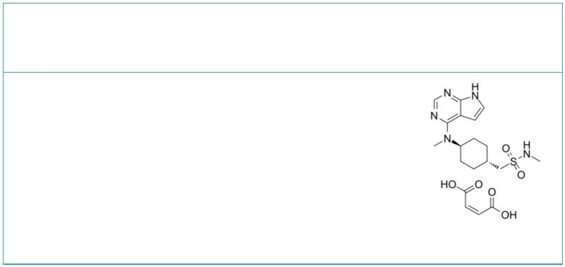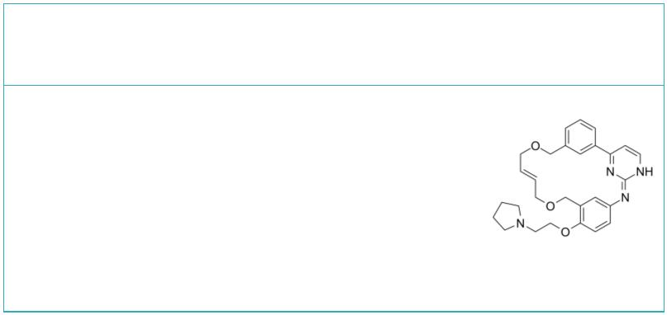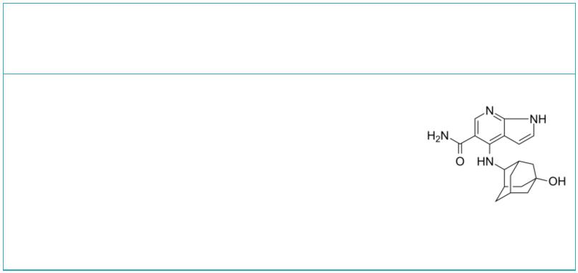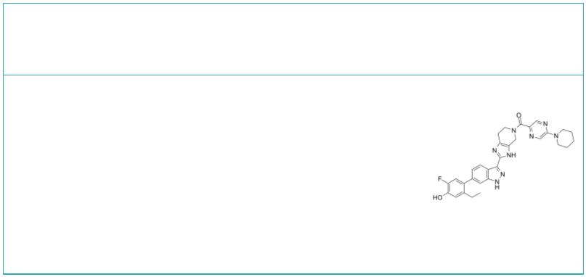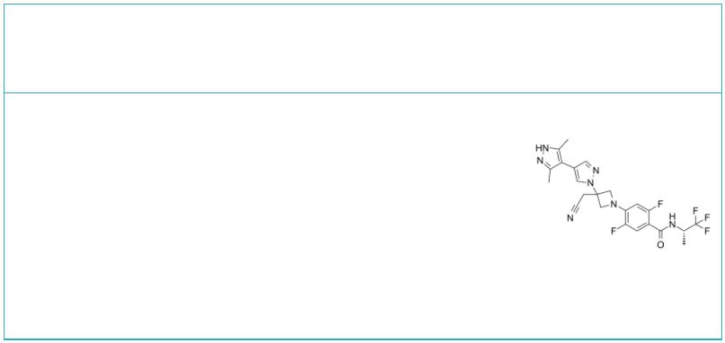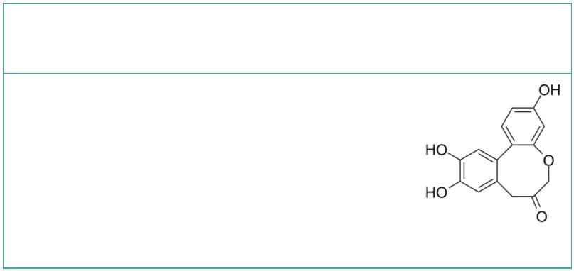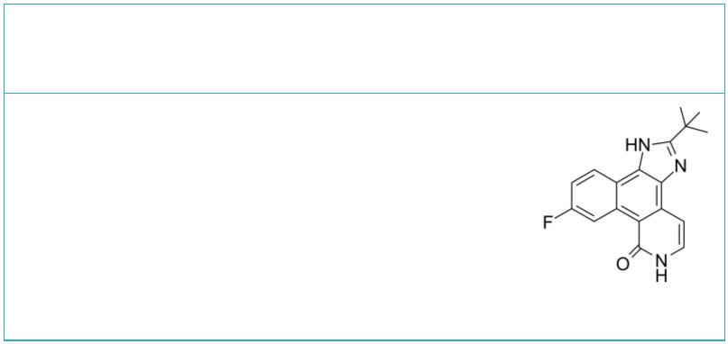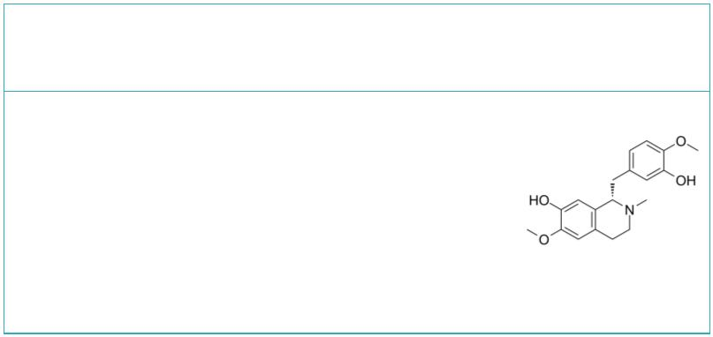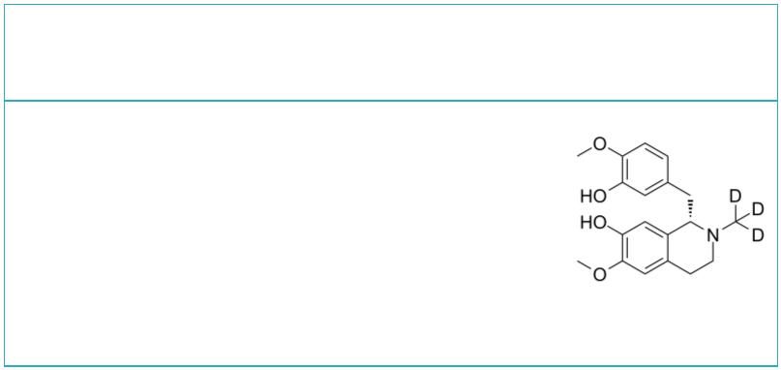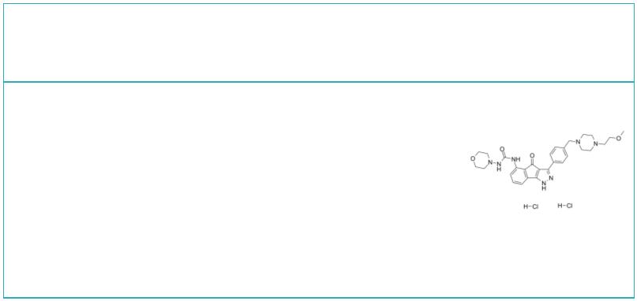 | Oclacitinib maleate  (PF-03394197 maleate) Cat. No.: HY-13577A |  |  |  |  |  | Pacritinib  (SB1518) Cat. No.: HY-16379
 | Oclacitinib maleate (PF-03394197 maleate) is a  novel JAK inhibitor. Oclacitinib maleate  (PF-03394197 maleate) is most potent at inhibiting  JAK1 (IC =10 nM).  50 |  |  |  |  |  | Pacritinib (SB1518) is a potent inhibitor of both  wild-type JAK2 (IC =23 nM) and mutant  50 JAK2^{V617F}  (IC =19 nM). Pacritinib also inhibits  50 FLT3  (IC =22 nM) and its mutant (IC =6 nM).  50 FLT3^{D835Y} 50
 | Purity: 99.65%  Clinical Data: Launched  Size: 10 mM × 1 mL, 5 mg, 10 mg, 50 mg, 100 mg |  |  |  |  |  | Purity: 99.93%  Clinical Data: Phase 3  Size: 10 mM × 1 mL, 5 mg, 10 mg, 50 mg, 100 mg
 | Peficitinib  (ASP015K; JNJ-54781532) Cat. No.: HY-19568 |  |  |  |  |  | PF-06263276 |  |  |  |  |  |  |  |  |  |  |  | Cat. No.: HY-101024
 | Peficitinib is an oral JAK inhibitor, with IC s  50  of 3.9, 5.0, 0.7 and 4.8 nM for JAK1, JAK2, JAK3  and Tyk2, respectively. |  |  |  |  |  | PF-06263276 (PF 6263276) is a potent and selective  pan-JAK inhibitor, with IC s of 2.2 nM, 23.1 nM,  50  59.9 nM and 29.7 nM for JAK1, JAK2, JAK3 and TYK2,  respectively.
 | Purity: 99.78%  Clinical Data: Launched  Size: 10 mM × 1 mL, 5 mg, 10 mg, 50 mg, 100 mg |  |  |  |  |  | Purity: ≥99.0%  Clinical Data: Phase 1  Size: 1 mg, 5 mg
 | Povorcitinib |  |  | Cat. No.: HY-145588 |  |  | Protosappanin A  (PTA) Cat. No.: HY-113573
 | Povorcitinib is a potent and selective inhibitor  of JAK1. Povorcitinib has the potential for the  research of disease selected from cutaneous lupus  erythematosus (CLE) and Lichen planus (LP)  (extracted from patent WO2021076124A1). |  |  |  |  |  | Protosappanin A (PTA), an immunosuppressive  ingredient and major biphenyl compound isolated  from Caesalpinia sappan L, suppresses  JAK2/STAT3-dependent inflammation pathway through  down-regulating the phosphorylation of JAK2 and  STAT3.
 | Purity: >98%  Clinical Data: No Development Reported  Size: 1 mg, 5 mg |  |  |  |  |  | Purity: 99.98%  Clinical Data:  Size: 1 mg, 5 mg, 10 mg
 | Pyridone 6 Reticuline
 |  |  |  |  | Cat. No.: HY-14435 Cat. No.: HY-N1356
 | Pyridone 6 is a pan-JAK inhibitor, which potently  inhibits the JAK kinase family, with IC s of 1 nM  50  for JAK2 and TYK2, 5 nM for JAK3, and 15 nM for  JAK1, while displaying significantly weaker  affinities (130 nM to >10 mM) for other protein  tyrosine kinases. |  |  |  |  |  | Reticuline shows anti-inflammatory effects through  JAK2/STAT3 and NF-κB signaling pathways.  Reticuline inhibits mRNA expressions of TNF-α, and  IL-6 and reduces the phosphorylation levels of  JAK2 and STAT3. Reticuline exhibits cardiovascular  effects.
 | Purity: 98.84%  Clinical Data: No Development Reported  Size: 10 mM × 1 mL, 2 mg, 5 mg, 10 mg, 50 mg, 100 mg |  |  |  |  |  | Purity: 98.11%  Clinical Data: No Development Reported  Size: 1 mg, 5 mg
 | Reticuline-d3 RGB-286638
 |  | Cat. No.: HY-N1356S Cat. No.: HY-15504
 | Reticuline-d3 is the deuterium labeled Reticuline.  Reticuline shows anti-inflammatory effects through  JAK2/STAT3 and NF-κB signaling pathways.  Reticuline inhibits mRNA expressions of TNF-α, and  IL-6 and reduces the phosphorylation levels of  JAK2 and STAT3.  Purity: >98%  Clinical Data: No Development Reported  Size: 1 mg, 5 mg |  |  |  |  |  | RGB-286638 is a CDK inhibitor that inhibits the  kinase activity of cyclin T1-CDK9, cyclin B1-CDK1,  cyclin E-CDK2, cyclin D1-CDK4, cyclin E-CDK3, and  p35-CDK5 with IC s of 1, 2, 3, 4, 5 and 5 nM,  50  respectively; also inhibits GSK-3β, TAK1, Jak2 and  MEK1, with IC s of 3, 5, 50, and 54 nM.  50  Purity: 99.84%  Clinical Data: Phase 1  Size: 10 mM × 1 mL, 5 mg, 10 mg, 50 mg, 100 mg
14 Tel: 609-228-6898 Fax: 609-228-5909 Email: sales@MedChemExpress.com
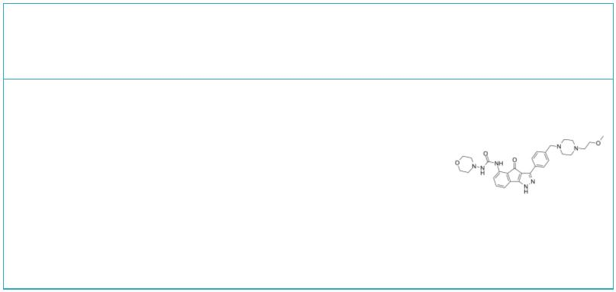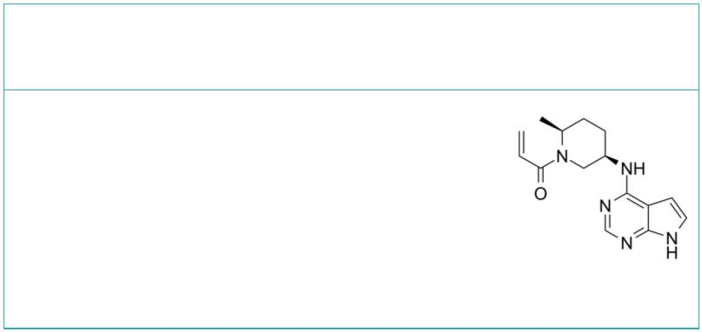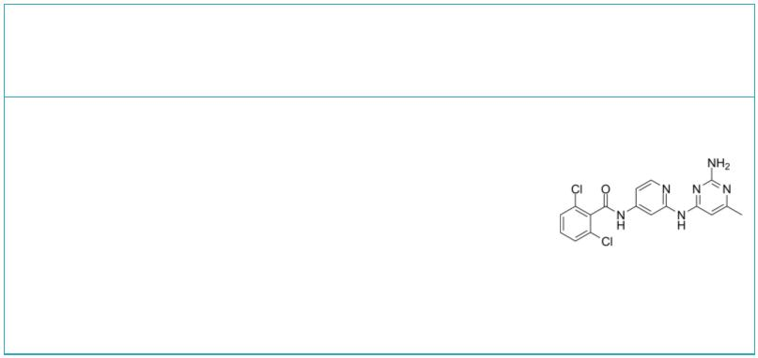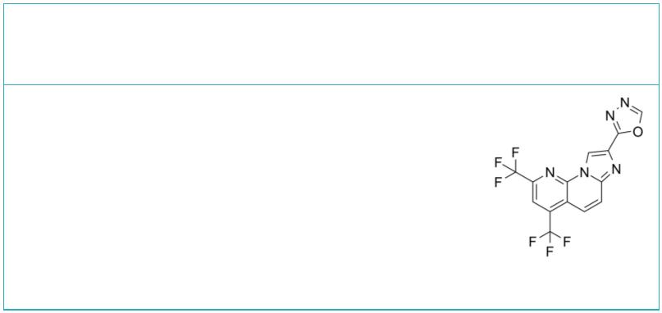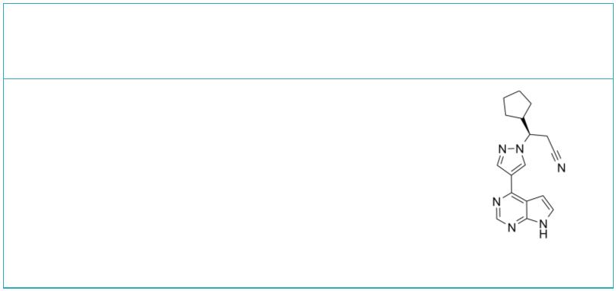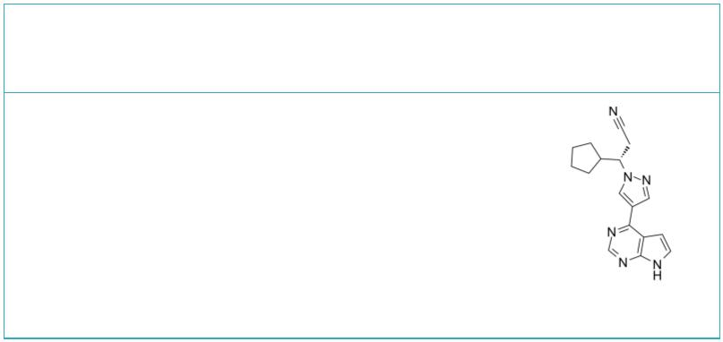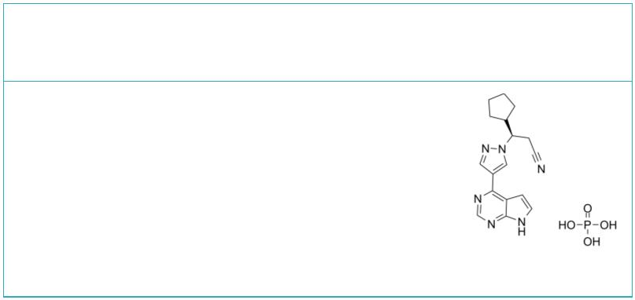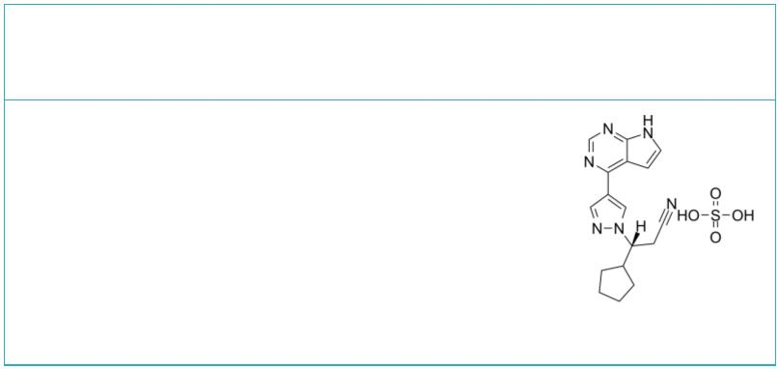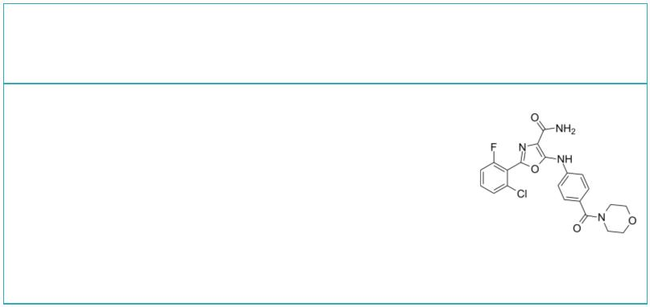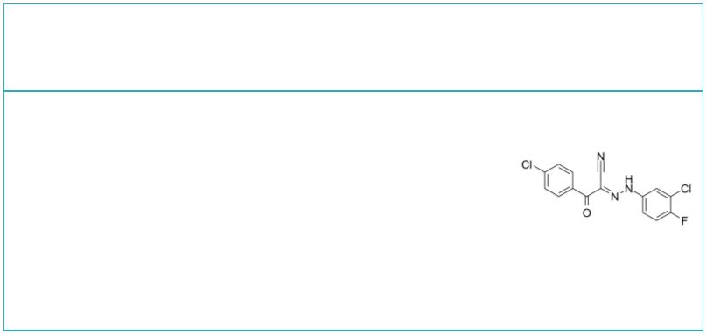RGB-286638 free base |  | Cat. No.: HY-15504A |  |  |  |  | Ritlecitinib  (PF-06651600) Cat. No.: HY-100754
RGB-286638 is a CDK inhibitor that inhibits the  kinase activity of cyclin T1-CDK9, cyclin B1-CDK1,  cyclin E-CDK2, cyclin D1-CDK4, cyclin E-CDK3, and  p35-CDK5 with IC s of 1, 2, 3, 4, 5 and 5 nM,  50  respectively; also inhibits GSK-3β, TAK1, Jak2 and  MEK1, with IC s of 3, 5, 50, and 54 nM.  50  Purity: 98.07%  Clinical Data: Phase 1  Size: 5 mg, 10 mg, 50 mg, 100 mg |  |  |  |  |  |  | Ritlecitinib (PF-06651600) is an orally active and  selective JAK3 inhibitor with an IC of 33.1 nM.  50  Purity: 99.98%  Clinical Data: Phase 3  Size: 10 mM × 1 mL, 5 mg, 10 mg, 25 mg, 50 mg
RO495 |  |  |  |  | Cat. No.: HY-18316 |  | RO8191  (CDM-3008; RO4948191) Cat. No.: HY-W063968
RO495 is a potent inhibitor of non-receptor  tyrosine-protein kinase 2 (TYK2 kinase). |  |  |  |  |  |  | RO8191 (CDM-3008), an imidazonaphthyridine  compound, is an orally active and potent interferon  (IFN) receptor agonist. RO8191 directly binds to  IFNα/β receptor 2 (IFNAR2) and activates  IFN-stimulated genes (ISGs) expression and  JAK/STAT phosphorylation.
Purity: >98%  Clinical Data: No Development Reported  Size: 1 mg, 5 mg |  |  |  |  |  |  | Purity: 98.53%  Clinical Data: No Development Reported  Size: 5 mg, 10 mg, 25 mg, 50 mg, 100 mg
Ruxolitinib  (INCB18424) Cat. No.: HY-50856 |  |  |  |  |  |  | Ruxolitinib (S enantiomer)  (S-Ruxolitinib; S-INCB18424) Cat. No.: HY-50856A
Ruxolitinib (INCB18424) is a potent and selective  JAK1/2 inhibitor with IC s of 3.3 nM and 2.8 nM  50  in cell-free assays, and has 130-fold selectivity  for JAK1/2 over JAK3. Ruxolitinib induces  autophagy and kills tumor cells through toxic  mitophagy. |  |  |  |  |  |  | Ruxolitinib S enantiomer is the S-enantiomer of  Ruxolitinib. Ruxolitinib S enantiomer is a JAK  inhibitor.
Purity: 99.99%  Clinical Data: Launched  Size: 10 mM × 1 mL, 5 mg, 10 mg, 50 mg, 100 mg, 200 mg |  |  |  |  |  |  | Purity: 99.77%  Clinical Data: Launched  Size: 10 mM × 1 mL, 5 mg, 10 mg, 50 mg, 100 mg
Ruxolitinib phosphate Ruxolitinib sulfate
(INCB018424 phosphate) Cat. No.: HY-50858 (INCB018424 sulfate) Cat. No.: HY-50859
Ruxolitinib phosphate (INCB018424 phosphate) is a  potent JAK1/2 inhibitor with IC s of 3.3 nM/2.8  50  nM, respectively, showing more than 130-fold  selectivity over JAK3. |  |  |  |  |  |  | Ruxolitinib sulfate (INCB018424 sulfate) is the  first potent, selective JAK1/2 inhibitor to enter  the clinic with IC s of 3.3 nM/2.8 nM, and has  50  > 130-fold selectivity for JAK1/2 versus JAK3.
Purity: 99.98%  Clinical Data: Launched  Size: 10 mM × 1 mL, 5 mg, 10 mg, 50 mg, 100 mg, 200 mg |  |  |  |  |  |  | Purity: >98%  Clinical Data: Launched  Size: 1 mg, 5 mg
SAR-20347 SC99
 |  |  | Cat. No.: HY-100895 Cat. No.: HY-124858
SAR-20347 is an inhibitor of TYK2, JAK1, JAK2  and JAK3 with IC s of 0.6, 23, 26 and 41 nM,  50  respectively. |  |  |  |  |  |  | SC99 is an orally active, selective STAT3  inhibitor targeting JAK2-STAT3 pathway. SC99 docks  into the ATP-binding pocket of JAK2. SC99 inhibits  phosphorylation of JAK2 and STAT3 with no effects  on the other kinases associated with STAT3  signaling.
Purity: 98.04%  Clinical Data: No Development Reported  Size: 10 mM × 1 mL, 5 mg, 10 mg, 25 mg, 50 mg, 100 mg |  |  |  |  |  |  | Purity: 99.07%  Clinical Data: No Development Reported  Size: 10 mM × 1 mL, 5 mg, 10 mg, 50 mg, 100 mg
www.MedChemExpress.com 15
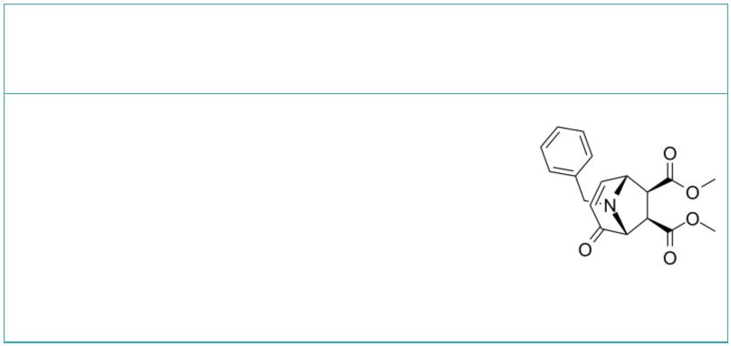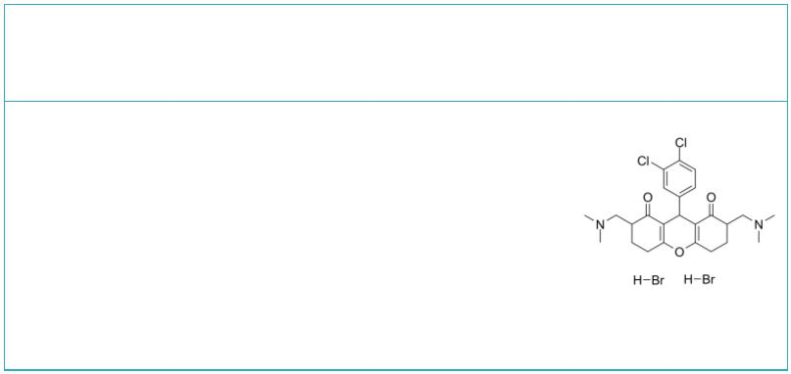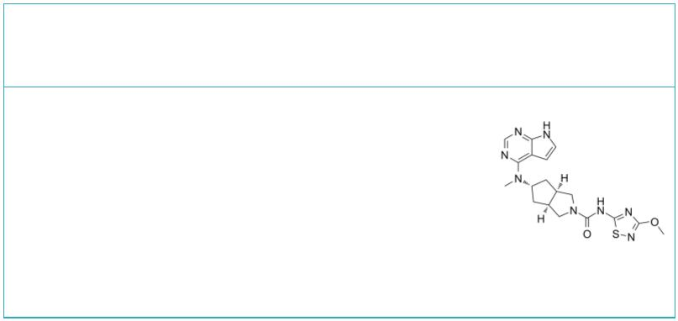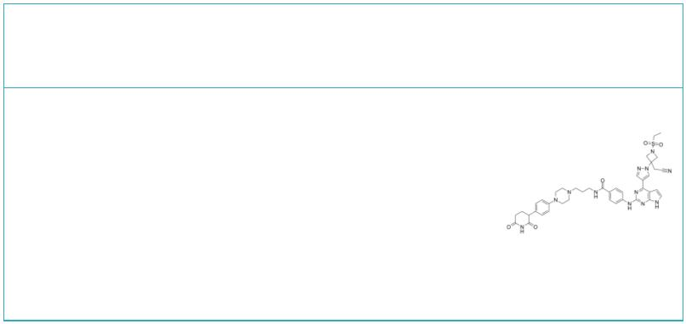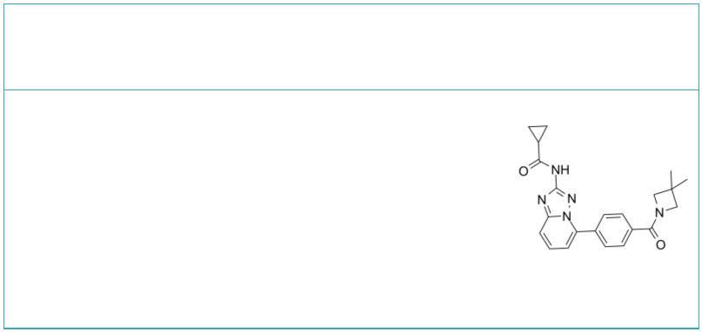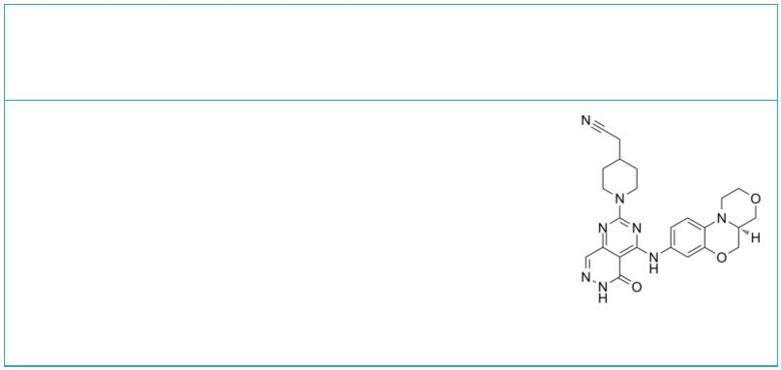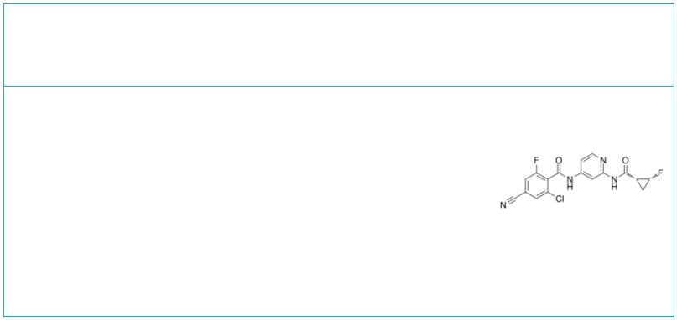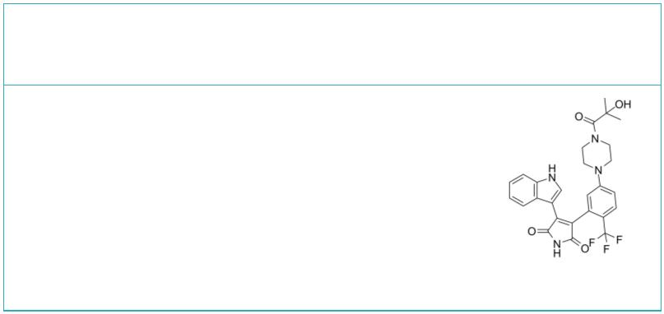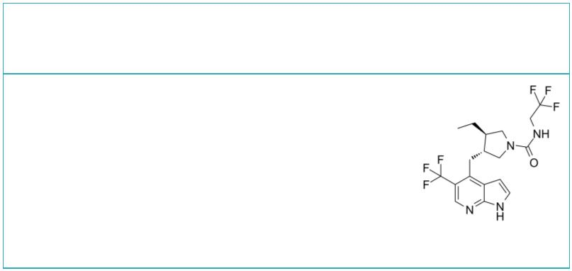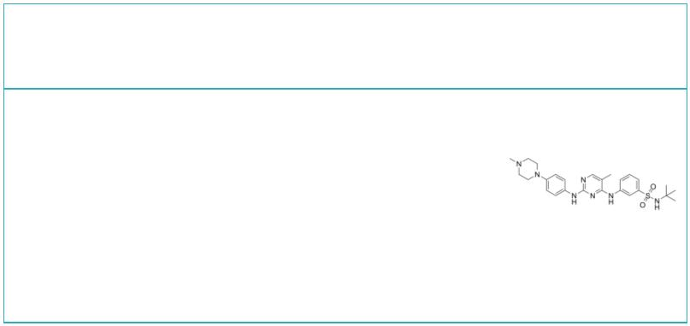 | SD-1008 SD-1029
 |  | Cat. No.: HY-107595 Cat. No.: HY-112391
 | SD-1008 is a potent JAK inhibitor. SD-1008  inhibits tyrosyl phosphorylation of STAT3, JAK2  and Src. SD-1008 also reduces STAT3-dependent  luciferase activity. SD-1008 enhances apoptosis  induced by Paclitaxel in ovarian cancer cells via  directly blocking the JAK-STAT3 signaling pathway. |  |  |  | SD-1029 is a JAK2/STAT3 inhibitor. SD-1029  inhibits STAT3 nuclear translocation. SD-1029 is  an inhibitor of STAT3 activation due to inhibition  of JAK2 phosphorylation.
 | Purity: >98%  Clinical Data: No Development Reported  Size: 1 mg, 5 mg |  |  |  | Purity: >98%  Clinical Data: No Development Reported  Size: 1 mg, 5 mg
 | SHR0302 SJ10542
 |  | Cat. No.: HY-112724 Cat. No.: HY-145696
 | SHR0302 is a potent and orally active all members  of the JAK family inhibitor, particularly  JAK1. The selectivity of SHR0302 for JAK1 is  >10-fold for JAK2, 77-fold for JAK3, 420-fold  for Tyk2. |  |  |  | SJ10542 is a potent and selective JAK2/3  directing phenyl glutarimide (PG)-PROTAC with  DC s of 14, 11, and 24 nM for JAK2, JAK3, and  50  JAK2-fusion ALL, respectively. SJ10542 utilizes a  PG ligand as the cereblon (CRBN) recruiter.
 | Purity: 99.58%  Clinical Data: No Development Reported  Size: 5 mg, 10 mg, 25 mg, 50 mg |  |  |  | Purity: >98%  Clinical Data: No Development Reported  Size: 5 mg, 10 mg, 25 mg, 50 mg
 | Solcitinib  (GSK-2586184; GLPG-0778) Cat. No.: HY-16755 |  |  |  | SYK/JAK-IN-1 |  |  |  |  |  |  |  |  |  |  |  |  |  |  | Cat. No.: HY-145029
 | Solcitinib is an orally active, competitive,  potent, selective JAK1 inhibitor, with an IC of  50  9.8 nM, and 11-, 55- and 23-fold selectivity over  JAK2, JAK3 and TYK2, respectively; Solcitinib is  used in the research of moderate-to-severe  plaque-type psoriasis. |  |  |  | SYK/JAK-IN-1 is dual SYK/JAK inhibitor with IC s  50  of <5 nM for SYK and JAK2, respectively.
 | Purity: 99.73%  Clinical Data: Phase 2  Size: 10 mM × 1 mL, 5 mg, 10 mg, 50 mg, 100 mg, 200 mg |  |  |  | Purity: >98%  Clinical Data: No Development Reported  Size: 1 mg, 5 mg
 | TCJL37 TCS 21311
 |  |  | Cat. No.: HY-16640 |  | (NIBR3049) Cat. No.: HY-108264
 | TCJL37 is a potent, selective, and orally  bioavailable TYK2 inhibitor with a K of 1.6 nM.  i  TCJL37 can be used for the research of  inflammatory bowel diseases (IBD). |  |  |  | TCS 21311 (NIBR3049) is a potent, highly selective  JAK3 inhibitor with an IC of 8 nM, it displays  50  >100-fold selectivity over JAK1, JAK2 and TYK2.  TCS 21311 (NIBR3049) inhibits PKCα, PKCθ, and  GSK3β with IC s of 13, 68, and 3 nM,  50  respectively.
 | Purity: >98%  Clinical Data: No Development Reported  Size: 1 mg, 5 mg |  |  |  | Purity: ≥98.0%  Clinical Data: No Development Reported  Size: 10 mM × 1 mL, 1 mg, 5 mg, 10 mg
 | Ten01 TG101209
 |  | Cat. No.: HY-139649 Cat. No.: HY-10410
 | Ten01 has 5.0 nM activity against JAK1 kinase. |  |  |  | TG101209 is a selective JAK2 inhibitor with IC  50  of 6 nM, less potent to Flt3 and RET with IC of  50  25 nM and 17 nM, appr 30-fold selective for JAK2  than JAK3, and sensitive to JAK2V617F and  MPLW515L/K mutations.
 | Purity: >98%  Clinical Data: No Development Reported  Size: 1 mg, 5 mg |  |  |  | Purity: 99.72%  Clinical Data: No Development Reported  Size: 10 mM × 1 mL, 5 mg, 10 mg, 50 mg, 100 mg
16 Tel: 609-228-6898 Fax: 609-228-5909 Email: sales@MedChemExpress.com
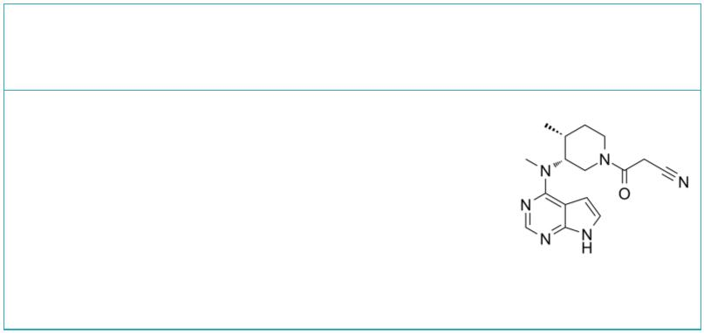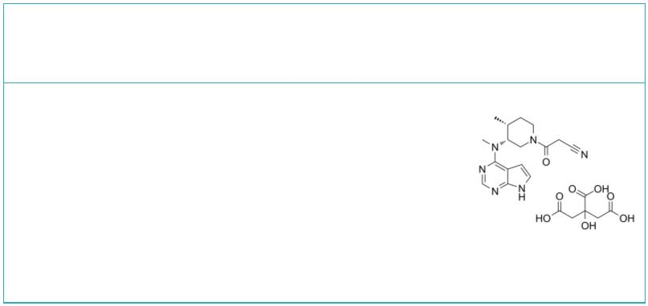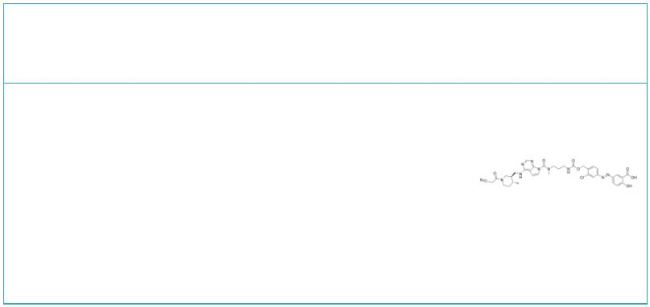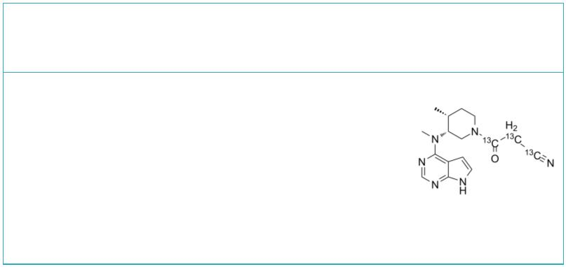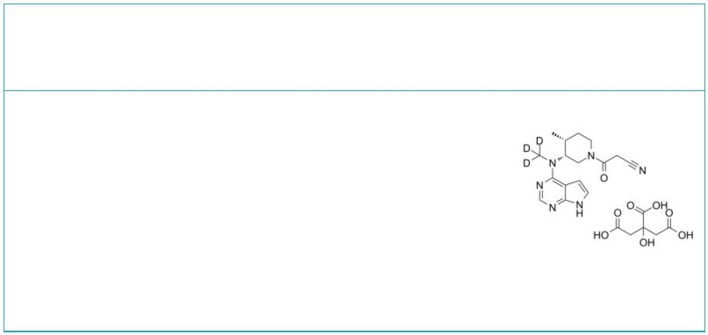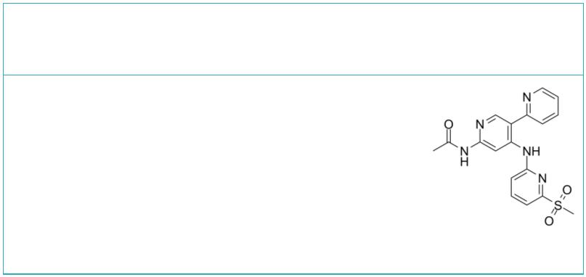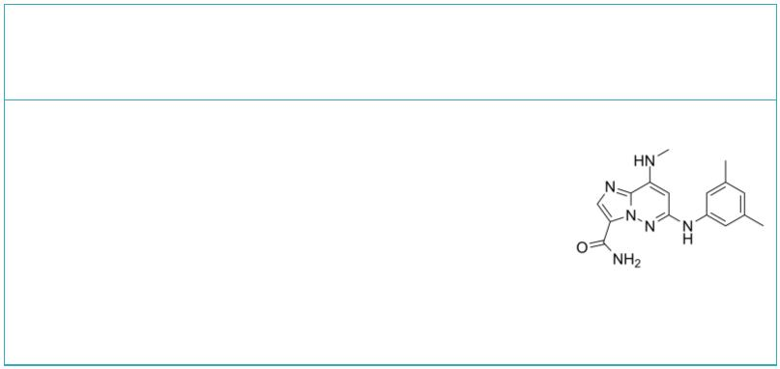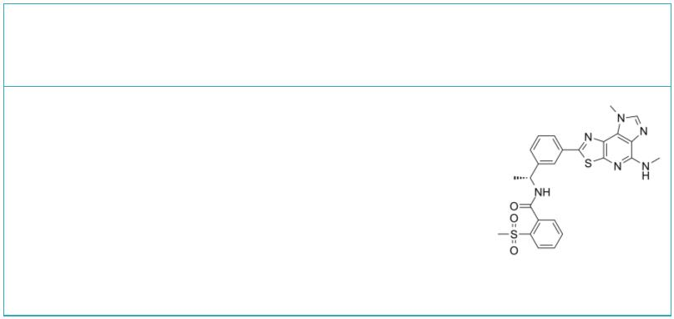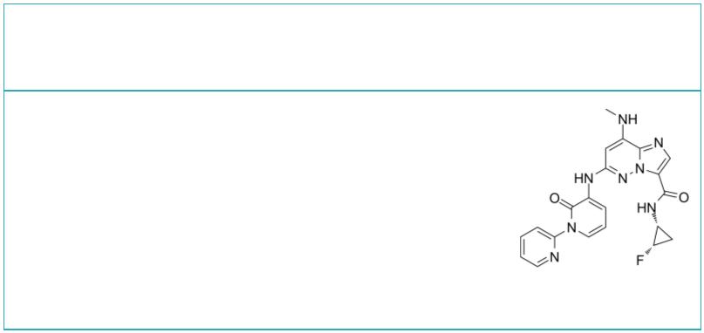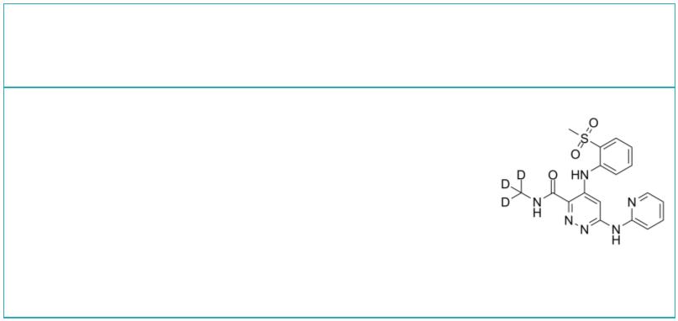Tofacitinib  (Tasocitinib; CP-690550) Cat. No.: HY-40354 |  |  |  | Tofacitinib citrate  (Tasocitinib citrate; CP-690550 citrate) Cat. No.: HY-40354A
Tofacitinib is an orally available JAK3/2/1  inhibitor with IC s of 1, 20, and 112 nM,  50  respectively. |  |  |  | Tofacitinib citrate is an orally available  JAK1/2/3 inhibitor with IC s of 1, 20, and 112  50  nM, respectively. Tofacitinib citrate has  antibacterial, antifungal and antiviral  activities.
Purity: 99.99%  Clinical Data: Launched  Size: 10 mM × 1 mL, 10 mg, 50 mg, 100 mg, 200 mg, 500 mg |  |  |  | Purity: 99.98%  Clinical Data: Launched  Size: 10 mM × 1 mL, 10 mg, 50 mg, 100 mg, 200 mg, 500 mg
Tofacitinib Prodrug-1 |  | Cat. No.: HY-145829 |  | Tofacitinib-13C3  (Tasocitinib-13C3; CP-690550-13C3) Cat. No.: HY-40354S
Tofacitinib Prodrug-1 is an effective and oral  active prodrug to mitigate the systemic adverse  effects of Tofacitinib. Tofacitinib Prodrug-1 can  effectively attenuate the oxazolone-induced  colitis in mice model with low toxicity. |  |  |  | Tofacitinib-13C3 (Tasocitinib-13C3) is the  13C-labeled Tofacitinib. Tofacitinib is an orally  available JAK3/2/1 inhibitor with IC s of 1, 20,  50  and 112 nM, respectively.
Purity: >98%  Clinical Data: No Development Reported  Size: 1 mg, 5 mg |  |  |  | Purity: >98%  Clinical Data: No Development Reported  Size: 1 mg, 5 mg
Tofacitinib-d3 citrate  (Tasocitinib-d3 citrate; CP-690550-d3 citrate) Cat. No.: HY-40354AS |  |  |  | TYK2-IN-11 |  |  |  |  |  |  |  |  |  | Cat. No.: HY-144087
Tofacitinib-d3 (citrate) is deuterium labeled  Tofacitinib (citrate). Tofacitinib citrate is an  orally available JAK1/2/3 inhibitor with IC50s of  1, 20, and 112 nM, respectively. Tofacitinib  citrate has antibacterial, antifungal and  antiviral activities. |  |  |  | TYK2-IN-11 (Compound 5B) is a selective Tyk-2  inhibitor with IC s of 0.016 and 0.31 nM for  50  TYK2-JH2 and JAK1-JH2, respectively. TYK2-IN-11  can be used for the research of inflammatory or  autoimmune disease.
Purity: >98%  Clinical Data: No Development Reported  Size: 1 mg, 5 mg |  |  |  | Purity: >98%  Clinical Data: No Development Reported  Size: 1 mg, 5 mg
TyK2-IN-2 Tyk2-IN-3
 |  | Cat. No.: HY-101762 Cat. No.: HY-18709
TyK2-IN-2 (Compoud 18) is a potent and selective  TYK2 inhibitor with IC s of 7 nM, 0.1 μM and  50  0.05 μM for TYK2 JH2, IL-23 and IFNα,  respectively. TyK2-IN-2 also inhibits  phosphodiesterase 4 (PDE4) with an IC of 62 nM.  50 |  |  |  | Tyk2-IN-3 is a Tyk2 pseudokinase inhibitor, with  an IC of 485 nM.  50
Purity: 99.71%  Clinical Data: No Development Reported  Size: 10 mM × 1 mL, 1 mg, 5 mg, 10 mg, 50 mg, 100 mg |  |  |  | Purity: >98%  Clinical Data: No Development Reported  Size: 1 mg, 5 mg
Tyk2-IN-5 Tyk2-IN-7
 |  | Cat. No.: HY-111745 Cat. No.: HY-126242S
Tyk2-IN-5 (compound 6) is a highly potent,  selective and orally active Tyk2 inhibitor and  targets the JH2 domain, with a K of 0.086 nM for  i  Tyk2 JH2 and an IC of 25 nM for IFNα.  50 |  |  |  | Tyk2-IN-7 (Compound 48) is a TYK2 JH2 inhibitor,  binds to TYK2 JH2 domain with IC₅₀ and K_{i.app} of  0.00053 μM and 0.00007 μM, respectively.
Purity: 99.78%  Clinical Data: No Development Reported  Size: 10 mM × 1 mL, 5 mg, 10 mg, 25 mg, 50 mg, 100 mg |  |  |  | Purity: 99.66%  Clinical Data: No Development Reported  Size: 5 mg, 10 mg, 25 mg, 50 mg, 100 mg
www.MedChemExpress.com 17
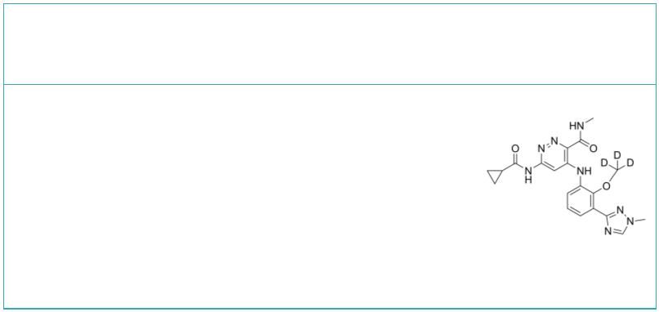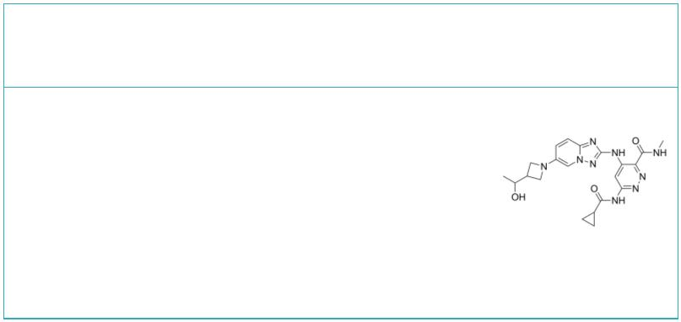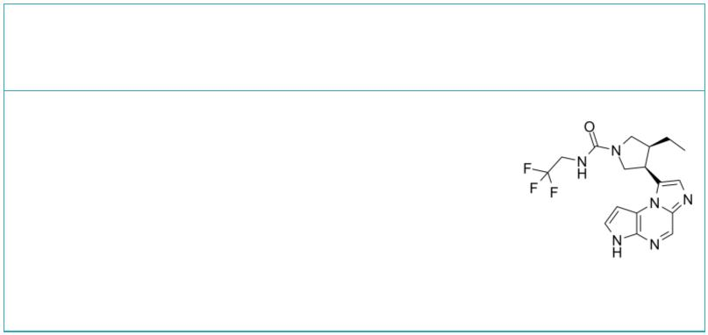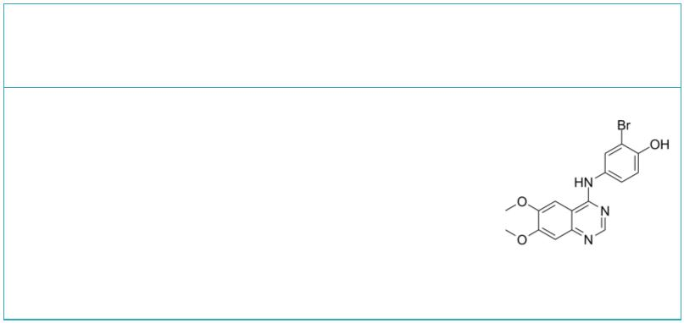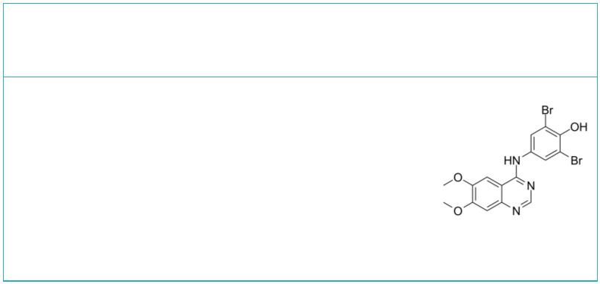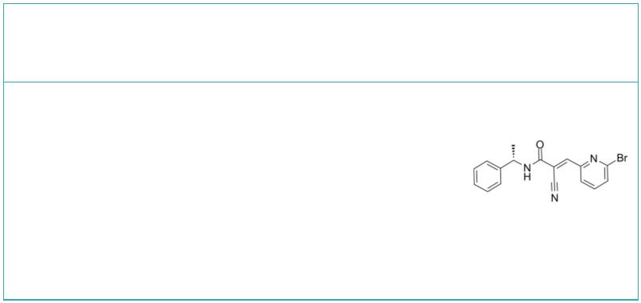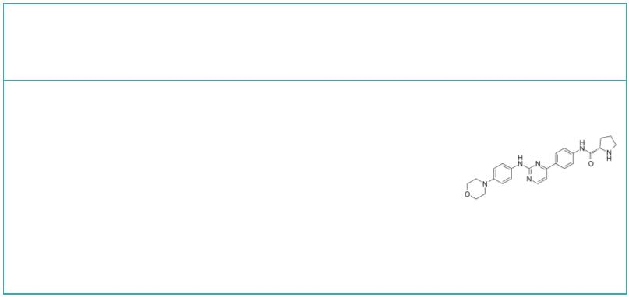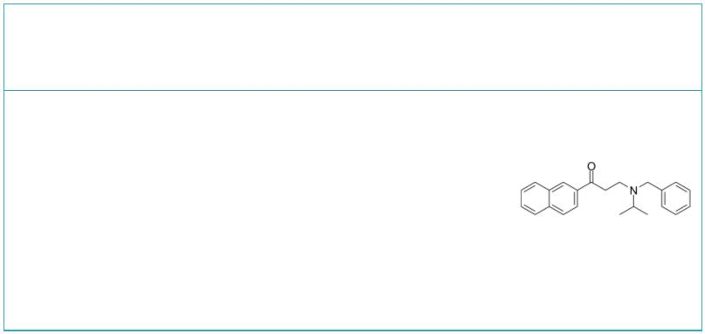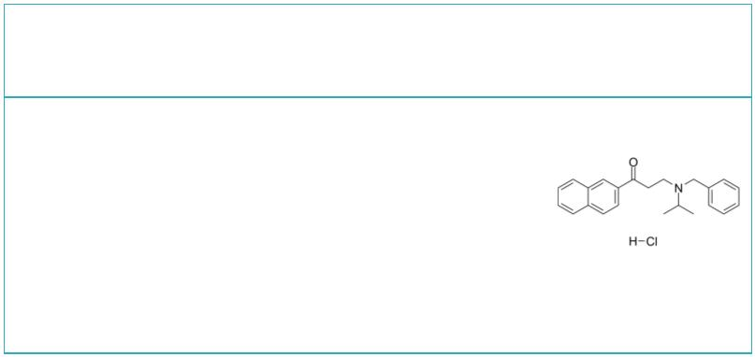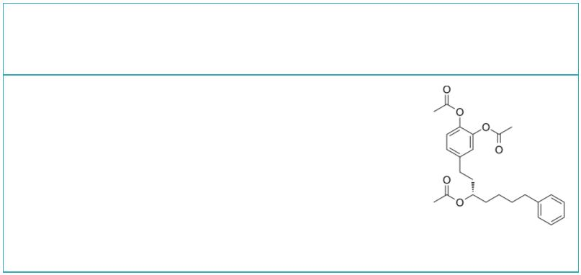 | Tyk2-IN-8 Tyk2-IN-9
 |  | Cat. No.: HY-144031S Cat. No.: HY-144032
 | Tyk2-IN-8 (Compound 3) is a selective Tyk-2  inhibitor with an IC of 5.7 nM for TYK2-JH2.  50  Tyk2-IN-8 inhibits JAK1-JH1 with IC of 3.0 nM.  50  Tyk2-IN-8 can be used for the research of  autoimmune disease. |  |  |  | Tyk2-IN-9 (Compound 26) is a selective Tyk-2  inhibitor with IC s of 0.076 and 1.8 nM for  50  TYK2-JH2 and JAK1-JH2, respectively. Tyk2-IN-9 can  be used for the research of inflammatory or  autoimmune disease.
 | Purity: >98%  Clinical Data: No Development Reported  Size: 1 mg, 5 mg |  |  |  | Purity: >98%  Clinical Data: No Development Reported  Size: 1 mg, 5 mg
 | Upadacitinib  (ABT-494) Cat. No.: HY-19569 |  |  |  | WHI-P154 |  |  |  |  |  |  |  |  |  |  |  |  | Cat. No.: HY-13895
 | Upadacitinib (ABT-494) is a potent, orally active  and selective Janus kinase 1 (JAK1) inhibitor  (IC =43 nM). Upadacitinib (ABT-494) displays  50  approximately 74 fold selective for JAK1 over JAK2  (200 nM) in cellular assays dependent on specific,  relevant cytokines. |  |  |  | WHI-P154 is a potent EGFR inhibitor, and also  modestly blocks JAK3, with IC s of 4 nM and 1.8  50  μM, respectively.
 | Purity: 99.96%  Clinical Data: Launched  Size: 10 mM × 1 mL, 5 mg, 10 mg, 25 mg, 50 mg, 100 mg |  |  |  | Purity: 98.92%  Clinical Data: No Development Reported  Size: 10 mM × 1 mL, 10 mg, 50 mg
 | WHI-P97 WP1066
 |  |  | Cat. No.: HY-11067 Cat. No.: HY-15312
 | WHI-P97 is a potent and selective JAK-3  inhibitor. WHI-P97 is effective in preventing the  development allergic asthma in vivo. |  |  |  | WP1066 is an inhibitor of JAK2 and STAT3, and  also shows effect on STAT5 and ERK1/2, without  affecting JAK1 and JAK3.
 | Purity: 99.13%  Clinical Data: No Development Reported  Size: 10 mM × 1 mL, 5 mg, 10 mg, 50 mg, 100 mg |  |  |  | Purity: 99.90%  Clinical Data: Phase 1  Size: 10 mM × 1 mL, 10 mg, 50 mg
 | XL019 ZM39923
 |  |  | Cat. No.: HY-13775 Cat. No.: HY-12589A
 | XL019 is a potent, orally active, and  selective JAK2 inhibitor, with IC s of 2.2,  50  134.3, and 214.2 nM for JAK2, JAK1 and JAK3,  respectively. |  |  |  | ZM39923 is a JAK3 inhibitor, with a pIC of 7.1;  50  ZM39923 also potently inhibits tissue  transglutaminase (TGM2) with an IC of 10 nM.  50
 | Purity: ≥98.0%  Clinical Data: Phase 1  Size: 10 mM × 1 mL, 5 mg, 10 mg, 50 mg, 100 mg |  |  |  | Purity: >98%  Clinical Data: No Development Reported  Size: 1 mg, 5 mg
 | ZM39923 hydrochloride α7 nAchR-JAK2-STAT3 agonist 1
 |  |  | Cat. No.: HY-12589 Cat. No.: HY-146066
 | ZM39923 hydrochloride is a JAK3 inhibitor, with a  pIC of 7.1; ZM39923 hydrochloride also potently  50  inhibits tissue transglutaminase (TGM2) with an  IC of 10 nM.  50 |  |  |  | α7 nAchR-JAK2-STAT3 agonist 1 is a potent α7  nAchR-JAK2-STAT3 agonist, with an IC value of  50  0.32 μM for nitric oxide (NO). α7 nAchR-JAK2-STAT3  agonist 1 effectively suppresses the expression of  iNOS, IL-1β, and IL-6 in murine RAW264.7  macrophages.
 | Purity: 99.86%  Clinical Data: No Development Reported  Size: 10 mM × 1 mL, 10 mg, 50 mg |  |  |  | Purity: >98%  Clinical Data: No Development Reported  Size: 1 mg, 5 mg
18 Tel: 609-228-6898 Fax: 609-228-5909 Email: sales@MedChemExpress.com

