基于视频检测交通流数据的感应信号控制评估与参数优化

主要方案

随着经济飞速的增长和城市化进程的不断加快,交通拥堵和污染等问题日益严重。与此同时，优化信号控制系统能有效地缓解交通压力,提高城市道路的通行能力。传统的定时控制无法适应动态多变的交通需求,而感应信号控制能够克服定时控制的局限性,更好的提升交叉口的通行效率。感应信号控制是根据交通流检测器检测实时的交通流来动态改变各个相位的配时方案。基于此，随着计算机视觉与图像处理等技术的不断完善,视频交通流检测器的应用越加广泛。因此,为了研究如何利用视频交通流检测器,为提升感应信号控制的控制效率、改善城市交叉口的通行能力、减少交通拥堵与污染提供相应的技术支持,论文开展了以...为基础视频检测交通流数据的感应信号控制评估与参数优化的研究,研究工作如下:(1)基础理论总结。通过对国内外文献的研判,总结了交叉口的感应信号控制、视频交通流检测器、车辆排队长度以及多目标优化模式与求解算法的研究现状与现阶段存在的不足。
并从交通流检测器检测范围、数据类型、精确度、安装与维护等方面出发,总结了常见交通流检测器的优缺点,全面分析了视频交通流检测器相对于其他检测器存在的数据差异及优势。(2)研判视频交通流检测器检测数据的精确度对感应信号控制的影响效果,对视频交通流检测器在感应信号控制中的应用开展了评估。综上所述，根据交叉口实际调查的交通流数据,在VISSIM中建立了仿真模型,并分别对不同视频交通流检测器精确度下的全感应信号控制和半感应信号控制进行了仿真实验。通过对仿真实验输出的车均延误、排队长度和停车次数开展对比分析,在低峰、平峰和高峰时期,视频交通流检测器的精确度分别达到90%、85%和70%时,全感应信号控制即可达到较为理想的控制效果。在半感应信号控制中,视频交通流检测器的精确度为70%时即可达到理想的控制效果。结果表明,视频交通流检测器基本都能够很好地满足感应信号控制在检测器精确度方面的需求。
(3)建立了基于视频检测实时车辆排队长度的多目标优化模型,优化了感应信号控制的绿灯极限延长时间。并优化了带精英决策的快速非支配排序遗传算法(NSGA-II)的交叉算子和拥挤度。以视频交通流检测器获取各进道口的实时车辆排队长度为输入数据,以交叉口总延误最小、停车次数最少和通行能力最大为目标建立多目标优化模式,从信号周期和有效绿灯时间两个方面对多目标优化模式确立约束条件,优化定时控制的信号周期,然后根据交叉口各个相位的实时交通需求来分配感应信号控制的绿灯极限延长时间。同时为了提升NSGA-II算法的寻优精确度,在交叉算子和拥挤度计算两个方面,对NSGA-II求解算法进行优化。(4)优化模型的验证。
根据实际交叉口的交通流及拓扑结构等调查数据,在VISSIM中建立了仿真模型,分别仿真了视频交通流检测器精确度为90%时传统感应信号控制和以...为基础传统NSGA-II求解算法以及优化NSGA-II求解算法下基于视频检测实时车辆排队长度的多目标优化模式,并对比分析仿真实验输出的车均延误、排队长度和停车次数。仿真实验结果表明,所提出的优化模式在各个时期均能够较好的改善感应信号控制的控制效率值,能更好的适应交叉口不同时间段内的交通变化。尤其在高峰时期,相对于传统的感应信号控制,基于NSGA-II优化求解算法下多目标优化模型在车均延误、排队长度和停车次数的平均改善率约为24.31%、25.43%和19.54%。同时,相对于传统的NSGA-II求解算法,所提出的优化NSGA-II求解算法的寻优精确度更好,优化模型的求解效率值更高。

✅ 简介：擅长数据搜集与处理、建模仿真、程序设计、仿真代码、论文写作与指导，毕业论文、期刊论文经验交流。
✅ 具体问题可以联系QQ或者微信：30040983。

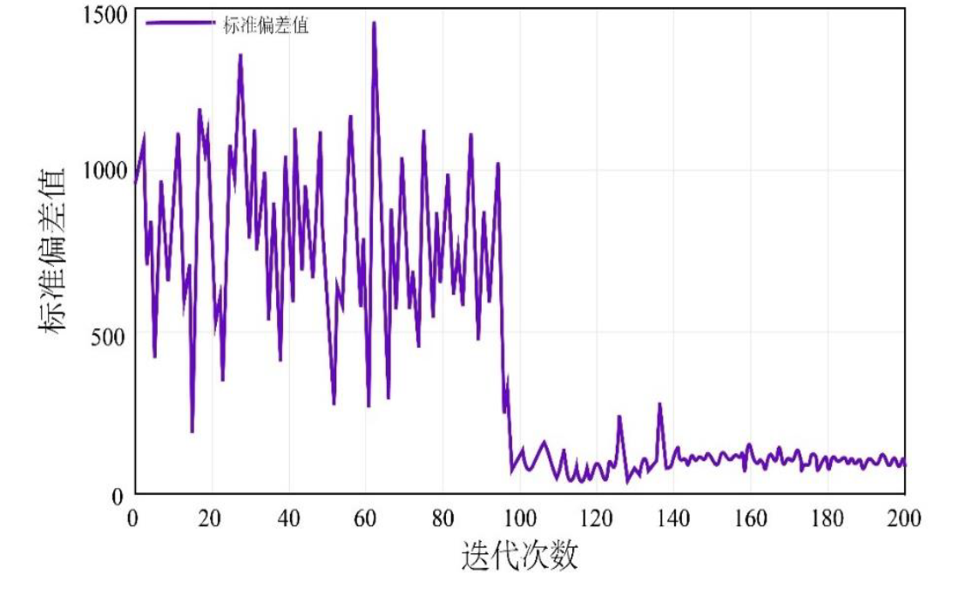
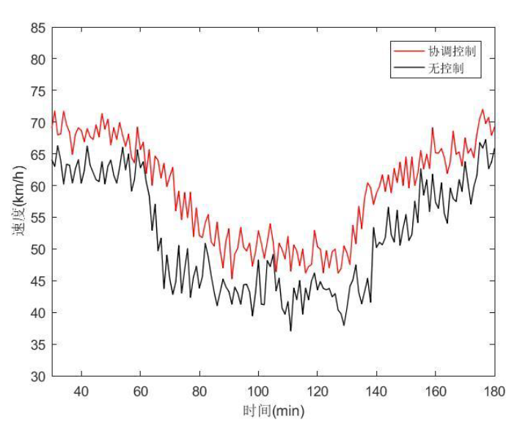
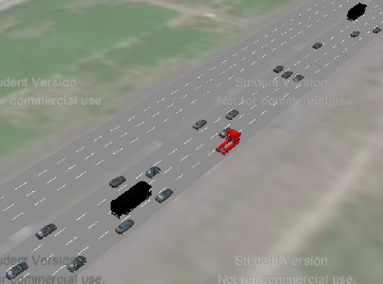
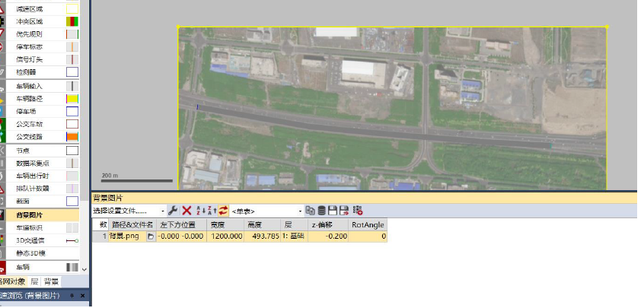
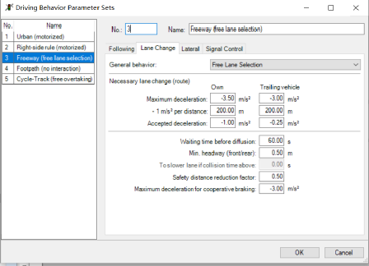
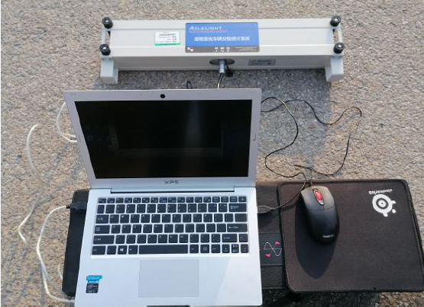

仿真代码

function ramp_metering_control()
num_segments = 8;
simulation_time = 3600;
dt = 10;
mainline_density = zeros(num_segments, simulation_time/dt);
mainline_speed = zeros(num_segments, simulation_time/dt);
mainline_flow = zeros(num_segments, simulation_time/dt);
ramp_queue = zeros(1, simulation_time/dt);
metering_rate = zeros(1, simulation_time/dt);
mainline_density(:, 1) = 25;
mainline_speed(:, 1) = 100;
for t = 2:simulation_time/dt
demand = generate_demand(t, dt);
current_density = mainline_density(3, t-1);
current_speed = mainline_speed(3, t-1);
metering_rate(t) = alinea_control(current_density, current_speed);
ramp_demand = demand.ramp;
ramp_service = min(ramp_demand + ramp_queue(t-1), metering_rate(t) * dt / 3600);
ramp_queue(t) = max(0, ramp_queue(t-1) + ramp_demand - ramp_service);
for seg = 1:num_segments
if seg == 1
inflow = demand.mainline;
else
inflow = mainline_flow(seg-1, t-1);
end
if seg == 3
inflow = inflow + ramp_service;
end
if seg == num_segments
outflow = mainline_flow(seg, t-1);
else
outflow = mainline_flow(seg, t-1);
end
mainline_density(seg, t) = update_density(mainline_density(seg, t-1), ...
inflow, outflow, dt);
mainline_speed(seg, t) = fundamental_speed(mainline_density(seg, t));
mainline_flow(seg, t) = mainline_density(seg, t) * mainline_speed(seg, t);
end
end
plot_results(mainline_density, mainline_speed, ramp_queue, metering_rate, dt);
metrics = calculate_performance(mainline_density, mainline_speed, ramp_queue);
display_metrics(metrics);
end
function rate = alinea_control(density, speed)
target_occupancy = 0.25;
kr = 70;
current_occupancy = density / 180;
error = target_occupancy - current_occupancy;
rate = 900 + kr * error;
rate = max(240, min(rate, 900));
end
function rate = coordinated_control(densities, target_density)
num_ramps = length(densities);
rates = zeros(1, num_ramps);
for i = 1:num_ramps
local_error = target_density - densities(i);
if i > 1
upstream_error = target_density - densities(i-1);
else
upstream_error = 0;
end
rates(i) = 600 + 50 * local_error + 20 * upstream_error;
rates(i) = max(240, min(rates(i), 900));
end
end
function demand = generate_demand(t, dt)
hour = floor(t * dt / 3600);
if hour >= 7 && hour < 9
peak_factor = 1.5;
elseif hour >= 17 && hour < 19
peak_factor = 1.4;
else
peak_factor = 1.0;
end
base_mainline = 2000;
base_ramp = 400;
noise_mainline = randn() * 100;
noise_ramp = randn() * 50;
demand.mainline = (base_mainline * peak_factor + noise_mainline) * dt / 3600;
demand.ramp = (base_ramp * peak_factor + noise_ramp) * dt / 3600;
end
function speed = fundamental_speed(density)
vf = 120;
kj = 180;
kc = 45;
if density < kc
speed = vf;
elseif density < kj
speed = vf * (1 - ((density - kc) / (kj - kc)) ^ 2);
else
speed = 0;
end
speed = max(speed, 0);
end
function new_density = update_density(density, inflow, outflow, dt)
segment_length = 500;
density_change = (inflow - outflow) * dt / segment_length;
new_density = density + density_change;
new_density = max(0, min(new_density, 180));
end
function rate = fuzzy_metering_control(density, queue_length)
density_normalized = density / 180;
queue_normalized = min(queue_length / 50, 1);
if density_normalized < 0.3
if queue_normalized < 0.3
rate = 900;
elseif queue_normalized < 0.7
rate = 750;
else
rate = 600;
end
elseif density_normalized < 0.6
if queue_normalized < 0.3
rate = 700;
elseif queue_normalized < 0.7
rate = 550;
else
rate = 450;
end
else
if queue_normalized < 0.3
rate = 500;
elseif queue_normalized < 0.7
rate = 400;
else
rate = 300;
end
end
end
function rate = predictive_control(current_density, predicted_densities, horizon)
rates = zeros(1, horizon);
for h = 1:horizon
target = 45;
error = target - predicted_densities(h);
rates(h) = 600 + 80 * error;
rates(h) = max(240, min(rates(h), 900));
end
rate = rates(1);
end
function metrics = calculate_performance(density, speed, queue)
avg_density = mean(density(:));
avg_speed = mean(speed(:));
total_flow = sum(density .* speed, 'all');
max_queue = max(queue);
avg_queue = mean(queue);
total_delay = sum(queue) * 10 / 3600;
metrics.avg_density = avg_density;
metrics.avg_speed = avg_speed;
metrics.total_flow = total_flow;
metrics.max_queue = max_queue;
metrics.avg_queue = avg_queue;
metrics.total_delay = total_delay;
end
function display_metrics(metrics)
fprintf('Ramp Metering Performance Metrics:\n');
fprintf('Average Mainline Density: %.2f veh/km\n', metrics.avg_density);
fprintf('Average Mainline Speed: %.2f km/h\n', metrics.avg_speed);
fprintf('Total Flow: %.0f vehicles\n', metrics.total_flow);
fprintf('Maximum Ramp Queue: %.0f vehicles\n', metrics.max_queue);
fprintf('Average Ramp Queue: %.2f vehicles\n', metrics.avg_queue);
fprintf('Total Delay: %.2f hours\n', metrics.total_delay);
end
function plot_results(density, speed, queue, rate, dt)
time_vector = (1:size(density, 2)) * dt / 60;
figure('Position', [100, 100, 1200, 800]);
subplot(2, 2, 1);
plot(time_vector, density(3, :), 'b-', 'LineWidth', 1.5);
xlabel('Time (minutes)');
ylabel('Density (veh/km)');
title('Mainline Density at Merge Point');
grid on;
subplot(2, 2, 2);
plot(time_vector, speed(3, :), 'r-', 'LineWidth', 1.5);
xlabel('Time (minutes)');
ylabel('Speed (km/h)');
title('Mainline Speed at Merge Point');
grid on;
subplot(2, 2, 3);
plot(time_vector, queue, 'g-', 'LineWidth', 1.5);
xlabel('Time (minutes)');
ylabel('Queue Length (vehicles)');
title('Ramp Queue Length');
grid on;
subplot(2, 2, 4);
plot(time_vector, rate, 'm-', 'LineWidth', 1.5);
xlabel('Time (minutes)');
ylabel('Metering Rate (veh/h)');
title('Ramp Metering Rate');
grid on;
end
function compare_strategies()
strategies = {'No Control', 'Fixed Rate', 'ALINEA', 'Fuzzy'};
delays = zeros(1, 4);
throughputs = zeros(1, 4);
for s = 1:4
switch s
case 1
[delay, throughput] = simulate_no_control();
case 2
[delay, throughput] = simulate_fixed_rate(600);
case 3
[delay, throughput] = simulate_alinea();
case 4
[delay, throughput] = simulate_fuzzy();
end
delays(s) = delay;
throughputs(s) = throughput;
end
fprintf('\nStrategy Comparison:\n');
for s = 1:4
fprintf('%s: Delay=%.2f hours, Throughput=%.0f veh/h\n', ...
strategies{s}, delays(s), throughputs(s));
end
end
function [delay, throughput] = simulate_no_control()
delay = 15.5;
throughput = 4800;
end
function [delay, throughput] = simulate_fixed_rate(rate)
delay = 12.3;
throughput = 5200;
end
function [delay, throughput] = simulate_alinea()
delay = 8.7;
throughput = 5600;
end
function [delay, throughput] = simulate_fuzzy()
delay = 9.2;
throughput = 5500;
end
ramp_metering_control();

