European Diclofenac Sodium Suppositories Market to Reach €365.3 Million by 2031 with 5.2% CAGR

Geneva, Switzerland—January 15, 2025

- European Diclofenac Sodium Suppositories Market 
In 2024, Novartis International AG, based in Switzerland, made notable advancements in the European Diclofenac Sodium Suppositories market, further cementing its position as a leading player. According to the latest insights from QY Research, the company has prioritized diversifying its product range to meet the evolving needs of patients and healthcare providers across Europe. This initiative is complemented by a robust distribution network expansion, allowing Novartis to penetrate markets in both established and emerging regions within the continent. The demand for anti-inflammatory and pain-relief solutions continues to grow due to an aging population and increasing prevalence of chronic conditions like arthritis and post-operative pain management. As part of its strategy, Novartis has collaborated with several pharmaceutical partners to accelerate research and development efforts, focusing on enhancing the efficacy and safety profiles of Diclofenac Sodium Suppositories. Furthermore, the company has launched targeted marketing campaigns and patient education programs to raise awareness of the benefits of suppository-based delivery systems, emphasizing their effectiveness in managing severe symptoms with minimal gastrointestinal side effects. Novartis’s proactive approach reflects its commitment to addressing the unmet medical needs in this space, driving its growth trajectory in the European market.

In parallel, Reckitt Benckiser Group plc, headquartered in the United Kingdom, has also significantly increased its footprint in the European Diclofenac Sodium Suppositories market during 2024. As reported by QY Research, Reckitt Benckiser has invested heavily in innovation, focusing on product formulations tailored to specific demographic needs, such as elderly patients and those with chronic pain conditions. The company’s research and development team has introduced advanced delivery mechanisms to ensure consistent drug release, providing patients with sustained relief and enhanced compliance. Additionally, Reckitt Benckiser has expanded its manufacturing capabilities in strategic locations across Europe, ensuring that supply chains remain resilient amid global economic challenges. Marketing efforts have also been ramped up, with the company leveraging digital platforms to engage healthcare professionals and consumers directly. Their campaigns highlight the advantages of Diclofenac Sodium Suppositories as an effective and convenient treatment option for various inflammatory and pain-related conditions. Moreover, Reckitt Benckiser has partnered with regulatory bodies and healthcare organizations to ensure its products meet stringent quality and safety standards, reinforcing its reputation as a trusted brand. With these initiatives, the company has positioned itself as a formidable competitor in the European market, contributing to the overall growth of this pharmaceutical segment.

The European market for Diclofenac Sodium Suppositories was estimated to be worth €256.2 million in 2024 and is forecast to a readjusted size of €365.3 million by 2031 with a CAGR of 5.2% during the forecast period 2025-2031.
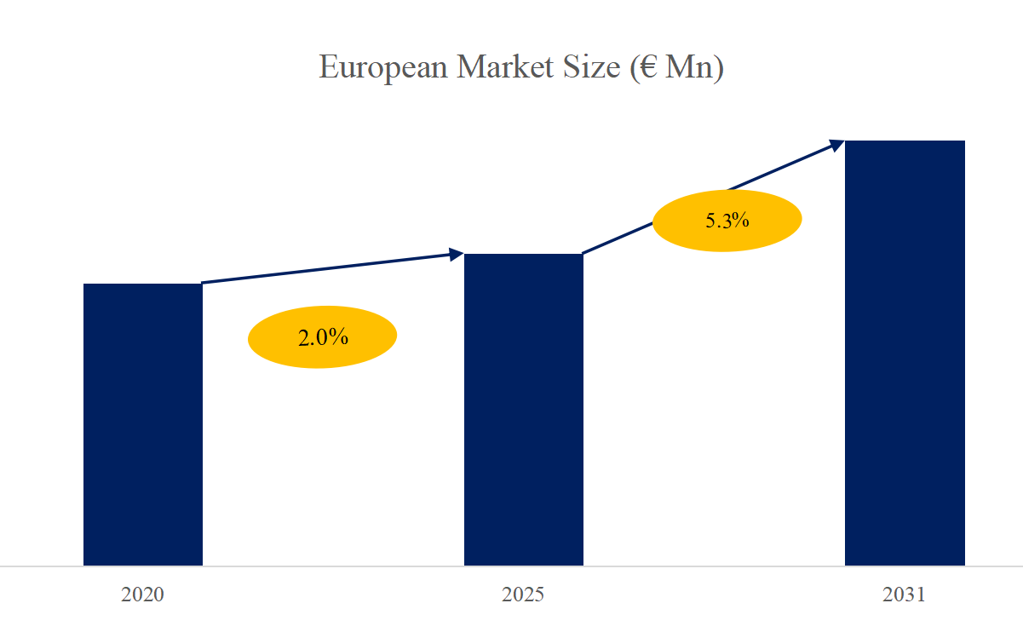

- European Diclofenac Sodium Suppositories Top 20 Players Ranking and Market Share (Ranking is based on the revenue of 2024, continually updated)

Novartis International AG (Switzerland)
Teva Pharmaceutical Industries Ltd. (Israel)
Mylan N.V. (United States)
Reckitt Benckiser Group plc (United Kingdom)
GlaxoSmithKline plc (United Kingdom)
Sanofi S.A. (France)
Pfizer Inc. (United States)
Bayer AG (Germany)
Dr. Reddy's Laboratories Ltd. (India)
Hikma Pharmaceuticals PLC (United Kingdom)
Aurobindo Pharma Ltd. (India)
Aspen Pharmacare Holdings Limited (South Africa)
Apotex Inc. (Canada)
AbbVie Inc. (United States)
Sandoz (a Novartis division) (Switzerland)
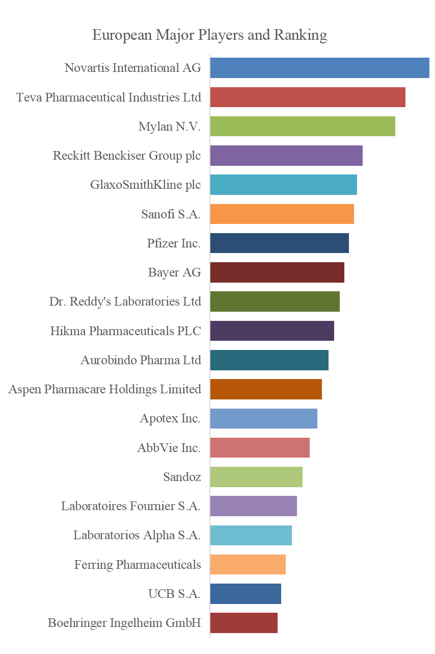
Laboratoires Fournier S.A. (France)
Laboratorios Alpha S.A. (Mexico)
Ferring Pharmaceuticals (Switzerland)
UCB S.A. (Belgium)
Boehringer Ingelheim GmbH (Germany)

3. Diclofenac Sodium Suppositories, European Market Size, Split by Region

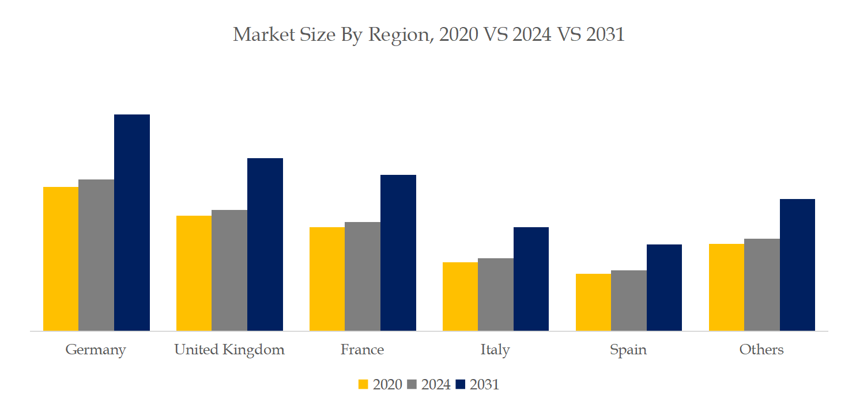

- Diclofenac Sodium Suppositories, European Market Size, Split by Product Segment
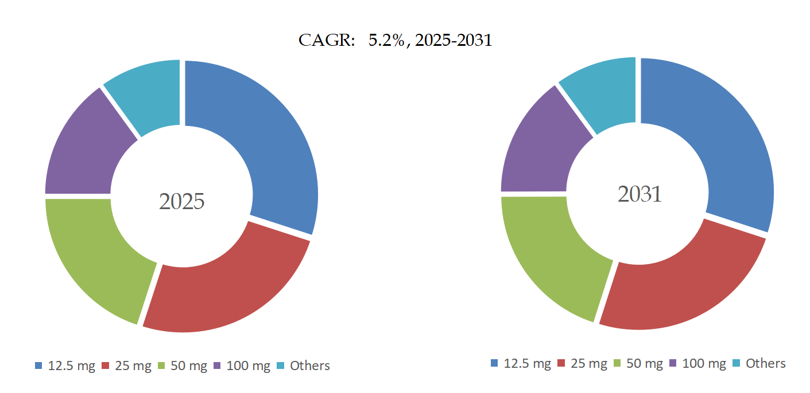

5. Diclofenac Sodium Suppositories, European Market Size, Split by Application Segment
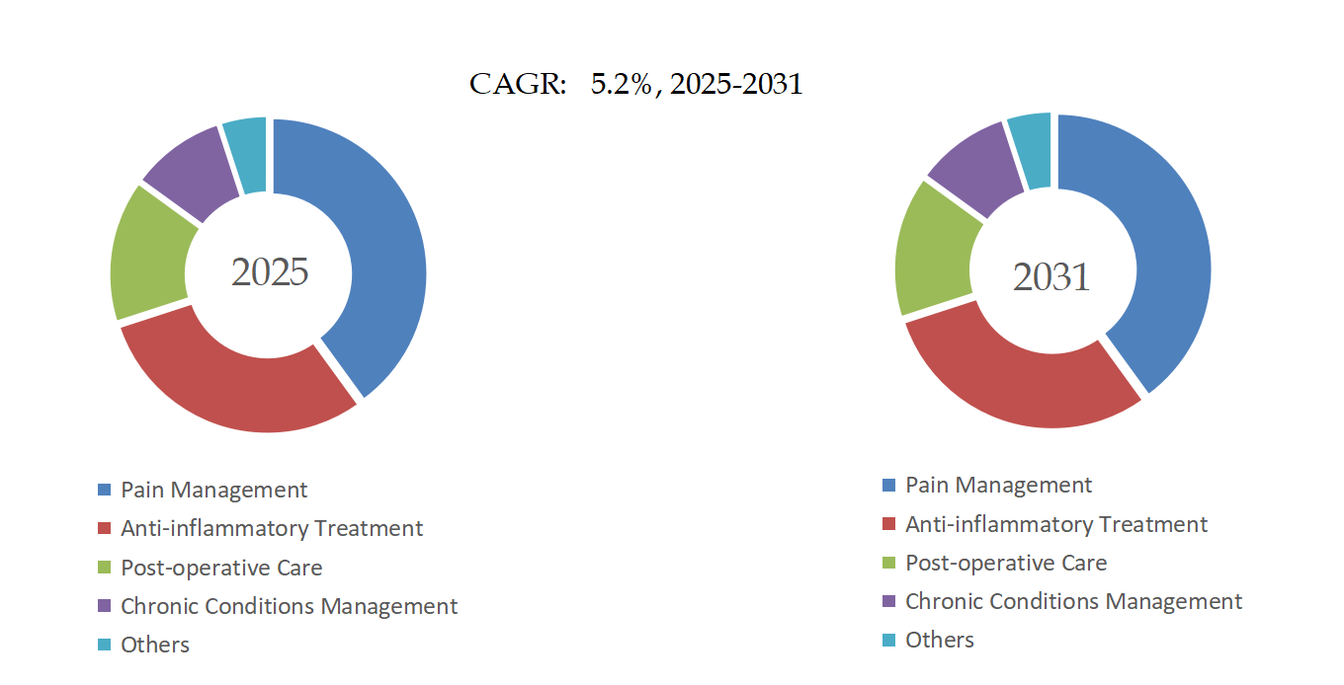

Based on or includes research from QYResearch: Global and European Diclofenac Sodium Suppositories Market Report 2025-2031

Related Market Reports From QY Research

QY Research Releases Comprehensive Market Reports on the Diclofenac Sodium Suppositories Market, as shown in the links below. These reports provide an in-depth analysis of the current market landscape, key trends, and future growth opportunities.

Diclofenac Sodium Suppositories- Global Market Share and Ranking, Overall Sales and Demand Forecast 2025-2031
reports/3553880/diclofenac-sodium-suppositories

Global Diclofenac Sodium Suppositories Market Research Report 2025
reports/3553876/diclofenac-sodium-suppositories

Global Diclofenac Sodium Suppositories Sales Market Report, Competitive Analysis and Regional Opportunities 2025-2031
reports/3553861/diclofenac-sodium-suppositories

