
.

2011 年普通高等学校招生全国统一考试（福建卷）

英语

第Ⅰ卷（选择题共 115 分）

第一部分，听力（共两节，满分 30 分）

做题时，先将答案标在试卷上，录音内容结束后，你将有两分钟的时间将你的答案转涂到客观题答题卡上。

一、听力（共 5 小题：每小题 1.5 分，满分 7.5 分）
听下面 5 段对话。每段对话后有一小题，从题中所给出的 | A.B.C 三个选项中选出
最佳选项，并标在试卷的相应位置。听完每段对话后，你都有 | 10 秒钟的时间来回
答有关小题和阅读下一小题，每段对话仅读一遍。
例： How mony is the shirt?
A. ＄19.15
B. ＄9.15
C. ＄9.18
答案是 B
What dose the man like about the play?
A.The story
B. The ending
C. The actor
2.Which place are the speakers trying to find?
A.A hotel.
B.A bank
C.A reastnurant.
3.At what time will the two speakers meet?
A.5:20.
B.5:10.
C.4:40.
4.What will the man do?
A.Change the plan

;.

.

B.Wait for a phone call.

C.Sort things out.

5.What does the woman want to do?

A. See a film with the man.

B. Offer the man some help.

C.listen to some great music.

第二节（共 15 小题：每小题 1.5 分，满分 22.5 分）

听下面 5 段对话，每段对话后有几个小题，从题中所给的 A、B、C 三个选项中选

出最佳选项，并标在试卷的相应位置。听每段对话前，你将有时间阅读各个小题，

每小题 5 秒钟；听完后，各小题给出 5 秒钟的作答时间，每段对话读两遍。

听第 6 段材料，回答第 6、7 题。

6.Where is Ben?

A.In the kitchen

B.At school

C.In the park

7.What will the children do in the afternoon?

A.Help act the table.

B.Have a part

C.their homrwork.

听第 7 段材料，回答 8、9 题。

8.What are the two spcakers talking about?

- family holiday B.A business trip

C.A travel plan

9.where did Rachel go?

A.Spa

B.Italy

C.China

听第 8 段材料，回答第 10 至 12 题。

10.How did the woman get to know about third-hand smoke?

;.

.

A.From young smokers

B.From a newspaper article

C.From a smoking parents

11.Why does the man say that he should keep away from babies?

A.He is just become a father

B.He wears dirty clothes

C.He is a smoker

12.What does the woman suggest smoking parents should do?

A.Stop smoking altogether

B.Smoke only outside their houses

C.Reduce dangerous matter in cigaretties

听第 9 段材料，回答第 13 至 16 题。

13.Where does Michelle Ray come from?

- middle-sized eity B.A small town

C.A his city

14.Which place would Michele Ray take her visitors to for shopping? A.The Zen Garden

B. The Heathland.

C. The P Raver area.

What does Michelle Ray do for complete quiet?

A. Go camping

B. Study in a library.

C. Read at home.

What are the speakers talking about in general?

A. Late-night shopping.

B. Asian food.

C. Louisville.

听第 10 段材料，回答第 17 至 20 题。

Why do some people say they never have dreams according to Dr Garfield ?

;.


.

Thy forget about their dreams.

Thy don't want to tell the truth.

They have no bad experiences.

Why did Davis stop having dreams?

He got a serious heart attack.

He was too sad about his brother's death

He was frightened by a terrible dream.

- What is Dr Garfield s opinion about dreaming? A. It is very useful.

B. It makes things worse.

C. It prevents the mind from working.

20.Why do some people turn off their dreams completely? A. To recover from illnesses.

B. To recover from illnesses.

C. To stay away from their problems.

第二部分 英语知识运用（共两节，满分 45 分）

第一节 单选填空（共 15 小题，每小题 1 分，满分 15 分）

- A、Ｂ、Ｃ、Ｄ、四个选项中，选出可以填入空白处的最佳选项，并在答题卡上将该选项涂黑。

例： It is generally considered unwise to give a child be or she wants.

you can choose ____ based on your own interests.

A. either B. each C. one D. it

22. good service, the restaurant offers different kinds of traditional

Fujian dished.

A. Far from B. Apart from

C. instead of D. Regardless of

23. Tsinghua University, in 1911,is home to a great number of outstanding

figures.

A. found B. founding

C. founded D. to be founded

;.


.

- She has a gift for creating an atmosphere for her students ____ allows them to communicate freely with each other.

A. which B. where C. what D. who

25.-Shall has a gift for creat an atmosphere for her students allow them to

communicate freely with each other.

-I am afraid you ,in case he comes late for the mooting .

A.will B.must C.may D.can

26.The lack of eco-friendly |  |  |  |  | habits |  | among | the | public | is thought to | be a major
of global climate change.
A.result |  | B.cause |  |  | C.warning |  |  | D.reflection
27.The | difference |  | in thinkness |  |  | and | weight | from the |  | earlier version | makes the
iPad 2 more comfortable |  |  |  |  |  | .
28.I ’ d prefer to |  |  | my judgement until I find all the evidence.
A.show | B. express |  |  | C.pass |  |  | D.reserve
29.- It ’ s nice.Never before |  |  |  |  |  | such a special drink!
-I ’ m glad you like it.
A.I have had |  |  | B. I had |  |  | C. have I had |  |  | D. had I
30.Nowedays, |  |  |  |  | increase |  | in children |  | ’creativity,fors they |  | are greatly
encouraged to drevelop their tilents.
A.sharp | B.slight |  | C.natural |  |  |  | D.modest
31.Born into a family with three brothers,David was |  |  |  |  |  |  |  |  |  | to value the sense of
sharing.
A.brought up |  | B.turned down |  |  |  | C.looked after |  |  | D.held back
32.Last month,the Japanese government expressed their thanks for the aid they
From China.
A.receive |  | B.are receiving |  |  |  | C.have received |  |  |  | D.had received

;.


.

33.It was April 29,2001 Prince William and Kate Middleton walked into

the palace hall of the wedding ceremony.

A.that B.when C.since D.berore

34. —— Play you missed the lecture on nuclear pollution 。

—— I it,but I was busy preparing for a job interview.

A.attended B.had attended

C.would sttend D.would have attended

35. —— My teacher says she ’ s canceling the class play.I just can nderstand.’ t u

—— |  | .You were looking forwars to it.
A.It doesn ’ t matter |  |  |  |  | B.It ’ s very unwise of her
C.Don’ t worry about it |  |  |  |  | C.You must be disappointed
第二节 完形填空（共 20 小题；每小题 1.5 分，满分 30 |  |  |  |  |  |  |  |  |  | 分）
 | 阅读下面短文，从短文后给题所给的四个选项（ |  |  |  |  |  |  |  | A、B、C、D）中，选出可以
填入空白处的最佳选项，并在答题卡上将该项涂黑。
 | Diana Velex does everythings with maximum effore |  |  |  |  |  |  |  |  | —and at maximum
speed.That 36 learning a new languague,completing two certificates and
opening a store.
 | When arriving in Canada in 2008,she had one |  |  |  |  |  |  |  | 37 |  | ;to | have what she
had back Home in Colombia. |  |  |  |  | ” I didn | ’ t want 38to |  |  | what I do ,like so many who
come to a new Country, |  |  |  | ” she said . 39” Ito open a store here in Canada but
knew I had to 40 |  |  | myself properly. |  |  | ”
 | Diana quickly realize that making her dream of shop owership in Canada a
41 | Meant | going | to | school | to get | the | 42 | education |  |  | and | certification. |  | ” My
experience of Owning a shop and working as a designer in Colombia gave me43
in my abilities. But I Cound’ tspeak |  |  |  |  |  | the language |  |  | and I had to 44 |  |  |  | how to do
things in Canada. It was like having to. 45 |  |  |  |  |  |  | all over again, |  |  |  | ” said Diana
 | 46 | ， she found |  |  | just the | help | she | needed |  | for | relaunch |  | ( 重新开张 )
47 continuing education at George Brown College. She began taking |  |  |  |  |  |  |  |  |  |  |  |  | 48
for | both the | Essential |  | Skills | in Fashion |  | Certificate |  | and the image |  |  |  | Consulting
Certificate in May 2009. |  |  |  | 49 Diana met with the language barrier, she was

;.


.

always going |  |  | 50 | while at college.
 | By the end of October 2009,she had completed all certificate requirements.
Within two years after her |  |  |  |  | 51 | in |  | Canada, | Diana | at | last achieved | her
52 goal when her new store opened its doors in Toronto |  |  |  |  |  |  |  |  |  |  | ’ s Sheppard Center.
She was on the fast-track to |  |  |  |  | 53 .
 | Looking back, Diana, a fashion （时装）designer, |  |  |  |  |  |  |  | 54 | her achievements to
the goal she set, the education she received from the college, and |  |  |  |  |  |  |  |  |  |  | 55 | the
efforts she made. Now Diana is very happy doing what she is doing.
36. | A. requires |  | B. encourages |  |  |  |  | C. interduce |  |  | D. advises
37. | A. goal |  | B. memory |  |  |  |  | C. choice |  |  | D. problem
38. | A. aontinue |  | B. choose |  |  |  |  | C. change |  |  | D. lose
39. | A. demanded |  | B. decided |  |  |  |  | C. agreed |  |  | D. hesitated
40. | A. teach |  | B. prepare |  |  |  |  | C. enjoy |  |  | D. persuade
41. | A. reality |  | B. fact |  |  |  | C. challenge |  |  |  | D. wonder
42. | A. phyaical |  | B. private |  |  |  |  | C. primary |  |  | D. necessary
43. | A. pressure |  | B. judgement |  |  |  |  | C. influence |  |  | D. confidence
44. | A. put away |  | B. depend on |  |  |  |  | C. learn about |  |  | D. look into
45. | A. advance |  | B. start |  |  |  |  | C. suffer |  |  | D. work
46. | A. Naturally |  | B. Gradually |  |  |  |  | C. Luckily |  |  | D. Clearly
47. | A. through |  | B. for |  |  |  |  | C. before |  |  | D. with
48. | A. notes |  | B. responsibilities |  |  |  | C. chances |  |  |  | D. courses
49. | A. Though |  | B. AS |  |  |  |  | C. Since |  |  | D. Once
50. | A. around |  | B. back |  |  |  |  | C. ahead |  |  | D. out
51. | A. adventure |  | B. arrival |  |  |  |  | C. performance |  |  | D. journey
52. | A. original |  | B. common |  |  |  |  | C. another |  |  | D. distant
53. | A. success |  | B. wealth |  |  |  |  | C. glory |  |  | D. happiness
54. | A. adds | B. connects |  |  | C. devotes |  |  | D. owes
55. | A. after all |  | B. above all |  | C. at least |  |  | D. at first
第三部分 阅读理解（共 |  |  |  | 20 小题；每小题 |  |  | 2 分，满分 40 分）

;.


.

阅读下列短文， 从每题所给的四个选项 （ A、B、C 和 D）中 ，选出最佳选项，

并在答题卡上将该项涂黑。

A

Driving a car is not just handling controls and judging speed and distance. It requires you to predict what other road users will do and get ready to react to something unexpected , When alcohol is consumed, it enters your bloodstream

and acts as a depressant （抑制药） ， damaging eyesight, judgment and co-ordination （协调），slowing down reaction time and greatly increasing the risk of accidents. Even below the drink driving link , driving well be affected.

Alcohol may take a few minutes to be absorbed into the bloodstream and start action on the brain. Absorption rate is increased when drinking on an empty stomach or when consuming drinks mixed with fruit juice. To get rid of alcohol from the body is a very slow process and it is not possible to speed it up with any measures like taking a shower or having a cup of tea or coffee.

The present Road Traffic Ordinance states clearly that the limit of alcohol concentration is :

- 50 milligrams of alcohol per 100ml of blood ;or

- 22 micrograms of alcohol per 100ml of breath ;or

● 67 milligrams of alcohol per 100ml of urine( 尿液 )

Drivers who cause traffic accidents, or who commit a moving traffic offence

or are being suspected of drink driving will be tested.

Any drive found drinking beyond the limit will be charged.The driver

declared guilty may be fined a maximum of HK ﹩25,000 and be sentenced to up

to 3 years in prison and punished for 10 driving-offence points; or temporarily

banned from driving.

The same punishment applices to failing to provide speciments( 样本 ) far

breath, blood or urine tests without good excuse.

Drink driving is a criminal offebce.Be a responsible,driver,think before you

drink. For the safety of yourself and other road users, never drive after

consuming alcohol.

;.

.

56.The first paragraph is mainly about_____________.

A. the introductions of driving skills B. the dangaga of drinking to your

body

C. the effect of drinking on driving D. the process of alcohol being

absorbed

57.The underlined word “ it ” in the second paragraph refers to “ ________”.

A. alcohol B. absorption C. blood D. process

58 Which of the following is TRUE according to the passage?

A. Drinking below the drink driving limit has no effect on driving.

B. Alcohol is taken in more quickly when drunk with fruit juice.

C. Having a cup of tea helps to get rid of alcohol from the body.

D.50 milligrams of alcohol per 100ml of breath is below the drink limit

59.A drive suspeced of drink driving_________.

A.Should provide specimens for testing.

B.be forbidden to drive for 3years

C.Will be punished for 10 driving-offence points

D.Should pay a maximum fine of HK ＄25,000

B

For five days,Edmonton's Downtown Park is transformed into one huge

stage where artists are able to share their talents, and where people are able to

celebrate and enjoy themselves .Since is beginning in 1980,the Edmonton

Folk Music Festival has been commemorating( 念） the ture feeling of what folk

music is all about and that's the traditional togetherness( 友爱） that is felt when

people gather to share stories and feelings through song.

This year will be the sixth year when volunteer Riedel will be offering up her

time to the festival. "People coming off a busy spring and summer have a

moment of relaxation ," Riedel said. "It's really east to relax, and it's great seeing

family and friends have fun together." These families and friends come from all

different kinds of musical tastes. People who take pleasure in Blues are there, so

are people who love Bluegrass. This festival does its best to develop everyone's

;.

.

musical interests.

With so many years of expenence .the festival has become a well-oiled

machine, and does whatever it can to make attendees feel as possible. There

are free water stations throughout the venue( 举办地） for people to fill up their

travel cups. When people buy food, reusable ashes are given a $2 plate fee, but that is returned when the plate is brought back.

The festival has completely sold out of tickets, and in record time. But with

big names such as Van Morrison and Jakob Dylan, it ’ s easy to see how that was

going to happen. There is no parking area during the festival, so using the Park

& Ride system or Edmonton Transit is highly recommended. A bike lock-up area

is provided and will be available Thursday until Sunday one hour before the

gates open until 45 minutes after the gates close.

The Edmonton Folk Music Festival begins on Wednesday, Aug.4 with Van

Morrison playing the special donation fund （基金） concert, and will finish up on

Sunday, Aug.8.

- The Edmonton Folk Music Festival is held mainly to ___________. A. gather people with different musical tastes

B. remind people of the real sense of folk music

C. exhibitive good voices of great talents in folk music D. collect old stories of folk music

- Which of the following is TRUE according to the passage?

A. Riedel has volunteered for the festival for at least 5years.

B. It ’hards for people to appreciate Blues.

C. It costs people a little to fill up their cups from water stations.

D. People have to pay ﹩ 2 for a plate of food.

- We can learn from the passenger that____. A. people can get tickets easily for the festival
B. the Edmonton Folk Music Festival is highly recommended.

C. driving one ’ s own car to the festival is highly recommended D. bikes are available at the festival from Wednesday to Sunday

;.

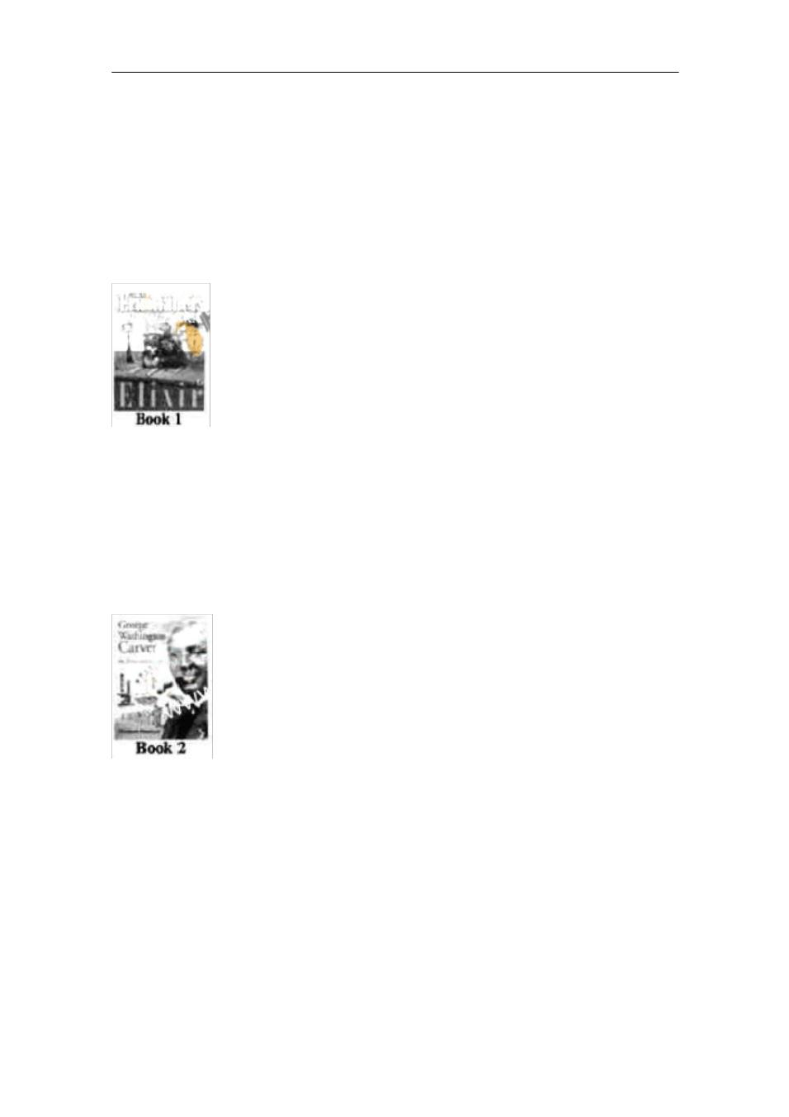
.

- What would the best title for the passenger? A. Folk Music of Blues

B. One Festival Family Gathering C. Festival for family Gathering D. Edmonton ’ s Downtown Park

C

Elixir

written by Eric Walters

Twelve-year-old Roth becomes a friend of Dr. Banting and his assistant, Mr.

Best, who are in search of a cure for diabetes （糖尿病） .She finds herself torn between her sympathy for the animals being experimented on and her friendship with Banting and Best.

George Washingtion Carver

Written by Elizabeth Macleod

Meet the “ Peanut（花生） Specialist ”George, Washington Carver, the

inventor and professor who made over 325 products out of peanuts. Through his

agricultural research, he also greatly improved the lives of countless black

farmers in the southern United States. See also Macleod ’ s Albert Einstein: A Life

of Genius.

;.

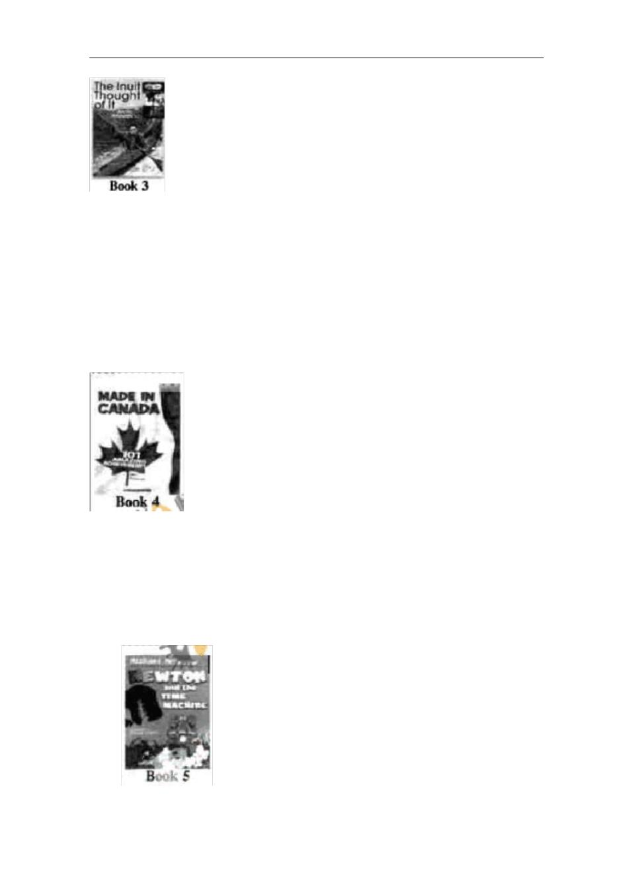
.

The Inuit Thought of It: Amazing Arctic Innovations

Written by Alootook Ipellie & David MacDonald

Explore more than 40 ideas necessary to Inuit survival. From ideas familiar to us today to inventive concepts that shaped their lives, celebrate the creativity of a remarkably intelligent people. Also see other books; The Chinese Thought of It by Tingxing Ye and A Native American Thought of It by Rocky Landon and David MacDonald.

Made in Canada:101 Amazing Achieverms

Written by Bev Spencer

What things do we use daily that have a Canadian connection?Here are 101 common things that were invented in Canada or by a Canadian,including the Blackberry,alkaline( 碱性 ) batterices and the Blue Box yecycling program.

Newton and the Tlme Machine

;.

.

Written by Michael Me Gowan

Ten-year-old boy Newton has invented a time machine to see dinesaurs up

close.But it disappears on a test run with his two huge friends,King Herbert and

Queen Certunde,in can he save them before time runs out?

64. Which of the following best describes Roth ’ s feeling in Book 1?

A. Painful B. Curious C. Frightened D. Disappointed

- Which of the following is TRUE according to the passage? A. Animals are mentioned in Book 1 and Book 5.

B. Book 3 introduces 40 inventive concepts.

C. Alkaline batteries were invented by Dr. Banting.

D. George Washington Carver was a black farmer in the US.

- In Book 5, King Herbert and Queen Gertrude are_______

A. Newton ’ s human friends |  |  |  |  |  |  | B. the names of the time machine
C. two dinosaurs |  |  |  |  |  |  | D. the inventions of the time machine
67. If you are interested in native Americans, you may read the book by _____.
A. Elizabeth Macleod |  |  |  |  |  |  | B. Eric Walters
C. Rocky London & David MacDonald |  |  |  |  |  |  |  |  | D. Bev Spencer
 |  |  |  |  |  |  | D
Jacqueline Bouvier Kennedy Onassis was one of the most private women in
the world, yet when she went to work as an editor in the last two decades of her
life, she revealed ( |  |  |  | 展现 ) herself as she did nowhere else.
After | the |  | death |  | of | her | second | husband,Greek |  |  | shipping |  |  | magnate
AristotieOnassis |  |  |  | laqueline |  | ’close friend and former White House social |  |  |  |  |  |  |  |  |  | ?
Letitis Baldrige made a suggestion that she consider a career in publishing.After
consideration,
Jacqueline accepted it.Perhaps she hoped to find there some ideas about
how to live her own life .She became not less but more interested in reading.For
the last | 20 | years of her life, |  |  |  | Jacqueline |  | worked as a publisher |  |  |  |  | ’ s editor, first at
Viking,then at Doubleday ,pursuing （追求） a late-life career longer than her two
marriages |  | combined.During |  |  |  | her time in publishing, |  |  |  | she | was |  | responsible |  |  | for
managing and editing more than 100 |  |  |  |  |  |  |  | sucessfully | marketed |  |  | books.Among |  |  |  | the
first books were In the Russian Style |  |  |  |  |  |  |  | and Inventive |  | Paris |  | Clothes.She |  |  | also
succeeded |  | in | persuading |  |  | TV | hosts | Bill Moyers and |  |  | Joseph Campbell |  |  |  |  | to
transform their popular television conversation |  |  |  |  |  |  |  |  | into | a | book |  | ,The | Power |  | of
Myth.The |  | book |  | went | on | to | become | an international |  |  | best-seller.She |  |  |  | dealt
too.with Michael Jackson as he prepared his autobiography( |  |  |  |  |  |  |  |  |  |  | 自传 )，Moonwalk.

Jaequelinered for her name and for her social relations,but she soon proved

Her worth.Her shoicas,suggestions and widespread social relations were of

benefit both to the publishing Since and to Jacqueline herself.In the books she

selected for publication,she built on a lifetime of spending time by herself as a

;.

’ s life both as Fist Lady andeditoras. ’ s lifelong experiences.
’ s career as an editor in her last 20 years. ’ s social relations in publishing
E

.

reader and left a record of the growth of her mind.Her books are the autobiofraphy she never wrote,Her role as First lady,in the end,was overshadowed by her performance as an editor.However,few knew that she had achteved so much.

68.We can learn from the passage that Jecqueline A.because fond of reading after working as an editor B.was in charge of publishing 100 books C.promoted lier books through social relations D.gained a lot from her career as an editor

69.The underlined sentence in the last paragph probably means this A.Jscqueline ’ s ended up as an editor rather than as First Lady

B. Jscqueline ’ s life as First Lady was more colorful than as an editor C. Jscqueline was more successful as an editor than as First Lady

D. Jscqueline ’ s role as First Lady was more brilliant than as an editor 70.What can be inferred from the passage?

A. Jscqueline ’ s two marriages lasted more than 20 years B. Jscqueline s ’own publishing firm was set up eventually

C. Jscqueline ’ s views and beliefs were reflected in the books she edited D. Jscqueline ’ s achievements were widely known

71.The passage is mainly A.an introduction of jacqueline B.a brief description of jacqueline C.a brief account of jacqueline D.an analysis of Jscqueline

The internet will open up new vistas ( 前景 ),creat the global village- -you

can make new friends all around the world. That,at least, is what it promised us.

The difficulty is that

It did not take the human mind into account. The reality is that we cannot

keep relationship than a limited number of people. No matter how hard the

;.


.

internet tries to put

You in communication, its best efforts will be defeated by your mind.

The problem is twofold （双重的） . First, there is a limit on the number of

people we can hole in mind and have a meaningful relationship with. That

number is about 150 and is set by the size of our brain. Second, the quality of

your relationships depends on the amount of time you invest （投入） in then. We

invest a lot in a small number of people and th en distribute what ’ s left among as

many others as we can. The problem is that if we invest little time in a person,

our engagement with that person will decline （减弱） until eventually it dies into

“ someone I once knew ”.

This is not, of course, to say that the internet doesn’ tserve a socially

valuable function. Of course it does. But the question is not that it allows you to

increase the size of your social circle to include the rest of the world, but that you

can keep your relationships with your existing friends going even though you

have to more to the other side of the world.

In one sense, that ’as good thing. But it also has a disadvantage. If you continue to invest in your old friends even though you can no longer see then,

then certainly you aren ’gt yourusin time to make new friends where you now live. And I suspect that probably isn ’the best use of your time. Meaningful relationships are about being able to communicate with each other, face to face.

The internet will slow down the rate with which relationships end, but it won’ t stop that happening eventually.

72. What is stressed in the first paragraph?

A. The present situation of the internet.

B. The difficulty in communication on the internet.

C. The socially valuable function of the internet.

D. The role of the human mind in the internet communication.

- The underlined word “ engagement”in the second paragraph probably means “ ____”.

A. appointment B. connection C. interview D. agreement

;.

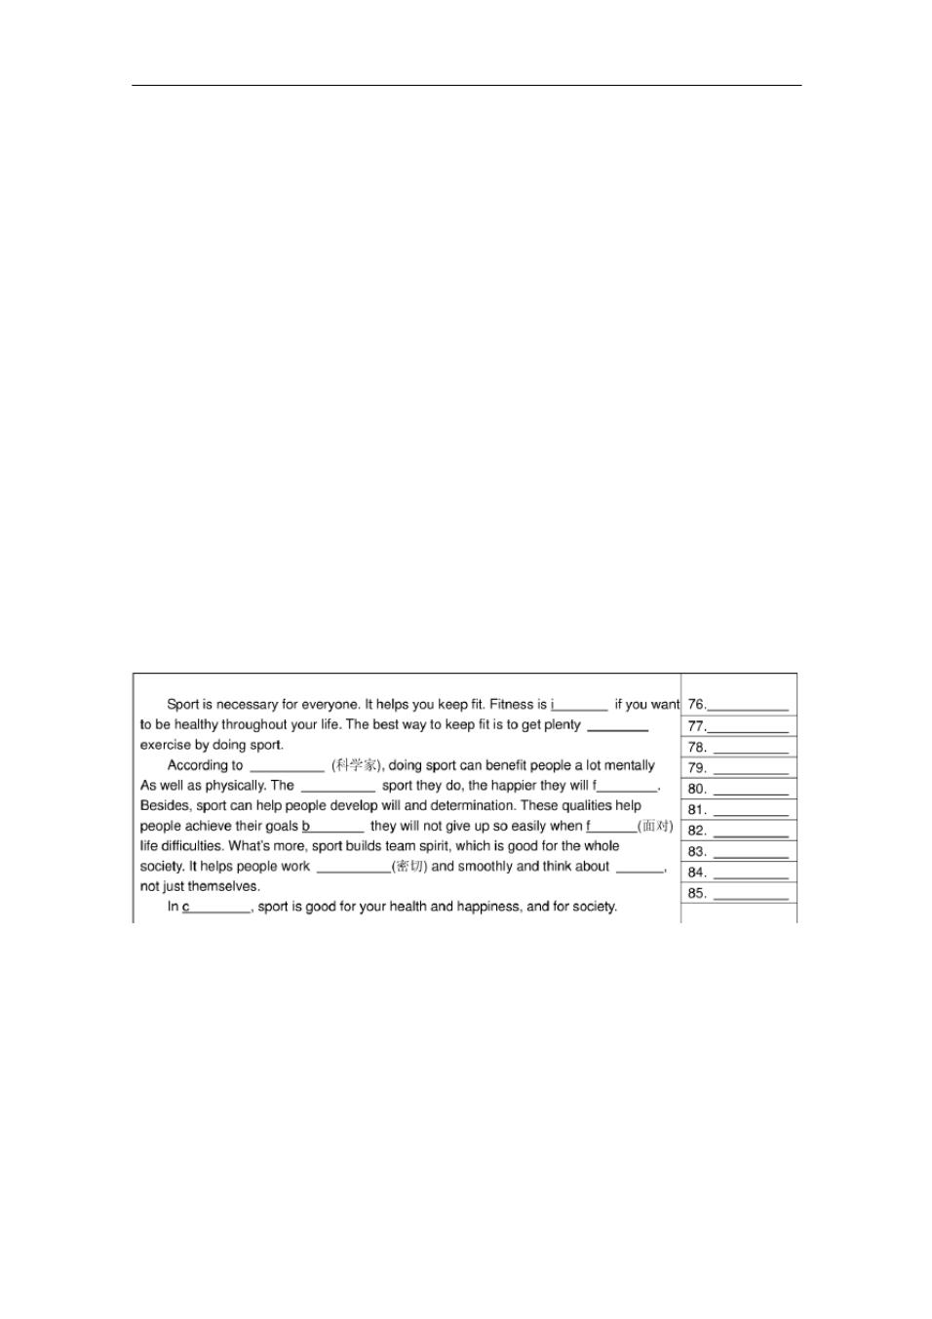
.

74. According to the passenger, the author holds the view that____.

A. the internet fails to play so valuable a role in communication as it promised B. the internet determines the quality of social relationships

C. the internet greatly increases the size of social circles D. the internet communication is no less effective than the face-to-face talk

- What is the author ’attitudes towards the use of the internet to strengthen relationships?

A. He is uncertain about it. B. He is hopeful of it.

C. He approves of it. D. He doubts it.

- II 卷（非选择题 共 35 分）

第一节 短文填词（共 10 小题；每小题 1 分，满分 10 分）

阅读下面短文，根据下列提示： 1）汉语提示， 2）首字母提示， 3）语境提示，

在每个空格内填入一个适当的英语单词，并将该词完整地写在右边相对应的横线

上。所填单词要求意义准确，拼写正确。

参考答案
1---20 | CABBA |  | CBACB |  | CAABC |  | CABAC
21---35 | CBCAB |  | BDDCA |  | ADBDD
36---55 | CACBB |  | ADDCB |  | CADAC |  | BAADB
56---75 | CDBAB |  | ABBAA |  | CCDCC |  | CDBAD
76 、important |  | 77 、 of |  | 78 、 scientists |  |  | 79 、 more | 80 、feel | 81 、because | 82 、
facing | 83 、closely |  |  | 84、 others |  | 85 、 conclusion

;.

