AbMole科研小讲堂丨Hepcidin-25：连接炎症、贫血与肿瘤的关键生物标志与研究工具
Hepcidin-25是一种由25个氨基酸组成的肽类激素，在其肽链中存在着一条金属结合基序，并在脊椎动物铁代谢调控中发挥核心作用¹。作为铁稳态的"主调控因子"，它通过抑制肠道铁吸收和巨噬细胞铁释放来调控循环铁的水平²。Hepcidin-25常常作为疾病模型中的分析指标或者生物标志分子。例如在健康状态下，大鼠血浆中Hepcidin-25的平均浓度为63.0 ng/mL，而在脂多糖刺激后显著升高至218.2 ng/mL，表明Hepcidin-25与炎症反应高度相关³。在心血管领域，研究发现Hepcidin-25与动脉僵硬度存在关联⁴。Hepcidin-25还可调节铁代谢，Hepcidin-25与其受体铁输出蛋白结合后，可抑制肠道铁吸收以及肝细胞和巨噬细胞的铁外排。检测Hepcidin-25可以预测机体的铁代谢状态，并有助于研究贫血和某些以贫血为特征的动物疾病模型，例如慢性肾脏病（CKD）、糖尿病相关的慢性肾病、炎症性肠病血色病等动物模型⁵。Hepcidin-25的升高还可用于监测肿瘤的发生发展，例如Hepcidin-25与肝细胞癌的肾脏转移有关⁶，并且Hepcidin-25还可作为非侵入性乳腺癌预测工具。目前针对Hepcidin-25的检测手段包括LC-MS/MS法、ELISA检测试剂盒等技术。Hepcidin-25还具有其它的生物学应用例如抗菌，有研究表明Hepcidin-25的水平在细菌感染后会明显上调，表明其与机体的主动防御有关。而在体外实验中，Hepcidin-25及其衍生物Hepcidin-20对多种病原微生物表现出抑制活性⁷。
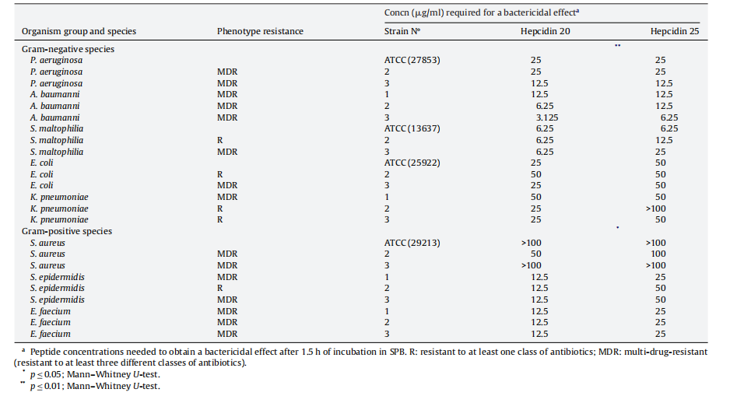
Hepcidin-25和Hepcidin-20对多药耐药性细菌的抑制浓度⁷
参考文献及鸣谢
(1) Mead, M. K.; Claus, M.; Litton, E.; Smart, L.; Raisis, A.; Rossi, G.; Trengove, R. D.; Gummer, J. P. A. Identification of The Canidae Iron Regulatory Hormone Hepcidin. Scientific reports 2019, 9 (1), 19400. DOI: 10.1038/s41598-019-55009-w From NLM.
(2) Kesharwani, P.; Dash, D.; Koiri, R. K. Deciphering the role of hepcidin in iron metabolism and anemia management. Journal of trace elements in medicine and biology : organ of the Society for Minerals and Trace Elements (GMS) 2025, 87, 127591. DOI: 10.1016/j.jtemb.2025.127591 From NLM.
(3) Sakamoto, S.; Kirinashizawa, M.; Mohara, Y.; Watanabe, Y. Generation and characterization of monoclonal antibodies against mature hepcidin and its application to neutralization and quantitative alteration assay. Bioscience, biotechnology, and biochemistry 2021, 85 (2), 340-350. DOI: 10.1093/bbb/zbaa013 From NLM.
(4) Wang, X.; Sheng, L.; Ye, P.; Cao, R.; Yang, X.; Xiao, W.; Zhang, Y.; Bai, Y.; Wu, H. The association between Hepcidin and arterial stiffness in a community-dwelling population. Lipids in health and disease 2018, 17 (1), 244. DOI: 10.1186/s12944-018-0866-6 From NLM.
(5) Ueda, N.; Takasawa, K. J. C. m. c. Role of hepcidin-25 in chronic kidney disease: anemia and beyond. 2017, 24 (14), 1417-1452.
(6) Kamai, T.; Tomosugi, N.; Abe, H.; Arai, K.; Yoshida, K.-I. J. B. c. Increased serum hepcidin-25 level and increased tumor expression of hepcidin mRNA are associated with metastasis of renal cell carcinoma. 2009, 9 (1), 270.
(7) Maisetta, G.; Petruzzelli, R.; Brancatisano, F. L.; Esin, S.; Vitali, A.; Campa, M.; Batoni, G. J. P. Antimicrobial activity of human hepcidin 20 and 25 against clinically relevant bacterial strains: effect of copper and acidic pH. 2010, 31 (11), 1995-2002.

