IRE1
Inositol requiring enzyme 1
Inositol-requiring enzyme 1 (IRE1) is a bifunctional serine/threonine kinase and endoribonuclease that is a major mediator of the
unfolded protein response (UPR) during endoplasmic reticulum (ER) stress. It represents a potential therapeutic target for a number
of diseases associated with endoplasmic reticulum stress.
IRE1 is the only identified ER stress sensor in yeast and essential for UPR in animals and plants. As an ER transmembrane protein,
IRE1 monitors ER homeostasis through an ER luminal stress-sensing domain and triggers UPR through a cytoplasmic kinase domain
and an RNase domain. Upon ER stress, IRE1 RNase is activated through conformational change, autophosphorylation, and higher
order oligomerization. Mammalian IRE1 initiates diverse downstream signaling of the UPR either through unconventional splicing
of the transcription factor Xbp-1 or and through posttranscriptional modifications via Regulated IRE1-Dependent Decay (RIDD) of
multiple substrates.
www.MedChemExpress.com 1
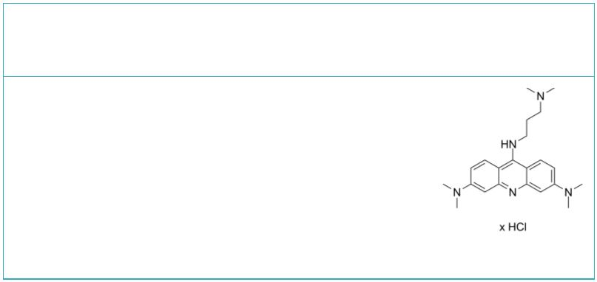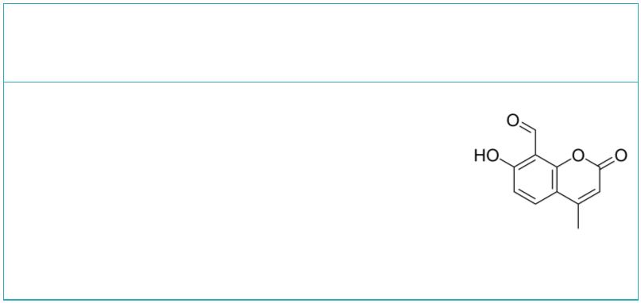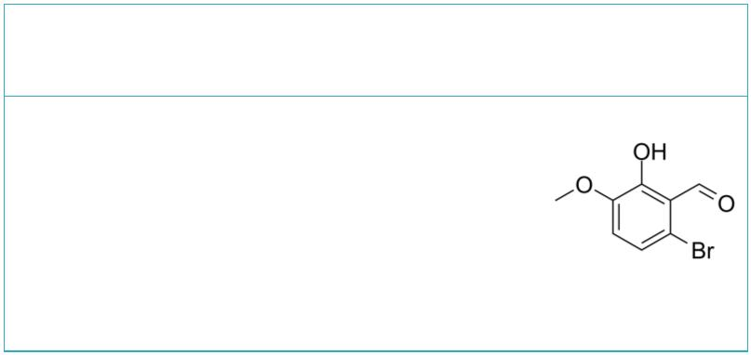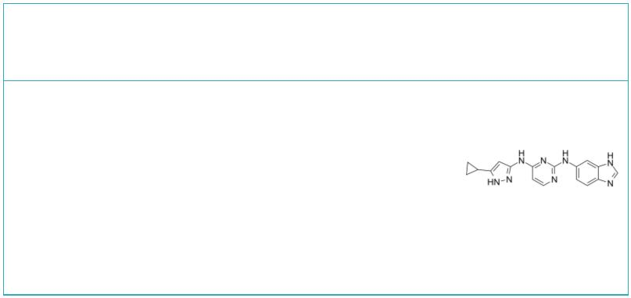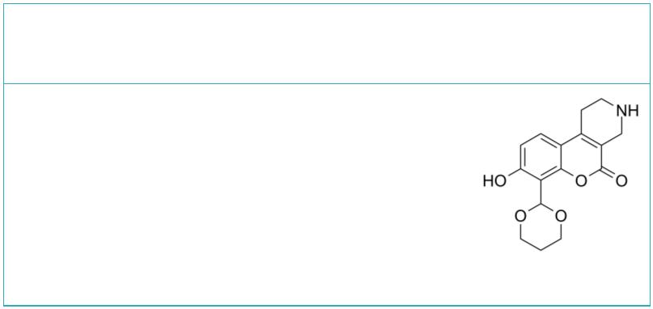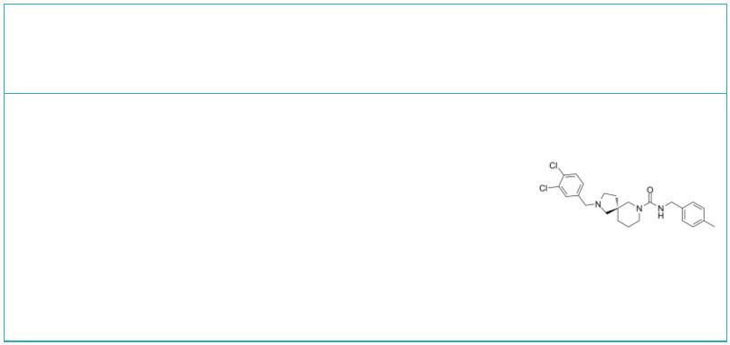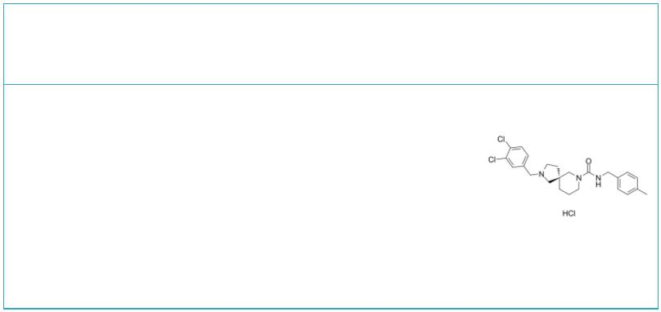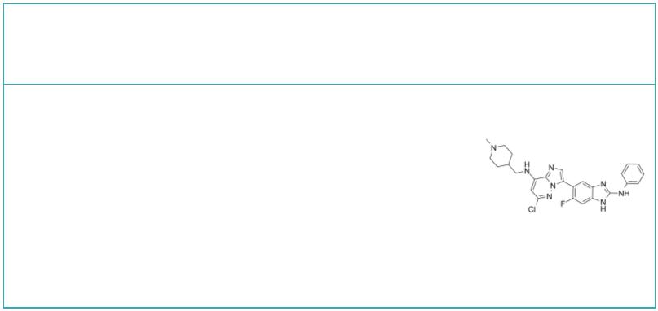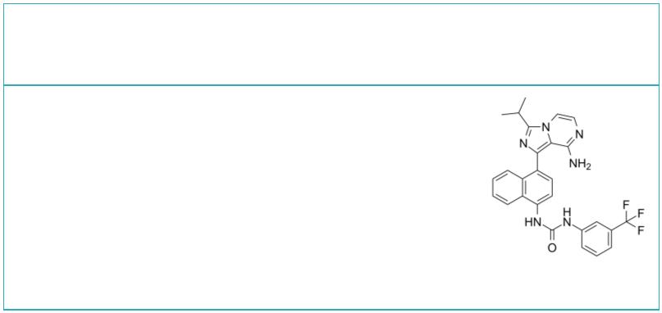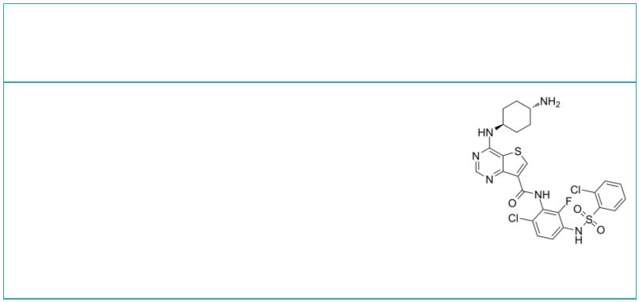IRE1 Inhibitors & Antagonists
 | 3,6-DMAD hydrochloride |  |  | Cat. No.: HY-U00460 |  |  |  | 4μ8C  (IRE1 Inhibitor III) Cat. No.: HY-19707
 | 3,6-DMAD hydrochloride is a inhibitor of the  IRE1α-XBP1 pathway of the unfolded protein  response. |  |  |  |  |  |  | 4μ8C (IRE1 Inhibitor III) is a small-molecule  inhibitor of IRE1α.
 | Purity: 98.88%  Clinical Data: No Development Reported  Size: 5 mg |  |  |  |  |  |  | Purity: 98.78%  Clinical Data: No Development Reported  Size: 10 mM × 1 mL, 5 mg, 10 mg, 25 mg, 50 mg, 100 mg
 | 6-Bromo-2-hydroxy-3-methoxybenzaldehyde  (NSC95682) Cat. No.: HY-107371 |  |  |  |  |  |  | APY29 |  |  |  |  |  |  |  |  |  |  |  |  | Cat. No.: HY-17537
 | 6-Bromo-2-hydroxy-3-methoxybenzaldehyde (NSC95682)  is an IRE-1α inhibitor with an IC of 0.08 μM,  50  extracted from patent WO 2008154484 A1, IRE-lα  inhibitor compound 3-5. |  |  |  |  |  |  | APY29, an ATP-competitive inhibitor, is an  allosteric modulator of IRE1α which inhibits IRE1α  autophosphorylation by binding to the ATP-binding  pocket with IC of 280 nM. APY29 acts as a ligand  50  that allosterically activates IRE1α adjacent RNase  domain.
 | Purity: 99.55%  Clinical Data: No Development Reported  Size: 10 mM × 1 mL, 50 mg |  |  |  |  |  |  | Purity: 99.90%  Clinical Data: No Development Reported  Size: 10 mM × 1 mL, 10 mg, 50 mg
 | B I09 GSK2850163
 |  |  |  |  | Cat. No.: HY-107400 Cat. No.: HY-U00459
 | B I09 is an IRE-1 RNase inhibitor, with an IC of  50  1230 nM. |  |  |  |  |  |  | GSK2850163 is a novel inhibitor of  inositol-requiring enzyme-1 alpha (IRE1α) which can  inhibit IRE1α kinase activity and RNase activity  with IC s of 20 and 200 nM, respectively.  50
 | Purity: 99.60%  Clinical Data: No Development Reported  Size: 10 mM × 1 mL, 5 mg, 10 mg, 50 mg, 100 mg |  |  |  |  |  |  | Purity: 98.48%  Clinical Data: No Development Reported  Size: 10 mM × 1 mL, 5 mg, 10 mg, 25 mg
 | GSK2850163 hydrochloride IRE1α kinase-IN-1
 |  | Cat. No.: HY-U00459B Cat. No.: HY-136735
 | GSK2850163 hydrochloride is a novel inhibitor of  inositol-requiring enzyme-1 alpha (IRE1α) which can  inhibit IRE1α kinase activity and RNase activity  with IC s of 20 and 200 nM, respectively.  50 |  |  |  |  |  |  | IRE1α kinase-IN-1 is a highly selective IRE1α  (ERN1) inhibitor, with an IC of 77 nM. IRE1α  50  kinase-IN-1 displays 100-fold selectivity for  IRE1α over the IRE1β isoform.
 | Purity: >98%  Clinical Data: No Development Reported  Size: 1 mg, 5 mg |  |  |  |  |  |  | Purity: 99.44%  Clinical Data: No Development Reported  Size: 5 mg, 10 mg, 25 mg, 50 mg, 100 mg
 | IRE1α kinase-IN-2 IRE1α kinase-IN-6
 |  |  |  |  |  | Cat. No.: HY-18509 Cat. No.: HY-142659
 | IRE1α kinase-IN-2 is a potent IRE1α kinase  inhibitor, with an EC of 0.82 μM. IRE1α  50  kinase-IN-2 inhibits IRE1α kinase  autophosphorylation (IC =3.12 μM). IRE1α  50  kinase-IN-2 inhibits XBP1 mRNA splicing in the WT  cell lines. |  |  |  |  |  |  | IRE1α kinase-IN-6 is a potent IRE1α inhibitor with  an IC value of 4.4 nM.  50
 | Purity: >98%  Clinical Data: No Development Reported  Size: 5 mg, 10 mg, 25 mg, 50 mg, 100 mg |  |  |  |  |  |  | Purity: >98%  Clinical Data: No Development Reported  Size: 1 mg, 5 mg
2 Tel: 609-228-6898 Fax: 609-228-5909 Email: sales@MedChemExpress.com
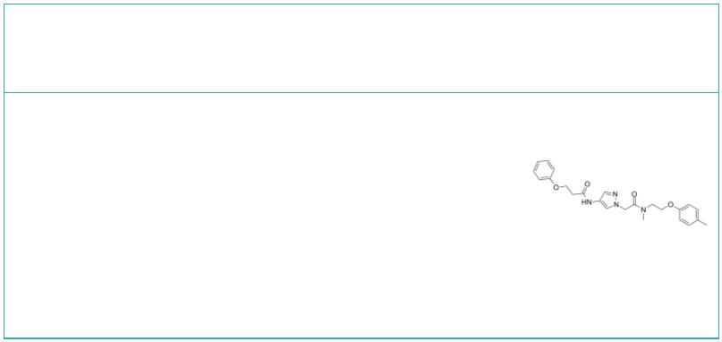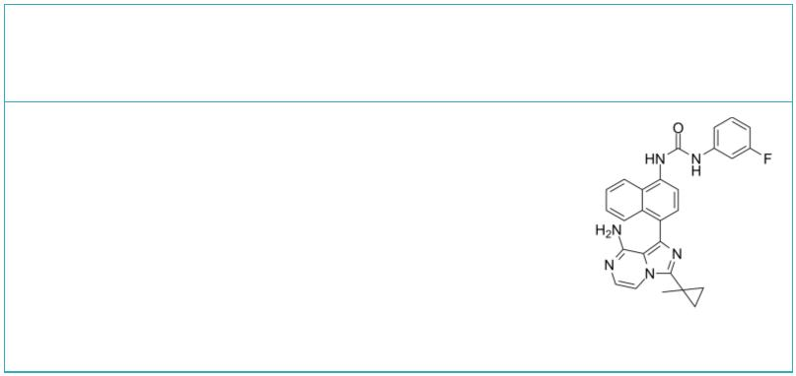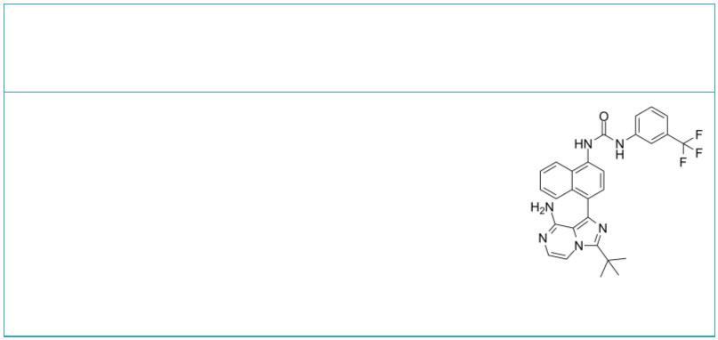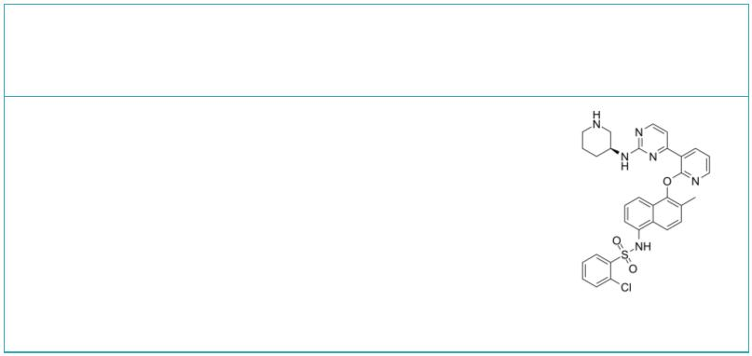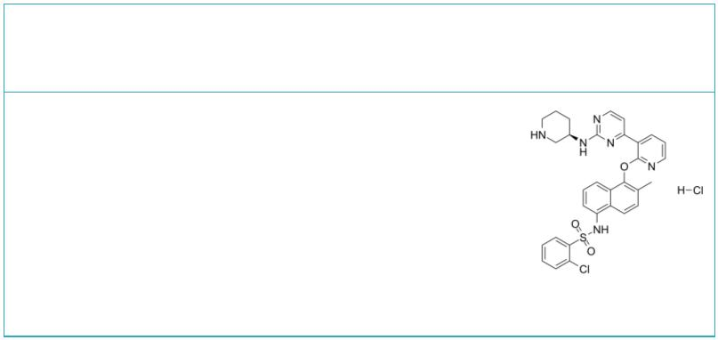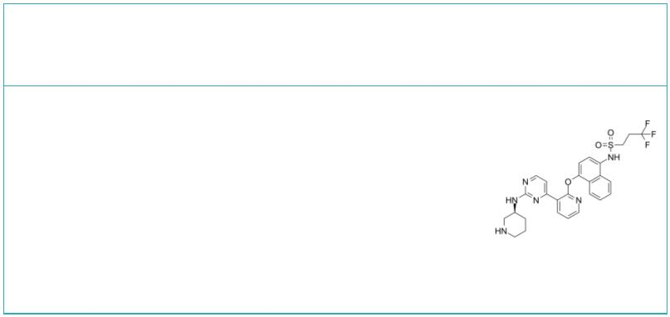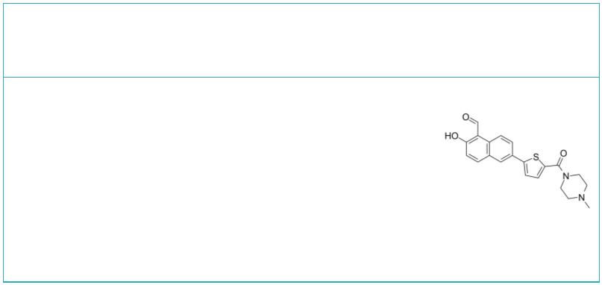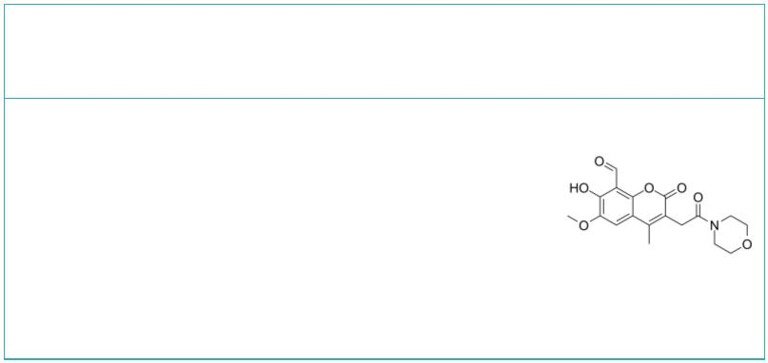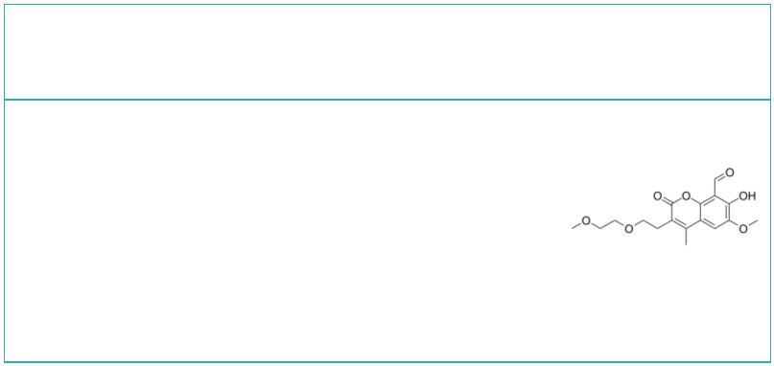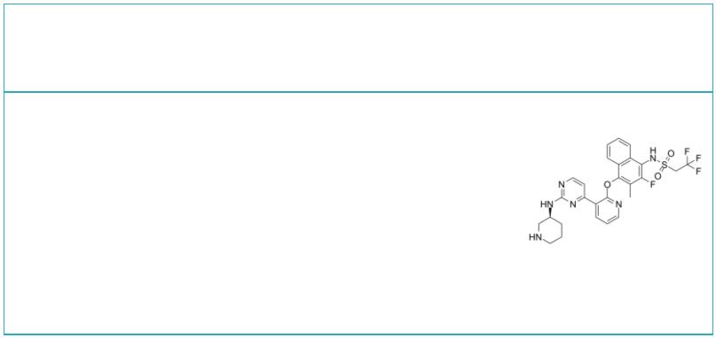IXA4 KIRA-7
 | Cat. No.: HY-139214 Cat. No.: HY-124646
IXA4 is a highly selective, non-toxic IRE1/XBP1s  activator. IXA4 activates IRE1/XBP1s signaling  without globally activating the unfolded protein  response (UPR) or other stress-responsive  signaling pathways (e.g., the heat shock response  or oxidative stress response). |  |  |  |  | KIRA-7, an imidazopyrazine compound, binds the  IRE1α kinase (IC of 110 nM) to allosterically  50  inhibit its RNase activity. KIRA-7 has an  anti-fibrotic effect.
Purity: 99.16%  Clinical Data: No Development Reported  Size: 5 mg, 10 mg, 25 mg, 50 mg, 100 mg |  |  |  |  | Purity: >98%  Clinical Data: No Development Reported  Size: 5 mg, 10 mg, 25 mg, 50 mg, 100 mg
KIRA6 |  |  | Cat. No.: HY-19708 |  | Kira8  (AMG-18) Cat. No.: HY-114368
KIRA6 is an advanced small-molecule IRE1α RNase  kinase inhibitor with an IC of 0.6 µM. KIRA6 can  50  trigger an apoptotic response. |  |  |  |  | Kira8 (AMG-18) is a mono-selective IRE1α inhibitor  that allosterically attenuates IRE1α RNase activity  with an IC of 5.9 nM.  50
Purity: 99.86%  Clinical Data: No Development Reported  Size: 5 mg, 10 mg, 25 mg, 50 mg |  |  |  |  | Purity: 99.74%  Clinical Data: No Development Reported  Size: 10 mM × 1 mL, 5 mg, 10 mg, 50 mg, 100 mg
Kira8 Hydrochloride  (AMG-18 Hydrochloride) Cat. No.: HY-114368A |  |  |  |  | KIRA9 |  |  |  |  |  |  |  |  |  |  |  |  | Cat. No.: HY-145422
Kira8 Hydrochloride (AMG-18 Hydrochloride) is a  mono-selective IRE1α inhibitor that allosterically  attenuates IRE1α RNase activity with an IC of 5.9  50  nM. |  |  |  |  | KIRA9 is a potent IRE1 inhibitor (IC =4.8 μM in  50  INS-1 cells). KIRA9 is able to fully engage the  ATP-binding site of IRE1α. KIRA9 can block  ER-localized mRNA decay and apoptosis.
Purity: >98%  Clinical Data: No Development Reported  Size: 1 mg, 5 mg |  |  |  |  | Purity: >98%  Clinical Data: No Development Reported  Size: 1 mg, 5 mg
MKC3946 MKC8866
 |  |  | Cat. No.: HY-19710 Cat. No.: HY-104040
MKC3946 is a potent IRE1α inhibitor, used for  cancer research. |  |  |  |  | MKC8866, a salicylaldehyde analog, is a potent,  selective IRE1 RNase inhibitor with an IC of  50  0.29μM in human vitro.
Purity: 99.68%  Clinical Data: No Development Reported  Size: 10 mM × 1 mL, 1 mg, 5 mg, 10 mg, 50 mg, 100 mg |  |  |  |  | Purity: 99.87%  Clinical Data: No Development Reported  Size: 10 mM × 1 mL, 5 mg, 10 mg, 25 mg, 50 mg, 100 mg
MKC9989 PAIR2
 |  |  | Cat. No.: HY-12399 Cat. No.: HY-145425
MKC9989 is a Hydroxy aryl aldehydes (HAA)  inhibitor and also inhibits IRE1α with an IC of  50  0.23 to 44 μM. |  |  |  |  | PAIR2 is a potent and selective partial antagonist  of IRE1α RNase. PAIR2 can completely occupy  IRE1α’s ATP-binding site in cells and block the  ability of a potent KIRA to inhibit XBP1 splicing.
Purity: 98.36%  Clinical Data: No Development Reported  Size: 10 mM × 1 mL, 1 mg, 5 mg, 10 mg, 50 mg, 100 mg |  |  |  |  | Purity: >98%  Clinical Data: No Development Reported  Size: 1 mg, 5 mg
www.MedChemExpress.com 3
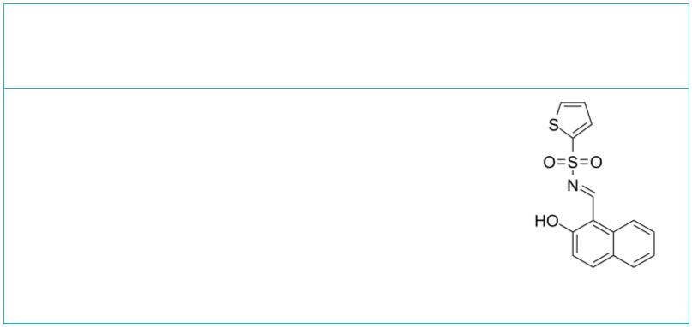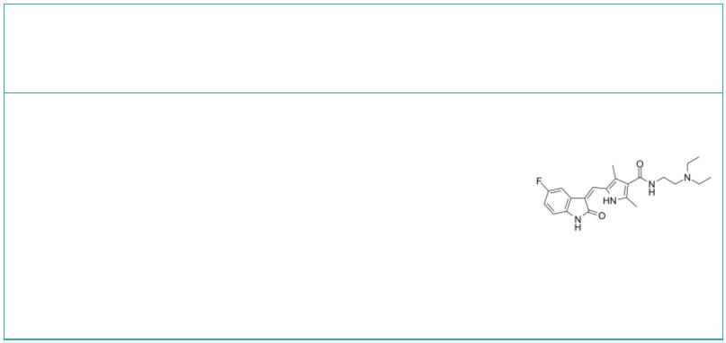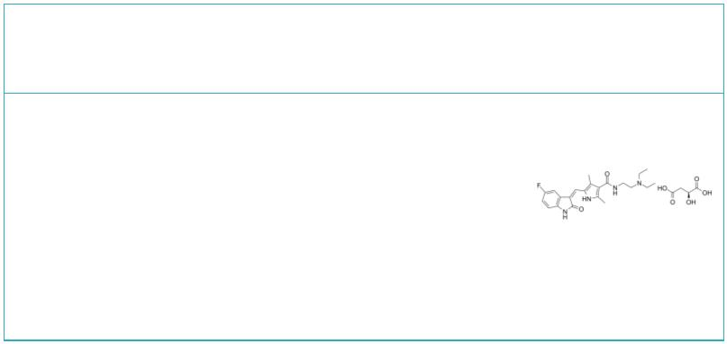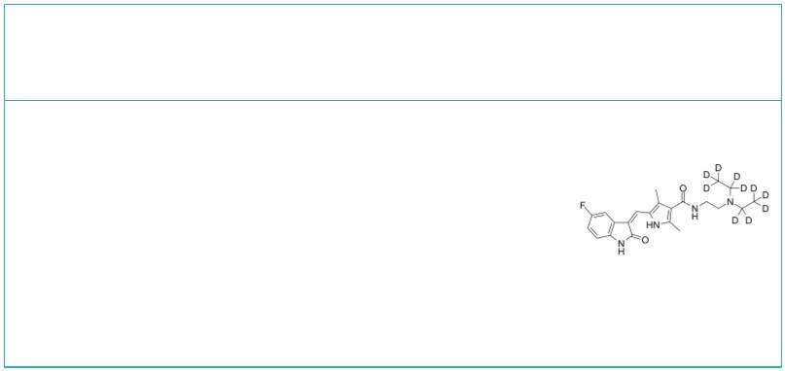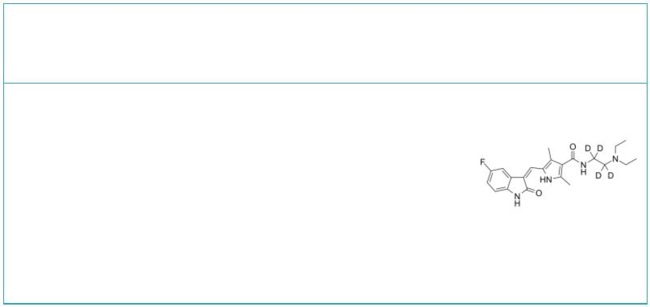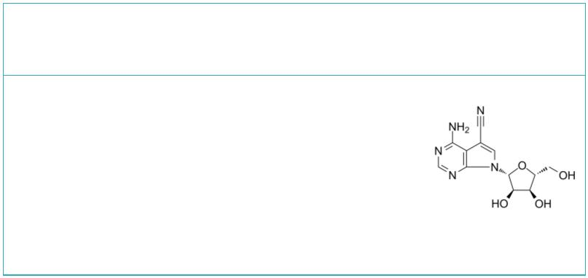 | STF-083010 |  |  |  | Cat. No.: HY-15845 |  | Sunitinib  (SU 11248) Cat. No.: HY-10255A
 | STF-083010 is a specific IRE1α inhibitor.  STF-083010 inhibits Ire1 endonuclease activity,  without affecting its kinase activity, after  endoplasmic reticulum stress. |  |  |  |  |  | Sunitinib (SU 11248) is a multi-targeted receptor  tyrosine kinase inhibitor with IC s of 80 nM and  50  2 nM for VEGFR2 and PDGFRβ, respectively.
 | Purity: ≥98.0%  Clinical Data: No Development Reported  Size: 10 mM × 1 mL, 5 mg, 10 mg, 50 mg, 100 mg, 200 mg |  |  |  |  |  | Purity: 98.96%  Clinical Data: Launched  Size: 10 mM × 1 mL, 100 mg, 200 mg, 500 mg
 | Sunitinib Malate  (SU 11248 Malate) Cat. No.: HY-10255 |  |  |  |  |  | Sunitinib-d10  (SU 11248-d10) Cat. No.: HY-10255AS
 | Sunitinib Malate (SU 11248 Malate) is a  multi-targeted receptor tyrosine kinase inhibitor  with IC₅₀s of 80 nM and 2 nM for VEGFR2 and  PDGFRβ, respectively. |  |  |  |  |  | Sunitinib D10 (SU 11248 D10) is a deuterium  labeled Sunitinib. Sunitinib is a multi-targeted  receptor tyrosine kinase inhibitor with IC s of  50  80 nM and 2 nM for VEGFR2 and PDGFRβ,  respectively.
 | Purity: 99.47%  Clinical Data: Launched  Size: 10 mM × 1 mL, 100 mg, 200 mg, 500 mg |  |  |  |  |  | Purity: 99.89%  Clinical Data: No Development Reported  Size: 1 mg, 5 mg
 | Sunitinib-d4 |  | Cat. No.: HY-10255AS1 |  |  |  | Toyocamycin  (Vengicide) Cat. No.: HY-103248
 | Sunitinib-d4 (SU 11248-d4) is the deuterium  labeled Sunitinib. Sunitinib (SU 11248) is a  multi-targeted receptor tyrosine kinase inhibitor  with IC₅₀s of 80 nM and 2 nM for VEGFR2 and  PDGFRβ, respectively. |  |  |  |  |  | Toyocamycin (Vengicide) is an adenosine analog  produced by Actinomycete, acts as an XBP1  inhibitor, inhibits IRE1α-induced ATP-dependent  XBP1 mRNA cleavage, with an IC of 80 nM.  50  Toyocamycin (Vengicide) induces apoptosis.
 | Purity: >98%  Clinical Data:  Size: 2.5 mg, 1 mg, 25 mg |  |  |  |  |  | Purity: 99.78%  Clinical Data: No Development Reported  Size: 10 mM × 1 mL, 5 mg, 10 mg, 50 mg, 100 mg
4 Tel: 609-228-6898 Fax: 609-228-5909 Email: sales@MedChemExpress.com

