PD-1/PD-L1
PD-1/Programmed death-ligand 1
Programmed death-1 (PD-1) is a cell surface receptor that functions as a T cell checkpoint and plays a central role in regulating T
cell exhaustion. PD-1 is activated by the engagement of its ligands PDL-1 or PDL-2. PD-1 receptor delivers inhibitory checkpoint
signals to activated T cells upon binding to its ligands PD-L1 and PD-L2 expressed on antigen-presenting cells and cancer cells,
resulting in suppression of T-cell effector function and tumor immune evasion. Inhibiting the programmed cell death-1
(PD-1)/programmed cell death-ligand 1 (PD-L1) pathway is an attractive strategy for tumor immunotherapy.
PD-1 is expressed on activated T cells, B cells, monocytes, dendritic cells (DCs), regulatory T cells (Tregs), and natural killer T cells
(NKT). It is a member of a family of immunoglobulin domain (Ig) co-receptors that modify the outcome of activation of the T cell
receptor by an antigen-presenting cell (APC) or infected target cell. PD-L1 is widely and constitutively expressed on both
hematopoietic and nonhematopoietic cells; e.g., naive T and B cells, vascular endothelial cells, and pancreatic islet cells, whereas
PD-L2 is exclusively and inducibly expressed on professional APCs.
www.MedChemExpress.com 1
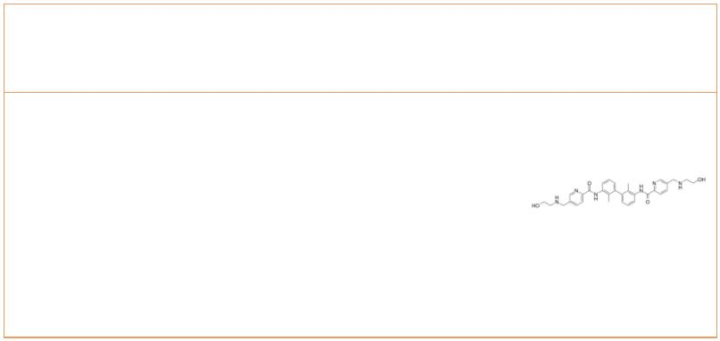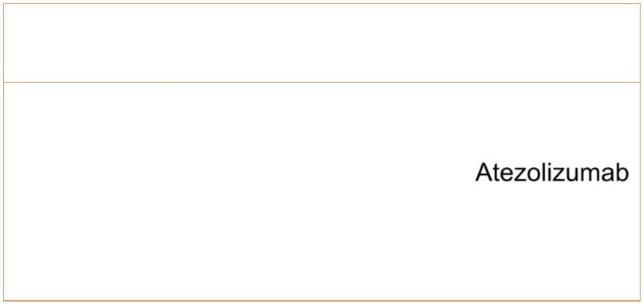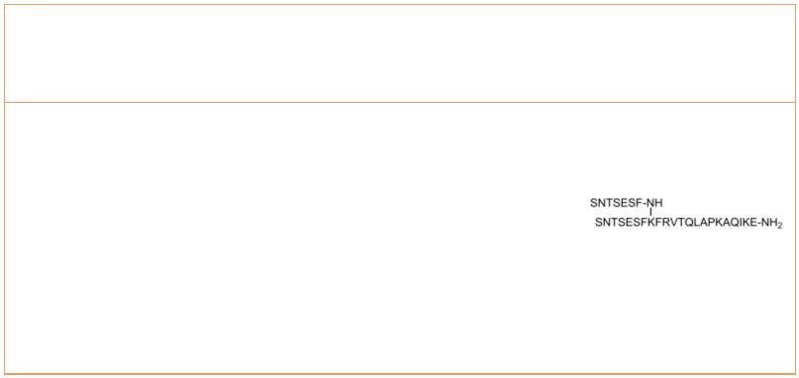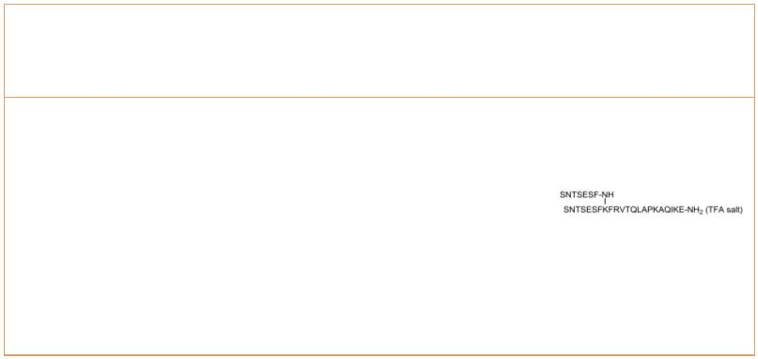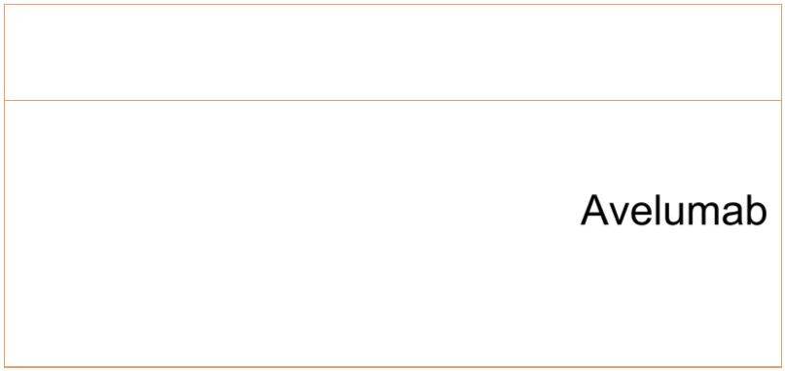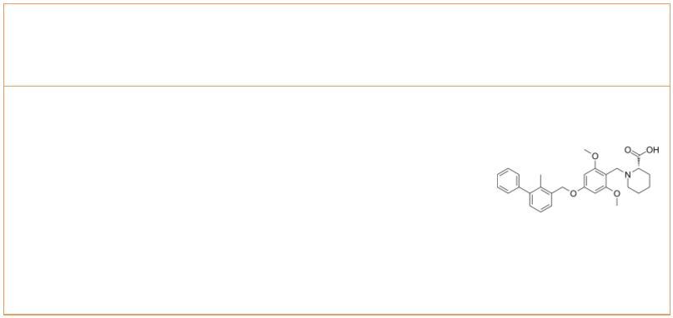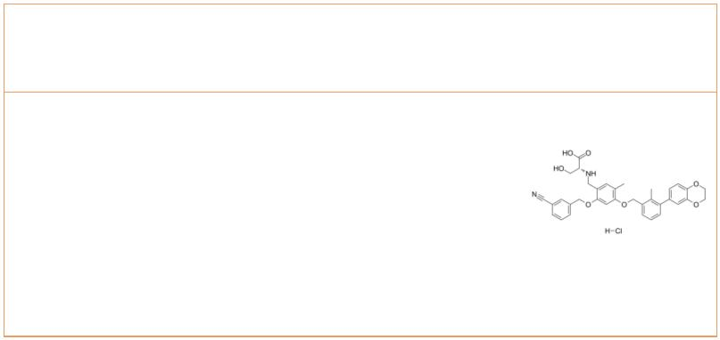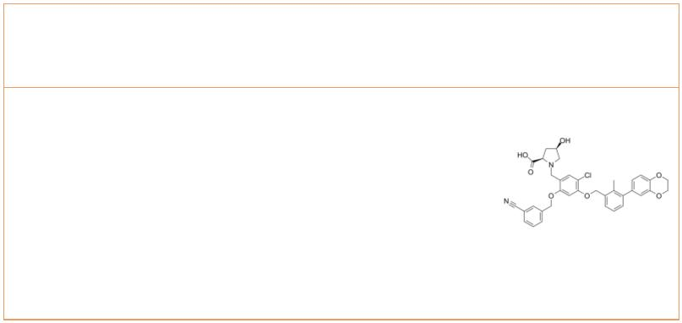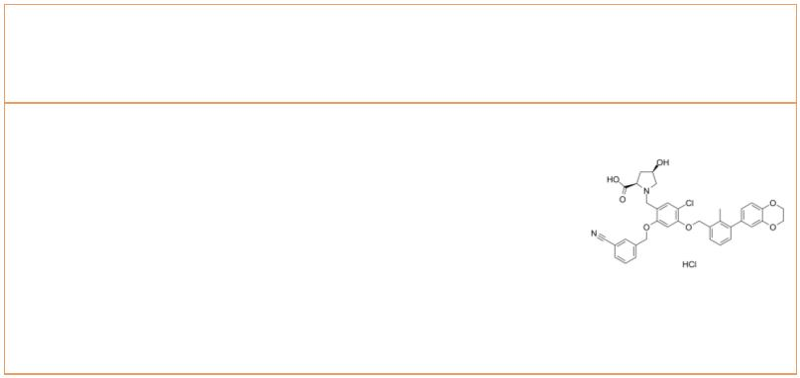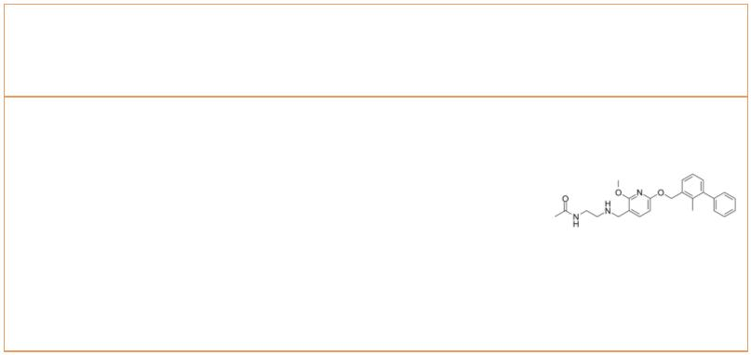PD-1/PD-L1 Inhibitors, Antagonists & Activators
 | ARB-272572 |  |  | Cat. No.: HY-142221 |  | Atezolizumab  (MPDL3280A) Cat. No.: HY-P9904
 | ARB-272572 is a potent small-molecule PD-L1  inhibitor with an IC value of 400pM.  50 |  |  |  |  | Atezolizumab (MPDL3280A) is a selective humanized  monoclonal IgG1 antibody against programmed death  ligand 1 (PD-L1), used for cancer research.
 | Purity: >98%  Clinical Data: No Development Reported  Size: 1 mg, 5 mg |  |  |  |  | Purity: 98.98%  Clinical Data: Launched  Size: 1 mg, 5 mg, 25 mg, 50 mg
 | AUNP-12  (NP-12) Cat. No.: HY-P1812 |  |  |  |  | AUNP-12 TFA  (NP-12 TFA) Cat. No.: HY-P1812A
 | AUNP-12 (NP-12) is a peptide antagonist of the  PD-1 signaling pathway, displays equipotent  antagonism toward PD-L1 and PD-L2 in rescue of  lymphocyte proliferation and effector functions. |  |  |  |  | AUNP-12 TFA (NP-12 TFA) is a peptide antagonist of  the PD-1 signaling pathway, displays  equipotent antagonism toward PD-L1 and PD-L2 in  rescue of lymphocyte proliferation and effector  functions.
 | Purity: >98%  Clinical Data: No Development Reported  Size: 1 mg, 5 mg |  |  |  |  | Purity: ≥96.0%  Clinical Data: No Development Reported  Size: 1 mg, 5 mg, 10 mg
 | Avelumab (Anti-Human PD-L1, Human Antibody; MSB 0010718C;  MSB0010718C) Cat. No.: HY-108730 |  |  |  |  | BMS-1  (PD-1/PD-L1 inhibitor 1) Cat. No.: HY-19991
 | Avelumab is a fully human IgG1 anti-PD-L1  monoclonal antibody with potential  antibody-dependent cell-mediated cytotoxicity. |  |  |  |  | BMS-1 is an inhibitor of the PD-1/PD-L1  protein/protein interaction (IC between 6 and 100  50  nM).
 | Purity: >98%  Clinical Data: Launched  Size: 1 mg, 5 mg, 10 mg |  |  |  |  | Purity: 99.56%  Clinical Data: No Development Reported  Size: 10 mM × 1 mL, 5 mg, 10 mg, 25 mg, 50 mg, 100 mg
 | BMS-1001 hydrochloride BMS-1166
 |  |  |  | Cat. No.: HY-120635 Cat. No.: HY-102011
 | BMS-1001 hydrochloride is an orally active human  PD-L1/PD-1 immune checkpoint inhibitor. BMS-1001  hydrochloride exhibits low-toxicity in cells. |  |  |  |  | BMS-1166 is a potent PD-1/PD-L1 immune checkpoint  inhibitor. BMS-1166 induces dimerization of PD-L1  and blocks its interaction with PD-1, with an IC  50  of 1.4 nM. BMS-1166 antagonizes the inhibitory  effect of PD-1/PD-L1 immune checkpoint on T cell  activation.
 | Purity: 98.46%  Clinical Data: No Development Reported  Size: 10 mM × 1 mL, 5 mg, 10 mg, 25 mg, 50 mg, 100 mg |  |  |  |  | Purity: 98.37%  Clinical Data: No Development Reported  Size: 10 mM × 1 mL, 5 mg, 10 mg, 25 mg, 50 mg, 100 mg
 | BMS-1166 hydrochloride BMS-202
 |  | Cat. No.: HY-102011A Cat. No.: HY-19745
 | BMS-1166 hydrochloride is a potent PD-1/PD-L1  immune checkpoint inhibitor. BMS-1166  hydrochloride induces dimerization of PD-L1 and  blocks its interaction with PD-1, with an IC of  50  1.4 nM. |  |  |  |  | BMS-202 is a potent and nonpeptidic PD-1/PD-L1  complex inhibitor with an IC of 18 nM and a  50  K of 8 μM. BMS-202 binds to PD-L1 and blocks  D  human PD-1/PD-L1 interaction. BMS-202 has  antitumor activity.
 | Purity: >98%  Clinical Data: No Development Reported  Size: 1 mg, 5 mg |  |  |  |  | Purity: 99.39%  Clinical Data: No Development Reported  Size: 10 mM × 1 mL, 5 mg, 10 mg, 25 mg, 50 mg, 100 mg
2 Tel: 609-228-6898 Fax: 609-228-5909 Email: sales@MedChemExpress.com
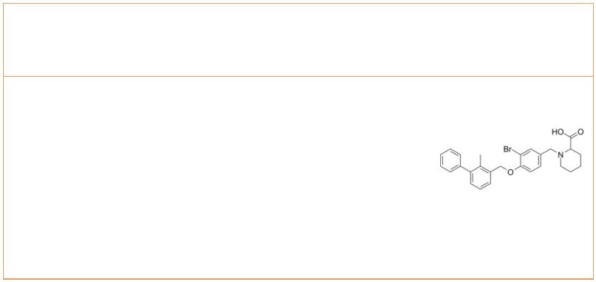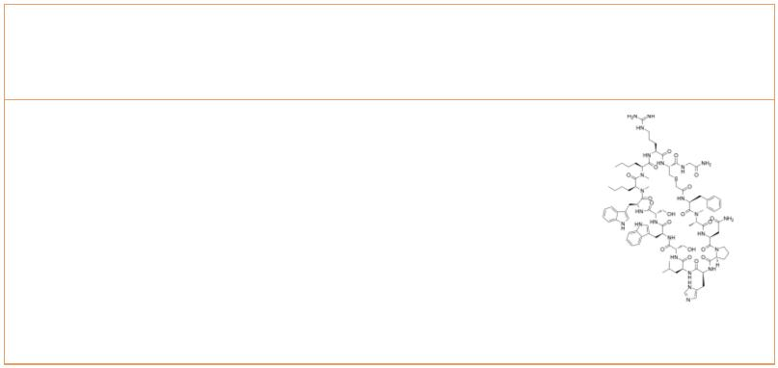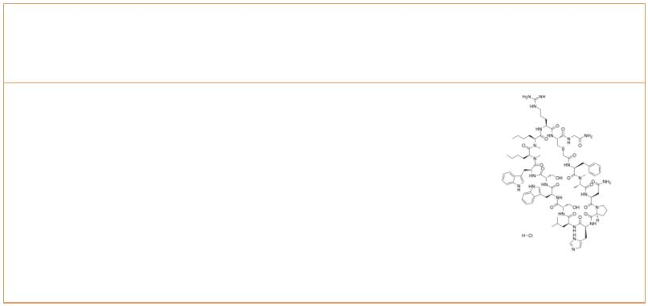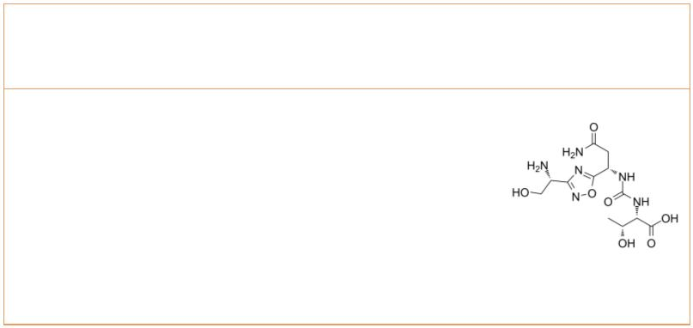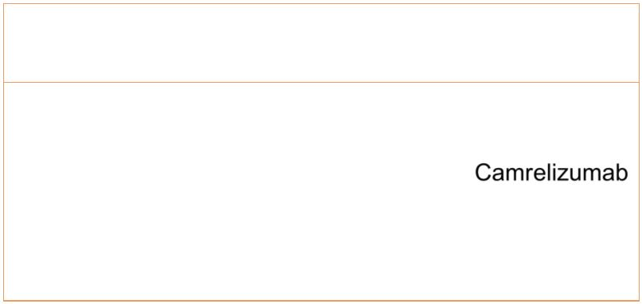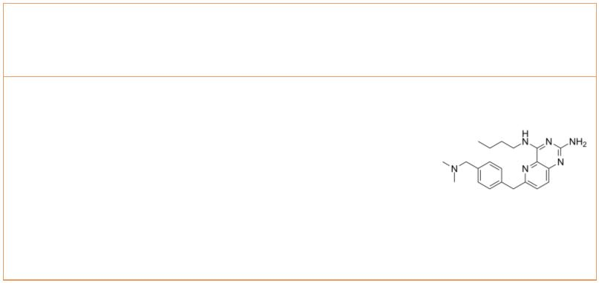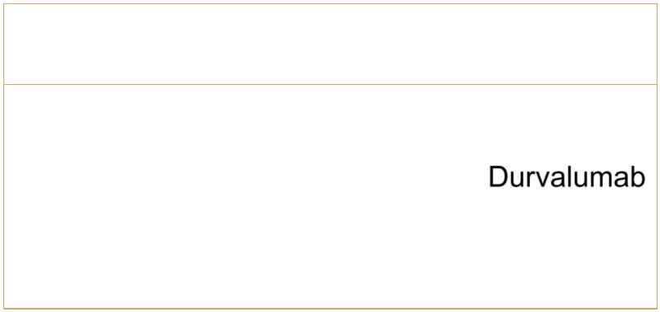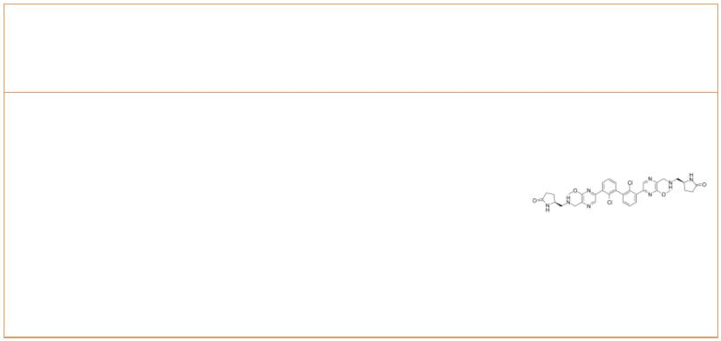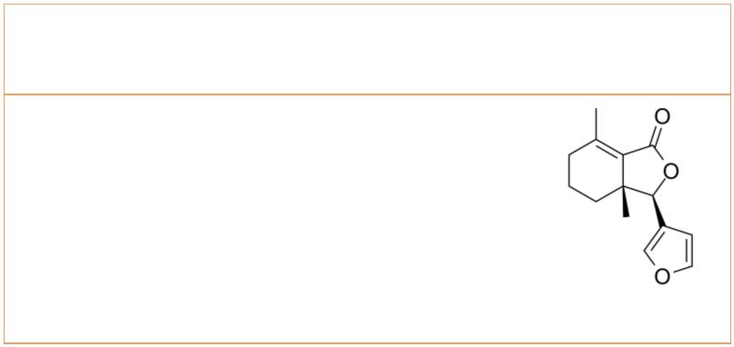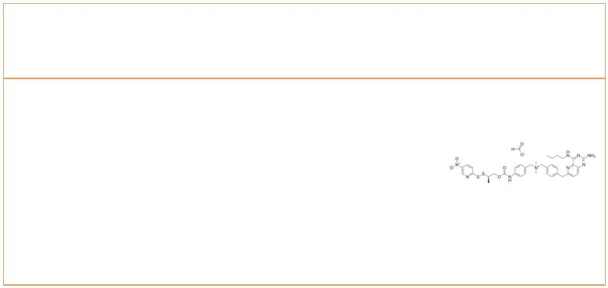BMS-8 BMSpep-57
 |  | Cat. No.: HY-116274 Cat. No.: HY-P3143
BMS-8 inhibits the PD-1/PD-L1 interaction with  IC of 7.2 μM. BMS-8, binds directly to PD-L1 and  50  induces formation of PD-L1 homodimers, which in  turn prevents the interaction with PD-1. |  |  |  |  | BMSpep-57 is a potent and competitive macrocyclic  peptide inhibitor of PD-1/PD-L1 interaction with  an IC of 7.68nM. BMSpep-57 binds to PD-L1  50  with K s of 19 nM and 19.88 nM in MST and  d  SPR assays,  respectively.
Purity: >98%  Clinical Data: No Development Reported  Size: 1 mg, 5 mg |  |  |  |  | Purity: >98%  Clinical Data: No Development Reported  Size: 1 mg, 5 mg
BMSpep-57 hydrochloride CA-170
 | Cat. No.: HY-P3143A Cat. No.: HY-101093
BMSpep-57 hydrochloride is a potent and  competitive macrocyclic peptide inhibitor of  PD-1/PD-L1 interaction with an IC of 7.68nM.  50  BMSpep-57 hydrochloride binds to PD-L1 with K s  d  of 19 nM and 19.88 nM in MST and SPR assays,  respectively. |  |  |  |  | CA-170 is an orally delivered dual inhibitor of  VISTA and PD-L1. CA-170 exhibits potent rescue of  proliferation and effector functions of T cells  inhibited by PD-L1/L2 and VISTA with selectivity  over other immune checkpoint proteins as well as a  broad panel of receptors and enzymes.
Purity: 99.79%  Clinical Data: No Development Reported  Size: 1 mg |  |  |  |  | Purity: 96.26%  Clinical Data: No Development Reported  Size: 10 mM × 1 mL, 1 mg, 5 mg, 10 mg, 25 mg, 50 mg, 100 mg
Camrelizumab  (SHR-1210) Cat. No.: HY-P9971 |  |  |  |  | D18 |  |  |  |  |  |  |  |  |  |  |  |  | Cat. No.: HY-144501
Camrelizumab (SHR-1210) is a potent humanied  high-affinity IgG4-κ monoclonal antibody (mAb) to  PD-1. Camrelizumab binds PD-1 at a high  affinity of 3 nM and inhibits the binding  interaction of PD-1 and PD-L1 with an IC of 0.70  50  nM. |  |  |  |  | D18 is an immune modulator. D18 acts as a TLR7/8  dual agonist (EC =24 nM for hTLR7 and 10 nM for  50  hTLR8, respectively). D18 increases PD-L1  expression through epigenetic regulation, thus  sensitizing tumors to PD-1/PD-L1 blockade.
Purity: 97.70%  Clinical Data: No Development Reported  Size: 1 mg, 5 mg |  |  |  |  | Purity: >98%  Clinical Data: No Development Reported  Size: 1 mg, 5 mg
Durvalumab Evixapodlin
(MEDI 4736) Cat. No.: HY-P9919 (PD-1/PD-L1-IN 7) Cat. No.: HY-138407
Durvalumab (MEDI 4736) is an humanized anti-PD-L1  monoclonal antibody. Durvalumab (MEDI4736)  completely blocks the binding of PD-L1 to both  PD-1 and CD80, with IC s of 0.1 and 0.04 nM,  50  respectively. |  |  |  |  | Evixapodlin (PD-1/PD-L1-IN 7) is a human  PD-1/PD-L1 protein/protein interaction inhibitor  with an IC of 0.213 nM. Evixapodlin has  50  anticancer and antiviral functions.
Purity: 99.60%  Clinical Data: Launched  Size: 1 mg, 5 mg, 25 mg, 50 mg |  |  |  |  | Purity: 98.48%  Clinical Data: No Development Reported  Size: 10 mM × 1 mL, 5 mg, 10 mg, 25 mg, 50 mg
Fraxinellone HE-S2
 |  |  | Cat. No.: HY-N0242 Cat. No.: HY-144497
Fraxinellone is isolated from the root bark of the  Rutaceae plant, Dictamnus dasycarpus.  Fraxinellone is a PD-L1 inhibitor and inhibits  HIF-1α protein synthesis without affecting HIF-1α  protein degradation. |  |  |  |  | HE-S2 is an antibody-drug conjugate triggering a  potent antitumor immune response. HE-S2 acts by  blocking the PD-1/PD-L1 interaction and  activating the Toll-like receptor 7/8 (TLR7/8)  signaling pathway. HE-S2 has remarkable antitumor  activity.
Purity: 99.99%  Clinical Data: No Development Reported  Size: 10 mM × 1 mL, 5 mg, 10 mg, 20 mg |  |  |  |  | Purity: >98%  Clinical Data: No Development Reported  Size: 1 mg, 5 mg
www.MedChemExpress.com 3
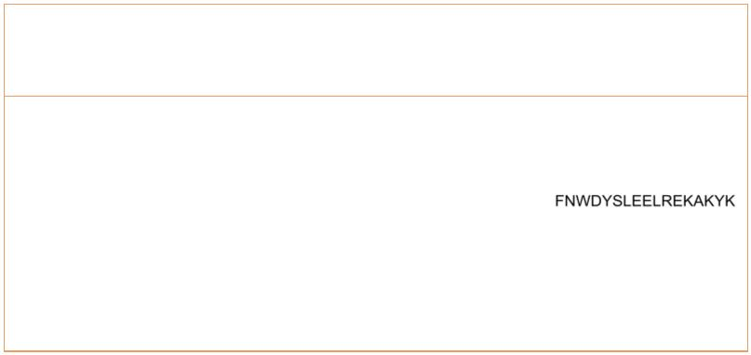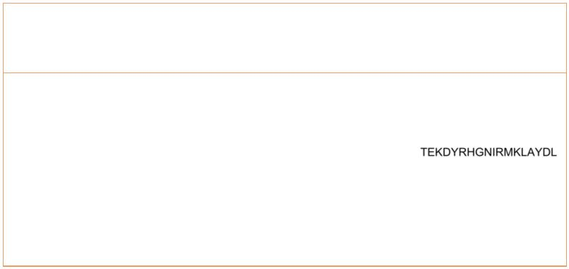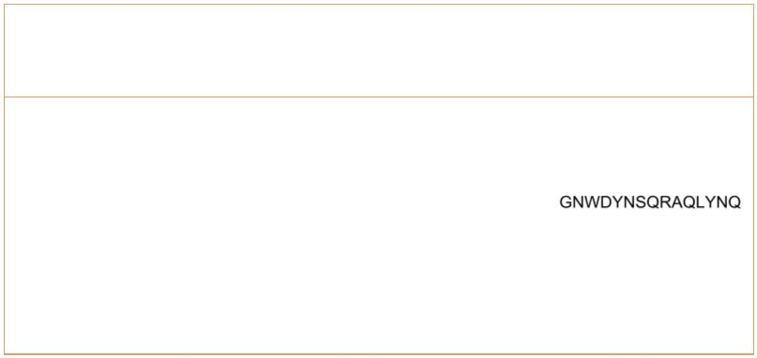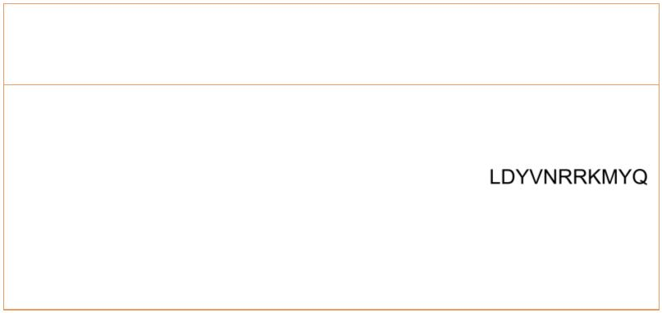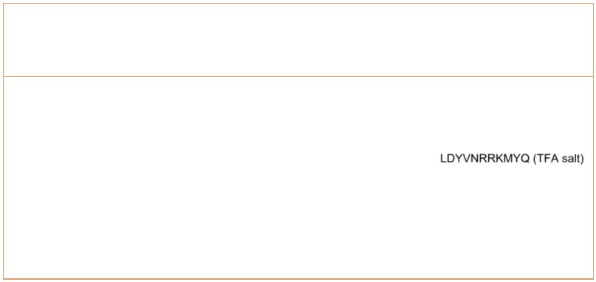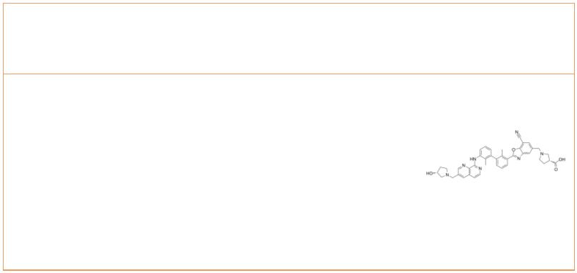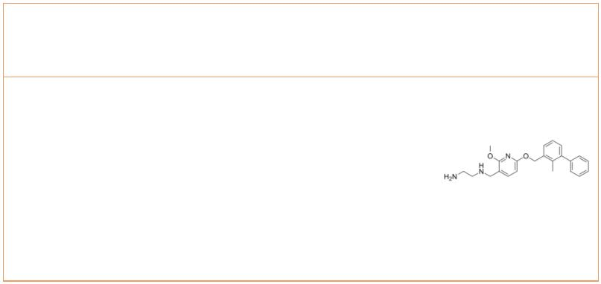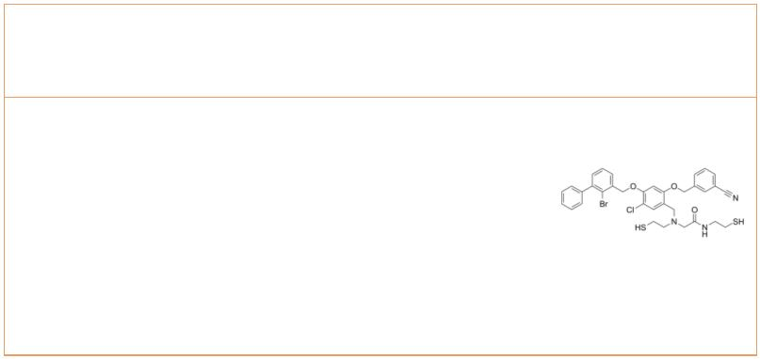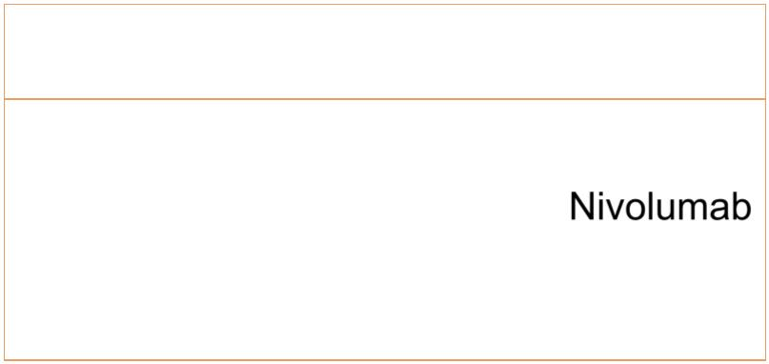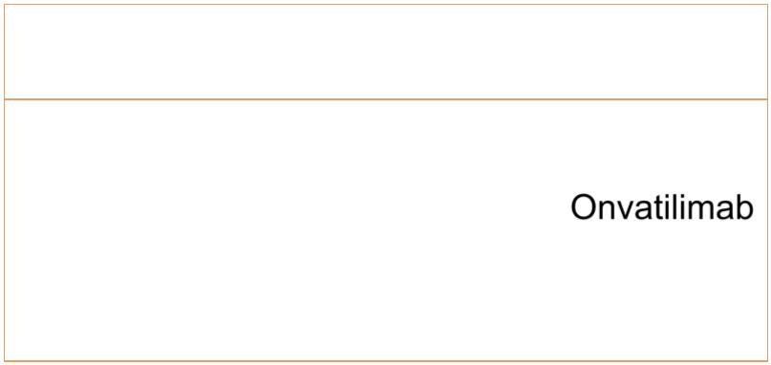 | Human PD-L1 inhibitor II Human PD-L1 inhibitor III
 |  |  |  |  | Cat. No.: HY-P2470 Cat. No.: HY-P2564
 | Human PD-L1 inhibitor II is a potent PD-L1  inhibitor with anti-cancer activity. |  |  |  |  |  | Human PD-L1 inhibitor III is a human PD-L1  inhibitor.
 | Purity: >98%  Clinical Data: No Development Reported  Size: 1 mg, 5 mg |  |  |  |  |  | Purity: >98%  Clinical Data: No Development Reported  Size: 1 mg, 5 mg
 | Human PD-L1 inhibitor IV Human PD-L1 inhibitor V
 |  |  |  |  | Cat. No.: HY-P2477 Cat. No.: HY-P2478
 | Human PD-L1 inhibitor IV, a polypeptide, is a  competitive human PD-1 protein inhibitor with a  K value of 1.38 μM. Human PD-L1 inhibitor IV  d  inhibits the interaction of hPD-1/hPD-L1. |  |  |  |  |  | Human PD-L1 inhibitor V, a human PD-1 protein  binding peptide with a K value of 3.32 μM.  d  Human PD-L1 inhibitor V inhibit the interaction of  hPD-1/hPD-L1.
 | Purity: >98%  Clinical Data: No Development Reported  Size: 1 mg, 5 mg |  |  |  |  |  | Purity: >98%  Clinical Data: No Development Reported  Size: 1 mg, 5 mg
 | Human PD-L1 inhibitor V TFA |  | Cat. No.: HY-P2478A |  |  |  | INCB086550  (PD-1/PD-L1-IN-8) Cat. No.: HY-134884
 | Human PD-L1 inhibitor V TFA, a human PD-1  protein binding peptide with a K value of 3.32  d  μM. Human PD-L1 inhibitor V TFA inhibit the  interaction of hPD-1/hPD-L1. |  |  |  |  |  | INCB086550 (PD-1/PD-L1-IN-8; example 24) is a  PD-1/PD-L1 inhibitor, with an IC <= 10 nM.  50
 | Purity: 96.63%  Clinical Data: No Development Reported  Size: 10 mg |  |  |  |  |  | Purity: 98.86%  Clinical Data: No Development Reported  Size: 5 mg, 10 mg
 | N-deacetylated BMS-202 N2S2-CBMBC
 |  |  |  | Cat. No.: HY-19745A Cat. No.: HY-145769
 | N-deacetylated BMS-202 is the deacetylated of  BMS-202. BMS-202 is an inhibitor of the  PD-1/PD-L1 interaction, mainly used for cancer  treatment. |  |  |  |  |  | N2S2-CBMBC, an N2S2 bromo-benzyl ether derivative,  acts as a ligand and use ^{99m}Tc-labelled  complexes ^{99m}Tc-N2S2-CBMBC can be used as an  imaging agent to be applied to the aspect of  detecting PD-L1 expression, realize the real-time,  comprehensive and convenient detection of…
 | Purity: 98.13%  Clinical Data: No Development Reported  Size: 10 mM × 1 mL, 5 mg, 10 mg, 25 mg, 50 mg, 100 mg |  |  |  |  |  | Purity: >98%  Clinical Data: No Development Reported  Size: 1 mg, 5 mg
 | Nivolumab Onvatilimab
 | (BMS-936558; ONO-4538; MDX-1106) Cat. No.: HY-P9903 (JNJ-61610588) Cat. No.: HY-P99040
 | Nivolumab is a programmed death receptor-1 (PD-1)  blocking human IgG4 antibody to treat advanced  (metastatic) non-small cell lung cancer. |  |  |  |  |  | Onvatilimab (JNJ-61610588) is a human IgG1κ  anti-VISTA (V-domain Ig Suppressor of T-cell  Activation) monoclonal antibody. Onvatilimab has an  anti-tumor activity.
 | Purity: 98.56%  Clinical Data: Launched  Size: 1 mg, 5 mg, 25 mg, 50 mg |  |  |  |  |  | Purity: >98%  Clinical Data: No Development Reported  Size: 1 mg, 5 mg
4 Tel: 609-228-6898 Fax: 609-228-5909 Email: sales@MedChemExpress.com
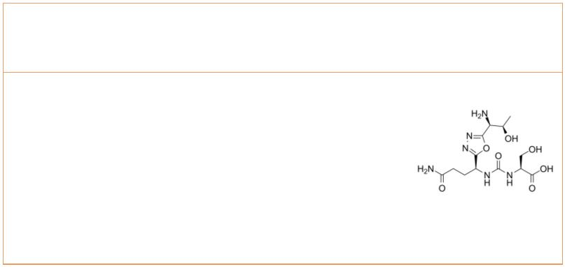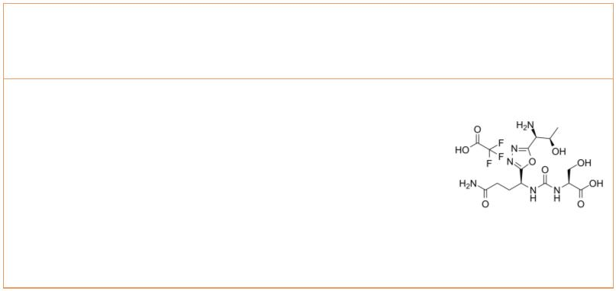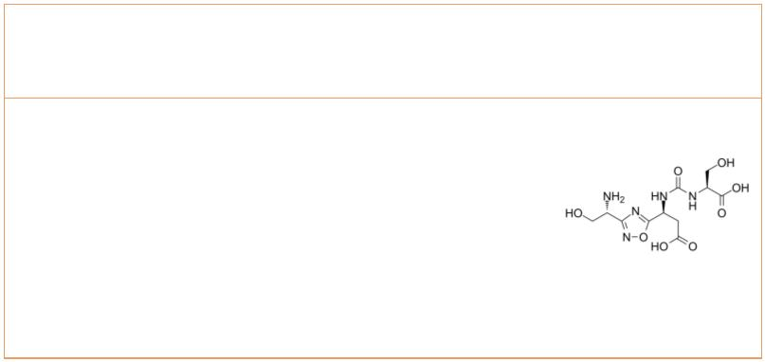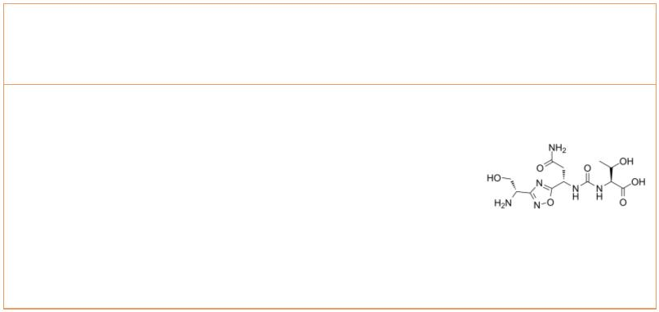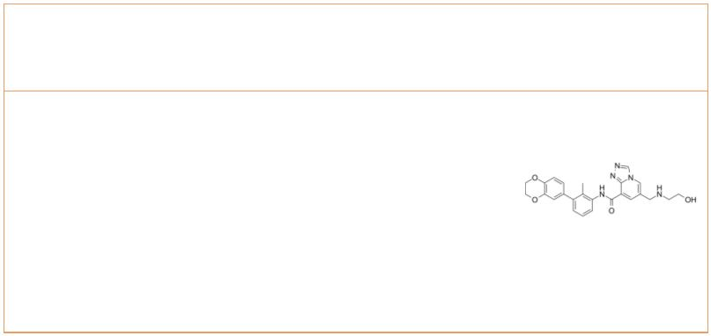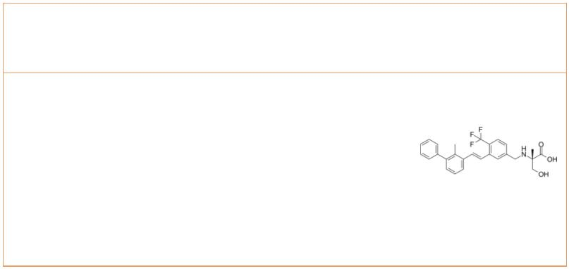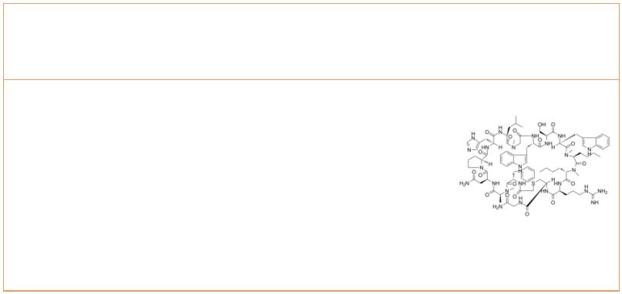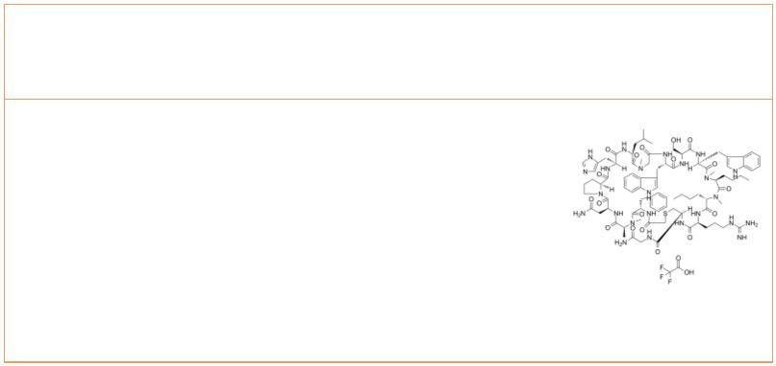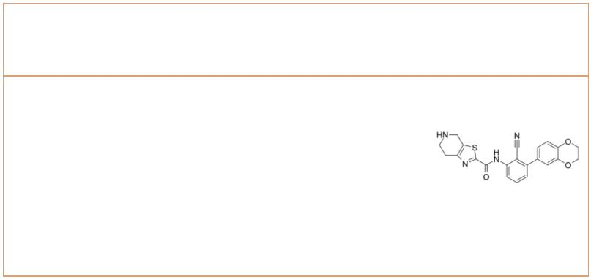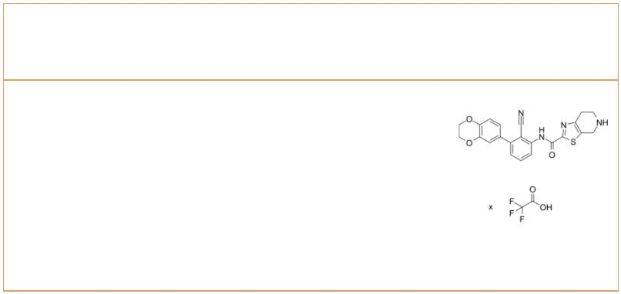PD-1-IN-17 PD-1-IN-17 TFA
 |  | Cat. No.: HY-101097 Cat. No.: HY-101097A
PD-1-IN-17 is a programmed cell death-1 (PD-1)  inhibitor extracted from patent WO2015033301A1,  Compound 12, inhibits 92% splenocyte proliferation  at 100 nM. |  |  |  | PD-1-IN-17 TFA is a programmed cell death-1  (PD-1) inhibitor extracted from patent  WO2015033301A1, Compound 12, inhibits 92%  splenocyte proliferation at 100 nM.
Purity: ≥95.0%  Clinical Data: No Development Reported  Size: 10 mM × 1 mL, 5 mg, 10 mg, 25 mg, 50 mg, 100 mg |  |  |  | Purity: >98%  Clinical Data: No Development Reported  Size: 1 mg, 5 mg
PD-1-IN-18 PD-1-IN-20
 |  | Cat. No.: HY-101098 Cat. No.: HY-101093B
PD-1-IN-18 is a PD1 signaling pathway inhibitor,  which acts as an immunomodulator. |  |  |  | PD-1-IN-20 is the less active enantiomer of  PD-1-IN-1. PD-1-IN-1 is an inhibitor of programmed  cell dealth-1 (PD-1) extracted from patent WO  2015033299 A1, compound example 4.
Purity: >98%  Clinical Data: No Development Reported  Size: 1 mg, 5 mg |  |  |  | Purity: >98%  Clinical Data: No Development Reported  Size: 1 mg, 5 mg
PD-1-IN-22 PD-1-IN-24
 |  | Cat. No.: HY-128605 Cat. No.: HY-134886
PD-1-IN-22 is a potent programmed cell death-1  (PD-1)/programmed cell death-ligand 1 (PD-L1)  interaction inhibitor with an IC of 92.3 nM.  50 |  |  |  | PD-1-IN-24 (compound 1) is an orally active PD-1  inhibitor.
Purity: >98%  Clinical Data: No Development Reported  Size: 1 mg, 5 mg |  |  |  | Purity: 98.04%  Clinical Data: No Development Reported  Size: 10 mM × 1 mL, 5 mg, 10 mg, 25 mg, 50 mg, 100 mg
PD-1/PD-L1-IN 3 PD-1/PD-L1-IN 3 TFA
 |  | Cat. No.: HY-103048 Cat. No.: HY-103048A
PD-1/PD-L1-IN 3, a macrocyclic peptide, is a  potent and selective inhibitor of the PD-1/PD-L1  and CD80/PD-L1 interactions extracted from patent  WO2014151634A1, compound No.1. |  |  |  | PD-1/PD-L1-IN 3 TFA, a macrocyclic peptide, is a  potent and selective inhibitor of the PD-1/PD-L1  and CD80/PD-L1 interactions extracted from patent  WO2014151634A1, compound No.1.
Purity: >98%  Clinical Data: No Development Reported  Size: 1 mg, 5 mg |  |  |  | Purity: >98%  Clinical Data: No Development Reported  Size: 1 mg, 5 mg
PD-1/PD-L1-IN 5 PD-1/PD-L1-IN 5 TFA
 | Cat. No.: HY-129172A Cat. No.: HY-129172
PD-1/PD-L1-IN 5 is a PD-1/PD-L1 protein/protein  interaction inhibitor extracted from patent  WO2017222976A1, compound Example 1, has an IC of  50  ≤100 nM. |  |  |  | PD-1/PD-L1-IN 5 TFA is a PD-1/PD-L1  protein/protein interaction inhibitor extracted  from patent WO2017222976A1, compound Example 1,  has an IC of ≤100 nM.  50
Purity: >98%  Clinical Data: No Development Reported  Size: 1 mg, 5 mg |  |  |  | Purity: >98%  Clinical Data: No Development Reported  Size: 1 mg, 5 mg
www.MedChemExpress.com 5
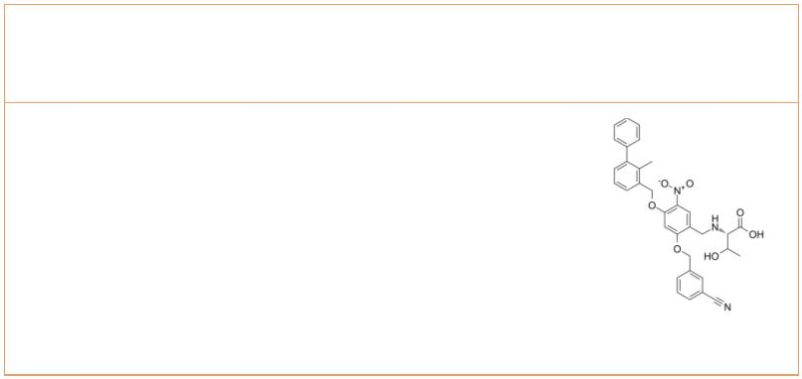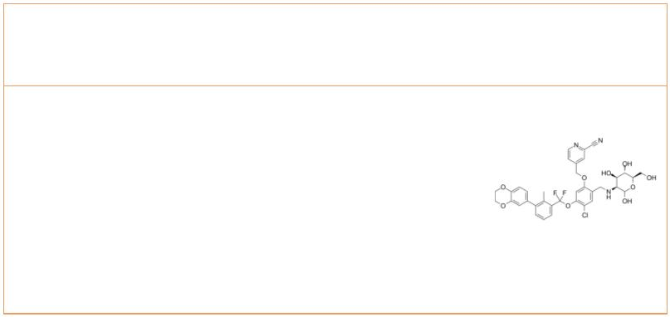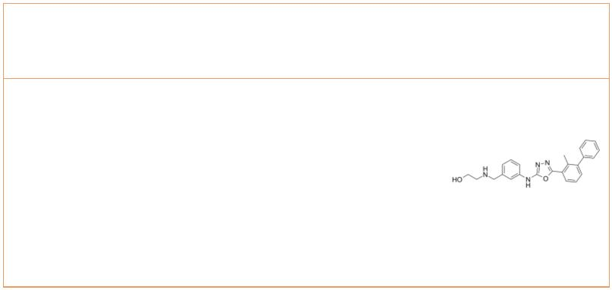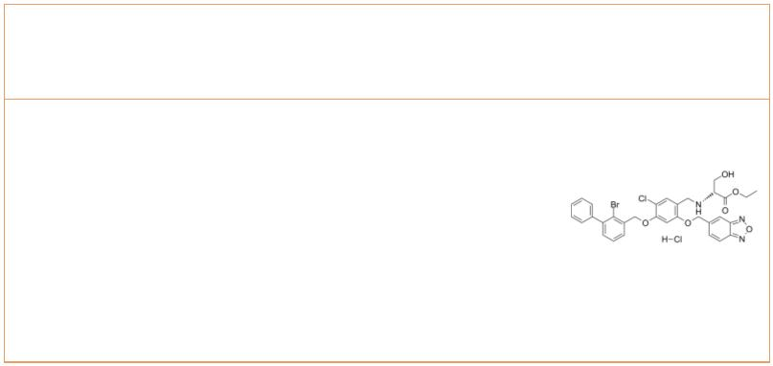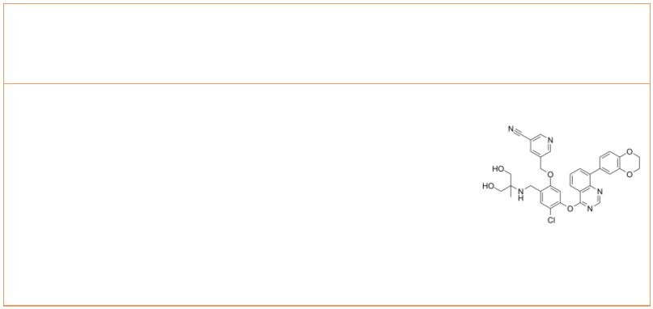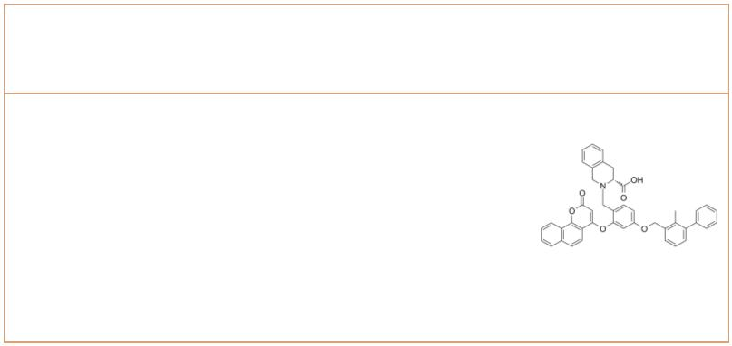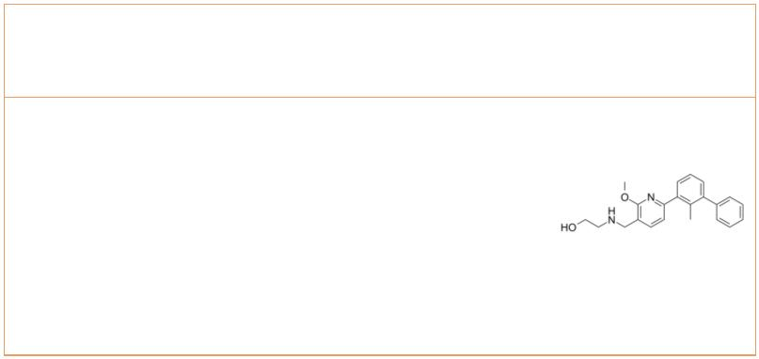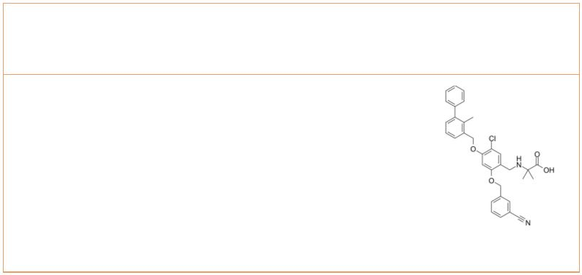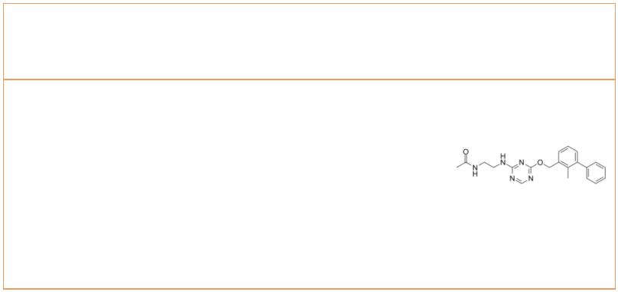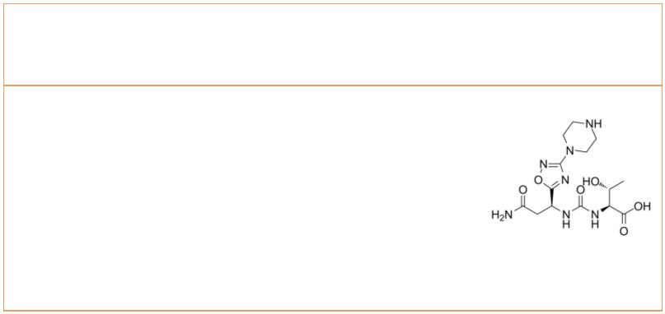 | PD-1/PD-L1-IN-10 PD-1/PD-L1-IN-13
 |  | Cat. No.: HY-132202 Cat. No.: HY-145239
 | PD-1/PD-L1-IN-10 (compound B2) is an orally active  PD-1/PD-L1 inhibitor (IC of 2.7 nM) with potent  50  anticancer efficacy. |  |  | PD-1/PD-L1-IN-13 (Compound 43) is a potent immune  checkpoint PD-1/PD-L1 inhibitor with an IC  50  value of 10.2 nM. PD-1/PD-L1-IN-13 promots CD8+ T  cell activation and delays the tumor growth in the  Hepa1-6 syngeneic mouse model.
 | Purity: 99.29%  Clinical Data: No Development Reported  Size: 5 mg, 10 mg, 25 mg, 50 mg, 100 mg |  |  | Purity: >98%  Clinical Data: No Development Reported  Size: 1 mg, 5 mg
 | PD-1/PD-L1-IN-14 PD-1/PD-L1-IN-23
 |  | Cat. No.: HY-144258 Cat. No.: HY-145774
 | PD-1/PD-L1-IN-14 (compound 17) is a bifunctional  inhibitor of PD-1/PD-L1 interactions, with an  IC of 27.8 nM. PD-1/PD-L1-IN-14 (compound 17)  50  inhibits PD-1/PD-L1 interactions and promotes  dimerization, internalization, and degradation of  PD-L1. |  |  | PD-1/PD-L1-IN-23 is a potent and orally active  inhibitor of PD-1/PD-L1. PD-1/PD-L1-IN-23 is an  ester prodrug of L7. L7 is a  benzo[c][1,2,5]oxadiazole derivative and  biologically evaluated as inhibitors of PD-L1.
 | Purity: >98%  Clinical Data: No Development Reported  Size: 1 mg, 5 mg |  |  | Purity: >98%  Clinical Data: No Development Reported  Size: 5 mg, 10 mg, 25 mg, 50 mg, 100 mg
 | PD-1/PD-L1-IN-24 PD-1/PD-L1-IN-27
 |  | Cat. No.: HY-144649 Cat. No.: HY-146740
 | PD-1/PD-L1-IN-24 is a highly potent PD-1/PD-L1  inhibitor with IC value of 1.57 nM.  50  PD-1/PD-L1-IN-24 can restore T-cell function at  the cellular level by significantly elevating the  IFN-γ level. PD-1/PD-L1-IN-24 has low toxicity on  the PBMCs. |  |  | PD-1/PD-L1-IN-27 is a potent PD-1/PD-L1 inhibitor  with an IC value of 134 nM. PD-1/PD-L1-IN-27  50  shows antitumor effects with low T cell  cytotoxicity. PD-1/PD-L1-IN-27 has the ability to  activate CD8+ T cells and reduces T cell  exhaustion.
 | Purity: >98%  Clinical Data: No Development Reported  Size: 1 mg, 5 mg |  |  | Purity: >98%  Clinical Data: No Development Reported  Size: 1 mg, 5 mg
 | PD-1/PD-L1-IN-9 PD-1/PD-L1-IN-NP19
 |  | Cat. No.: HY-132192 Cat. No.: HY-131347
 | PD-1/PD-L1-IN-9 is a potent and orally active  inhibitor of PD-1/PD-L1 interaction, with an IC  50  of 3.8 nM. PD-1/PD-L1-IN-9 can enhance the killing  activity of tumor cells by immune cells.  PD-1/PD-L1-IN-9 also exhibits significant in vivo  antitumor activity in a CT26 mouse model. |  |  | PD-1/PD-L1-IN-NP19 is a PD-1/PD-L1 inhibitor,  with an IC of 12.5 nM for human PD-1/PD-L1  50  interaction. PD-1/PD-L1-IN-NP19 could activate the  immune microenvironment in tumor, which may  contribute to its antitumor effects.
 | Purity: 98.01%  Clinical Data: No Development Reported  Size: 5 mg, 10 mg, 25 mg, 50 mg, 100 mg |  |  | Purity: 98.05%  Clinical Data: No Development Reported  Size: 10 mM × 1 mL, 5 mg, 10 mg, 25 mg, 50 mg, 100 mg
 | PD-L1-IN-1 PD1-PDL1-IN 1
 |  | Cat. No.: HY-139781 Cat. No.: HY-101058
 | PD-L1-IN-1 is a potent PD-L1 inhibitor with an  IC of 115 nM.  50 |  |  | PD1-PDL1-IN 1 is a potent programmed cell death  1 (PD-1) inhibitor. PD1-PDL1-IN 1 is useful as  immune modulator.
 | Purity: 99.53%  Clinical Data: No Development Reported  Size: 5 mg, 10 mg, 25 mg, 50 mg, 100 mg |  |  | Purity: >98%  Clinical Data: No Development Reported  Size: 1 mg, 5 mg
6 Tel: 609-228-6898 Fax: 609-228-5909 Email: sales@MedChemExpress.com
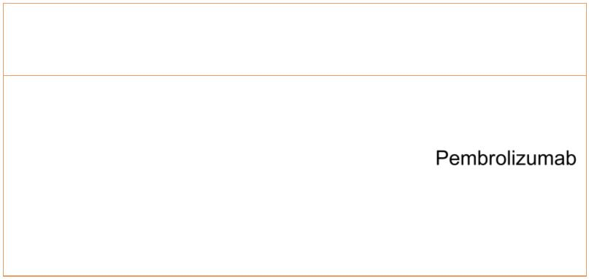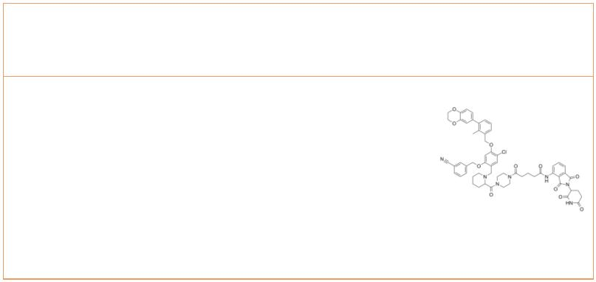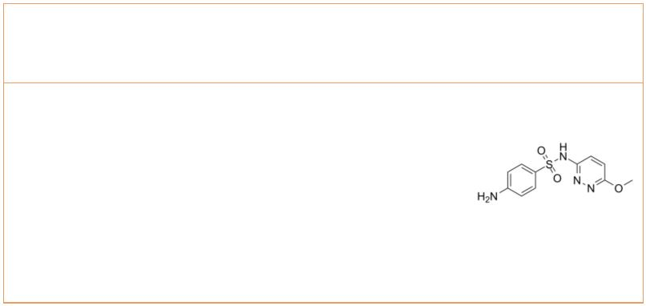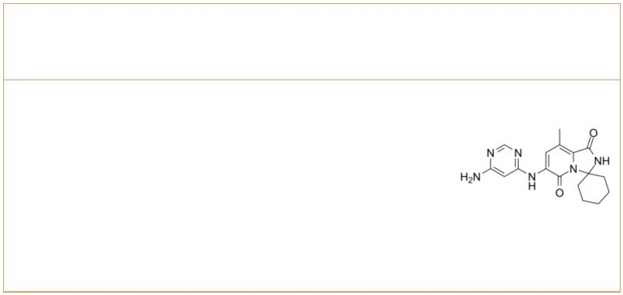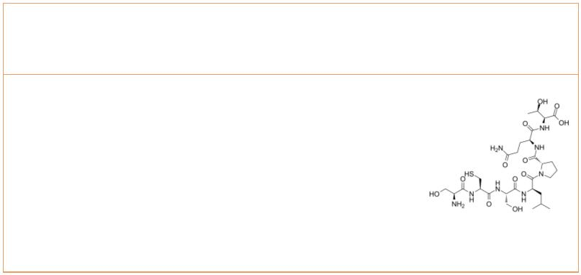Pembrolizumab  (MK-3475; Lambrolizumab) Cat. No.: HY-P9902 |  |  |  |  | PROTAC PD-1/PD-L1 degrader-1 |  |  |  |  |  |  |  | Cat. No.: HY-131183
Pembrolizumab is a humanized IgG4 antibody  inhibiting the programmed cell death 1 (PD-1)  receptor, used in cancer immunotherapy. |  |  |  |  | PROTAC PD-1/PD-L1 degrader-1, a PD-1/PD-L1 PROTAC  based on Cereblon E3 ligand, inhibits PD-1/PD-L1  interaction with an IC of 39.2 nM. PROTAC  50  PD-1/PD-L1 degrader-1 significantly restores the  immunity repressed in a co-culture model of  Hep3B/OS-8/hPD-L1 and CD3 T cells.
Purity: 99.06%  Clinical Data: Launched  Size: 1 mg, 5 mg, 25 mg, 50 mg |  |  |  |  | Purity: 98.35%  Clinical Data: No Development Reported  Size: 5 mg, 10 mg, 25 mg, 50 mg, 100 mg
Sulfamethoxypyridazine |  | Cat. No.: HY-B1387 |  |  | Tomivosertib  (eFT508) Cat. No.: HY-100022
Sulfamethoxypyridazine is a long-acting  sulfonamide antibiotic, for treatment of  Dermatitis herpetiformis. |  |  |  |  | Tomivosertib (eFT508) is a potent, highly  selective, and orally active MNK1 and MNK2  inhibitor, with IC s of 1-2 nM against both  50  isoforms.
Purity: 99.67%  Clinical Data: No Development Reported  Size: 10 mM × 1 mL, 100 mg |  |  |  |  | Purity: 99.92%  Clinical Data: Phase 2  Size: 10 mM × 1 mL, 1 mg, 5 mg, 10 mg, 50 mg, 100 mg
TPP-1 TPP-1 TFA
 |  |  | Cat. No.: HY-P3139 Cat. No.: HY-P3139A
TPP-1 is a potent inhibitor of  the PD-1/PD-L1 interaction. TPP-1 binds  specifically to PD-L1 with a high affinity  (K =95 nM). TPP-1 inhibits human tumor growth  D in  vivo via reactivating T-cell function. |  |  |  |  | TPP-1 TFA is a potent inhibitor of  the PD-1/PD-L1 interaction. TPP-1 TFA binds  specifically to PD-L1 with a high affinity  (K =95 nM). TPP-1 TFA inhibits human tumor  D  growth in vivo via reactivating T-cell function.
Purity: 98.04%  Clinical Data: No Development Reported  Size: 25 mg |  |  |  |  | Purity: >98%  Clinical Data: No Development Reported  Size: 1 mg, 5 mg
[D-Leu-4]-OB3
Cat. No.: HY-P3342
[D-Leu-4]-OB3 inhibits expressions of
pro-inflammatory, proliferative and metastatic
genes and PD-L1 expression. [D-Leu-4]-OB3
stimulates expression of pro-apoptotic genes.
Purity: >98%
Clinical Data: No Development Reported
Size: 1 mg, 5 mg
www.MedChemExpress.com 7

