LRRK2
Leucine-rich repeat kinase 2
Leucine-rich repeat kinase 2 (LRRK2) is a ubiquitously expressed member of the ROCO protein family. LRRK2 is a complex,
multidomain protein containing kinase and GTPase enzymatic activities and multiple protein-protein interaction domains. LRRK2 is
the genetic cause of both familial and idiopathic Parkinson's disease (PD), and it is associated with neuronal death, vesicle
trafficking, mitochondrial dysfunction, and inflammation.
LRRK2 is a very large protein comprised of 2527 amino acids which has been determined to contain multiple functional domains,
including armadillo (ARM), ankyrin-repeats (ANK), leucine-rich repeats (LRR), Ras of complex proteins (ROC), C-terminal of Roc
(COR), MAPK-like kinase, and WD40 motifs. Mutations in LRRK2 represent a significant component of both sporadic and familial
PD. Pathogenic mutations cluster in the enzymatic domains of LRRK2, and kinase activity seems to correlate with cytotoxicity,
suggesting the possibility of kinase-based therapeutic strategies for LRRK2-associated PD. The best-characterized mutation to date,
G2019S, leads to increased kinase activity, and mutations in the GTPase domain, such as R1441C and R1441G, have also been
reported to influence kinase activity.
www.MedChemExpress.com 1
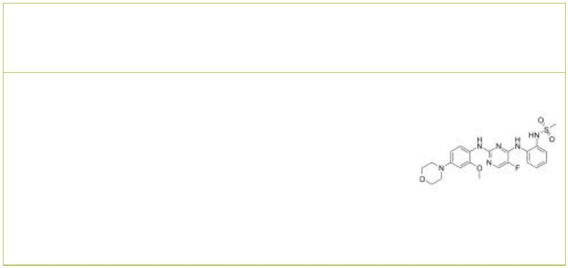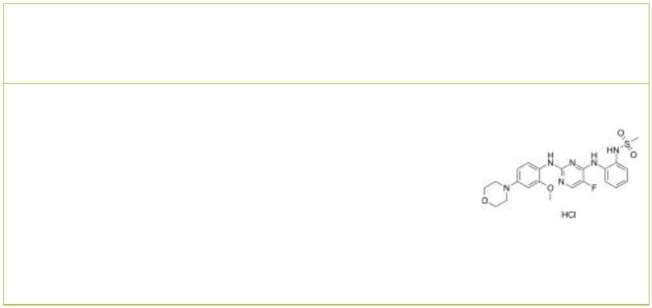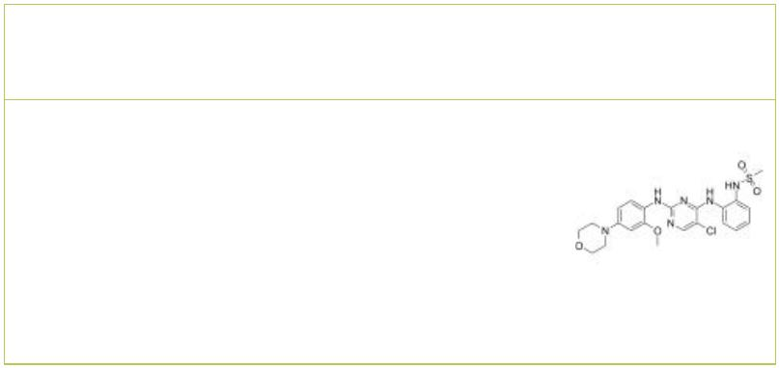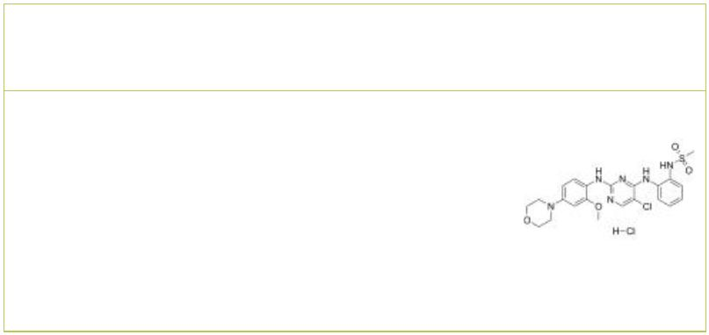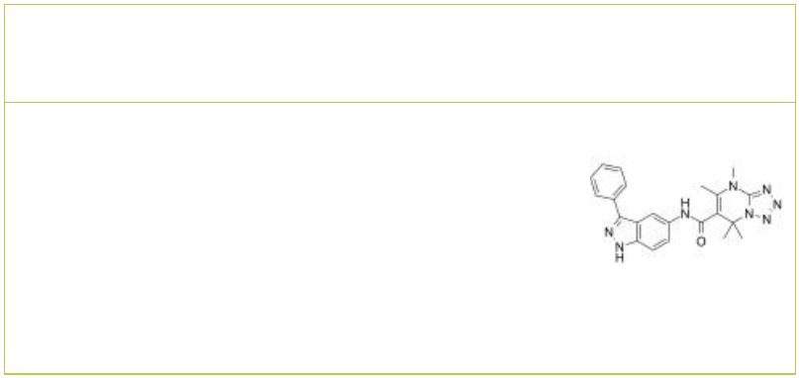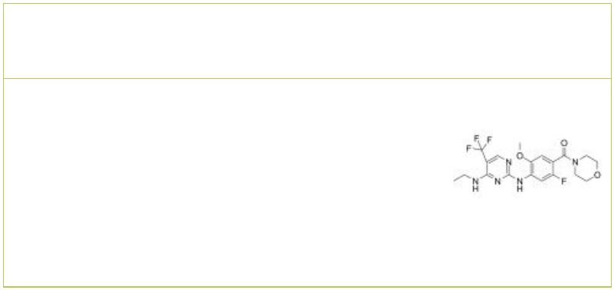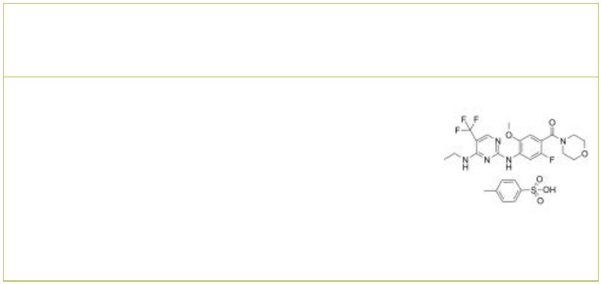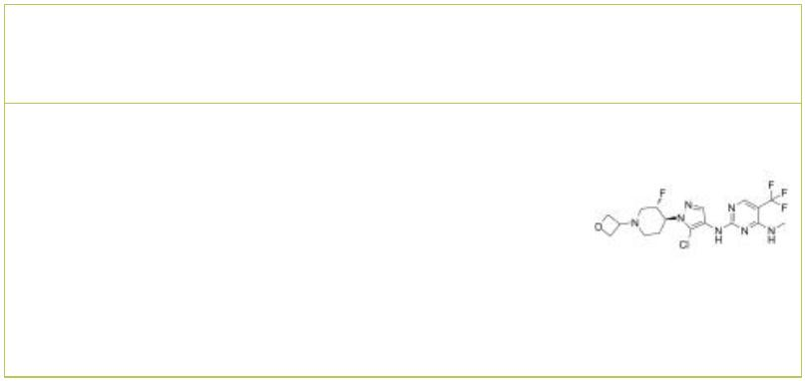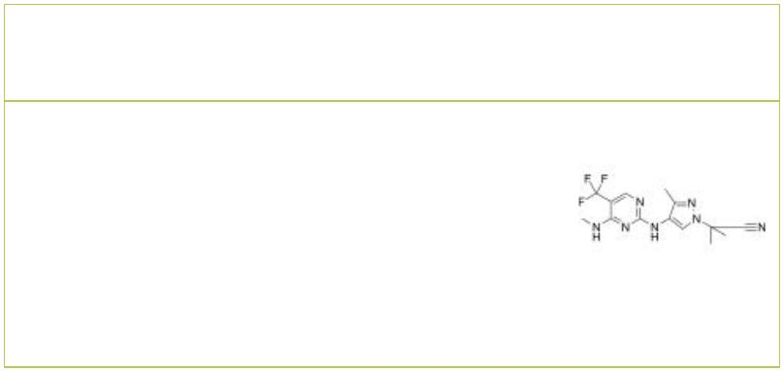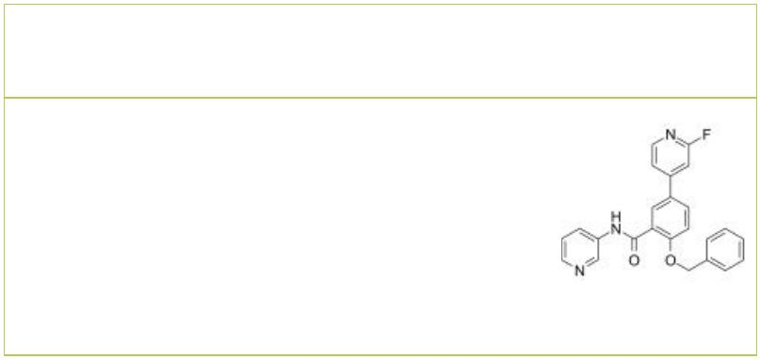LRRK2 Inhibitors
 | CZC-25146 CZC-25146 hydrochloride
 |  | Cat. No.: HY-15800A Cat. No.: HY-15800
 | CZC-25146 is a potent, selective and metabolically  stable LRRK2 inhibitor with IC50 of 4.76 nM/6.87  nM for wild type LRRK2 and G2019S LRRK2  respectively. |  |  |  |  |  | CZC-25146 Hcl is a potent, selective and  metabolically stable LRRK2 inhibitor with IC50 of  4.76 nM/6.87 nM for wild type LRRK2 and G2019S  LRRK2 respectively.
 | Purity: 98.85%  Clinical Data: No Development Reported  Size: 10 mM × 1 mL, 5 mg, 10 mg, 50 mg, 100 mg |  |  |  |  |  | Purity: >98%  Clinical Data: No Development Reported  Size: 1 mg, 5 mg
 | CZC-54252 CZC-54252 hydrochloride
 |  |  |  | Cat. No.: HY-B0792 Cat. No.: HY-B0792A
 | CZC-54252 is a potent and selective LRRK2  inhibitor with IC s of 1.28 nM and 1.85 nM for  50  wild-type and G2019S LRRK2, respectively.  CZC-54252 attenuates G2019S LRRK2-induced human  neuronal injury with an EC of ~1 nM. CZC-54252  50  has a neuroprotective activity.  Purity: 99.18%  Clinical Data: No Development Reported  Size: 10 mM × 1 mL, 10 mg, 50 mg |  |  |  |  |  | CZC-54252 hydrochloride is a potent and selective  LRRK2 inhibitor with IC s of 1.28 nM and 1.85 nM  50  for wild-type and G2019S LRRK2, respectively.  G2019S LRRK2-induced human neuronal injury is  attenuated by CZC-54252 hydrochloride with an  EC of ~1 nM.  50  Purity: >98%  Clinical Data: No Development Reported  Size: 1 mg, 5 mg
 | EB-42486 GNE-7915
 |  |  | Cat. No.: HY-142647 Cat. No.: HY-18163
 | EB-42486 is a novel, potent, and highly selective  G2019S-LRRK2 inhibitor (IC < 0.2 nM).  50 |  |  |  |  |  | GNE-7915 is a potent, selective and  brain-penetrant inhibitor of LRRK2 with an IC  of 9 nM.  50
 | Purity: >98%  Clinical Data: No Development Reported  Size: 1 mg, 5 mg |  |  |  |  |  | Purity: 99.79%  Clinical Data: No Development Reported  Size: 10 mM × 1 mL, 5 mg, 10 mg, 25 mg, 50 mg, 100 mg
 | GNE-7915 tosylate GNE-9605
 |  | Cat. No.: HY-18163A Cat. No.: HY-12282
 | GNE-7915 tosylate is a potent, selective and  brain-penetrant inhibitor of LRRK2 with an IC  of 9 nM.  50 |  |  |  |  |  | GNE-9605 is a highly potent, selective, and  brain-penetrant LRRK2 inhibitor with IC50 of 19  nM. IC50 value: Target: LRRK2 GNE-9605 retained  excellent predicted human metabolic stability when  assayed in human liver microsomes and hepatocytes.
 | Purity: 99.62%  Clinical Data: No Development Reported  Size: 10 mM × 1 mL, 5 mg, 10 mg, 25 mg, 50 mg, 100 mg |  |  |  |  |  | Purity: 99.72%  Clinical Data: No Development Reported  Size: 10 mM × 1 mL, 5 mg, 10 mg, 50 mg, 100 mg
 | GNE0877 GSK2578215A
 |  |  |  |  | Cat. No.: HY-15796 Cat. No.: HY-13237
 | GNE0877 is a highly potent, selective, and  brain-penetrant aminopyrazole leucine-rich repeat  kinase 2 (LRRK2) small molecule inhibitor with an  IC50 of 3 nM. |  |  |  |  |  | GSK2578215A is a potent and highly selective  LRRK2 inhibitor, which exhibits IC s of around  50  10 nM against both wild-type LRRK2 and the G2019S  mutant.
 | Purity: 98.89%  Clinical Data: No Development Reported  Size: 10 mM × 1 mL, 2 mg, 5 mg, 10 mg, 25 mg, 50 mg |  |  |  |  |  | Purity: 99.79%  Clinical Data: No Development Reported  Size: 10 mM × 1 mL, 5 mg, 10 mg, 50 mg, 100 mg
2 Tel: 609-228-6898 Fax: 609-228-5909 Email: sales@MedChemExpress.com
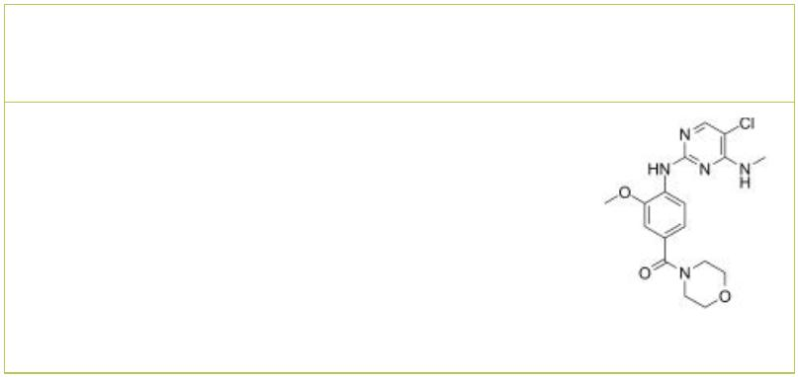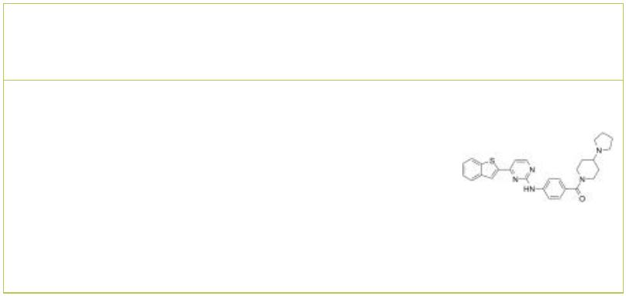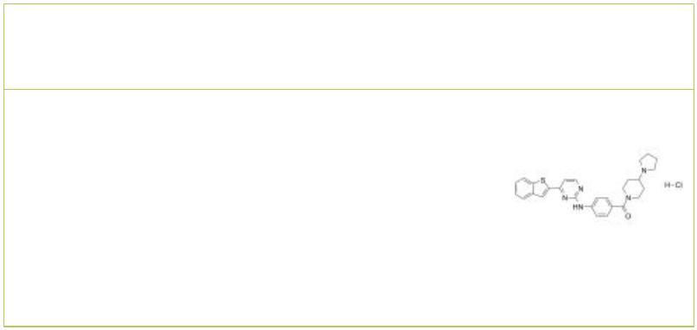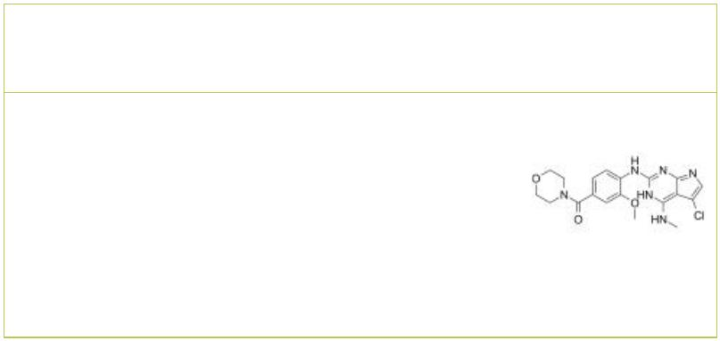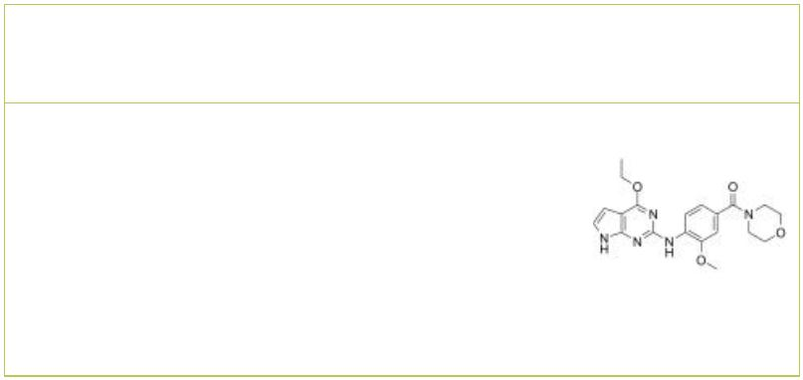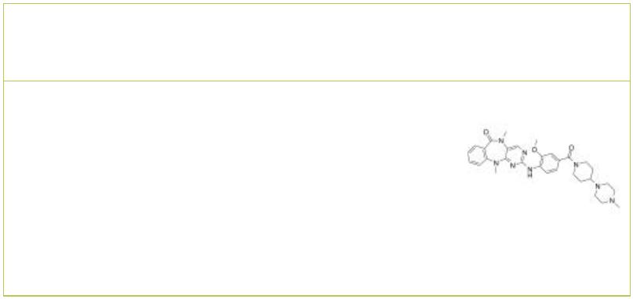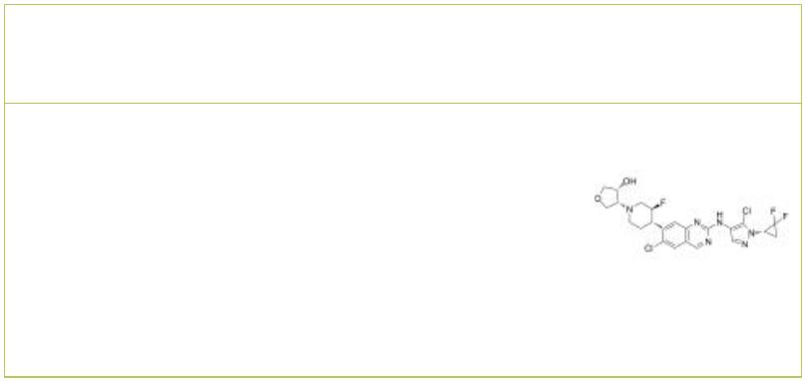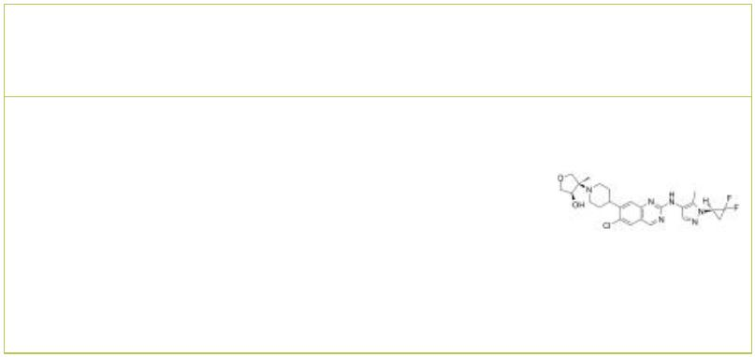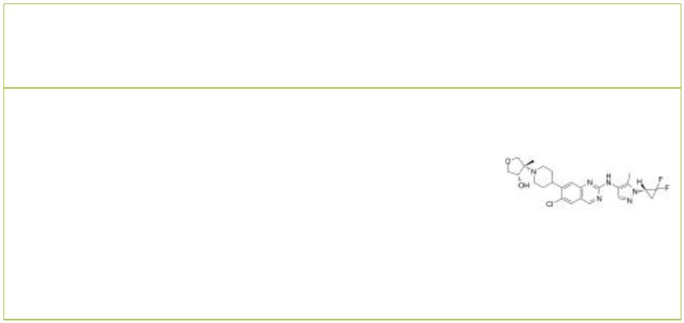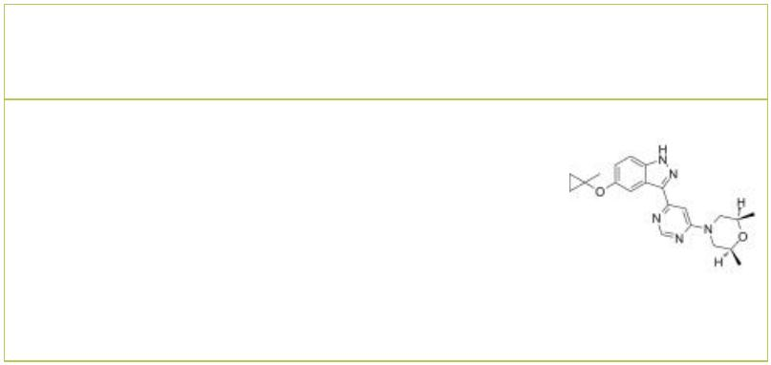HG-10-102-01 IKK 16
 |  |  | Cat. No.: HY-13488 Cat. No.: HY-13687
HG-10-102-01 is a potent and selective inhibitor  of wild-type LRRK2(IC50=23.3 nM) and the G2019S  mutant(IC50=3.2 nM) IC50 Value: 23.3 nM (WT  LRRK2); 3.2 nM (LRRK2 G2019S) Target: LRRK2  HG-10-102-01 maintains the ability to potently  inhibit the biochemical activity of wild-type… |  |  |  |  | IKK 16 is a selective IκB kinase (IKK) inhibitor  for IKK2, IKK complex and IKK1 with IC s of 40  50  nM, 70 nM and 200 nM, respectively. IKK16 also  inhibits leucine-rich repeat kinase-2 (LRRK2)  with an IC of 50 nM.  50
Purity: 99.34%  Clinical Data: No Development Reported  Size: 10 mM × 1 mL, 5 mg, 10 mg, 50 mg |  |  |  |  | Purity: 99.09%  Clinical Data: No Development Reported  Size: 10 mM × 1 mL, 5 mg, 10 mg, 50 mg, 100 mg
IKK 16 hydrochloride JH-II-127
 | Cat. No.: HY-13687A Cat. No.: HY-16936
IKK 16 hydrochloride is a selective IκB kinase  (IKK) inhibitor for IKK2, IKK complex and IKK1 with  IC s of 40 nM, 70 nM and 200 nM, respectively.  50  IKK16 also inhibits leucine-rich repeat kinase-2  (LRRK2) with an IC of 50 nM.  50 |  |  |  |  | JH-II-127 is a highly potent, selective, and brain  penetrant LRRK2 inhibitor, with IC50 of 6.6 nM,  2.2 nM ,47.7 nM for LRRK2-wild-type, LRRK2-G2019S,  LRRK2-A2016T.
Purity: ≥98.0%  Clinical Data: No Development Reported  Size: 5 mg, 10 mg, 50 mg, 100 mg |  |  |  |  | Purity: 98.02%  Clinical Data: No Development Reported  Size: 10 mM × 1 mL, 5 mg, 10 mg, 50 mg, 100 mg
LRRK2 inhibitor 1 LRRK2-IN-1
 |  | Cat. No.: HY-111493 Cat. No.: HY-10875
LRRK2 inhibitor 1 is a potent, selective and oral  LRRK2 inhibitor with an pIC of 6.8.  50 |  |  |  |  | LRRK2-IN-1 is a potent and  selective LRRK2 inhibitor  with IC of 6 nM and 13 nM for  50  LRRK2 (G2019S) and LRRK2 (WT), respectively.
Purity: 99.72%  Clinical Data: No Development Reported  Size: 10 mM × 1 mL, 5 mg, 10 mg, 50 mg, 100 mg |  |  |  |  | Purity: 99.19%  Clinical Data: No Development Reported  Size: 10 mM × 1 mL, 10 mg, 50 mg, 100 mg, 500 mg
LRRK2-IN-2 LRRK2-IN-3
 |  | Cat. No.: HY-145317 Cat. No.: HY-145318
LRRK2-IN-2 (compoubd 22) is a potent, selective,  orally active and brain-penetrant inhibitor  LRRK2, with IC of <0.6 nM. LRRK2-IN-2 can be  50  used for the research of Parkinson's disease. |  |  |  |  | LRRK2-IN-3 (compoubd 24) is a potent, selective,  orally active and brain-penetrant inhibitor  LRRK2, with IC of 2.6 nM in human PBMCs.  50  LRRK2-IN-3 can be used for the research of  Parkinson's disease.
Purity: >98%  Clinical Data: No Development Reported  Size: 1 mg, 5 mg |  |  |  |  | Purity: >98%  Clinical Data: No Development Reported  Size: 1 mg, 5 mg
LRRK2-IN-4 MLi-2
 |  | Cat. No.: HY-144074 Cat. No.: HY-100411
LRRK2-IN-4 is a potent, selective, CNS-penetran  and orally active leucine-rich repeat kinase 2  (LRRK2) inhobitor with an IC of 2.6 nM.  50  LRRK2-IN-4 has the potential for the research of  Parkinson’s disease. |  |  |  |  | MLi-2 is an orally active and highly selective  LRRK2 inhibitor with an IC of 0.76 nM. MLi-2  50  has the potential for Parkinson’s disease.
Purity: >98%  Clinical Data: No Development Reported  Size: 1 mg, 5 mg |  |  |  |  | Purity: 99.74%  Clinical Data: No Development Reported  Size: 10 mM × 1 mL, 5 mg, 10 mg, 50 mg, 100 mg
www.MedChemExpress.com 3
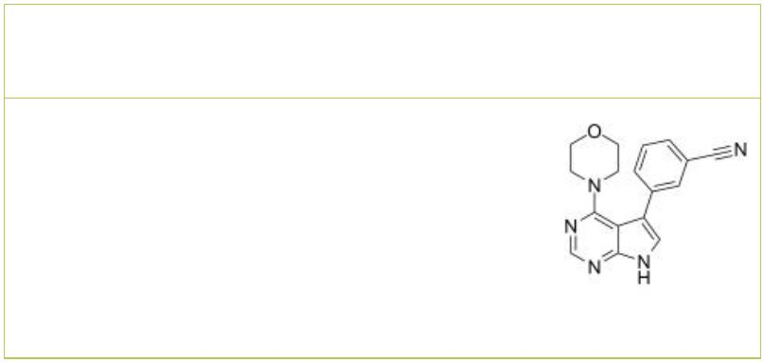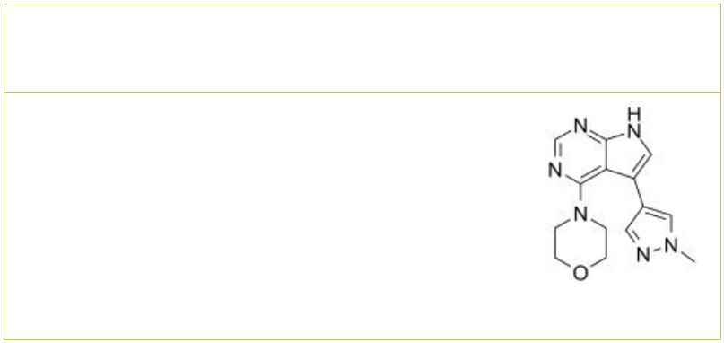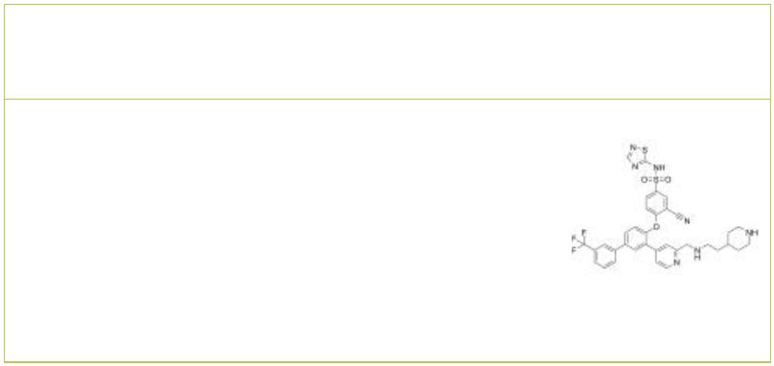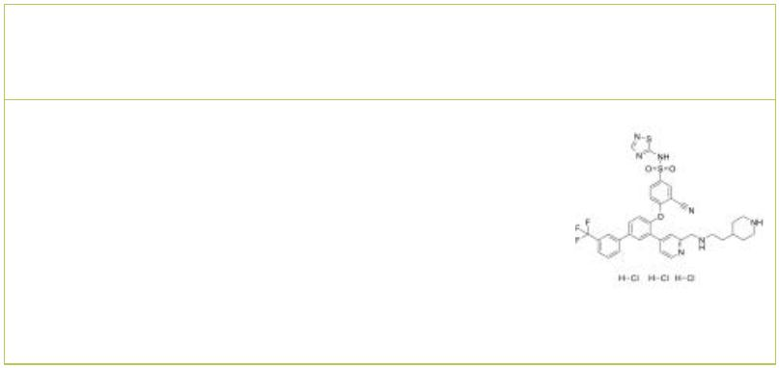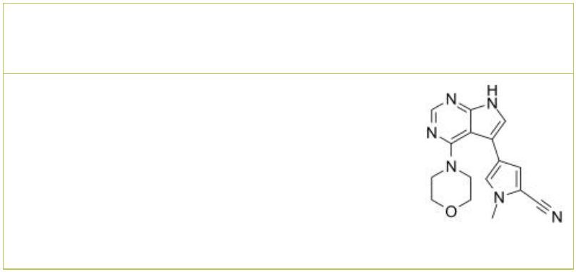 | PF-06447475 PF-06454589
 |  |  | Cat. No.: HY-12477 Cat. No.: HY-112855
 | PF-06447475 is a highly potent, selective and  brain penetrant LRRK2 inhibitor with an IC of 3  50  nM. |  |  |  | PF-06447475 is a highly potent, selective, brain  penetrant LRRK2 kinase inhibitor with IC values  50  of 3 nM and 11 nM for WT LRRK and G2019S LRRK2,  respectively. PF-06447475 can be used for  parkinson's disease (PD) research.
 | Purity: 99.88%  Clinical Data: No Development Reported  Size: 10 mM × 1 mL, 5 mg, 10 mg, 25 mg, 50 mg, 100 mg, 200 mg |  |  |  | Purity: >98%  Clinical Data: No Development Reported  Size: 5 mg, 10 mg, 25 mg, 50 mg, 100 mg
 | PF-06456384 PF-06456384 trihydrochloride
 |  | Cat. No.: HY-118952 Cat. No.: HY-118952A
 | PF-06447475 is a highly potent, selective, brain  penetrant LRRK2 kinase inhibitor with IC values  50  of 3 nM and 11 nM for WT LRRK and G2019S LRRK2,  respectively. PF-06447475 can be used for  parkinson's disease (PD) research. |  |  |  | PF-06447475 trihydrochloride is a highly potent,  selective, brain penetrant LRRK2 kinase inhibitor  with IC values of 3 nM and 11 nM for WT LRRK and  50  G2019S LRRK2, respectively. PF-06447475  trihydrochloride can be used for parkinson's  disease (PD) research.
 | Purity: >98%  Clinical Data: No Development Reported  Size: 1 mg, 5 mg |  |  |  | Purity: >98%  Clinical Data: No Development Reported  Size: 25 mg
PFE-360
(PF-06685360) Cat. No.: HY-120085
PFE-360 (PF-06685360) is a potent, selective,
brain penetrated and orally active leucine-rich
repeat kinase 2 (LRRK2) inhibitor with a mean IC of 2.3 nM in vivo.
50
Purity: 98.94%
Clinical Data: No Development Reported
Size: 10 mM × 1 mL, 5 mg, 10 mg, 50 mg, 100 mg
4 Tel: 609-228-6898 Fax: 609-228-5909 Email: sales@MedChemExpress.com

