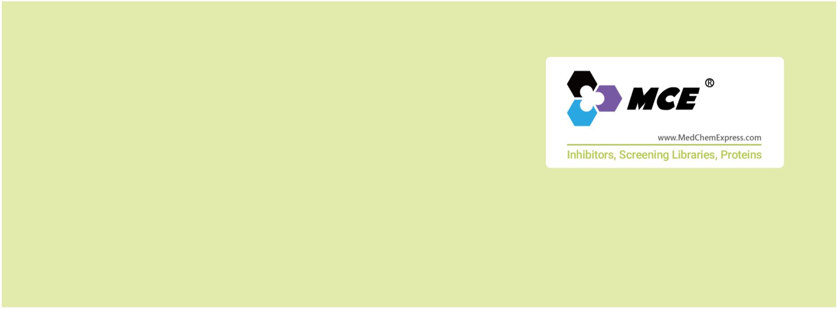ULK
Unc-51 like kinase
The ULK (UNC51-like) enzymes are a family of mammalian kinases that have critical roles in autophagy and development. The ULK
family of kinases comprises 5 genes in mammals: ULK1 through ULK4 and STK36. In mammals, ULK1 and ULK2 have been shown to
be necessary for the proper autophagy induction and contribute to various developmental, physiological, and pathological
processes.
The serine/threonine-protein kinases ULK1 and ULK2 are evolutionarily conserved serine/threonine kinase orthologs of the yeast
autophagy related (Atg) family member Atg1, that have redundant roles in the regulation of autophagy. Autophagy targets
long-lived proteins or organelles for degradation in lysosomes, and the products of this process are then recycled for other cellular
pathways. The canonical ULK/Atg1 complex is composed of ULK1, ATG13, RB1CC1/FIP200/ATG17, and ATG101. It initiates
autophagosome formation, at least in part by phosphorylating components of the autophagy-inducing class III phosphatidylinositol
3-kinase complex (e.g., PI3K3C/Vps34, PIK3R4/Vps15, BECN1/Vps30/ATG6, ATG14). ULK/Atg1 also promotes membrane recycling
via ATG9. Consistent with the established role of ULK1/2 in autophagy, disrupting ULK1 expression in mice results in a defect in
autophagy-mediated clearance of mitochondria during red blood cell maturation, and mice lacking both ULK1 and ULK2 expression
die shortly after birth due to a defect in glycogen metabolism, which is similar to other autophagy-defective mice.
www.MedChemExpress.com 1
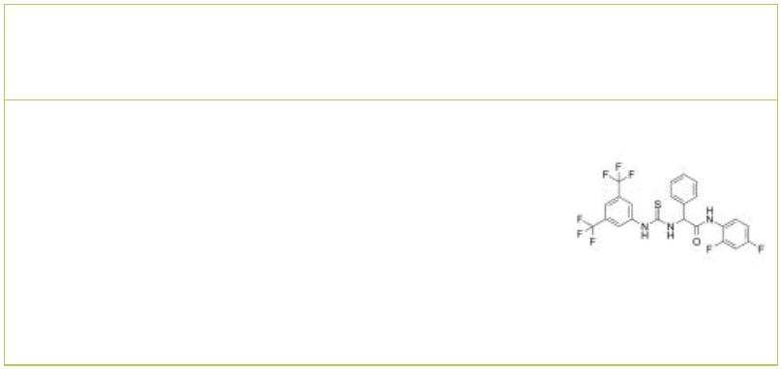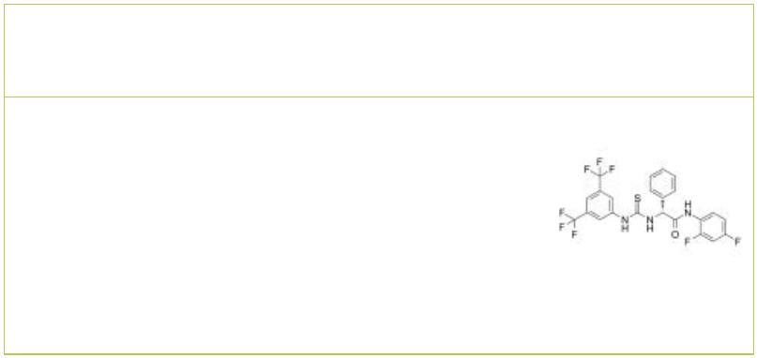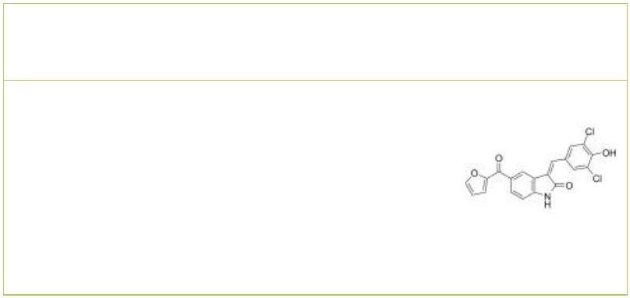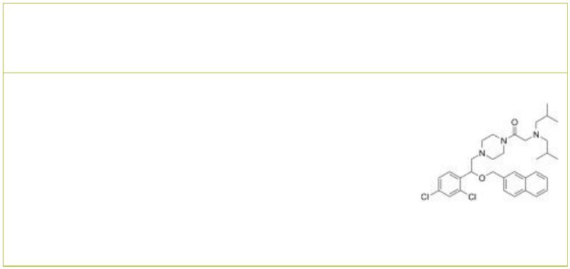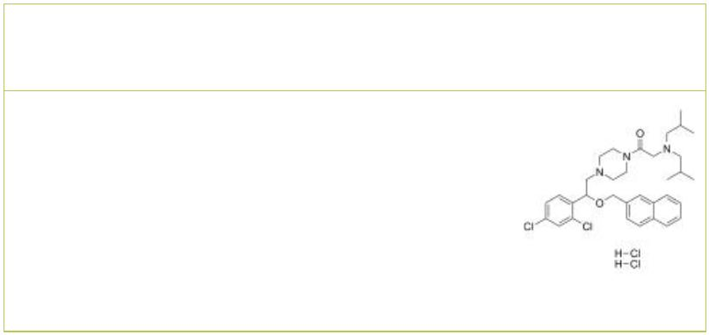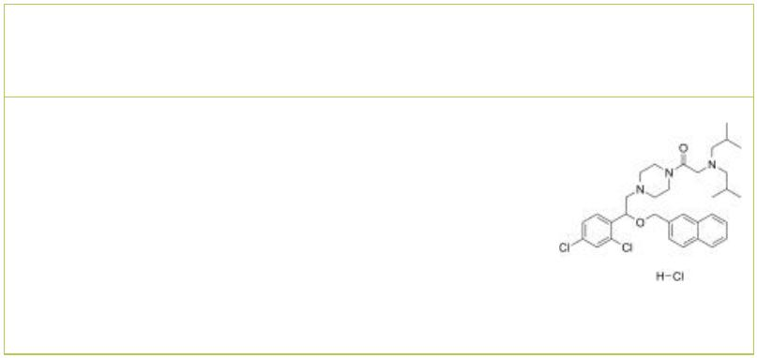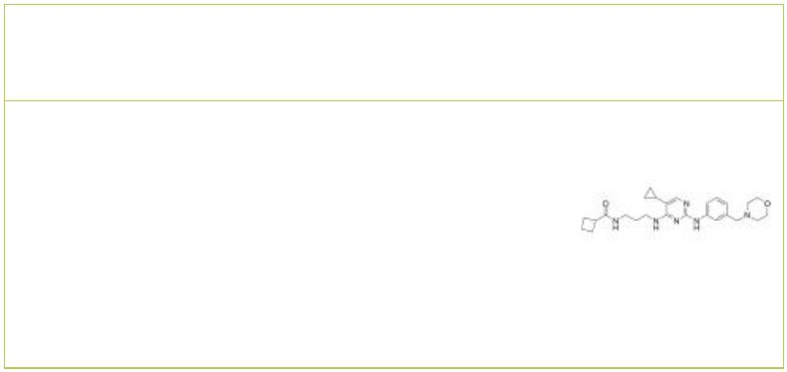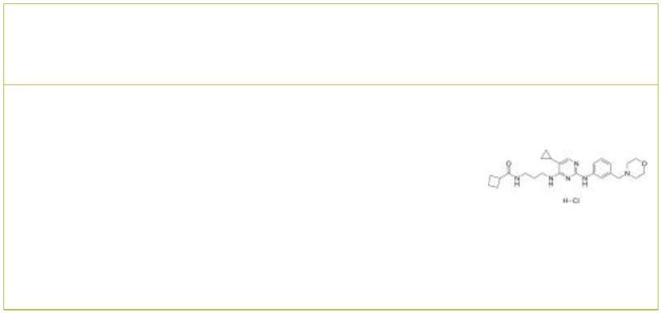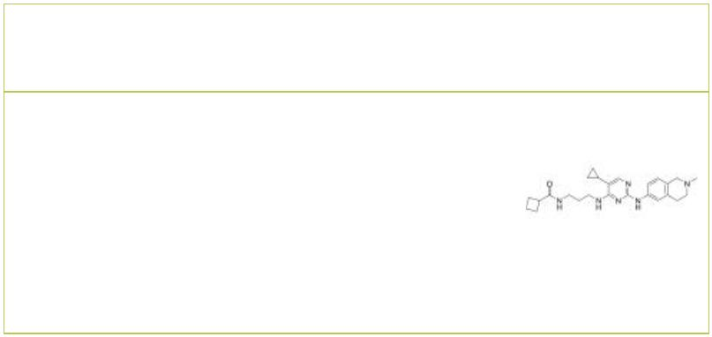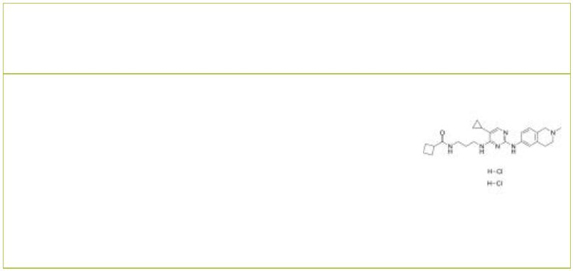ULK Inhibitors & Activators
 | (Rac)-BL-918 BL-918
 |  | Cat. No.: HY-124729A Cat. No.: HY-124729
 | (Rac)-BL-918 is the racemate of BL-918. BL-918 is  a potent activator of UNC-51-like kinase 1 (ULK1),  inducing cytoprotective autophagy for Parkinson’s  disease treatment. |  |  |  |  |  | BL-918 is an orally active UNC-51-like kinase 1  (ULK1) activator with an EC of 24.14 nM.  50  BL-918 exerts its cytoprotective autophagic effect  by targeting ULK complex. BL-918 has the potential  for Parkinson’s disease (PD) treatment.
 | Purity: 98.06%  Clinical Data: No Development Reported  Size: 10 mM × 1 mL, 5 mg, 10 mg, 50 mg, 100 mg |  |  |  |  |  | Purity: 98.36%  Clinical Data: No Development Reported  Size: 10 mM × 1 mL, 5 mg, 10 mg, 50 mg, 100 mg
 | GW406108X  (GW108X) Cat. No.: HY-115570 |  |  |  |  |  | LYN-1604 |  |  |  |  |  |  |  |  |  |  |  |  | Cat. No.: HY-101923
 | GW406108X is a specific Kif15 (Kinesin-12) inhibitor  with an IC of 0.82 uM in ATPase assays.  50  GW406108X, a potent autophagy inhibitor, shows  ATP competitive inhibition against ULK1 with a  pIC of 6.37 (427 nM).  50 |  |  |  |  |  | LYN-1604 is a potent UNC-51-like kinase 1 (ULK1)  activator (EC =18.94 nM) for the research of  50  triple negative breast cancer (TNBC).
 | Purity: 96.02%  Clinical Data: No Development Reported  Size: 10 mM × 1 mL, 5 mg, 10 mg, 25 mg, 50 mg, 100 mg |  |  |  |  |  | Purity: >98%  Clinical Data: No Development Reported  Size: 1 mg, 5 mg
 | LYN-1604 dihydrochloride LYN-1604 hydrochloride
 |  |  | Cat. No.: HY-101923B Cat. No.: HY-101923A
 | LYN-1604 dihydrochloride is a potent UNC-51-like  kinase 1 (ULK1) activator (EC =18.94 nM) for  50  the research of triple negative breast cancer  (TNBC). |  |  |  |  |  | LYN-1604 hydrochloride is a potent UNC-51-like  kinase 1 (ULK1) activator (EC =18.94 nM) for  50  the research of triple negative breast cancer  (TNBC).
 | Purity: 98.73%  Clinical Data: No Development Reported  Size: 10 mM × 1 mL, 5 mg, 10 mg, 25 mg, 50 mg, 100 mg |  |  |  |  |  | Purity: >98%  Clinical Data: No Development Reported  Size: 10 mM × 1 mL, 5 mg, 10 mg, 25 mg, 50 mg, 100 mg
 | MRT67307 MRT67307 hydrochloride
 |  |  |  |  | Cat. No.: HY-13018 Cat. No.: HY-13018A
 | MRT67307 is a dual inhibitor of the IKKε and TBK-1  with IC s of 160 and 19 nM, respectively.  50  MRT67307 also inhibits ULK1 and ULK2 with IC s  50  of 45 and 38 nM, respectively. MRT67307 also  blocks autophagy in cells. |  |  |  |  |  | MRT67307 hydrochloride is a dual inhibitor of the  IKKε and TBK-1 with IC s of 160 and 19 nM,  50  respectively. MRT67307 hydrochloride also inhibits  ULK1 and ULK2 with IC s of 45 and 38 nM,  50  respectively. MRT67307 hydrochloride also blocks  autophagy in cells.
 | Purity: 99.34%  Clinical Data: No Development Reported  Size: 10 mM × 1 mL, 5 mg, 10 mg, 50 mg, 100 mg |  |  |  |  |  | Purity: >98%  Clinical Data: No Development Reported  Size: 1 mg, 5 mg
 | MRT68921 MRT68921 dihydrochloride
 |  |  |  | Cat. No.: HY-100006 Cat. No.: HY-100006A
 | MRT68921 is a potent inhibitor of ULK1 and ULK2,  with IC values of 2.9 nM and 1.1 nM,  50  respectively. |  |  |  |  |  | MRT68921 dihydrochloride is a potent inhibitor of  ULK1 and ULK2, with IC values of 2.9 nM and  50  1.1 nM, respectively.
 | Purity: >98%  Clinical Data: No Development Reported  Size: 1 mg, 5 mg |  |  |  |  |  | Purity: 99.58%  Clinical Data: No Development Reported  Size: 10 mM × 1 mL, 5 mg, 10 mg, 25 mg, 50 mg, 100 mg, 200 mg
2 Tel: 609-228-6898 Fax: 609-228-5909 Email: sales@MedChemExpress.com
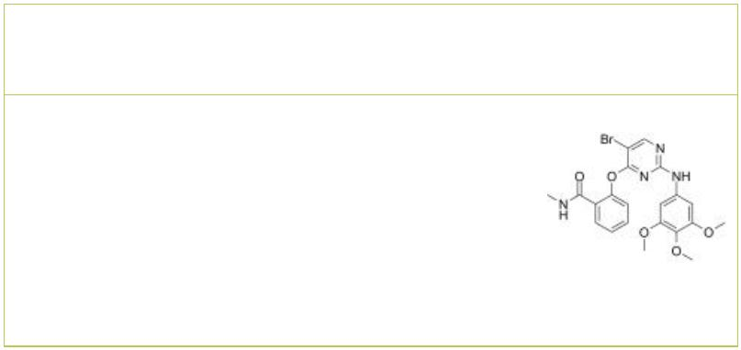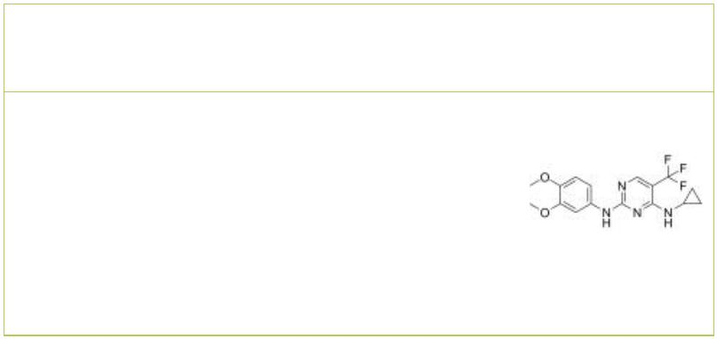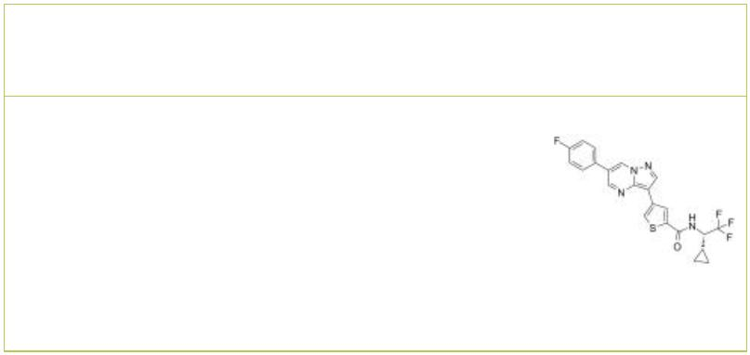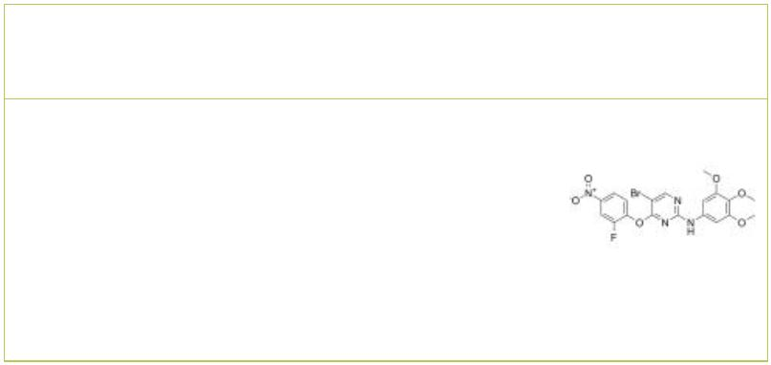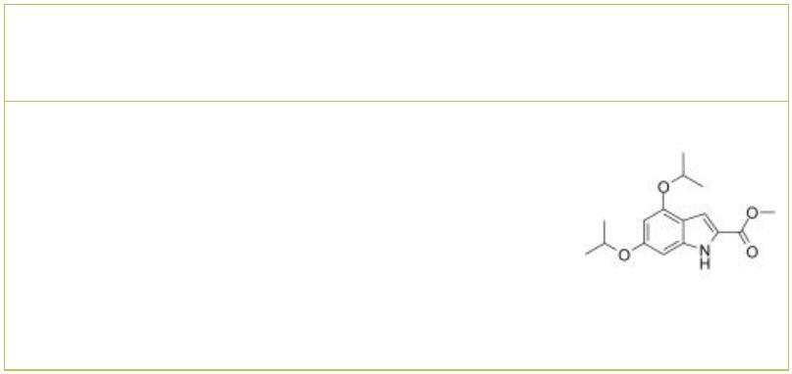SBI-0206965 SBP-7455
 |  | Cat. No.: HY-16966 Cat. No.: HY-137742
SBI-0206965 is a potent, selective and cell  permeable autophagy kinase ULK1 inhibitor with  IC s of 108 nM for ULK1 kinase and 711 nM for the  50  highly related kinase ULK2. |  |  |  | SBP-7455 is a potent, high affinity and orally  active dual ULK1/ULK2 autophagy inhibitor with  IC s of 13 nM and 476 nM in the ADP-Glo assays,  50  respectively. SBP-7455 potently inhibits ULK1/2  enzymatic activity and can be used for  triple-negative breast cancer (TNBC) research.
Purity: 99.39%  Clinical Data: No Development Reported  Size: 10 mM × 1 mL, 5 mg, 10 mg, 50 mg, 100 mg |  |  |  | Purity: 98.29%  Clinical Data: No Development Reported  Size: 5 mg, 10 mg, 25 mg, 50 mg, 100 mg
ULK-101 ULK1-IN-2
 | Cat. No.: HY-114490 Cat. No.: HY-143466
ULK-101 is a potent and selective ULK1 inhibitor,  with IC values of 1.6 nM and 30 nM for ULK1 and  50  ULK2, respectively. ULK-101 suppresses autophagy  and sensitizes cancer cells to nutrient stress. |  |  |  | ULK1-IN-2 (compound 3s) is a potent ULK1  inhibitor. ULK1-IN-2 shows highest cytotoxic  effect against cancer cell lines, with IC of  50  1.94 μM in A549. ULK1-IN-2 can induce apoptosis  and simultaneously block autophagy, and can be  used to study NSCLC (Non-small cell lung cancer).
Purity: 99.96%  Clinical Data: No Development Reported  Size: 10 mM × 1 mL, 5 mg, 10 mg |  |  |  | Purity: >98%  Clinical Data: No Development Reported  Size: 1 mg, 5 mg
XST-14
Cat. No.: HY-137506
XST-14 is a potent, competitive and highly selective ULK1 inhibitor with an IC of 26.6 nM.
50
XST-14 induces autophagy inhibition by reducing
the phosphorylation of the ULK1 downstream
substrate.
Purity: 99.69%
Clinical Data: No Development Reported
Size: 10 mM × 1 mL, 5 mg, 10 mg, 25 mg, 50 mg, 100 mg
www.MedChemExpress.com 3

