European RF Mixer Market Projected to Reach €579.3 Million by 2031 with 3.2% CAGR

Porto, Portugal—January 7, 2025

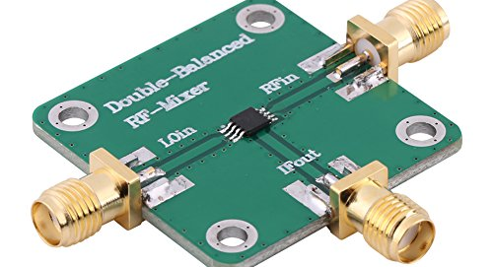

- European RF Mixer Market
According to a recent QY Research report, NXP Semiconductors continues to solidify its position in the European RF Mixer market through strategic collaborations and advancements in radar technology. In December 2024, NXP announced a partnership with South Korean startup bitsensing to develop cutting-edge radar systems for automotive applications. This collaboration integrates NXP's radar chips with bitsensing's hardware and software solutions, enhancing the safety and performance features of modern vehicles. This move reflects NXP's commitment to leveraging its expertise in semiconductors to meet the growing demand for advanced automotive safety technologies in Europe and beyond.
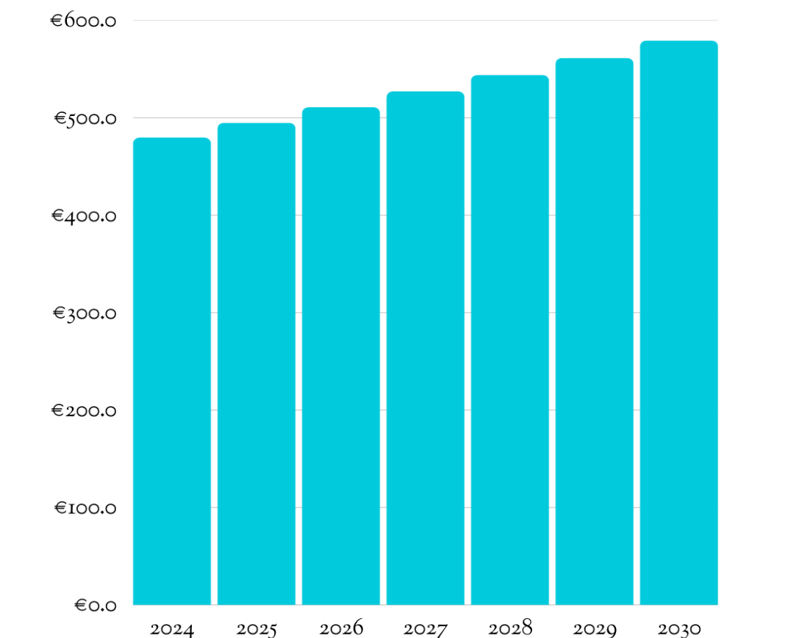
United Monolithic Semiconductors (UMS) has also been making significant strides in the European RF Mixer market, focusing on expanding access to its high-performance technologies. In July 2023, UMS collaborated with Fraunhofer IIS to broaden the reach of its Gallium Nitride (GaN) and Gallium Arsenide (GaAs) technologies through the EUROPRACTICE platform. This initiative allows EUROPRACTICE customers to utilize UMS's advanced RF and microwave Monolithic Microwave Integrated Circuit (MMIC) processes, fostering innovation in RF and microwave applications. The partnership highlights UMS's role in supporting European technological development and maintaining competitiveness in the global RF market.
The European market for RF Mixer was estimated to be worth €464.7 million in 2024 and is forecast to a readjusted size of €579.3 million by 2031 with a CAGR of 3.2% during the forecast period 2025-2031.
European RF Mixer Market Size (€ Million), 2025-2031

- European RF Mixer Top 20 Players Ranking and Market Share (Ranking is based on the revenue of 2024, continually updated)
• Mini Circuits (United States)
• Qorvo (United States)
• Analog Devices (United States)
• Marki Microwave (United States)
• Skyworks Solutions (United States)
• NXP Semiconductors (Netherlands)
• Texas Instruments (United States)
• Mercury Systems (United States)
• Peregrine Semiconductor (United States)
• L3 Narda-MITEQ (United States)
• Maxim Integrated (United States)
• Anaren (United States)
• UMS (United Monolithic Semiconductors) (France)
• MACOM Technology Solutions (United States)
• Renesas Electronics Corporation (Japan)
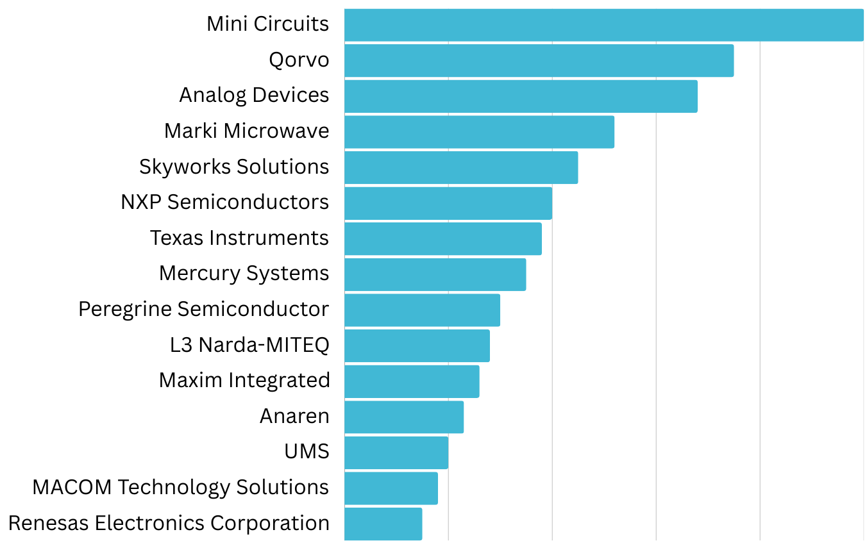

3. RF Mixer, European Market Size, Split by Region
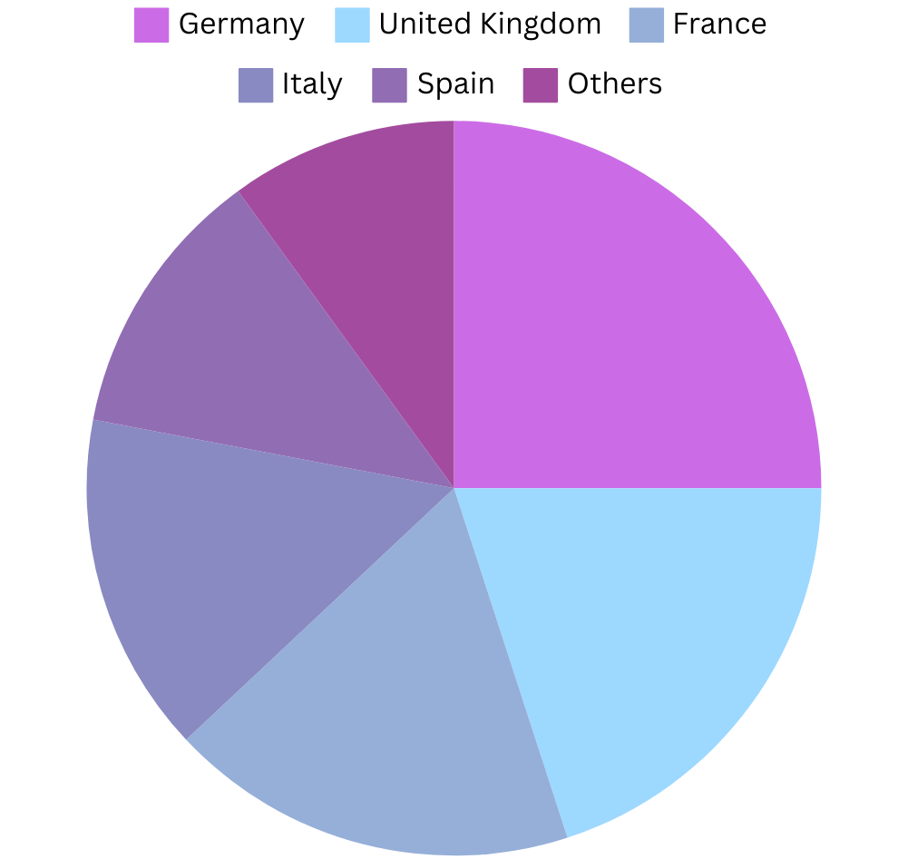
- RF Mixer, European Market Size, Split by Product Segment
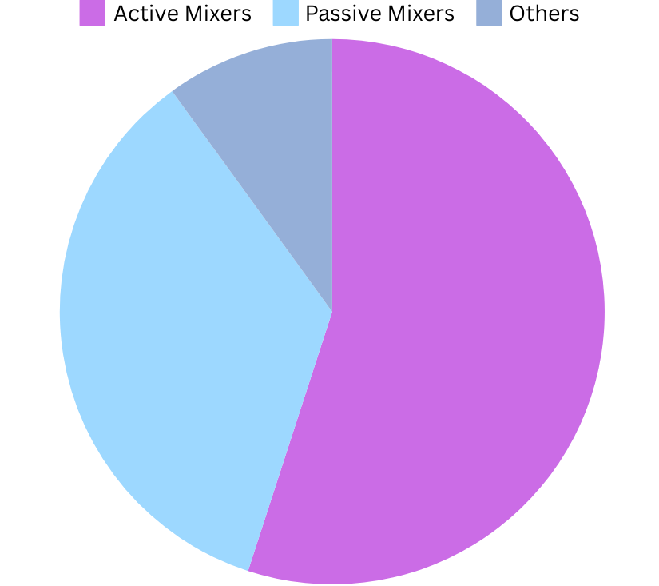

5. RF Mixer, European Market Size, Split by Application Segment
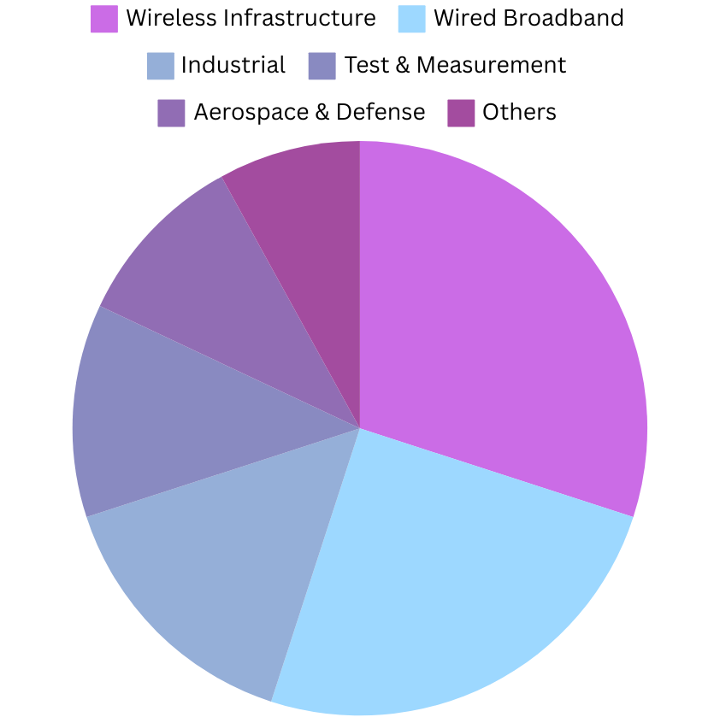

Based on or includes research from QYResearch: Global and European RF Mixer Market Report 2025-2031

Related Market Reports From QY Research

QY Research Releases Comprehensive Market Reports on the RF Mixer Market, as shown in the links below. These reports provide an in-depth analysis of the current market landscape, key trends, and future growth opportunities.

RF Mixer- Global Market Share and Ranking, Overall Sales and Demand Forecast 2025-2031
reports/3474841/rf-mixer
Global RF Mixer Market Research Report 2025
reports/3467043/rf-mixer

