大学英语（三）20171203 第一阶段 a
交卷时间：2017-10-27 07:53:31
一、词汇与结构
1.
(5 分)
These games allow gamers to_____________ with each other and play wit
h or against other gamers.
•
•
•
D. meet
•
纠错
2.
(5 分)Unlike desktops, smartphones and tablets offer limited space and
may ________to a customer being less thorough about exploring the me
nu.
•
•
•
C. contribute
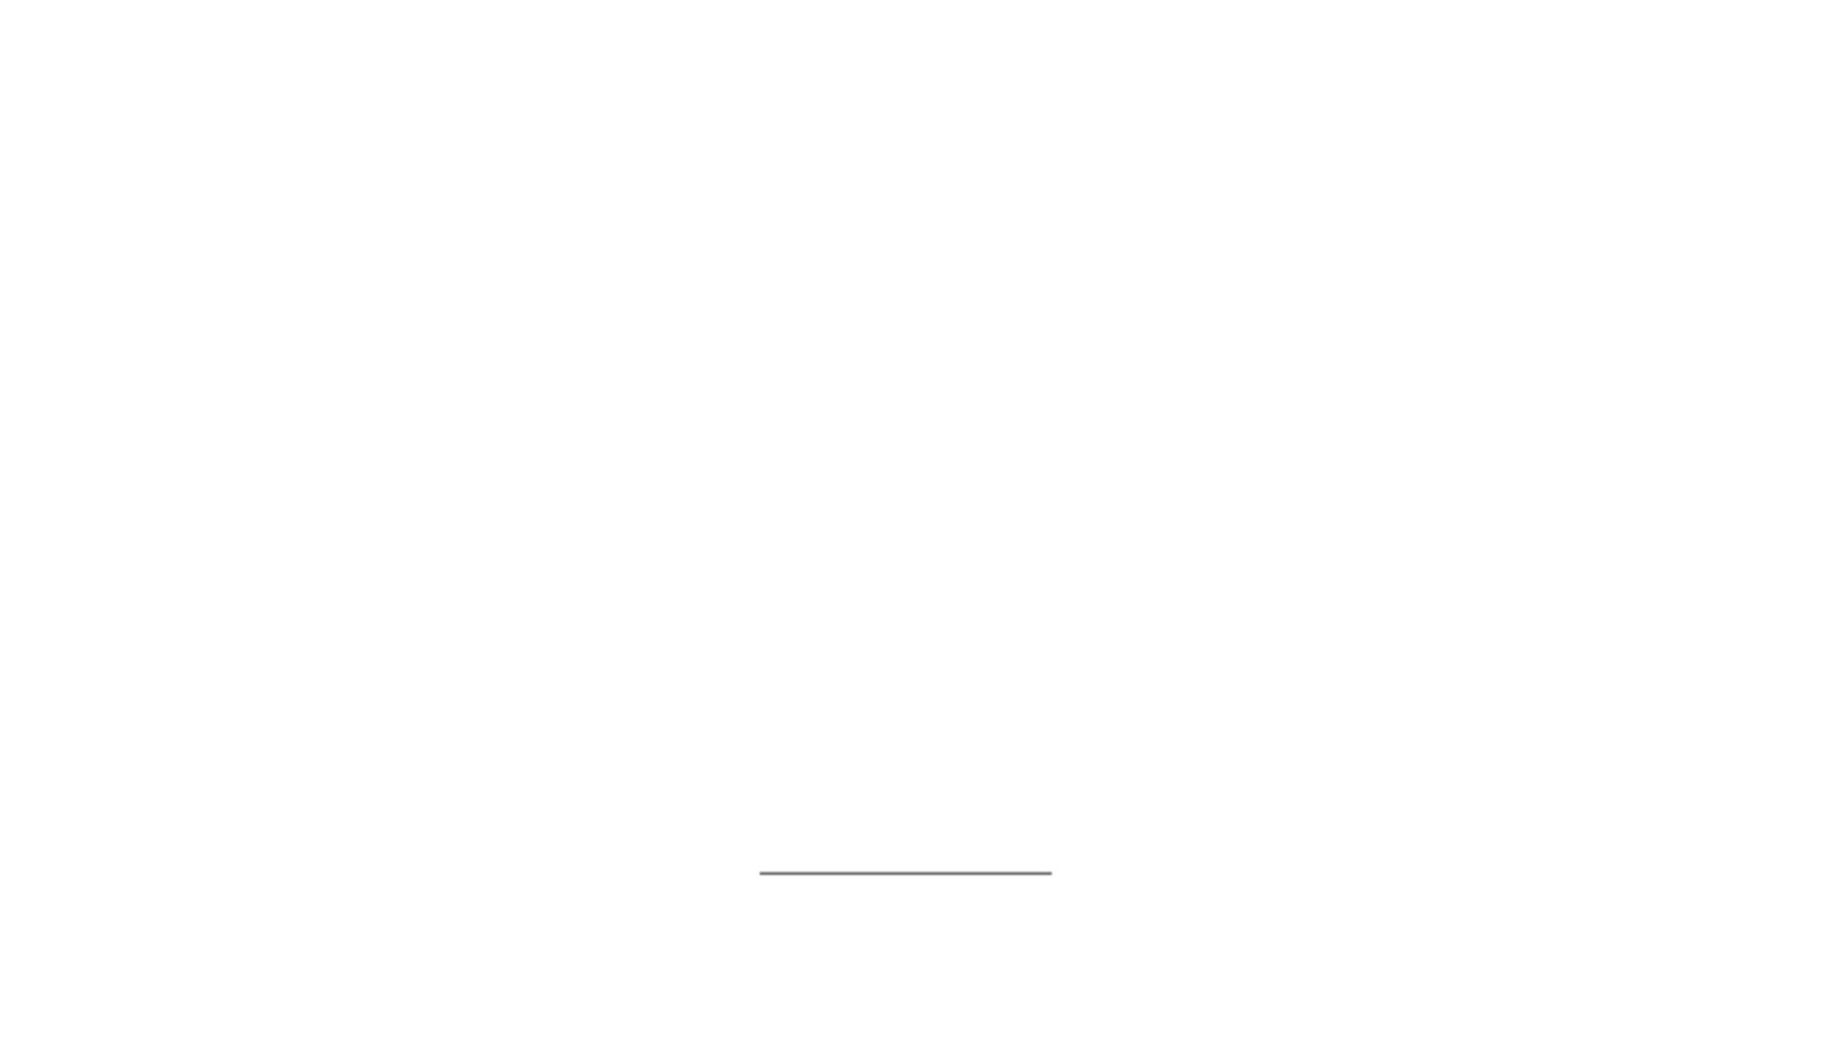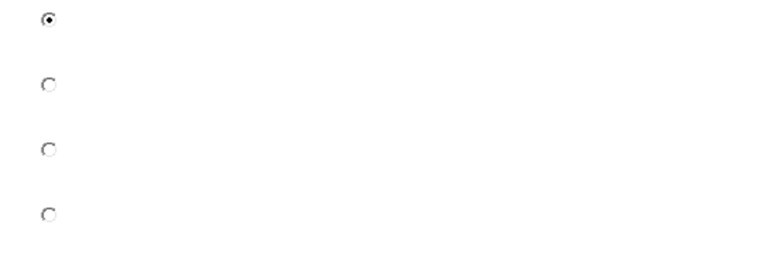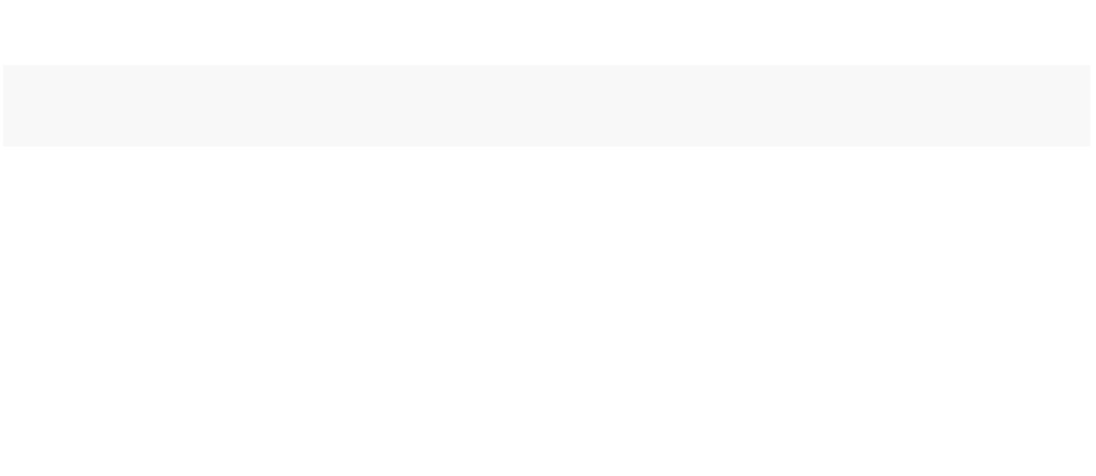

D. cause
•
纠错
3.
(5 分)So why do we order with more reckless __________when we're usin
g our smartphones and laptops?
A. food
•
•
•
B. drinks
C. snacks
D. abandon
•
纠错
4.
(5 分)So, social media is just any Internet _________that can be used to s
hare information with others.
A. tool
•
•
•
B. way
C. medium
D. trick
•
纠错
得分： 5
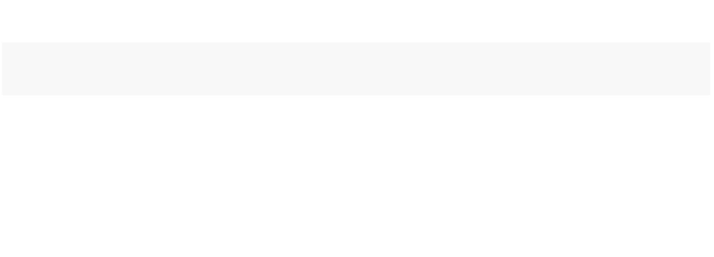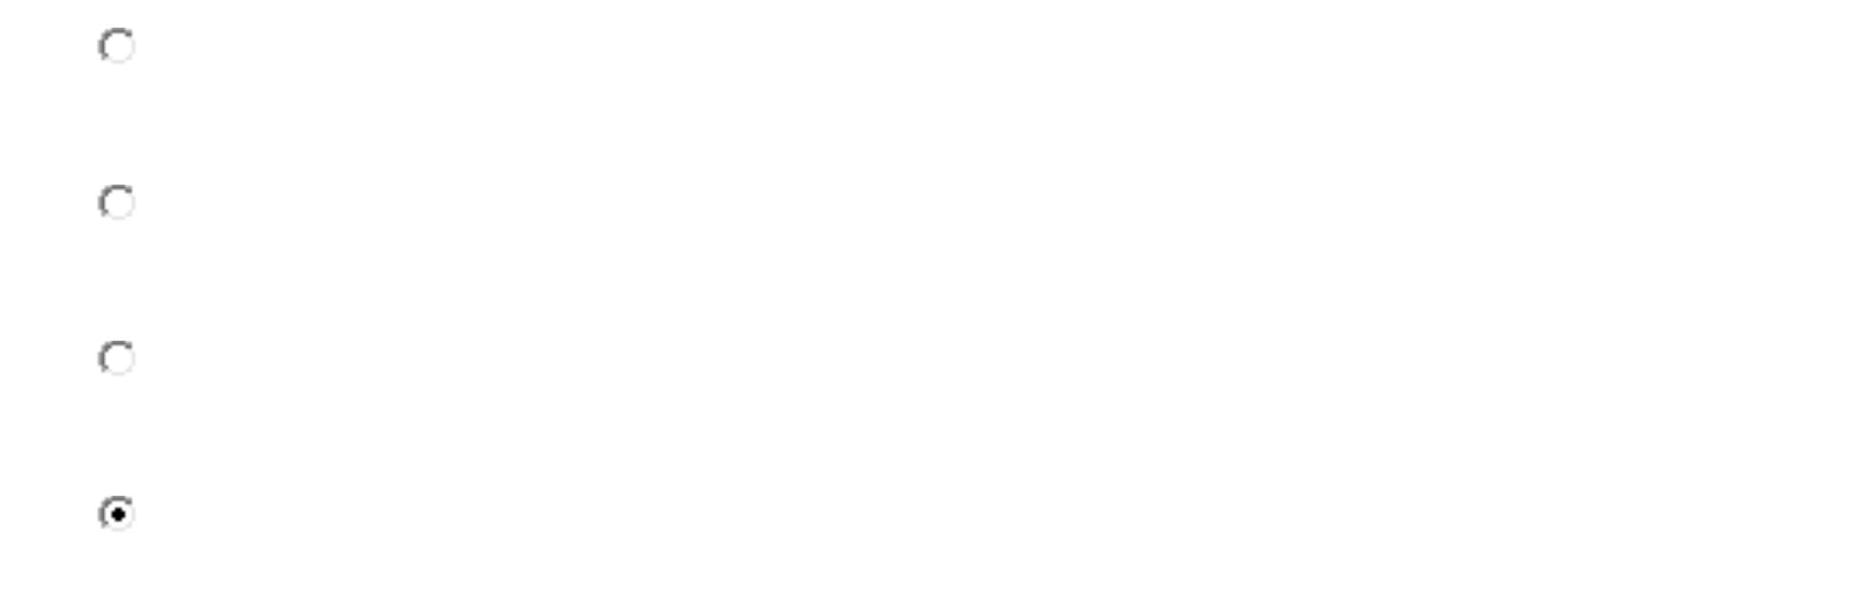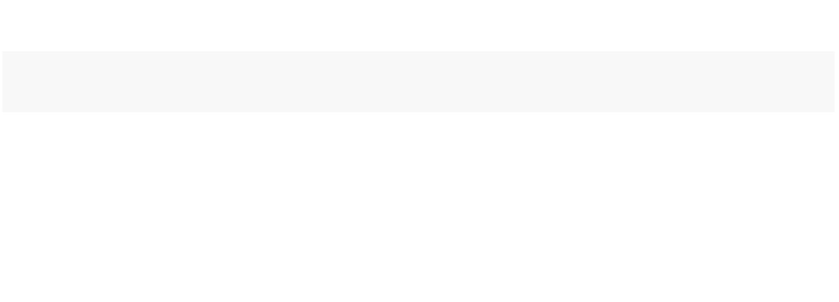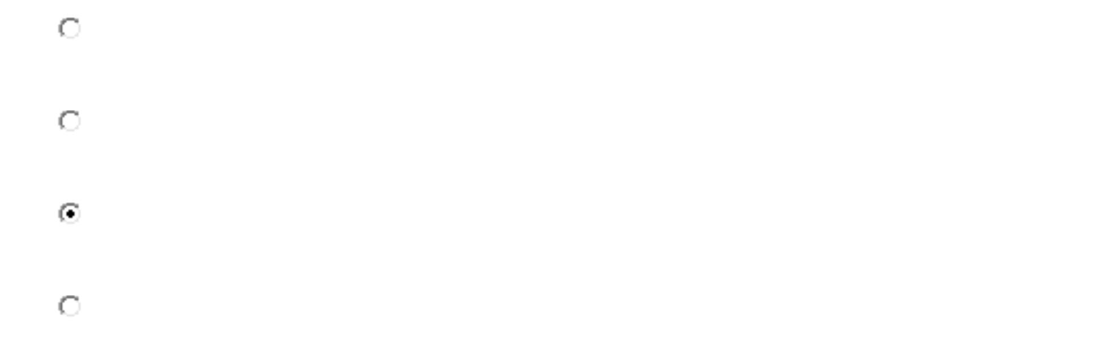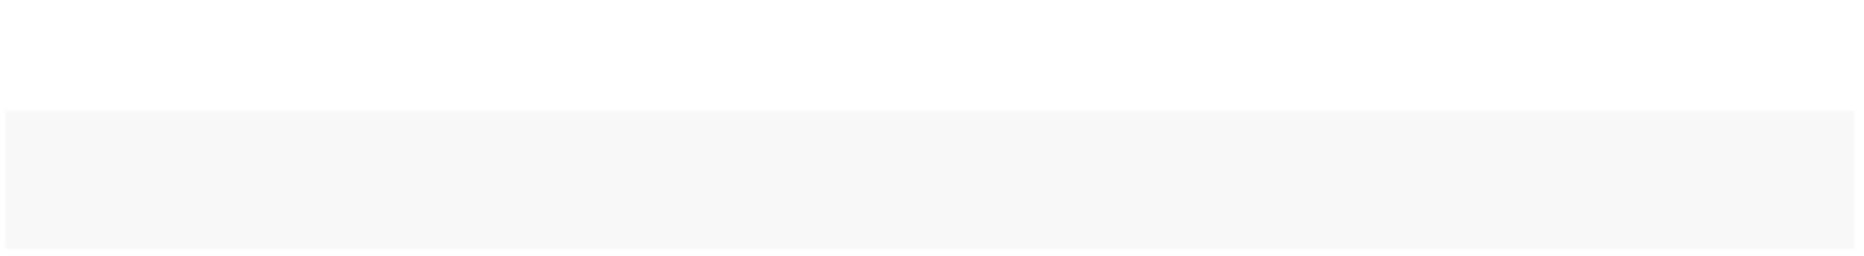

5.
(5 分)According to Wikipedia, social media has been defined to be “a
group of Internet-based __________________.
A. facilities
•
•
•
D. principles
•
纠错
得分： 5
6.
(5 分)Ordering food online might be_________and faster, but it’s not gre
at for our health.
•
•
•
C. convenient
D. waste
•
纠错
7.
(5 分)Social Media is about how you use it to _____________ your relation
ships with other people in real life.
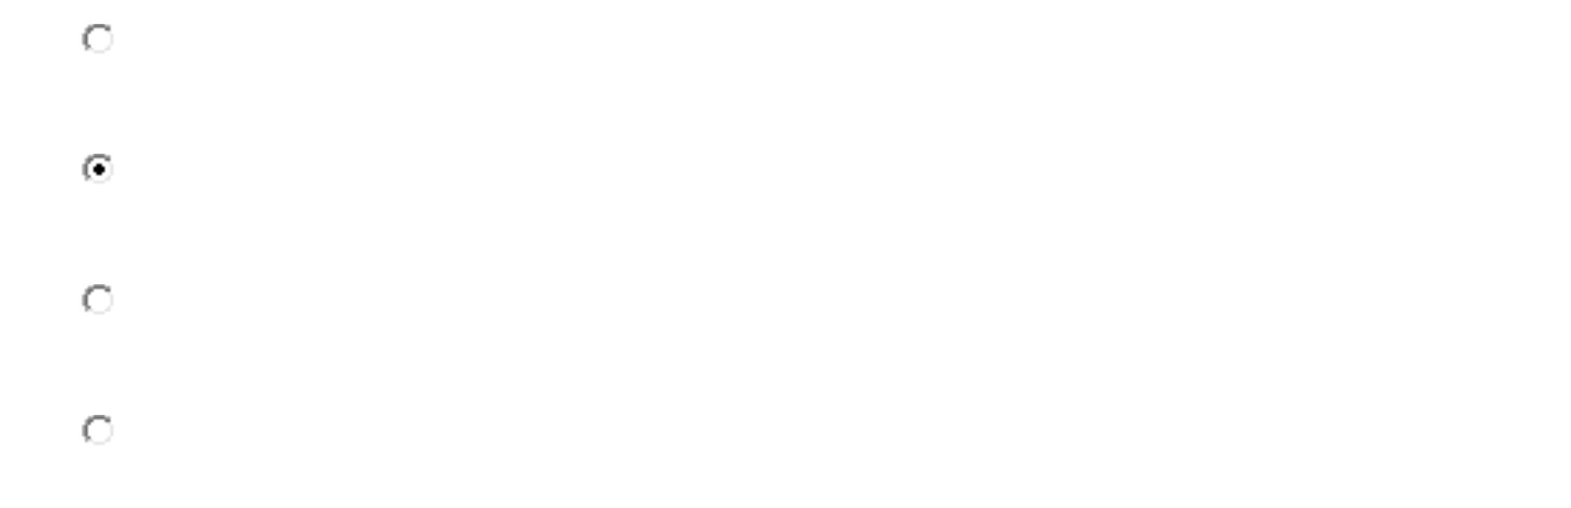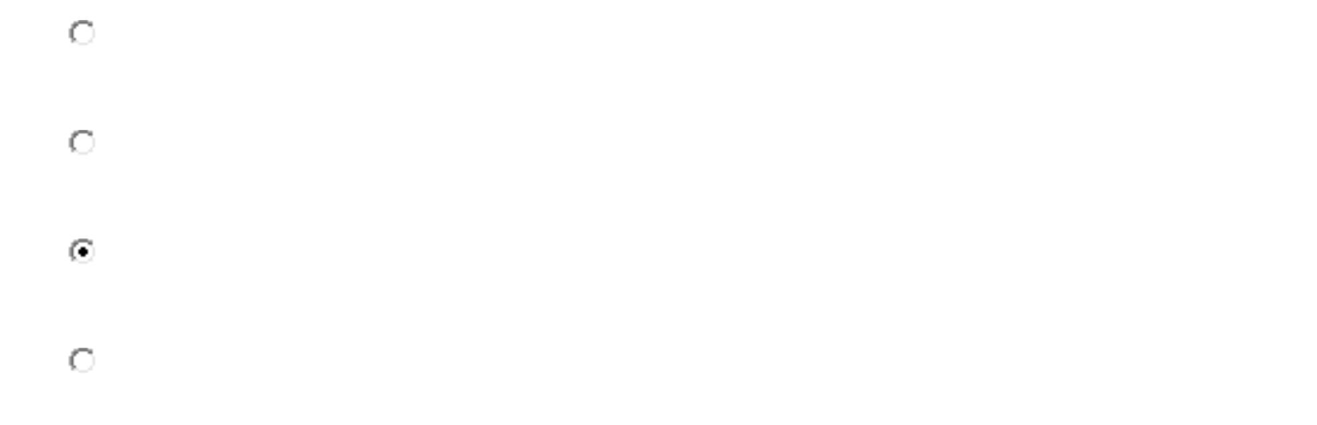

•
•
•
B. enhance
C. build
D. make
•
纠错
得分： 5
8.
(5 分)These types of media often involve the ____________ and sharing of
content (writing, pictures, and video) that people make themselves, m
ostly through the Internet.
A. creative
B. creating
C. creation
D. creativity
•
•
•
•
纠错
9.
(5 分)We tend to get ___________ by their numbers game, thinking of m
ore updates, more friends, more followers, more links, more photos, m
ore everything.
A. information
•
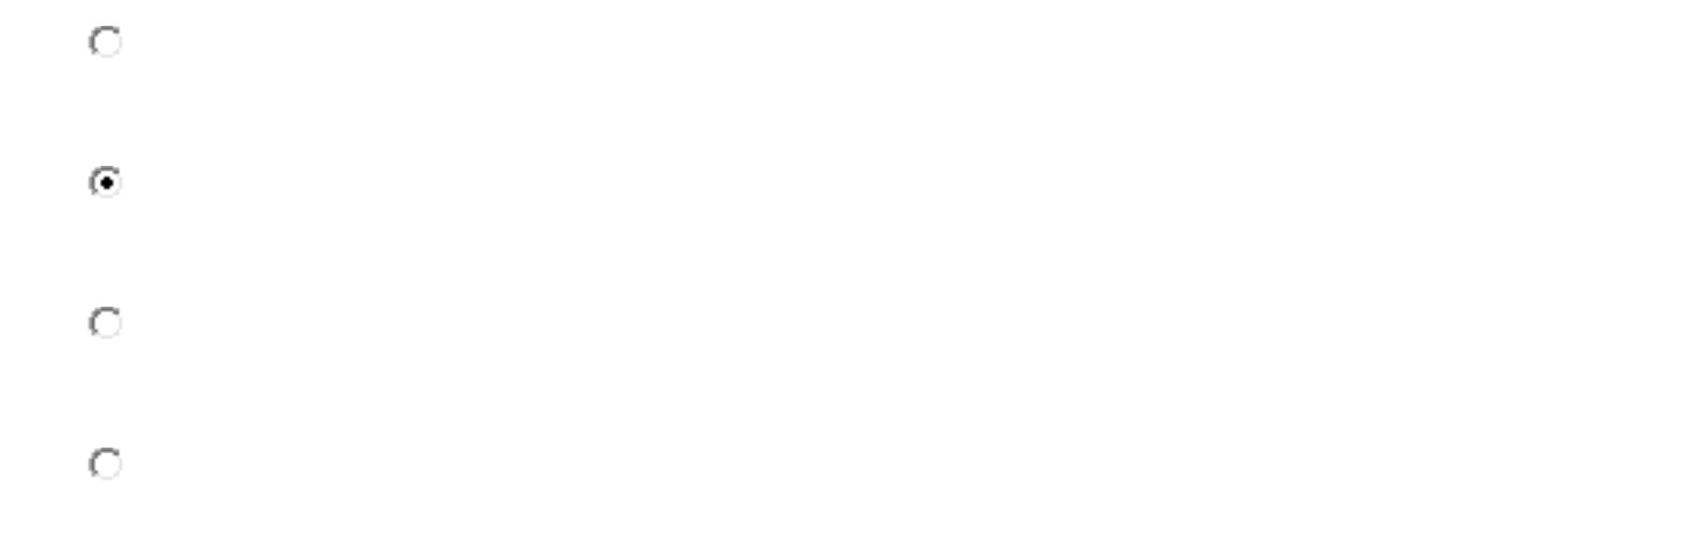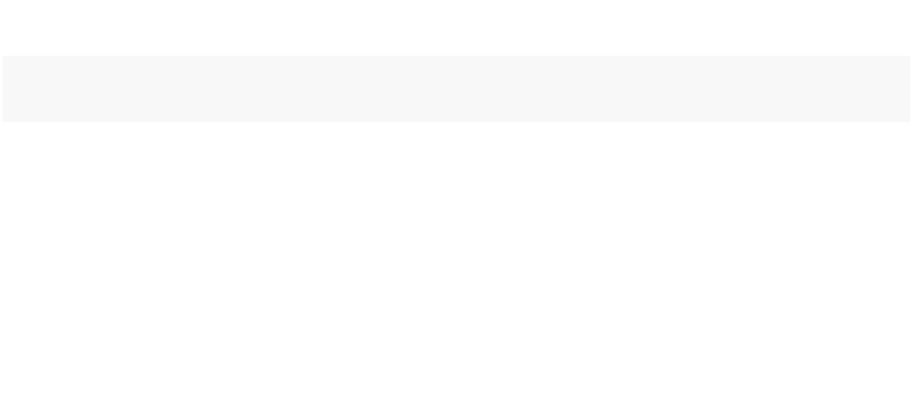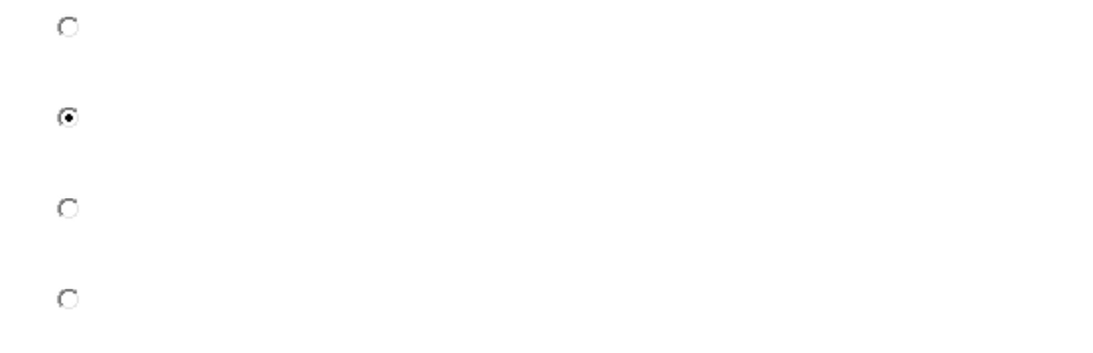

B. distracted
C. absorbing
D. excitement
•
•
•
纠错
得分： 5
10.
(5 分)Most of the junk foods are__________ and easy to snack on foods,
while they hit the bottom low with their nutritional factor.
•
•
•
C. useful
D. nutritious
•
纠错
二、完形填空
1.
My mother used to ask me what is the most important part of the bo
dy. Through the years I would _1___the correct answer. When I was yo
unger, I thought _2___ was very important to us as humans , so I said,
“My ears, Mummy.” She said, “No. Many people are _3_____ . But y
ou keep thinking about it and I will ask you again soon.


Several years passed before she asked me again. Since making my first
_4____, I had often thought over the question. So this time I told her,
“Mummy, it must be our eyes.” She looked at me and said, “You a
re _5____ fast, but the answer is not correct because there are many p
eople who are blind.”
___6____the years, mother asked me a couple more _7_____and always h
er response to my answers was,“No, but you are getting _8____ every
year, my child.” Then last year, my Grandpa _9_____. Everybody was he
art-broken. Everybody was crying. My mum looked at me when it was
our _10____ to say our final good-bye to Grandpa. She asked me, “Do
you know the most important body part yet, my dear?”
I was __11____ when she was asking me this now. I always thought thi
s was a _12____between her and me. She saw the _13____ on my face
and told me, “This question is very important. It show that you have r
eally _14___ your life.” I saw her eyes well up with tears. She said, “M
y dear, the most important body part is your __15____.” I asked, “Is it
because they hold up your head?” She replied , “No, it is _16____ o
n them a crying friend or loved one can rest their head. I only hope t
hat you have enough _17____ and friends that you will have a shoulder
to cry __18____ when you need it” Then and there I understood the
most important body part is not a __19___one. It is sympathetic to the
pain of __20____.


纠错
(1 分)
A. notice
•
•
•
D. guess at
•
得分： 1
(1 分)
A. love
•
•
•
B. health
C. sound
D. sight
•
(3)
(1 分)
•
•
•
C. invisible
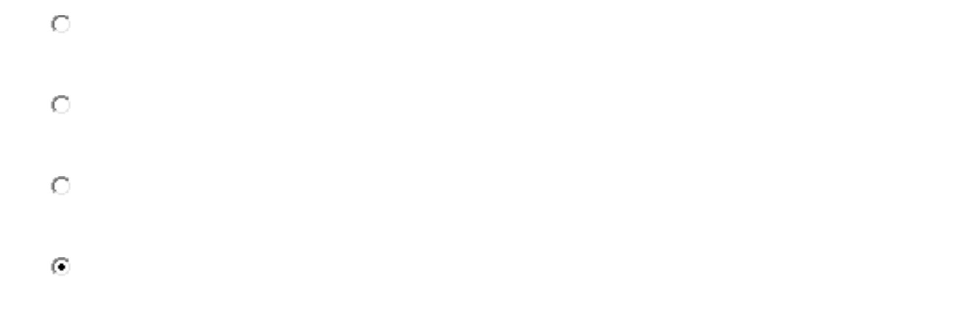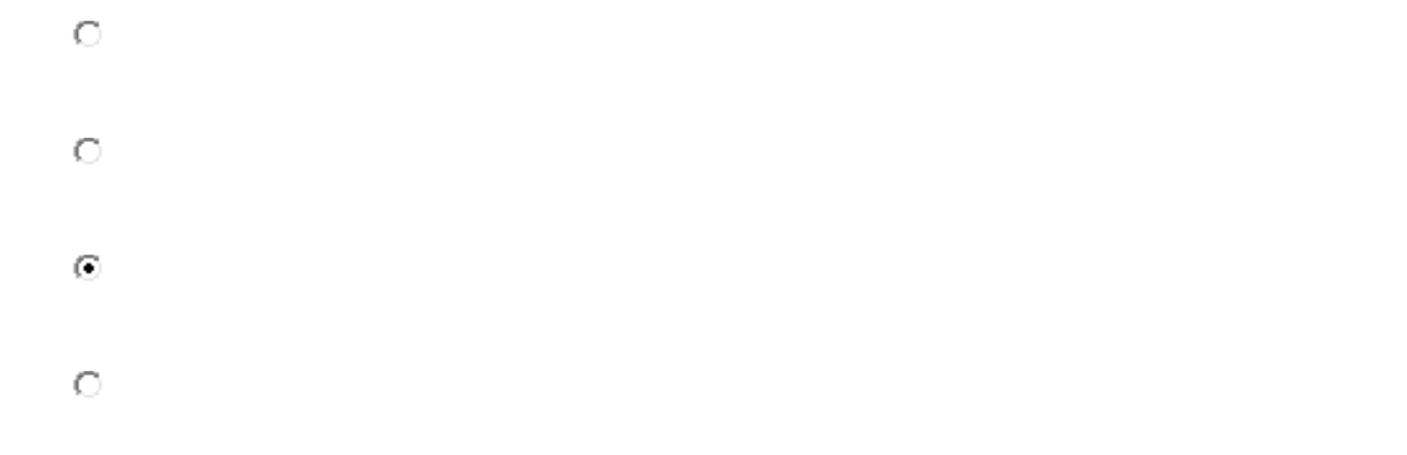

D. thoughtful
•
(1 分)
•
•
•
D. suggestion
•
(1 分)
A. learning
B. thinking
C. growing
D. changing
•
•
•
•
(6)
(1 分)
A. Before
B. Till
•
•
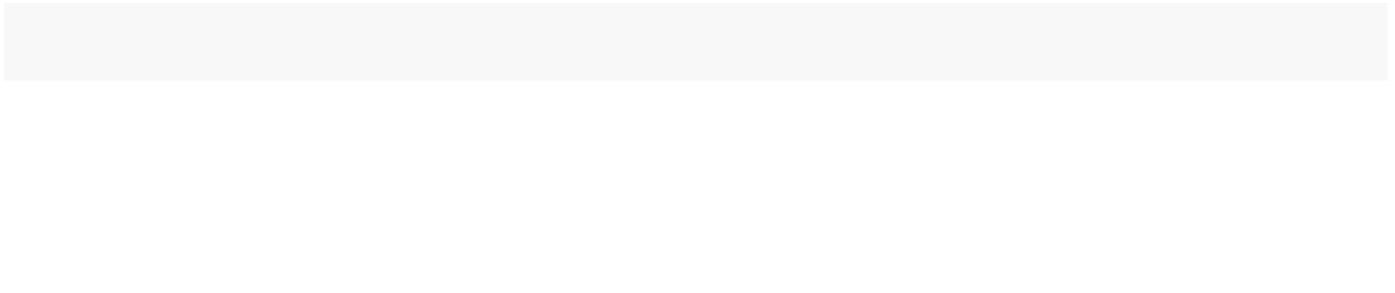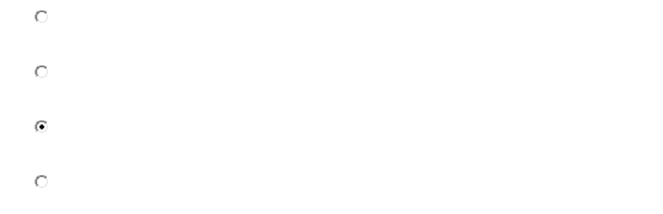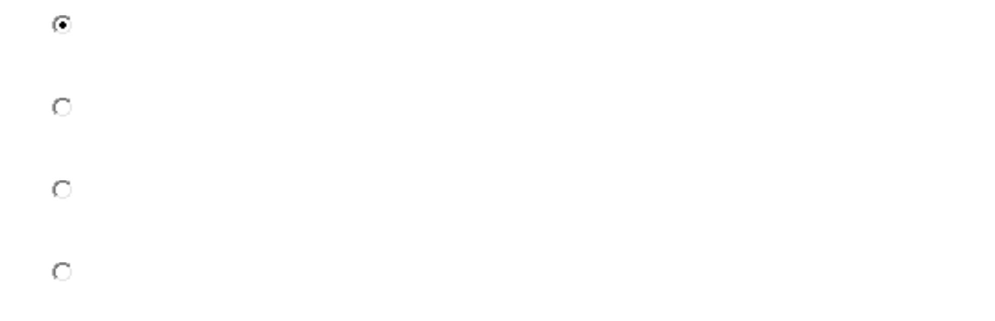

C. Beyond
D. Over
•
•
(1 分)
A. way
•
•
•
B. things
C. questions
D. times
•
(8)
(1 分)
•
•
•
C. smarter
D. nicer
•
(9)
(1 分)
A. left
•
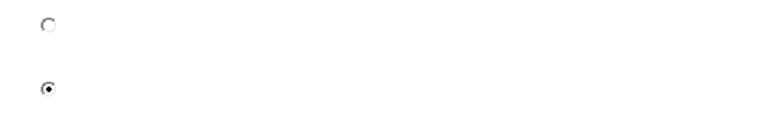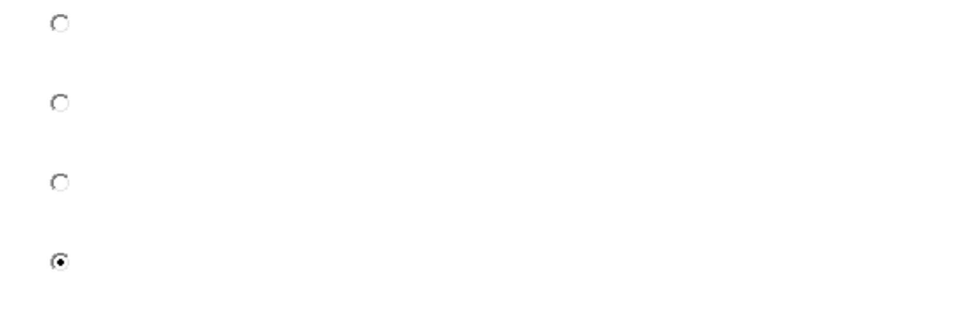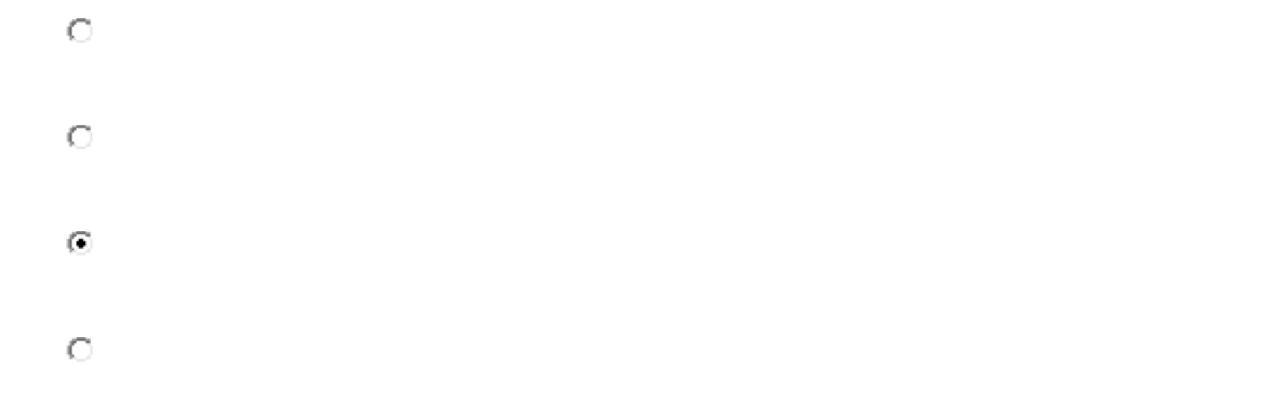

•
•
D. got wounded
•
(1 分)
•
•
•
C. pity
D. chance
•
(1 分)
A. shocked
B. satisfied
C. interested
D. excited
•
•
•
•
(1 分)
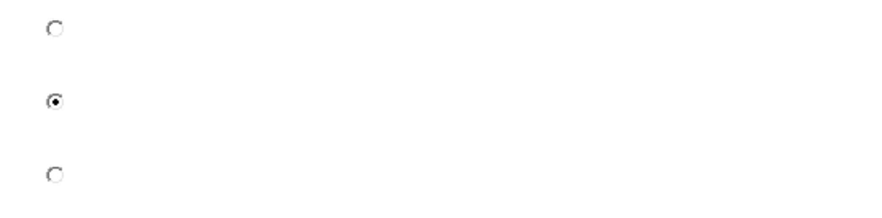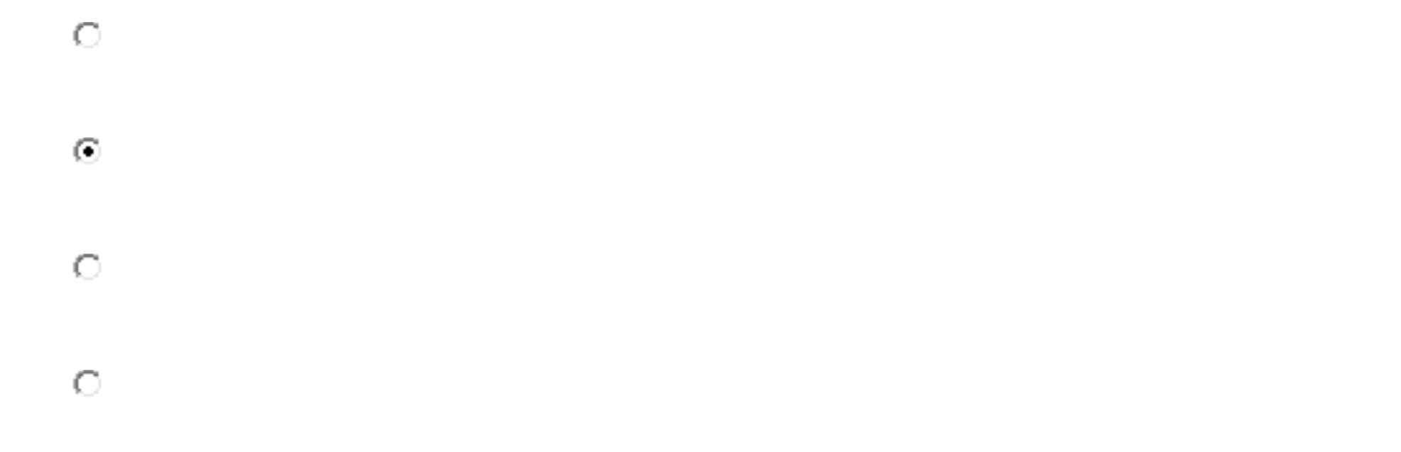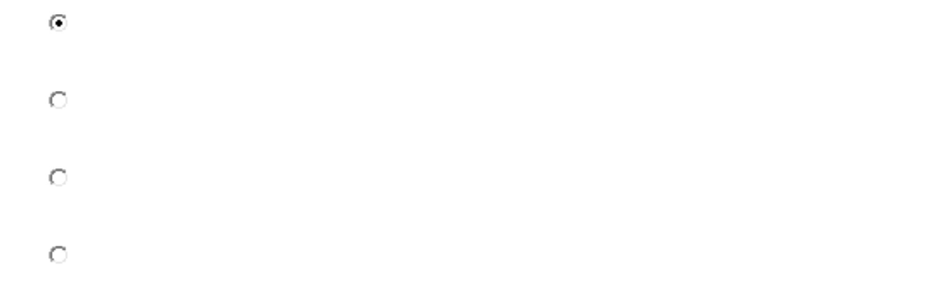

•
•
•
C. match
D. secret
•
(1 分)
A. worry
•
•
•
D. pain
•
(1 分)
A. enjoyed
B. found
C. disliked
D. lived
•
•
•
•
得分： 1
(15)
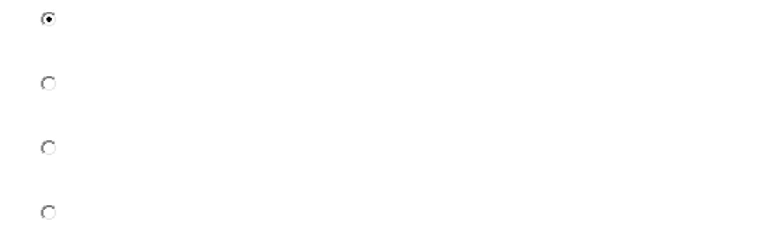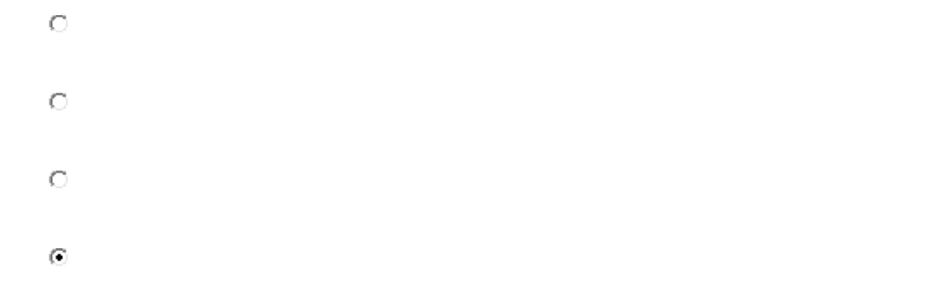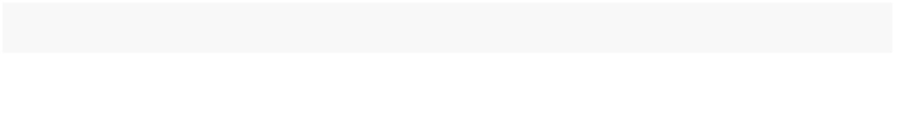

(1 分)
•
•
•
C. hands
D. hair
•
(1 分)
A. how
•
•
•
D. whether
•
(1 分)
•
•
•
D. fun
•
得分： 1
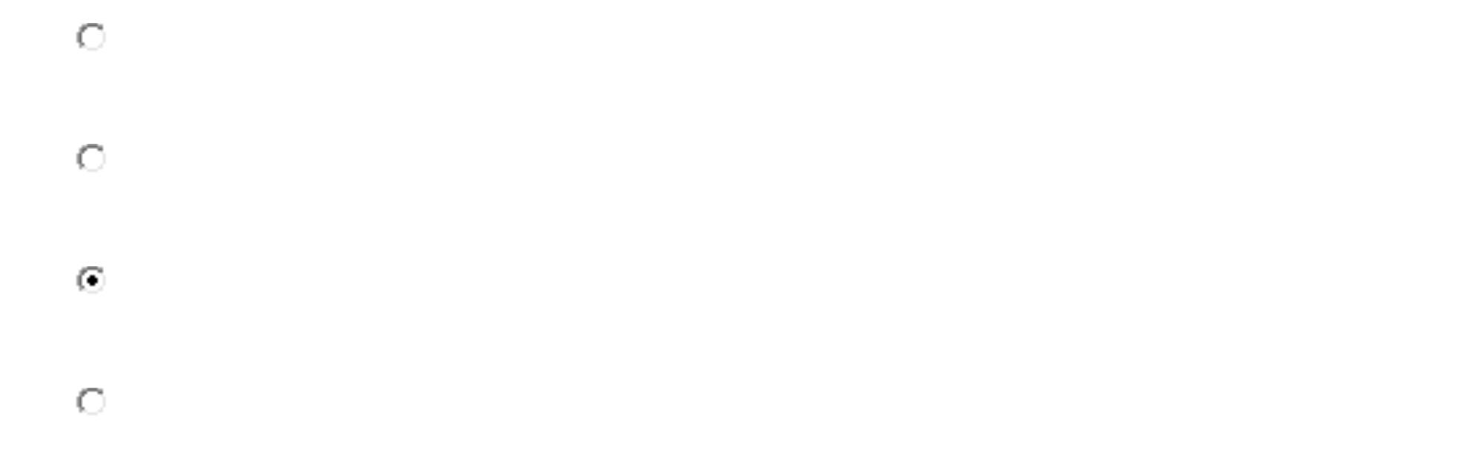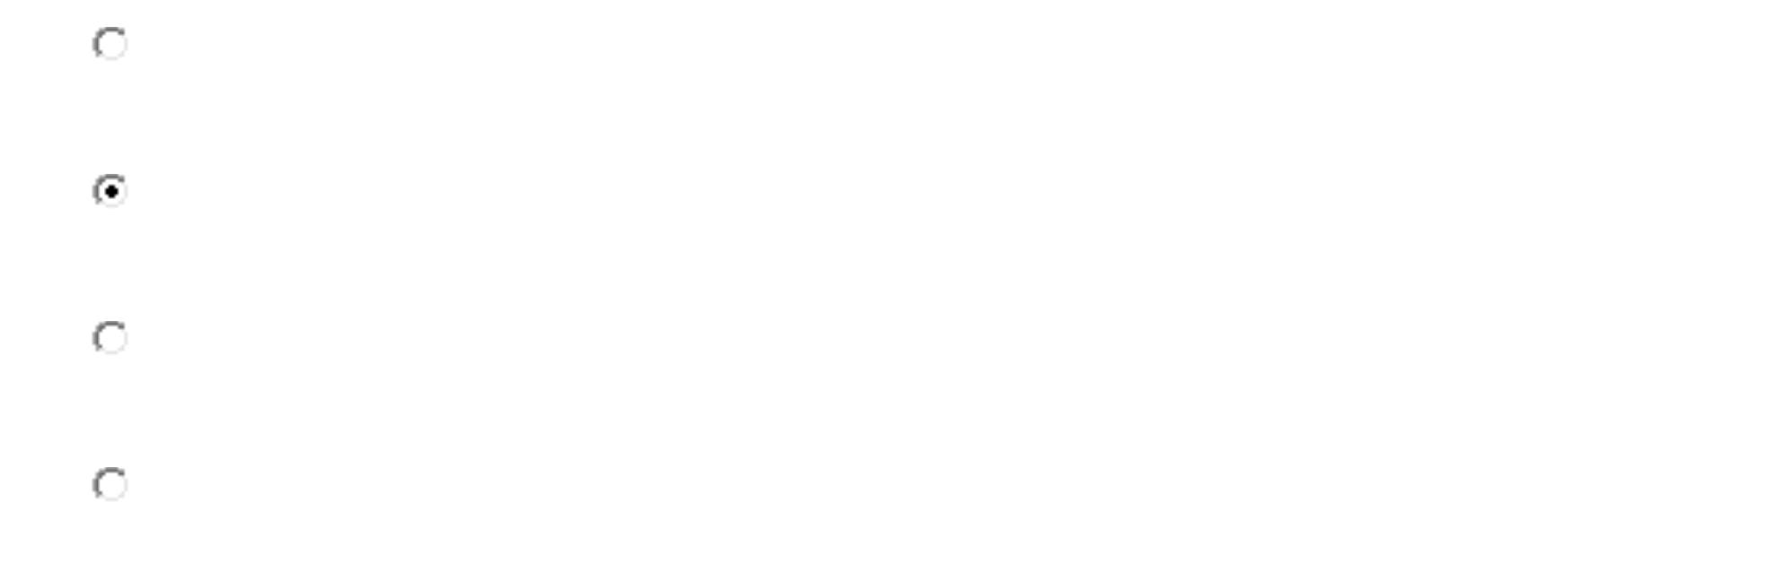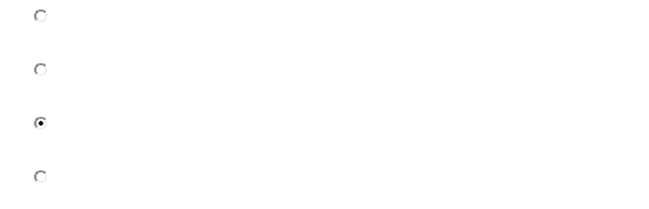

(18)
(1 分)
•
•
•
B. on
C. above
D. for
•
(1 分)
•
•
•
C. selfish
D. precious
•
(1 分)
A. others
•
•
•
•
B. the deaf
C. Grandpa
D. the blind
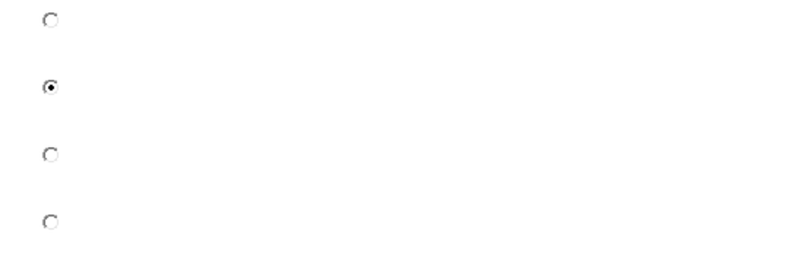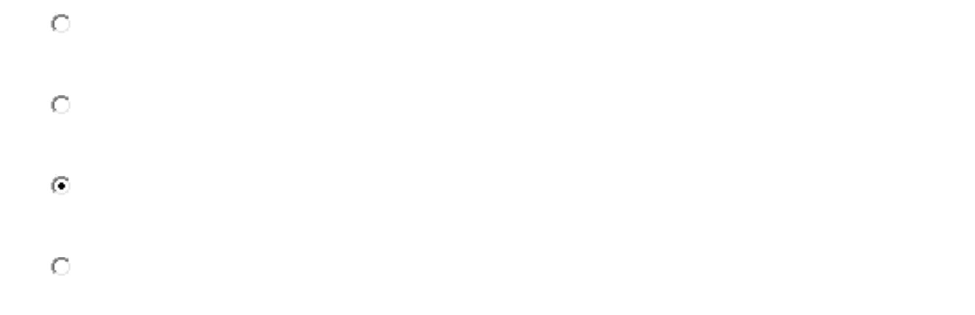

得分： 1
三、阅读理解
1.
An ebook(also referred to as an electronic book，eBook，or e-book)is a
digital version(版本)of a print book that you download and read. But i
f you want to read an ebook, you must have an Ebook Reader, which
is a kind of free software used by your computer. Make sure you have
installed the appropriate Reader before you download your ebook fro
m the Internet. The software allows you to turn the words on the scre
en into the size you like. It also helps you turn pages and change you
r viewing options(计算机屏幕上的阅读选择). Ebooks are a fun alternative t
o regular books. You can download them to any computers and create
your own library of hundreds of titles. If you load them onto your po
rtable computer，you can take them with you when you travel. Some e
books are even interactive! Best of all，when you order an ebook，ther
e is no waiting and no shipping charges. The amount of time it takes
to download your ebook depends on the speed of your connection an
d the size of your ebook.
纠错
(1)
(6 分)From this passage，we learn that an ebook___________.
A. can be found in any library


•
•
C. can be read by any one who has a computer
D. can be read when special software is installed
•
得分： 6
(6 分)The Ebook Reader is used for___________.
A. reading an ebook you’ve downloaded
B. turning a print book into a digital version
C. downloading an ebook from the Internet
D. copying an ebook onto a portable computer
•
•
•
•
(3)
(6 分)From this passage，we can learn that______________.
A. you can read an ebook on a laptop when you travel
B. you Can order an ebook using the Ebook Reader
C. the ebooks ordered have to be shipped to you
D. it takes a lot of trouble reading an ebook
•
•
•
•
(4)
(6 分)Which of the following statements is TRUE?
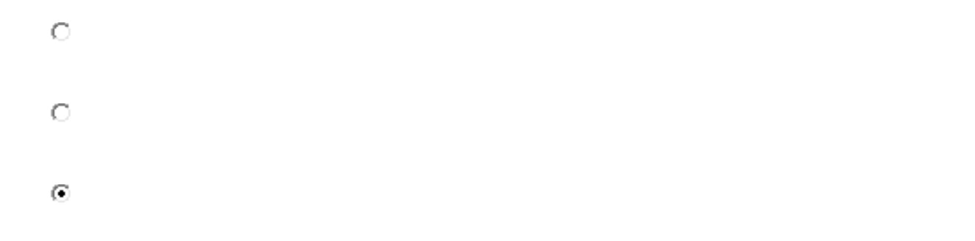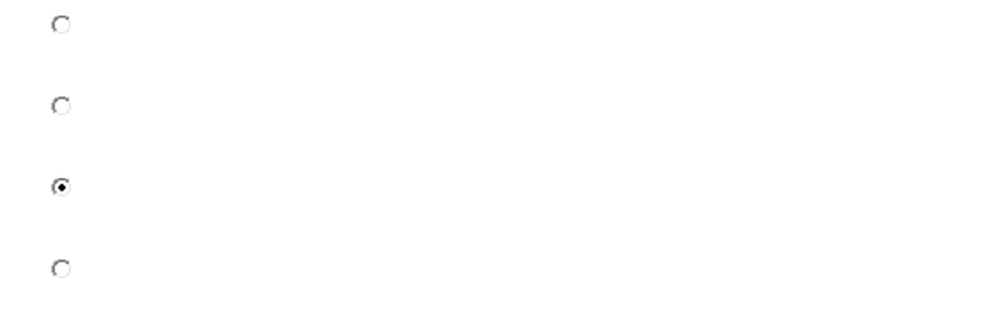

A. An ebook is ordered in print book is.
•
•
•
B. The size of the words in an ebook cannot be changed.
C. The downloading time is decided by the ebook’s size.
D. There is less fun reading an ebook than a print book.
•
得分： 6
(6 分)The passage is mainly about_______________.
A. a better way to download an Ebook
B. a new kind of book—the Ebooks
C. the new version of Ebooks
•
•
•
D. the fun of reading Ebooks
•
得分： 6
