GnRH Receptor
Gonadotropin releasing hormone receptor; GNRHR
The GnRH receptor (Gonadotropin-releasing hormone receptor, GNRHR) is a member of the rhodopsin-like G protein-coupled
receptor (GPCR) family and consists of seven transmembrane helical domains connected via extra- and intra-cellular segments.
GnRH receptor is located on the plasma membrane of gonadotrophs, pituitary cells that synthesize the gonadotrophins LH and
FSH.
Mammalian type I and II GnRH receptors show differential ligand preference for GnRH-I and GnRH-II, respectively. All GnRH receptors activate the G family of G proteins, which activate phospholipase C-catalyzed production of second messengers that
q/11
activate protein kinase C (PKC). GnRH receptor activated by GnRH analogues stimulates the synthesis and release of LH and FSH.
GnRH receptors can be used for the research of breast and prostate cancer, regulation of fertility, endometriosis and a range of
other medical and veterinary uses.
www.MedChemExpress.com 1
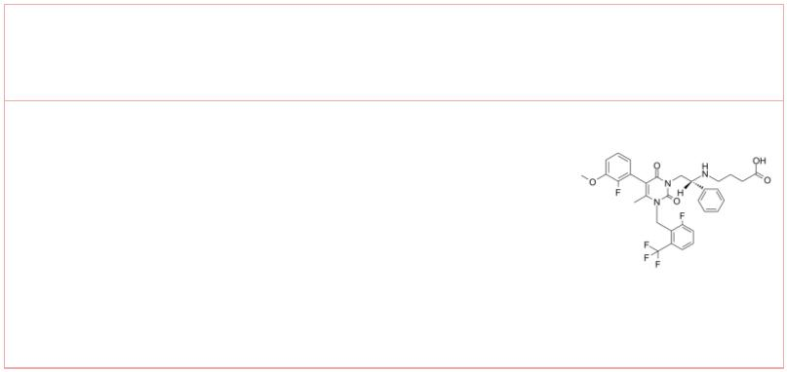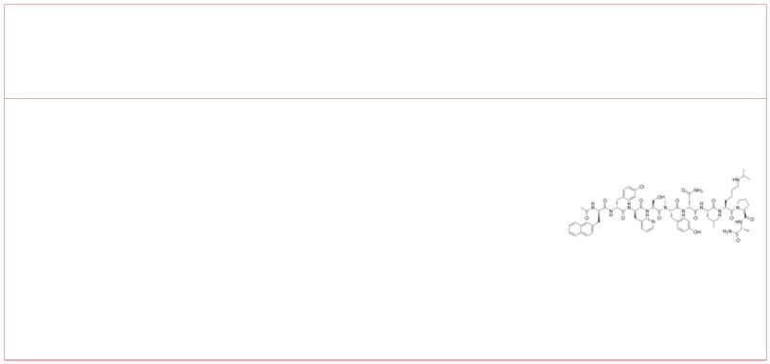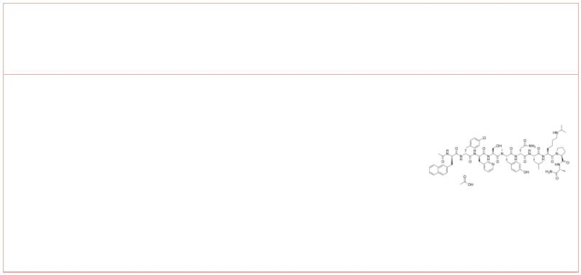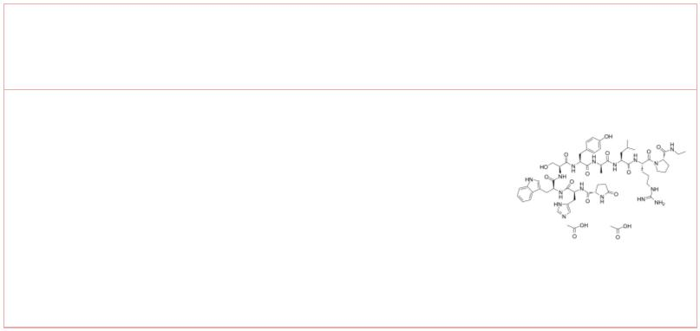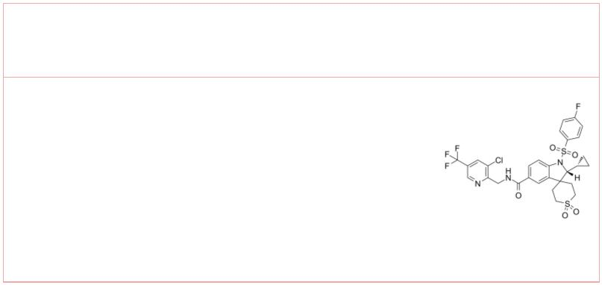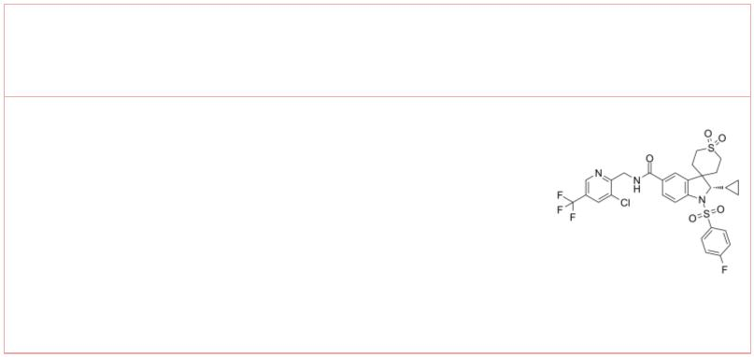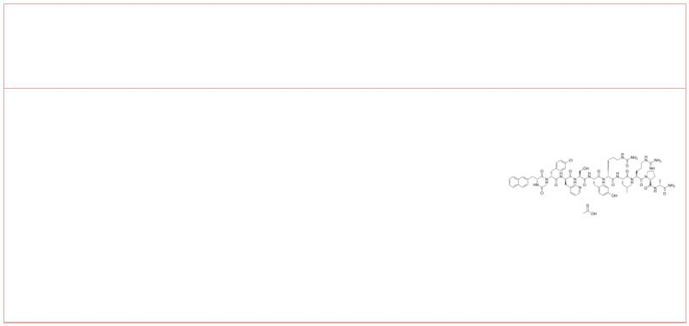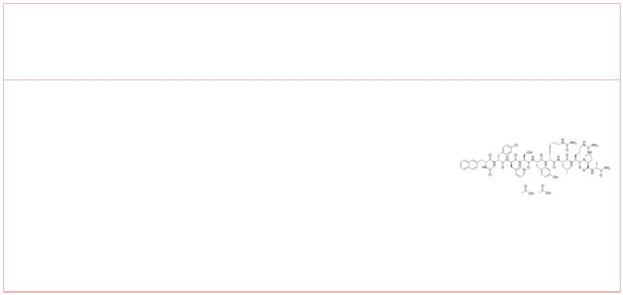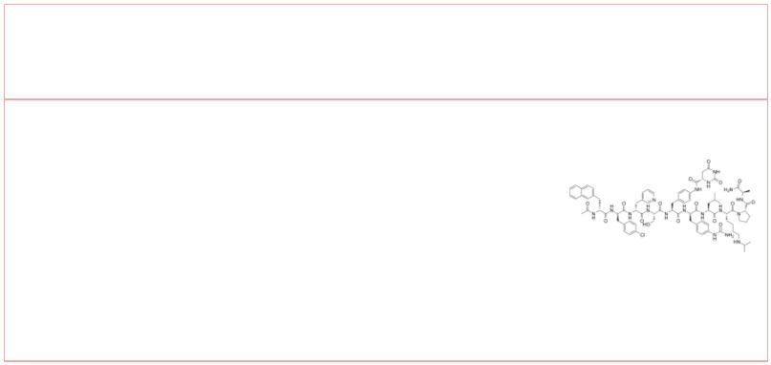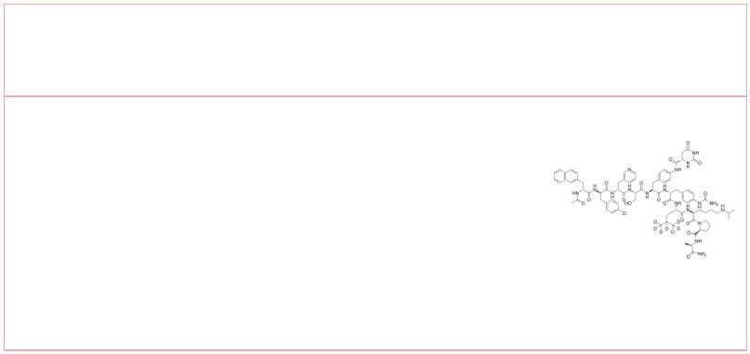GnRH Receptor Agonists & Antagonists
 | (R)-Elagolix  (NBI-56418) Cat. No.: HY-14789 |  |  |  | Abarelix  (R3827; PPI 149) Cat. No.: HY-13534
 | Elagolix is a highly potent, selective,  orally-active, short-duration, non-peptide  antagonist of the gonadotropin-releasing hormone  receptor (GnRHR) (KD = 54 pM). |  |  |  | Abarelix (R3827; PPI 149) is a potent  gonadotrophin-releasing hormone (GnRH)  used for prostate cancer treatment. |  |  |  |  |  |  | antagonist,
 | Purity: 95.74%  Clinical Data: Phase 3  Size: 10 mM × 1 mL, 5 mg, 10 mg, 50 mg, 100 mg |  |  |  | Purity: 99.62%  Clinical Data: Launched  Size: 10 mM × 1 mL, 5 mg, 10 mg, 25 mg, 50 mg
 | Abarelix Acetate  (PPI 149 Acetate; R 3827 Acetate) Cat. No.: HY-13534A |  |  |  | Alarelin Acetate  (Alarelin) Cat. No.: HY-17405
 | Abarelix Acetate (PPI 149 Acetate; R 3827 Acetate)  is a potent gonadotrophin-releasing hormone (GnRH)  antagonist, used for prostate cancer research. |  |  |  | Alarelin acetate is a synthetic GnRH agonist.
 | Purity: 99.61%  Clinical Data: Launched  Size: 10 mM × 1 mL, 5 mg, 10 mg, 25 mg, 50 mg |  |  |  | Purity: 99.43%  Clinical Data: Launched  Size: 10 mM × 1 mL, 10 mg, 100 mg
 | BAY 1214784 BAY-784
 |  |  | Cat. No.: HY-144863 Cat. No.: HY-133080
 | BAY 1214784 is a potent, selective, and orally  active antagonist of the human  gonadotropin-releasing hormone receptor  (hGnRH-R). BAY 1214784 is a spiroindoline  derivative compound. |  |  |  | BAY-784 is a gonadotropin releasing hormone  receptor (GnRH-R) antagonist probe with IC s of  50  21 and 24 nM for human and rat GnRH-R,  respectively.
 | Purity: >98%  Clinical Data: No Development Reported  Size: 1 mg, 5 mg |  |  |  | Purity: >98%  Clinical Data: No Development Reported  Size: 1 mg, 5 mg
 | Cetrorelix Acetate Cetrorelix diacetate
 | (SB-75 acetate) Cat. No.: HY-P0009A (SB-75 diacetate) Cat. No.: HY-P0009B
 | Cetrorelix Acetate (SB-75 acetate) is a potent  gonadotropin-releasing hormone (GnRH) receptor  antagonist with an IC of 1.21 nM.  50 |  |  |  | Cetrorelix diacetate (SB-075 diacetate) is a  potent gonadotropin-releasing hormone (GnRH)  receptor antagonist with an IC of 1.21 nM.  50
 | Purity: 99.69%  Clinical Data: Launched  Size: 10 mM × 1 mL, 1 mg, 5 mg, 10 mg, 25 mg, 50 mg |  |  |  | Purity: >98%  Clinical Data: No Development Reported  Size: 1 mg, 5 mg
 | Degarelix Degarelix-d7
 |  | Cat. No.: HY-16168A Cat. No.: HY-16168AS
 | Degarelix is a competitive and reversible  gonadotropin-releasing hormone receptor (GnRHR)  antagonist. |  |  |  | Degarelix-d7 is deuterium labeled Degarelix.  Degarelix is a competitive and reversible  gonadotropin-releasing hormone receptor (GnRHR)  antagonist.
 | Purity: 99.92%  Clinical Data: Launched  Size: 2 mg, 5 mg, 10 mg, 50 mg, 100 mg |  |  |  | Purity: >98%  Clinical Data: No Development Reported  Size: 1 mg, 5 mg
2 Tel: 609-228-6898 Fax: 609-228-5909 Email: sales@MedChemExpress.com
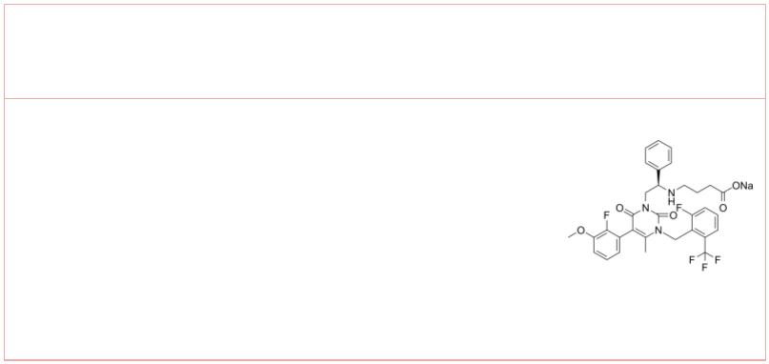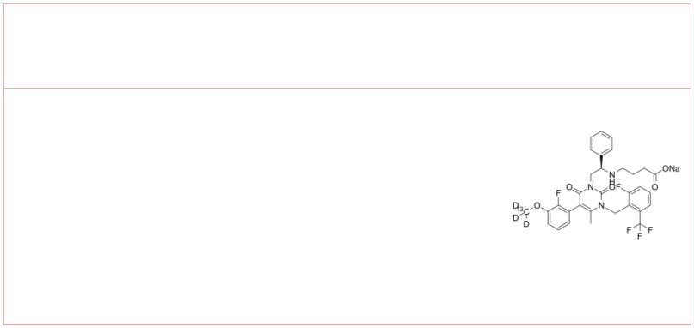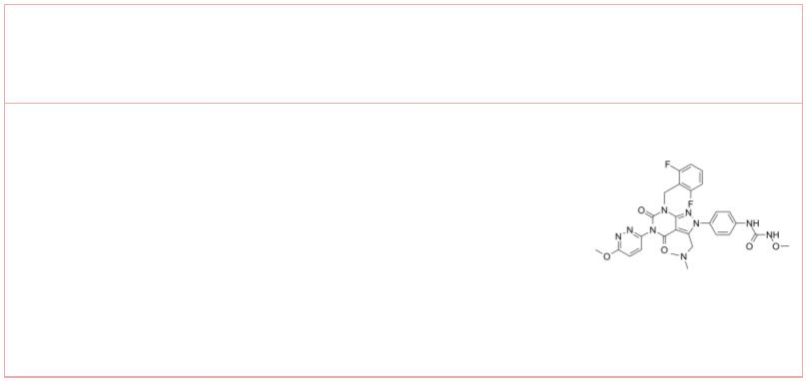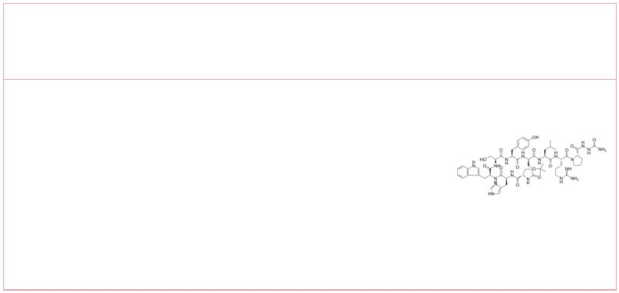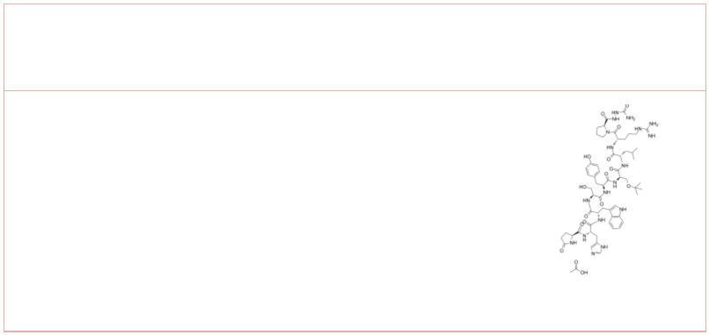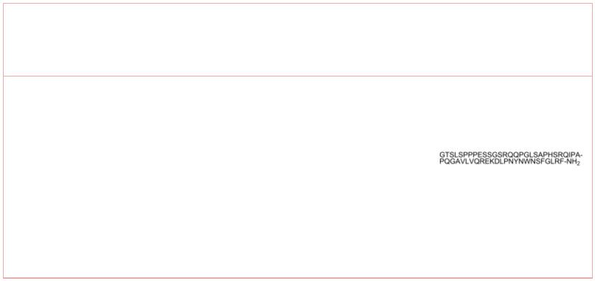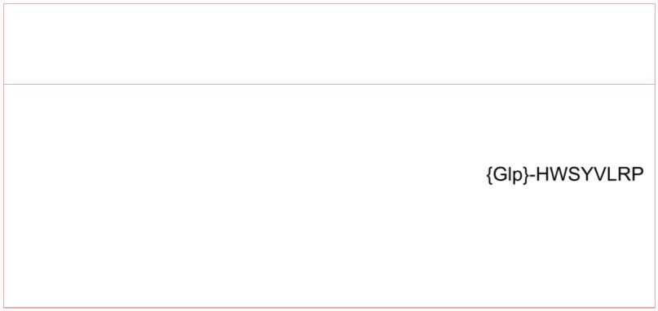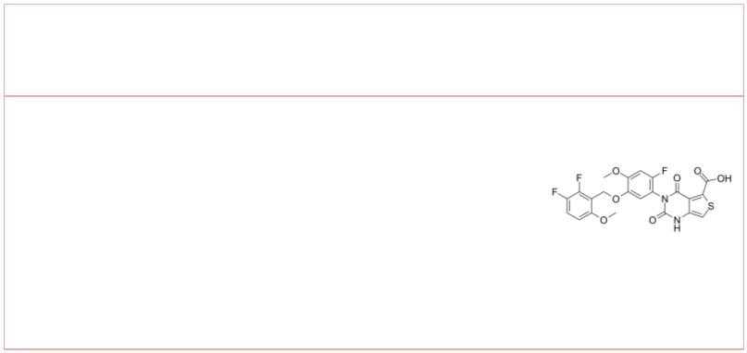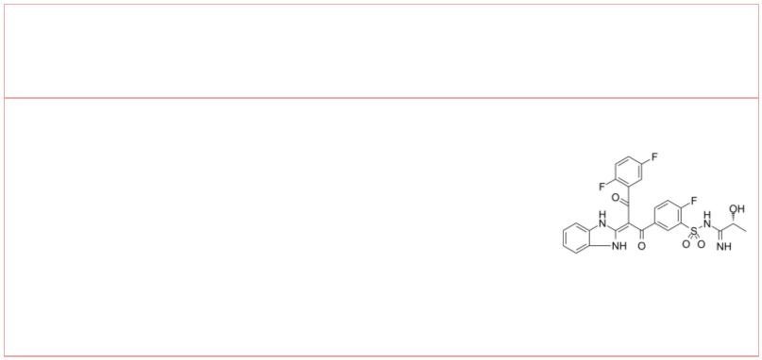Elagolix sodium  (NBI-56418 sodium) Cat. No.: HY-14369 |  |  |  | Elagolix-13C,d3 sodium  (NBI-56418-13C,d3 sodium) Cat. No.: HY-14369S
Elagolix sodium is a human GnRH receptor  (GnRHR) antagonist with an IC₅₀ and K_{i} of 0.25  and 3.7 nM, respectively. |  |  |  | Elagolix-13C,d3 (sodium) is the 13C- and deuterium  labeled. Elagolix sodium is a human GnRH receptor  (GnRHR) antagonist with an IC50 and Ki of 0.25 and  3.7 nM, respectively.
Purity: 99.66%  Clinical Data: Launched  Size: 10 mM × 1 mL, 5 mg, 10 mg, 50 mg, 100 mg |  |  |  | Purity: >98%  Clinical Data: No Development Reported  Size: 1 mg, 5 mg
GnRH antagonist 2 |  | Cat. No.: HY-134864 |  | Goserelin  (ICI 118630) Cat. No.: HY-13673
GnRH antagonist 2 (formula I) is a GnRH receptor  antagonist that can be used for endometriosis  research. |  |  |  | Goserelin (ICI 118630), a decapeptide analogue of  gonadotropin-releasing hormone (GnRH/LHRH),  functions as a GnRH agonist. Goserelin can be  used for the research of breast cancer, epithelial  ovarian cancer and prostate cancer.
Purity: 98.16%  Clinical Data: No Development Reported  Size: 10 mM × 1 mL, 5 mg, 10 mg, 25 mg, 50 mg |  |  |  | Purity: >98%  Clinical Data: Launched  Size: 1 mg, 5 mg
Goserelin acetate  (ICI-118630 acetate) Cat. No.: HY-13673A |  |  |  | Kisspeptin-54(human)  (Metastin(human)) Cat. No.: HY-P1022
Goserelin acetate (ICI-118630 acetate), a  decapeptide analogue of gonadotropin-releasing  hormone (GnRH/LHRH), functions as a GnRH agonist.  Goserelin acetate can be used for the research of  breast cancer, epithelial ovarian cancer and  prostate cancer. |  |  |  | Kisspeptin-54(human) (Metastin(human)) is an  endogenous ligand for kisspeptin receptor (KISS1,  GPR54). Kisspeptin-54(human) binds to rat and  human GPR54 receptors with K values of 1.81  i  nM and 1.45 nM, respectively.
Purity: 99.89%  Clinical Data: Launched  Size: 10 mM × 1 mL, 5 mg, 10 mg, 50 mg |  |  |  | Purity: >98%  Clinical Data: No Development Reported  Size: 1 mg, 5 mg
Kisspeptin-54(human) TFA Lecirelin
(Metastin(human) TFA) Cat. No.: HY-P1022A |  |  |  |  |  |  |  |  |  |  |  |  |  |  |  | Cat. No.: HY-P0051
Kisspeptin-54(human) TFA (Metastin(human) TFA) is  an endogenous ligand for kisspeptin receptor  (KISS1, GPR54). Kisspeptin-54(human) TFA binds to  rat and human GPR54 receptors with K values  i  of 1.81 nM and 1.45 nM, respectively. |  |  |  | Lecirelin, a synthetic gonadotropin-releasing  hormone (GnRH) analogue, acts as a GnRH agonist.  Lecirelin is widely used for the research of  bovine ovarian follicular cysts.
Purity: >98%  Clinical Data: No Development Reported  Size: 1 mg, 5 mg |  |  |  | Purity: 99.83%  Clinical Data: No Development Reported  Size: 1 mg, 5 mg, 10 mg, 25 mg
Linzagolix opigolix
(KLH-2109; OBE-2109) Cat. No.: HY-109093 |  |  |  |  |  |  |  |  |  |  |  |  |  | Cat. No.: HY-U00289
Linzagolix (KLH-2109; OBE-2109) is a potent,  non-peptide, and orally active GnRH antagonist.  Linzagolix can be used for uterine fibroids,  endometriosis, adenomyosis research. |  |  |  | Opigolix is a Gonadotropin-releasing hormone  (GnRH) receptor antagonist, used for the research  of endometriosis and rheumatoid arthritis.
Purity: 99.81%  Clinical Data: No Development Reported  Size: 5 mg, 10 mg, 50 mg, 100 mg |  |  |  | Purity: >98%  Clinical Data: Phase 2  Size: 1 mg, 5 mg
www.MedChemExpress.com 3
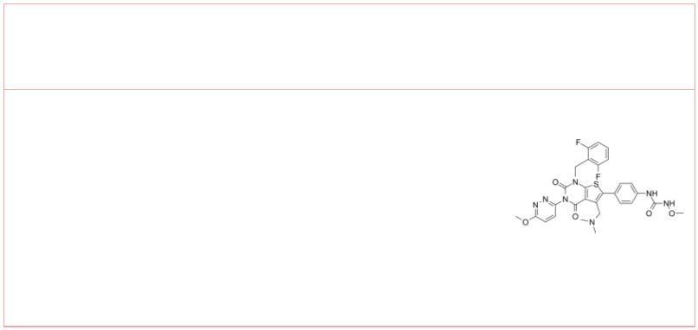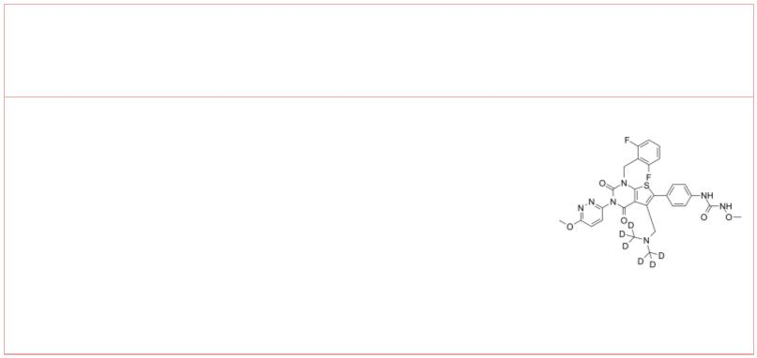 | Relugolix  (TAK-385) Cat. No.: HY-16474 |  | Relugolix-d6  (TAK-385-d6) Cat. No.: HY-16474S
 | Relugolix (TAK-385) is a potent, orally  active, nonpeptidic gonadotropin-releasing hormone  (GnRH) antagonist. |  | Relugolix-d6 is deuterium labeled Relugolix.  Relugolix (TAK-385) is a potent, orally  active, nonpeptidic gonadotropin-releasing hormone  (GnRH) antagonist.
 | Purity: 99.67%  Clinical Data: Launched  Size: 10 mM × 1 mL, 5 mg, 10 mg, 50 mg, 100 mg |  | Purity: >98%  Clinical Data: No Development Reported  Size: 1 mg, 5 mg
4 Tel: 609-228-6898 Fax: 609-228-5909 Email: sales@MedChemExpress.com

