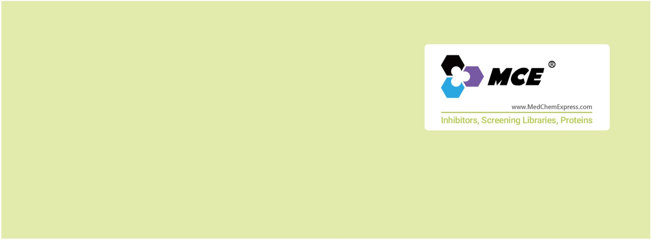p38 MAPK
The p38 MAPK family consists of highly conserved proline-directed serine-threonine protein kinases that are activated in response
to a number many growth factors, cytokines, and chemotactic substances, such as vascular endothelial growth factor (VEGF),
fibroblast growth factor (FGF), PDGF, TNF, interleukins, lipopolysaccharide (LPS) and formyl-methionyl-leucyl-phenylalanine (fMLP).
It is well known that p38 is involved in inflammation, apoptosis, cardiomyocyte hypertrophy and cell differentiation.
The p38 MAPK family is composed of four proteins: p38α (encoded by the gene Mapk14), p38β (Mapk11), p38γ (Mapk12), and
p38δ (Mapk13). Their coding genes have a distinct tissue distribution and they appear differentially expressed, being Mapk14 the
most highly expressed. p38 MAPKs are substrates for three MAP2K (MKK6, MKK3, and MKK4). The contribution of each of these
MAP2K to p38 MAPKs activation depends on the stimulus and the cell type. The MAP3Ks that lead to p38 MAPKs activation are
ASK1, DLK1, TAK1, TAO1, TAO2, TPL2, MLK3, MEKK3, MEKK4, and ZAK1.
www.MedChemExpress.com 1
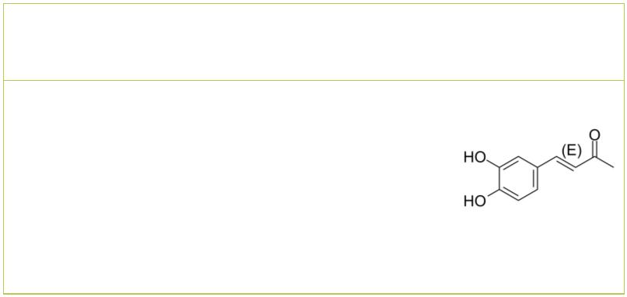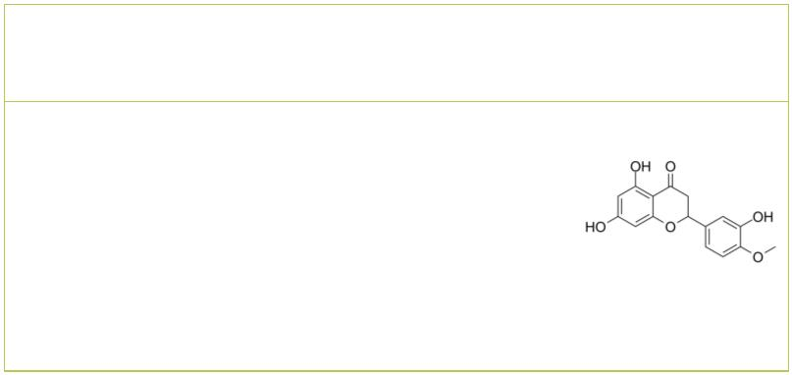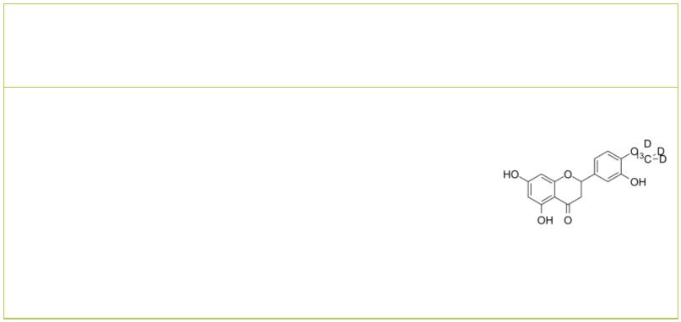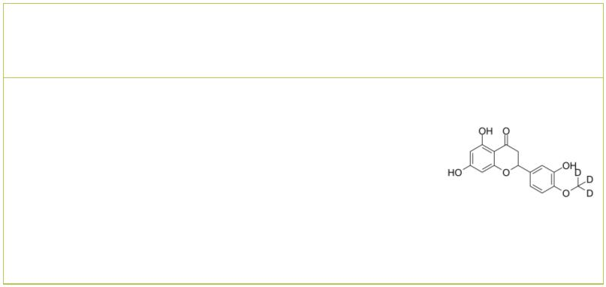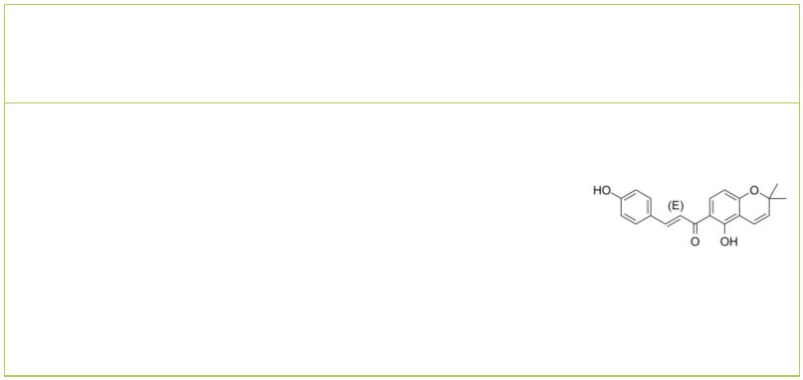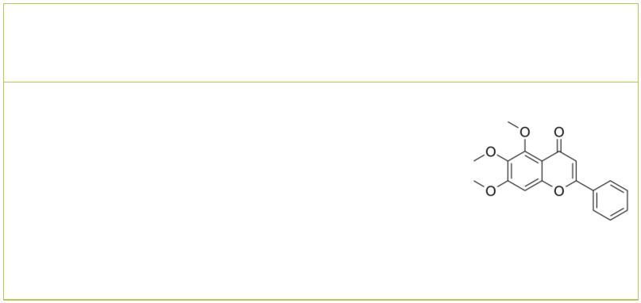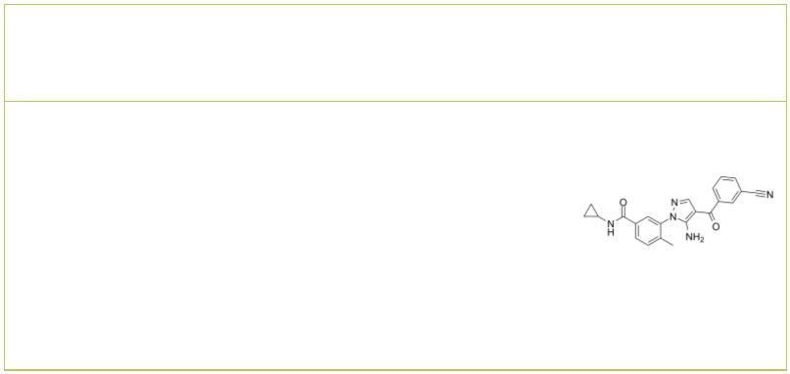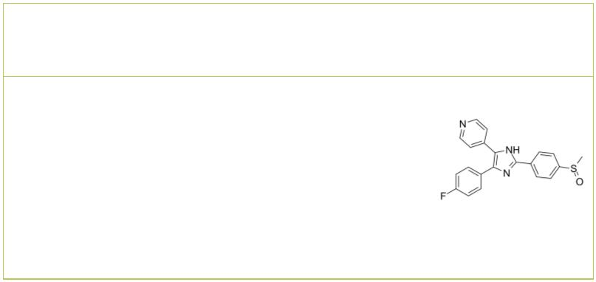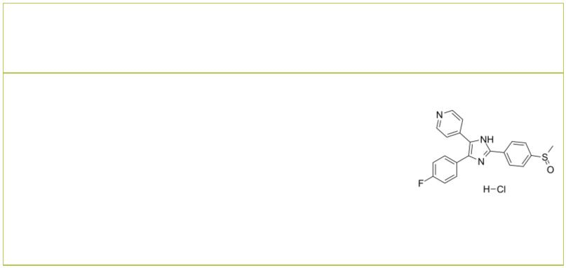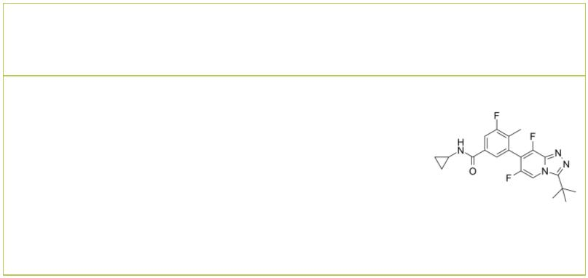p38 MAPK Inhibitors, Activators & Modulators
 | (E)-Osmundacetone (Rac)-Hesperetin
 |  |  |  | Cat. No.: HY-N1966 Cat. No.: HY-N0168A
 | (E)-Osmundacetone is the isomer of Osmundacetone.  Osmundacetone significantly suppresses the  phosphorylation of MAPKs, including JNK, ERK, and  p38 kinases. Osmundacetone has a neuroprotective  effect against oxidative stress. |  |  |  |  | (Rac)-Hesperetin is the racemate of Hesperetin.  Hesperetin is a natural flavanone, and acts as a  potent and broad-spectrum inhibitor against human  UGT activity. Hesperetin induces apoptosis via  p38 MAPK activation.
 | Purity: ≥99.0%  Clinical Data: No Development Reported  Size: 5 mg, 10 mg, 25 mg, 50 mg |  |  |  |  | Purity: 98.20%  Clinical Data: No Development Reported  Size: 100 mg
 | (Rac)-Hesperetin-13C,d3 (Rac)-Hesperetin-d3
 |  | Cat. No.: HY-N0168AS1 Cat. No.: HY-N0168AS
 | (Rac)-Hesperetin-13C,d3 is the 13C- and deuterium  labeled. (Rac)-Hesperetin is the racemate of  Hesperetin. Hesperetin is a natural flavanone, and  acts as a potent and broad-spectrum inhibitor  against human UGT activity. Hesperetin induces  apoptosis via p38 MAPK activation. |  |  |  |  | (Rac)-Hesperetin-d3 is the deuterium labeled  (Rac)-Hesperetin. (Rac)-Hesperetin is the racemate  of Hesperetin. Hesperetin is a natural flavanone,  and acts as a potent and broad-spectrum inhibitor  against human UGT activity. Hesperetin induces  apoptosis via p38 MAPK activation.
 | Purity: >98%  Clinical Data: No Development Reported  Size: 1 mg, 5 mg |  |  |  |  | Purity: >98%  Clinical Data: No Development Reported  Size: 1 mg, 10 mg
 | 4-Hydroxylonchocarpin |  |  | Cat. No.: HY-N2208 |  | 5,6,7-Trimethoxyflavone  (Baicalein trimethyl ether) Cat. No.: HY-110398
 | 4-Hydroxylonchocarpin is a chalcone compound from  an extract of Psoralea corylifolia.  4-Hydroxylonchocarpin increases phosphorylation of  p38 MAPK, JNK and ERK. |  |  |  |  | 5,6,7-Trimethoxyflavone is a novel p38-α MAPK  inhibitor with an anti-inflammatory effect.  5,6,7-Trimethoxyflavone is isolated from several  plants including Zeyhera tuberculosa, Callicarpa  japonica, and Kickxia lanigera.
 | Purity: 92.14%  Clinical Data: No Development Reported  Size: 5 mg, 10 mg |  |  |  |  | Purity: 98.76%  Clinical Data:  Size: 10 mg
 | Acumapimod Adezmapimod
 | (BCT197) Cat. No.: HY-16715 (SB 203580; RWJ 64809) Cat. No.: HY-10256
 | Acumapimod (BCT197) is an orally active p38  MAP kinase inhibitor, with an IC of less than  50  1 μM for p38α. |  |  |  |  | Adezmapimod (SB 203580) is a selective and  ATP-competitive p38 MAPK inhibitor with IC s  50  of 50 nM and 500 nM for SAPK2a/p38 and  SAPK2b/p38β2, respectively. Adezmapimod inhibits  LCK, GSK3β and PKBα with IC s of 100-500-fold  50  higher than that for SAPK2a/p38.
 | Purity: 99.63%  Clinical Data: Phase 2  Size: 10 mM × 1 mL, 5 mg, 10 mg, 25 mg, 50 mg, 100 mg |  |  |  |  | Purity: 99.92%  Clinical Data: No Development Reported  Size: 10 mM × 1 mL, 10 mg, 50 mg, 100 mg, 200 mg
 | Adezmapimod hydrochloride AL 8697
 | (SB 203580 hydrochloride; RWJ 64809 hydrochloride) Cat. No.: HY-10256A |  |  |  |  |  |  |  |  |  |  |  |  |  |  |  |  |  |  | Cat. No.: HY-108645
 | Adezmapimod (SB 203580) hydrochloride is a  selective and ATP-competitive p38 MAPK  inhibitor with IC s of 50 nM and 500 nM for  50  SAPK2a/p38 and SAPK2b/p38β2, respectively. |  |  |  |  | AL 8697 is a specific and orally active p38α  MAPK inhibitor with an IC of 6 nM. AL 8697  50  displays 14-fold greater inhibition of p38α  compared to p38β (IC =82 nM), and 300-fold  50  selectivity for p38α over a panel of 91 kinases.  Anti-inflammatory activity.
 | Purity: 99.71%  Clinical Data: No Development Reported  Size: 10 mM × 1 mL, 10 mg, 50 mg, 100 mg, 200 mg |  |  |  |  | Purity: 99.49%  Clinical Data: No Development Reported  Size: 10 mM × 1 mL, 5 mg
2 Tel: 609-228-6898 Fax: 609-228-5909 Email: sales@MedChemExpress.com
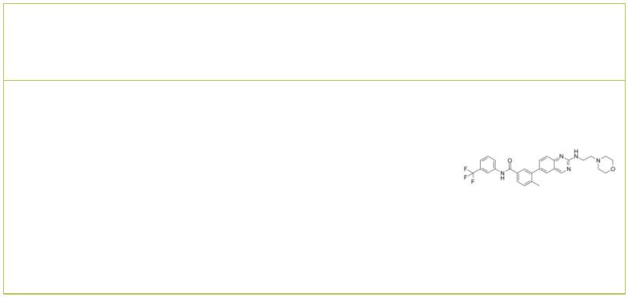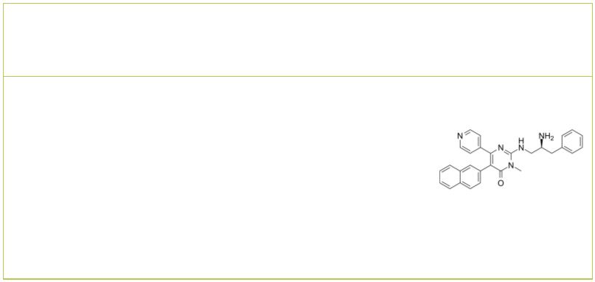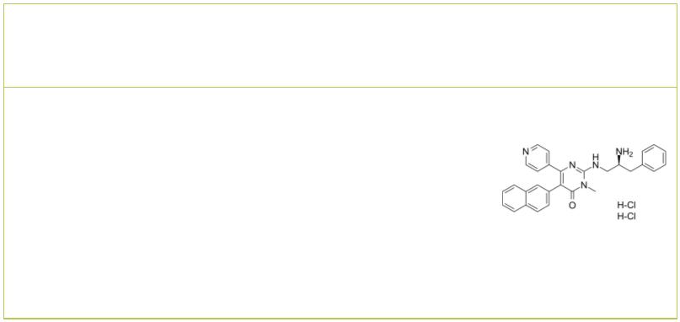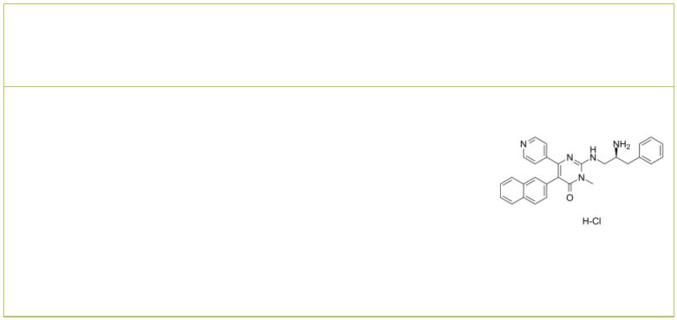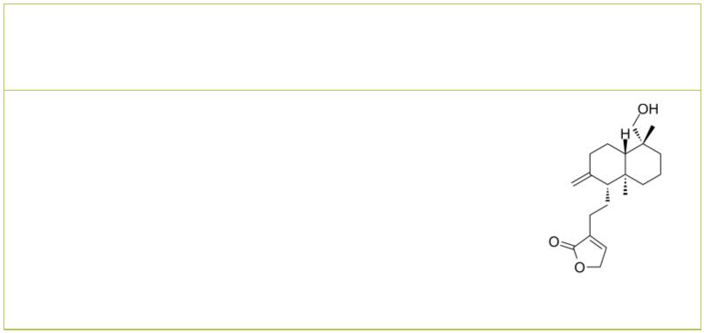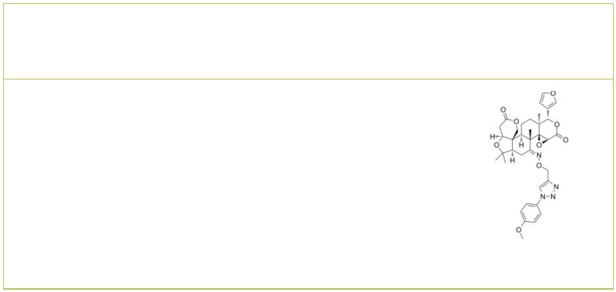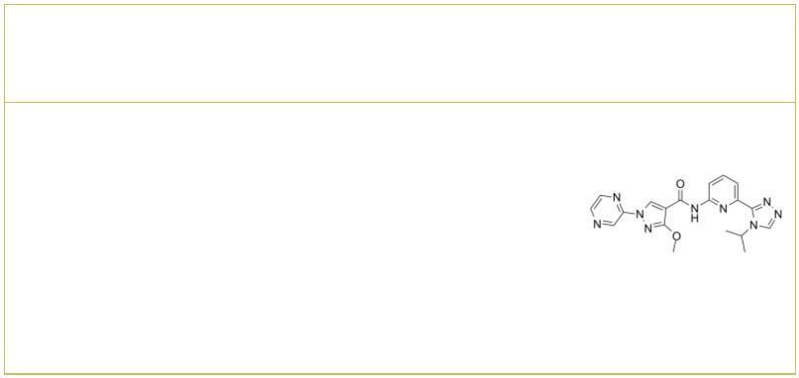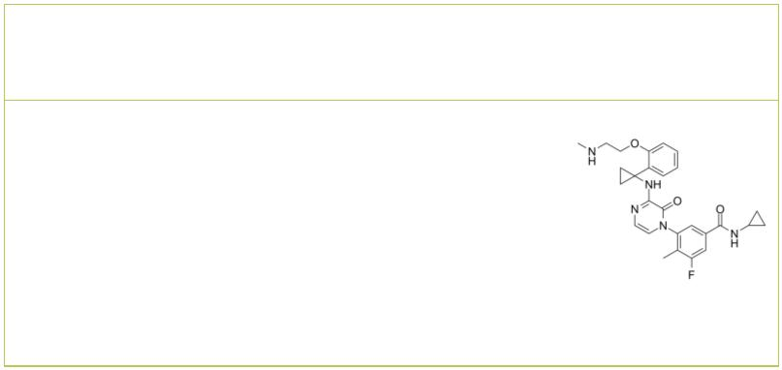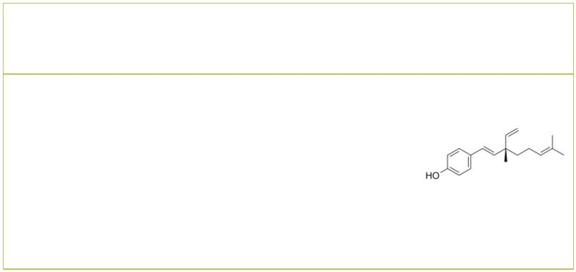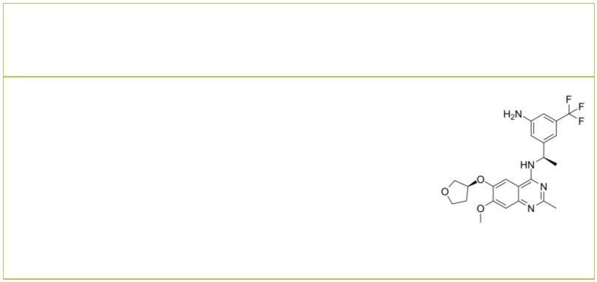AMG-47a AMG-548
 |  |  |  | Cat. No.: HY-18303 Cat. No.: HY-108642
AMG-47a is a potent and orally active  lymphocyte-specific protein tyrosine kinase  (Lck) inhibitor, with an IC of 0.2 nM. AMG-47a  50  also inhibits VEGF2, p38α, Jak3 and MLR and  IL-2 with IC s of 1 nM, 3 nM, 72 nM, 30 nM and 21  50  nM, respectively.  Purity: 98.72%  Clinical Data: No Development Reported  Size: 10 mM × 1 mL, 5 mg, 10 mg, 25 mg, 50 mg |  |  |  |  |  | AMG-548, an orally active and selective p38α  inhibitor (K=0.5 nM), shows slightly selective  i  over p38β (K=36 nM) and >1000 fold selective  i  against p38γ and p38δ. AMG 548 is also extremely  potent in the inhibition of whole blood LPS  stimulated TNFα (IC =3 nM).  50  Purity: ≥99.0%  Clinical Data:  Size: 1 mg, 5 mg
AMG-548 dihydrochloride AMG-548 hydrochloride
 | Cat. No.: HY-108642B Cat. No.: HY-108642A
AMG-548 dihydrochloride, an orally active and  selective p38α inhibitor (K=0.5 nM), shows  i  slightly selective over p38β (K=36 nM) and  i  >1000 fold selective against p38γ and p38δ. |  |  |  |  |  | AMG-548 hydrochloride, an orally active and  selective p38α inhibitor (K=0.5 nM), shows  i  slightly selective over p38β (K=36 nM) and  i  >1000 fold selective against p38γ and p38δ.
Purity: 99.85%  Clinical Data: No Development Reported  Size: 10 mM × 1 mL, 1 mg, 5 mg, 10 mg, 25 mg, 50 mg, 100 mg |  |  |  |  |  | Purity: >98%  Clinical Data: No Development Reported  Size: 1 mg, 5 mg
Andrograpanin Anti-inflammatory agent 7
 |  |  | Cat. No.: HY-N9388 Cat. No.: HY-139844
Andrograpanin, a bioactive compound from  Andrographis paniculata, exhibits  anti-inflammatory and anti-infectious  properties. |  |  |  |  |  | Anti-inflammatory agent 7 inhibits proinflammatory  cytokines by blocking the NF-κB/MAPK signaling  pathway in LPS-treated RAW 264.7 cells as well as  mice.
Purity: >98%  Clinical Data: No Development Reported  Size: 5 mg, 10 mg, 25 mg |  |  |  |  |  | Purity: >98%  Clinical Data: No Development Reported  Size: 1 mg, 5 mg
ASK1-IN-1 AZD7624
 |  | Cat. No.: HY-133554 Cat. No.: HY-103672
ASK1-IN-1 is a CNS-penetrant ASK1 (apoptosis  signal-regulating kinase 1) inhibitor, with good  potency (cell IC =138 nM; Biochemical =21  50 IC₅₀  nM). |  |  |  |  |  | AZD7624 is an inhaled p38 inhibitor, with potent  anti-inflammatory activity.
Purity: 99.79%  Clinical Data: No Development Reported  Size: 10 mM × 1 mL, 5 mg, 10 mg, 25 mg, 50 mg, 100 mg |  |  |  |  |  | Purity: 98.08%  Clinical Data: No Development Reported  Size: 10 mM × 1 mL, 5 mg
Bakuchiol BI-3406
((S)-(+)-Bakuchiol) Cat. No.: HY-N0235 |  |  |  |  |  |  |  |  |  |  |  |  |  |  |  |  |  |  | Cat. No.: HY-125817
Bakuchiol is a phytoestrogen isolated from the  seeds of Psoralea corylifolia L; has anti-tumor  effects. |  |  |  |  |  | BI-3406 (compound I-6) is an orally active, highly  potent and selective inhibitor of the interaction  between KRAS and Son of Sevenless 1 (SOS1) with  an IC of 6 nM. BI-3406 potently reduces the  50  formation of GTP-loaded KRAS, and inhibits MAPK  pathway signaling.
Purity: 99.25%  Clinical Data: Phase 2  Size: 10 mM × 1 mL, 5 mg, 10 mg, 25 mg, 50 mg, 100 mg |  |  |  |  |  | Purity: 99.79%  Clinical Data: No Development Reported  Size: 10 mM × 1 mL, 5 mg, 10 mg, 25 mg, 50 mg, 100 mg
www.MedChemExpress.com 3
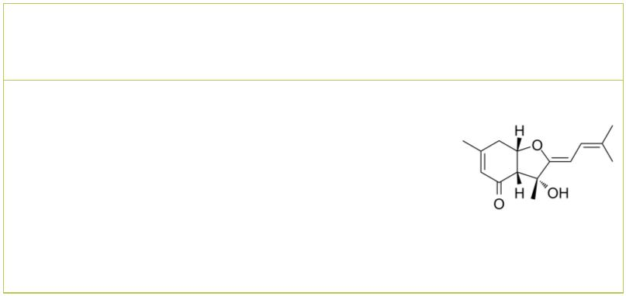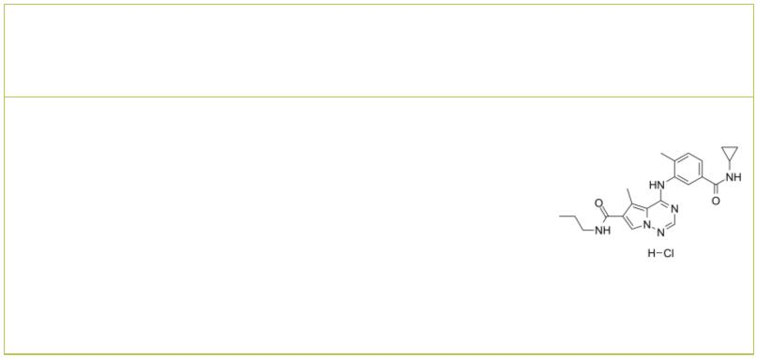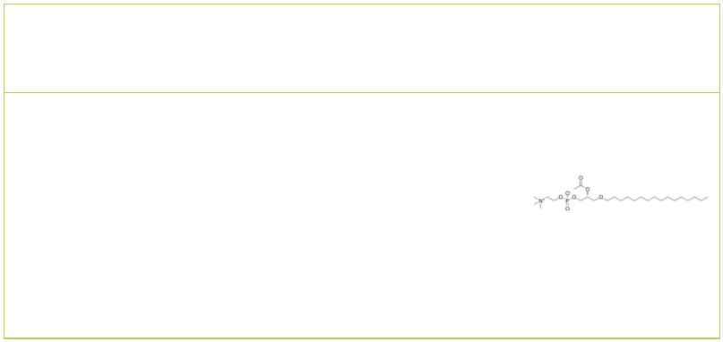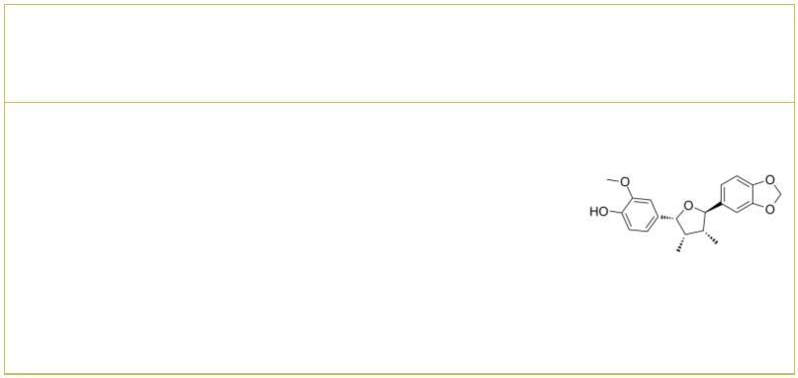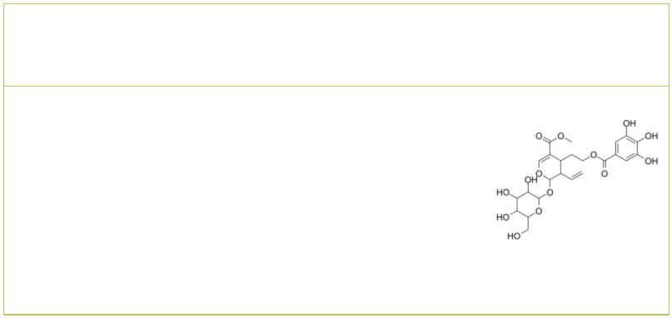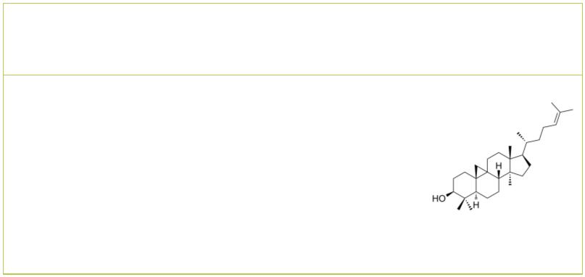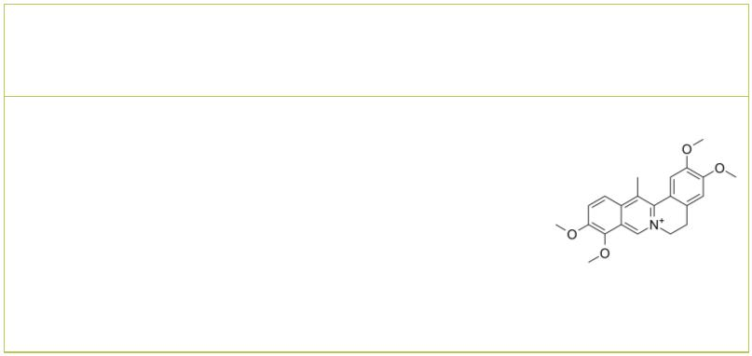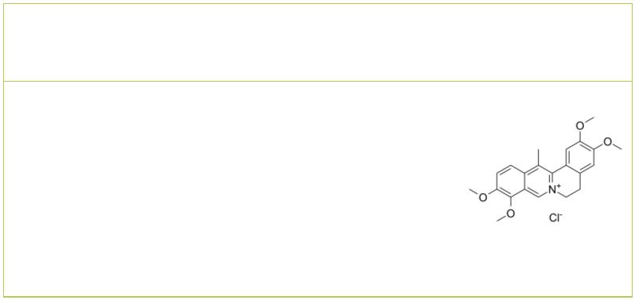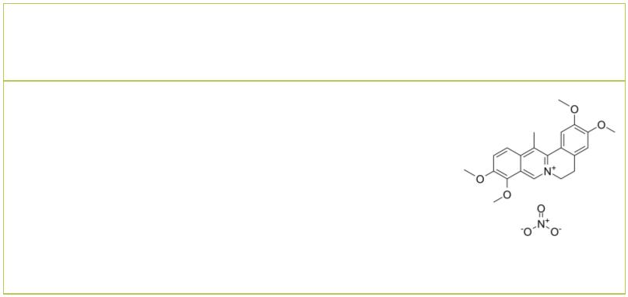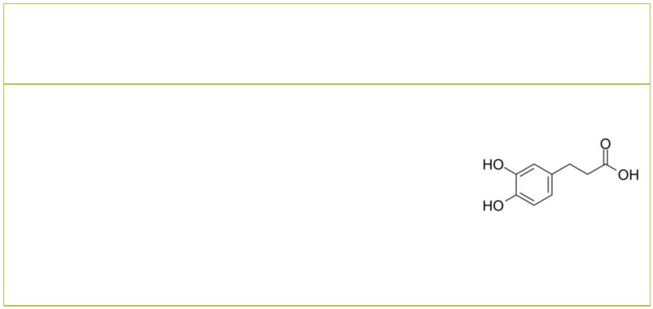 | Bisabolangelone BMS-582949 hydrochloride
 |  | Cat. No.: HY-N4233 Cat. No.: HY-14305A
 | Bisabolangelone, a sesquiterpene derivative, is  isolated from the roots of Osterici Radix. |  |  | BMS-582949 hydrochloride is an orally active and  highly selective p38α MAPK inhibitor, with an  IC of 13 nM. BMS-582949 hydrochloride displays a  50  significantly improved pharmacokinetic profile and  is effective in inflammatory disease.
 | Purity: 98.22%  Clinical Data: No Development Reported  Size: 5 mg, 10 mg |  |  | Purity: 98.29%  Clinical Data: Phase 2  Size: 10 mM × 1 mL, 5 mg, 10 mg, 25 mg, 50 mg, 100 mg
 | C16-PAF  (PAF (C16)) Cat. No.: HY-108635 |  |  | Chicanine |  |  |  |  |  |  |  |  |  |  |  | Cat. No.: HY-N2270
 | C16-PAF (PAF (C16)), a phospholipid mediator, is a  platelet-activating factor and ligand for PAF  G-protein-coupled receptor (PAFR). C16-PAF  exhibits anti-apoptotic effect and inhibits  caspase-dependent death by activating the PAFR. |  |  | Chicanine is a lignan compound of Schisandra  chinesis, inhibits LPS-induced phosphorylation of  p38 MAPK, ERK 1/2 and IκB-α, with  anti-inflammatory activity.
 | Purity: ≥98.0%  Clinical Data: No Development Reported  Size: 10 mM × 1 mL, 5 mg, 10 mg |  |  | Purity: >98%  Clinical Data: No Development Reported  Size: 5 mg, 10 mg
 | Cornuside Cycloartenol
 |  | Cat. No.: HY-N0631 Cat. No.: HY-N7255
 | Cornuside is a secoiridoid glucoside isolated from  the fruit of Cornus officinalis Sieb. et Zucc.,  which is a traditional oriental medicine for  treating inflammatory diseases and invigorating  blood circulation. |  |  | Cycloartenol, a phytosterol compound, is one of  the key precusor substances for biosynthesis of  numerous sterol compounds. Cycloartenol inhibits  the migration of glioma cells and suppresses the  phosphorylation of the p38 MAP kinase.
 | Purity: 99.26%  Clinical Data: No Development Reported  Size: 5 mg, 10 mg |  |  | Purity: 98.0%  Clinical Data: No Development Reported  Size: 1 mg, 5 mg
 | Dehydrocorydaline Dehydrocorydaline chloride
 | (13-Methylpalmatine) Cat. No.: HY-N0674 (13-Methylpalmatine chloride) Cat. No.: HY-N0674A
 | Dehydrocorydaline (13-Methylpalmatine) is an  alkaloid that regulates protein expression of  Bax, Bcl-2; activates caspase-7, caspase-8, and  inactivates PARP. Dehydrocorydaline elevates p38  MAPK activation. Anti-inflammatory and  anti-cancer activities. |  |  | Dehydrocorydaline chloride (13-Methylpalmatine  chloride) is an alkaloid that regulates protein  expression of Bax, Bcl-2; activates caspase-7,  caspase-8, and inactivates PARP.  Dehydrocorydaline chloride elevates p38 MAPK  activation.
 | Purity: 99.01%  Clinical Data: No Development Reported  Size: 10 mM × 1 mL, 5 mg, 10 mg |  |  | Purity: 99.72%  Clinical Data: No Development Reported  Size: 10 mM × 1 mL, 5 mg, 10 mg
 | Dehydrocorydaline nitrate Dihydrocaffeic acid
 | (13-Methylpalmatine nitrate) Cat. No.: HY-N4238 (3,4-Dihydroxy-benzenepropanoic acid) Cat. No.: HY-N2406
 | Dehydrocorydaline nitrate (13-Methylpalmatine  nitrate) is an alkaloid. Dehydrocorydaline  regulates protein expression of Bax, Bcl-2;  activates caspase-7, caspase-8, and inactivates  PARP. Dehydrocorydaline nitrate elevates p38  MAPK activation. |  |  | Dihydrocaffeic acid is a phenolic acid found in  Gynura bicolor, reduces phosphorylation of MAPK  p38 and prevent UVB-induced skin damage.  Antioxidant potential and anti-inflammatory  activity.
 | Purity: 99.89%  Clinical Data: No Development Reported  Size: 5 mg, 10 mg |  |  | Purity: ≥98.0%  Clinical Data: No Development Reported  Size: 10 mM × 1 mL, 10 mg
4 Tel: 609-228-6898 Fax: 609-228-5909 Email: sales@MedChemExpress.com
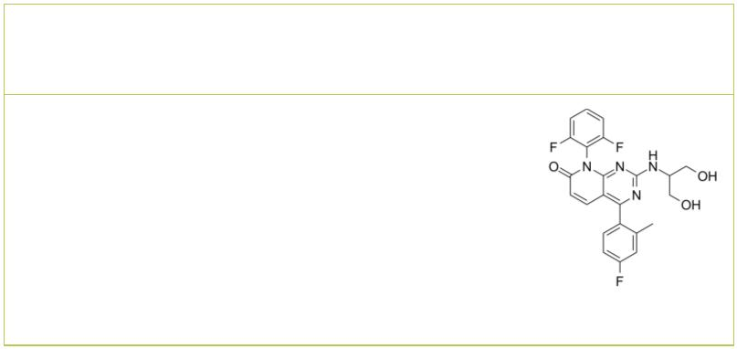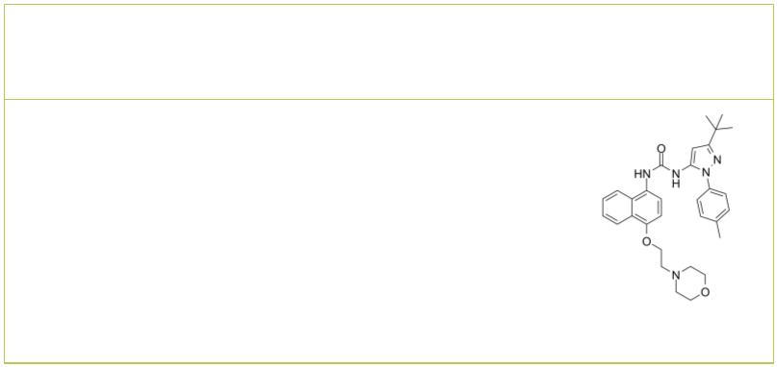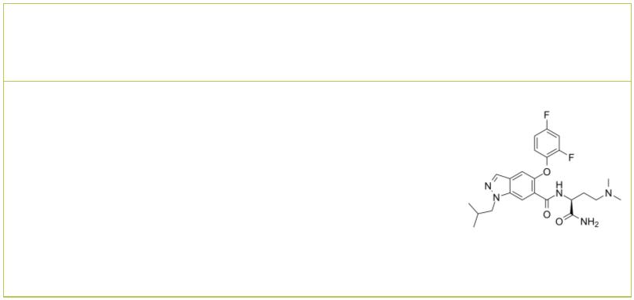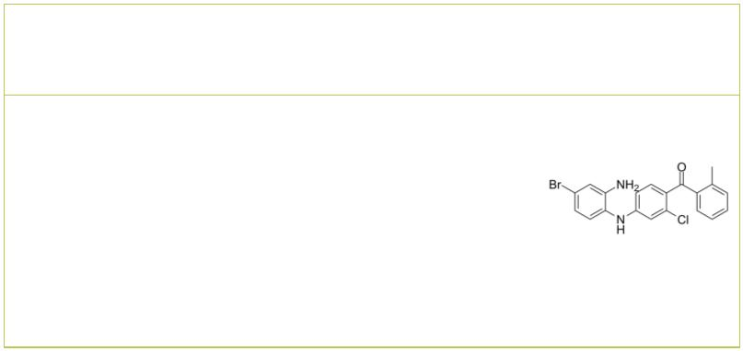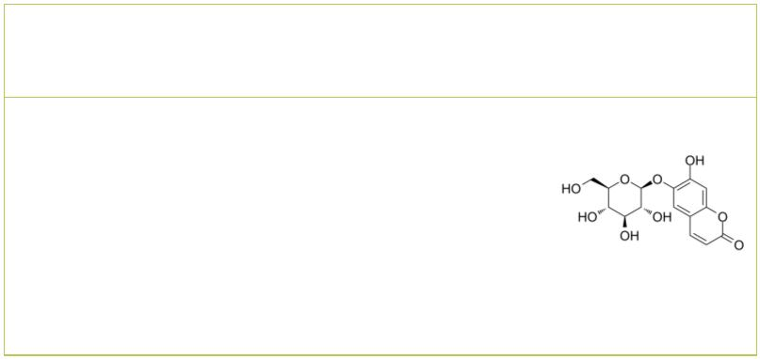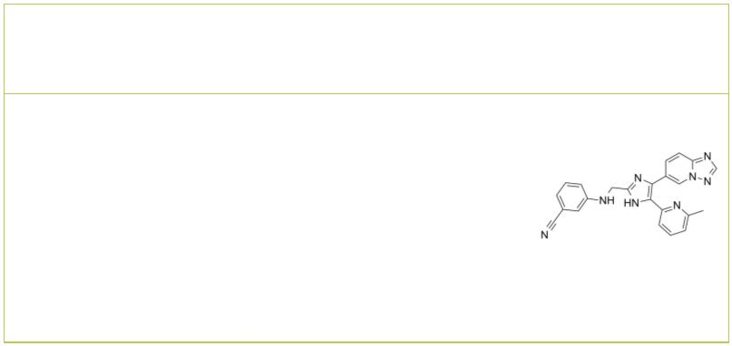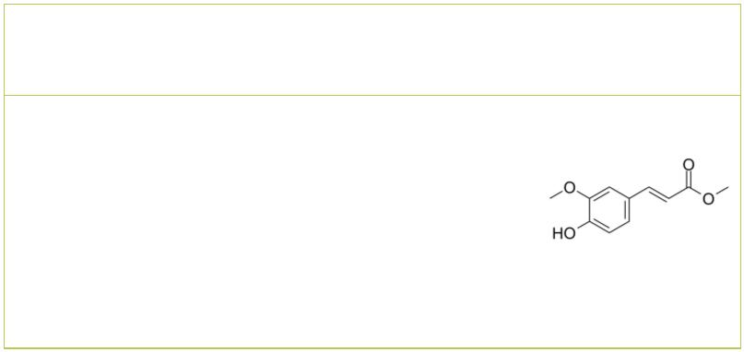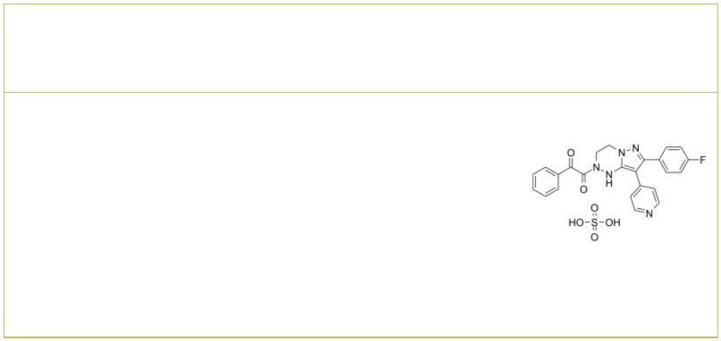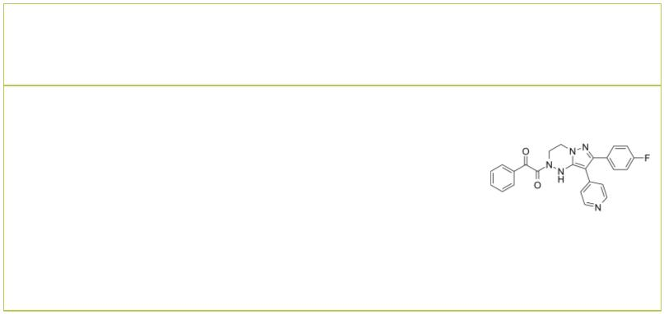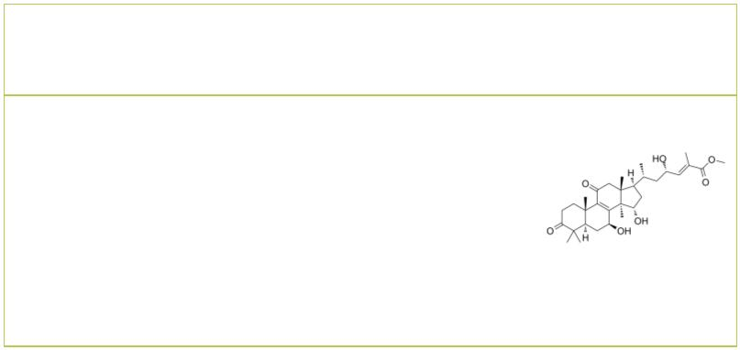Dilmapimod  (SB-681323; GW 681323) Cat. No.: HY-10404 |  |  |  | Doramapimod  (BIRB 796) Cat. No.: HY-10320
Dilmapimod (SB-681323) is a potent p38 MAPK  inhibitor that potentially suppresses inflammation  in chronic obstructive pulmonary disease.  Purity: 99.56%  Clinical Data: Phase 2  Size: 5 mg, 10 mg, 25 mg, 50 mg, 100 mg |  |  |  | Doramapimod (BIRB 796) is an orally active, highly  potent p38 MAPK inhibitor, which has an IC  50  for p38α=38 nM, for p38β=65 nM, for p38γ=200 nM,  and for p38δ=520 nM. Doramapimod has picomolar  affinity for p38 kinase (K =0.1 nM). Doramapimod  d  also inhibits B-Raf with an IC of 83 nM.  50  Purity: 99.88%  Clinical Data: Phase 2  Size: 10 mM × 1 mL, 10 mg, 50 mg, 100 mg, 200 mg
Emprumapimod  (PF-07265803) Cat. No.: HY-145564 |  |  |  | EO 1428 |  |  |  |  |  |  |  |  |  |  | Cat. No.: HY-108647
Emprumapimod is a potent, orally bioavailable and  selective inhibitor of p38α MAPK directly  inhibits LPS-induced IL-6 production from  RPMI-8226 cell (IC =100 pM). Emprumapimod can be  50  used for the research of dilated cardiomyopathy  and acute inflammatory pain. |  |  |  | EO 1428 is a highly specific inhibitor of p38 of  the aminobenzophenone class. EO 1428 (1 μM )  markedly attenuates LPS-induced tumor necrosis  factor α-converting enzyme (TACE) activity  up-regulation.
Purity: >98%  Clinical Data: No Development Reported  Size: 1 mg, 5 mg |  |  |  | Purity: >98%  Clinical Data: No Development Reported  Size: 1 mg, 5 mg
Esculin EW-7195
 | Cat. No.: HY-N0188 Cat. No.: HY-18766
Esculin, a fluorescent coumarin glucoside, is an  active ingredient of ash bark. Esculin ameliorates  cognitive impairment in experimental diabetic  nephropathy (DN), and exerts antioxidative stress  and antiinflammatory effects, via the MAPK  signaling pathway. |  |  |  | EW-7195 is a potent and selective ALK5 (TGFβR1)  inhibitor with an IC of 4.83 nM. EW-7195 has  50  >300-fold selectivity for ALK5 over p38α.  EW-7195 efficiently inhibits TGF-β1-induced Smad  signaling, epithelial-to-mesenchymal transition  (EMT) and breast tumour metastasis to the lung.
Purity: 99.19%  Clinical Data: No Development Reported  Size: 10 mM × 1 mL, 500 mg |  |  |  | Purity: >98%  Clinical Data: No Development Reported  Size: 1 mg, 5 mg
Ferulic acid methyl ester FR 167653
(Methyl ferulate) Cat. No.: HY-W018643 (FR 167653 sulfate) Cat. No.: HY-18754A
Ferulic acid methyl ester (Methyl ferulate) is a  derivative of ferulic acid, isolated from  Stemona tuberosa, with anti-inflammatory and  antioxidant properties. |  |  |  | FR 167653 (FR 167653 sulfate), an orally active  and selective p38 MAPK inhibitor, is a potent  suppressor of TNF-α and IL-1β production via  specific inhibition of p38 MAPK activity.
Purity: 99.95%  Clinical Data: No Development Reported  Size: 10 mM × 1 mL, 100 mg |  |  |  | Purity: >98%  Clinical Data: No Development Reported  Size: 1 mg, 5 mg
FR 167653 free base Ganoderterpene A
 |  | Cat. No.: HY-18754 Cat. No.: HY-N10119
FR 167653 free base, an orally active and  selective p38 MAPK inhibitor, is a potent  suppressor of TNF-α and IL-1β production via  specific inhibition of p38 MAPK activity. |  |  |  | Ganoderterpene A attenuates LPS-induced  inflammation and apoptosis via suppressing MAPK  and TLR-4/NF-κB pathways in BV-2 cells.
Purity: >98%  Clinical Data: No Development Reported  Size: 1 mg, 5 mg |  |  |  | Purity: >98%  Clinical Data: No Development Reported  Size: 5 mg, 10 mg, 25 mg
www.MedChemExpress.com 5
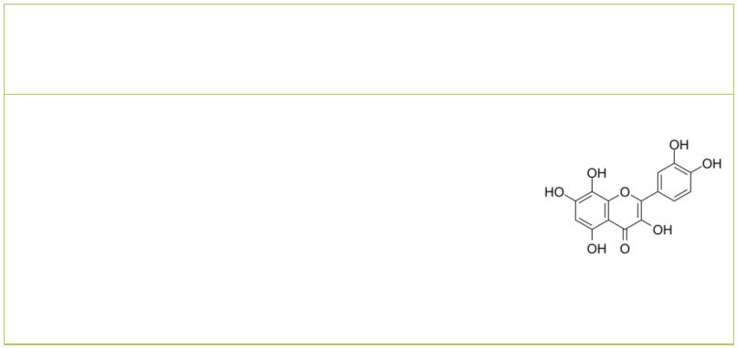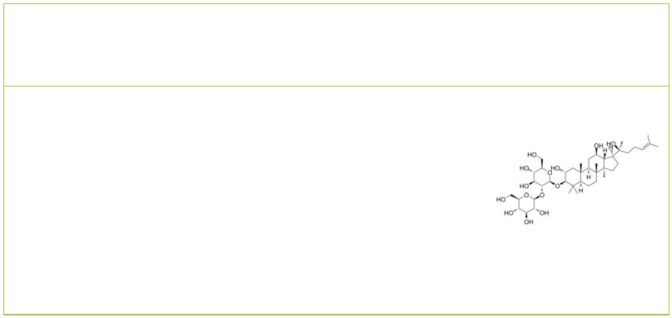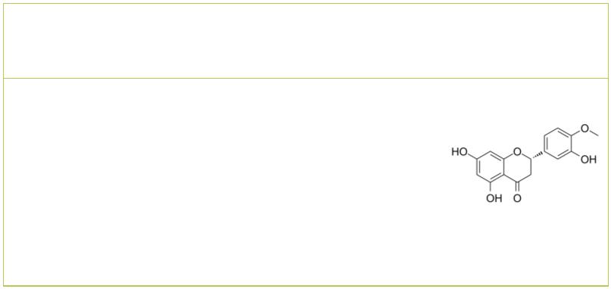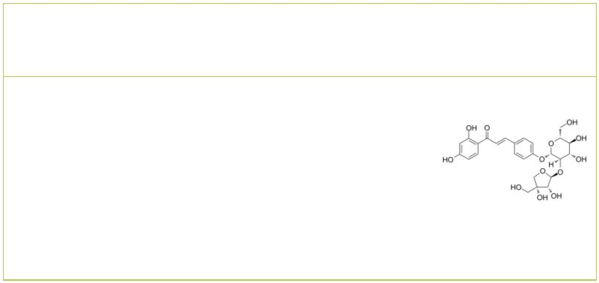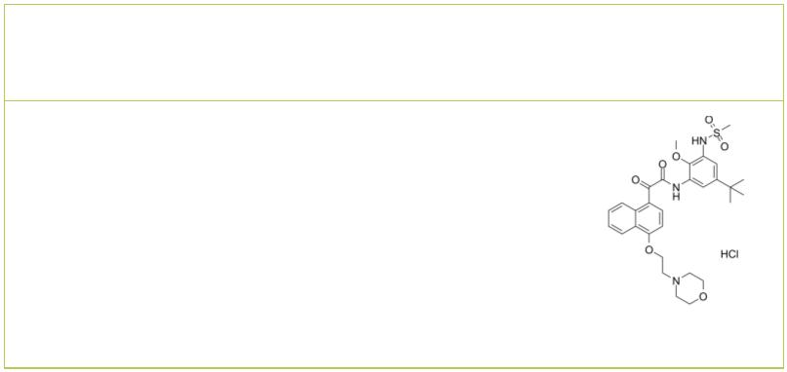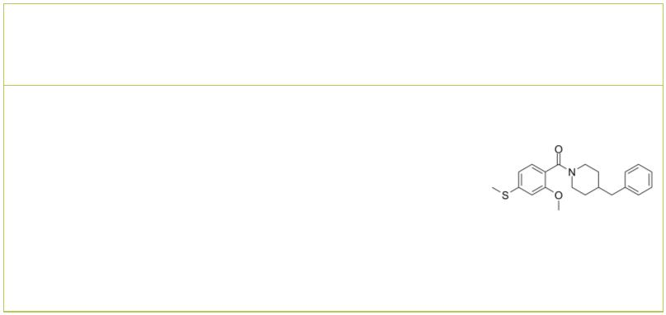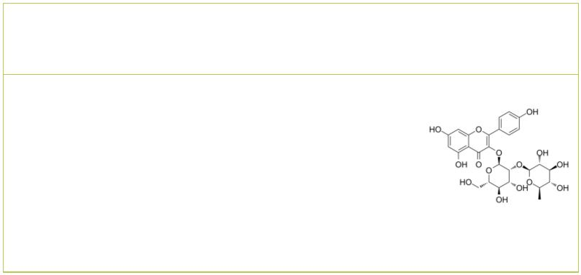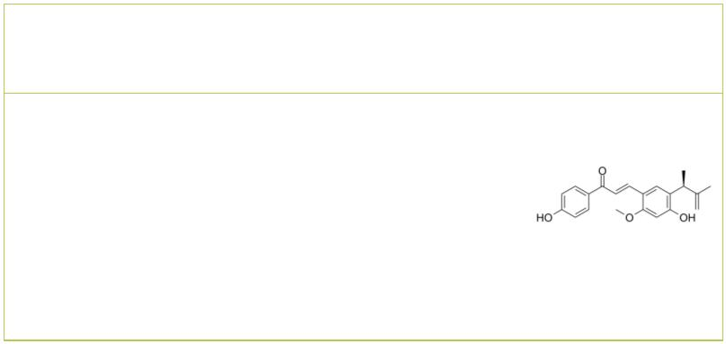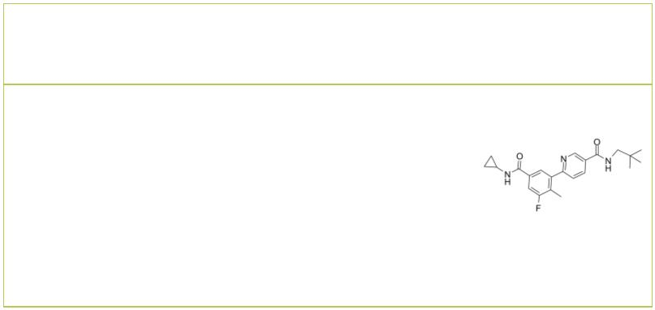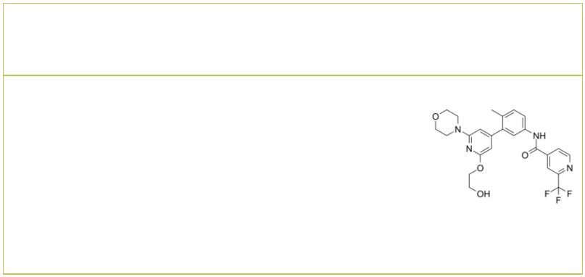 | Gossypetin Gypenoside L
 |  | Cat. No.: HY-119917 Cat. No.: HY-N8211
 | Gossypetin is a hexahydroxylated flavonoid and is  a potent mitogen-activated protein kinase  kinase (MKK)3 and MKK6 inhibitor with  strongly attenuates the MKK3/6-p38 signaling  pathway, has various pharmacological activities,  including antioxidant, antibacterial… |  |  |  |  | Gypenoside L is a saponin that can be found in  Gynostemma pentaphyllum. Gypenoside L  increases the SA-β-galactosidase activity,  promotes the production of senescence-associated  secretory cytokines.
 | Purity: 99.82%  Clinical Data: No Development Reported  Size: 1 mg |  |  |  |  | Purity: 99.42%  Clinical Data: No Development Reported  Size: 5 mg
 | Hesperetin Isoliquiritin apioside
 |  |  | Cat. No.: HY-N0168 Cat. No.: HY-N2497
 | Hesperetin is a natural flavanone, and acts as a  potent and broad-spectrum inhibitor against human  UGT activity. Hesperetin induces apoptosis. |  |  |  |  | Isoliquiritin apioside significantly decreases  PMA-induced increases in MMP9 activities and  suppresses PMA-induced activation of MAPK and  NF-κB. Isoliquiritin apioside auppresseses  invasiveness and angiogenesis of cancer cells and  endothelial cells.
 | Purity: 98.75%  Clinical Data: No Development Reported  Size: 10 mM × 1 mL, 50 mg |  |  |  |  | Purity: 99.87%  Clinical Data: No Development Reported  Size: 5 mg, 10 mg
 | ITX5061 JX401
 |  |  |  | Cat. No.: HY-19900 Cat. No.: HY-108346
 | ITX5061 is a type II inhibitor of p38 MAPK and  also an antagonist of scavenger receptor B1  (SR-B1). |  |  |  |  | JX401 is a potent inhibitor of p38alpha, containing  a 4-benzylpiperidine motif. p38alpha is  hyperactive in inflammatory diseases, and various  indications suggest that its inhibition would  reverse inflammation. JX401 has the potential for  the research of inflammation.
 | Purity: 98.38%  Clinical Data: No Development Reported  Size: 5 mg, 10 mg, 50 mg |  |  |  |  | Purity: >98%  Clinical Data: No Development Reported  Size: 1 mg, 5 mg
 | Kaempferol-3-O-glucorhamnoside Licochalcone E
 |  |  | Cat. No.: HY-N0208 Cat. No.: HY-N4182
 | Kaempferol-3-O-glucorhamnoside, a flavonoid  derived from plant Thesium chinense Turcz,  inhibits inflammatory responses via MAPK and NF-κB  pathways in vitro and in vivo. |  |  |  |  | Licochalcone E, a flavonoid compound isolated from  Glycyrrhiza inflate, inhibits NF-κB and AP-1  transcriptional activity through the inhibition of  AKT and MAPK activation.
 | Purity: 99.39%  Clinical Data: No Development Reported  Size: 5 mg, 10 mg |  |  |  |  | Purity: 99.63%  Clinical Data: No Development Reported  Size: 5 mg, 10 mg
 | Losmapimod LXH254
 | (GSK-AHAB; GW856553X; SB856553) Cat. No.: HY-10402 |  |  |  |  |  |  |  |  |  |  |  |  |  |  |  |  |  |  | Cat. No.: HY-112089
 | Losmapimod (GSK-AHAB) is a selective, potent, and  orally active p38 MAPK inhibitor with pKs of  i  8.1 and 7.6 for p38α and p38β, respectively. |  |  |  |  | LXH254 is a potent, selective, orally active, type  II BRAF and CRAF inhibitor, with IC values of  50  0.072 and 0.21 nM against CRAF and BRAF,  respectively.
 | Purity: 98.06%  Clinical Data: Phase 3  Size: 10 mM × 1 mL, 10 mg, 50 mg |  |  |  |  | Purity: 99.95%  Clinical Data: Phase 2  Size: 10 mM × 1 mL, 5 mg, 10 mg, 25 mg, 50 mg
6 Tel: 609-228-6898 Fax: 609-228-5909 Email: sales@MedChemExpress.com
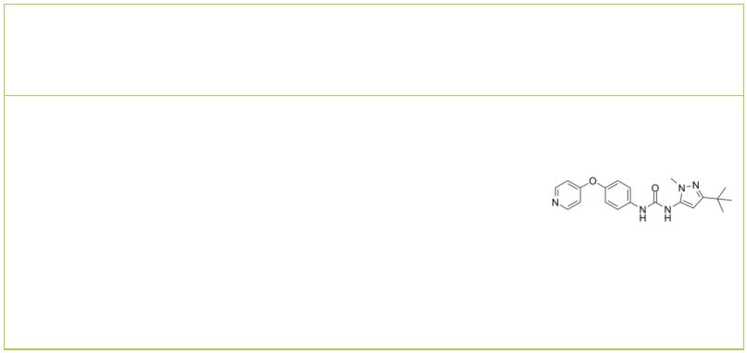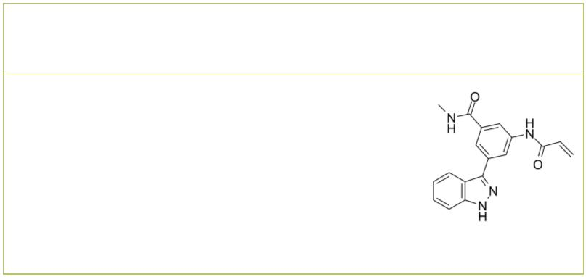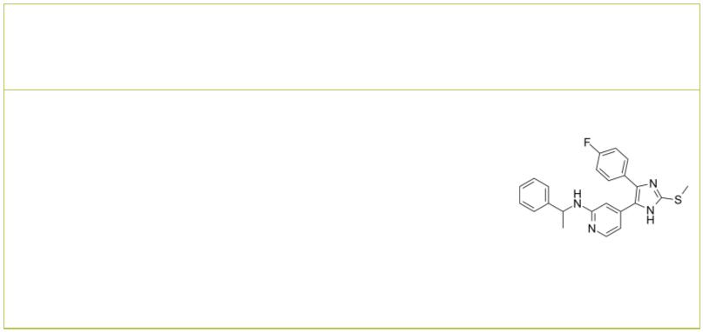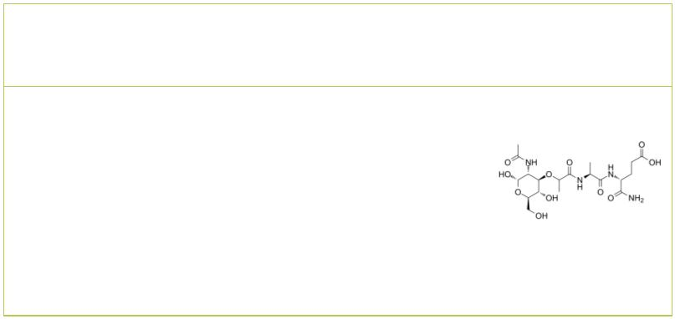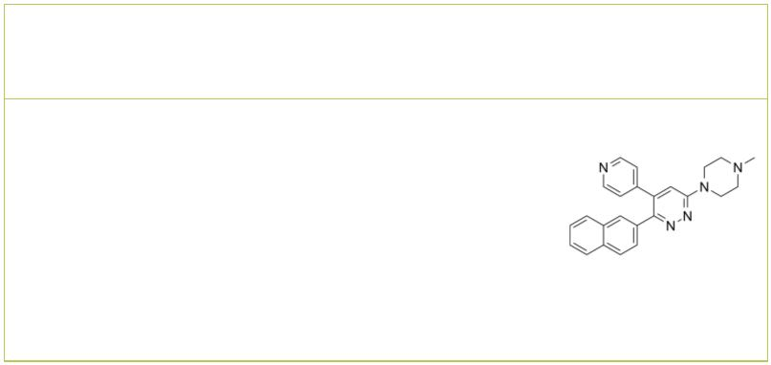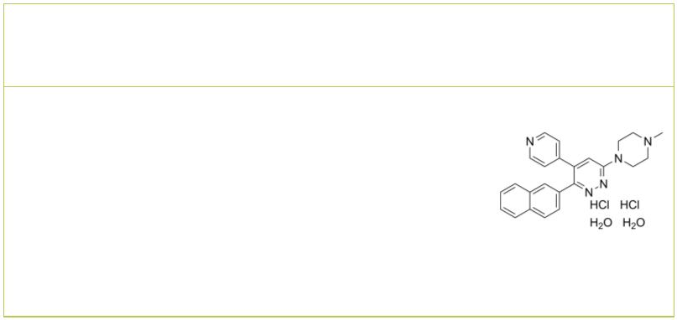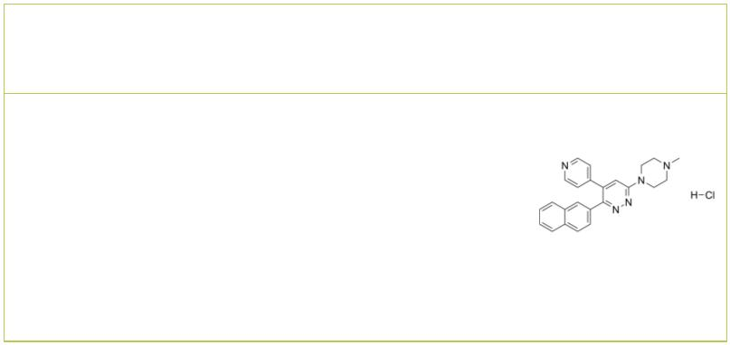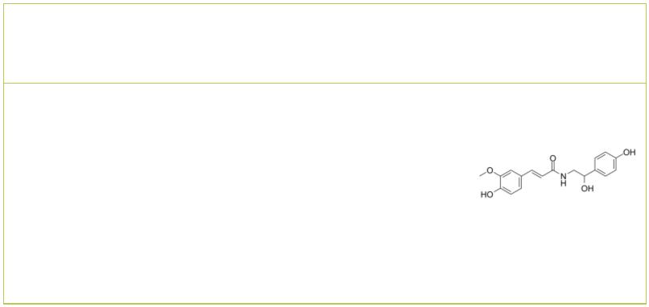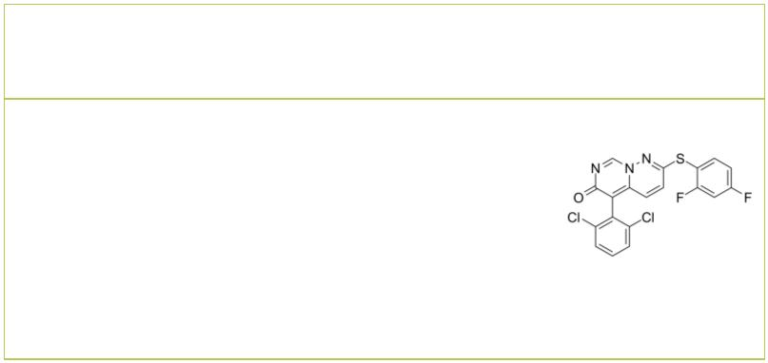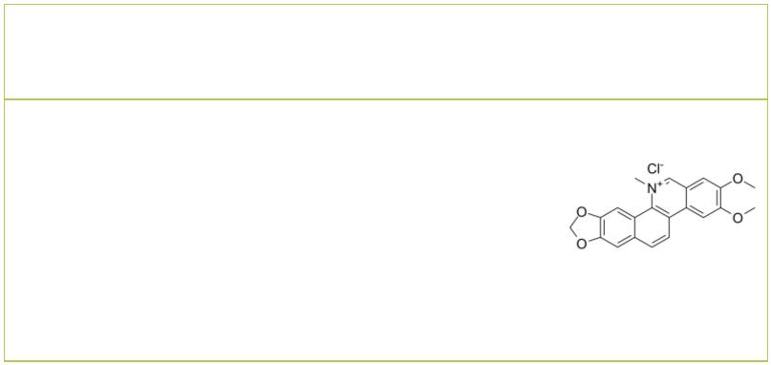MAPK13-IN-1 MKK7-COV-9
 |  |  | Cat. No.: HY-18850 Cat. No.: HY-122872
MPAK13-IN-1 is a MAPK13 (p38δ) inhibitor, with  an IC of 620 nM.  50 |  |  |  |  | MKK7-COV-9 is a potent and selective covalent  inhibitor of MKK7 and targets a specific  protein–protein interaction of MKK7. MKK7-COV-9  blocks primary B cell activation in response to  LPS with an EC of 4.98 μM.</br>.  50
Purity: 99.63%  Clinical Data: No Development Reported  Size: 10 mM × 1 mL, 5 mg, 10 mg, 50 mg, 100 mg |  |  |  |  | Purity: 97.09%  Clinical Data: No Development Reported  Size: 5 mg, 10 mg, 25 mg, 50 mg, 100 mg
ML3403 |  | Cat. No.: HY-110103 |  |  | Muramyl dipeptide  (MDP) Cat. No.: HY-127090
ML3403 is a potent p38 MAPK inhibitor with an  IC of 0.38 μM.  50 |  |  |  |  | Muramyl dipeptide (MDP) is a synthetic  immunoreactive peptide, consisting of N-acetyl  muramic acid attached to a short amino acid chain  of L-Ala-D-isoGln. Muramyl dipeptide is an inducer  of bone formation through induction of Runx2.
Purity: >98%  Clinical Data: No Development Reported  Size: 1 mg, 5 mg |  |  |  |  | Purity: ≥98.0%  Clinical Data: Phase 4  Size: 1 mg, 5 mg, 10 mg, 25 mg
MW-150  (MW01-18-150SRM) Cat. No.: HY-120111 |  |  |  |  | MW-150 dihydrochloride dihydrate  (MW01-18-150SRM dihydrochloride dihydrate) Cat. No.: HY-120111B
MW150 (MW01-18-150SRM) is a selective, CNS  penetrant, and orally active inhibitor of p38α  MAPK with a K of 101 nM. MW-150 inhibits the  i  ability of the endogenous p38α MAPK to  phosphorylate an endogenous substrate MK2 in  activated glia. |  |  |  |  | MW-150 dihydrochloride dihydrate (MW01-18-150SRM  dihydrochloride dihydrate) is a selective, CNS  penetrant, and orally active inhibitor of p38α  MAPK with a K of 101 nM.  i
Purity: 99.90%  Clinical Data: No Development Reported  Size: 10 mM × 1 mL, 5 mg, 10 mg, 50 mg, 100 mg |  |  |  |  | Purity: >98%  Clinical Data: No Development Reported  Size: 1 mg, 5 mg
MW-150 hydrochloride N-Feruloyloctopamine
(MW01-18-150SRM hydrochloride) Cat. No.: HY-120111A |  |  |  |  |  |  |  |  |  |  |  |  |  |  |  |  |  | Cat. No.: HY-N2232
MW-150 hydrochloride (MW01-18-150SRM  hydrochloride) is a selective, CNS penetrant, and  orally active inhibitor of p38α MAPK with a K  i  of 101 nM. |  |  |  |  | N-Feruloyloctopamine is an antioxidant  constituent. N-Feruloyloctopamine significantly  decreases the phosphorylation levels of  Akt and p38 MAPK.
Purity: >98%  Clinical Data: No Development Reported  Size: 1 mg, 5 mg |  |  |  |  | Purity: 99.69%  Clinical Data: No Development Reported  Size: 1 mg, 5 mg
Neflamapimod Nitidine chloride
(VX-745) Cat. No.: HY-10328 |  |  |  |  |  |  |  |  |  |  |  |  |  |  |  |  |  | Cat. No.: HY-N0498
Neflamapimod (VX-745) is a potent, blood-brain  barrier penetrant, highly selective inhibitor of  p38α inhibitor with an IC for p38α of 10 nM and  50  for p38β of 220 nM. Neflamapimod (VX-745)  possesses anti-inflammatory activity. |  |  |  |  | Nitidine chloride, a potential anti-malarial  lead compound derived from Zanthoxylum nitidum  (Roxb) DC, exerts potent anticancer activity  through diverse pathways, including inducing  apoptosis, inhibiting STAT3 signaling cascade,  DNA topoisomerase 1 and 2A, ERK and…
Purity: 99.32%  Clinical Data: Phase 2  Size: 10 mM × 1 mL, 10 mg, 50 mg |  |  |  |  | Purity: 99.61%  Clinical Data: No Development Reported  Size: 5 mg, 10 mg, 20 mg
www.MedChemExpress.com 7
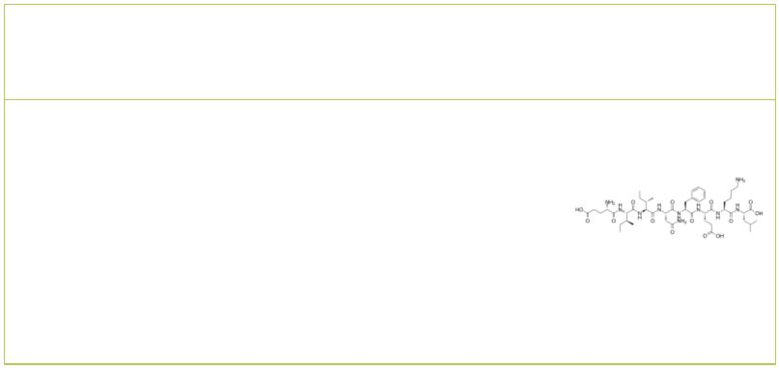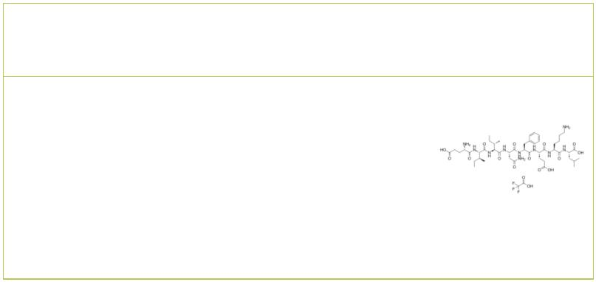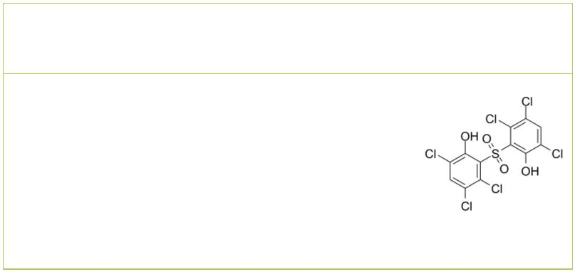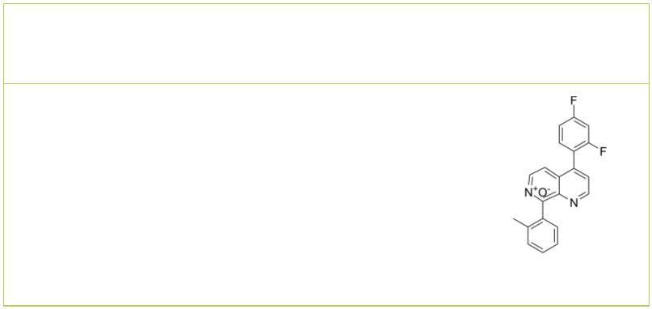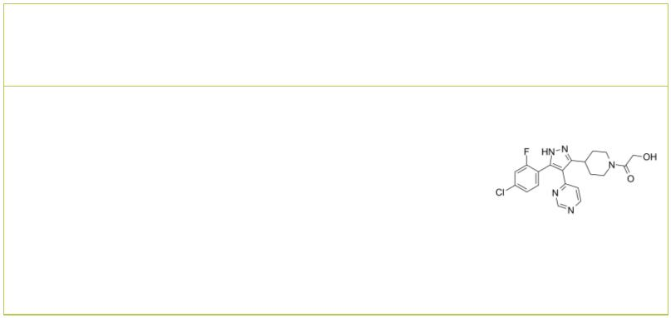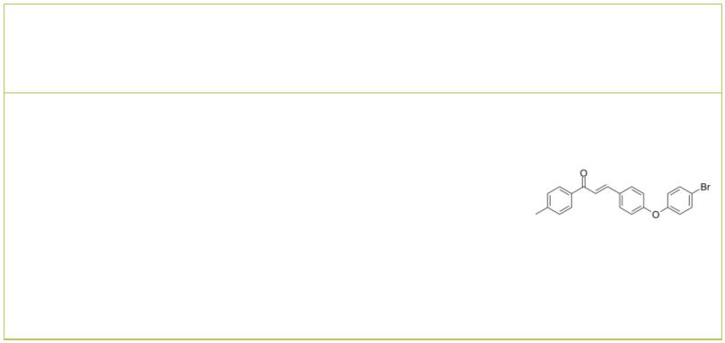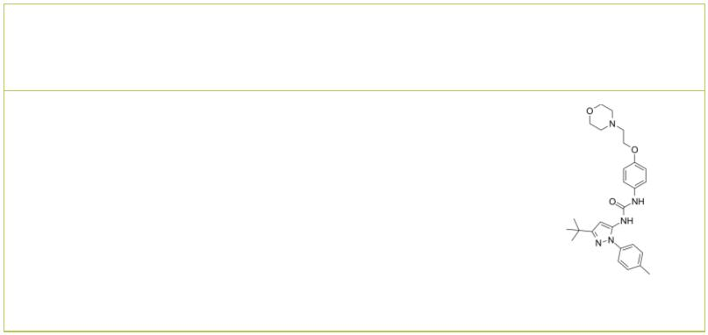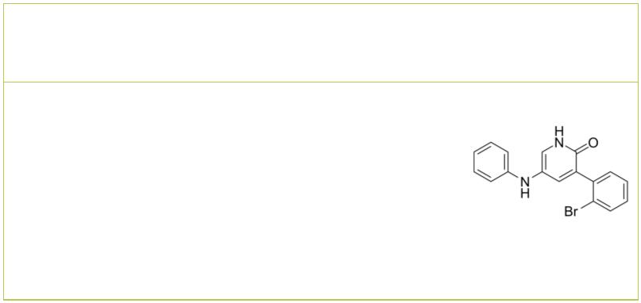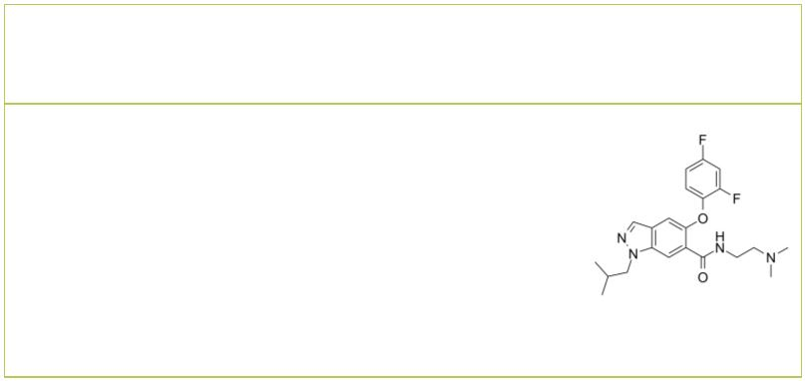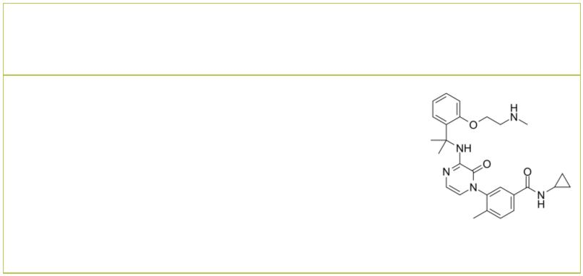 | OVA-E1 peptide OVA-E1 peptide TFA
 |  |  |  | Cat. No.: HY-P2319 Cat. No.: HY-P2319A
 | OVA-E1 peptide, is an antagonist variant of  SIINFEKL [OVA (257-264). OVA-E1 peptide, activates  the p38 and JNK cascades similarly in mutant and  wild-type thymocytes. |  |  |  |  |  | OVA-E1 peptide TFA, is an antagonist variant of  SIINFEKL [OVA (257-264). OVA-E1 peptide, activates  the p38 and JNK cascades similarly in mutant and  wild-type thymocytes.
 | Purity: >98%  Clinical Data: No Development Reported  Size: 1 mg, 5 mg |  |  |  |  |  | Purity: >98%  Clinical Data: No Development Reported  Size: 1 mg, 5 mg
 | p38 MAP Kinase Inhibitor IV p38 MAPK-IN-1
 |  |  | Cat. No.: HY-112401 Cat. No.: HY-12839
 | p38 MAP Kinase Inhibitor IV is a highly specific  ATP-competitive p38α MAPK inhibitor with IC s  50  of 0.13 and 0.55 μM for p38α and p38β MAPK,  respectively. |  |  |  |  |  | p38 MAPK-IN-1 (Compound 4) is a novel potent and  selective inhibitor of p38 MAPK with IC of  50  68 nM. p38 MAPK-IN-1 shows sustained levels, low  clearance and good bioavailability.
 | Purity: >98%  Clinical Data: No Development Reported  Size: 1 mg, 5 mg |  |  |  |  |  | Purity: 98.91%  Clinical Data: No Development Reported  Size: 5 mg, 10 mg, 50 mg, 100 mg
 | p38 MAPK-IN-2 p38 MAPK-IN-3
 |  | Cat. No.: HY-U00324 Cat. No.: HY-144697
 | p38 MAPK-IN-2 is an inhibitor of p38 kinase. |  |  |  |  |  | p38 MAPK-IN-3 (Compound 2c) is a p38α MAPK  inhibitor. p38 MAPK-IN-3 has antitumor activities  and induces apoptosis and ROS.
 | Purity: >98%  Clinical Data: No Development Reported  Size: 1 mg, 5 mg |  |  |  |  |  | Purity: >98%  Clinical Data: No Development Reported  Size: 1 mg, 5 mg
 | p38-α MAPK-IN-1 p38-α MAPK-IN-4
 |  |  |  |  | Cat. No.: HY-18874 Cat. No.: HY-146032
 | p38-α MAPK-IN-1 is an inhibitor of MAPK14  (p38-α), with IC of 2300 nM in EFC displacement  50  assay, and 5500 nM in HTRF assay. |  |  |  |  |  | p38-α MAPK-IN-4 (Compound 69) is a selective p38α  MAPK inhibitor with an IC of 1.5 µM. p38-α  50  MAPK-IN-4 rapidly and strongly prevents the  development of mechanical allodynia (MA) in vivo.
 | Purity: 99.90%  Clinical Data: No Development Reported  Size: 10 mM × 1 mL, 1 mg, 5 mg, 10 mg, 50 mg, 100 mg |  |  |  |  |  | Purity: >98%  Clinical Data: No Development Reported  Size: 1 mg, 5 mg
 | p38α inhibitor 1 p38α inhibitor 2
 |  |  | Cat. No.: HY-114423 Cat. No.: HY-131335
 | p38α inhibitor 1 is a p38α inhibitor extracted  from patent WO 2008076265 A1. |  |  |  |  |  | p38α inhibitor 2 is a highly potent and selective  p38α MAPK inhibitor, with a pIC of 9.6.  50
 | Purity: 98.70%  Clinical Data: No Development Reported  Size: 10 mM × 1 mL, 5 mg, 10 mg, 50 mg, 100 mg |  |  |  |  |  | Purity: 98.97%  Clinical Data: No Development Reported  Size: 10 mM × 1 mL, 5 mg, 10 mg, 25 mg, 50 mg, 100 mg
8 Tel: 609-228-6898 Fax: 609-228-5909 Email: sales@MedChemExpress.com
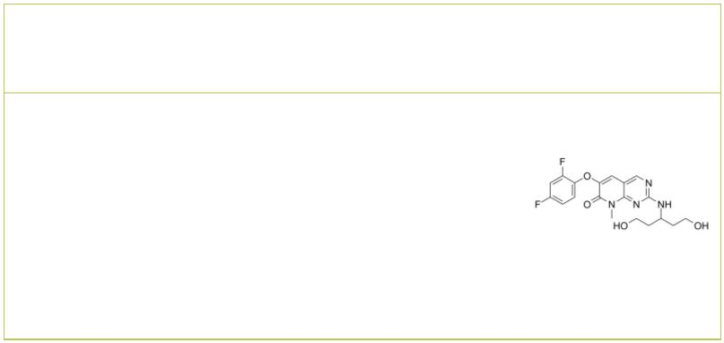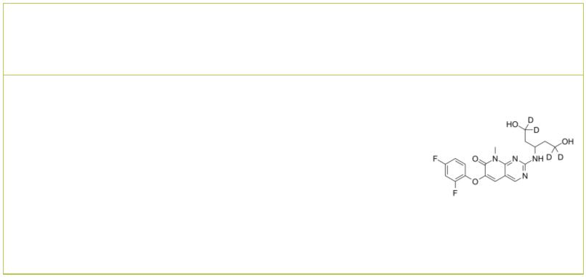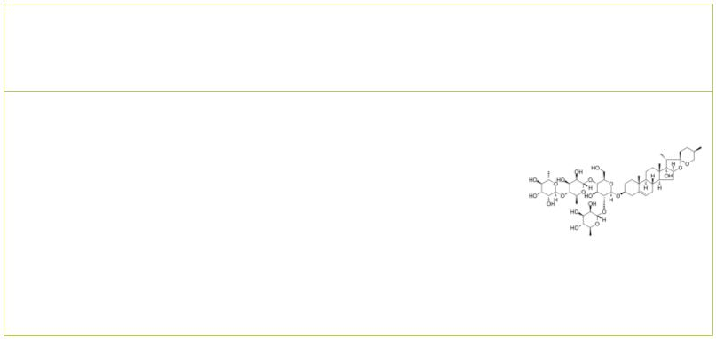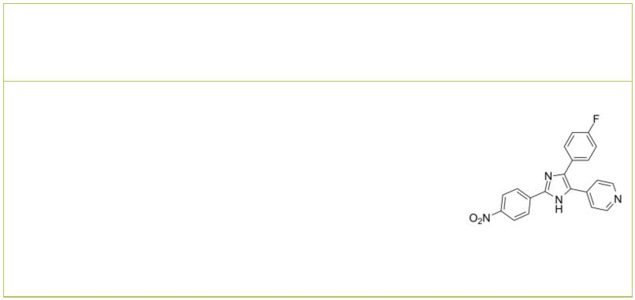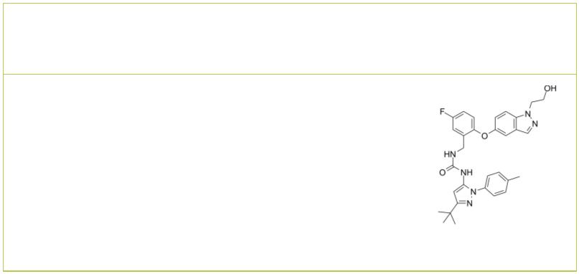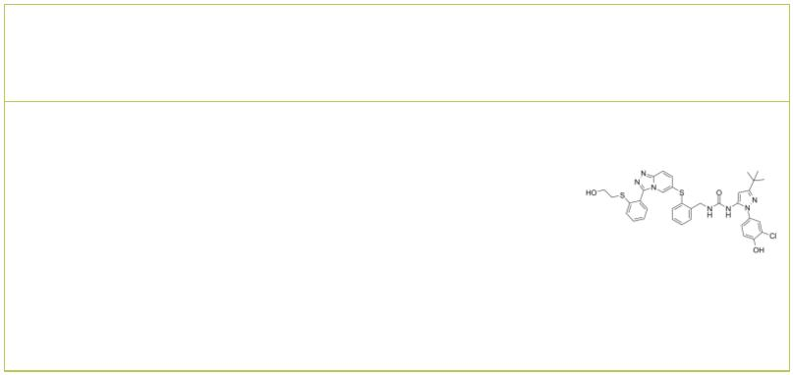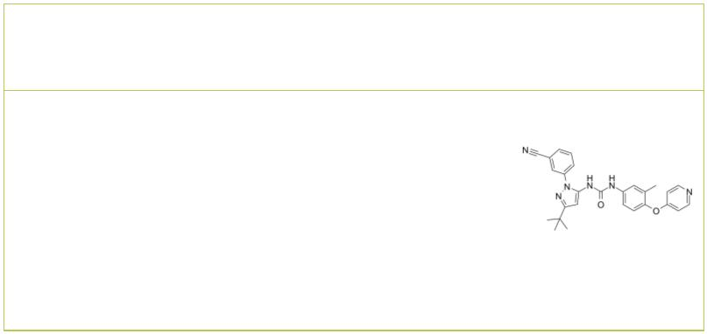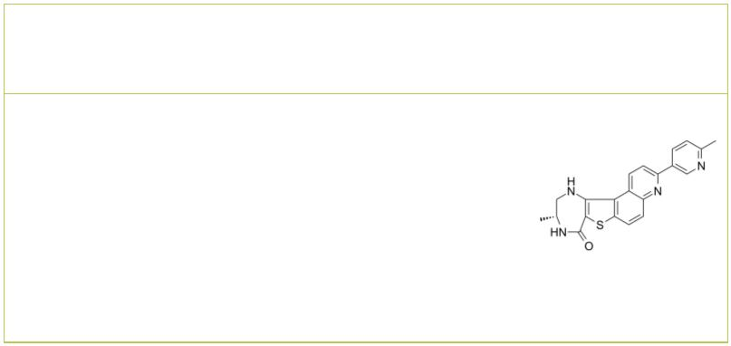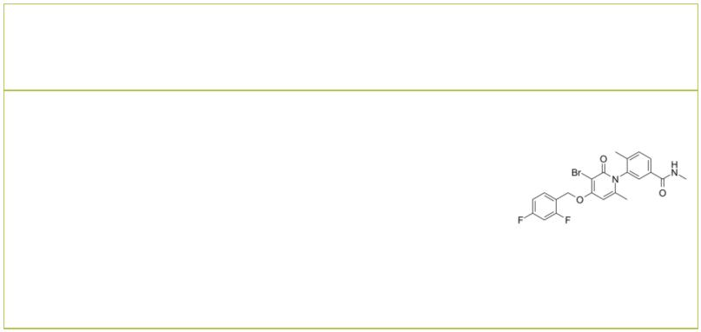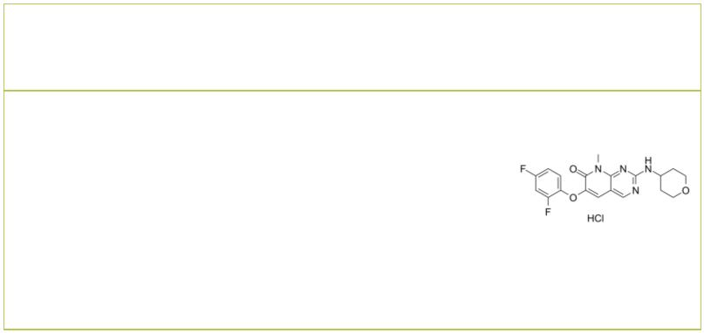Pamapimod  (Ro4402257; R1503) Cat. No.: HY-10405 |  |  |  | Pamapimod-d4 |  |  |  |  |  |  |  |  |  |  | Cat. No.: HY-10405S
Pamapimod (Ro4402257) is a potent, selective and  orally active p38 MAPK inhibitor with IC s of  50  14 nM and 480 nM and Ks of 1.3 nM and 120 nM for  i  p38α and p38β, respectively. Pamapimod has no  activity against p38δ or p38γ isoforms. |  |  |  | Pamapimod-d4 (Ro4402257-d4) is the deuterium  labeled Pamapimod. Pamapimod (Ro4402257) is a  potent, selective and orally active p38 MAPK  inhibitor with IC s of 14 nM and 480 nM and s  50 K_{i}  of 1.3 nM and 120 nM for p38α and p38β,  respectively.
Purity: 99.92%  Clinical Data: Launched  Size: 10 mM × 1 mL, 5 mg, 10 mg, 25 mg, 50 mg |  |  |  | Purity: >98%  Clinical Data:  Size: 1 mg, 5 mg, 10 mg
Paris saponin VII  (Chonglou Saponin VII) Cat. No.: HY-N3584 |  |  |  | PD 169316 |  |  |  |  |  |  |  |  |  |  |  |  | Cat. No.: HY-10578
Paris saponin VII (Chonglou Saponin VII) is a  steroidal saponin isolated from the roots and  rhizomes of Trillium tschonoskii Maxim.  Paris saponin VII-induced apoptosis in K562/ADR  cells is associated with Akt/MAPK and the  inhibition of P-gp. |  |  |  | PD 169316 is a potent, cell-permeable and  selective p38 MAP kinase inhibitor, with IC of  50  89 nM. PD169316 selectively inhibits the kinase  activity of the phosphorylated p38 without  hindering upstream kinases to phosphorylate p38.
Purity: 99.13%  Clinical Data: No Development Reported  Size: 5 mg, 10 mg |  |  |  | Purity: 98.0%  Clinical Data: No Development Reported  Size: 10 mM × 1 mL, 10 mg, 50 mg, 100 mg, 500 mg
Pexmetinib  (ARRY-614) Cat. No.: HY-16782 |  |  |  | PF-03715455 |  |  |  |  |  |  |  |  |  |  |  |  | Cat. No.: HY-18862
Pexmetinib is a potent Tie-2 and p38 MAPK dual  inhibitor, with IC s of 1 nM, 35 nM and 26 nM for  50  Tie-2, p38α and p38β, respectively, and can be  used in the research of acute myeloid leukemia.  Purity: 99.93%  Clinical Data: No Development Reported  Size: 10 mM × 1 mL, 5 mg, 10 mg, 25 mg, 50 mg, 100 mg |  |  |  | PF-03715455 is a potent inhaled p38 MAPK  inhibitor. PF-03715455 shows some selectivity for  p38α over p38β with respective IC values of 0.88  50  and 23 nM. PF-03715455 potently inhibits  LPS-induced TNFα production in human whole blood  (IC =1.7 nM).  50  Purity: >98%  Clinical Data: No Development Reported  Size: 1 mg, 5 mg
PF-05381941 PF-3644022
 | Cat. No.: HY-120823 Cat. No.: HY-107427
PF-05381941 is a potent dual inhibitor of  TAK1/p38α, with IC s of 156 and186 nM,  50  respectively. |  |  |  | PF-3644022 is a potent, selective, orally active  and ATP-competitive MAPKAPK2 (MK2) inhibitor  with an IC₅₀ of 5.2 nM and a K_{i} of 3 nM.  PF-3644022 also inhibits MK3 and p38  regulated/activated kinase (PRAK) with IC s of  50  53 nM and 5.0 nM, respectively.
Purity: 99.75%  Clinical Data: No Development Reported  Size: 5 mg, 10 mg, 25 mg |  |  |  | Purity: 99.93%  Clinical Data: No Development Reported  Size: 10 mM × 1 mL, 5 mg, 10 mg, 25 mg, 50 mg, 100 mg
PH-797804 R1487 Hydrochloride
 |  | Cat. No.: HY-10403 Cat. No.: HY-14975
PH-797804 is a ATP-competitive, selective  p38α/p38β inhibitor (IC₅₀=26 nM and K_{i}=5.8 nM for  p38α; K=40 nM for p38β) and does not inhibit  i  JNK2. |  |  |  | R1487 Hydrochloride is a highly potent and  selective p38α inhibitor, with K values of 0.2  d  nM and 29 nM for p38α and p38β, respectively.
Purity: 98.94%  Clinical Data: No Development Reported  Size: 10 mM × 1 mL, 5 mg, 10 mg, 25 mg, 50 mg, 100 mg, 200 mg |  |  |  | Purity: 98.94%  Clinical Data: No Development Reported  Size: 10 mM × 1 mL, 5 mg, 10 mg, 25 mg, 50 mg, 100 mg
www.MedChemExpress.com 9
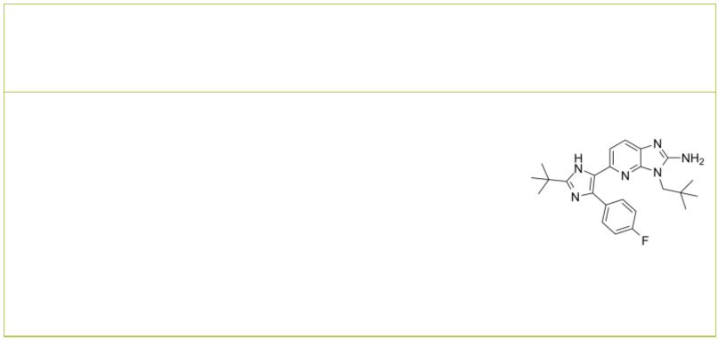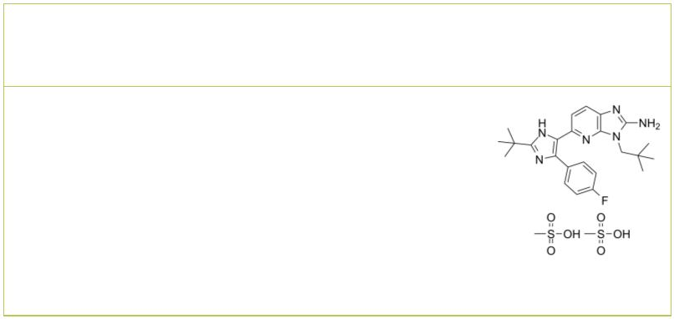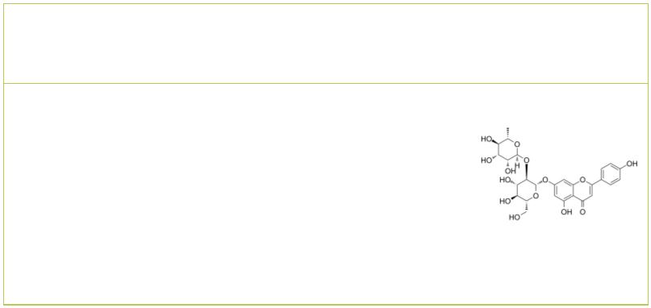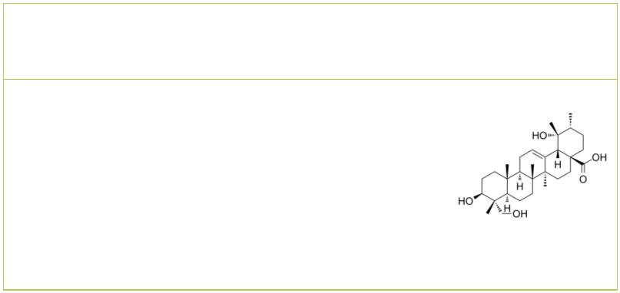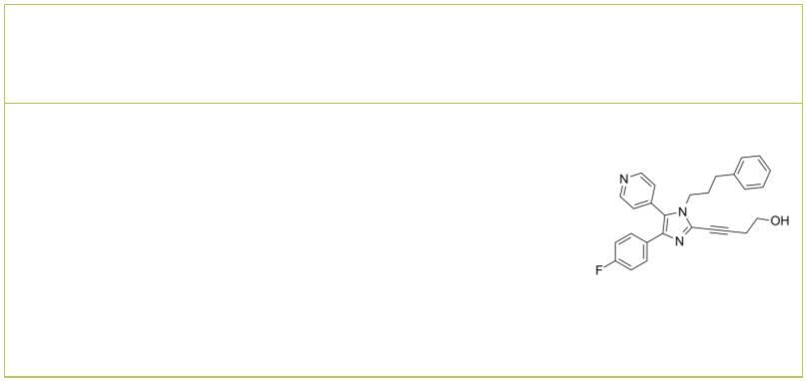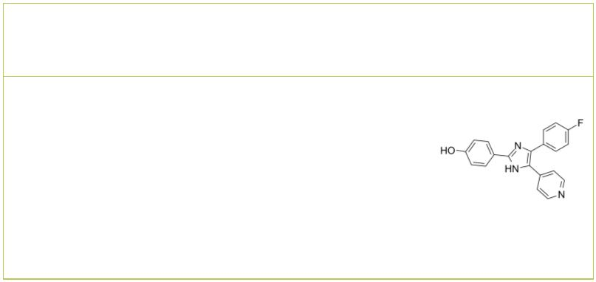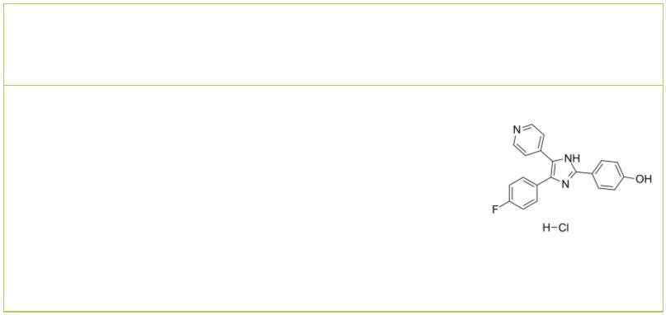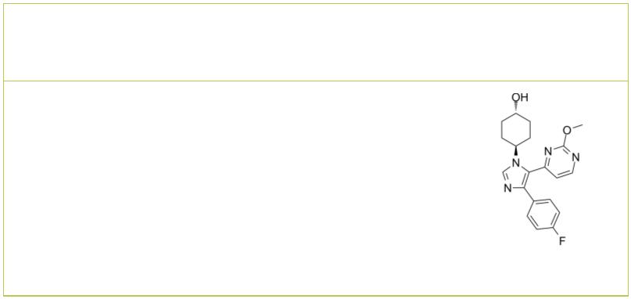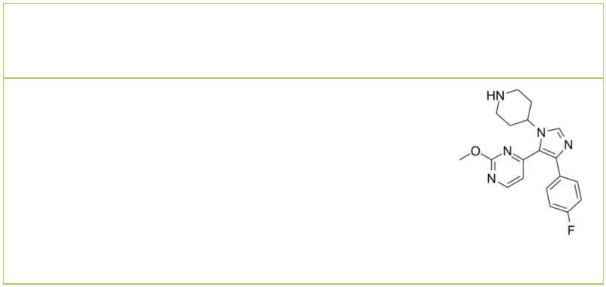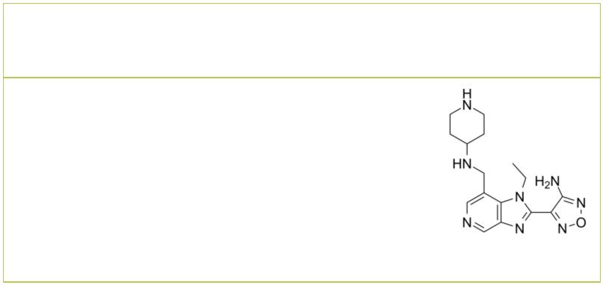 | Ralimetinib  (LY2228820) Cat. No.: HY-13241A |  |  |  |  | Ralimetinib dimesylate  (LY2228820 dimesylate) Cat. No.: HY-13241
 | Ralimetinib (LY2228820) is a potent and selective,  ATP-competitive inhibitor of p38 MAPK α/β, with  IC s of 5.3 and 3.2 nM, respectively. Ralimetinib  50  (LY2228820) selectively inhibits phosphorylation  of MK2 (Thr334), with no effect on phosphorylation  of p38α MAPK, JNK, ERK1/2, c-Jun, ATF2, or c-Myc. |  |  |  |  | Ralimetinib dimesylate (LY2228820 dimesylate) is a  selective, ATP-competitive inhibitor of p38 MAPK  α/β with IC s of 5.3 and 3.2 nM, respectively.  50
 | Purity: >98%  Clinical Data: No Development Reported  Size: 1 mg, 5 mg |  |  |  |  | Purity: 99.52%  Clinical Data: Phase 2  Size: 10 mM × 1 mL, 5 mg, 10 mg, 50 mg, 100 mg
 | Rhoifolin Rotundic acid
 |  |  | Cat. No.: HY-N0755 Cat. No.: HY-N2217
 | Rhoifolin is a flavone glycoside isolated from  Citrus grandis (L.) Osbeck leaves. Rhoifolin is  beneficial for diabetic complications through  enhanced adiponectin secretion, tyrosine  phosphorylation of insulin receptor-β and glucose  transporter 4 (GLUT 4) translocation. |  |  |  |  | Rotundic acid, a triterpenoid obtained from I.  rotunda, induces DNA damage and cell apoptosis in  hepatocellular carcinoma through AKT/mTOR and  MAPK Pathways. Rotundic acid possesses  anti-inflammatory and cardio-protective abilities.
 | Purity: 99.24%  Clinical Data: No Development Reported  Size: 5 mg, 10 mg, 20 mg |  |  |  |  | Purity: 99.41%  Clinical Data: No Development Reported  Size: 5 mg, 10 mg
 | RWJ-67657  (JNJ 3026582) Cat. No.: HY-15505 |  |  |  |  | SB 202190 |  |  |  |  |  |  |  |  |  |  |  |  | Cat. No.: HY-10295
 | RWJ-67657 (JNJ 3026582) is an orally active and  selective p38α and p38β MAPK inhibitor with  IC s of 1 and 11 μM, respectively. RWJ-67657  50  displays no activity at p38γ and p38δ, and  exhibits cardio protective effect.  Anti-inflammatory and anti-tumor activity. |  |  |  |  | SB 202190 is a selective p38 MAP kinase inhibitor  with IC s of 50 nM and 100 nM for p38α and p38β2,  50  respectively. SB 202190 binds to the ATP pocket of  the active recombinant human p38 kinase with a  K of 38 nM. SB 202190 has anti-cancer activity  d  and rescued memory deficits.
 | Purity: 99.32%  Clinical Data: No Development Reported  Size: 10 mM × 1 mL, 5 mg, 10 mg, 25 mg, 50 mg, 100 mg |  |  |  |  | Purity: 99.89%  Clinical Data: No Development Reported  Size: 10 mM × 1 mL, 50 mg, 100 mg, 200 mg
 | SB 202190 hydrochloride SB 239063
 |  | Cat. No.: HY-10295A Cat. No.: HY-11068
 | SB 202190 hydrochloride is a selective p38 MAP  kinase inhibitor with IC s of 50 nM and 100 nM for  50  p38α and p38β2, respectively. SB 202190  hydrochloride binds to the ATP pocket of the  active recombinant human p38 kinase with a K of  d  38 nM. |  |  |  |  | SB 239063 is a potent, selective and orally active  p38 MAPK inhibitor, exhibits an IC of 44 nM  50  for recombinant purified human p38α, with  equipotent inhibitory activity against p38α and  p38β. SB 239063 has no effect on p38γ or p38δ.
 | Purity: >98%  Clinical Data: No Development Reported  Size: 1 mg, 5 mg |  |  |  |  | Purity: 99.80%  Clinical Data: No Development Reported  Size: 10 mM × 1 mL, 1 mg, 5 mg, 10 mg, 25 mg, 50 mg
 | SB 242235 SB-747651A
 |  |  |  | Cat. No.: HY-18306 Cat. No.: HY-114038
 | SB-242235 is a potent and selective p38 MAP kinase  inhibitor, with an IC of 1.0μM in primary human  50  chondrocytes. |  |  |  |  | SB-747651A is an ATP-competitive mitogen- and  stress-activated kinase 1 (MSK1) inhibitor with  an IC of 11 nM. SB-747651A also inhibits PRK2,  50  RSK1, p70S6K and ROCK-II. SB-747651A can be used  for inflammation research.
 | Purity: 99.51%  Clinical Data: No Development Reported  Size: 10 mM × 1 mL, 5 mg, 10 mg, 50 mg, 100 mg |  |  |  |  | Purity: >98%  Clinical Data: No Development Reported  Size: 1 mg, 5 mg
10 Tel: 609-228-6898 Fax: 609-228-5909 Email: sales@MedChemExpress.com
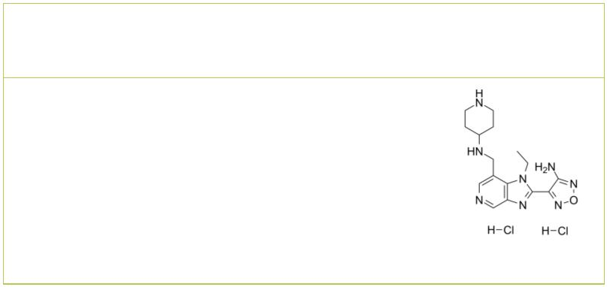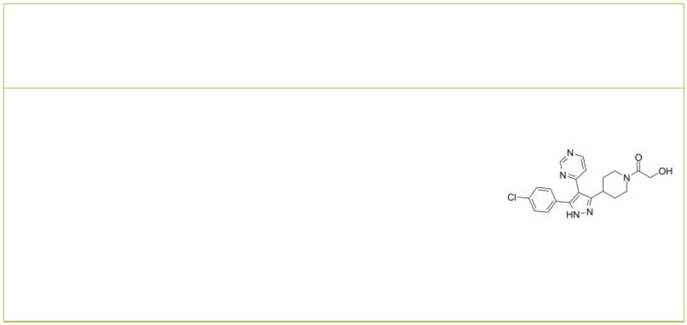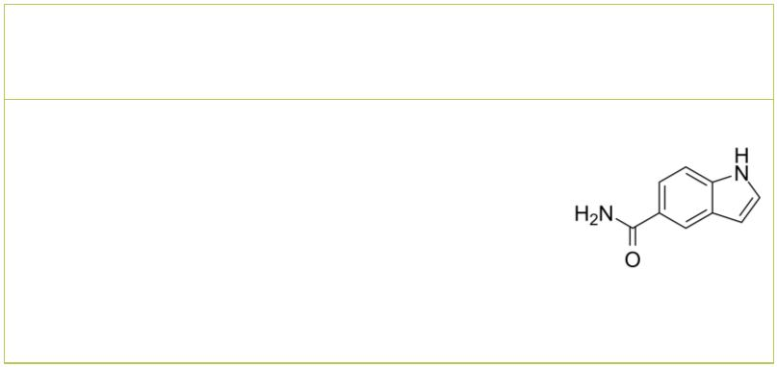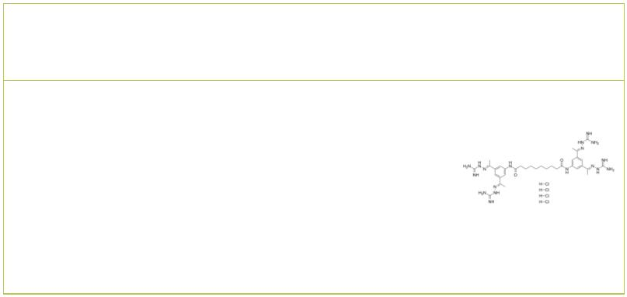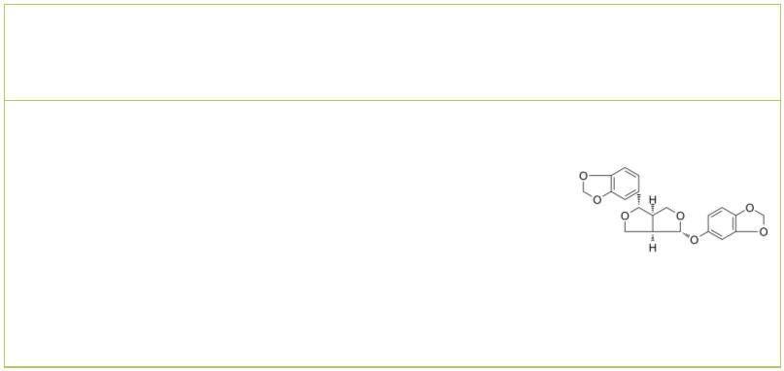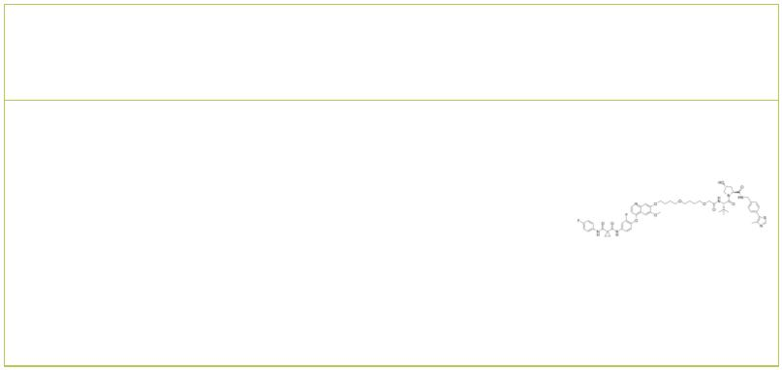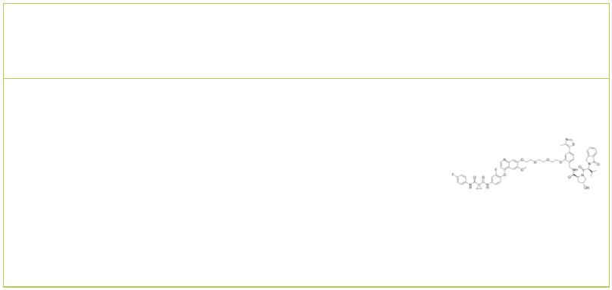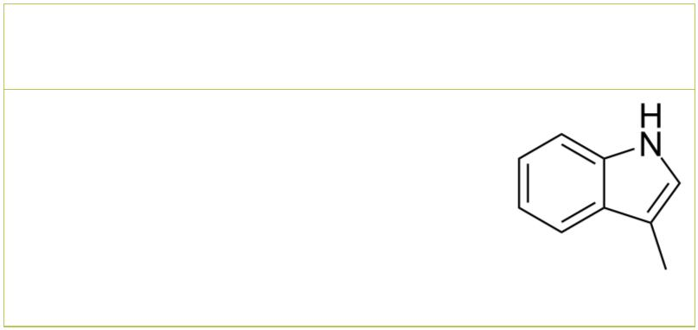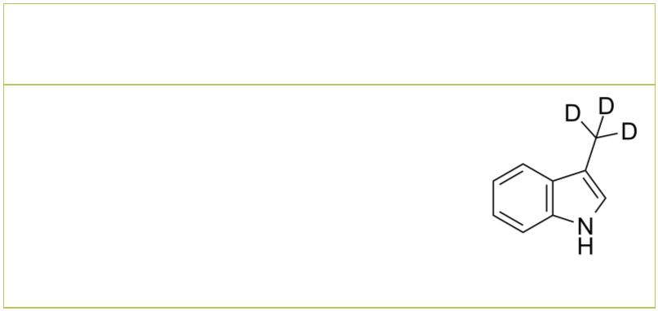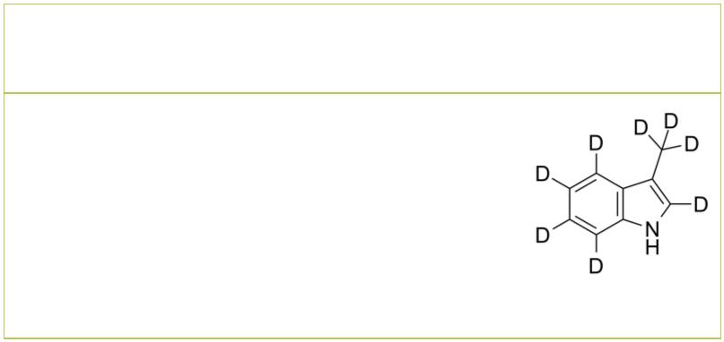SB-747651A dihydrochloride |  |  |  | Cat. No.: HY-110313 |  |  | SD 0006  (SD-06) Cat. No.: HY-11087
SB-747651A dihydrochloride is an ATP-competitive  mitogen- and stress-activated kinase 1  (MSK1) inhibitor with an IC of 11 nM.  50  SB-747651A dihydrochloride also inhibits PRK2,  RSK1, p70S6K and ROCK-II. |  |  |  |  |  |  | SD 0006 (SD-06) is an orally active, selective,  ATP-competitive and potent diaryl pyrazole  inhibitor of p38α MAP kinase, with an IC of 110  50  nM for p38α.
Purity: ≥99.0%  Clinical Data: No Development Reported  Size: 1 mg |  |  |  |  |  |  | Purity: 98.60%  Clinical Data: No Development Reported  Size: 10 mM × 1 mL, 5 mg, 10 mg, 25 mg, 50 mg, 100 mg
SD-169 |  | Cat. No.: HY-W015445 |  |  |  |  | Semapimod tetrahydrochloride  (CNI-1493; CPSI-2364 tetrahydrochloride) Cat. No.: HY-15509A
SD-169 is an orally active ATP-competitive  inhibitor of p38α MAPK, with an IC of 3.2  50  nM. SD-169 also weakly inhibits p38β MAPK with  an IC of 122 nM. SD-169 prevents the development  50  and progression of diabetes by inhibiting T cell  infiltration and activation. |  |  |  |  |  |  | Semapimod tetrahydrochloride (CNI-1493), an  inhibitor of proinflammatory cytokine  production, can inhibit TNF-α, IL-1β, and IL-6.  Semapimod tetrahydrochloride inhibits TLR4  signaling (IC ≈0.3 μM).  50
Purity: 99.44%  Clinical Data: No Development Reported  Size: 10 mM × 1 mL, 50 mg, 100 mg |  |  |  |  |  |  | Purity: 98.43%  Clinical Data: No Development Reported  Size: 5 mg, 10 mg, 25 mg, 50 mg, 100 mg
Sesamolin SJFα
 |  |  |  |  | Cat. No.: HY-N0809 Cat. No.: HY-114404
Sesaminol, isolated from Justicia orbiculata, has  antioxidative activity, Sesaminol inhibits lipid  peroxidation and shows neuroprotection effect.  Sesaminol potently inhibits MAPK cascades by  preventing phosphorylation of JNK, p38 MAPKs,  and caspase-3 but not ERK-MAPK expression. |  |  |  |  |  |  | SJFα is a 13-atom linker PROTAC based on von  Hippel-Lindau ligand. SJFα degrades p38α with a  DC of 7.16nM, but is far less effective at  50  degrading p38δ (DC =299nM) and does not  50  degrade the other p38 isoforms (β and γ) at  concentrations up to 2.5µM.
Purity: 99.78%  Clinical Data: No Development Reported  Size: 5 mg, 10 mg, 20 mg |  |  |  |  |  |  | Purity: >98%  Clinical Data: No Development Reported  Size: 1 mg, 5 mg
SJFδ Skatole
 |  |  |  | Cat. No.: HY-114405 |  |  | (3-Methylindole; 3-Methyl-1H-indole) Cat. No.: HY-W007355
SJFδ is a 10-atom linker PROTAC based on von  Hippel-Lindau ligand. SJFδ degrades p38δ with a  DC of 46.17nM, but does not degrade p38α,  50  p38β, or p38γ. |  |  |  |  |  |  | Skatole is produced by intestinal bacteria,  regulates intestinal epithelial cellular functions  through activating aryl hydrocarbon receptors and  p38.
Purity: >98%  Clinical Data: No Development Reported  Size: 5 mg |  |  |  |  |  |  | Purity: 99.86%  Clinical Data: No Development Reported  Size: 10 mM × 1 mL, 100 mg
Skatole-d3 Skatole-d8
(3-Methylindole-d3; 3-Methyl-1H-indole-d3) Cat. No.: HY-W007355S (3-Methylindole-d8; 3-Methyl-1H-indole-d8) Cat. No.: HY-W007355S1
Skatole-d3 (3-Methylindole-d3) is the deuterium  labeled Skatole. Skatole is produced by intestinal  bacteria, regulates intestinal epithelial cellular  functions through activating aryl hydrocarbon  receptors and p38. |  |  |  |  |  |  | Skatole-d8 (3-Methylindole-d8) is the deuterium  labeled Skatole. Skatole is produced by intestinal  bacteria, regulates intestinal epithelial cellular  functions through activating aryl hydrocarbon  receptors and p38.
Purity: >98%  Clinical Data: No Development Reported  Size: 1 mg, 5 mg |  |  |  |  |  |  | Purity: >98%  Clinical Data: No Development Reported  Size: 1 mg, 5 mg
www.MedChemExpress.com 11
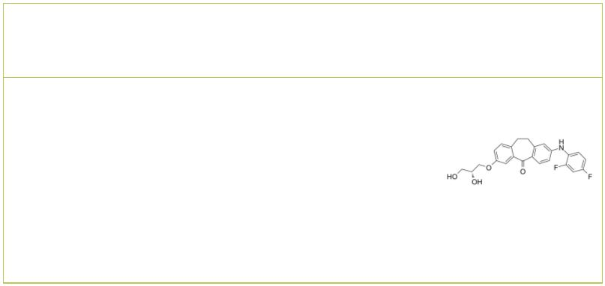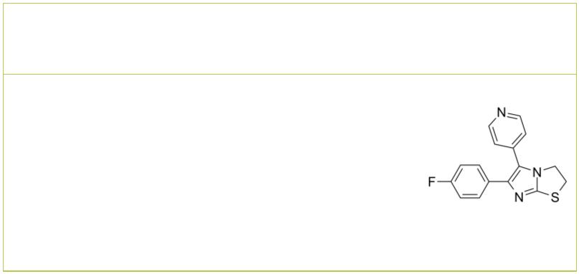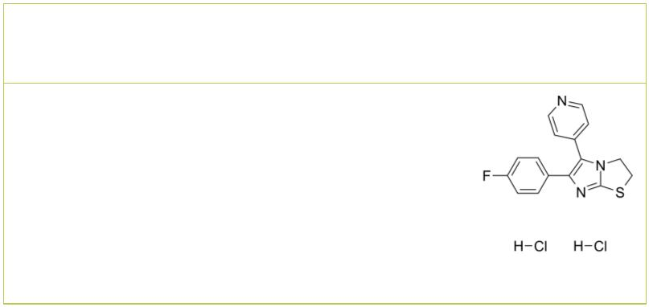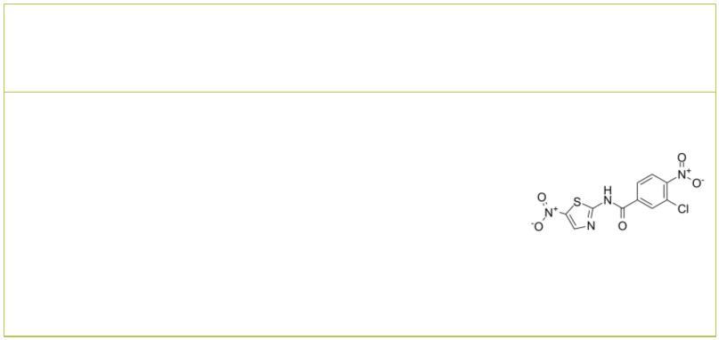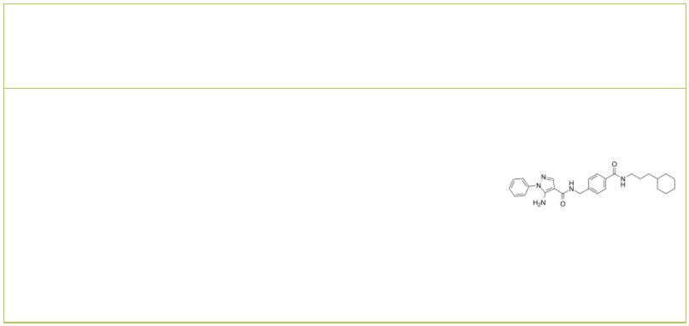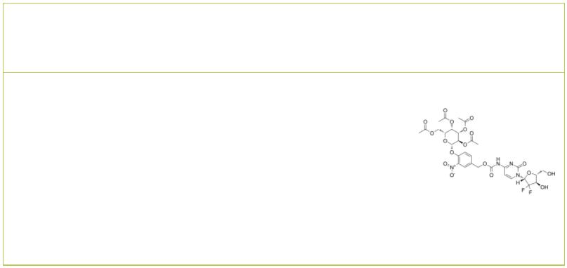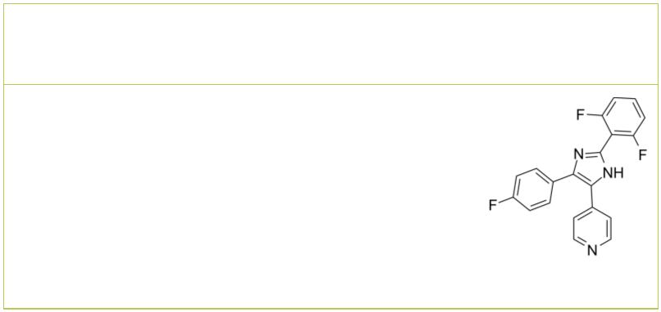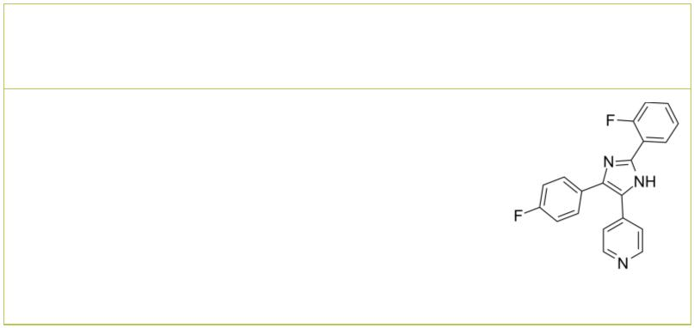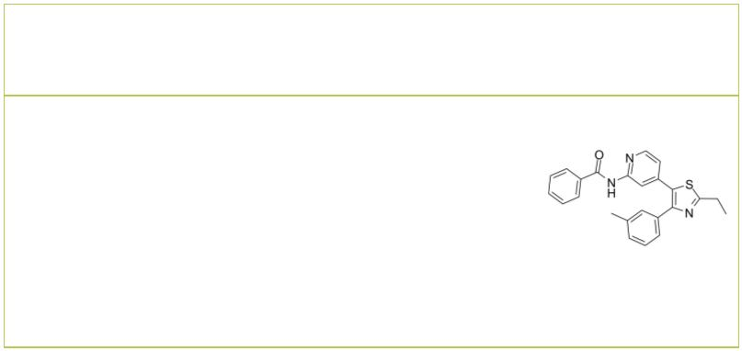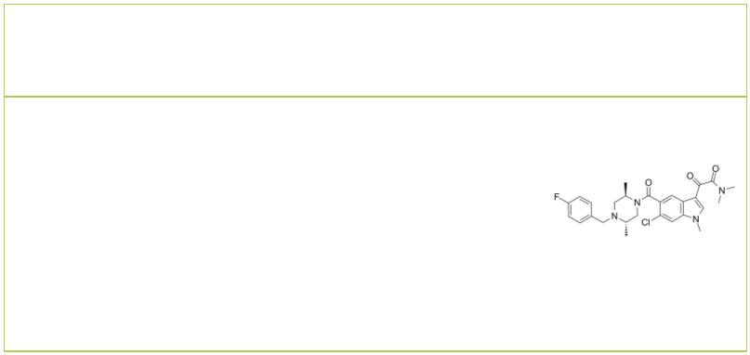 | Skepinone-L  (CBS3830) Cat. No.: HY-15300 |  |  |  | SKF-86002 |  |  |  |  |  |  |  |  |  |  |  |  |  | Cat. No.: HY-12511
 | Skepinone-L (CBS3830) is a selective p38  mitogen-activated protein kinase inhibitor. |  |  |  | SKF-86002 is an orally active p38 MAPK  inhibitor, with anti-inflammatory, anti-arthritic  and analgesic activities. SKF-86002 inhibits  lipopolysaccharide (LPS)-stimulate human monocyte  IL-1 and TNF-α production (IC = 1 μM).  50
 | Purity: 99.77%  Clinical Data: No Development Reported  Size: 10 mM × 1 mL, 5 mg, 10 mg, 50 mg |  |  |  | Purity: 99.46%  Clinical Data: No Development Reported  Size: 10 mM × 1 mL, 5 mg, 10 mg, 50 mg
 | SKF-86002 dihydrochloride SM-7368
 |  | Cat. No.: HY-108641 Cat. No.: HY-116626
 | SKF-86002 dihydrochloride is an orally active p38  MAPK inhibitor, with anti-inflammatory,  anti-arthritic and analgesic activities. SKF-86002  dihydrochloride inhibits lipopolysaccharide  (LPS)-stimulate human monocyte IL-1 and TNF-α  production (IC = 1 μM).  50  Purity: >98%  Clinical Data: No Development Reported  Size: 1 mg, 5 mg |  |  |  | SM-7368 is a potent NF-kB inhibitor that targets  downstream of MAPK p38 activation. SM-7368  inhibits TNF-α-induced MMP-9 upregulation.  SM-7368 can be used for the research of  chemotherapies targeting TNF-α-mediated tumor  invasion and metastasis .  Purity: >98%  Clinical Data: No Development Reported  Size: 5 mg, 10 mg, 25 mg, 50 mg
 | SR-318 SSK1
 |  | Cat. No.: HY-135674 Cat. No.: HY-138936
 | SR-318 is a potent and highly selective p38  MAPK inhibitor with IC s of 5 nM, 32 nM and  50  6.11 μM for p38α, p38β and p38α/β, respectively.  SR-318 potently inhibits the TNF-α release in  whole blood with an IC of 283 nM. SR-318 has  50  anti-cancer and anti-inflammatory activity. |  |  |  | SSK1, a senescence-specific killing compound, is a  β-galactosidase-targeted prodrug attenuates  inflammation. SSK1 is activated by lysosomal  β-galactosidase and selectively killed senescent  cells through the activation of p38 MAPK and  induction of apoptosis.
 | Purity: 98.87%  Clinical Data: No Development Reported  Size: 10 mM × 1 mL, 5 mg, 10 mg, 25 mg, 50 mg, 100 mg |  |  |  | Purity: 99.19%  Clinical Data: No Development Reported  Size: 5 mg, 10 mg
 | TA-01 TA-02
 |  | Cat. No.: HY-100114 Cat. No.: HY-100115
 | TA-01 is a potent CK1 and p38 MAPK inhibitor,  with IC s of 6.4 nM, 6.8 nM, 6.7 nM for CK1ε,  50  CK1δ and p38 MAPK, respectively. TA-01 acts as a  cardiogenic inhibitor. |  |  |  | TA-02, an analog of SB 203580 (HY-10256), is a  p38 MAPK inhibitor with an IC of 20 nM.  50  TA-02 especially inhibits TGFBR-2. TA-02 exhibits  similar cardiogenic properties as SB 203580 and SB  202190 (HY-10295).
 | Purity: 99.77%  Clinical Data: No Development Reported  Size: 10 mM × 1 mL, 5 mg, 10 mg, 50 mg, 100 mg |  |  |  | Purity: 99.57%  Clinical Data: No Development Reported  Size: 10 mM × 1 mL, 1 mg, 5 mg, 10 mg, 50 mg, 100 mg
 | TAK-715 Talmapimod
 |  |  | Cat. No.: HY-10456 |  | (SCIO-469) Cat. No.: HY-10406
 | TAK-715 is an orally active and potent p38  MAPK inhibitor with IC s of 7.1 nM, 200 nM for  50  p38α and p38β, respectively. TAK-715 inhibits  casein kinase I (CK1δ/ε) to regulate activation of  Wnt/β-catenin signaling. TAK-715 shows good  significant efficacy in a rat arthritis model. |  |  |  | Talmapimod (SCIO-469) is an orally active,  selective, and ATP-competitive p38α inhibitor  with an IC of 9 nM. Talmapimod shows about  50  10-fold selectivity over p38β, and at least  2000-fold selectivity over a panel of 20 other  kinases, including other MAPKs.
 | Purity: 99.89%  Clinical Data: Phase 2  Size: 10 mM × 1 mL, 5 mg, 10 mg, 50 mg |  |  |  | Purity: 98.04%  Clinical Data: Phase 2  Size: 10 mM × 1 mL, 5 mg, 10 mg, 25 mg, 50 mg
12 Tel: 609-228-6898 Fax: 609-228-5909 Email: sales@MedChemExpress.com
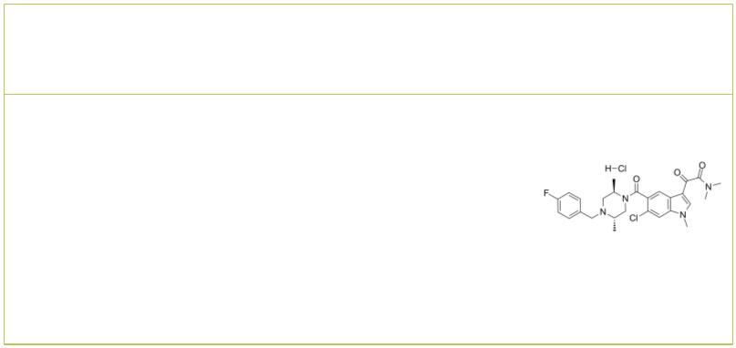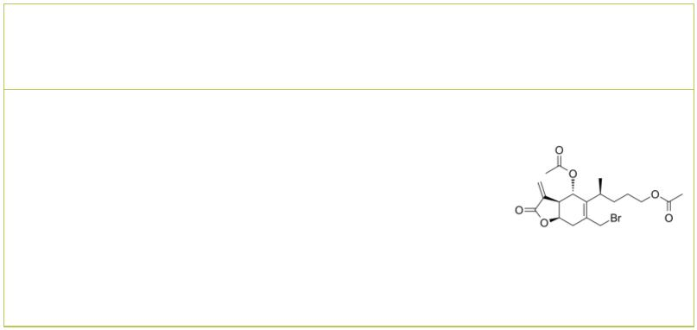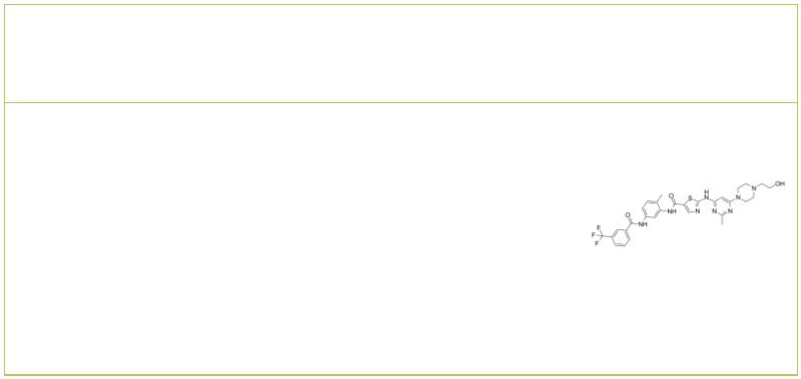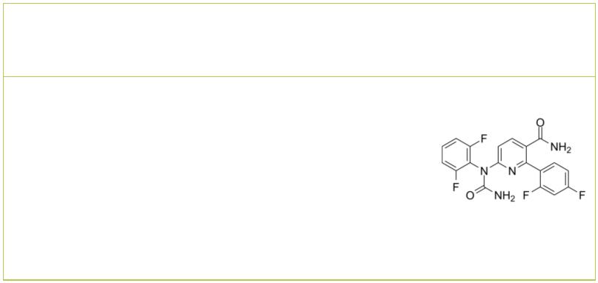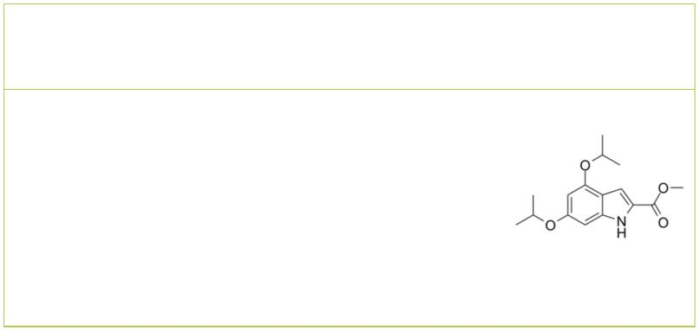Talmapimod hydrochloride  (SCIO-469 hydrochloride) Cat. No.: HY-10406A |  | TLR4/NF-κB/MAPK-IN-1 |  |  |  |  |  | Cat. No.: HY-142963
Talmapimod (SCIO-469) hydrochloride is an orally  active, selective, and ATP-competitive p38α  inhibitor with an IC of 9 nM. Talmapimod  50  hydrochloride shows about 10-fold selectivity over  p38β, and at least 2000-fold selectivity over a  panel of 20 other kinases, including other MAPKs. |  | TLR4/NF-κB/MAPK-IN-1 is a new type of  antineuroinflammatory agent by suppressing  TLR4/NF-kB/MAPK pathways.
Purity: >98%  Clinical Data: No Development Reported  Size: 1 mg, 5 mg |  | Purity: >98%  Clinical Data: No Development Reported  Size: 1 mg, 5 mg
UM-164  (DAS-DFGO-II) Cat. No.: HY-112182 |  | VX-702 |  |  |  |  |  |  |  | Cat. No.: HY-10401
UM-164 (DAS-DFGO-II) is a highly potent inhibitor  of c-Src with a K of 2.7 nM. UM-164 also  d  potently inhibits p38α and p38β. |  | VX-702 is a highly selective inhibitor of p38α  MAPK, 14-fold higher potency against the p38α  versus p38β.
Purity: 98.91%  Clinical Data: No Development Reported  Size: 5 mg, 10 mg |  | Purity: 99.44%  Clinical Data: Phase 2  Size: 10 mM × 1 mL, 10 mg, 50 mg, 100 mg, 200 mg
XST-14
Cat. No.: HY-137506
XST-14 is a potent, competitive and highly selective ULK1 inhibitor with an IC of 26.6 nM.
50
XST-14 induces autophagy inhibition by reducing
the phosphorylation of the ULK1 downstream
substrate.
Purity: 99.69%
Clinical Data: No Development Reported
Size: 10 mM × 1 mL, 5 mg, 10 mg, 25 mg, 50 mg, 100 mg
www.MedChemExpress.com 13

