PART 1 - 英语
Passage I
Grandpa’s Remote Control
[1]
My grandfather is not known for embracing technological change. He still drives his’ 59 Chevy Impala. (He says, he can’t imagine needing frivolous options like automatic transmission or power steering.) So, when he has went to buy a new color television—owing to the knowledge that his old black-and-white model had finally quit—and the salesperson tried to talk him into buying a model with a remote control, he resisted. He said that he had two good legs and was perfectly capable of getting out of his chair. (5)
[2]
However, the salesperson was persistent and, appealing to Grandpa’s TV-viewing habits, described the various functions on the remote. However, my grandpa could punch in the time, and the channel of his favorite daily news program, and the TV would turn on that program at the proper time. In the end, Grandpa did buy the remote, and it has since become something he uses all the time.
[3]
Grandpa is intrigued by the various uses for that remote. He has confided in me that the volume control is perfect for turning up the sound whenever Grandma asks him to take out the garbage. For example, he says, the button that mutes the sound lets him cut them off in midsentence. WX小程序 橙子ACT
[4]
Grandpa’s favorite feature on the remote is the sleep function. This option automatically turns the TV off after a preset amount of time, which is very convenient when he falls asleep while watching a show. For him, Grandpa says what he wants his TV doing, even when he sleeps, is to know a source of both pleasure and power.
[5]
[1] As for the programming function, Grandpa not only uses it for the news but also for playing jokes on his youngest grandchildren. [2] Explaining to the unsuspecting child that he has a remote control implanted in his little finger, Grandpa points his finger at the TV and, to the child's amazement, seemingly turns it on. [3] I suppose Grandpa hasn’t learned all the possible uses of the remote control, but I don't doubt he will continue to discover new and creative ways of using it. (14)
1.
- NO CHANGE
- change he still drives
- change still driving,
- change, and still driving

Answer：A

2.
- NO CHANGE
- Says
- says, that
- says, that,

Answer：B

3.
- NO CHANGE
- had went
- Went
- Goes

Answer：C

4.
- NO CHANGE
- due to the understandable fact that
- Because
- So

Answer：C

- Given that all are true, which of the following additions to the preceding sentence (replacing “chair.”) would be most relevant?
- chair that was made of black leather.
- chair when he wanted to change the channel.
- chair by the south window in the family room.
- chair where he liked to sit.

Answer：B

PART 2 - 数学

- A restaurant occupying the top floor of a skyscraper rotates as diners enjoy the view. Ling and Sarah notice that they began their meal at 7:00 P.M. looking due north. At 7:45 P.M. they had rotated 180° to a view that was due south. At this rate, how many degrees will the restaurant rotate in 1 hour ?
- 90°
- 180°
- 240°
- 270°
- 400°

Answer：C

- If 12 vases cost ＄18.00, what is the cost of 1 vase ?
- $0.67
- $1.05
- $1.33
- $1.50
- $1.60
Answer：D

- Your friend shows you a scale drawing of her apartment. The drawing of the apartment is a rectangle 4 inches by 6 inches. Your friend wants to know the length of the shorter side of the apartment. If she knows that the length of the longer side of the apartment is 30 feet, how many feet long is the shorter side of her apartment ?
- 9
- 20
- 24
- 30
- 45

Answer：B

- A company earned a profit of $8.0 million each year for 3 consecutive years. For each of the next 2 years the company earned a profit of $9.0 million. For this 5-year period, what was the company’s average yearly profit, in millions of dollars ?
- 8.2
- 8.25
- 8.4
- 8.5
- 8.6

Answer：C

- A company rents moving vans for a rental fee of $25.00 per day with an additional charge of $0.30 per mile that the van is driven. Which of the following expressions represents the cost, in dollars, of renting a van for 1 day and driving it m miles ?
- 0.30m + 25
- 25m + 30
- 30m + 25
- 25.30m
- 55m

Answer：A

PART 3 - 阅读

Passage I
PROSE FICTION: This passage is adapted from the novel Monkey Bridge by Lan Cao (©1997 by Lan Cao). The story is set in the late 1970s in Virginia, where the narrator and her mother have moved from Vietnam after he fall of Saigon.
I discovered soon after my arrival in Virginia that everything, even the simple business of shopping the American way, unsettled my mother’s nerves. From the outside, it had been an ordinary building that held no promises or threats. But inside, the A & P brimmed with unexpected abundance. Metal stands overflowed with giant oranges and meticulously arranged grapefruits. Columns of canned vegetables and fruits stood among multiple shelves as people well rehearsed to the demands of modern shopping meandered though florescent aisles. I remembered the sharp chilled air against may face, the way the hydraulic door made a sucking sound as it closed behind.
My mother did not appreciate the exacting orderliness of the A & P. She could not five in to the precision of previously weighed and packaged food, the bloodlessness of beef slabs in translucent wrappers, the absence of carcasses and pigs’ heads. When we were in Saigon, there were only outdoor markets. “Sky markets,” they were called, vast, prosperous expanses in the middle of the city where barrels of live crabs and yellow craps and booths of ducks and geese would be stacked side by side with cardboard stands of expensive silk fabric. It was always noisy there—a voluptuous of animal and human sounds. The sharp acrid smell of gutters choked by the monsoon rain. The odor of horses, partially camouflaged by the scent of guavas and bananas.
My mother knew the vendors and the shoppers byname and would take me from stall to stall to expose me to her skills. They were all addicted to each other’s oddities. My mother would feign indifference and they would inevitably call out to her. She would heed their all and they would immediately retreat into sudden apathy. They knew my mother’s slick bargaining skills, and she, in turn, knew how to navigate with grace though their extravagant prices and rehearsed huffiness. Theirs had been a mating dance, a match of wills.
Every morning, we drifted from vendor to vendor. Tables full of shampoo and toothpaste were pocketed among vegetable stands one day and jars of herbs the nest. The market was randomly organized, and only the might and experienced like my mother could navigate its patternless paths.
But with a sense of neither drama nor calamity, my mother’s ability to navigate and decipher simply became undone in our new life. She preferred the improvisation of haggling to the conventional certainty of discount coupons, the primordial messiness and fishmongers' stink of the open-air market to the aroma-free order of individually wrapped fillets.
Now, a mere three and a half years or so after her last call to the sky market, the dreadful truth was simply this: we were going through life in reverse, and I was the one who would help my mother through the hard scrutiny of ordinary suburban life. I would have to forgo the luxury of adolescent experiments and temper tantrums, so that I could scoop my mother out of harm’s way and give her sanctuary. Now, when we stepped into the exterior world, I was the one who told my mother what was acceptable or unacceptable behavior.
All children of immigrant parents have experienced these moments. When it first occurs, when the parent first reveals the behavior of a child, is a defining moment. Of course all children eventually watch their parents’ astonishing return to the vulnerability of childhood, but for us the process begins much earlier than expected.
“We don’t have to pay the moment we decide to buy the pork. We can put as much as we want in the cart and pay only once, at the checkout counter.” It took a few moments’ hesitation for my mother to succumb to the peculiarity of my explanation.
“I can take you in this aisle,” a store clerk offered as she unlocked a new register to accommodate the long line of customers. She gestured us to “come over here” with an upturned index finger, a disdainful hook we Vietnamese use to summon dogs. My mother did not understand the ambiguity of American hand gestures. In Vietnam, we said “Come here” to humans differently, with our palm up and all four fingers waved in unison—the way people over here waved goodbye.
“Even the store clerks look down on us,” my mother grumbled. This was a truth I was only beginning to realize: it was not the enormous or momentous event, but the gradual suggestion of irrevocable and protracted change that threw us off balance and made us know in no uncertain terms that we would not be returning to the familiarity of our former lives.

- At time of the events of the story, the narrator is:
- an adult remembering how hard it was on her mother when the wow of them visited the United States from Saigon.
- an adult planning to take her mother back to their native Saigon after an unsuccessful trip to the United State.
- an adolescent imagining what it had been like when her mother moved to the United States years ago.
- an adolescent trying to ease her mother’s adjustment to life in the United States.

Answer：D

- It can reasonably be inferred from the passage as a whole that the narrator views her mother’s bargaining skills as ones that were developed:
- to a degree that was exceptional even in Saigon but that have no apparent outlet in the United States.
- to a degree that is commonplace in the competitive sky markets but that is exceptional in the United States.
- to a lesser degree than those of most sky market shippers in Saigon but to a degree that seems exceptional in the United States.
- solidly and irrevocably over years of shopping in Saigon, putting her at an advantage in the challenging circumstances of her adopted home.

Answer：A

- It can reasonably be inferred from the passage that when shopping at the sky market the narrator’s mother viewed which of the following as something disagreeable to overcome ?
- The primordial messiness
- The extravagant prices
- The odors of animals
- The other shoppers

Answer：B

- The passage states that the narrator’s mother finds all of the following aspects of shopping at the A & P troubling EXCEPT the:
- orderliness of the place.
- absence of carcasses.
- hurried shoppers.
- system of paying for merchandise.

Answer：C

- It can reasonably be inferred that the narrator views her mother’s approach to shipping at the sky market with a mixture of:
- anxiety and huffiness.
- surprise and embarrassment.
- impatience and amusement.
- respect and nostalgia.
Answer：D

PART 4 - 科学

Passage Ⅰ
A team of researchers constructed a greenhouse, consisting of 3 artificially lighted and heated sections, to be used to grow food during a long space voyage. The researchers found the weekly average light intensity, in arbitrary units, and the weekly average air temperature, in degrees Celsius (°C), in each section. The results for the first 6 weeks of their measurements are given in Table 1 (weekly average light intensity) and Table 2 (weekly average air temperature).
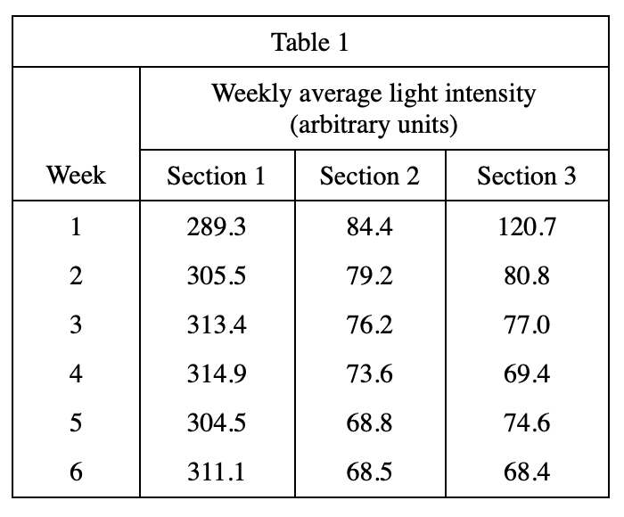
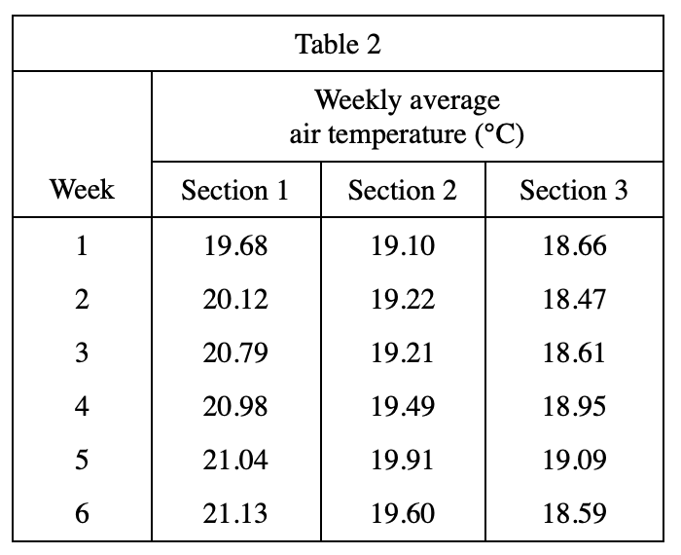

- The highest weekly average air temperature recorded during the first 6 weeks of the study was:
- 18.47°C.
- 21.13°C.
- 120.7°C.
- 314.9°C.

Answer：B

- According to Table 2, weekly average air temperatures were recorded to the nearest:
- 0.01℃.
- 0.1℃.
- 1.0℃.
- 10℃.

Answer：A

- A plot of weekly average air temperature versus weekly average light intensity for Section 1 is best represented by which of the following graphs ?
- 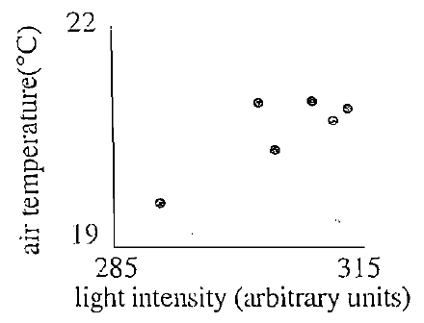
- 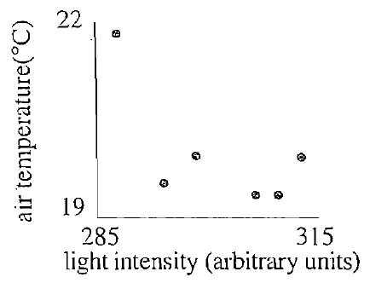
- 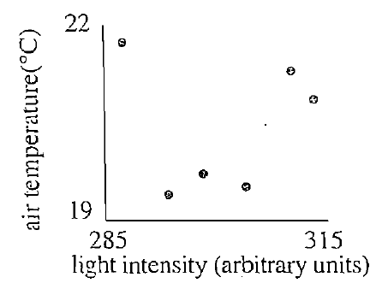
- 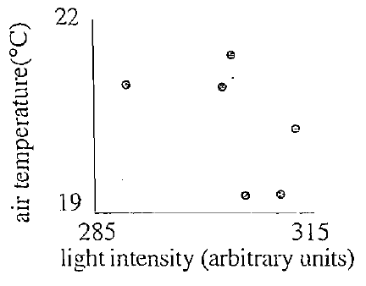

Answer：A

- Which of the following statements best describes the changes in the weekly average air temperature in Section 1 during Weeks 1-6 ?
- The weekly average air temperature increased between Weeks 1 and 3 and decreased between Weeks 4 and 6.
- The weekly average air temperature decreased between Weeks 1 and 3 and increased between Weeks 4 and 6.
- The weekly average air temperature always increased.
- The weekly average air temperature always decreased.

Answer：C

- Suppose the efficiency of illumination is defined as the intensity of light absorbed by the plants divided by the intensity of light provided to the plants. Based on the data, would one be justified in concluding that the efficiency of illumination was higher in Section 1 than in the other sections ?
- Yes，because the illumination provided to the plants was highest in Section 1.
- Yes，because the amount of light not absorbed by the plants was highest in Section 1.
- No, because the amount of light absorbed by the plants was lowest in Section 1.
- No,because the information provided is insufficient to determine efficiency of illumination.

Answer：D

